SIGEMAIL: End-to-End Encrypted Email using the Signal Protocol
John Agapeyev A00928238
COMP8045 9 Credit Major Project

Table of Contents
1 Student Background 2
2 Project Description 2
3 Background 2
4 Complexity 3
5 Scope and Depth 3
6 Design Decisions 4
7 Innovation 4
8 Technologies Used 4
9 Testing 5
9.1 Unit Tests 5
9.1.1 Expected run 5
9.1.2 Expected run with AAD 5
9.1.3 Corrupt message 5
9.1.4 Decrypt with bad key 5
9.1.5 Decrypt with bad nonce 6
9.1.6 Decrypt with missing AAD 6
9.1.7 Decrypt with bad AAD 6
9.2 Integration Tests 6
9.2.1 Incoming message expected run 6
9.2.2 Alternate sending messages 6
9.2.3 Send messages out of order 7
9.2.4 Skip message, receive message, send skipped message 7
9.3 System Tests 7
10 System Architechture 8
11 Expertise Development 8
12 Deliverables 9
13 Timeline 9
13.1 Client 9
13.2 Server 9
13.3 Documentation 10
14 Appendix A 10
14.1 X3DH 10
14.2 Double Ratchet 11
15 References 15

Student Background
John is in his 4th year as a student at BCIT, and is currently enrolled in the Bachelor of Technology Degree for Computer Systems, with a specialization of Network Security and Administration. Previously he completed a Diploma in Computer Systems Technology in the Data Communications and Inter-networking option. John has worked as a Software Developer Co-op, a peer tutor, and as a Research Assistant at BCIT.

Project Description
SIGEMAIL is a tool for End-To-End encrypted email communications using the Signal Protocol. It will feature a full implementation of the Signal Protocol in C++, including a server for key and message distribution, a client for sending and receiving messages, a GUI for interacting with the client, and import/export of messages via IMAPS.

Background
Email as a service has been around since the 1970’s, with experimental usage going back to the 1960’s. It has existed longer than the internet, and is a major backbone of communication to this day. As the name implies, it is essentially digital mail. Email has grown to encompass images, HTML, CSS, and sometimes even scripting. This allows email to be a flexible platform for messages, and carries everything from personal communications, to advertising, and subscription updates.
After the 2013 Snowden leaks, it was revealed that the emails of hundreds of millions of people were having their emails automatically read by intelligence agencies such as the NSA. In response, providers such as Yahoo, Google, and Microsoft adopted TLS for their email services, to ensure that eavesdropping of these emails was no longer viable. This solved the passive eavesdropping issue, but the NSA had powers they could use to bypass those protections. Using secretive rulings, they forced these providers to comply to warrants in which they would have to hand over the contents of user’s emails. As their business models and spam filters revolve around the ability of reading their user’s messages, this cannot be prevented. This has spurred an increase in communication protocols and services using End-To-End Encryption.
End-to-End encryption requires that the contents of the message are encrypted both at rest, and in transit, and that they can only be decrypted by the participants in the conversation. So an End-To-End encrypted email would only be readable by the sender and the receiver, and not by Google, or the NSA.
One of the best well-known End-To-End encrypted communication systems is PGP. PGP relied heavily on peer-to-peer interactions and user-based key management in a decentralized ecosystem. PGP allowed arbitrary chunks of data to be signed and encrypted, which allowed it to be used for email encryption. PGP uses a Web-of-Trust security model, where keys can be exchanged in any protocol or format, but it was ultimately up to the user to trust that key. To prevent issues with malicious keys, a Web-of-Trust was established. So instead of placing an unwavering level of trust into a single key, you can then trust a connection of other people you already trust to verify the authenticity. If your friend’s public key has been signed and verified by 10 of your close friends, it’s likely legitimate.
The issue with PGP is the reliance on manual key management, and when it comes to security, users are the weakest point. From this came TextSecure, which would eventually change its name to Signal. Signal used a custom protocol that involved transparent key transfers, and a key distribution server. It was designed to ensure that keys could be exchanged asynchronously, could be verified Out-of-Band, and that the worst thing a malicious server could do, was refuse to distribute keys to the users. This type of approach to encryption and key management has revolutionized secure messaging, allowing people who are completely technically illiterate to be able to have fully End-to-End encrypted communications without any hassle or learning necessary.

Complexity
The complexity of the project comes from a mix of technical and user-experience hurdles that much be overcome. Email as a protocol is complex, and allowing arbitrary HTML and remote resources can introduce a serious security risk. The Signal Protocol itself involves a complicated series of key-exchanges, key negotiations, and key ratcheting, that is ultimately transparent to the user. For a full explanation on the Signal Protocol’s key ratcheting, see Appendix A. There is little info available on the server-side aspect of Signal outside of the state requirements for each connection, so a protocol and data-encoding scheme must be devised for client-server communication. Lastly, the User Experience is critical to the success of the project, as it must be aimed at non-technical users.

Scope and Depth
The base features I will include are as follows:
- Signal protocol fully implemented on client side
- Server is up and running for key and message exchanges
- Full graphical interface for email creation and retrieval
- Outside email import/export via IMAPS
I believe this list of features will be sufficient to fully explore the complexity and design implications that arise from this project.
I will impose some limitations on those features, to limit the potential scope of the application:
- The application will only target x64 Linux Desktops
- The application will not target mobile devices such as Android phones
- The application will not involve a web-mail interface
- The application will not be built as a plugin for existing email clients (eg. Mozilla Thunderbird)

Design Decisions
The core aspect of the project – the Signal Protocol, is quite descriptive and fleshed out, so there is little room for divergence or creativity in its design. I am taking one liberty in that I am using ChaCha20-Poly1305 as the main cipher instead of AES-CBC with HMAC-SHA256, due to its better security properties as an AEAD cipher, while also having better speed than AES. The majority of the design decisions will revolve around the implementation of the client, as well as the entirety of the server. The Signal Protocol does mention what behaviour the server should do for handling new clients, devices, messages, and key exchanges, but those are very high level aspects. The protocol and design of the server is completely open-ended, assuming it meets those requirements. The client also has complete freedom on how it handles non-protocol actions, such as GUI design.

Innovation
The innovation of this project comes in applying multiple existing concepts in a unique fashion. Email encryption through PGP and services which use/mimic it such as ProtonMail and Tutanota has been around for decades, but suffers from both technical and user experience pitfalls. Signal as an application is fairly recent, but does not target email, and intentionally refuses to open their servers to forks and custom implementations of the protocol. The rise of services such as ProtonMail, show that email encryption is in high demand, and there are no existing email encryption services that do not use PGP or some variant of it; which SIGEMAIL seeks to rectify.

Technologies Used
The high complexity of the project necessitates the use of external libraries for handling various aspects of the application that are tangential to its end-goal. To this end, I am designing the application in C++ with the following libraries:
- OpenSSL – For the majority of cryptographic functions; also required for TLS
- Boost
  - Serialization – For serializing data for sending over the network
  - Beast – For handling network connections, TLS, and the server
  - Test – For unit and integration tests
- Curl – For adding support of IMAPS
- Qt – For the entirety of the GUI
- libsignal-c – For its implementation of XedDSA, otherwise unused
- Cmake – For building the project and finding/linking all dependencies
- Redis – For managing keys and in-transit messages on server

Testing
SIGEMAIL will require rigorous testing of its components at a variety of scales to ensure proper operation of its components. There are many individual components that must be tested both alone and together. To this end, testing will feature a major part of the development process. All features will require a set of tests before they are committed, as well as requiring all existing tests to pass. The Boost Test library will be heavily used here for defining and running test cases. The following sections detail efforts for unit, integration, and systems testing.

Unit Tests
Unit testing will be a large portion of the tests, and will entirely done as part of the automated testing framework done using Boost Test. Each individual feature will require multiple unit tests to exhaustively test its functionality. The following tests are examples of what would be produced for basic encryption and decryption of messages.

Expected run
- Encrypt test message with key and nonce
- Decrypt test message with tag
- Decrypted ciphertext should equal original plaintext

Expected run with AAD
- Encrypt test message with key and nonce, and Additional Authenticated Data
- Decrypt test message with tag
- Decrypted ciphertext should equal original plaintext

Corrupt message
- Encrypt test message with key and nonce
- Corrupt message by incrementing a random ciphertext byte
- Decrypt test message with tag
- Decryption should fail

Decrypt with bad key
- Encrypt test message with key and nonce
- Decrypt test message with tag, and using a different key
- Decryption should fail

Decrypt with bad nonce
- Encrypt test message with key and nonce
- Decrypt test message with tag, and using a different nonce
- Decryption should fail

Decrypt with missing AAD
- Encrypt test message with key and nonce, and Additional Authenticated Data
- Decrypt test message with tag, and do not provide the AAD
- Decryption should fail

Decrypt with bad AAD
- Encrypt test message with key and nonce, and Additional Authenticated Data
- Decrypt test message with tag, and provide a different AAD
- Decryption should fail

Integration Tests
Integration testing will be the other large portion of the tests, and will be a mix of tests in the test framework, along with additional manual testing. Each subsystem will require tests on its interfaces to be considered complete. The following tests are examples of what would be produced for the interaction between communication session state, and sending/receiving messages

Incoming message expected run
- Parse message header for public key
- Key will not be in skipped key dictionary
- Message will not be skipped, so no skipped keys are added to the dictionary
- Perform chain key derivation
- Decrypt message

Alternate sending messages
- Parse message header for public key
- Key will not be in skipped key dictionary
- Message will not be skipped, so no skipped keys are added to the dictionary
- Perform chain key derivation
- Decrypt incoming message
- Perform DH ratchet
- Update root and chain keys
- Encrypt message with message key
- Send message

Send messages out of order
- Update root and chain keys
- Encrypt message with message key
- Update root and chain keys
- Encrypt message with second message key
- Send second message
- Send first message
- Receiver should decrypt second message with generated skipped message key
- Receiver should decrypt first message after finding skipped key in dictionary
- Messages will be decrypted, but fundamentally out-of-order (limitation of the protocol)

Skip message, receive message, send skipped message
- Update root and chain keys
- Encrypt message with message key
- Receive message
- Parse message header for public key
- Perform DH ratchet
- Key will not be in skipped key dictionary
- Message will not be skipped, so no skipped keys are added to the dictionary
- Perform chain key derivation
- Decrypt incoming message
- Send old skipped message
- Receiver will detect old public key, perform DH ratchet, and add old keys to dictionary
- Decrypt message with skipped message key in dictionary

System Tests
There will also be system tests of SIGEMAIL, but due to their high complexity, will be performed almost entirely manually during development. Included in this will be import/export testing with external email servers, since it is system outside the developer’s control. Some examples of system tests will be adding and deleting users, adding and deleting devices, and group messaging functionality. Detailed breakdown of these tests is omitted for the sake of brevity.

System Architechture
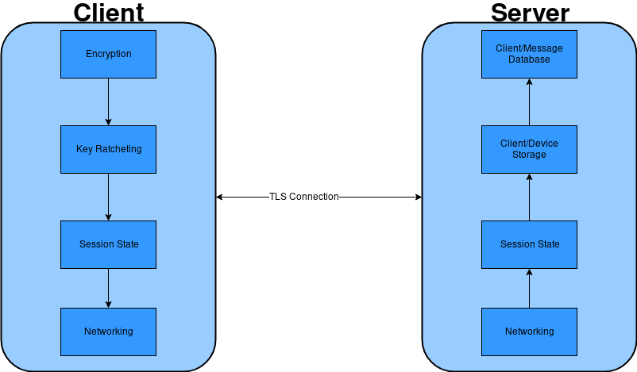

Expertise Development
SIGEMAIL covers a wide spectrum of skills for developing my technical expertise. This project requires a strong protocol design which has normally been relegated to the classroom, so experiencing firsthand the technical challenges found in designing a robust protocol will help develop my networking abilities. The test design and requirements also go far beyond what even the classroom has shown, so learning about proper testing usage will help develop my technical workflow skills, and how testing can reflect upon the success of a project. Lastly, I have never made any large-scale cryptographic software, which has its own unique challenges such as zeroing memory used for keys and plaintexts, and constant time memory comparisons. Having exposure to a cryptographic mindset will strengthen my skills in network security, and help open up a future avenue in cryptographic software as a niche focus on my career.

Deliverables
The Following deliverables will be provided for this application:
- Client application
- Server application
- Final report
- User guide for compilation, running, and installation of the client/server

Timeline
This project aims to fulfill the 405 hour work requirement, and provides the following expected work breakdown to satisfy that claim.

Client
Total: 185 Hours
- Encryption/decryption – 10 hours
- Session state – 15 hours
- X3DH – 5 hours
- Key Derivation – 10 hours
- Message formatting – 15 hours
- Server network connection – 20 hours
- Import/Export over IMAPS – 30 hours
- GUI functionality – 60 hours
- Tests – 20 hours

Server
Total: 195 Hours
- Client/device state storage – 20 hours
- Redis integration – 60 hours
- Protocol design – 40 hours
- Client/device addition and deletion – 15 hours
- Client/device verification – 25 hours
- Message transmission – 10 hours
- Key upload/retrieval – 10 hours
- Tests – 15 hours

Documentation
Total: 25 hours
- Writing User guide - 2
- Commenting code - 3
- Writing final report - 10
- Editing final report - 10

Appendix A

X3DH
For key-agreement, Signal uses a modified Diffie-Hellman protocol, dubbed X3DH, or Extended Triple Diffie-Hellman [1]. The name implies the use of multiple keys, and multiple runs of traditional Diffie-Hellman exchanges. X3DH is designed for forward secrecy, mutual authentication, and deniability. It requires the following set of keys for each participant.
Alice’s keys:
- IK_{A} - Alice’s Identity Key
- EK_{A} - Alice’s Ephemeral Key
Bob’s keys:
- IK_{B} - Bob’s Identity Key
- SPK_{B} - Bob’s Signed PreKey
- OPK_{B} - Bob’s One-time PreKey
Where SPK_{B} is signed using IK_{B} and the XedDSA algorithm.
Alice, when wanting to initiate communication with Bob, retrieves his keys from the server. The One-time prekey is optional for the protocol, but highly recommended. Alice then verifies the signature on the pre-key, and aborts the protocol is it is not valid. If the signature is valid, Alice then performs the following set of DH agreements.

- DH1 = DH(IKA, SPKB)
- DH2 = DH(EKA, IKB)
- DH3 = DH(EKA, SPKB)
- DH4 = DH(EKA, OPKB)
- SK = KDF(DH1 || DH2 || DH3 || DH4)
Where KDF is a suitable key derivation function.
Alice now sends Bob their initial message, encrypted using SK, as well as both IK_{A} and EK_{A,} and an identifier representing the specific one-time prekey that was used.
Upon receiving the intial message, Bob retrieves his private keys for his identity, pre-key, and one-time key pairs, as well as the received keys from Alice. Bob can now repeat the same key-exchange protocol to arrive at the same shared key. Bob then can decrypt the message, as well as delete the used one-time prekey from the server.
If the one-time prekey is not used during the protocol, then it has implications for both forward secrecy and protocol replay. Without a pre-key, the forward secrecy of the session is bounded by the lifetime of the signed pre-key. Also, the session is vulnerable to replay, which may result in the same secret key being derived for multiple sessions. To prevent this, a new fresh source of randomness must be mixed into the key after key exchange to prevent security compromises. This immediate renegotiation is typical in Diffie-Hellman exchange protocols, and Signal performs this via its key ratcheting.

Double Ratchet
Once a shared secret key has been established by the participants, the Double Ratchet algorithm specifies how to modify and update the keys during a session to maintain forward secrecy, backward secrecy, as well as being self-healing to temporary key compromises [2]. The Double Ratchet algorithm, as the name implies, involves two distinct key ratchets working together. These ratchets are a traditional Diffie-Hellman ratchet, as well as a Key-Derivation-Function based ratchet. The KDF ratchet provides the forward secrecy aspect, and the Diffie-Hellman ratchet provides the backward secrecy and self-healing components of the protocol.
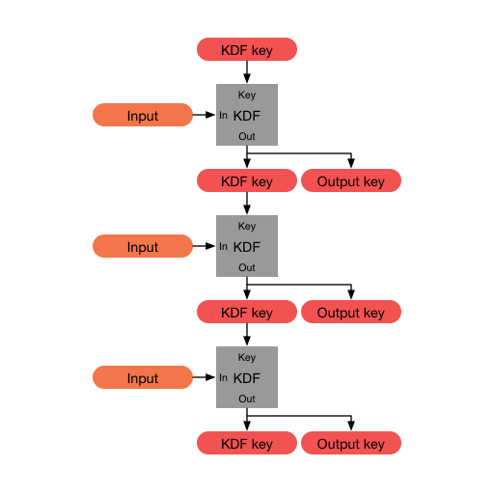Figure 1: A KDF chain

The KDF ratchet is built upon something called a KDF-chain. A KDF-chain is a series of calls to a Key derivation function given some existing key, and an input, and returns two equal-length outputs. The first output is the new KDF chain key, while the second key can be used as an output for another function, or for encrypting messages. The Double ratchet protocol requires each party to store and maintain 3 chains: A root chain, a sending chain, and a receiving chain, where Alice’s sending chain matches Bob’s receiving chain, and vice versa. The root chain is used to initialize the other 2 chains, and is tied into the Diffie-Hellman ratchet in the protocol. The sending and receiving chains are ratcheting forward on a per-message basis. When a message is sent, the sending chain is ratcheted forward a step, and the output key is the message key for that individual message. The same process happens for the receiving chain when an incoming message is received. This allows the protocol to flow in a hall-duplex communication mode, and as long as the same parties keeps sending and receiving, the respective chains will continue to increase without disturbance. Once the communication switches via a message response, then the Diffie-Hellman ratchet kicks in to update the existing chain infrastructure.
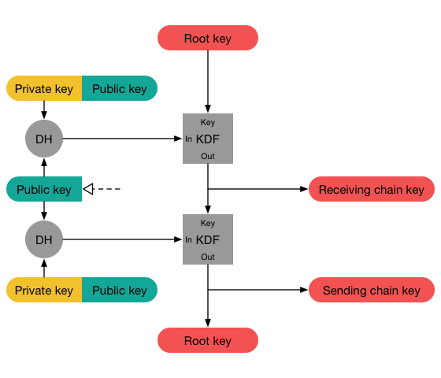Figure 2: A full step of the Diffie-Hellman Ratchet

Every message exchanged during the Double Ratchet protocol contains a header with the Diffie-Hellman ephemeral public key the sender is currently using. Upon receival of the message, the receiver takes that public key, performs a DH exchange using their current private, and the received public key, and the resulting value is the new chain key for the receiving chain. The receiver then creates a new ephemeral keypair, performs another DH exchange and this resulting key is used to update the root chain. This two-part process is shown in Figure 2.
In this way, the root chain uses ephemeral and received Diffie-Hellman keys to create new sending and receiving chain keys. Those sending and receiving chain keys then perform iterated KDF steps on their chain key using a constant input to produce per-message encryption and decryption keys. Figure 3 shows how these two ratchets intertwine to produce fresh keys for every message, while continually injecting new randomness into the keys via DHE key exchanges.
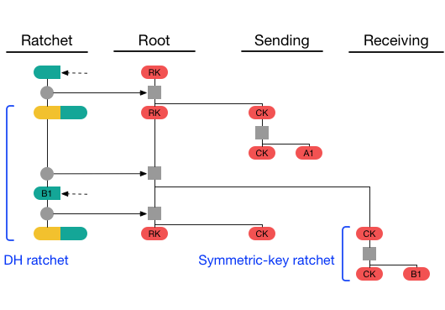Figure 3: A full visualization of a single send-receive cycle
With all this complexity and key shuffling, it is tempting to believe that any out-of-order message may permanently cripple the session by preventing these key chains from ever resyncing. Thankfully, this is not the case. By sending both the length of the current chain, and the length of the previous chain inside the header of every message, it is possible to replay the session ratcheting offline and store unused or skipped message keys. The current chain length value allows the application to increment the symmetric-key ratchet to the required decryption key, while storing the skipped keys for later when the missing message is received. Likewise, the previous chain length value can determine the number of missed messages before a DH exchange occured. This allows out-of-order messages to be accounted for, both from a symmetric-key ratchet, as well as a DH ratcheting scenario.
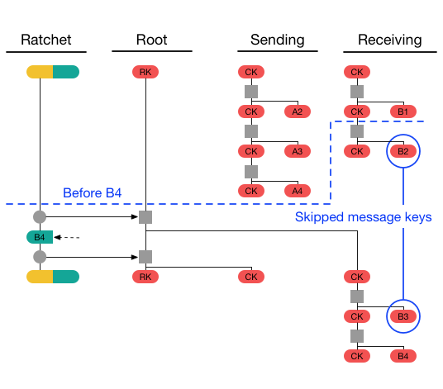Figure 4: An example of creating and detecting skipped message keys
To integrate the Double Ratchet protocol with X3DH, the shared secret key SK is used as the initial root chain key, while Bob’s signed pre-key SPK_{B} becomes the remote public key used to initialize the DH ratchet.

References
[1] - https://signal.org/docs/specifications/x3dh/
[2] - https://signal.org/docs/specifications/doubleratchet/

