SIGEMAIL: End-to-End Encrypted Email using the Signal Protocol
John Agapeyev A00928238
COMP8045 9 Credit Major Project

Table of Contents
1 Student Background 3
2 Project Description 3
3 Background 3
4 Complexity 4
5 Scope and Depth 4
6 Design Decisions 5
7 Development 7
8 Innovation 8
9 Technologies Used 9
10 Testing 9
10.1 Unit Tests 10
10.2 Integration Tests 15
10.3 System Tests 23
11 System Architecture 27
12 System Context Diagram 28
13 Data Flow Diagram 29
14 Network Diagram 30
15 Expertise Development 31
16 Deliverables 31
17 Projected Timeline 31
17.1 Client 31
17.2 Server 32
17.3 Documentation 32
18 Actual Timeline 32
18.1 Client 32
18.2 Server 33
18.3 Documentation 33
18.4 Milestones 33
19 Implementation Implications 34
19.1 Performance 34
19.2 Features 34
19.3 Scalability 35
20 Future Enhancements 36
21 Lessons Learned 36
22 Closing Remarks 37
23 Appendix A – Background on X3DH and Double Ratchet 38
23.1 X3DH 38
23.2 Double Ratchet 39
24 Appendix B – Full Project Proposal 45
24.1 Student Background 45
24.2 Project Description 45
24.3 Background 45
24.4 Complexity 46
24.5 Scope and Depth 46
24.6 Design Decisions 47
24.7 Innovation 47
24.8 Technologies Used 47
24.9 Testing 48
24.9.1 Unit Tests 48
Expected run 48
Expected run with AAD 48
Corrupt message 48
Decrypt with bad key 49
Decrypt with bad nonce 49
Decrypt with missing AAD 49
Decrypt with bad AAD 49
24.9.2 Integration Tests 49
Incoming message expected run 49
Alternate sending messages 50
Send messages out of order 50
Skip message, receive message, send skipped message 50
24.9.3 System Tests 51
24.10 System Architechture 51
24.11 Expertise Development 51
24.12 Deliverables 52
24.13 Timeline 52
24.13.1 Client 52
24.13.2 Server 52
24.13.3 Documentation 53
24.14 Appendix A 53
24.14.1 X3DH 53
24.14.2 Double Ratchet 54
24.14.3 References 58
25 Appendix C – User Guide 59
26 Change Log 60

Student Background
John is in his 4th year as a student at BCIT, and is currently enrolled in the Bachelor of Technology Degree for Computer Systems, with a specialization of Network Security and Administration. Previously he completed a Diploma in Computer Systems Technology in the Data Communications and Inter-networking option. John has worked as a Software Developer Co-op, a peer tutor, and as a Research Assistant at BCIT. His area of specialization is in Network Security, specifically Cryptography, and the challenges of designing and implementing a secure protocol. This specialization is chosen due to its requirements of both a strong technical mindset, while keeping in mind abstract higher principles, founded in mathematics and cutting-edge research. Cryptography is traditionally defined as a pure mathematical creation of perfect security. This notion is cast aside in the implementation and design phase where the realities of software development creep in and disrupt not only the ideal nature of cryptography, but also introduce security errors of varying levels of severity. What was once a simple logic error now escalates into a security flaw which can reveal potentially sensitive messages of end users. It is this sort of complex challenge and mindset that motivates John towards this applied and highly technical specialization of network security.

Project Description
SIGEMAIL is a tool for End-To-End encrypted email communications using the Signal Protocol. It will feature a full implementation of the Signal Protocol in C++, including a server for key and message distribution, a client for sending and receiving messages, a GUI for interacting with the client, and import/export of messages via IMAPS.

Background
Email as a service has been around since the 1970’s, with experimental usage going back to the 1960’s. It has existed longer than the internet, and is a major backbone of communication to this day. As the name implies, it is essentially digital mail. Email has grown to encompass images, HTML, CSS, and sometimes even scripting. This allows email to be a flexible platform for messages, and carries everything from personal communications, to advertising, and subscription updates.
After the 2013 Snowden leaks, it was revealed that the emails of hundreds of millions of people were having their emails automatically read by intelligence agencies such as the NSA. In response, providers such as Yahoo, Google, and Microsoft adopted TLS for their email services, to ensure that eavesdropping of these emails was no longer viable. This solved the passive eavesdropping issue, but the NSA had powers they could use to bypass those protections. Using secretive rulings, they forced these providers to comply to warrants in which they would have to hand over the contents of user’s emails. As their business models and spam filters revolve around the ability of reading their user’s messages, this cannot be prevented. This has spurred an increase in communication protocols and services using End-To-End Encryption.
End-to-End encryption requires that the contents of the message are encrypted both at rest, and in transit, and that they can only be decrypted by the participants in the conversation. So an End-To-End encrypted email would only be readable by the sender and the receiver, and not by Google, or the NSA.
One of the best well-known End-To-End encrypted communication systems is PGP. PGP relied heavily on peer-to-peer interactions and user-based key management in a decentralized ecosystem. PGP allowed arbitrary chunks of data to be signed and encrypted, which allowed it to be used for email encryption. PGP uses a Web-of-Trust security model, where keys can be exchanged in any protocol or format, but it was ultimately up to the user to trust that key. To prevent issues with malicious keys, a Web-of-Trust was established. So instead of placing an unwavering level of trust into a single key, you can then trust a connection of other people you already trust to verify the authenticity. If your friend’s public key has been signed and verified by 10 of your close friends, it’s likely legitimate.
The issue with PGP is the reliance on manual key management, and when it comes to security, users are the weakest point. From this came TextSecure, which would eventually change its name to Signal. Signal used a custom protocol that involved transparent key transfers, and a key distribution server. It was designed to ensure that keys could be exchanged asynchronously, could be verified Out-of-Band, and that the worst thing a malicious server could do, was refuse to distribute keys to the users. This type of approach to encryption and key management has revolutionized secure messaging, allowing people who are completely technically illiterate to be able to have fully End-to-End encrypted communications without any hassle or learning necessary.

Complexity
The complexity of the project comes from a mix of technical and user-experience hurdles that much be overcome. Email as a protocol is complex, and allowing arbitrary HTML and remote resources can introduce a serious security risk. The Signal Protocol itself involves a complicated series of key-exchanges, key negotiations, and key ratcheting, that is ultimately transparent to the user. For a full explanation on the Signal Protocol’s key ratcheting, see Appendix A. There is little info available on the server-side aspect of Signal outside of the state requirements for each connection, so a protocol and data-encoding scheme must be devised for client-server communication. Lastly, the User Experience is critical to the success of the project, as it must be aimed at non-technical users.

Scope and Depth
The base features I will include are as follows:
- Signal protocol fully implemented on client side
- Server is up and running for key and message exchanges
- Full graphical interface for email creation and retrieval
- Outside email import/export via IMAPS
I believe this list of features will be sufficient to fully explore the complexity and design implications that arise from this project.
I will impose some limitations on those features, to limit the potential scope of the application:
- The application will only target x64 Linux Desktops
- The application will not target mobile devices such as Android phones
- The application will not involve a web-mail interface
- The application will not be built as a plugin for existing email clients (eg. Mozilla Thunderbird)

Design Decisions
The core aspect of the project – the Signal Protocol, is quite descriptive and fleshed out, so there is little room for divergence or creativity in its design. I am taking one liberty in that I am using ChaCha20-Poly1305 as the main cipher instead of AES-CTR with HMAC-SHA256, due to its better security properties as an AEAD cipher, while also having better speed than AES. The majority of the design decisions will revolve around the implementation of the client, as well as the entirety of the server. The Signal Protocol does mention what behaviour the server should do for handling new clients, devices, messages, and key exchanges, but those are very high level aspects. The protocol and design of the server is completely open-ended, assuming it meets those requirements. The client also has complete freedom on how it handles non-protocol actions, such as GUI design.
For designing the system, I wanted to keep the interface as simple and modular as possible. My goal was to have layers of functionality built up so that the final interface would be as simple as possible, both from a usage and implementation perspective. To this end, my ultimate goal for this layering was the implementation of two functions, “send_signal_message()”, which only required a message and a recipient, and “receive_signal_message()” which took no arguments. To accomplish this, my implementation was layered as following:
- Device
  - Client networking
  - Client database
  - Signal Sessions
    - Encryption
    - Key agreement
The highest level interface is the device, which represents the overarching functionality of the client device. These functions would be the ones that the GUI would interact with. Devices would then handle calls to networking, database, and signal session functionality. Sessions would be further decomposed into their encryption primitives, leaving the sessions to only care about the ratcheting behaviour they were implementing. Each layer would then expose its own high level interface which could be called from the preceding layer. For example, the client networking has a function called “submit_message()” which takes an encrypted message, and a list of recipients, and submits them to the server for transmission. The networking code is then responsible for contacting the server, crafting a packet, sending it over the network, and parsing the response. Similarly, the client has a database wrapper that stores and retrieves data such as contact information, and handles the SQL statement execution. This layered approach makes it simple to implement layers during development, as well as enabling extensive testing due to loose coupling.
For each of these aspects, I relied on libraries to handle aspects that would be too complex to be part of the scope or would be tangential to the core of the practicum, which is the Signal Protocol implementation. Section 9 contains a full list of libraries used by the application, and briefly lists their general uses. This section will cover more of the decision making process as to how each library was selected.
For cryptography, OpenSSL is the de facto standard, so it was an obvious choice for the implementation of primitives. One important note on these primitives is the lack of XedDSA implementation. XedDSA is a custom signature scheme devised by Signal for reusing the same key to both exchange keys and sign messages. Normally this is done with separate keys for security purposes, but since Signal changes keys per-message, this is not an issue, and simplifies design significantly by reducing the number of keys involved. Originally, this was planned to be implemented by hand using the low-level primitives for elliptic curve point manipulation present in OpenSSL. Unfortunately, I was not successful in implementing a proof-of-concept of XedDSA using their primitives, primarily due to a lack of familiarity with elliptic curve mathematics. To compensate for this, I used the signal protocol library for its implementation of XedDSA, since it is a known working implementation. It’s important that I emphasize that the signal library was only used for the implementation of this signature scheme, and nothing else. This was done as both a time-saving measure, and a security one, which are the same reasons I did not reimplement my own version of OpenSSL. Lastly, OpenSSL was required for TLS support in the chosen networking library.
For a database, my initial plan was to use Redis, but I soon learned that it was too complex for my needs, and that I could settle for a simple relational database. From there I found SQLite, which is a very simple database that can be embedded in an application. SQLite’s website was abundantly clear on its pros and cons, which were taken into consideration. The main concern I had was the limitation of a single writer thread per database connection, which would likely bottleneck my application under heavy load. For a deeper discussion on what this means for scalability, see section 19.3. I ultimately decided that the simplicity gained by using SQLite outweighed the lack of scalability found in traditional client-server databases such as MariaDB.
The last major library decision made was regarding networking. I knew that I wanted TLS as a bare minimum for client-server communication, as well as requiring SMTP and IMAP support. I also wanted some sort of HTTP support as that was what the Signal server was using as its communication protocol, and I wanted to emulate that. Naturally, implementing those protocols would be far out of scope for this project, so I had to find a library for them. Unfortunately, no single library covered all my uses cases, so I had to use multiple. For SMTP and IMAP, my best solution was libcurl, a ubiquitous and well-known C library for performing client network transactions. The lack of server functionality was not a limitation, since I never intended to create my own email server, but rather to interface with existing services such as Gmail. For handling HTTPS as the base protocol, I went with Boost, consisting of two libraries: Asio, and Beast. Asio handled the TLS protocol, as well as all the lower level networking involved. Asio also exposes interfaces for multi-threaded and asynchronous operations. These were used in the design of the server to ensure that it would scale across multiple clients transparently, even though large numbers of clients was not a goal of this project. Beast on the other hand would use the objects created by Asio as a way of handling HTTP. So by combining TLS support in Asio, along with HTTP support through Beast, I was able to cover my core networking protocol. Boost was chosen due to the fact that it is again, a well-known collection of libraries, and contained the functionality I required.
There are other libraries used for other aspects, but they were not as important to the design of the application. Since I was already using Boost, adding its unit testing framework and serialization libraries covered those needs easily. Spdlog was a simple header-only logging library that was fast and easy to use. Qt is the primary GUI library for C++, making it a natural pick. Lastly, Cmake is the de facto C++ build system, and I was already familiar with it prior to the practicum, making it an excellent choice.

Development
During development, I planned to reach regular milestones in terms of functionality, whilst maintaining a Test-Driven-Development plan. All functionality would require testing, and all tests must be written and working before the functionality was considered complete. This would serve to being very useful over the course of the practicum, as some early features may not have been touched or used for over a month, and ensuring they work as expected when I needed them was crucial.
My original plan was to get the core functionality working. This consisted of essentially an offline version of Signal. There were no databases, no networking, only keys, ratcheting, encryption, and the basic build system. This was used to build the Signal sessions, proving that I had successfully followed the specification, and that everything fit together as expected. This was accomplished relatively early on in the practicum. For specific dates, see section 18.4 on the major milestones.
From there, my goals were to expand this functionality bit by bit until I had completed the practicum. Unfortunately this was not as smooth as I would have hoped, primarily due to various systems requiring data from other systems. For example, the server database needed to store user IDs, but user IDs needed a server to register with to be created, but the server required the database to perform registration. This cyclical chain of requirements made it difficult to progress in linear steps. While I would have preferred a continuous progression, that did not work, so progress was instead done in a very abstract fashion. I worked piecemeal to implement partial features which could be used to implement other features, and repeated this pattern. For example, I would implement basic networking without requiring serialization or database integration. This would then allow me to implement serialization, which would allow me to create the database tables and the network requests using that serialized data.
This continued on until I got to a point where everything was starting to work together. I unfortunately hit a roadblock as I had originally followed the Signal specification so literally that I had created Devices and User Records, without any consideration as to how they would be stored. As it stood, I had a working system, but one that existing purely in-memory, which is not useful for a long-lived messaging service. This required me to redesign my client interface to integrate with the database, which mostly went without issues. The big hurdle I had to overcome was that sessions, the core part of the practicum, had to be saved, and was too complex to convert into a database table. As a consolation, I used my existing serialization code to convert sessions into strings, and then updated them before and after every use, to ensure they were always consistent and saved. One of the last issues I faced was forgetting to handle initial messages for session establishment. Since sessions are shared state between clients, there is a special process used to establish them in the form of an initiation message containing the required information in its header. My original implementation did not consider this, and had to be updated to fit these requirements. This required an extensive reworking of the session code, of which I was thankful to already have working tests which would verify the correctness once it was done. The last requirements to be completed were the GUI and external email integration. The GUI was straightforward, due to the layered design I had adopted since the beginning allowing it to easily integrate with my systems. The email integration was frustrating due to Gmail’s requirements around sending emails, and libcurl’s limitations on downloading them. This is also partially discussed in section 19.2. Gmail would not allow an unauthenticated user to send an email to their service, likely to prevent spam, rendering me unable to send emails without a user’s password. Libcurl also had issues on downloading multiple emails at once, forcing me to manually request every email one at a time, which made email importing orders of magnitude slower. Overall, I am happy with how the development of this practicum went, as I feel I designed a clean, modular system, which enabled extensive testing, and that despite some minor obstacles, resulted in a professional quality application.

Innovation
The innovation of this project comes in applying multiple existing concepts in a unique fashion. Email encryption through PGP and services which use/mimic it such as ProtonMail and Tutanota have been around for decades, but suffers from both technical and user experience pitfalls. Signal as an application is fairly recent, but does not target email, and intentionally refuses to open their servers to forks and custom implementations of the protocol. The rise of services such as ProtonMail, show that email encryption is in high demand, and there are no existing email encryption services that do not use PGP or some variant of it; which SIGEMAIL seeks to rectify. Nobody has previously attempted to merge the Signal Protocol with email to provide end-to-end encrypted email services in a way that is friendly to users who aren’t technical experts with a background in cryptography.

Technologies Used
The high complexity of the project necessitates the use of external libraries for handling various aspects of the application that are tangential to its end-goal. To this end, I am designing the application in C++ with the following libraries:
- OpenSSL – For the majority of cryptographic functions; also required for TLS
- Boost
  - Serialization – For serializing data for sending over the network and the database
  - Asio – For handling network connections and TLS
  - Beast – For handling HTTP on the client and server
  - Test – For unit and integration tests
- Curl – For adding support of IMAPS
- Qt – For the entirety of the GUI
- libsignal-c – For its implementation of XedDSA, otherwise unused
- CMake – For building the project and finding/linking all dependencies
- SQLite – For managing state on the client and server
- Spdlog – For handling logging on the client and server

Testing
SIGEMAIL as a project contained a large amount of complexity, and relied heavily on tests of various levels and scopes to ensure proper operation. Tests were structured by responsibility, and by level of abstraction. Tests used ranged from minimal unit tests to large-scale systems tests involving network and database connections, emulating real user activities. The Boost Unit Test Framework was used to orchestrate and implement these tests. Tests were used in a Test-Driven-Development model, where failing tests were prioritized over features, new features required tests of their functionality, and all tests must be implemented and passed before features were considered complete. The project as a whole contains 212 automated tests. For the sake of brevity, an exhaustive description of every test has been forsaken in favour of a high level overview, with specific examples detailed for each category of test.
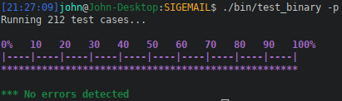Figure 1: Demonstration of all tests running successfully

The following sections detail the various levels of testing used.

Unit Tests
Unit testing is the smallest proportion of tests in SIGEMAIL. Nevertheless, these tests cover the core primitives which are utilized by all other features, such as the Signal Sessions, and thus carry immense weight in their correctness. Unit testing covers the following features:
- Encryption
- Key Derivation
- Key Agreement
- Hashing
- Key Signing
- Message serialization
An example of a test is as follows:
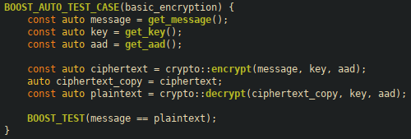Figure 2: Basic Encryption Test

This test covers the basic case of encryption and decryption, in order to verify that the base primitive code is correct. As can be seen below in Figure 3, the plaintext is transformed into random data, and then returned back to the input.

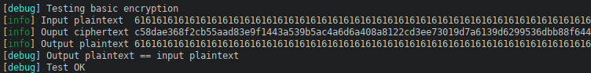Figure 3: Proof of encryption test working correctly

Another example of a test is seen below. This test attempts to decrypt a corrupted ciphertext, and ensures the operation fails as expected.
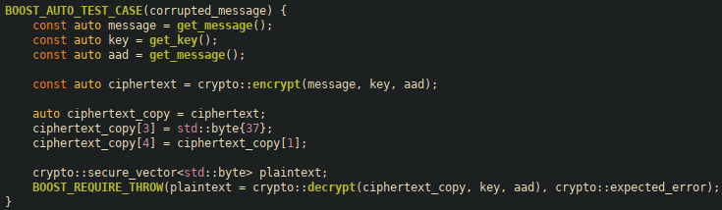Figure 4: Corrupted ciphertext test case
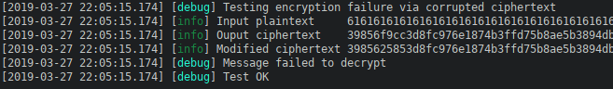Figure 5: Proof of corrupted ciphertext failing to decrypt
As we can see, the test encrypts the input plaintext into random bytes, which is mildly corrupted. This corrupted ciphertext fails to decrypt, as expected, passing the test. In case it is not clear from the image, the original ciphertext begins with “39856f9cc3d...” while the corrupted ciphertext begins with “3985625853d...”. The bolded bytes are the difference induced by the test, and what causes the decryption failure.

Another example test is key-agreement. This is done through the X3DH key agreement scheme, part of the Signal Protocol.
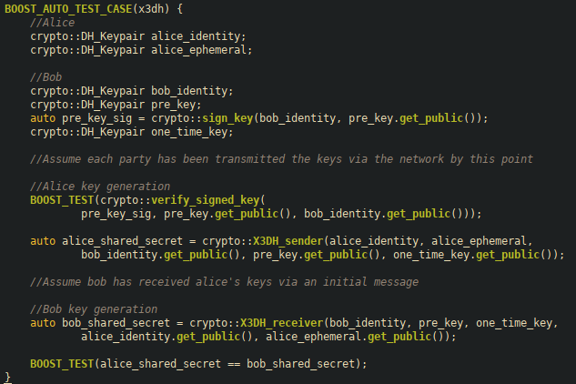Figure 6: X3DH key agreement test
The purpose of this test is to ensure that two parties can arrive to the same shared secret through an extended Diffie-Hellman key agreement scheme, without ever having to transmit any sensitive information across the channel.
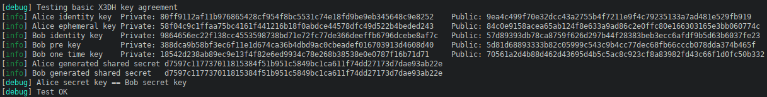Figure 7: Proof of successful key agreement
In the above figure, we can see a proof of the test running, where all the key pairs are displayed, and without any secret information being transmitted, both parties arrive to the same shared key.

This is one of the key parts of the Signal Protocol that I had to implement, and is crucial to the success of the implementation. More information on the specifics of X3DH can be found in Appendix A.
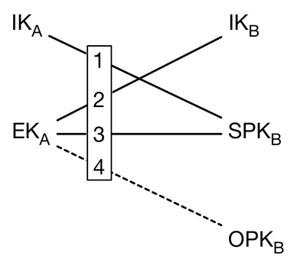Figure 8: A visual representation of the multiple DH calculations being performed (https://signal.org/docs/specifications/x3dh/X3DH.png)

My test performs the same steps as the above figure, demonstrating that my implementation has the same behaviour as the Signal Protocol specification dictates it must have.
Similar tests are performed for success without a one-time key, or for ensuring failure in the case of bad keys.
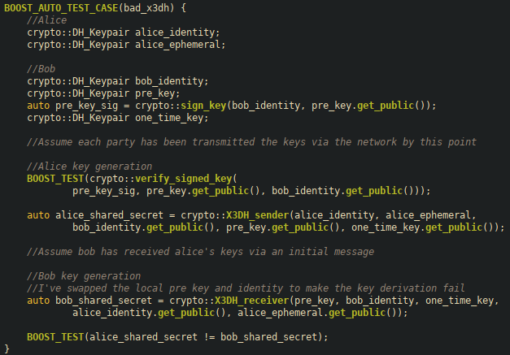Figure 9: Test of intentionally failing X3DH agreement

Integration Tests
Integration testing consist of the largest subset of tests in SIGEMAIL. These tests cover larger scopes, and build off the unit tests to provide complex primitives, or to integrate with external services. These are then utilized as building blocks in other parts of the application so their validity is important in constructing the final systems of the application. Specifically of note, the integration tests contain the Signal session tests which is the core functionality and innovation present in the practicum. Therefore, ensuring both the correctness of the sessions, as well as following the same specification as the original Signal protocol. As part of the testing, database instances are created in-memory for every test to ensure a clean slate. Integration tests cover the following features:
- Client database integration
- Server database integration
- Session ratchet encryption

An example of a test is as follows:
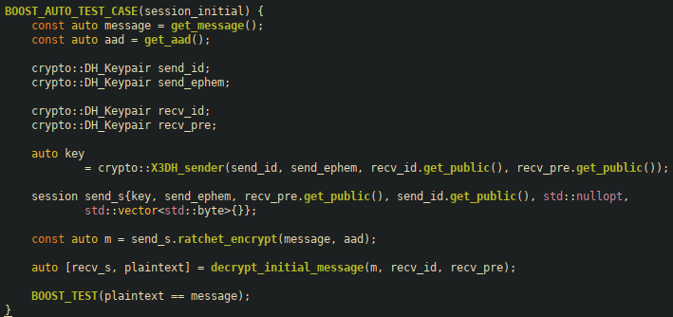Figure 10: Example of initial session message exchange test
This test handles the initial encrypt/decrypt of a session. This is a special case because it contains extra information in the header to ensure the exact same session can be created on the recipient device.
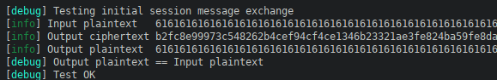Figure 11: Output showing encryption working successfully
As the above figure shows, the input plaintext is transformed into random data, which is then turned back into the plaintext. There is no visible difference between this test and the earlier encryption unit tests, which is by design. The session API and functionality should be transparent to the end user, having the same end result.
A more complex test case follows:
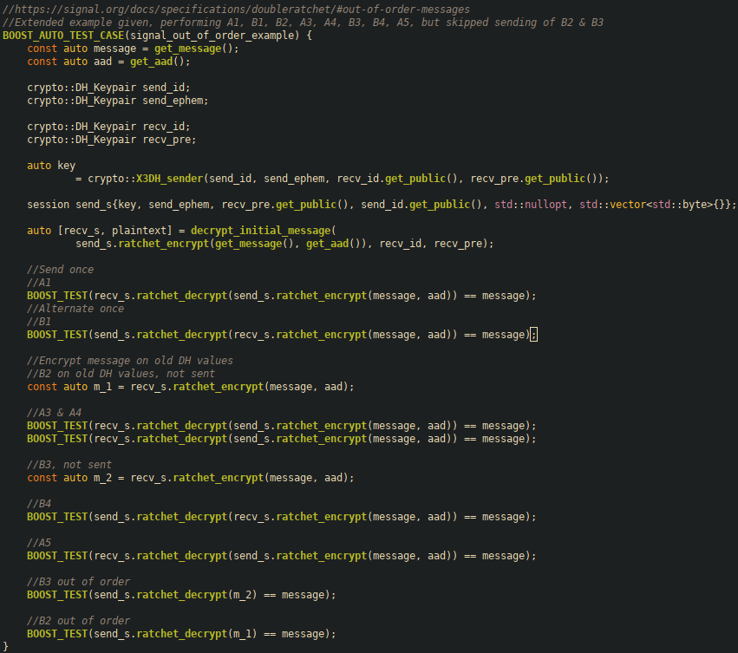Figure 12: Session test based off of Official Signal Protocol Documentation example

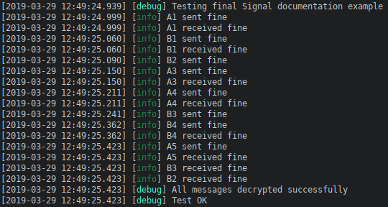Figure 13: Output showing the sessions remaining intact as expected
The core of this application is the Signal Sessions, as this is the primary innovation and research involved aspect. Therefore, it is of utmost importance that the sessions not only function correctly, but also to the specification that they were designed to match. This test case specifically demonstrates every aspect of that required functionality, exactly as required.

The below figure shows the full set of chains and keys that were created and used during this test, retrieved directly from the Signal Documentation. For more information on this chart, and the implications of it, see Appendix A.
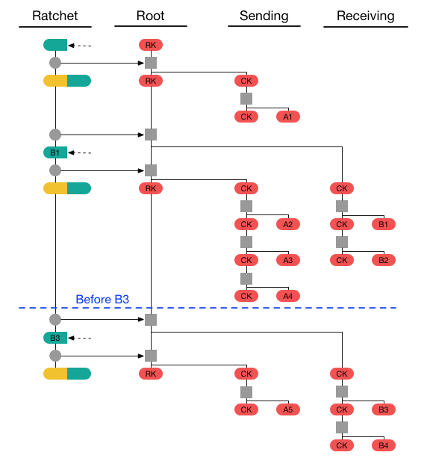Figure 14: Final session chain graph (https://signal.org/docs/specifications/doubleratchet/Set3_4.png)
The core test consists of multiple messages sent between Alice and Bob, in various orders, in order to trigger different effects. The order of messages sent is A1, B1, A2, B2, A3, A4, B3, B4, A5, but delayed sending of B2 & B3 until the end. This means that Alice sends her first message (A1), then Bob (B1), Alice sends her second (A2), and so on. This test case covers repeated sends, alternating sends between clients, as well as handling out-of-order messages both before and after a DH ratchet was performed. This is the most complex example given by the Signal documentation, representing the collective functionality of sessions. By following this test exactly, and ensuring it performs as expected, my implementation is validated both in its correctness, but also on the cryptographic guarantees provided by Signal itself.
There are other tests covering similar examples shown in the documentation, but this was the most complex one provided, which is why it has been highlighted. These tests are the core of the application, ensuring that the End-to-End Encryption properties and guarantees provided are as advertised and functional. The rest of the application is built upon these sessions, specifically in the storage and transference of state required to create and maintain these sessions.

System Tests
System tests are also performed in SIGEMAIL to emulate high level usage of APIs that depend on lower systems and constructs. These tests are the most complex as they emulate 1-to-1 usage of interfaces by users, and rely on multiple levels of systems to function. Following the integration testing example of utilizing external systems in test, such as the database, the systems tests perform live networking over localhost, in addition to their database usage. The systems test cover the following features:
- Client-Server Networking
- Network REST API
- High level user actions (Sending messages between clients using the server as a relay)
An example of a system test is as follows:
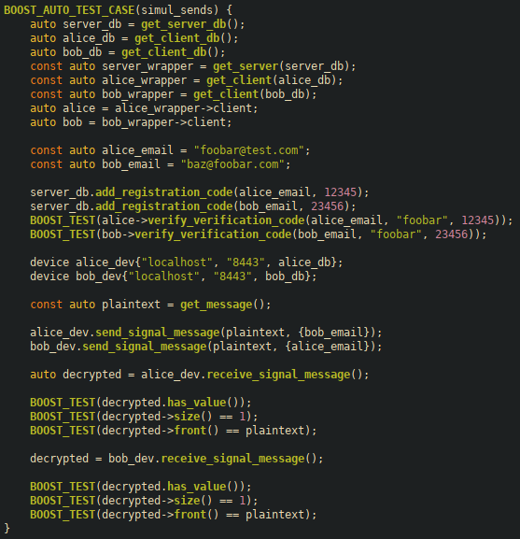Figure 15: An example of a high-level user interaction test
This test handles two clients registering for the service and simultaneously sending messages to the other. It does this via the high level device API, which handles all of the requests, error handling, encryption, and session creation.
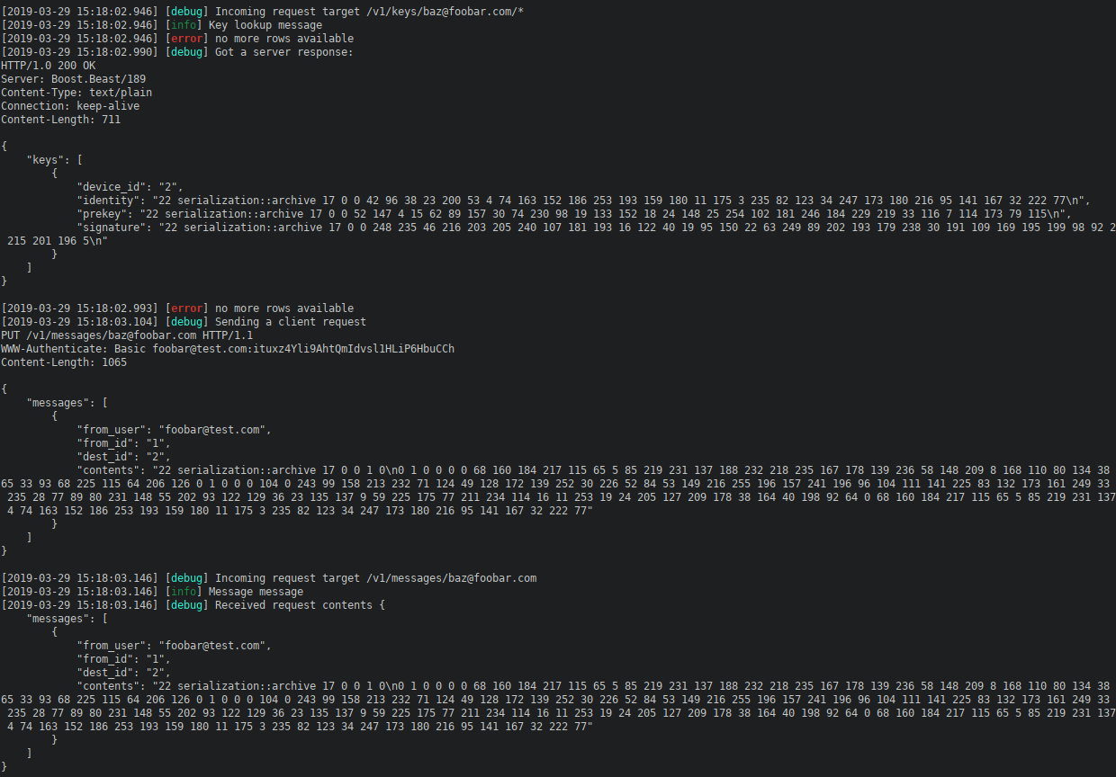Figure 16: Network requests generated as part of the previous test
The above figure shows some of the network requests being sent as part of the test. Since networking tests are performed over localhost, I can emulate the entire client-server relationship, ensuring all aspects of the application have test coverage, including parts such as request formatting, networking calls, request parsing, database lookup, and client processing.

Of note, these tests, including the one shown are lower level than real user actions due to restrictions of user registration. Real user registration involves an SMTPS call to Gmail to distribute the registration code, but to prevent difficulties from accidentally abusing Google’s services, this registration is not automated. As a consolation, registration is manually manipulated in the database to achieve a sufficient starting point. To ensure proper test coverage, SMTPS and IMAPS calls were tested manually during development, along with the GUI.

Unlike the sessions, there is very little information on the networking and server requirements in Signal. This is likely done to enable flexibility in implementation. Nevertheless, there is little guidance in terms of concrete requirements beyond phrases such as “There is a server which stores the current record of all users and devices.”. For general principles, the server API and design is structured based on the Signal official server repository on Github. Unfortunately, this API has not been updated since 2014, and is likely out of date. This lack of concrete information prevents the same level of formal verification on the networking implementation as is found in the sessions and X3DH key agreement.

System Architecture
Figure 17: SIGEMAIL System Architecture (Self-written code is in green, library code is in red)
Due to the overall complexity of the project, and the strict requirements on implementing cryptographic primitives, this practicum used multiple libraries to handle various aspects of the application. The primary focus was on the research and innovation on the cryptographic protocol side, which is where the bulk of my effort was focused. Aspects that were tangential to that goal were offloaded to libraries for correctness and ease of integration with the broader practicum. The largest amount of complexity was in the network connections and request parsing, as that had to accommodate multiple types of requests, containing serialized objects which had to be verified, deserialized, stored in a database, and returned to clients. All of this is necessary to store and transfer various aspects to state to each client in order to establish Signal Sessions which allows them to exchange messages.

System Context Diagram
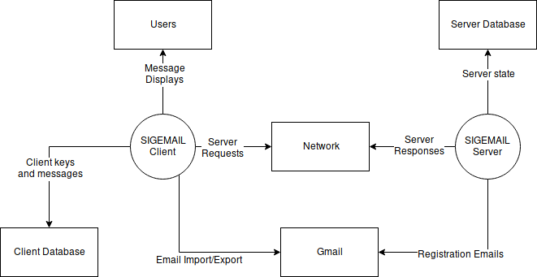Figure 18: SIGEMAIL System Context Diagram
This system context diagram shows a more high level overview of where the client and server fit into the broader ecosystem that it engages with.

Data Flow Diagram
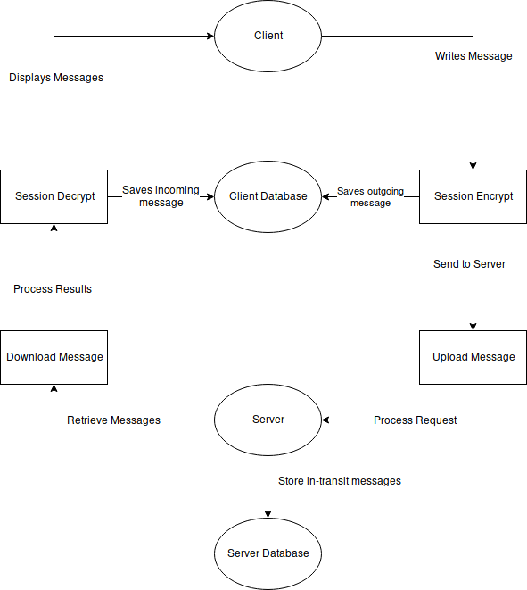Figure 19: SIGEMAIL Data Flow Diagram
This diagram represents the high-level flow of information from the clients to the server, and back again, while interacting with their respective databases, and passing through session handling for encryption purposes.

Network Diagram
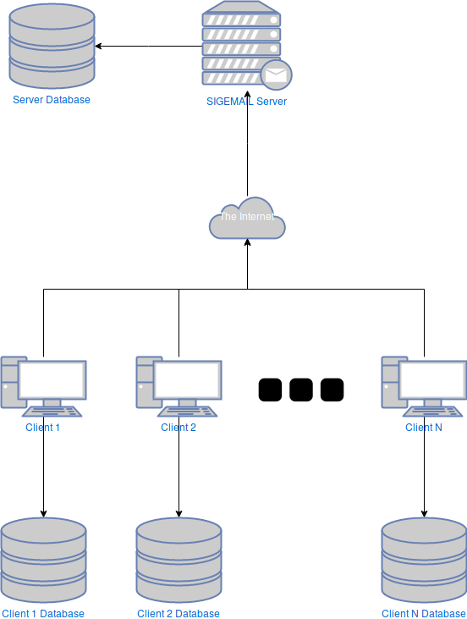Figure 20: SIGEMAIL Network Diagram
This diagram shows the 1-to-many relationship between clients and the server.

Expertise Development
SIGEMAIL covers a wide spectrum of skills for developing my technical expertise. This project requires a strong protocol design which has normally been relegated to the classroom, so experiencing firsthand the technical challenges found in designing a robust protocol will help develop my networking abilities. The test design and requirements also go far beyond what even the classroom has shown, so learning about proper testing usage will help develop my technical workflow skills, and how testing can reflect upon the success of a project. Lastly, I have never made any large-scale cryptographic software before, which has its own unique challenges such as zeroing memory used for keys and plaintexts, and constant time memory comparisons. Having exposure to a cryptographic mindset during development of this project will strengthen my skills in network security, and help open up a future avenue in cryptographic software as a niche focus on my career.

Deliverables
The Following deliverables will be provided for this application:
- Client application
- Server application
- Final report
- User guide for compilation, running, and installation of the client/server

Projected Timeline
This project aims to fulfill the 405 hour work requirement, and provides the following expected work breakdown to satisfy that claim.

Client
Total: 185 Hours
- Encryption/decryption – 10 hours
- Session state – 15 hours
- X3DH – 5 hours
- Key Derivation – 10 hours
- Message formatting – 15 hours
- Server network connection – 20 hours
- Import/Export over IMAPS – 30 hours
- GUI functionality – 60 hours
- Tests – 20 hours

Server
Total: 195 Hours
- Client/device state storage – 20 hours
- Redis integration – 60 hours
- Protocol design – 40 hours
- Client/device addition and deletion – 15 hours
- Client/device verification – 25 hours
- Message transmission – 10 hours
- Key upload/retrieval – 10 hours
- Tests – 15 hours

Documentation
Total: 25 hours
- Writing User guide - 2
- Commenting code - 3
- Writing final report - 10
- Editing final report – 10

Actual Timeline
The actual timeline deviated from the projections mainly in terms of relative complexity. Tasks that were projected to take a large amount of time were simpler than anticipated, but other seemingly trivial tasks were more complex than projected. The largest changes between real and projected timelines were on the state storage, database integration, network protocol, and message formats.

Client
Total: 205 Hours
- Encryption/decryption – 10 hours
- Client and Session state – 50 hours
- X3DH – 5 hours
- Key Derivation – 10 hours
- Message formatting – 40 hours
- Server network connection – 60 hours
- Import/Export over IMAPS – 5 hours
- GUI functionality – 5 hours
- Tests – 20 hours

Server
Total: 190 Hours
- Server state storage – 50 hours
- Protocol design – 60 hours
- Client/device addition and deletion – 5 hours
- Client/device verification – 15 hours
- Message transmission – 10 hours
- Key upload/retrieval – 10 hours
- Tests – 40 hours

Documentation
Total: 25 hours
- Writing User guide - 2
- Commenting code - 3
- Writing final report - 10
- Editing final report – 10

Milestones
I started work on January 1st, since my proposal had been approved before the term began. On January 18th, I had achieved offline Signal message handling as a proof-of concept, demonstrating the core encryption ratcheting functionality that I would require. Work then began on implementing the rest of the application. Due to multiple systems relying on each other, such as the server networking requiring the server database, it is difficult to list milestones on most of these aspects since progress was not a linear process. On February 28th, I had a fully functioning system consisting of the client and server network and databases, essentially completing the core functionality without a GUI or external email integration. The GUI was finished on March 5th, and the email integration was finished on March 15th.

Implementation Implications

Performance
The goal of the implementation was focused on correctness and security foremost. Performance was considered, but was deemed noncritical to the application due to its usage of encryption and networking being the primary potential bottlenecks which would overshadow any implementation details. Nevertheless, the application is far from being considered slow. To measure the overall system delay, I instrumented one of my high level system tests with timing information. The test consists of Alice sending a message to Bob, Bob receiving the message, Bob sending Alice a message, and Alice receiving, performed multiple times to emulate real usage. The test is performed over localhost with both clients and the server on the same machine, and the three databases involved being run in-memory. This test is useful for demonstrating round-trip delays since it eliminates disk and network I/O from bottle-necking the application, and the vast majority of time spent will be in the implementation handling of messages across the clients and server, in and out of the databases on each end. My results show that a single message send-receive pair takes approximately 0.45 seconds. To put that in perspective, that’s faster than it takes my browser to perform a full TLS handshake to a website and begin sending data. So while a half-second round trip time may be very slow by most computing standards, it is significantly faster than the connection establishment process to the server, as well as any potential disk I/O that the database incurs. Since email is not typically a fast and repeated process, it will also not throttle the user’s attempts to send or receive messages.

Features
In terms of features, the implementation is necessarily constrained to prevent scope creep. While the project was originally designed to an external specification, and the overall scope was well-constrained, there are multiple aspects of the Signal Protocol that are useful and desirable, but ultimately optional. These extra features will be covered in the section on Future Enhancements. This section will instead cover restrictions, rather than potential bonus features. In terms of usability restrictions, there are several. The first is that users are limited to single devices per registration, so it is not possible to send a message and have it transmitted to multiple machines registered to the same user. In a similar fashion, group messages are not possible, limiting recipients to single users only. Next, users are required to receive pending messages prior to sending their own. The reasoning behind this is that due to session semantics in Signal, clients must send an initiation message in order to exchange key information to be used in creating the first session. If two users were to send their initial messages simultaneously, this would involve each receiving the other’s message, creating incompatible sessions due to random key generation. These sessions would then desynchronize, preventing all further communication between clients. Normally, Signal would handle this via message retry requests, which would delete the conflicting sessions and resynchronize communication. Unfortunately, message retry requests are optional, and were not implemented due to scope concerns. Lastly, user passwords are required for sending and receiving emails via SMTPS and IMAPS. This is due to complexity involved in sending email to Gmail, and I was unable to find a viable solution that did not require the user’s password or a massive increase in scope. As a compromise the user’s Gmail password is required for all email import/export. This is unfortunate and undesirable, but was the best choice I had under the circumstances.

Scalability
Regarding the overall scalability of the system, it generally was not considered outside of the design phase. As mentioned above, performance was deemed to be noncritical, and scalability plays a part in performance of the overall application. Due to the nature of the application, the client cannot send multiple messages at the same time, and therefore is single-threaded in its workflow. This also extends to other aspects of message sending, such as performing a contact intersection, or retrieving client keys, as they are only required during the send and receive process. This means each client performs their requests one at a time, blocking until a result is received. Work was done to ensure this would not block the UI thread, but otherwise was not extended. The initial design did use a multi-threaded asynchronous interface, but due to the system design, this was deemed unnecessary and overcomplicated.
The server was somewhat designed for scalability, but it was not a chief concern. The server employs an asynchronous multi-threaded model of execution, performed by a thread pool. The size of this thread pool is static and is selected at run time via a command argument. This allows the server to scale across various levels of hardware by dictating how many simultaneous threads are used for handling connections and requests. Unfortunately, SQLite is limited to a single writer thread at any given point, and the database wrappers I have written follow that constraint. This means that as the system scales, it will eventually hit a bottleneck in the database requests, of which all server requests require access. In addition, for error handling, transaction semantics are used to ensure database consistency, but this introduces more synchronization on the database, which limits overall scalability. This flaw with the database was considered in the design phase, and is explicitly stated on the SQLite website, but was deemed to not be of concern due to the fact that scaling to thousands of clients, while ideal, was not a goal of this practicum. To overcome this limitation, I would have had to used a more traditional client-server database such as Postgresql, or MariaDB, which would introduce much larger complexities in implementation and configuration. The simplicity of SQLite as what drew me to it, and is the primary reason it was chosen for this project.
Some minor tests were performed on the server and database with multiple clients/threads to ensure there were no issues with correctness or thread safety, but were otherwise not explored. No stress-testing of the server was performed to measure scalability of the number of clients. The largest known bottleneck of the system is the key derivation function used on a per-message basis. By necessity, a good key derivation function should be slow to execute, so if I were to perform large-scale stress testing, I would quickly run into a CPU bottleneck since each client would take up to one second of real time to derive its next key. This makes it impractical to run thousands of clients simultaneously on the same machine for testing purposes.

Future Enhancements
For further enhancements, there are multiple avenues that can be taken to improve functionality. As previously mentioned, adding message retry requests would greatly improve user experience by allowing sending without first retrieving messages. Similarly, adding multiple devices and multiple destination emails would bring SIGEMAIL closer to feature parity with existing email implementations. Following the idea of more email features, more work could certainly be done in the email client to make it more useful. Features such as read vs unread messages, folder management, message tagging, and deletion would all be useful features to implement. Looking towards the core Signal Protocol, there are also multiple aspects that could be added to improve security. The Signal Protocol supports a ratcheting header key system on top of the existing key ratchets to encrypt the message headers. As it currently stands, Signal messages have their header sent in the plain, containing information such as Diffie-Hellman public keys, message chain size, and message number. These cannot leak information about the plaintext, and modification of these values would only result in a denial of service, of which there are much simpler paths to take. Nevertheless, this exposes user metadata to an eavesdropper, which may be undesirable. There are also features present in Signal which are not part of the core protocol specification, such as sealed sender and performing contact intersections in a secure enclave that can be used to reduce metadata as well. These are all potential avenues of improvement, and it may be worth exploration to further expand both SIGEMAIL’s functionality, and my own skills.

Lessons Learned
The practicum project has helped me develop many of my skills in software development such as interface design, database design, system architecture, protocol design, and many others. It has given me an appreciation for how a clean and logical interface can affect the larger system through their requirements. Some of the new techniques and concepts I learned via this practicum are as follows:
- Asynchronous networking design
- Automated unit testing
- Database integration
- HTTP Design and Authentication
- Cryptographic software development such as zeroing memory and constant-time comparisons
- Email technologies such as SMTP and IMAP

Closing Remarks
Overall, this practicum has been an interesting experience with highs and lows that have broadened my horizons as a developer. I went into this with little to no experience in cryptographic software and email protocols, and delving into those worlds has given me a new appreciation for the work that is put into them. I accomplished my mission, but not without some concessions, namely in terms email support. Email as a protocol is incredibly complex, far more than I had ever envisioned. The work required to creating a viable email client with full IMAP support is far beyond my skill set, but it is a challenge I shall keep in mind for the future in case I decide to expand upon my practicum any further.

Appendix A – Background on X3DH and Double Ratchet
The following information was retrieved from the official Signal Protocol documentation (https://www.signal.org/docs).

X3DH
For key-agreement, Signal uses a modified Diffie-Hellman protocol, dubbed X3DH, or Extended Triple Diffie-Hellman. The name implies the use of multiple keys, and multiple runs of traditional Diffie-Hellman exchanges. X3DH is designed for forward secrecy, mutual authentication, and deniability. It requires the following set of keys for each participant.
Alice’s keys:
- IK_{A} - Alice’s Identity Key
- EK_{A} - Alice’s Ephemeral Key
Bob’s keys:
- IK_{B} - Bob’s Identity Key
- SPK_{B} - Bob’s Signed PreKey
- OPK_{B} - Bob’s One-time PreKey
Where SPK_{B} is signed using IK_{B} and the XedDSA algorithm.
Alice, when wanting to initiate communication with Bob, retrieves his keys from the server. The One-time pre-key is optional for the protocol, but highly recommended. Alice then verifies the signature on the pre-key, and aborts the protocol is it is not valid. If the signature is valid, Alice then performs the following set of DH agreements.

- DH1 = DH(IKA, SPKB)
- DH2 = DH(EKA, IKB)
- DH3 = DH(EKA, SPKB)
- DH4 = DH(EKA, OPKB)
- SK = KDF(DH1 || DH2 || DH3 || DH4)
Where KDF is a suitable key derivation function.
Alice now sends Bob their initial message, encrypted using SK, as well as both IK_{A} and EK_{A,} and an identifier representing the specific one-time pre-key that was used.
Upon receiving the initial message, Bob retrieves his private keys for his identity, pre-key, and one-time key pairs, as well as the received keys from Alice. Bob can now repeat the same key-exchange protocol to arrive at the same shared key. Bob then can decrypt the message, as well as delete the used one-time pre-key from the server.
If the one-time pre-key is not used during the protocol, then it has implications for both forward secrecy and protocol replay. Without a pre-key, the forward secrecy of the session is bounded by the lifetime of the signed pre-key. Also, the session is vulnerable to replay, which may result in the same secret key being derived for multiple sessions. To prevent this, a new fresh source of randomness must be mixed into the key after key exchange to prevent security compromises. This immediate renegotiation is typical in Diffie-Hellman exchange protocols, and Signal performs this via its key ratcheting.

Double Ratchet
Once a shared secret key has been established by the participants, the Double Ratchet algorithm specifies how to modify and update the keys during a session to maintain forward secrecy, backward secrecy, as well as being self-healing to temporary key compromises. The Double Ratchet algorithm, as the name implies, involves two distinct key ratchets working together. These ratchets are a traditional Diffie-Hellman ratchet, as well as a Key-Derivation-Function based ratchet. The KDF ratchet provides the forward secrecy aspect, and the Diffie-Hellman ratchet provides the backward secrecy and self-healing components of the protocol.

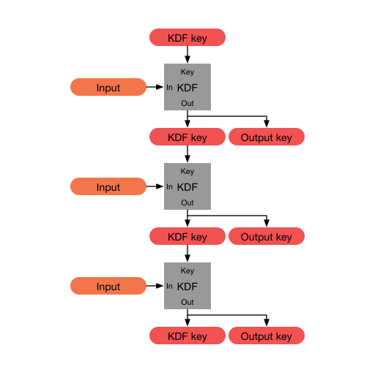Figure 21: A KDF chain

The KDF ratchet is built upon something called a KDF-chain. A KDF-chain is a series of calls to a Key derivation function given some existing key, and an input, and returns two equal-length outputs. The first output is the new KDF chain key, while the second key can be used as an output for another function, or for encrypting messages. The Double ratchet protocol requires each party of a session to store and maintain 3 chains: A root chain, a sending chain, and a receiving chain, where Alice’s sending chain matches Bob’s receiving chain, and vice versa. The root chain is used to initialize the other two chains, and is tied into the Diffie-Hellman ratchet in the protocol. The sending and receiving chains are ratcheting forward on a per-message basis. When a message is sent, the sending chain is ratcheted forward a step, and the output key is the message key for that individual message. The same process happens for the receiving chain when an incoming message is received. This allows the protocol to flow in a half-duplex communication mode, and as long as the same parties keeps sending and receiving, the respective chains will continue to increase without disturbance. Once the communication switches via a message response, then the Diffie-Hellman ratchet kicks in to update the existing chain infrastructure.
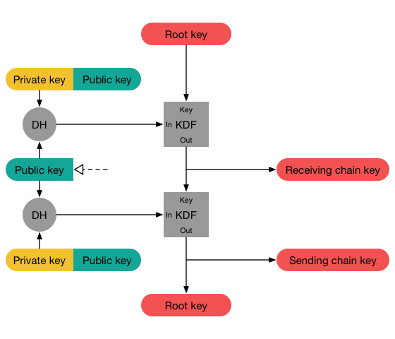Figure 22: A full step of the Diffie-Hellman Ratchet

Every message exchanged during the Double Ratchet protocol contains a header with the Diffie-Hellman ephemeral public key the sender is currently using. Upon receiving the message, the receiver takes that public key, performs a DH exchange using their current private, and the received public key, and the resulting value is the new chain key for the receiving chain. The receiver then creates a new ephemeral key pair, performs another DH exchange and this resulting key is used to update the root chain. This two-part process is shown in the above figure.
In this way, the root chain uses ephemeral and received Diffie-Hellman keys to create new sending and receiving chain keys. Those sending and receiving chain keys then perform iterated KDF steps on their chain key using a constant input to produce per-message encryption and decryption keys. The following figure shows how these two ratchets intertwine to produce fresh keys for every message, while continually injecting new randomness into the keys via DHE key exchanges.
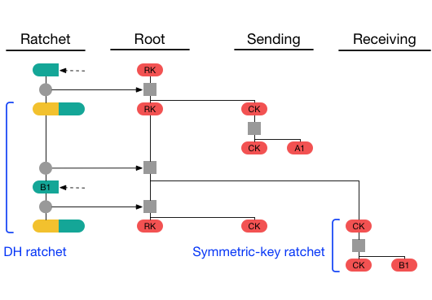Figure 23: A full visualization of a single send-receive cycle
With all this complexity and key shuffling, it is tempting to believe that any out-of-order message may permanently cripple the session by preventing these key chains from ever re-syncing. Thankfully, this is not the case. By sending both the length of the current chain, and the length of the previous chain inside the header of every message, it is possible to replay the session ratcheting offline and store unused or skipped message keys. The current chain length value allows the application to increment the symmetric-key ratchet to the required decryption key, while storing the skipped keys for later when the missing message is received. Likewise, the previous chain length value can determine the number of missed messages before a DH exchange occurred. This allows out-of-order messages to be accounted for, both from a symmetric-key ratchet, as well as a DH ratcheting scenario.
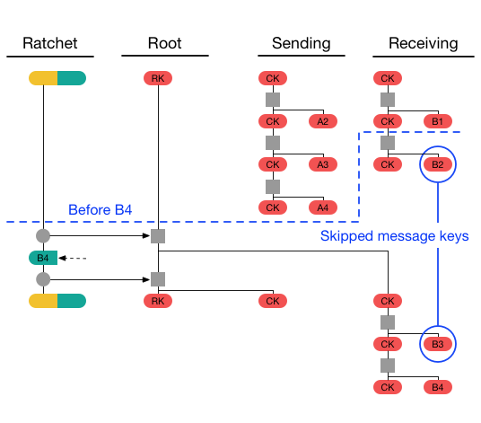Figure 24: An example of creating and detecting skipped message keys
To integrate the Double Ratchet protocol with X3DH, the shared secret key SK is used as the initial root chain key, while Bob’s signed pre-key SPK_{B} becomes the remote public key used to initialize the DH ratchet.

Appendix B – Full Project Proposal

Student Background
John is in his 4th year as a student at BCIT, and is currently enrolled in the Bachelor of Technology Degree for Computer Systems, with a specialization of Network Security and Administration. Previously he completed a Diploma in Computer Systems Technology in the Data Communications and Inter-networking option. John has worked as a Software Developer Co-op, a peer tutor, and as a Research Assistant at BCIT. His area of specialization is in Network Security, specifically Cryptography, and the challenges of designing and implementing a secure protocol. This specialization is chosen due to its requirements of both a strong technical mindset, while keeping in mind abstract higher principles, founded in mathematics and cutting-edge research. Crytoptgraphy is traditionally defined as a pure, perfect mathematicaly creation of perfect security. This notion is cast aside in the implementation and design phase where the realities of software development creep in and disrupt not only the ideal nature of cryptography, but also introduce security errors of varying levels of severity. What was once a simple logic error now escalates into a security flaw which can reveal potentially sensitive messages of end users. It is this sort of complex challenge and mindset that motivates John towards this applied and highly technical specialization of network security.

Project Description
SIGEMAIL is a tool for End-To-End encrypted email communications using the Signal Protocol. It will feature a full implementation of the Signal Protocol in C++, including a server for key and message distribution, a client for sending and receiving messages, a GUI for interacting with the client, and import/export of messages via IMAPS.

Background
Email as a service has been around since the 1970’s, with experimental usage going back to the 1960’s. It has existed longer than the internet, and is a major backbone of communication to this day. As the name implies, it is essentially digital mail. Email has grown to encompass images, HTML, CSS, and sometimes even scripting. This allows email to be a flexible platform for messages, and carries everything from personal communications, to advertising, and subscription updates.
After the 2013 Snowden leaks, it was revealed that the emails of hundreds of millions of people were having their emails automatically read by intelligence agencies such as the NSA. In response, providers such as Yahoo, Google, and Microsoft adopted TLS for their email services, to ensure that eavesdropping of these emails was no longer viable. This solved the passive eavesdropping issue, but the NSA had powers they could use to bypass those protections. Using secretive rulings, they forced these providers to comply to warrants in which they would have to hand over the contents of user’s emails. As their business models and spam filters revolve around the ability of reading their user’s messages, this cannot be prevented. This has spurred an increase in communication protocols and services using End-To-End Encryption.
End-to-End encryption requires that the contents of the message are encrypted both at rest, and in transit, and that they can only be decrypted by the participants in the conversation. So an End-To-End encrypted email would only be readable by the sender and the receiver, and not by Google, or the NSA.
One of the best well-known End-To-End encrypted communication systems is PGP. PGP relied heavily on peer-to-peer interactions and user-based key management in a decentralized ecosystem. PGP allowed arbitrary chunks of data to be signed and encrypted, which allowed it to be used for email encryption. PGP uses a Web-of-Trust security model, where keys can be exchanged in any protocol or format, but it was ultimately up to the user to trust that key. To prevent issues with malicious keys, a Web-of-Trust was established. So instead of placing an unwavering level of trust into a single key, you can then trust a connection of other people you already trust to verify the authenticity. If your friend’s public key has been signed and verified by 10 of your close friends, it’s likely legitimate.
The issue with PGP is the reliance on manual key management, and when it comes to security, users are the weakest point. From this came TextSecure, which would eventually change its name to Signal. Signal used a custom protocol that involved transparent key transfers, and a key distribution server. It was designed to ensure that keys could be exchanged asynchronously, could be verified Out-of-Band, and that the worst thing a malicious server could do, was refuse to distribute keys to the users. This type of approach to encryption and key management has revolutionized secure messaging, allowing people who are completely technically illiterate to be able to have fully End-to-End encrypted communications without any hassle or learning necessary.

Complexity
The complexity of the project comes from a mix of technical and user-experience hurdles that much be overcome. Email as a protocol is complex, and allowing arbitrary HTML and remote resources can introduce a serious security risk. The Signal Protocol itself involves a complicated series of key-exchanges, key negotiations, and key ratcheting, that is ultimately transparent to the user. For a full explanation on the Signal Protocol’s key ratcheting, see Appendix A. There is little info available on the server-side aspect of Signal outside of the state requirements for each connection, so a protocol and data-encoding scheme must be devised for client-server communication. Lastly, the User Experience is critical to the success of the project, as it must be aimed at non-technical users.

Scope and Depth
The base features I will include are as follows:
- Signal protocol fully implemented on client side
- Server is up and running for key and message exchanges
- Full graphical interface for email creation and retrieval
- Outside email import/export via IMAPS
I believe this list of features will be sufficient to fully explore the complexity and design implications that arise from this project.
I will impose some limitations on those features, to limit the potential scope of the application:
- The application will only target x64 Linux Desktops
- The application will not target mobile devices such as Android phones
- The application will not involve a web-mail interface
- The application will not be built as a plugin for existing email clients (eg. Mozilla Thunderbird)

Design Decisions
The core aspect of the project – the Signal Protocol, is quite descriptive and fleshed out, so there is little room for divergence or creativity in its design. I am taking one liberty in that I am using ChaCha20-Poly1305 as the main cipher instead of AES-CTR with HMAC-SHA256, due to its better security properties as an AEAD cipher, while also having better speed than AES. The majority of the design decisions will revolve around the implementation of the client, as well as the entirety of the server. The Signal Protocol does mention what behaviour the server should do for handling new clients, devices, messages, and key exchanges, but those are very high level aspects. The protocol and design of the server is completely open-ended, assuming it meets those requirements. The client also has complete freedom on how it handles non-protocol actions, such as GUI design.

Innovation
The innovation of this project comes in applying multiple existing concepts in a unique fashion. Email encryption through PGP and services which use/mimic it such as ProtonMail and Tutanota have been around for decades, but suffers from both technical and user experience pitfalls. Signal as an application is fairly recent, but does not target email, and intentionally refuses to open their servers to forks and custom implementations of the protocol. The rise of services such as ProtonMail, show that email encryption is in high demand, and there are no existing email encryption services that do not use PGP or some variant of it; which SIGEMAIL seeks to rectify. Nobody has previously attempted to merge the Signal Protocol with email to provide end-to-end encrypted email services in a way that is friendly to users who aren’t technical experts with a background in cryptography.

Technologies Used
The high complexity of the project necessitates the use of external libraries for handling various aspects of the application that are tangential to its end-goal. To this end, I am designing the application in C++ with the following libraries:
- OpenSSL – For the majority of cryptographic functions; also required for TLS
- Boost
  - Serialization – For serializing data for sending over the network
  - Beast – For handling network connections, TLS, and the server
  - Test – For unit and integration tests
- Curl – For adding support of IMAPS
- Qt – For the entirety of the GUI
- libsignal-c – For its implementation of XedDSA, otherwise unused
- Cmake – For building the project and finding/linking all dependencies
- Redis – For managing keys and in-transit messages on server

Testing
SIGEMAIL will require rigorous testing of its components at a variety of scales to ensure proper operation of its components. There are many individual components that must be tested both alone and together. To this end, testing will feature a major part of the development process. All features will require a set of tests before they are committed, as well as requiring all existing tests to pass. The Boost Test library will be heavily used here for defining and running test cases. The following sections detail efforts for unit, integration, and systems testing.

Unit Tests
Unit testing will be a large portion of the tests, and will entirely done as part of the automated testing framework done using Boost Test. Each individual feature will require multiple unit tests to exhaustively test its functionality. The following tests are examples of what would be produced for basic encryption and decryption of messages.

Expected run
- Encrypt test message with key and nonce
- Decrypt test message with tag
- Decrypted ciphertext should equal original plaintext

Expected run with AAD
- Encrypt test message with key and nonce, and Additional Authenticated Data
- Decrypt test message with tag
- Decrypted ciphertext should equal original plaintext

Corrupt message
- Encrypt test message with key and nonce
- Corrupt message by incrementing a random ciphertext byte
- Decrypt test message with tag
- Decryption should fail

Decrypt with bad key
- Encrypt test message with key and nonce
- Decrypt test message with tag, and using a different key
- Decryption should fail

Decrypt with bad nonce
- Encrypt test message with key and nonce
- Decrypt test message with tag, and using a different nonce
- Decryption should fail

Decrypt with missing AAD
- Encrypt test message with key and nonce, and Additional Authenticated Data
- Decrypt test message with tag, and do not provide the AAD
- Decryption should fail

Decrypt with bad AAD
- Encrypt test message with key and nonce, and Additional Authenticated Data
- Decrypt test message with tag, and provide a different AAD
- Decryption should fail

Integration Tests
Integration testing will be the other large portion of the tests, and will be a mix of tests in the test framework, along with additional manual testing. Each subsystem will require tests on its interfaces to be considered complete. The following tests are examples of what would be produced for the interaction between communication session state, and sending/receiving messages

Incoming message expected run
- Parse message header for public key
- Key will not be in skipped key dictionary
- Message will not be skipped, so no skipped keys are added to the dictionary
- Perform chain key derivation
- Decrypt message

Alternate sending messages
- Parse message header for public key
- Key will not be in skipped key dictionary
- Message will not be skipped, so no skipped keys are added to the dictionary
- Perform chain key derivation
- Decrypt incoming message
- Perform DH ratchet
- Update root and chain keys
- Encrypt message with message key
- Send message

Send messages out of order
- Update root and chain keys
- Encrypt message with message key
- Update root and chain keys
- Encrypt message with second message key
- Send second message
- Send first message
- Receiver should decrypt second message with generated skipped message key
- Receiver should decrypt first message after finding skipped key in dictionary
- Messages will be decrypted, but fundamentally out-of-order (limitation of the protocol)

Skip message, receive message, send skipped message
- Update root and chain keys
- Encrypt message with message key
- Receive message
- Parse message header for public key
- Perform DH ratchet
- Key will not be in skipped key dictionary
- Message will not be skipped, so no skipped keys are added to the dictionary
- Perform chain key derivation
- Decrypt incoming message
- Send old skipped message
- Receiver will detect old public key, perform DH ratchet, and add old keys to dictionary
- Decrypt message with skipped message key in dictionary

System Tests
There will also be system tests of SIGEMAIL, but due to their high complexity, will be performed almost entirely manually during development. Included in this will be import/export testing with external email servers, since it is a system outside the developer’s control. Some examples of system tests will be adding and deleting users, adding and deleting devices, and group messaging functionality. Detailed breakdown of these tests is omitted for the sake of brevity.

System Architechture
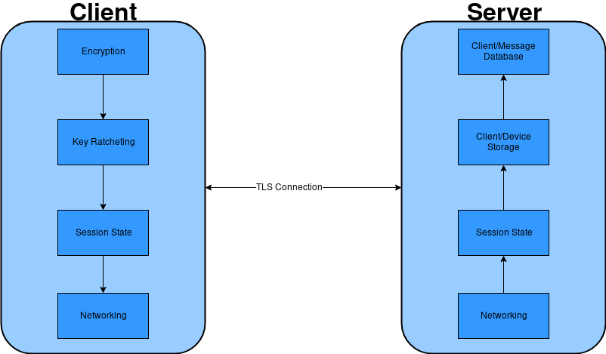

Expertise Development
SIGEMAIL covers a wide spectrum of skills for developing my technical expertise. This project requires a strong protocol design which has normally been relegated to the classroom, so experiencing firsthand the technical challenges found in designing a robust protocol will help develop my networking abilities. The test design and requirements also go far beyond what even the classroom has shown, so learning about proper testing usage will help develop my technical workflow skills, and how testing can reflect upon the success of a project. Lastly, I have never made any large-scale cryptographic software before, which has its own unique challenges such as zeroing memory used for keys and plaintexts, and constant time memory comparisons. Having exposure to a cryptographic mindset during developement of this project will strengthen my skills in network security, and help open up a future avenue in cryptographic software as a niche focus on my career.

Deliverables
The Following deliverables will be provided for this application:
- Client application
- Server application
- Final report
- User guide for compilation, running, and installation of the client/server

Timeline
This project aims to fulfill the 405 hour work requirement, and provides the following expected work breakdown to satisfy that claim.

Client
Total: 185 Hours
- Encryption/decryption – 10 hours
- Session state – 15 hours
- X3DH – 5 hours
- Key Derivation – 10 hours
- Message formatting – 15 hours
- Server network connection – 20 hours
- Import/Export over IMAPS – 30 hours
- GUI functionality – 60 hours
- Tests – 20 hours

Server
Total: 195 Hours
- Client/device state storage – 20 hours
- Redis integration – 60 hours
- Protocol design – 40 hours
- Client/device addition and deletion – 15 hours
- Client/device verification – 25 hours
- Message transmission – 10 hours
- Key upload/retrieval – 10 hours
- Tests – 15 hours

Documentation
Total: 25 hours
- Writing User guide - 2
- Commenting code - 3
- Writing final report - 10
- Editing final report - 10

Appendix A

X3DH
For key-agreement, Signal uses a modified Diffie-Hellman protocol, dubbed X3DH, or Extended Triple Diffie-Hellman [1]. The name implies the use of multiple keys, and multiple runs of traditional Diffie-Hellman exchanges. X3DH is designed for forward secrecy, mutual authentication, and deniability. It requires the following set of keys for each participant.
Alice’s keys:
- IK_{A} - Alice’s Identity Key
- EK_{A} - Alice’s Ephemeral Key
Bob’s keys:
- IK_{B} - Bob’s Identity Key
- SPK_{B} - Bob’s Signed PreKey
- OPK_{B} - Bob’s One-time PreKey
Where SPK_{B} is signed using IK_{B} and the XedDSA algorithm.
Alice, when wanting to initiate communication with Bob, retrieves his keys from the server. The One-time prekey is optional for the protocol, but highly recommended. Alice then verifies the signature on the pre-key, and aborts the protocol is it is not valid. If the signature is valid, Alice then performs the following set of DH agreements.

- DH1 = DH(IKA, SPKB)
- DH2 = DH(EKA, IKB)
- DH3 = DH(EKA, SPKB)
- DH4 = DH(EKA, OPKB)
- SK = KDF(DH1 || DH2 || DH3 || DH4)
Where KDF is a suitable key derivation function.
Alice now sends Bob their initial message, encrypted using SK, as well as both IK_{A} and EK_{A,} and an identifier representing the specific one-time prekey that was used.
Upon receiving the intial message, Bob retrieves his private keys for his identity, pre-key, and one-time key pairs, as well as the received keys from Alice. Bob can now repeat the same key-exchange protocol to arrive at the same shared key. Bob then can decrypt the message, as well as delete the used one-time prekey from the server.
If the one-time prekey is not used during the protocol, then it has implications for both forward secrecy and protocol replay. Without a pre-key, the forward secrecy of the session is bounded by the lifetime of the signed pre-key. Also, the session is vulnerable to replay, which may result in the same secret key being derived for multiple sessions. To prevent this, a new fresh source of randomness must be mixed into the key after key exchange to prevent security compromises. This immediate renegotiation is typical in Diffie-Hellman exchange protocols, and Signal performs this via its key ratcheting.

Double Ratchet
Once a shared secret key has been established by the participants, the Double Ratchet algorithm specifies how to modify and update the keys during a session to maintain forward secrecy, backward secrecy, as well as being self-healing to temporary key compromises [2]. The Double Ratchet algorithm, as the name implies, involves two distinct key ratchets working together. These ratchets are a traditional Diffie-Hellman ratchet, as well as a Key-Derivation-Function based ratchet. The KDF ratchet provides the forward secrecy aspect, and the Diffie-Hellman ratchet provides the backward secrecy and self-healing components of the protocol.
Figure 25: A KDF chain

The KDF ratchet is built upon something called a KDF-chain. A KDF-chain is a series of calls to a Key derivation function given some existing key, and an input, and returns two equal-length outputs. The first output is the new KDF chain key, while the second key can be used as an output for another function, or for encrypting messages. The Double ratchet protocol requires each party to store and maintain 3 chains: A root chain, a sending chain, and a receiving chain, where Alice’s sending chain matches Bob’s receiving chain, and vice versa. The root chain is used to initialize the other 2 chains, and is tied into the Diffie-Hellman ratchet in the protocol. The sending and receiving chains are ratcheting forward on a per-message basis. When a message is sent, the sending chain is ratcheted forward a step, and the output key is the message key for that individual message. The same process happens for the receiving chain when an incoming message is received. This allows the protocol to flow in a hall-duplex communication mode, and as long as the same parties keeps sending and receiving, the respective chains will continue to increase without disturbance. Once the communication switches via a message response, then the Diffie-Hellman ratchet kicks in to update the existing chain infrastructure.
Figure 26: A full step of the Diffie-Hellman Ratchet

Every message exchanged during the Double Ratchet protocol contains a header with the Diffie-Hellman ephemeral public key the sender is currently using. Upon receival of the message, the receiver takes that public key, performs a DH exchange using their current private, and the received public key, and the resulting value is the new chain key for the receiving chain. The receiver then creates a new ephemeral keypair, performs another DH exchange and this resulting key is used to update the root chain. This two-part process is shown in Figure 2.
In this way, the root chain uses ephemeral and received Diffie-Hellman keys to create new sending and receiving chain keys. Those sending and receiving chain keys then perform iterated KDF steps on their chain key using a constant input to produce per-message encryption and decryption keys. Figure 3 shows how these two ratchets intertwine to produce fresh keys for every message, while continually injecting new randomness into the keys via DHE key exchanges.
Figure 27: A full visualization of a single send-receive cycle
With all this complexity and key shuffling, it is tempting to believe that any out-of-order message may permanently cripple the session by preventing these key chains from ever resyncing. Thankfully, this is not the case. By sending both the length of the current chain, and the length of the previous chain inside the header of every message, it is possible to replay the session ratcheting offline and store unused or skipped message keys. The current chain length value allows the application to increment the symmetric-key ratchet to the required decryption key, while storing the skipped keys for later when the missing message is received. Likewise, the previous chain length value can determine the number of missed messages before a DH exchange occured. This allows out-of-order messages to be accounted for, both from a symmetric-key ratchet, as well as a DH ratcheting scenario.
Figure 28: An example of creating and detecting skipped message keys
To integrate the Double Ratchet protocol with X3DH, the shared secret key SK is used as the initial root chain key, while Bob’s signed pre-key SPK_{B} becomes the remote public key used to initialize the DH ratchet.

References
[1] - https://signal.org/docs/specifications/x3dh/
[2] - https://signal.org/docs/specifications/doubleratchet/

Appendix C – User Guide
# SIGEMAIL
This application implements the [Signal Protocol](https://signal.org/docs/) in C++ to create an End-to-End Encrypted email service.
Similar to Signal, the primary communication is direct over the network, with external email import/export via SMTP/IMAP.

## Usage:
Server usage:
`./bin/sigemail_server <listening_port> <number of threads>`

Client usage:
`./bin/sigemail <server_address> <server_port>`

## Compilation:
To compile simply run the following commands:
```
cmake .
make
```

Compilation requires:
- CMake 3.13.0 or later
- Linux
- C++17 compliant compiler
- OpenSSL 1.1.1 or later
- Curl 7.30 or later
- Qt5
- Boost 1.67 or later

Change Log
- Version 1.0
  - March 25th, 2019
  - Initial draft created
- Version 1.1
  - March 30th, 2019
  - Updated based on supervisor comments
    - Improved system architecture diagram to better document boundary between self-written and library code
    - Improved testing section to show more tests, including output data and formal verification comments
- Version 1.2
  - April 16th, 2019
  - Updated based on committee feedback
    - Added scalability to implementation section addressing question of multiple client testing for performance (Page 35)
    - Rewrote and greatly expanded design decisions to better include design process (Pages 5-7)
    - Added development section to cover similar process as above, but for development (Pages 7-8)

https://signal.org/docs/specifications/xeddsa/
https://signal.org/docs/specifications/sesame/#assumptions
https://github.com/signalapp/Signal-Server/wiki/API-Protocol

