8506 Assignment 1 Testing
John Agapeyev A00928238

Table of Contents
Notes 1
Sample Packet Data 1
Server-side Covert Channel Output 2
Running server as non-root user 2
Running server while existing session is active 2
Attempting to load module without userspace helper 2
Decrypting a corrupted message 2

Notes
Packet capture was done via port 666 for testing purposes, to avoid being mixed up with existing 443 outbound traffic.

Sample Packet Data
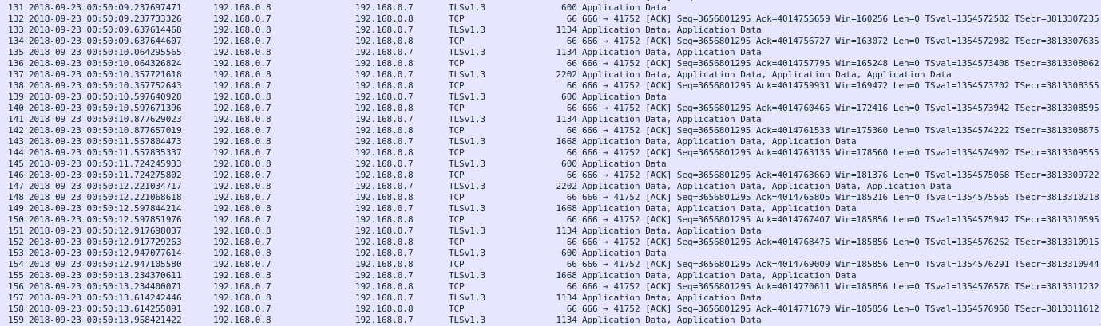
A full capture of the covert channel data was included in the assignment submission

Server-side Covert Channel Output
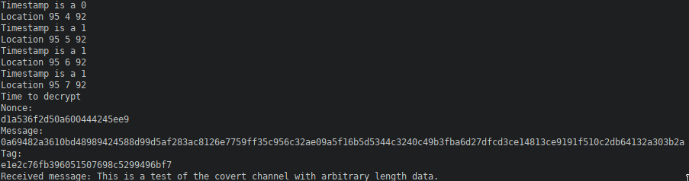
Client-side intentionally produces no output, which is why it is not shown.

Running server as non-root user

Running server while existing session is active

Attempting to load module without userspace helper

Decrypting a corrupted message
