8506 Assignment 1 Design
John Agapeyev A00928238

Table of Contents
State Machine 3
Pseudocode 3
Userspace 3
Init Userspace 3
Wait for module connections 3
Connect to server 4
Wait for data 4
Send to server 4
Reply 4
Module 4
Init module 4
Run netfilter hook 4
Send data 5
Server 5
Init server 5
Read data 5
Read raw data 5
Parse LSB 6
Print message 6

State Machine
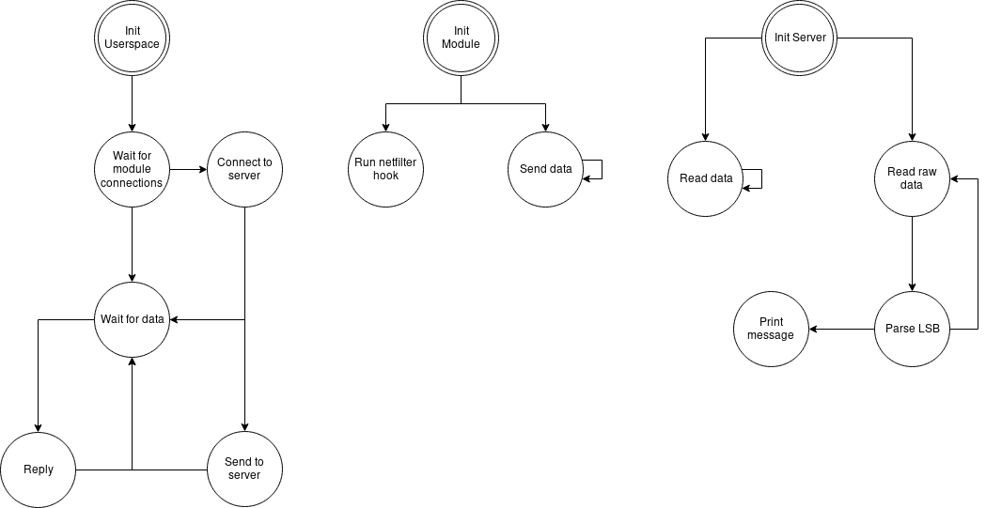

Pseudocode

Userspace

Init Userspace
- Daemonize process
- Initialize local and remote sockets
- Set local sockets to listen for incoming connections
- goto WAIT FOR MODULE CONNECTIONS state

Wait for module connections
- Wait for incoming connections to local sockets by the kernel module
- Accept incoming connections
- In one thread, goto CONNECT TO SERVER state
- In the other threads, goto WAIT FOR DATA state

Connect to server
- Connect to server using hardcoded IP and port
- Initialize TLS connection with server
- goto WAIT FOR DATA state

Wait for data
- Wait for data on respective socket
- When data is received:
  - If current thread is server thread, goto SEND TO SERVER state
  - Else, goto REPLY state

Send to server
- Take received data and send via the TLS connection to the server
- goto WAIT FOR DATA state

Reply
- If the socket is the encrypt socket, encrypt the data
- If the socket is the decrypt socket, decrypt the data
- Send the new resulting data back to the module
- goto WAIT FOR DATA state

Module

Init module
- Register netfilter hooks
- Allocate buffers
- Start packet sending thread and goto SEND DATA state

Run netfilter hook
- Parse incoming or outgoing packet
- Ignore packets that are not TCP
- Ignore packets that do not have PSH flag or timestamp option
- If packet is incoming:
  - Decrement timestamp value
  - Recalculate packet timestamp
  - Accept packet
- If packet is outgoing:
  - Compare current bit of data and timestamp
  - If they match, drop the packet
  - If they do not match, increment timestamp
  - Recalculate packet checksum
  - Increment bit and byte counters for sending data
  - Accept packet

Send data
- While data has not been fully sent:
  - Send fixed length data
  - Wait random amount of time

Server

Init server
- Initialize raw and listening sockets
- In raw socket thread, goto READ RAW DATA state
- Wait for incoming connection on listening socket
- When a connection is received, accept it and goto READ DATA state

Read data
- Initialize TLS connection with incoming connection
- While there is data to read, read data and discard it

Read raw data
- Read raw incoming packet data
- If data is not TCP on designated port, ignore it
- Else, goto PARSE LSB state

Parse LSB
- Parse incoming packet
- Read timestamp value
- Save least-significant-bit of timestamp into buffer
- If the message length has been fully received, goto PRINT MESSAGE state

Print message
- Decrypt the contents of the received covert message buffer
- Print the resulting data to the screen

