Quarto Basics

# Markdown

Markdown is an easy to read and write text format:

* It’s *plain text* so works well with version control
* It can be **rendered** into HTML, PDF, and more
* Learn more at: <https://quarto.org/docs/authoring/>

## Code Cells

Here is a Python code cell:

import os  
os.cpu_count()

8

## Equation

Use LaTeX to write equations:

inline math: $E=mc^{2}$

display math:

$$E=mc^{2}$$

$$\begin{matrix}V_{sphere}=\frac{4}{3}πr^{3}\end{matrix}$$

idow ## Mermaid

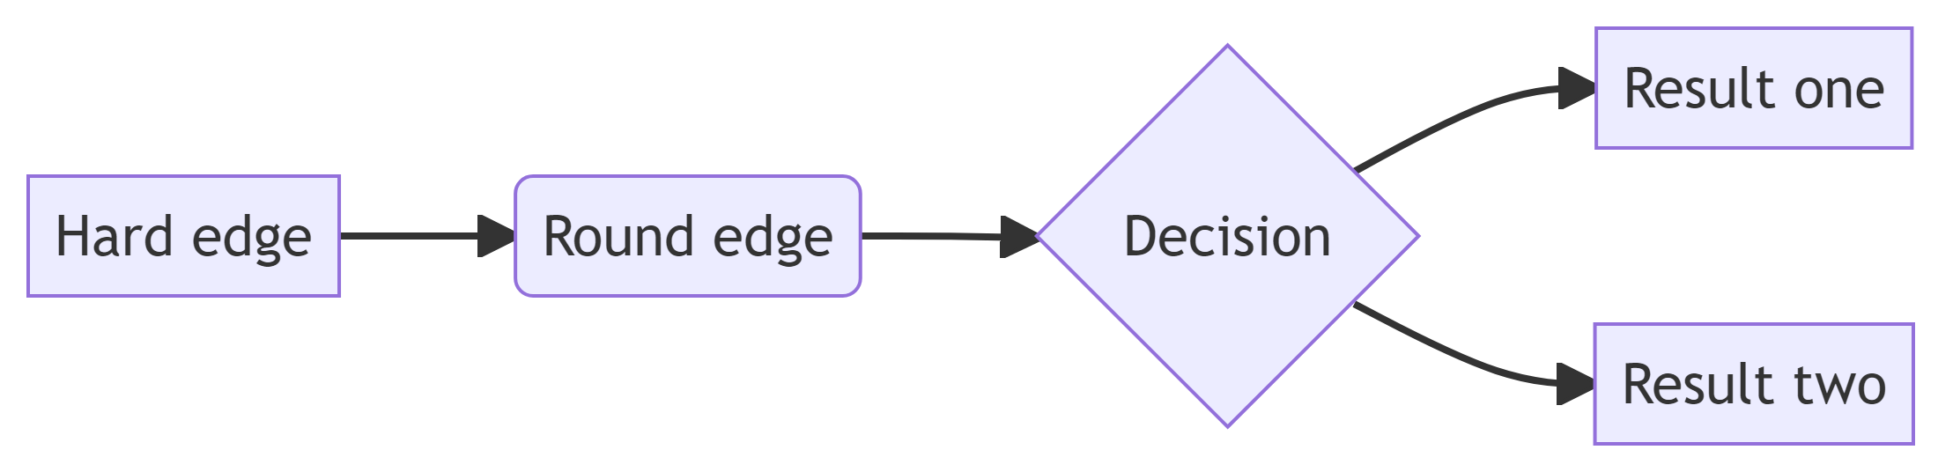

# Plot examples

For a demonstration of a line plot on a polar axis, see Figure 1.

import numpy as np  
import matplotlib.pyplot as plt  
  
r = np.arange(0, 2, 0.01)  
theta = 2 * np.pi * r  
fig, ax = plt.subplots(  
 subplot_kw = {'projection': 'polar'}   
)  
ax.plot(theta, r)  
ax.set_rticks([0.5, 1, 1.5, 2])  
ax.grid(True)  
plt.show()

|  |
| --- |
| Figure 1: A line plot on a polar axis |

## NumPy

import numpy as np  
a = np.arange(15).reshape(3, 5)  
a

array([[ 0, 1, 2, 3, 4],  
 [ 5, 6, 7, 8, 9],  
 [10, 11, 12, 13, 14]])

## Matplotlib

import matplotlib.pyplot as plt  
  
fig = plt.figure()  
x = np.arange(10)  
y = 2.5 * np.sin(x / 20 * np.pi)  
yerr = np.linspace(0.05, 0.2, 10)  
  
plt.errorbar(x, y + 3, yerr=yerr, label='both limits (default)')  
plt.errorbar(x, y + 2, yerr=yerr, uplims=True, label='uplims=True')  
plt.errorbar(x, y + 1, yerr=yerr, uplims=True, lolims=True,  
 label='uplims=True, lolims=True')  
  
upperlimits = [True, False] * 5  
lowerlimits = [False, True] * 5  
plt.errorbar(x, y, yerr=yerr, uplims=upperlimits, lolims=lowerlimits,  
 label='subsets of uplims and lolims')  
  
plt.legend(loc='lower right')  
plt.show(fig)

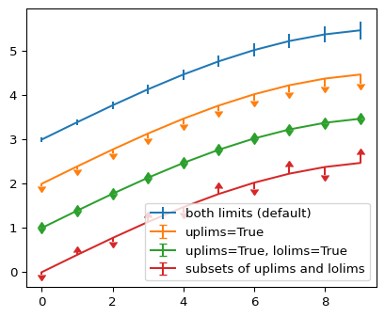

## Plotly

import plotly.express as px  
import plotly.io as pio  
gapminder = px.data.gapminder()  
gapminder2007 = gapminder.query("year == 2007")  
fig = px.scatter(gapminder2007,   
 x="gdpPercap", y="lifeExp", color="continent",   
 size="pop", size_max=60,  
 hover_name="country")  
fig.show()

Unable to display output for mime type(s): text/html

Unable to display output for mime type(s): text/html

# Callouts

|  |
| --- |
| Note |
| Note that there are five types of callouts, including: note, tip, warning, caution, and important. |

|  |
| --- |
| Tip with Title |
| This is an example of a callout with a title. |

|  |
| --- |
| Expand To Learn About Collapse |
| This is an example of a ‘folded’ caution callout that can be expanded by the user. You can use collapse="true" to collapse it by default or collapse="false" to make a collapsible callout that is expanded by default. |

|  |  |
| --- | --- |
|  | **Pay Attention**  Using callouts is an effective way to highlight content that your reader give special consideration or attention. |