Technical Memo — Zetarix
Team Arkova · Global Hackathon on AI for Digital Trade Regulatory Analysis (UN ESCAP & KMITL, 2026). Apache 2.0.
Companion deck covers walkthrough; this memo = 2-page technical summary.
Problem. Automate ~80% of the RDTII workflow (discover → describe) for Pillar 6 (Cross-border Data Flows) and Pillar 7 (Domestic Data Protection) at article-level granularity, with a transparent 20% human-review step. Model-agnostic by design — every model is a swappable adapter.
Pipeline
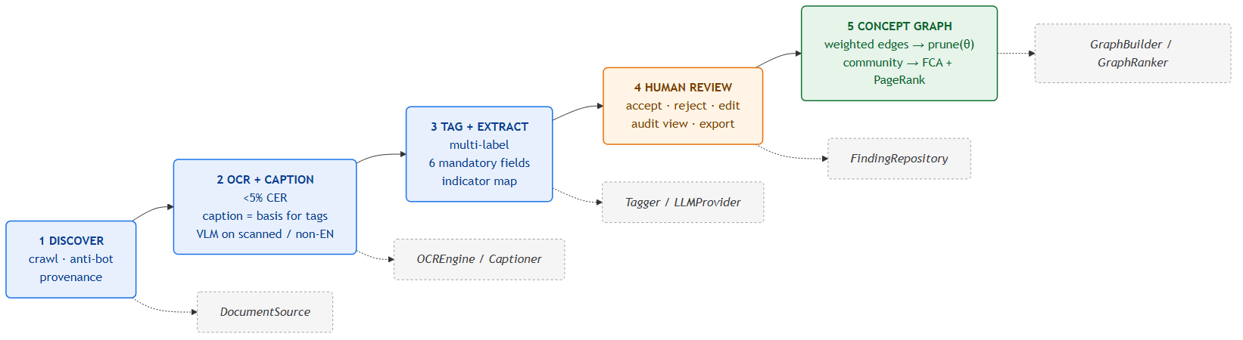
Stages 1–5 with the ports they bind to (dashed). Adapters are config-selected; the core domain depends on the ports only.
6 mandatory fields / article: title · last_update · url · scope · provisions · impact (+ pillar, indicator, confidence, review_status). Document-level summaries rejected.
Stage 5 (core contribution): tagged sections = nodes; edges = IDF-weighted tag overlap + embedding cosine; pruned at calibrated θ (fixed seeds + θ ⇒ reproducible). Community detection + Formal Concept Analysis lattice + weighted PageRank → navigable entry-point → sub-topic hierarchy for cross-jurisdiction evidence discovery.
Architecture — ports & adapters
Core domain imports no framework/model SDK; concrete tools are config-selected adapters.
Port | Suggested adapter (dev) | Open-weight target | License
DocumentSource | Playwright + BeautifulSoup | same | BSD/MIT
OCREngine | Tesseract 5 + OpenCV / PaddleOCR | same | Apache-2.0
Captioner | Qwen2-VL / ColQwen2 | same | Apache-2.0
Tagger (embeddings) | BGE-M3 + reranker | same | MIT/Apache
VectorStore | pgvector / Chroma | same | PostgreSQL/Apache
LLMProvider | Claude / GPT | Llama 3.1 8B/70B via Ollama | Apache-compat
GraphBuilder/Ranker | NetworkX + FCA `concepts` | same | BSD/MIT
⚠ License discipline: ColQwen2 over PaliGemma/ColPali (Gemma); NetworkX/Louvain over GPL leidenalg/igraph; no CC-BY-NC models. All components Apache-2.0-compatible.
Cost per 50-page document (preliminary)
~200 article-level chunks / 50-pp doc.
Configuration | Total / 50 pp
Open-weight (Llama 3.1 8B, self-host GPU) | ~USD 0.05–0.10 (API: $0.00)
API (Claude/GPT) | ~USD 0.10–0.25
Open-weight basis: A10G-class GPU at batch rates. Final CER / latency / cost reported post-test.
Generalisation, fine-tuning, originality
- Generalisation: no per-country retraining; non-English via captioning + translation; scanned PDFs via OCR (<5% CER); anti-bot portals via headless browser + archive fallback. Target ≥3 of 10 assigned countries at finale.
- Fine-tuning (planned): few-shot tune small encoder/classifier for Pillar 6/7 sub-indicators using RDTII taxonomy; θ calibrated F1-optimal on RDTII labelled data. Weights published in repo.
- Originality: not a new model — a complete, deployable, open-source RDTII pipeline that does not yet exist, with a concept-graph layer for cross-jurisdiction evidence discovery.
Deploy: docker-compose up → api + web + Postgres/pgvector. No proprietary production dependency. Full design: docs/ARCHITECTURE.md, docs/GRAPH_PIPELINE.md.

