

Data Management System for the Lancaster Amateur Radio Club

Josef Mechure, Thomas Jones, John Apel

IST 659: Data Administration Concepts and Database Management

March 24, 2025

# **Abstract**

This technical report outlines the design and implementation of a data management system for the Lancaster Amateur Radio Club (LARC). The goal is to enhance operational efficiency by supporting membership management, communication, dues tracking, and regulatory compliance. This report discusses the business requirements, specific data rules, system design, and key project learnings. The project demonstrates the value of structured data administration in improving stakeholder communication and ensuring scalability for future growth.

# **Introduction**

According to their website, the Lancaster Amateur Radio Club (LARC) was established in March 1987 and continues to serve radio enthusiasts in the eastern suburbs of Buffalo, NY. Beginning with just 20 members, it has grown to over 150 participants. The club promotes community engagement through events such as Hamfest and provides emergency communication services. Since becoming a special service member of the American Radio Relay League in 2002, LARC has further extended its capabilities with technologies like Echolink. The club's data needs have also grown, making the development of a robust data management system essential.

# **Business Requirements and Specific Business Rules**

The data system must fulfill key functional areas such as:  
 - Member information tracking and communication  
 - License management  
 - Membership categorization and tracking  
 - Club officer designation and permissions  
 - Key issuance and facility access management  
 - Membership dues and activity coordination  
 - Historical record keeping and regulatory compliance  
   
Business rules include:  
 1. Each member must have a unique Member ID.  
 2. Licenses are optional but tracked for certified users.  
 3. Members may hold only one active membership type.  
 4. Club officers must be active members.  
 5. Keys are uniquely assigned and monitored for accountability.  
   
As Watson (2013) notes, “Effective data management is essential to the success of any organization, enabling informed decision-making and operational efficiency.” These business rules ensure data integrity and operational clarity across club functions.

Goals

The overarching goals of the data system are to:

- Ensure data integrity and accuracy through validation and normalization   
 - Facilitate membership and officer management   
 - Improve member engagement and communication   
 - Coordinate volunteers and event participation   
 - Ensure scalability to support LARC’s future growth

A well-designed data architecture can reduce redundancy, improve access, and enable proactive decision-making (Harrington, 2016).

**Glossary**

* **Member ID**: A unique identifier assigned to each club member.
* **License**: Certification granted to members, e.g., Technician, General, Extra.
* **Membership Type**: Classification of membership status
  + Active –
    - Regular Paid Membership
    - New Probationary Membership
    - Family Membership
    - Lifetime Membership
  + Inactive
    - Quit
    - Failure to Pay Dues
    - Expelled
  + Silent Key
* **Club Officer**: Elected or appointed member holding a specific role within the club.
* **Key Holder**: Member who has been issued a key for club facilities.

**Stakeholders**

* **Club Members**: Individuals whose data is being managed.
* **Club Officers**: Members responsible for administrative roles.
* **IT Personnel**: Individuals managing the data system.
* **External Partners**: Organizations collaborating with the club for events or services.

**Conclusion**

**Implementing a well-structured data management system enables LARC to streamline membership tracking, enhance communication, maintain regulatory compliance, and ensure secure facility access. By adopting modern data design principles, the club can improve member satisfaction, transparency, and long-term sustainability.**

**Appendices**

* **Appendix A: Entities and Attributes**
* A screenshot of a computer

  AI-generated content may be incorrect.
* A screenshot of a computer

  AI-generated content may be incorrect.
* **Appendix B: Conceptual Data Model Diagram**

**Appendix C :Logical Data Model Diagram**

**Appendix D: samples**

* Sample Query of Members Pending a Call Sign:
* 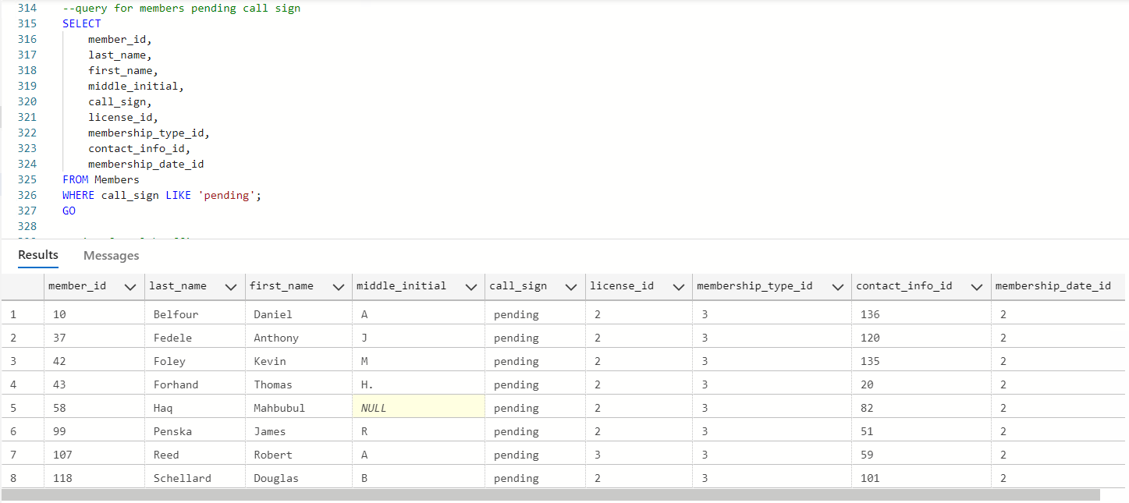
* Query for Keys Issued by Club
* 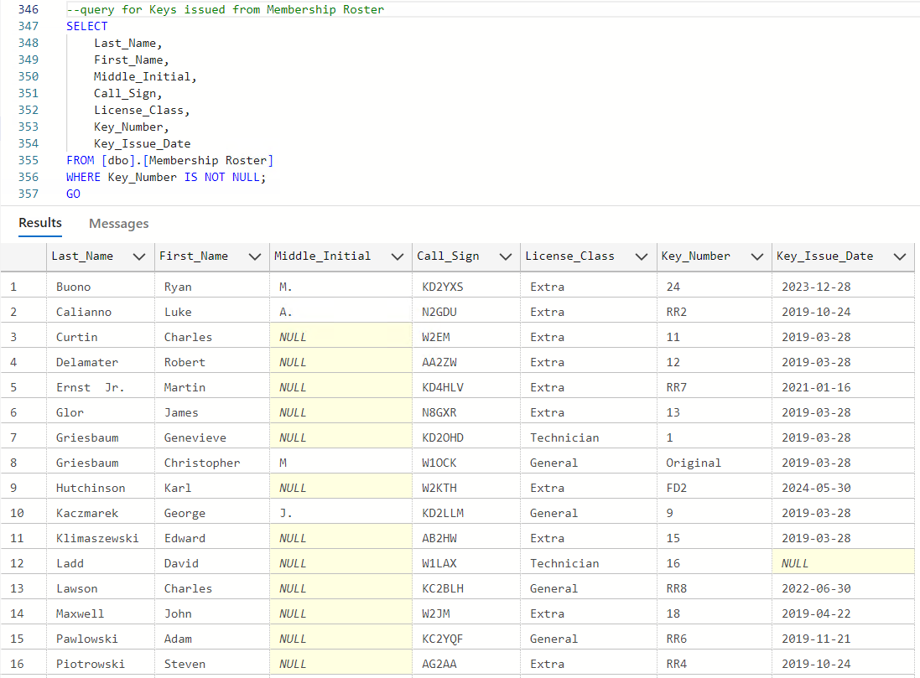
* Created View for Club Officers:
* 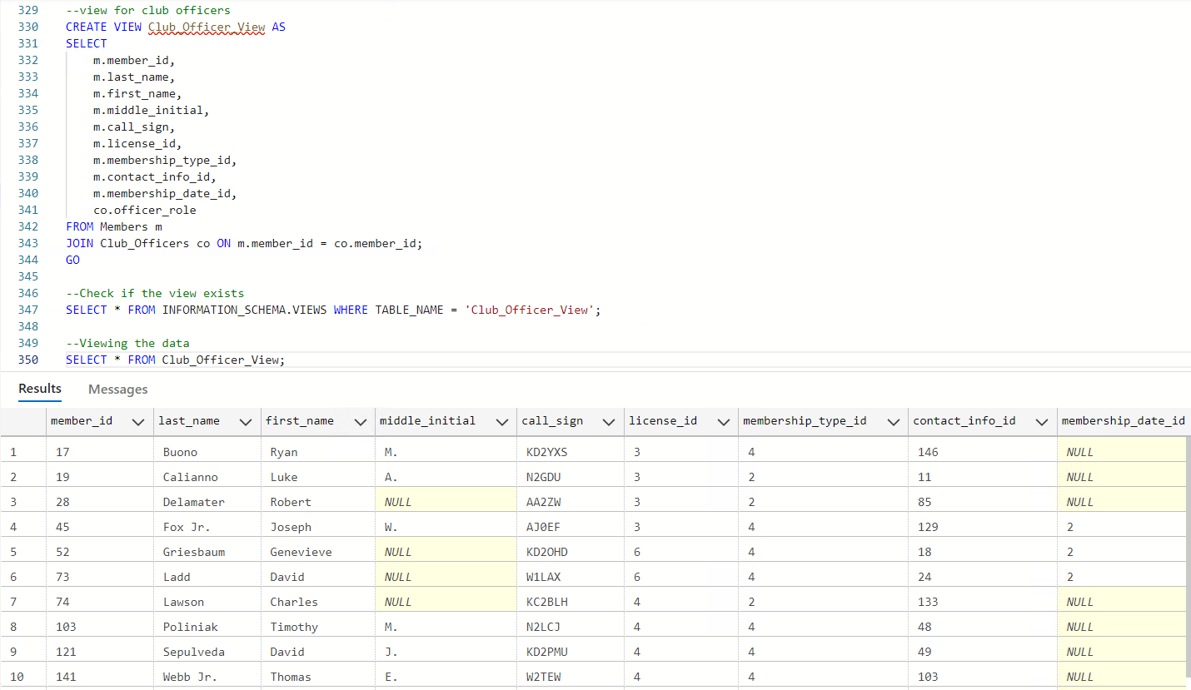
* Reflection of what was learned from project

Writing real-world SQL scripts for table creation, data insertion, and stored procedures improved our skills in both syntax and structure. We gained experience in designing up/down migration scripts, creating views for simplified queries, and using stored procedures for business logic automation.

Creating a database from scratch taught the importance of conceptualization, logical structuring, and meeting end user needs. Before designing tables, we had to consider how the database would support the mission of the LARC organization. Though we did not implement a user interface, we researched low code/no code options for how this could evolve into an application. That gave us a big picture perspective connecting how the skills taught in this class are applied in real world scenarios.

Implementation of a real-world dataset that contained no statistical data. This project was different than previous projects in other courses that involved statistical analysis of a dataset to inspect trends and create charts from the dataset to answer a business purpose. There are times in the real-world especially with database creation, where there is little to no statistical analysis and this dataset was a good practical example for us. There is opportunity later for a project like this to incorporate statistical analysis such as information regarding donations or geographical location for member concentration, but these were outside of the scope of our current business goal and would require that information to added by the organization towards the dataset if it is desired by them in the future.

References

Harrington, J. L. (2016). *Relational database design and implementation* (4th ed.). Morgan Kaufmann.  
 Loshin, D. (2013). *Enterprise knowledge management: The data quality approach*. Morgan Kaufmann.  
 Watson, H. J. (2013). *Data management: Databases and organizations* (6th ed.). Wiley.