Individual Calendar

Requirements Specification Report

01/24/2020

CSC 340 Ethics and Software Engineering

John Booker

Contents

I. Introduction 1

A. Problem Statement 1

B. Proposal 1

II. System Description 1

III. System Requirements 1

A. Functional Requirements 1

A. Non-Functional Requirements 1

B. Domain Requirements (op) 1

IV. Use Case Diagram 1

V. Domain Diagram 1

VI. Conclusion 1

VII. Data Dictionary 1

# Introduction

## Problem Statement

A branch enterprise of EKU wants a software that will act as a calendar, to keep track of one individual.

## Proposal

We propose a software to help the enterprise. The calendar system will be created with Visual Studio.

# System Description

The individual calendar system will be able to add an event with conflict checking, delete an event, edit an event, view an event, and view a monthly-based event list.

# System Requirements

## Functional Requirements

1. The system shall display a list of the current month’s events.
   1. The user shall select the correct month by clicking the left and right arrows at the top corners of the calendar.
   2. 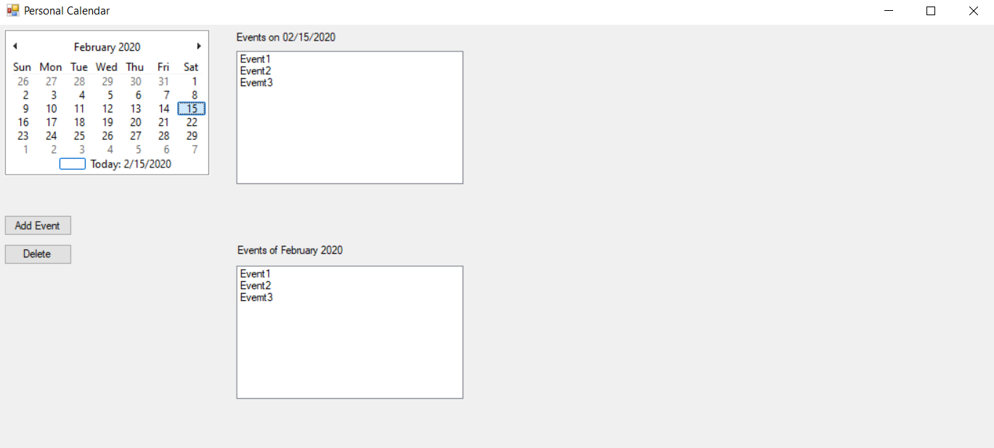The system shall update the textbox below “Events of [current month and year]” to display all the events of the current month
2. The system shall allow a user to view an event.
   1. The user shall select the correct event from the day-related list or the month related list.
   2. The system shall display a panel with the information related to that event.

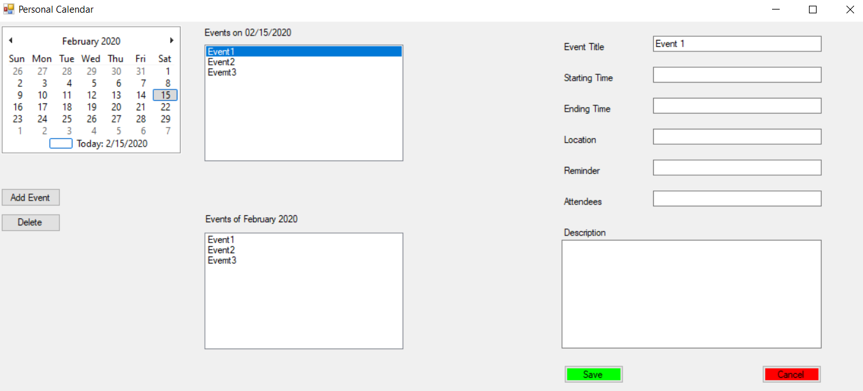

1. The system shall allow a user to add a new event to the calendar.
   1. The user shall select a date from the monthly calendar to add the new event to.
   2. 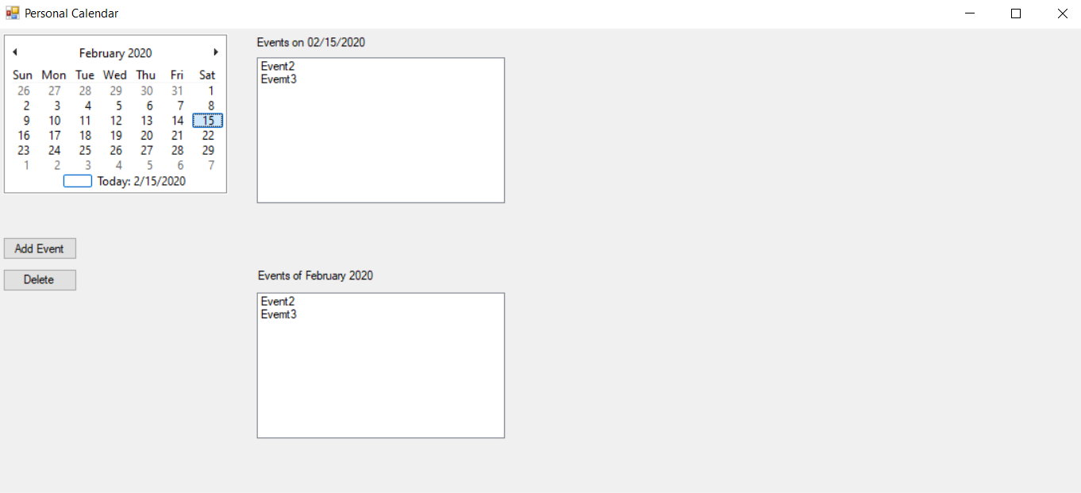The system will highlight the selected date on the calendar.
   3. The user shall press the “Add Event” Button.
   4. The system shall display a form to allow a user to enter the event information: event title, event contents, starting time, ending time, reminder time, location, and attendees.

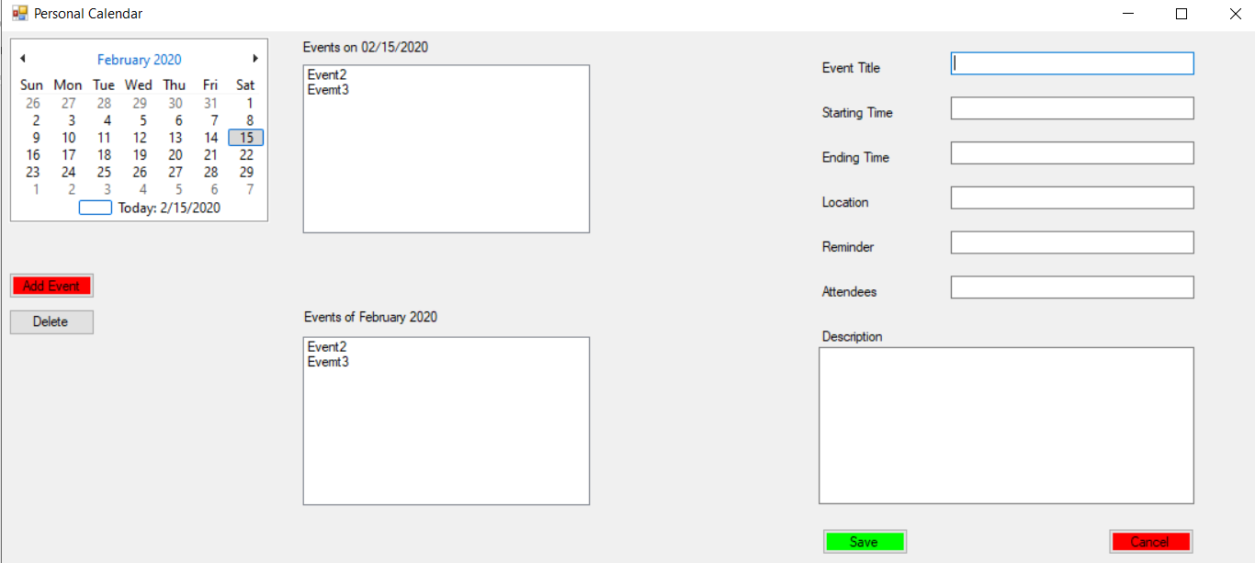

* 1. The user shall enter the data for the event, and press the save button
  2. The system will check if the new event conflicts with any current events.
     1. 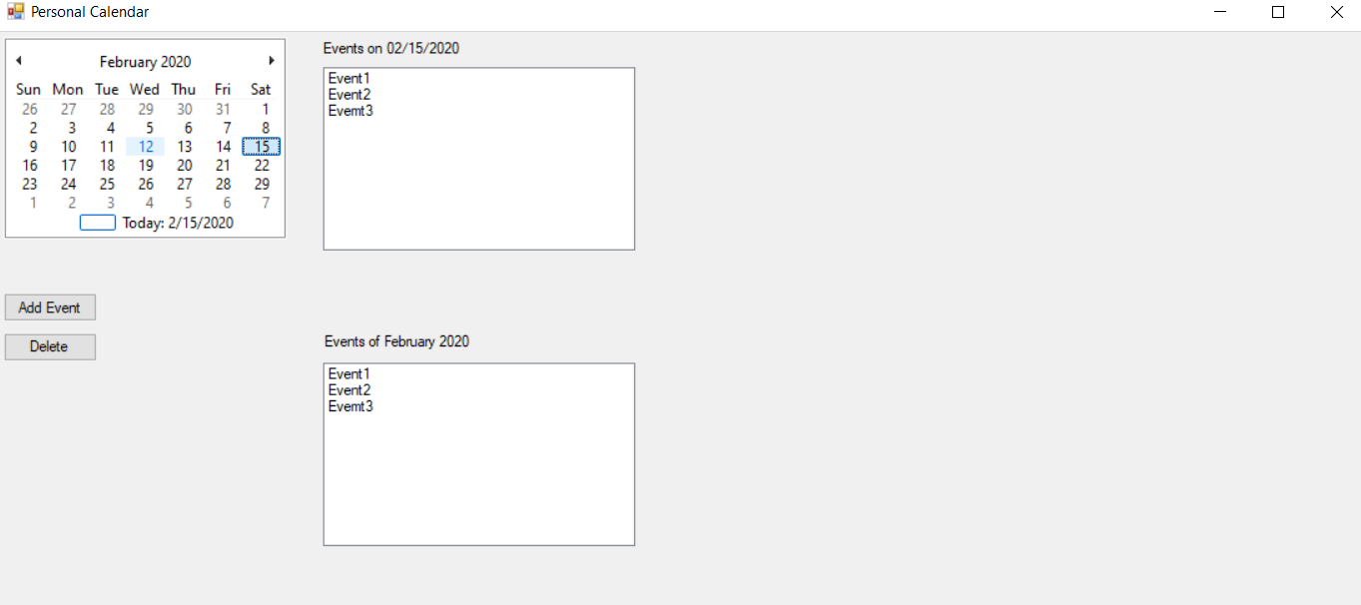 If there is no conflict, the system will save the event to the database and display the event title on the calendar.
     2. If there is a conflict, the system shall display an error message.

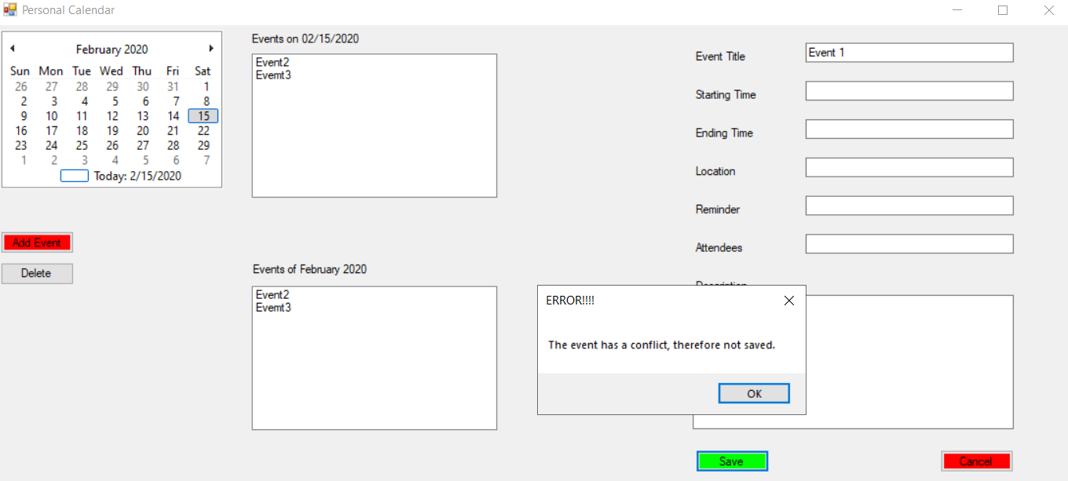

1. The system shall allow a user to delete an event from the calendar.
   1. The user shall select an event from the Calendar by clicking on the event title in the monthly list or in the event list of a selected day.
   2. 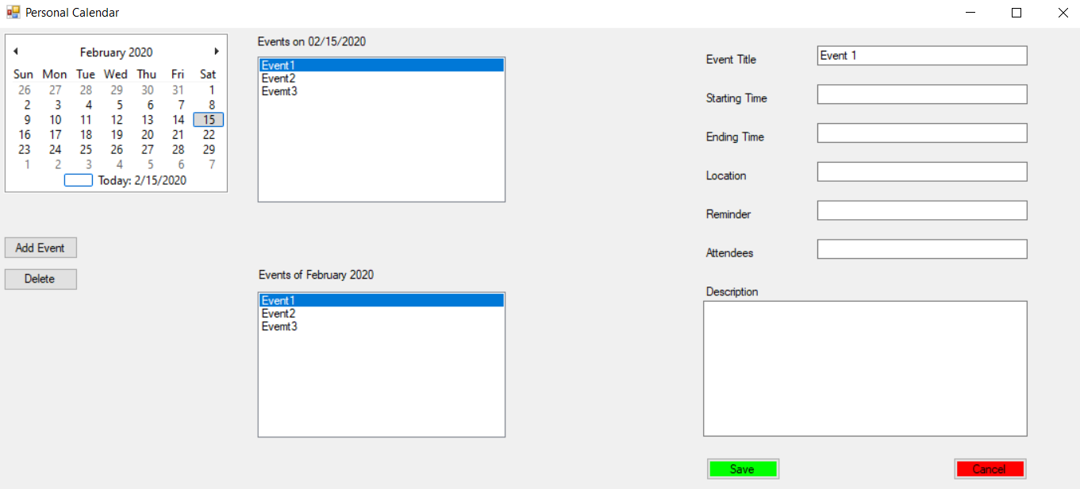The system will highlight the selected event.
   3. The user shall click the “Delete Event” button at the left side of the screen.
   4. The system shall create a new popup box, asking the user if they are sure they want to delete the event.

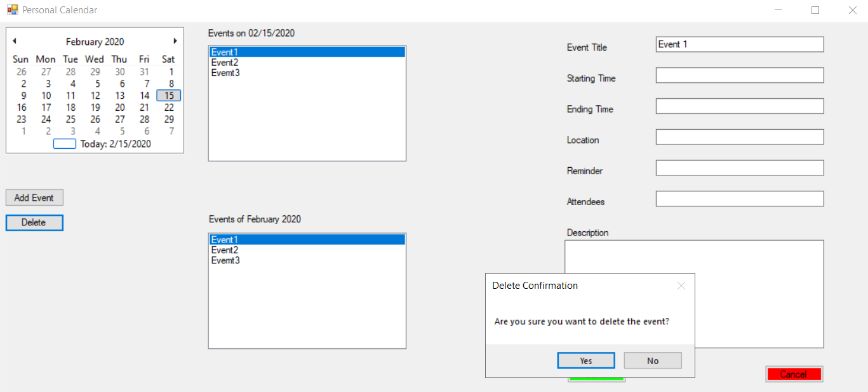

* 1. The user shall press the “Yes” button on the new popup box.
  2. 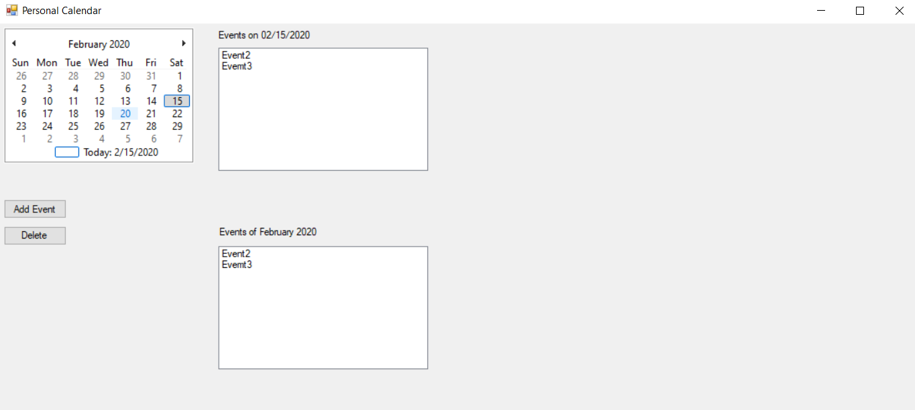The system will delete the event from the calendar and the database.

1. The system shall allow a user to edit a created event.
   1. The user shall select an event from the Calendar by clicking on the event title.
   2. The system shall then reveal the information of the clicked-on event.

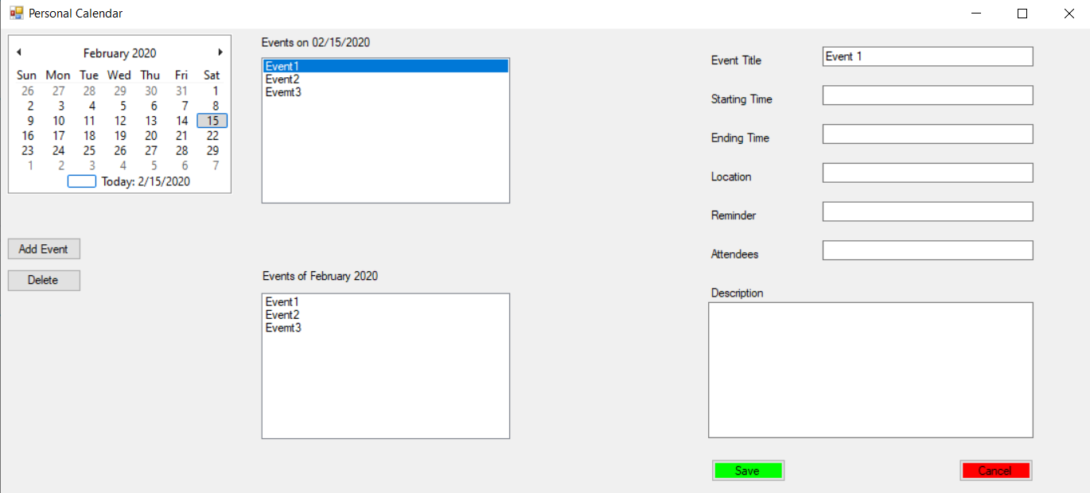

* 1. The user shall edit any portions they wish to change and click “Save” to keep the changes or “Cancel” to not keep the changes.
     1. If the user presses “Save”, the system shall update the details in the database and hide the panel of information.
     2. If the user presses “Cancel”, the system shall discard the details and hide the panel of information.

## Non-Functional Requirements

1. The system will only save changes if the user explicitly clicks the save button for an event.
2. The system will check for time conflicts.
3. The monthly list only displays one month at a time.
4. The deletion of an event from the monthly or day related lists will delete the same event in the other list.

## Domain Requirements

* The calendar system shall be based on the Gregorian Calendar.

# Use Case Diagram

The individual calendar system will allow a user add, edit, delete, and view events. The viewing of events can be done by day or by month. The user may also access information about one particular event by selecting it.



# Domain Diagram

|  |
| --- |
| Events |
| * Title * Attendees * StartTime * EndTime * Location * Reminder * Description |

|  |
| --- |
| Day |
| * Date * EventList |

|  |
| --- |
| Month |
| * Year * EventList |

# Conclusion

The individual calendar system will allow the manipulation of events through for one calendar.

# Data Dictionary