**Dairy Industry Today**

**Interpretative summary**

Dairy Industry Today: Surveying housing and bedding practices on Vermont organic dairy farms, Andrews et al. At least 27% of Vermont dairy farms are certified organic. Among other requirements cows on organic dairies must be allowed daily pasture access during the grazing season. During the winter months, cattle may be housed indoors due to inclement weather. However, there is limited knowledge of the frequency and diversity of different winter housing and bedding systems used for lactating dairy cows on organic dairy farms. In this project, we surveyed organic dairy farmers in Vermont to estimate the frequency and diversity of winter housing and bedding systems.

**Dairy Industry Today: Survey of winter housing and bedding practices on Vermont organic dairy farms**

Tucker Andrews**\***, Caitlin Jeffrey**†**, Rachel Gilker‡, Deborah A. Neher**\***, John W. Barlow**†1**

**\***Department ofPlant and Soil Science, University of Vermont, Burlington 05405

**†**Department ofAnimal and Veterinary Sciences, University of Vermont, Burlington 05405

‡TBD

Corresponding author: John Barlow, Department of Animal and Veterinary Sciences, University of Vermont, 570 Main Street, 202 Terrill Building, Burlington, VT 05405; 802-656-1396; john.barlow@uvm.edu

**ABSTRACT**

The aim of this report is to describe survey methods that corresponded with a high response rate to a survey designed to quantify the frequency and diversity of winter housing and bedding practices among organic dairy farms in Vermont. We speculate that the mixed methods approach, timing of the survey, and high level of interest were key to a successful survey. A short questionnaire was administered by web, mailing, and telephone to a source population defined as all organic dairy farmers in Vermont listed on ?a database? At XX month, year (n = 171). Our approach yielded 82% (n = 145) response rate from certified organic farms selling organic milk from cows in Vermont at the time of the survey. The three most common housing and bedding material combinations used by respondents were tiestall housing with wood bedding (45%), freestall housing with wood bedding (14%), and freestall housing with sand bedding (12%). The remaining were combinations of housing and bedding systems: 9% used loose housing facilities with a bedded pack in combination with another housing type (e.g., tiestall and freestall facilities), 6% exclusively used a bedded pack facility, and 6% used a combination of both tiestall and freestall facilities. The median number of lactating cows on farms among respondents was 59.5 (range 2 to 400), and the odds of using more than one type of facility to house lactating cows increased proportionately with the number of lactating cows reported for a herd. Four categories of breeds were identified among the respondent herds: 1) Holstein cattle only; 2) Jersey cattle only; 3) mixed Holstein and Jersey herds with crosses; and 4) mixed Jersey and Holstein herds with one or more additional breeds. Breed distribution was similar across the housing and bedding type categories. An association between frequency of individual somatic cell count testing and housing type was identified; respondents using freestall sand facilities were less likely to test approximately monthly or more frequently compared to herds housed in tiestalls with wood bedding. We conclude the survey results? are robust and reliable, and credit the phrasing of questions, pre-survey testing, multiple modes of distribution, and timing for capturing the attention and reflecting the interest of the source population.

***Key words.*** dairy cow, certified organic, questionnaire, tiestall, freestall, compost bedded pack

**INTRODUCTION**

Dairy cattle housing and bedding systems greatly influence animal health, reproduction, milk quality, animal well-being, productivity and farm profitability. Future trends of dairy cattle housing will be a reflection of consumer demands, animal behavior, and environmental impact (Bewley et al. 2017) and the long-term sustainability of the dairy industry depends on the extent that housing systems reflect these priorities (,. In 2014, tiestall housing systems were ?one of the? the most common housing types for lactating cowstiestall among all operations and foremost among operations with less than 100 cows (USDA 2016). However, it is unknown whether this trend also applies to lactating cattle on organic farms in the US. Certainly, regional differences in herd size and types of facilities exist among US dairy operations (USDA 2016), and it is unclear how Vermont organic dairy farms compare to the other northern tier US states that lead in organic dairy production, e.g., Wisconsin, New York, Pennsylvania, Maine and Minnesota (O’Hara and Parsons, 2013; Richert et al., 2013).

Vermont ranks sixth by number of certified organic dairy farms per state and first by number of certified organic dairies per square mile in the US (USDA-NASS, 2017). In 2018, 27% (*n* = 197) of Vermont dairy farms were certified organic. US organic production regulations stipulate living conditions provide “year-round access for all animals to the outdoors, shade, shelter, exercise areas, fresh air, clean water for drinking, and direct sunlight, suitable to the species, its stage of life, the climate, and the environment” and pasture access providing “a minimum of 30 percent of a ruminant's dry matter intake (DMI), on average, over the course of the grazing season(s)” (USDA, 2020). Temporary confinement or shelter is allowed because of inclement weather or conditions under which the health, safety, or well-being of the animal could be jeopardized. In the northern US, including in Vermont, where inclement weather may dominate in winter months, organic dairy herds may be housed indoors for extended time periods; the type of confinement housing facility and associated bedding material may affect annual production, health and behavior. Management practices on organic dairy farms in other northern states (Minnesota, New York, Oregon and Wisconsin) provide expected frequencies of milking facility types (e.g., parlor vs. tiestall or stanchion milking), which may provide a crude estimate of the number of operations housing cattle in tiestall or stanchion barns versus other types of facilities, but do not provide reliable estimates of winter housing or bedding management practices (Stiglbauer et al., 2013; Sorge et al., 2016). For example, pasture or dry-lot was designated as the primary housing type (110 of 192 farms) for lactating cows on organic farms in New York, Oregon and Wisconsin (Richert et al., 2013), but only 22% of farm visits were conducted in the winter, suggesting that seasonality could bias the primary housing type reported. Further, these surveys did not capture the type of bedding material used and some styles of housing (e.g., loose or open housing pack barns) appear to be less frequent in these studies.

In Vermont and nationally, the construction and use of bedded pack or compost bedded pack systems are promoted as an alternative to traditional housing systems (Bewley et al., 2012; Gilker at el., 2012; Ogejo, 2018; Endres and Janni, 2019), although it is unclear how many US organic dairy farms have adopted this technology. Bedded packs, compost bedded packs, or loose housing systems allows cows an enclosed area with an open floor plan and bedding that is refreshed regularly, and are designed for cow comfort (Leso et al., 2020). Utilization of compost bedded pack facilities for lactating dairy cattle seems to be limited in the US despite evidence of benefits. For example, increased cow comfort, increased lying times, decreased lameness, improved hygiene and reduced mastitis rates are relevant to farm productivity, and may be important to consumer preferences and market access. Continued research is necessary to better understand how housing and bedding management systems impact dairy cattle health and welfare on organic farms. A paucity of information on the distribution and types of bedding management styles implemented on organic dairy farms nationally or regionally in the US makes it a challenge to properly design and conduct observational studies to identify associations between housing systems and productivity or health and welfare outcomes, such as mastitis and lameness.

The goal of this descriptive study was to gain robust estimates of how frequent different housing types and bedding management styles were practiced on organic dairy farms in Vermont. Confidence in our results depended on a high response rate. Specifically, we aimed to quantify the number of organic dairy farms in Vermont utilizing bedded pack or compos bedded pack systems for winter housing of lactating cows and to compare this to the frequency of other, possibly more common, types of housing systems. We designed and implemented a questionnaire that was administered by multiple methods (mail and web-based, with mail and telephone follow-up). Herein, we report the results of the Vermont organic dairy winter housing and bedding survey and detail the survey methods.

**MATERIALS AND METHODS**

The survey was designed with the primary objective of ascertaining the frequency of different housing and bedding types used on organic dairy farms in Vermont. The survey tool was a short questionnaire designed to be administered by multiple methods (mailed, internet-based, telephone interview). The process included follow-up mailings and telephone reminders with the opportunity to complete the questionnaire by telephone interview. Survey methodology was approved by the Institutional Review Board at the University of Vermont (CHRBSS: 19-0057) and respondents received no reimbursement for completion of the survey. The Strengthening the Reporting of Observational Studies in Epidemiology statement checklist for Veterinary medicine (STROBE-Vet; O’Connor et al., 2016) was considered during survey design and reporting results.

***Sampling method***

The target population was organic dairy farms in Vermont, USA, with possible relevance to organic dairy farms in the northeastern United States. The source population was all farms producing certified organic milk at the time of the survey and located within Vermont, USA. Dairy farm names and addresses were retrieved from the publicly accessible USDA Organic Integrity (USDA-OI) database (<https://organic.ams.usda.gov/integrity/>) using terms “Dairy cow: milk” and “VT-Vermont”. Two replicate searches were performed. First, a search of the USDA-OI database, conducted 10 October 2018, yielded 197 farms. A second search of the same database on 10 January 2019, yielded 177 farms which reflected an update in December of 2018. Results of the first search created the mailing list for the initial questionnaire, and results of the second search served as a reference for subsequent follow-up.

***Questionnaire Design***

The survey tool was designed to be administered as a mailed questionnaire with the opportunity for participants to complete an internet-based version. We opted for a short-format questionnaire (8 questions) with the goal of achieving a high response rate, and the trade-off of accumulating limited specific data (Supplemental Figure S1; https://doi.org/10.3168/jds.20XX-XXXXX). Questions were phrased using the fewest words necessary, using non-technical language assumed to be understood by dairy farmers, and limited the scope to avoid the necessity of a farmer or manager to seek other sources of information such as farm records. Multiple question types were used, e.g., open “fill-in-the-blank” questions on number of lactating cows , years of farming experience and breed(s) of cattle; and closed multiple choice questions on winter housing type, bedding material use and somatic cell count testing frequency. A third option “other, fill-in-the-blank” was included for multiple choice questions on housing and bedding types because we anticipated a possible range of responses beyond the categorical options we provided.

The survey tool included a statement informing participants of confidentiality and introduced the goals of the study and the URL address of the web survey version. Personal identifiable information was limited to farm name and location. This information was included to identify and eliminate duplication of results across the three administration methods (e.g., if a farm completed both the mailed and internet-based versions). The assurance of confidentiality was reiterated at the end of the question section, just before a boxed section that asked for contact information for the farm. The questionnaire was pre-tested for clarity with members of the research team not involved in the initial question design and with a volunteer dairy herd manager excluded from the source population.

***Questionnaire Administration***

The survey tool was administered through direct individual mailings and was available simultaneously as a web-based format. The web-based questionnaire content was identical to the paper version and was created using Lime survey software (<https://www.limesurvey.org/>). The web-based questionnaire format was tested by research team members prior to opening for public access.

The web-based questionnaire went live on 7 December 2018 and was available until 1 May 2019. During the week following live access to the web-based survey, the source population was informed of the study via announcements on University of Vermont Extension social media platforms and newsletters, and with a press release sent to local newspapers, agriculturally focused web-based news outlets, stakeholder email list serves, and organic association e-newsletters. Promotional materials were included with the web-based questionnaire (URL address).

The first mailing, including the questionnaire, study goals description and a separate stamped, self-addressed return envelope, was mailed on 21 December 2018 to the 197 farms in the USDA-OI database from the October 2018 search (Fig. 1). A telephone call reminder was made the week of 21 February 2019 to farms that had not yet responded on either the mailed or web-based forms. Respondents who answered the call were given the opportunity to complete the questionnaire as a telephone interview, otherwise, if possible, a reminder message was left with a telephone number to call if the farmer preferred a telephone interview. After cross-referencing the updated USDA-OI database, a second mailing was distributed on 6 March 2019 to farms that had not yet responded (87 farms of the 177 in the December 2018 updated USDA-OI database). To eliminate duplicate contact attempts, identifying information (farm name) from completed questionnaires was used to identify non-responding farms for each successive administration of the survey, but this private information was not included in any downstream analyses. The second mailing included a partial-sheet disclaimer to apologize if the recipient had already completed the survey in another format and to prevent multiple submissions from the same farm.

***Analyses of survey responses***

Individual farms were identified by a numerical code and questionnaire response data were separated from identifying information and digitally entered using Microsoft Excel*.* Data from the web-based questionnaire was exported as a CSV file and merged into a single file with the mailed and telephone response data. Response method was recorded for each response and occasional duplications removed (i.e., farms that responded by more than one method). Data entry accuracy was assessed by... All statistics were performed using R software (need version). Descriptive summary statistics were calculated for each question. The DescTools package in R was used for calculation of 95% confidence intervals (CI95) on observed proportions for types of housing and bedding systems used by respondents. Associations between key outcomes of interest were explored, including… *maybe* *add info here.* Independence of categorical variables was assessed with Pearson’s chi-square test. Kruskal-Wallis (K-W) rank sum test was used to test associations between ordinal dependent variables and independent variables with multiple categories, and when significant differences were observed the Dunn test for multiple comparisons with adjustment was applied using the FSA package in R (Ogle et al., 2020). Relationships between categorical independent variables with two or more levels and continuous dependent variables were assessed using one-way analysis of variance (ANOVA). Associations between binary dependent variables and independent predictors were tested by logistic regression. *P* values were assigned to assess significance of association, with significance at *P* ≤ 0.05.

**RESULTS AND DISCUSSION**

The overall response rate was 82% (*n* = 142) of 177 certified organic dairy farms selling cow milk in Vermont. X and X individuals responded to the initial and second mailing, respectively, and reported they were no-longer active dairy producers (excluded from analysis). Four additional farms responded that were located outside of Vermont (excluded from analysis).

Numbers of Vermont organic dairy operations fluctuate over time; for example, the number of organic dairies in Vermont increased from 184 in 2015 to 203 in 2016, and then declined to 187 by 2019 (Vermont Agency of Agriculture, 2020). USDA-OI data are provided by USDA-Accredited Certifying Agents (certifiers) and databases are updated by certifiers monthly or more frequently. At the time of our initial USDA-OI database search, it was unclear when the database had last been updated, although from the initial source population x operations returned surveys indicating they were no longer milking cattle. We discovered that it is useful to confirm that the database being used to identify the source population is the most current to report an accurate response rate. For example, we identified the USDA-OI December 2018 update listed 20 fewer farms (10% of the initial source population), which allowed us to adjust the size of subsequent mailings to match the updated database. W/or) if the update was not completed or the new data pool was not used.

The initial response to the web-based questionnaire was 26 producers, 15% of the source population (Figure 1). Web responses were received between days 4 and 45 of the 144-day live period of the survey. In contrast, the response to the first mailing was 75 participants or 42% of the source population within 75 days of the initial mailing. Telephone and mailed reminders accounted for 18 and 26 additional responses, respectively (Figure 1). This response far exceeds the response proportion described as typical for mailed questionnaires administered to farmers (Pennings et al., 2002; Pereira et al., 2013). While mailed questionnaires are most commonly used, at least partly due to cost and convenience advantages, their low response rate can be a barrier to obtaining a representative sample (,. Potential factors that influence response to mail surveys among farmers include the 1) timing of administration in context of seasonal farm production schedules, 2) length of the questionnaire and amount of time perceived to complete the mail survey, 3) potential compensation for participation, and 4) limiting questions to those that do not require farmers to consult records for factual information. The subject’s interest in the topic of the questionnaire, content of the cover letter introducing the study, its “sponsors,” and the stated goals of the study (including intended use of the data) also influence response, as does the use of follow-up reminders (Penning et al., 2002). We suspect the same factors may apply to farmers’ response to questionnaires administered by other methods, such as internet-based or telephone, although in our review of the literature we were? unable to find published research exploring these factors. Many factors may have contributed to a high response frequency to this survey, including multiple administration methods, relatively short length of the questionnaire, and advertisement and administration of the survey in the “slower” winter season. Timeliness of the topic and interest to members of the source population, also known as “selection by the respondent,” may have also been a factor (Pennings et al., 2002). Producer interest in the subject matter was measured by question 8 of the survey and appeared to be high with greater than 65% of respondents overall indicated they were “somewhat” or “very” interested in the survey results. Respondent interest was associated with the method of administration (K-W chi square = 14.35, *p =* 0.002) (Table 1). The proportion of respondents indicating “very” interested in the survey results was highest for those completing a web-based questionnaire, and pairwise comparisons indicated the distribution of responses among web-based respondents differed from those who responded to the first and second mailings (adjusted *p* = 0.024 and 0.001, respectively). This suggests an interest in the study may have motivated web-based participation, although it is likely other factors influenced the choice between completing a survey on the internet or by mail. Neither years of dairy farm management experience nor total years of organic dairy farming experience were associated with method of survey response (*p* = xxx). The web-based survey was primarily accessed in clusters following outreach. Completion of 70% of web-based questionnaires occurred within between 10-13 December 2019, when the first media communication went out, and 21-23 December 2019, when the first mailing was delivered. While this suggests the importance of multiple reminders from varied media, no additional web-based participation of producers indicating less interest in the study occurred after the telephone call or second mailing, further evincing that web-based participation was related to interest level. In contrast, respondents to the second mailing had the lowest proportion of “very” interested and a high proportion with no interest in survey results. Respondents interviewed by telephone also had a high level of interest (56% “very”). Though this may have been inflated by a desire to not offend the researcher (is there a citation for this?). It may be possible that web-based respondents were the “low hanging fruit” who would have also responded to the mail survey or telephone call, had they not first filled out the web survey. Response rates for internet-based questionnaires may be lower than for responses to survey tools that can be returned by mail, although they found no evidence that internet tools had an increased risk of non-response bias when compared to mail surveys (, . In the context of our survey, the addition of an internet-based approach did not significantly increase the cost of our survey and had some advantages in ease of data processing. We speculate that internet-based administration can be an effective supplement as an option to mailed questionnaires, and additional research is needed to determine if it is a suitable mode of administration when used as the only option for farmer populations. We also speculate that timing for survey administration may have contributed to the high response proportion. The survey was advertised and conducted in winter months when field work was done for the year in the region; the farmers in the source population may have had more time available to participate. The limited number of questions may also have contributed to the high response rate, but was also a limitation; many questions remain unanswered by this survey, including why respondents demonstrated interest in this topic area, especially given that housing and bedding management was not identified as a research and education need in a previous survey of organic farmers in the northeastern US (Pereira et al., 2013). Additional research would be necessary to understand the true motivation behind the high response rate. For example, do the respondents perceive challenges with current housing and bedding systems that motivated reported interest and response, or is this farmer population considering alternative housing and bedding systems?

***Housing and Bedding Styles and Materials***

The most common housing type for lactating cows on farms that used a single housing system was tiestall (46%, CI95 39-55%) followed by freestall (29%, CI95 21-38%). Loose housing (including bedded pack) was used solely or in combination with another housing type on 25 (17%) farms. Multiple housing systems were used on 15% of farms, while the remaining 85% reported using a single housing system. Among the 22 farms that reported using a bedded pack for lactating cows, 13 used this strategy in conjunction with another lactating cow housing type (“Bedded Pack Plus” Figure 2), including tiestalls, *add other types, e.g., freestalls?*. 9 farms reported housing lactating cattle in ?both? tiestall and freestall barns. Four additional farms reported using freestalls with both wood and sand bedding. Future research might explore the reasons why some organic dairy farms are housing lactating cattle in different types of facilities. For example, one possibility may be that simultaneous use of multiple housing types is related to larger herd size, and is a result of herd expansion over time. In support of this hypothesis, a logistic regression model found an positive association between using more than one type of facility to house lactating cows and the number of lactating cows in respondent herds (*p* = 0.034).

Wood-based bedding was the only material used on 70% (CI95 66-78%) of farms. Sand was the sole bedding material used on 12% (CI95 6-12%) of the farms, and unsurprisingly the use of this material was limited to farms with freestall facilities (Figure 2).

Three major combinations of housing type and bedding materials were identified, each with 18 or more respondents: 1) sole use of a tiestall bedded with wood products (63 farms, 45%), 2) sole use of a freestall bedded with wood products (21 farms, 14%), and 3) sole use of a freestall bedded with sand (18 farms, 12%). Thirteen farms (9%) reported using with a bedded-pack in combination with another type of housing system (e.g., tiestall or freestall) (Figure 2). Nine (6%) farms reported using only a bedding pack housing system, and used either woodor hay/straw bedding material. The remaining farms (14%) reported a mixed tiestall and freestall system (*n* = 9), freestalls using both sand and wood (*n* = 4), a tiestall bedded with rubber mats only, hay or straw, or a combination of several bedding materials (*n* =5), or a loose housing system that was not described as a bedded pack and was bedded with wood products (*n* = 3). Among the 22 farms that reported using bedded packs, 11 farms built bedded packs with wood products, or a combination of wood and hay/straw.

Bedding and housing management practices on herds using bedded pack style housing were most variable. “Mixed” housing systems using bedded packs in combination with another style were common. Clarifying the extent of these mixed or hybrid housing systems and the reasons for their use might be a direction for future study. To encourage a high response rate, questions were designed to be brief and targeted. For example, because it is always constructed in an open floor plan barn, we chose to include “bedded pack” as a housing style, rather than ask about loose housing and then clarify if it was managed as a bedded pack. Furthermore, while respondents were able to select more than one bedding or housing type, there was an open component to this question where respondents could write a short response specifying which bedding was associated with which housing type. While this had the effect of shortening the survey, it may have introduced some confusion among respondents who had multiple housing and or bedding types, or loose housing systems, introducing potential measurement error. X respondents who used loose housing without a bedded pack or used mixed systems noted this in the “other” category of question 3. In X cases among the X respondents who selected multiple housing and bedding strategies the respondents were not specific about which bedding was used in each housing type, highlighting a limitation of the current survey method and format. Future surveys could incorporate alternative methods (e.g., interview questionnaires) or questionnaire designs that allow respondents to provide more detailed information. From the current survey we believe we have obtained reasonable estimates of the approximate frequency of three most common housing and bedding types used on organic dairy farms in Vermont (tiestalls with wood products, free-stalls with wood products or freestalls with sand), and have identified some challenges with characterizing housing and bedding management practices on farms that did not fit these categories, which were approximately 30% of respondents, and including farms using bedded-pack housing systems.

Survey administration type was associated with housing/bedding system (chi-square = 21.68, *P* = 0.04) (Figure 3). Producers using bedded pack and freestall wood systems were the most common users of the web-based survey (32% and 43% of each) relative to all other housing bedding types (average 12% among all categories). Correspondingly, producers using bedded pack or freestall wood systems responded with high level of interest (91% and 88% “very” or “sorta” interested, respectively). In contrast, producers using a freestall bedded with sand exhibited the greatest “nope” not interested and least “very” interested and did not show a preference among survey administration types. We speculate providing multiple modes of questionnaire administration contributed to the high response rate across all interest levels and management styles.

While we found that the frequency of organic dairy farmers using bedded packs was low relative to other types of facilities, we speculate that an interest level in this system may have motivated producers to participate in the survey, and respondents may have also been influenced by our University’s reputation, prior research and publications related to bedded pack housing systems or mastitis control of organic dairy farms (Pennings et al., 2002). Additionally, the press release (Supplemental Figure S2; https://doi.org/10.3168/jds.20XX-XXXXX) highlighted our research interests in bedded pack specifically and this may have evoked reciprocation influence (Groves, 1990).

***Cattle Breeds***

We grouped breed types reported by respondents into four categories: 1) Holstein only 2) Jersey only 3) mixed Holstein and Jersey herds with crosses, or 4) mixed Jersey and Holstein herds with one or more additional breeds. While breed distribution was similar across the housing and bedding type combination categories (*P* = 0.1), five of nine (55%) producers using only bedded pack style housing reported using Jerseys and Jersey crosses compared to the next highest proportion of Jersey herds among tiestall farms (*n* = 19, 30%) and freestall farms (*n* = 8, 22%) (Figure 4).

***Frequency of Individual Cow Somatic Cell Count Testing***

Data on the frequency of individual cow somatic cell count testing was collected because our research group is interested in conducting future studies on the relationship between bedding practices and mastitis for the target population. Ninety (63%, CI95 56 – 71%) of 142 producers reported testing somatic cell count (SCC) for individual cows approximately monthly or more frequently (Figure 4). In previous surveys, 69% of 35 organic dairy farms in Minnesota (Sorge et al., 2017) and 53% of 192 organic dairy farms in New York, Oregon and Wisconsin (Stiglbauer et al., 2013), reporting using DHIA services, although neither study appeared to explore how organic dairy farmers use DHIA testing data, frequency of SCC testing, or if SCC testing frequency was associated with other management practices. There was a significant association (*P* = 0.019) between housing type and SCC testing frequency in a logistic regression model with a binary outcome of SCC testing approximately monthly or greater (“yes” or “no”), and including the combined housing & bedding type as predictor variable with 5 levels (tiestall wood, freestall sand, freestall wood, bedded-pack, or other) freestall sand. Producers using freestall sand facilities were less likely to test approximately monthly compared to tiestall with wood bedding (Post-hoc pairwise comparisons using Tukey's HSD *P* = 0.012). Number of lactating cows was not associated with SCC testing frequency (*P* = 0.17) and inclusion of both housing type and herd size did not improve the overall fit of the model compared to the model with only housing type. While our estimate of individual cow SCC testing frequency appears to be similar to the frequency of DHIA testing reported previously (Stiglbauer et al., 2013; Sorge et al., 2017), the accuracy of our estimate may have been limited due to the wording of our survey question. We asked about individual cow testing, not whether the producer had subscribed to a regular testing service, and provided, as an example, an acronym, DHIA (Dairy Herd Improvement Association) commonly associated with a regular testing service that can include individual cows SCC testing. Further research is needed to quantify mastitis control practices in this target population. For example, one producer reported never performing individual cow SCC tests but then noted in a comment that the California Mastitis Test was used for testing individual cows on their farm. Routine use of California Mastitis Test (CMT) or cow-side SCC testing was more frequent than use of DHIA on organic dairy herds, so it is likely organic dairy farms in our source population also use alternative mastitis screening tools like CMT (,

***Number of lactating cows***

The median lactating cow herd size among all respondents was 59.5 cows (range 2-400, mean 71, SD 4.5, CI95 62 – 80 cows; Figure 6). The number of lactating cows reported by respondents is in the range reported by other surveys of US organic dairy farms (Sorge, 2016). In this study population the number of cows varied between housing bedding types (*P* < 0.001), while past surveys of US organic dairy farms did not appear to explore this association. Producers using freestall barns only or as a component of a mixed housing system generally had a wider range in farm size compared to producers using any other system. Producers using a freestall system with sand and wood bedding typically housed more cows than any other housing system aside from producers using a bedded pack combined with another housing system (*p* ≤ 0.05). Despite this difference, most producers using freestall barns had a similar herd size to all other housing strategies.

Eighteen herds (12%) reported using a combination of facility types, including 9 herds using freestalls and tiestalls and x herds using bedded-pack and tiestalls. As discussed previously, the use of multiple or combination facility types was associated with an increased number of lactating cows. A limitation of this study is we did not ask about herd size history or age of facilities. In prior studies, herd size and facility age are reported separately but not together in the same survey. For example, Sorge et al. (2016) reported a 10 year mean change in herd size of 5.7 cows (range -11 to +30), but did not report on changes in facility types, while Stiglbauer et al. (2013) reported the mean age of housing (36.5 years) but did not report changes in herd size or facility types for US organic farms. Future studies might address how organic dairy producers are responding to public concerns and animal health and well-being priorities with changes in herd size and housing systems. Because we opted for a short form questionnaire, we did not capture data on multiple housing and bedding scenarios or the history or age of those facilities. We can only speculate, for example, if a producer had two free stall barns, one of which was bedded with sand and the other with sawdust, they would have reported housing style as “freestall” and bedding as “sand” and “wood”. Likewise, farms that used a bedded pack barn in combination with another housing type might have more overall cow space available than a farm with a single barn type. This may explain elevated cow numbers in these categories. Future surveys might allow for more specific data to be collected on farms that use multiple housing and bedding types as well as farmers’ planning for responding to future pressures on the industry to develop “cow-friendly” housing systems.

***Years of Dairy Farming Experience***

Years of experience could be perceived as a variable in studies measuring the impact of management. We found a wide variation of experience in all housing/bedding categories (Figure 7). The years of organic dairy farm experience had a narrower range than total dairy experience, we suspect because many producers transitioned to organic from conventional dairy management. There was no difference in overall years of experience between housing/bedding strategy *(p =* 0.2). While organic experience mostly did not differ between housing/bedding strategy, producers using a tiestall without a wood-based bedding (“Tiestall other bedding”) tended to have more experience that freestall sand producers (*p* = 0.04), but this difference was not found for overall experience (Figure 7), suggesting perhaps, on average, producers in this source population using freestall sand facilities were the most recent to transition to organic dairy production.



***Future housing trends and research priorities for organic dairy farms***

In the United States, producers of organic ruminant livestock must provide daily grazing throughout the grazing season and year-round access to the outdoors. US organic dairy farmers may provide temporary confinement or shelter for animals because of inclement weather, and animal health, safety and well-being, among other reasons. Shelter or housing for US organic dairy cattle must be designed to allow for: “(i) Natural maintenance, comfort behaviors, and opportunity to exercise; (ii) Temperature level, ventilation, and air circulation suitable to the species; and (iii) Reduction of potential for livestock injury” (USDA, 2020). To the best of our knowledge, research on shelter or housing for US organic dairy farms is limited. We propose that research on the impact of housing and bedding on dairy cattle productivity and well-being, including animal health (e.g., lameness and mastitis) would inform best practices regionally and nationally, especially for regions where winter housing and bedding technologies are used for five to six months of the year. However, better knowledge of the distribution and types of bedding management styles practiced on organic dairy farms is necessary to identify representative samples for research populations. The results of our survey, improved knowledge of lactating cow housing types used on organic dairy farms in our region and in the process also identified some key issues for further study. In particular, given the relative high frequency of tiestall housing facilities in this sample, research on how organic dairy producers perceive and are responding to changing consumer demands related to confinement housing is sorely needed. Research on the relationship between housing types and animal behavior, health, and well-being and environmental impacts are important to help direct the future of housing for dairy cattle, and could help inform consumer acceptance of common cattle husbandry systems. For example, a picture-based approach to assess the public acceptance of common indoor housing systems in Germany found that the acceptance of loose housing (freestall barns) was relatively low (17% or less) and paddock or pasture access increased public acceptance , . Notably, their study did not include an assessment of consumer acceptance of bedded pack systems.

Bedded pack, compost bedded pack, or loose housing systems, where cows have an enclosed area with an open floor plan and bedding that is refreshed regularly, are designed for cow comfort (Astiz et al., 2014; Leso et al., 2020). Fewer foot and leg injuries are cited in loose-housing bedded pack or compost bedded pack systems compared to freestall barns (Burgstaller et al., 2016). There are also reports of decreased incidence of mastitis for dairy cows housed on compost bedded pack (Astiz et al., 2014). Bedded-pack compost material is also a highly suitable soil amendment which can increase soil organic matter and fertility, although studies of the gaseous emissions from these systems appear to be limited (Leso et al., 2020). Despite these potential benefits, our survey results indicate the adoption of compost bedded pack technologies on organic dairy farms in Vermont is relatively limited. We suggest that understanding the potential benefits of and barriers to transitioning organic dairy farms from tiestall confinement facilities to alternative housing is a critical research need for the organic dairy industry in our region, and perhaps globally.

In this study, we implemented a mixed methods approach to questionnaire administration. We speculate that this approach contributed to the high frequency of survey responses. However, other factors associated with survey response proportions among farmers likely contributed, including timing of the survey (during the non-grazing and cropping season), our cover letter and promotion of the research, the survey topic area, and the shared interest between the research team and survey respondents. Future studies might be designed to quantify the relative importance of these factors for organic dairy farmers.

**CONCLUSIONS**

Tiestall barns bedded with wood products are the dominant winter housing system for lactating organic dairy cattle in Vermont. Our survey identified a diversity of housing systems including a number of farms using mixed housing and bedding styles in organic dairy production in Vermont. We conclude the high response rate to this survey suggests a motivated and interested source population; future research in this area should access this interest and use it to foster key relationships with organic producers to build a more robust research and extension program supporting housing and facilities management. The methodology presented here is easily followed in other regions to assess interest and current housing practices in organic dairy production.

**ACKNOWLEDGEMENTS**

We thank Jennifer Colby and Juan Alvez for assistance with identifying organic herd mailing lists and developing and promoting the survey through extension and industry mailing lists, and Cheryl Herrick and Colene Reed for their administrative support. Jennifer Colby and Alissa White’s provided much appreciated advice on questionnaire design and administration methods.

**REFERENCES**

Astiz, S., F. Sebastian, O. Fargas, M. Fernandez, and E. Calvet. 2014. Enhanced udder health and milk yield of dairy cattle on compost bedding systems during the dry period: A comparative study. Livest. Sci. 159:161-164.

Beaver, A., K. L. Proudfoot, and M. A. G. von Keyserlingk. 2020. Symposium review: Considerations for the future of dairy cattle housing: An animal welfare perspective. J. Dairy. Sci. 103:5746-5758

Bewley, J. M., L. M. Robertson, and E. A. Eckelkamp. 2017. A 100-year review: Lactating dairy cattle housing management. J. Dairy Sci. 100:10418-10431.

Bewley J.M., J. L. Taraba, G.B. Day, R. Black., and F. A. Damasceno. 2012. Compost Bedded Pack Barn Design: Features and Management Considerations. University of Kentucky Cooperative Extension Publication ID-206 <http://www2.ca.uky.edu/agcomm/pubs/id/id206/id206.pdf> (access 23 May 2020).

Burgstaller, J., J. Raith, S. Kuchling, V. Mandl, A. Hund, and J. Kofler. 2016. Claw health and prevalence of lameness in cows from compost bedded and cubicle freestall dairy barns in Austria. Vet. J. 216:81-86.

Endres M.I. and K.A. Janni. 2019. Compost Bedded Pack Barns for Dairy Cows. <https://dairy-cattle.extension.org/compost-bedded-pack-barns-for-dairy-cows/> (accessed 23 May 2020).

Gilker, R . E., Bakelaar, J. E. Cannella, M.P., and Neher, D. A. 2012. Bedded pack in Vermont: Five stories. University of Vermont. <https://www.uvm.edu/sites/default/files/media/508_beddedpackwebversionfinal.pdf> (accessed 23 May 2020).

Groves, R.M. 1990. Theories and Methods of Telephone Surveys. Annu. Rev. Sociol. 16:221-240. <https://doi.org/10.1146/annurev.so.16.080190.001253>

Hudson, D., L-H. Seah, D. Hite, and T. Haab, T. 2004. Telephone presurveys, self-selection, and non-response bias to mail and Internet surveys in economic research. Appl. Econ. Lett. 11:237-240.

Kühl, S., S. Gauly, and A. Spiller. 2019. Analysing public acceptance of four common husbandry systems for dairy cattle using a picture-based approach. Livestock Sci. 220:196-204.

Leso, L., M. Barbari, M. A. Lopes, F. A. Damasceno, P. Galama, J. L. Taraba, and A. Kuipers. 2020. Invited review: Compost-bedded pack barns for dairy cows. J. Dairy Sci. 103:1072-1099.

O'Connor, A. M., J. M. Sargeant, I. R. Dohoo, H. N. Erb, M. Cevallos, M. Egger , A. K. Ersbøll, S. W. Martin, L. R. Nielsen, D. L. Pearl, D. U. Pfeiffer, J. Sanchez, M. E. Torrence, H. Vigre, C. Waldner, and M. P. Ward. 2016. Explanation and elaboration document for the STROBE-Vet Statement: Strengthening the reporting of observational studies in epidemiology - veterinary extension. Zoonoses Public Hlth. 63:662-698.

Ogejo, J. A. 2018. Compost Bedded Pack Dairy Barns Virginia Cooperative Extension, Publication 442-124 <https://vtechworks.lib.vt.edu/bitstream/handle/10919/84284/BSE-228.pdf?sequence=1&isAllowed=y> (accessed 23 May 2020).

Ogle, D. H., P. Wheeler, and A. Dinno. 2020. FSA: Fisheries Stock Analysis. R package version 0.8.30, <https://github.com/droglenc/FSA> (accessed 14 August 2020).

O'Hara, J. K., and R. L. Parsons. 2013. The economic value of organic dairy farms in Vermont and Minnesota. J. Dairy Sci. 96:6117-6126.

Pennings, J. M. E., S. H. Irwin, and D. L. Good. 2002. Surveying Farmers: A case study. Rev. Agr. Econ. 24:266-277.

Pereira, A. B., A. F. Brito, L. L. Townson, and D. H. Townson. 2013. Assessing the research and education needs of the organic dairy industry in the northeastern United States. J. Dairy Sci. 96:7340-7348.

Richert, R. M., K. M. Cicconi, M. J. Gamroth, Y. H. Schukken, K. E. Stiglbauer, and P. L. Ruegg. 2013. Risk factors for clinical mastitis, ketosis, and pneumonia in dairy cattle on organic and small conventional farms in the United States. J. Dairy Sci. 96:4269-4285.

Sorge, U. S., R. Moon, L. J. Wolff, L. Michels, S. Schroth, D. F. Kelton, and B. Heins. 2016. Management practices on organic and conventional dairy herds in Minnesota. J. Dairy Sci. 99:3183-3192.

Stiglbauer, K. E., K. M. Cicconi-Hogan, R. Richert, Y. H. Schukken, P. L. Ruegg, and M. Gamroth. 2013. Assessment of herd management on organic and conventional dairy farms in the United States. J. Dairy Sci. 96:1290-1300.

USDA-NASS 2017. Certified Organic Survey 2016 Summary. <https://www.nass.usda.gov/Surveys/Guide_to_NASS_Surveys/Organic_Production/index.pp> (accessed 23 May 2020).

USDA. 2016. Dairy 2014, Dairy Cattle Management Practices in the United States, 2014”USDA–APHIS–VS–CEAH–NAHMS. Fort Collins, CO#692.0216 https://www.aphis.usda.gov/animal_health/nahms/dairy/downloads/dairy14/Dairy14_dr_PartI_1.pdf (accessed 21 July 2020)

USDA. 2020. National Organic Program (NOP) Organic Rules and Regulations. <https://www.ams.usda.gov/rules-regulations/organic> (accessed 23 July 2020).

Vermont Agency of Agriculture. 2020. At this stage this is a personal communication from Diane Bothfeld via her monthly dairy reports – need to find where this is available on the web site of back into the USDA NASS data

**Tables**

|  |  |  |  |  |  |
| --- | --- | --- | --- | --- | --- |
| **Table 1.** Frequency (%, within column) of participant interest level in the project results, stratified by the questionnaire administration method used by respondents | | | | | |
| Self-reported interest level |  | | | | |
| **Mail 1** | **Mail 2** | **Phone** | **Web** | **Total** |
| **Did not Respond** | 7 ( 9.3) | 1 ( 3.9) | 0 ( - ) | 3 (11.5) | 11 ( 7.6) |
| **Nope** | 9 (12.0) | 6 (23.1) | 4 (22.2) | 0 ( - ) | 19 (13.1) |
| **Not Really** | 11 (14.7) | 3 (11.5) | 1 ( 5.6) | 2 ( 7.7) | 17 (11.7) |
| **Sorta** | 24 (32.0) | 13 (50.0) | 3 (16.6) | 6 (23.1) | 46 (31.7) |
| **Very** | 24 (32.0) | 3 (11.5) | 10 (55.6) | 15 (57.7) | 52 (35.9) |
| **Total** | 75 | 26 | 18 | 26 | 145 |

**Figures**

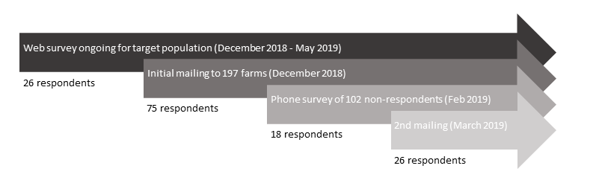

**Figure 1.** Flow chart of survey administration. Number of respondents over time using questionnaires administered on either web, first mailing, second mailing, or telephone call.

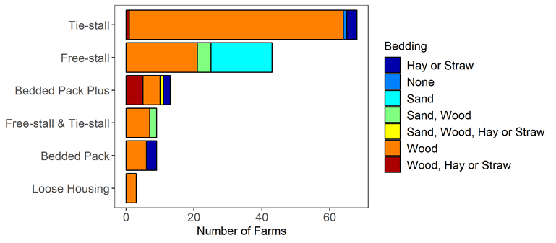

**Figure 2.** Number of farms within each housing strategy stratified by type of bedding material used. Each stacked bar represents a different housing strategy and color within bar represents the frequency of bedding material used within each strategy. Producers that reported using a bedded pack barn in combination with another housing type are grouped together (“Bedded Pack Plus”).

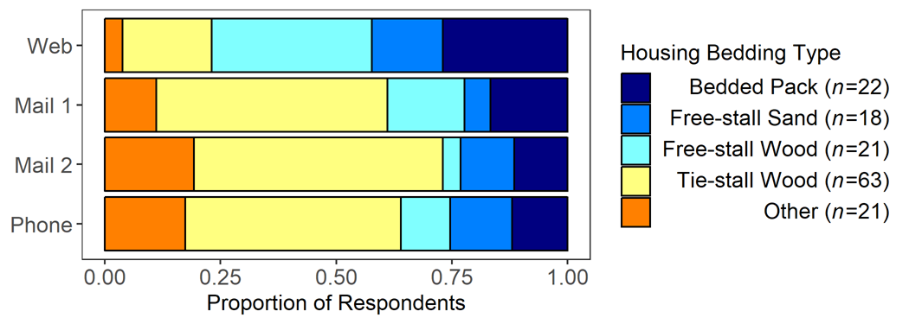

**Figure 3.** Proportion of farms using each housing/bedding type that responded to questionnaires by the method of administration. Bedded pack category includes all farms that reported using a bedded pack solely or in combination with another type of facility. Number (*n)* of respondents is shown adjacent to each category in the legend. “Other” category includes tiestalls not bedded with wood (*n* = 5), farms with both a freestall and a tiestall (*n* = 9), farms that used non-bedded pack loose housing (*n* = 3), and farms with freestalls with both sand and wood bedding (*n* =4).

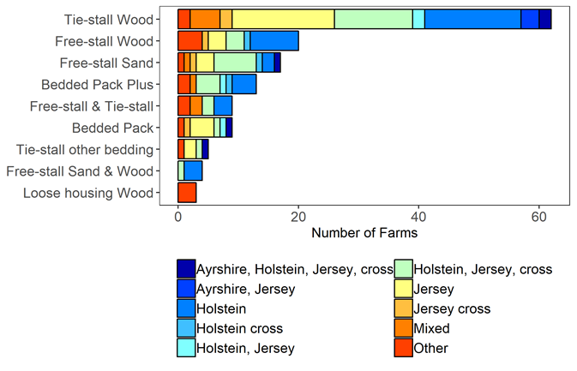

**Figure 4.** Dairy cattle breeds reported among categories of housing and bedding combinations. Each stacked bar represents a different combination of housing strategy and bedding material. The frequency of breed types reported by respondents (n=145) in each housing and bedding category are represented by the different colors within the bar. Only breeds that were used on more than two farms were included in the figure.

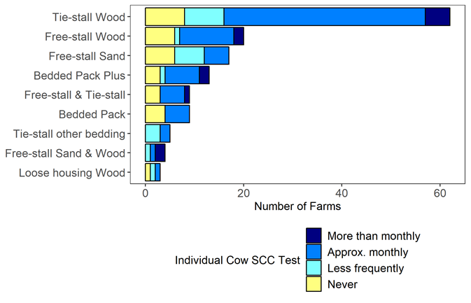

**Figure 5.** Somatic cell counts (SCC) of individual cows in each housing/bedding strategy. Each stacked bar represents a different combination of housing strategy and bedding material. Color within bar represents frequency of SCC determinations on individual cows (*n* = 145).

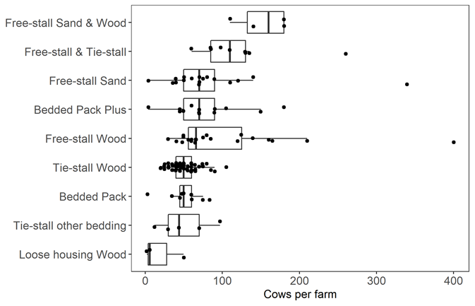

**Figure 6.** Number of cows varies among housing/bedding types. Illustrated is a box plot with the center line as median (*n* =145). Points represent individual farm herd size.

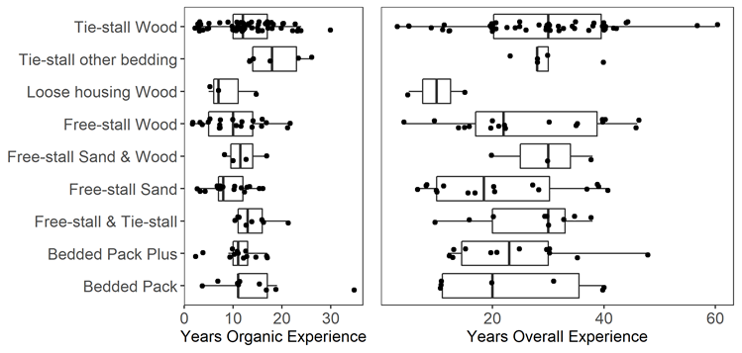

**Figure 7.** Distribution of management experience in each housing/bedding strategy. Illustrates is a box plot with a median center line for years of A) organic dairy experience, and b) total dairy experience (*n* = 145).

**Supplemental materials**

S1. Questionnaire



S2. Press Release

