* Applied summaries and recommendations useful to dairy industry
  + How is it useful to know what kind of bedding and housing is used by farms?
    - Useful to know frequency of people using bedded pack
    - How widely it’s been adopted
* Contribute to solutions of problems in dairy industry
  + Mastitis
  + Welfare/restrictive housing
  + Manure management
  + Integration of grazing/organic requirements to housing solutions
* Outreach techniques
  + Mailing/online availability/calling people

Intended for *Our Industry Today* section in *J Dairy Science*.

Style Guide: <https://www.elsevier.com/journals/journal-of-dairy-science/0022-0302/guide-for-authors>

**Vermont organic dairy bedding survey analysis**

Tucker Andrews**\***, Caitlin Jeffrey**†**, …Deb**\***, John**†**, Rachel‡

**\***Plant and Soil science, University of Vermont, Burlington 05405

**†**Animal and Veterinary Sciences, University of Vermont, Burlington 05405

**Interpretative summary**

**ABSTRACT**

**KEY WORDS**

**INTRODUCTION**

The future of housing systems for lactating dairy cattle is shifting toward improved cow comfort. Bedded pack loose housing systems are designed for cow comfort (Bewley et al. 2017). In loose-housing bedded-pack or composted bedded-pack systems there are fewer foot and leg injuries than free-stall barns (Burgstaller et al. 2016). There are also reports of decreased incidence of mastitis for dairy cows on compost bedded pack (Astiz et al. 2014). Bedding managed for low moisture and high temperature reduce counts of bacterial pathogens (*Staphylococci*, *Streptococci*, and *Bacilli* species) and improve herd hygiene (Eckelkamp et al 2016). Bedding is an important source of bacteria and fungi that can be transmitted to the teat and mammary gland (Eckelkamp et al. 2016), potentially changing the ability of these communities to resist dysbiosis. The indigenous microbiome may modulate the potential for opportunistic bacteria or fungi to become pathogenic, preventing infection.

*Not sure these statements entirely true, needs to be more nuanced*

*Do we even want to spend a ton of words on CBP interest/importance, or just focus on novelty of our survey?*

Based on our preliminary research, we discovered an apparent paradox of greater pathogen counts yet less disease on bedded packs suggests that organic dairy producers may benefit from integrating bedded-pack technologies into their farm systems (Andrews et al. 2019). Dairy producers are always under pressure to maximize profitability, improve market access and meet consumer demands. Furthermore, consumers are increasingly expressing interest and concern for animal welfare and animal housing.

There is limited knowledge on the distribution and types of bedding management styles on organic dairy farms nationally or in Vermont. Therefore, the goal of the survey was to obtain a quantitative industry-wide survey to quantify the bedding styles and materials of operating organic dairies in Vermont. A descriptive study (survey) designed to quantify the frequency of different housing types and bedding management styles on organic dairy farms in Vermont.

**MATERIALS AND METHODS**

There were eight questions in the questionnaire, plus a request for farm location and contact information. The questions in the on-line and mailed versions were identical and optional. Questions included: 1. Winter housing for lactating cows Multiple choice (Free-stall, Tie-stall, Bedded Pack, or Other specified in comments) 2. Winter bedding for lactating cows Multiple choice (Sand, Wood, Hay/Straw, or Other specified in comments) 3. Breed(s) of cow (open question) 4. Level of interest in the project (multiple choice) 5. Frequency of testing of individual cow somatic cell count, i.e. through DHIA Multiple choice (more than monthly, about monthly, every other month, less frequently, never) 6. Experience managing a dairy farm in years (open question) 7. Experience managing an organic dairy farm in years (open question) 8. Average number of lactating cows (open question) 9. Farm name, Farm location, and contact person, phone number, email address, preferred time to contact

First – established a press release (<https://www.morningagclips.com/uvm-seeks-input-from-organic-dairy-farmers/>)

Second- The survey was mailed to 197 Vermont producers of dairy milk listed in the 2017 USDA Organic Integrity Database. The database was updated in December of 2018, after the survey was mailed, to include only 177 farms. The questionnaire was mailed to all organic dairy farmers in Vermont and the mailing included postage paid pre-addressed return envelopes. The questionnaire was also available on-line from 12/7/18-5/1/2019. The on-line version was promoted through UVM web-sites and social media, as well as through regional industry publications.

Two months after the initial survey mailing, we conducted telephone interviews using the questionnaire for a subset of farms that did not respond to the first mailing, and we completed a second mailing to 83 farms that did not respond to the first mailing.

Statistical Analyses ….

**RESULTS AND DISCUSSION**

Of the 177 farms, 145 Vermont farms housing lactating cows responded (82% industry response). Four farms from outside of Vermont also responded but were not included in this analysis. This is the first industry-wide survey to quantify the frequency of bedding and housing management styles used on organic dairy farmers in Vermont.

***Bedding styles and materials***

Four major (n > xx) categories of housing/bedding styles were identified: tie-stall housing using wood product bedding, free-stall housing with wood products, free-stall housing bedded with sand, and bedded-pack housing. The most common housing type was tie-stall (47%) followed by free-stall (30%) (Fig 1). Most tie-stall producers used a wood-based bedding material, while free-stalls were split between sand and wood-based bedding. Bedded pack was a component of lactating cow housing on 15% of farms. Bedded pack was commonly used in conjunction with another housing strategy (Fig. 1). Ten farms reported using only a bedded pack for lactating cows. Most farms using a bedded pack bedded with wood, followed by hay or straw (Fig. 1). The remaining farms (8%) reported a mixed tie-stall and free-stall system or a loose housing system (n = 3).

Bedding and housing management practices on herds using bedded pack style housing were most variable. These “mixed” housing systems, where bedded packs are used in combination with another style are common. Clarifying the extent of these mixed or hybrid housing systems and the reasons for their use might be a direction for future study.

***Cattle Breeds***

Breed distribution was similar across all housing bedding types, although bedded pack and sand-bedded free-stall producers were more likely to use Jersey and Jersey crosses (Fig. 2). There were four primary breed types: herds that identified as 1) Holstein only 2) Jersey only 3) mixed Holstein and Jersey herds with crosses, or 4) mixed Jersey and Holstein herds with one or more additional breeds.

***Frequency of Individual Cow Testing***

Most (77%) producers reported an approximately monthly or more frequent test of SCC for individual cows. Sand-bedded free-stall producers were half as likely to test approximately monthly. A review of the answers given (including comments) suggests to us there may be some confusion among farmers interpreting whether or not they participate in DHIA SCC testing. Prior experience suggests some farmers might confuse bulk tank SCC testing provided by their milk cooperatives, the ability to submit individual cow samples for SCC testing through their milk cooperative, and subscriptions to DHIA testing services. Such confusion might explain the some of the variation observed in answers provided to this question.

Maybe even not include this as people seemed so confused about it

***Herd size***

The median herd size among all dairies was 59.5 cows (Fig 4). Producers using free-stall barns and producers using multiple housing systems housed more cows than producers using tie-stall barns (*p $≤$* 0.08). Despite this difference, the majority of producers using free-stall had a similar herd size to all other housing strategies.

There a way to show this statistically?

***Years of dairy farming experience***

There was wide variation in experience in all housing bedding categories (Fig. 5). Years of overall management experience and organic experience were similar among housing bedding strategies, despite a narrower band of organic experience. There was no difference in years of experience (overall or organic) between housing/bedding strategy (p > 0.05). However, producers that used free-stall bedded with sand tended to have less experience, while producers using tie-stall bedding with wood tended to have the most experience.

Actually put in mean years experience here with p values?

**CONCLUSIONS**

These survey results provide insight into the potential study design and pitfalls of different sample collection procedures for the future observational analytical study.

What are the research priorities: runoff management, role of GI tract

* There is a critical need to define the ecological relationships of bedding, teat skin, and mammary microbiota and assess their association with mastitis resistance.
* address an environmentally friendly method of managing manure as a solid rather than as a liquid

Next steps

* empirically evaluate relationships between bedding microbiomes and their impact on animal health and milk yield

**REFERENCES**

Andrews, T., D. A. Neher, T. R. Weicht, , and J. W. Barlow. 2019. Mammary microbiome of lactating organic dairy cows varies by time, tissue site, and infection status. PloS ONE (PONE-D-19-08116).

Astiz, S., F. Sebastian, O. Fargas, M. Fernandez, and E. Calvet. 2014. Enhanced udder health and milk yield of dairy cattle on compost bedding systems during the dry period: A comparative study. Livest. Sci. 159:161-164.

Bewley, J. M., L. M. Robertson, and E. A. Eckelkamp. 2017. A 100-year review: Lactating dairy cattle housing management. J. Dairy Sci. 100:10418-10431.

Burgstaller, J., J. Raith, S. Kuchling, V. Mandl, A. Hund, and J. Kofler. 2016. Claw health and prevalence of lameness in cows from compost bedded and cubicle freestall dairy barns in Austria. Vet J 216:81-86.

Eckelkamp, E. A., J. L. Taraba, K. A. Akers, R. J. Harmon, and J. M. Bewley. 2016. Understanding compost bedded pack barns: Interactions among environmental factors, bedding characteristics, and udder health. Livest. Sci. 190:35-42.

**ACKNOWLEDGEMENTS**

We thank Jennifer Colby and Juan Alvez for assistance with identifying organic herd mailing lists and developing the questionnaire and promoting the survey through mailing lists. We also thank Rachel Gilker for assistance with administering the survey by telephone with a selected group of producers, and Colene Reed for administrative support.

FIGURE LEGENDS

Figure 1: Number of farms with each housing strategy. Each stacked bar represents a different combination of housing strategy and color within bar represents the bedding material (define colors….). Bedded pack was commonly used in conjunction with another housing strategy ( “Bedded pack, Other”)

Figure 2 : Dairy cattle breeds by housing bedding strategy. Each stacked bar represents a different combination of housing strategy and bedding material. Color within bar represents the farms with breeds on that housing strategy and bedding material (total N = 145). Only breeds that were used on more than 2 farms were included in the figure.

Figure 3 : Somatic cell counts (SCC) of individual cows in each housing/bedding strategy. Each stacked bar represents a different combination of housing strategy and bedding material. Color within bar represents frequency of SCC determinations on individual cows (total N = 145).

Figure 4: Number of cows varies among housing/bedding types. Illustrated is a box plot with the center line as median (N =145). Points represent individual farm herd size.

Figure 5: Distribution of management experience in each housing/bedding strategy. Illustrates is a box plot with a median center line for years of A) organic dairy experience, and b) total dairy experience (total N = 145).

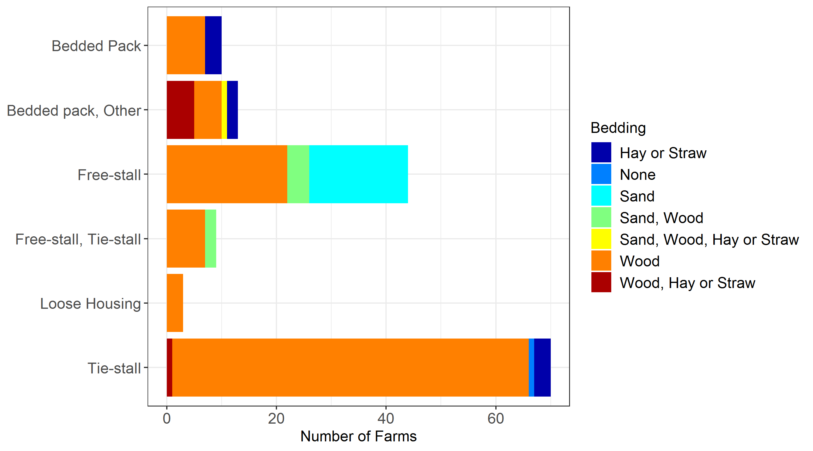

Andrews, Figure 1

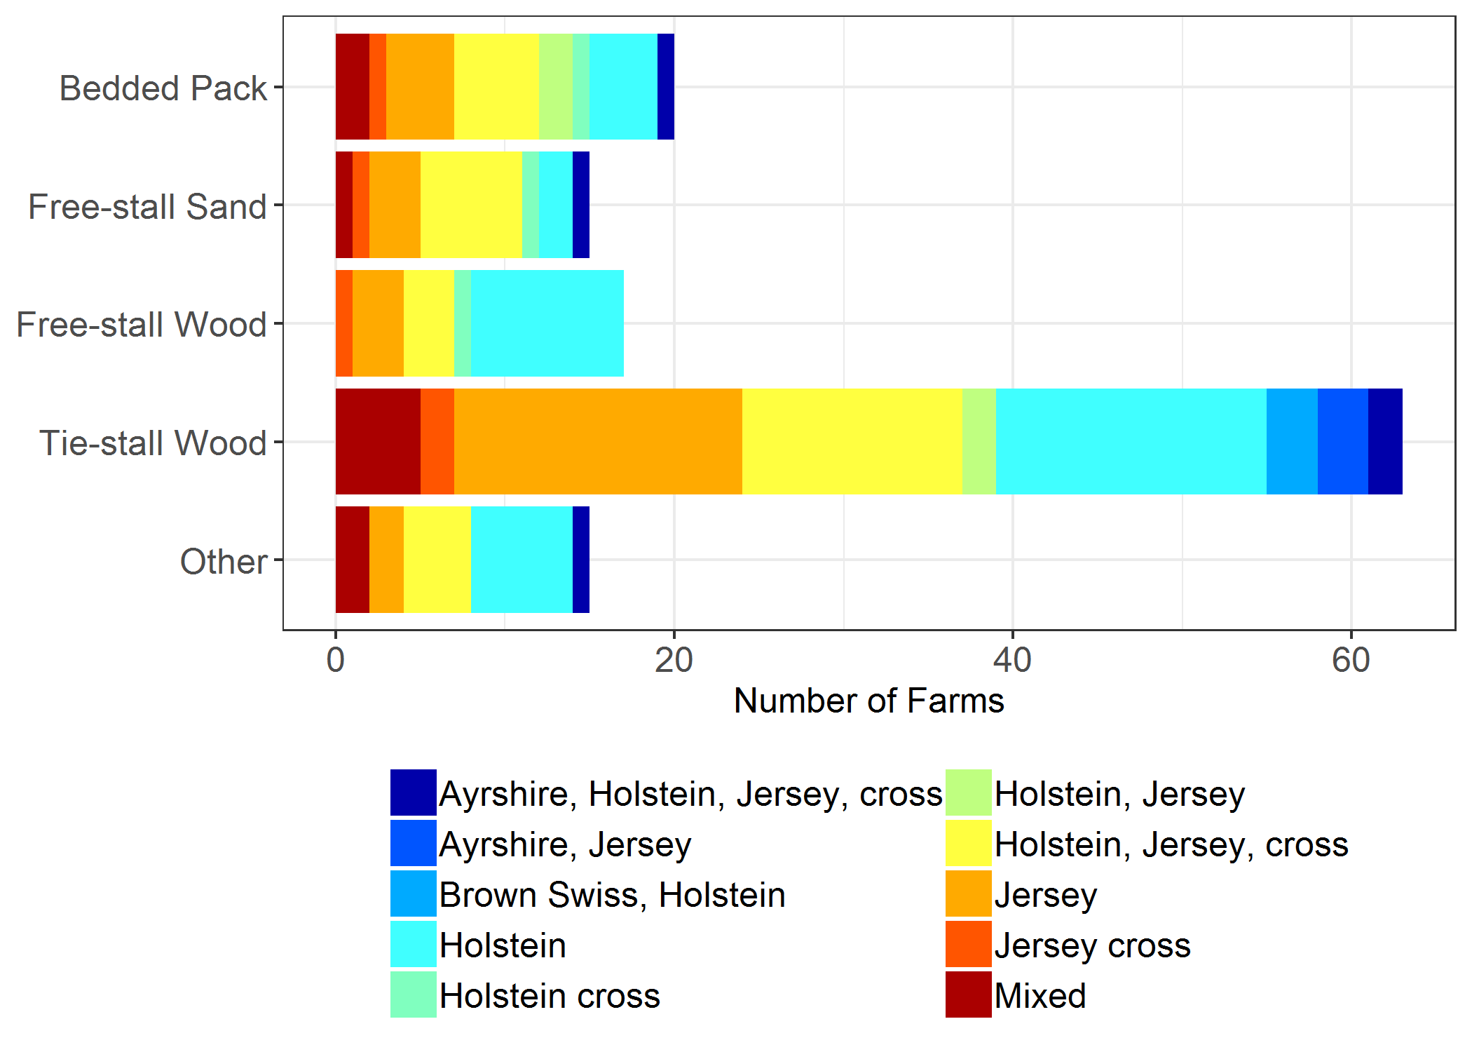

Andrews, Figure 2What does mixed even mean?

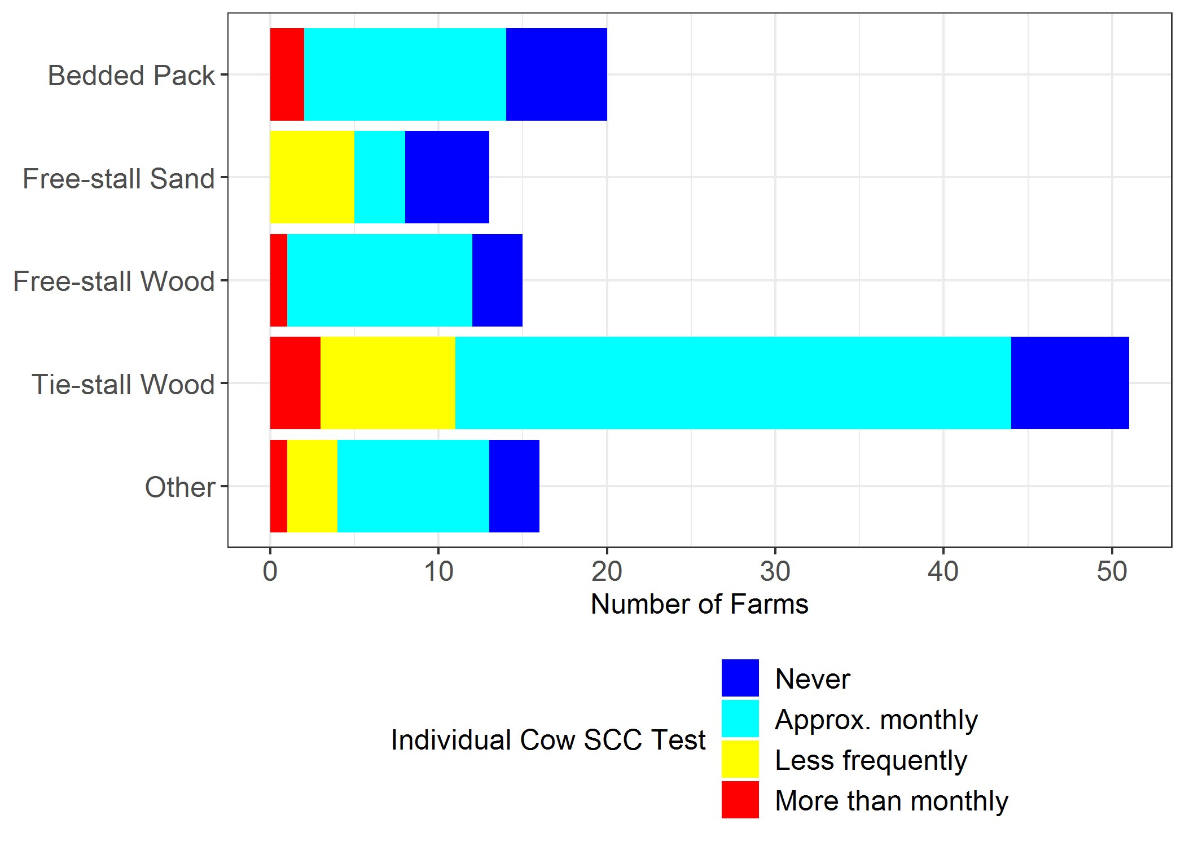

Andrews, Figure 3

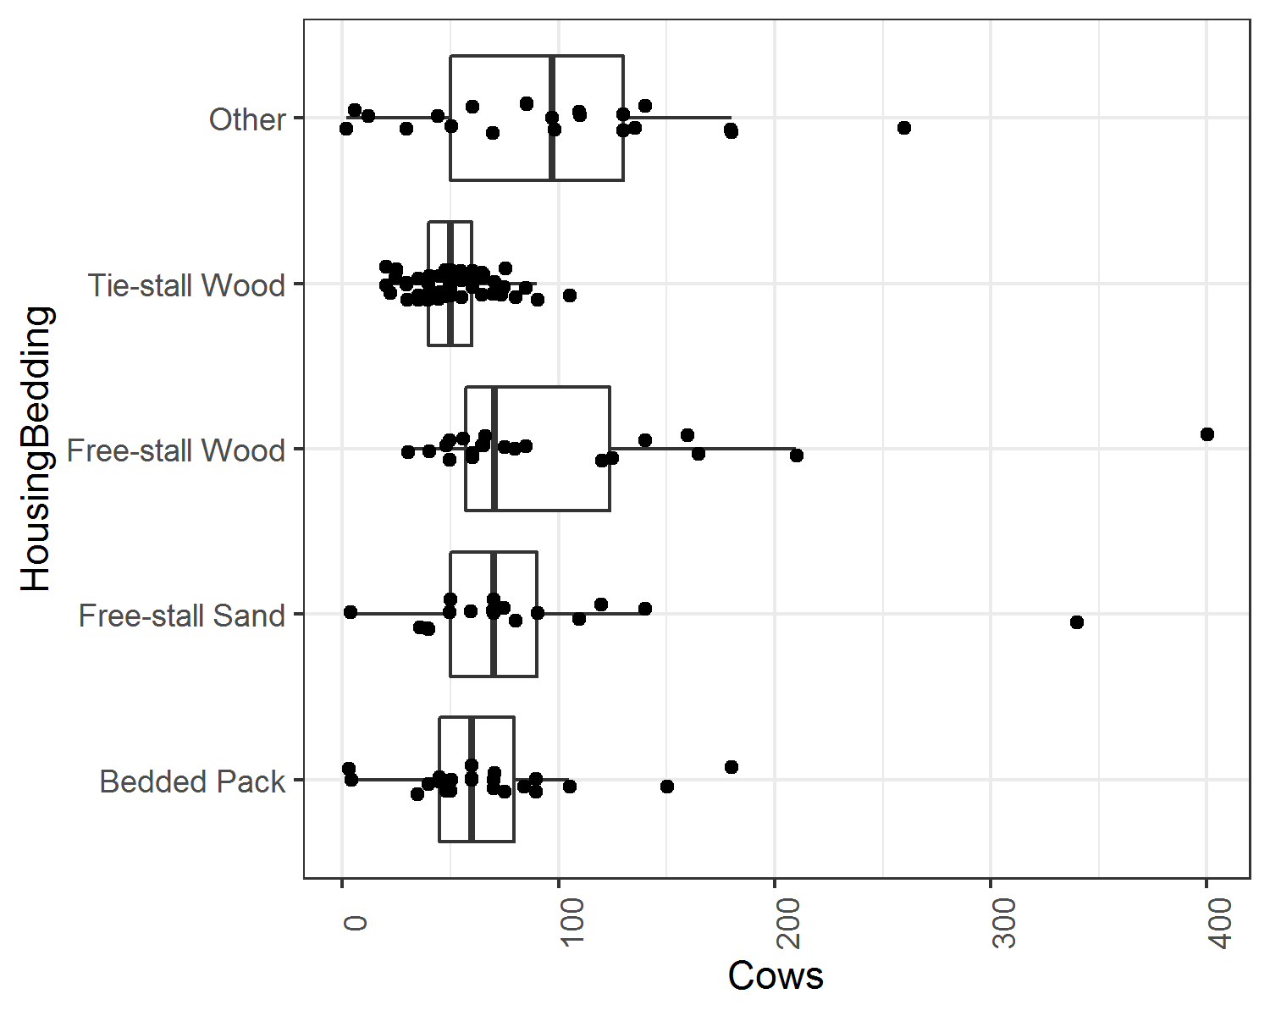

Andrews, Figure 4

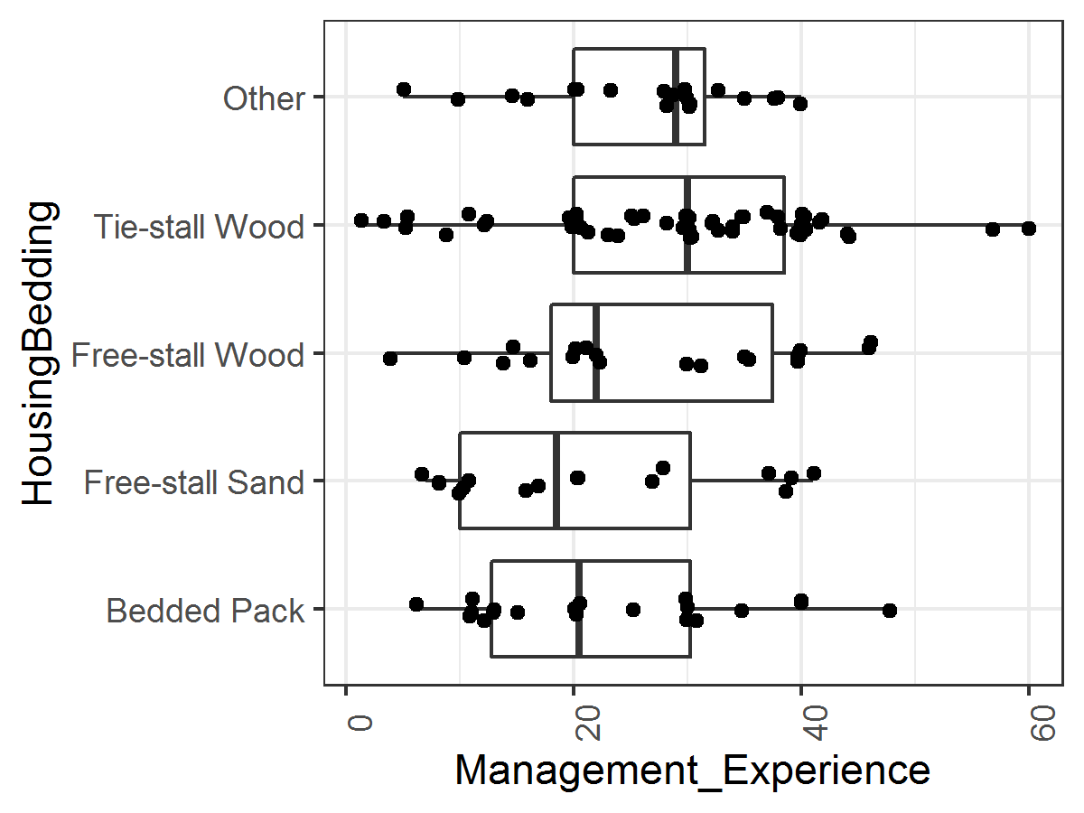

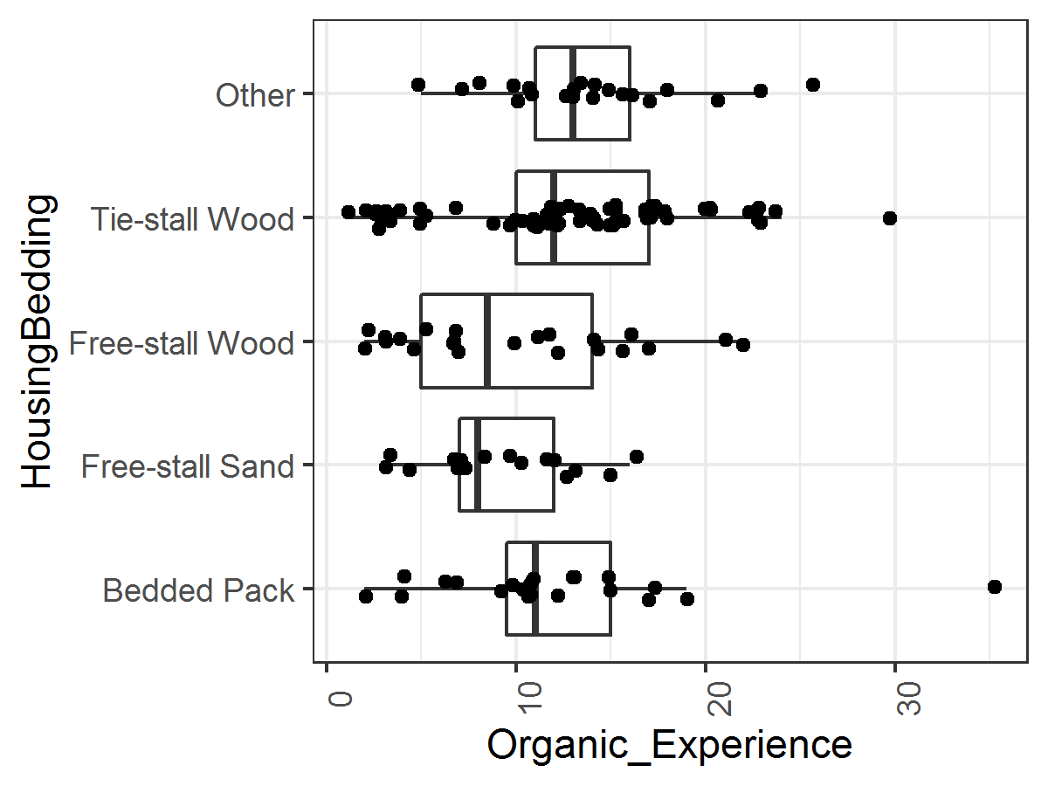

Andrews, Figure 5