STI Ormoc Smart Library
System Design Models
User and Admin Feature Flows
All diagrams are drawn top-to-bottom (vertical) for manuscript layout. They reflect the implemented React web portals and Node.js API modules. Figure 8 uses the Operations / Resources / People section layout.

1. Design Model Figures

Figure 1. Overall System Design Model (Users and Admin)
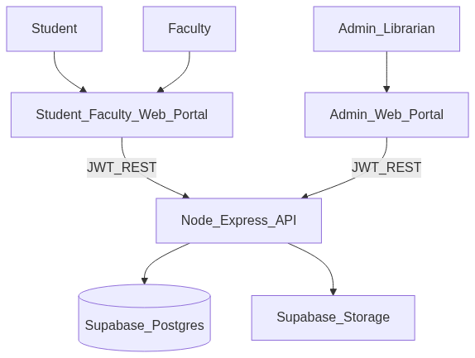
Figure 1. Overall System Design Model (Users and Admin)
Mermaid source (vertical / flowchart TB):
flowchart TB
Student[Student]
Faculty[Faculty]
Admin[Admin_Librarian]
UserPortal[Student_Faculty_Web_Portal]
AdminPortal[Admin_Web_Portal]
API[Node_Express_API]
DB[(Supabase_Postgres)]
Storage[Supabase_Storage]
Student --> UserPortal
Faculty --> UserPortal
Admin --> AdminPortal
UserPortal -->|JWT_REST| API
AdminPortal -->|JWT_REST| API
API --> DB
API --> Storage

Figure 2. User Features Design Model (Student and Faculty)
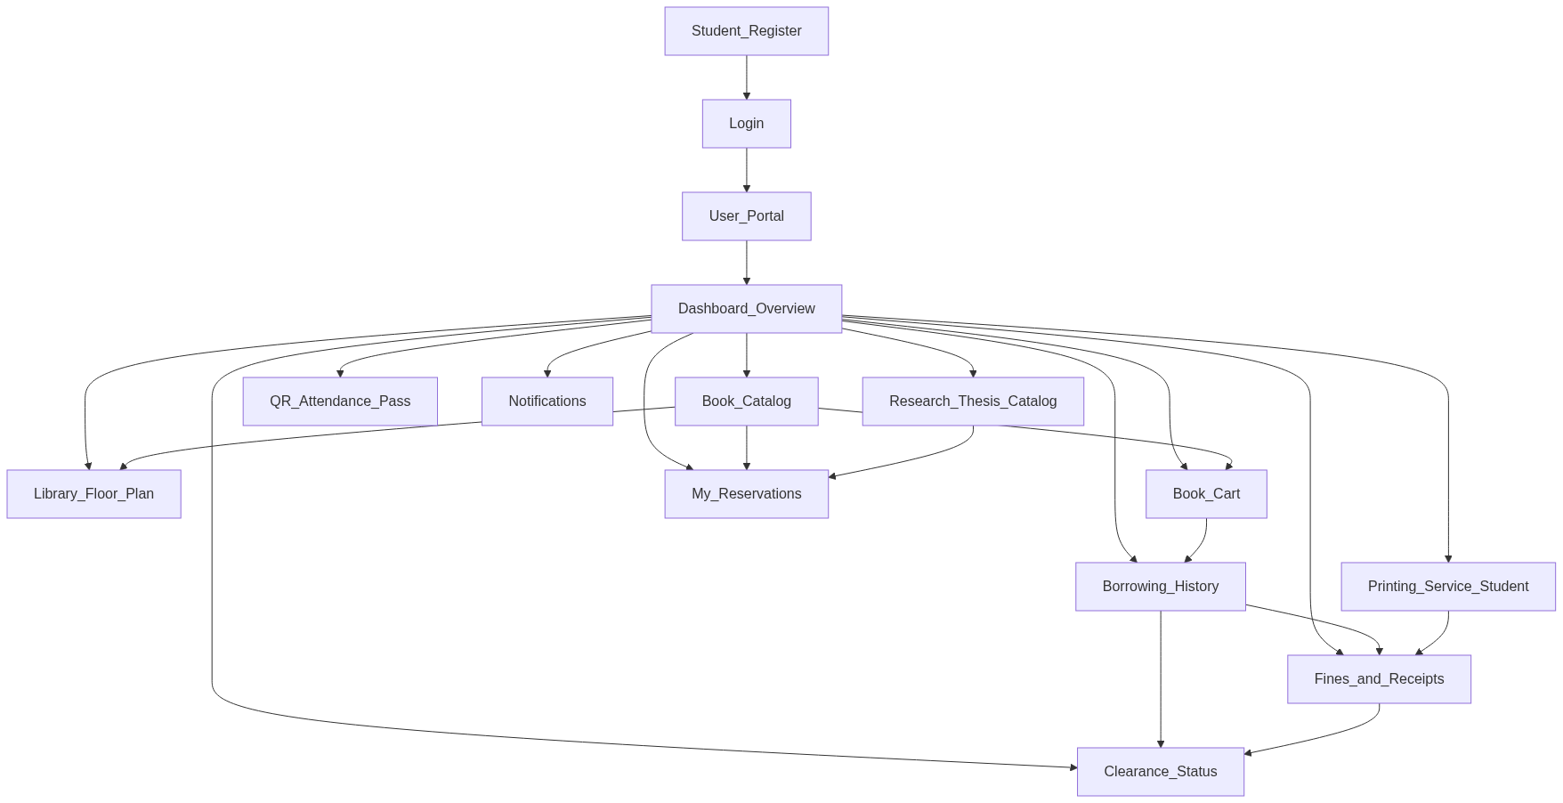
Figure 2. User Features Design Model (Student and Faculty)
Mermaid source (vertical / flowchart TB):
flowchart TB
ULogin[Login]
UReg[Student_Register]
UPortal[User_Portal]
UDash[Dashboard_Overview]
UCat[Book_Catalog]
UFloor[Library_Floor_Plan]
UCart[Book_Cart]
UResearch[Research_Thesis_Catalog]
UHist[Borrowing_History]
URes[My_Reservations]
UPrint[Printing_Service_Student]
UQR[QR_Attendance_Pass]
UNotif[Notifications]
UFine[Fines_and_Receipts]
UClear[Clearance_Status]
ULogin --> UPortal
UReg --> ULogin
UPortal --> UDash
UDash --> UCat
UDash --> UFloor
UDash --> UCart
UDash --> UResearch
UDash --> UHist
UDash --> URes
UDash --> UPrint
UDash --> UQR
UDash --> UNotif
UDash --> UFine
UDash --> UClear
UCat --> UCart
UCat --> UFloor
UCart --> UHist
UCat --> URes
UResearch --> URes
UHist --> UFine
UHist --> UClear
UPrint --> UFine
UFine --> UClear

Figure 3. User Borrowing Process Design Model
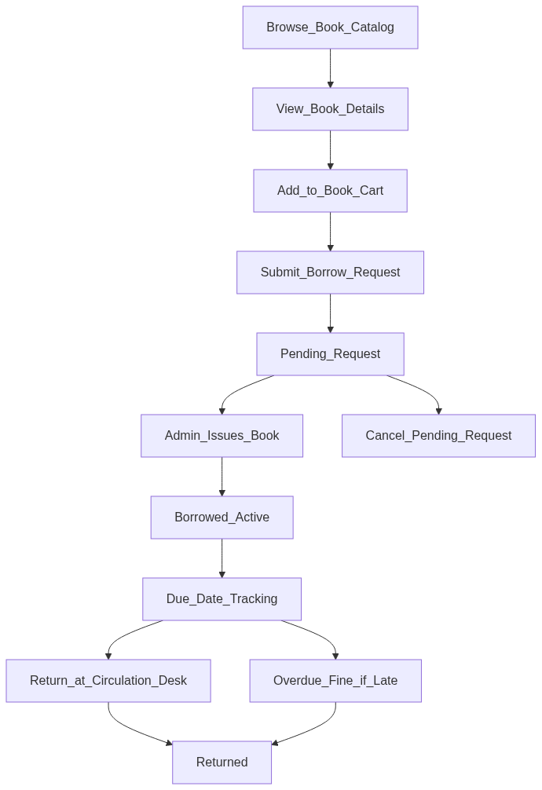
Figure 3. User Borrowing Process Design Model
Mermaid source (vertical / flowchart TB):
flowchart TB
B1[Browse_Book_Catalog]
B2[View_Book_Details]
B3[Add_to_Book_Cart]
B4[Submit_Borrow_Request]
B5[Pending_Request]
B6[Admin_Issues_Book]
B7[Borrowed_Active]
B8[Due_Date_Tracking]
B9[Return_at_Circulation_Desk]
B10[Returned]
B11[Overdue_Fine_if_Late]
B12[Cancel_Pending_Request]
B1 --> B2
B2 --> B3
B3 --> B4
B4 --> B5
B5 --> B6
B5 --> B12
B6 --> B7
B7 --> B8
B8 --> B9
B9 --> B10
B8 --> B11
B11 --> B10

Figure 4. User Reservation Process Design Model
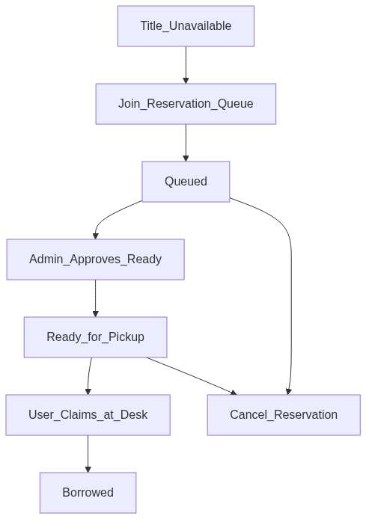
Figure 4. User Reservation Process Design Model
Mermaid source (vertical / flowchart TB):
flowchart TB
R1[Title_Unavailable]
R2[Join_Reservation_Queue]
R3[Queued]
R4[Admin_Approves_Ready]
R5[Ready_for_Pickup]
R6[User_Claims_at_Desk]
R7[Borrowed]
R8[Cancel_Reservation]
R1 --> R2
R2 --> R3
R3 --> R4
R3 --> R8
R4 --> R5
R5 --> R6
R6 --> R7
R5 --> R8

Figure 5. User QR Attendance Process Design Model
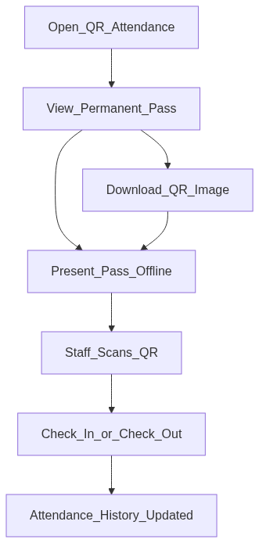
Figure 5. User QR Attendance Process Design Model
Mermaid source (vertical / flowchart TB):
flowchart TB
A1[Open_QR_Attendance]
A2[View_Permanent_Pass]
A3[Download_QR_Image]
A4[Present_Pass_Offline]
A5[Staff_Scans_QR]
A6[Check_In_or_Check_Out]
A7[Attendance_History_Updated]
A1 --> A2
A2 --> A3
A2 --> A4
A3 --> A4
A4 --> A5
A5 --> A6
A6 --> A7

Figure 6. User Printing Process Design Model (Student)
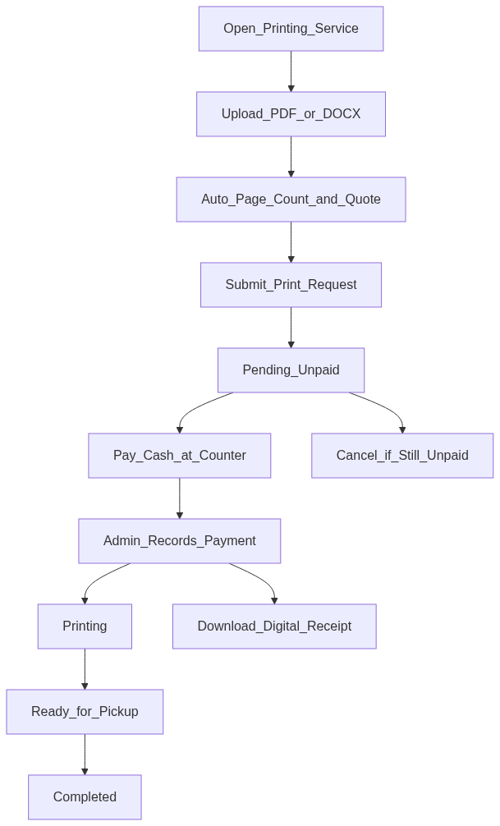
Figure 6. User Printing Process Design Model (Student)
Mermaid source (vertical / flowchart TB):
flowchart TB
P1[Open_Printing_Service]
P2[Upload_PDF_or_DOCX]
P3[Auto_Page_Count_and_Quote]
P4[Submit_Print_Request]
P5[Pending_Unpaid]
P6[Pay_Cash_at_Counter]
P7[Admin_Records_Payment]
P8[Printing]
P9[Ready_for_Pickup]
P10[Completed]
P11[Download_Digital_Receipt]
P12[Cancel_if_Still_Unpaid]
P1 --> P2
P2 --> P3
P3 --> P4
P4 --> P5
P5 --> P6
P5 --> P12
P6 --> P7
P7 --> P8
P8 --> P9
P9 --> P10
P7 --> P11

Figure 7. User Account Support Design Model
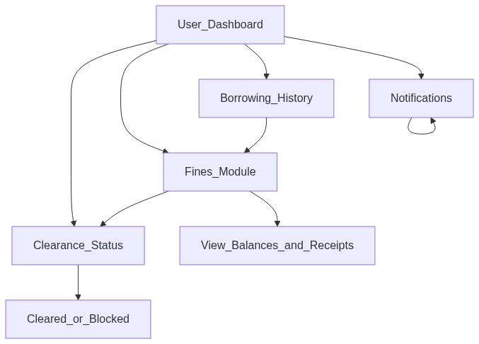
Figure 7. User Account Support Design Model
Mermaid source (vertical / flowchart TB):
flowchart TB
S1[User_Dashboard]
S2[Borrowing_History]
S3[Notifications]
S4[Fines_Module]
S5[Clearance_Status]
S6[View_Balances_and_Receipts]
S7[Cleared_or_Blocked]
S1 --> S2
S1 --> S3
S1 --> S4
S1 --> S5
S2 --> S4
S4 --> S6
S4 --> S5
S5 --> S7
S3 --> S3

Figure 8. Admin Features Design Model
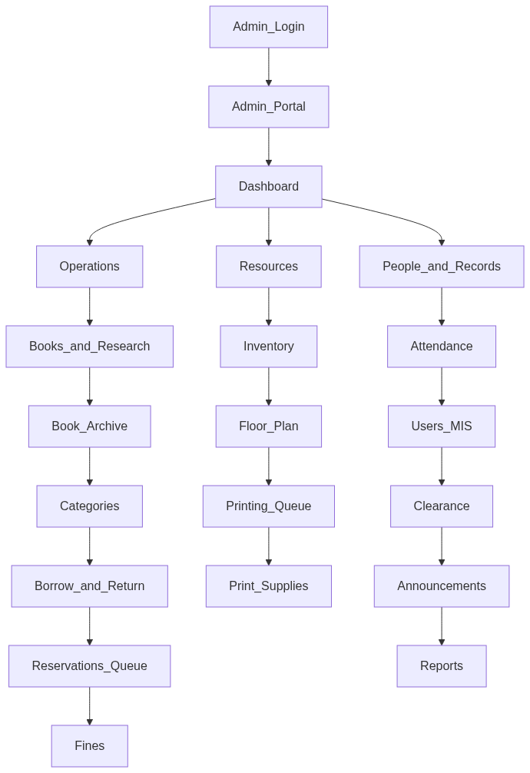
Figure 8. Admin Features Design Model
Mermaid source (vertical / flowchart TB):
flowchart TB
AdminLogin[Admin_Login]
AdminPortal[Admin_Portal]
ADash[Dashboard]
Ops[Operations]
Res[Resources]
People[People_and_Records]
ACat[Books_and_Research]
AArch[Book_Archive]
ACatg[Categories]
ACirc[Borrow_and_Return]
AResQ[Reservations_Queue]
AFines[Fines]
AInv[Inventory]
AFloor[Floor_Plan]
APrintQ[Printing_Queue]
ASupp[Print_Supplies]
AAtt[Attendance]
AUsers[Users_MIS]
AClear[Clearance]
AAnn[Announcements]
ARep[Reports]
AdminLogin --> AdminPortal
AdminPortal --> ADash
ADash --> Ops
ADash --> Res
ADash --> People
Ops --> ACat
ACat --> AArch
AArch --> ACatg
ACatg --> ACirc
ACirc --> AResQ
AResQ --> AFines
Res --> AInv
AInv --> AFloor
AFloor --> APrintQ
APrintQ --> ASupp
People --> AAtt
AAtt --> AUsers
AUsers --> AClear
AClear --> AAnn
AAnn --> ARep

Figure 9. Admin Circulation Design Model
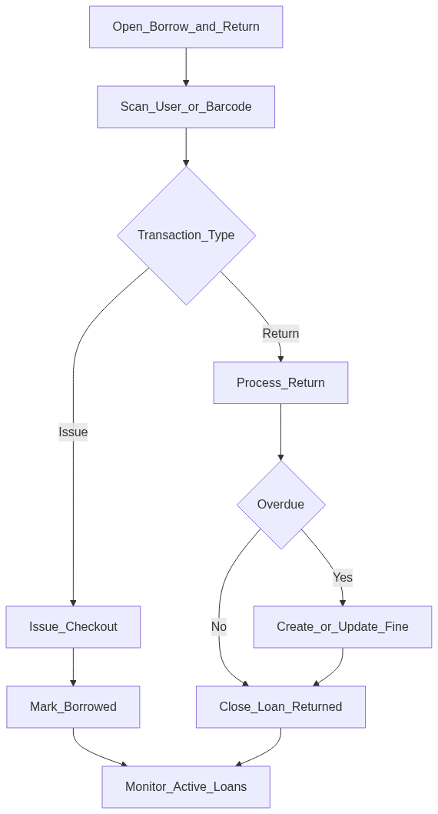
Figure 9. Admin Circulation Design Model
Mermaid source (vertical / flowchart TB):
flowchart TB
C1[Open_Borrow_and_Return]
C2[Scan_User_or_Barcode]
C3{Transaction_Type}
C4[Issue_Checkout]
C5[Mark_Borrowed]
C6[Process_Return]
C7{Overdue}
C8[Create_or_Update_Fine]
C9[Close_Loan_Returned]
C10[Monitor_Active_Loans]
C1 --> C2
C2 --> C3
C3 -->|Issue| C4
C4 --> C5
C3 -->|Return| C6
C6 --> C7
C7 -->|Yes| C8
C7 -->|No| C9
C8 --> C9
C5 --> C10
C9 --> C10

Figure 10. Admin Catalog and Inventory Design Model
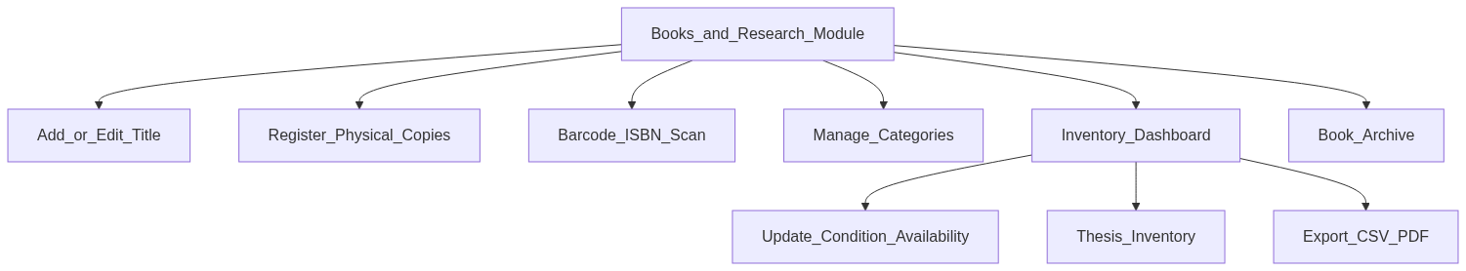
Figure 10. Admin Catalog and Inventory Design Model
Mermaid source (vertical / flowchart TB):
flowchart TB
I1[Books_and_Research_Module]
I2[Add_or_Edit_Title]
I3[Register_Physical_Copies]
I4[Barcode_ISBN_Scan]
I5[Manage_Categories]
I6[Inventory_Dashboard]
I7[Update_Condition_Availability]
I8[Thesis_Inventory]
I9[Export_CSV_PDF]
I10[Book_Archive]
I1 --> I2
I1 --> I3
I1 --> I4
I1 --> I5
I1 --> I6
I6 --> I7
I6 --> I8
I6 --> I9
I1 --> I10

Figure 11. Admin Printing and Supplies Design Model
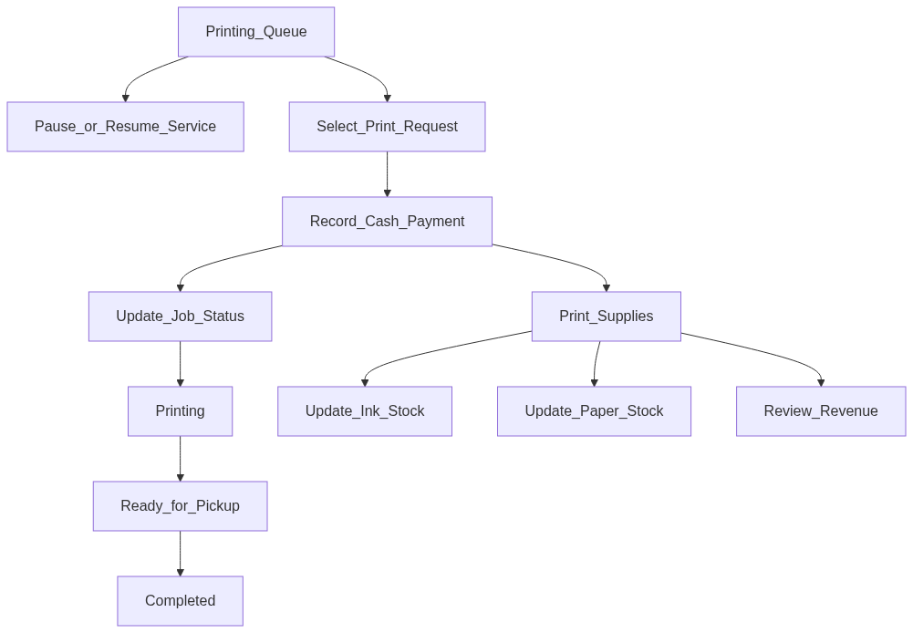
Figure 11. Admin Printing and Supplies Design Model
Mermaid source (vertical / flowchart TB):
flowchart TB
Pr1[Printing_Queue]
Pr2[Pause_or_Resume_Service]
Pr3[Select_Print_Request]
Pr4[Record_Cash_Payment]
Pr5[Update_Job_Status]
Pr6[Printing]
Pr7[Ready_for_Pickup]
Pr8[Completed]
Pr9[Print_Supplies]
Pr10[Update_Ink_Stock]
Pr11[Update_Paper_Stock]
Pr12[Review_Revenue]
Pr1 --> Pr2
Pr1 --> Pr3
Pr3 --> Pr4
Pr4 --> Pr5
Pr5 --> Pr6
Pr6 --> Pr7
Pr7 --> Pr8
Pr4 --> Pr9
Pr9 --> Pr10
Pr9 --> Pr11
Pr9 --> Pr12

Figure 12. Admin People and Records Design Model
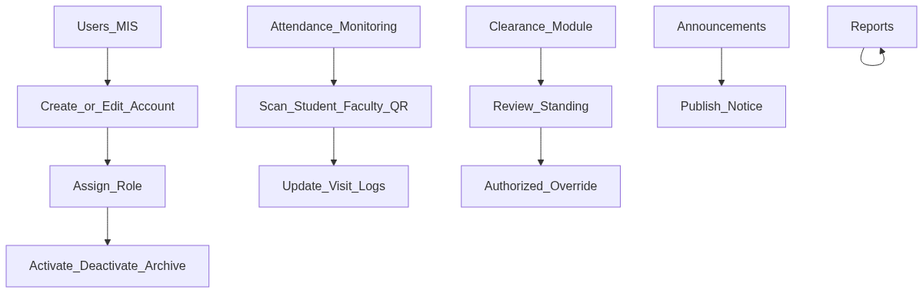
Figure 12. Admin People and Records Design Model
Mermaid source (vertical / flowchart TB):
flowchart TB
P1[Users_MIS]
P2[Create_or_Edit_Account]
P3[Assign_Role]
P4[Activate_Deactivate_Archive]
P5[Attendance_Monitoring]
P6[Scan_Student_Faculty_QR]
P7[Update_Visit_Logs]
P8[Clearance_Module]
P9[Review_Standing]
P10[Authorized_Override]
P11[Announcements]
P12[Publish_Notice]
P13[Reports]
P1 --> P2
P2 --> P3
P3 --> P4
P5 --> P6
P6 --> P7
P8 --> P9
P9 --> P10
P11 --> P12
P13 --> P13

Figure 13. User and Admin Feature Interaction Design Model
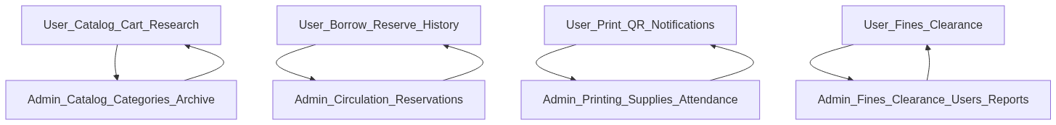
Figure 13. User and Admin Feature Interaction Design Model
Mermaid source (vertical / flowchart TB):
flowchart TB
UCat[User_Catalog_Cart_Research]
UBorrow[User_Borrow_Reserve_History]
UPrint[User_Print_QR_Notifications]
UAcct[User_Fines_Clearance]
ACat[Admin_Catalog_Categories_Archive]
ACirc[Admin_Circulation_Reservations]
AOps[Admin_Printing_Supplies_Attendance]
ARec[Admin_Fines_Clearance_Users_Reports]
UCat --> ACat
ACat --> UCat
UBorrow --> ACirc
ACirc --> UBorrow
UPrint --> AOps
AOps --> UPrint
UAcct --> ARec
ARec --> UAcct

2. Scope Notes
- User portal covers Student and Faculty. Printing Service is Student-only in the current build.
- Admin portal covers Librarian/System Administrator operational modules.
- Returning is performed at the admin circulation desk; users track status in Borrowing History.
- Diagrams align with Flowcharts.docx proposed processes and the implemented routes in apps/web.

