

SeedRover Web Portal
Software Testing, Validation, and Playwright Automation Report
Web Administration Portal | Formal browser testing | TypeScript + Playwright

Submission Information | Details
Institution / Department | [Enter institution and department]
Course / Section | [Enter course and section]
Team Members | [Enter team member names]
Instructor | [Enter instructor name]
Submission Date | [Enter submission date]
Test Cycle | 20261005T153119448-21704

Formal run | Result
Playwright regression | 50 passed | 0 failed | 2 blocked
Executed-case pass rate | 100.0%
Automated scenarios | 52 of 52 in-scope cases
Prepared for academic review. Names, signatures, and approvals remain editable.

Contents
Section | Contents
1. Document Information | Project identity and run overview
2. Objective | Purpose and test goals
3. Scope | Included and excluded web testing
4. Test Environment | Browser, application, database, and data controls
5. Automation Framework Details | Playwright stack and implementation
6. Entry Criteria | Conditions before execution
7. Exit Criteria | Completion and acceptance conditions
8. Automation Test Scenarios | Scenario catalogue
9. Automated Test Cases | Detailed Playwright cases and evidence
10. Test Data Management | Fixture isolation and cleanup
11. Defect Tracking | Observed defects, blockers, and assertion limits
12. Test Execution Summary | Actual results and run history
13. Automation Coverage | Coverage by module
14. Risks and Assumptions | Known constraints
15. Reporting and Dashboard | Reports and metrics
16. CI/CD Integration Checklist | Pipeline status
17. Test Sign-Off | Reviewer decision and signatures

1. Document Information
Field | Details
Project Name | SeedRover
Application Name | SeedRover Web Admin Portal
Version | Current repository build; commit 681d7b9c93682136b153ce9f3c4e95990c3855c8
Test Cycle | Formal browser regression 20261005T153119448-21704
Prepared By | [Enter team member names]
Reviewed By | [Enter reviewer]
Date | [Enter submission date]
Automation Framework | Playwright Test with TypeScript
Test Environment | Local web portal; existing development/demo Supabase project; Chromium

Report Overview
This report presents the SeedRover Web Admin testing effort using the supplied template’s section topics as its structure. Its scope is limited to the 52 automated Playwright cases in the formal regression. The report distinguishes automated execution results from execution and automation coverage.
The formal regression (20261005T153119448-21704) ran 52 browser cases: 50 passed, none failed, and two were blocked by current test conditions. Its pass rate among executed cases is 100%. A separate one-test Playwright terminal check also passed and is presented as supplementary proof, not added to the formal run totals.

2. Objective

Purpose
Validate SeedRover Web Admin authentication, role-based workflows, business rules, saved records, and browser-visible reports using repeatable Playwright tests. Results in this document are limited to the named runs and their recorded evidence.

Testing Objectives
- Confirm important user workflows through the visible web interface.
- Check business rules and validation at representative normal, boundary, and invalid inputs.
- Verify saved outcomes after navigation or reload when the automated case reads back persisted state.
- Check role-specific navigation and actions while stating whether the assertion covers the interface or a persisted/server-side outcome.
- Preserve repeatable evidence through Playwright reports, run manifests, and selected screenshots.

3. Scope

In Scope
- Login and Authentication
- User Management
- Dashboard Functions
- Order Processing
- Reports Generation
- API Validation

Out of Scope
- Performance Testing
- Penetration Testing
- Third-Party Vendor Systems
Coverage applies to the web portal. Physical rover operation and the native Flutter application are outside this test cycle.
Table 1. Web portal scope and representative validation areas.
Coverage area | Representative web checks
Authentication and roles | Login/logout, protected pages, role landing pages and restricted controls
Business records | Inventory, stock movement, sales, customers, crops, care and user management
Reporting and monitoring | Dashboard filters, CSV/print views, activity, notifications and read-only rover display
Quality characteristics | Input validation, persistence, basic usability, browser behavior and authorization boundaries

4. Test Environment
Table 2. Browser and application environment used for the formal test cycle.
Environment | Details
Environment | Local development/demo web test environment
Application URL | http://127.0.0.1:3100
Database | Existing development/demo Supabase project; no database reset
Browser | Chromium; Playwright 1.63.0
Mobile Device | Not used
Operating System | Windows
API Endpoint | Supabase-backed application actions; secrets and endpoint credentials omitted
Build Version | SeedRover web-admin commit 681d7b9c93682136b153ce9f3c4e95990c3855c8; Node v22.23.3
Formal run started 2026-10-05T15:31:19.449Z. The formal run used one worker and zero retries. A later smoke rerun stopped during setup after a Supabase fetch error, before any case executed; it is excluded from the reported metrics.

Environment and Data Controls
- The existing development/demo Supabase project was used; the runner did not reset or rebuild it.
- AUTOTEST-labelled records and exact record IDs were written to run manifests; unrelated demo rows were not selected for cleanup.
- One worker and serialized runs reduce collisions. Audit/history rows may remain after transactional fixtures are cleaned up.
- Credentials, session tokens, and secret environment values are omitted from the report and evidence registers.

5. Automation Framework Details

Framework Type
- ☐ Data Driven
- ☐ Keyword Driven
- ☒ Hybrid Framework
- ☐ BDD Framework
- ☐ Model-Based Testing

Technology Stack
Table 3. Automation tools and report outputs.
Component | Tool
Test Automation | Playwright Test
Mobile Automation | Not used
API Automation | Playwright request context for selected checks
Programming Language | TypeScript
Build Tool | npm
Reporting | Playwright HTML and JSON reports
CI/CD | GitHub Actions workflow; manually triggered
Source Control | Git

Browser Test Workflow
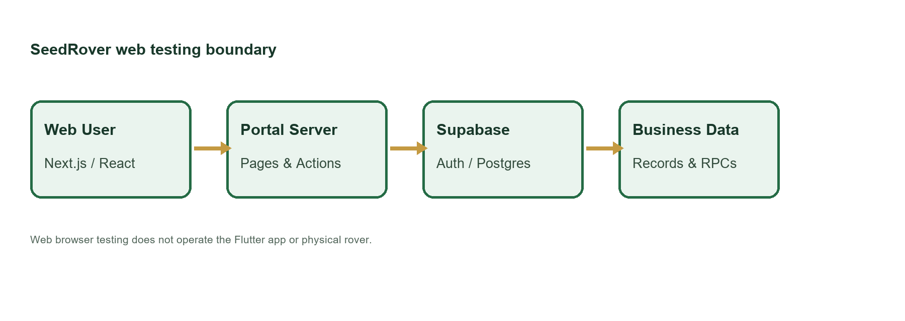
Figure 1. Web test boundary from the local browser portal to the existing Supabase-backed service; native and physical rover operation are outside this cycle.
The Playwright project starts the local web server, launches Desktop Chrome at a 1440 × 1000 viewport, applies Asia/Manila time, and stores HTML and JSON results under the unique run directory. Authentication and fixture helpers support the module tests; screenshot-on-failure and retained traces support diagnosis.
npm run test:e2e:preflight
npm run test:e2e:smoke
npm run test:e2e
Commands used to verify the environment, run the smoke subset, and execute the formal suite.

6. Entry Criteria
The following conditions must be met before automation execution:
- Stable test environment available — met for the formal run; the later setup-only network failure is separately recorded.
- Test data prepared — dedicated synthetic records were prepared and tracked by run.
- User stories completed — project requirement completion was not independently assessed in this test report.
- Test cases approved — report review/sign-off remains pending.
- Test scripts developed and reviewed — scripts ran in the recorded formal regression; review approval is not asserted.
- Build deployed successfully — local web build was available for the recorded browser run.

7. Exit Criteria
Automation testing may be considered complete when:
- All critical test cases executed — 50 cases reached a pass/fail result; two automated cases were blocked.
- No Sev-1 or Sev-2 defects open — no such open issue appears in the supplied defect register.
- Automation pass rate ≥ 95% — 50 passed and 0 failed among 50 executed cases (100.0%).
- Defect retesting completed — the focused stock-rejection retest passed; remaining blocked scenarios are disclosed.
- Final test report approved — pending reviewer sign-off.

8. Automation Test Scenarios
The automated suite contains 52 distinct web scenarios. Each row maps to a Playwright case and its corresponding detailed case record in Section 9.
Table 4. Scenario catalogue: 52 unique web test scenarios.
Test ID | Module | Scenario | Priority
SR-AUTH-001 | Authentication and recovery | @smoke Valid administrator login reaches dashboard | High
SR-AUTH-002 | Authentication and recovery | Invalid credentials are rejected | High
SR-AUTH-003 | Authentication and recovery | Required username and password prevent empty submission | High
SR-AUTH-004 | Authentication and recovery | Signed-out dashboard access redirects to login | High
SR-AUTH-005 | Authentication and recovery | @smoke Logout prevents subsequent protected access | High
SR-AUTH-006 | Authentication and recovery | Inactive account cannot access portal | High
SR-ROLE-001 | Role authorization | System Administrator receives the correct landing page | High
SR-ROLE-002 | Role authorization | Farm Planting Manager receives the correct landing page | High
SR-ROLE-003 | Role authorization | Farm Inventory Manager receives the correct landing page | High
SR-ROLE-004 | Role authorization | Planting Staff receives the correct landing page | High
SR-ROLE-005 | Role authorization | Inventory Staff receives the correct landing page | High
SR-ROLE-011 | Role authorization | Farm Planting Manager cannot open user administration | High
SR-ROLE-012 | Role authorization | Farm Inventory Manager cannot open user administration | High
SR-ROLE-013 | Role authorization | Planting Staff cannot open user administration | High
SR-ROLE-014 | Role authorization | Inventory Staff cannot open user administration | High
SR-ROLE-020 | Role authorization | Planting role cannot change inventory through database API | High
SR-ROLE-021 | Role authorization | Inventory role cannot change crops through database API | High
SR-ROLE-022 | Role authorization | Signed-out and planting-role sales exports are rejected | High
SR-CROP-001 | Crops, care and harvest | Seeded crop batch displays correct details | High
SR-CROP-002 | Crops, care and harvest | Edit crop details through a reachable UI control | High
SR-CROP-003 | Crops, care and harvest | Record field care and verify persisted activity history | High
SR-CROP-004 | Crops, care and harvest | Missing field observation prevents saving care | High
SR-CUST-001 | Customers, discounts and payment records | Completed sale appears in customer purchase history | Medium
SR-CUST-002 | Customers, discounts and payment records | Create and apply a valid discount to a sale | Medium
SR-CUST-003 | Customers, discounts and payment records | Expired discount cannot be selected for a new sale | Medium
SR-DASH-001 | Dashboard and analytics | @smoke Dashboard loads and all period selectors work | Medium
SR-DASH-002 | Dashboard and analytics | Dashboard sales total increases by the controlled sale amount | Medium
SR-DASH-003 | Dashboard and analytics | Empty customer search displays an explicit empty state | Medium
SR-REPORT-001 | Reports, exports and print views | Inventory CSV contains headers and exact fixture values | Medium
SR-REPORT-002 | Reports, exports and print views | Sales CSV respects date filters and includes the new receipt | Medium
SR-REPORT-003 | Reports, exports and print views | Receipt and report print views render their fixture data | Medium
SR-INV-001 | Inventory catalogue | @smoke Inventory displays a persisted test item | High
SR-INV-002 | Inventory catalogue | Create inventory item through UI and verify persistence | High
SR-INV-003 | Inventory catalogue | Edit inventory location and verify after reload | High
SR-INV-004 | Inventory catalogue | Receive stock updates balance and movement history | High
SR-INV-005 | Inventory catalogue | Issue stock updates balance and movement history | High
SR-INV-006 | Inventory catalogue | Insufficient stock issue is rejected without changing balance | High
SR-INV-007 | Inventory catalogue | Negative selling price is rejected | High
SR-OBS-001 | Notifications and activity history | Mark a dedicated notification read and verify persistence | Medium
SR-OBS-002 | Notifications and activity history | Inventory edit creates an attributable activity record | Medium
SR-OBS-003 | Notifications and activity history | Rover monitoring presents existing stale or unavailable data honestly | Medium
SR-OBS-004 | Notifications and activity history | Rover monitor exposes no movement or planting controls | Medium
SR-SALE-001 | Sales and receipts | @smoke Cash sale saves receipt total change and exact stock deduction | High
SR-SALE-002 | Sales and receipts | Multi-item sale deducts each stock once | High
SR-SALE-003 | Sales and receipts | Overselling is rejected and stock remains unchanged | High
SR-SALE-004 | Sales and receipts | Non-cash payment requires a transaction reference | High
SR-SALE-005 | Sales and receipts | Authorized cancellation restores inventory exactly once | High
SR-SALE-006 | Sales and receipts | Inventory staff cannot cancel a completed sale | High
SR-USER-001 | User management | Administrator creates a user through UI | High
SR-USER-002 | User management | Duplicate username is rejected | High
SR-USER-003 | User management | Update account details and role persists | High
SR-USER-004 | User management | Deactivate account through UI and deny its login | High

9. Automated Test Cases
Each case records its objective, module, role, priority, preconditions, test data, numbered steps, expected result, cleanup, method, actual result, status, and evidence source. A status is Passed only when that case ran and its assertions passed. A blocked test remains blocked and is excluded from the pass-rate denominator.
The formal run has a case-specific screenshot for 42 of 52 cases. Screenshots were not attached for: SR-AUTH-004, SR-REPORT-001, SR-REPORT-002, SR-ROLE-011, SR-ROLE-012, SR-ROLE-013, SR-ROLE-014, SR-ROLE-020, SR-ROLE-021, SR-ROLE-022. Those cases remain linked to their actual Playwright results; no substitute image is presented as execution evidence.
SR-AUTH-001 | @smoke Valid administrator login reaches dashboard
Objective | Verify that @smoke Valid administrator login reaches dashboard, then document the visible and persisted result supported by the test assertions.
Preconditions | Local production build running; target database host is the previously verified development/demo project; one Playwright worker; dedicated role session prepared.
Test Data | Synthetic data for run 20261005T153119448-21704; exact related labels and record IDs are listed in run-artifacts/20261005T153119448-21704/records.jsonl. Credentials are excluded.
Numbered Steps | 1. Use the case's declared role session and run-labelled fixture prepared by web-admin/e2e/support.ts.  2. Open /login and perform: @smoke Valid administrator login reaches dashboard.  3. Check the visible or persisted outcome asserted in web-admin/e2e/tests/auth-roles.spec.ts.  4. Compare the outcome with the named scenario; the run-specific fixture IDs are recorded in the run manifest.
Expected Result | @smoke Valid administrator login reaches dashboard. The observed behavior must match the specific assertions in web-admin/e2e/tests/auth-roles.spec.ts; any database outcome is claimed only when that test reads it back.
Cleanup | Dedicated test accounts deactivated; labeled transactional/history rows retained under the run's exact-ID cleanup policy. See run-artifacts/20261005T153119448-21704/cleanup.json.
Actual Result | Passed; Playwright assertions completed in the named run. Persisted outcomes were independently checked where the test source performs database reads.
Evidence / Source | Evidence: evidence/20261005T153119448-21704/SR-AUTH-001_verified-result.png  Playwright source: web-admin/e2e/tests/auth-roles.spec.ts
Case record | Module: Authentication and recovery Role: As stated in the test title; staff cases use the named role session Priority: High Test type: Functional / authorization / validation as described by the scenario Method: Automated — Playwright Test / Chromium Automation status: Passed  Evidence: evidence/20261005T153119448-21704/SR-AUTH-001_verified-result.png  Source: web-admin/e2e/tests/auth-roles.spec.ts

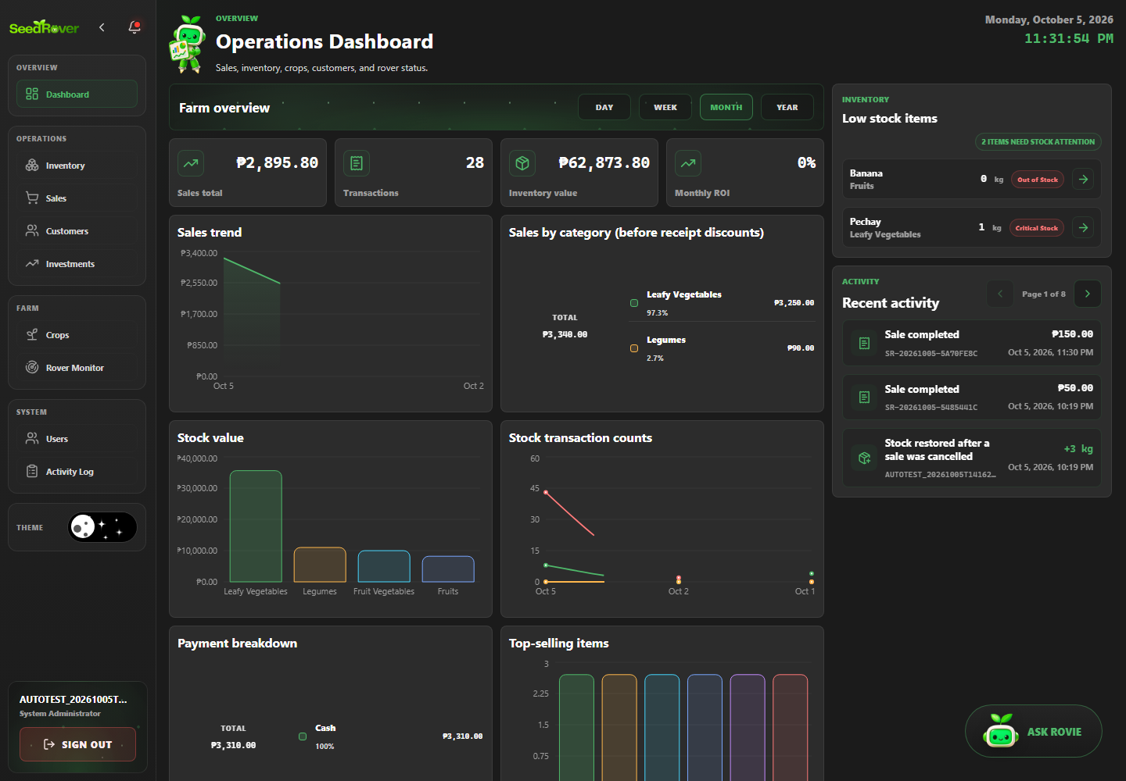
Figure 2. Login succeeds and opens the authenticated dashboard. Case SR-AUTH-001; Playwright run 20261005T153119448-21704.
SR-AUTH-002 | Invalid credentials are rejected
Objective | Verify that invalid credentials are rejected, then document the visible and persisted result supported by the test assertions.
Preconditions | Local production build running; target database host is the previously verified development/demo project; one Playwright worker; dedicated role session prepared.
Test Data | Synthetic data for run 20261005T153119448-21704; exact related labels and record IDs are listed in run-artifacts/20261005T153119448-21704/records.jsonl. Credentials are excluded.
Numbered Steps | 1. Use the case's declared role session and run-labelled fixture prepared by web-admin/e2e/support.ts.  2. Open /login and perform: Invalid credentials are rejected.  3. Check the visible or persisted outcome asserted in web-admin/e2e/tests/auth-roles.spec.ts.  4. Compare the outcome with the named scenario; the run-specific fixture IDs are recorded in the run manifest.
Expected Result | Invalid credentials are rejected. The observed behavior must match the specific assertions in web-admin/e2e/tests/auth-roles.spec.ts; any database outcome is claimed only when that test reads it back.
Cleanup | Dedicated test accounts deactivated; labeled transactional/history rows retained under the run's exact-ID cleanup policy. See run-artifacts/20261005T153119448-21704/cleanup.json.
Actual Result | Passed; Playwright assertions completed in the named run. Persisted outcomes were independently checked where the test source performs database reads.
Evidence / Source | Evidence: run-artifacts/20261005T153119448-21704/html/index.html  Playwright source: web-admin/e2e/tests/auth-roles.spec.ts
Case record | Module: Authentication and recovery Role: As stated in the test title; staff cases use the named role session Priority: High Test type: Functional / authorization / validation as described by the scenario Method: Automated — Playwright Test / Chromium Automation status: Passed  Evidence: run-artifacts/20261005T153119448-21704/html/index.html  Source: web-admin/e2e/tests/auth-roles.spec.ts


Figure 3. Invalid credentials are rejected. Case SR-AUTH-002; Playwright run 20261005T153119448-21704.
SR-AUTH-003 | Required username and password prevent empty submission
Objective | Verify that required username and password prevent empty submission, then document the visible and persisted result supported by the test assertions.
Preconditions | Local production build running; target database host is the previously verified development/demo project; one Playwright worker; dedicated role session prepared.
Test Data | Synthetic data for run 20261005T153119448-21704; exact related labels and record IDs are listed in run-artifacts/20261005T153119448-21704/records.jsonl. Credentials are excluded.
Numbered Steps | 1. Use the case's declared role session and run-labelled fixture prepared by web-admin/e2e/support.ts.  2. Open /login and perform: Required username and password prevent empty submission.  3. Check the visible or persisted outcome asserted in web-admin/e2e/tests/auth-roles.spec.ts.  4. Compare the outcome with the named scenario; the run-specific fixture IDs are recorded in the run manifest.
Expected Result | Required username and password prevent empty submission. The observed behavior must match the specific assertions in web-admin/e2e/tests/auth-roles.spec.ts; any database outcome is claimed only when that test reads it back.
Cleanup | Dedicated test accounts deactivated; labeled transactional/history rows retained under the run's exact-ID cleanup policy. See run-artifacts/20261005T153119448-21704/cleanup.json.
Actual Result | Passed; Playwright assertions completed in the named run. Persisted outcomes were independently checked where the test source performs database reads.
Evidence / Source | Evidence: run-artifacts/20261005T153119448-21704/html/index.html  Playwright source: web-admin/e2e/tests/auth-roles.spec.ts
Case record | Module: Authentication and recovery Role: As stated in the test title; staff cases use the named role session Priority: High Test type: Functional / authorization / validation as described by the scenario Method: Automated — Playwright Test / Chromium Automation status: Passed  Evidence: run-artifacts/20261005T153119448-21704/html/index.html  Source: web-admin/e2e/tests/auth-roles.spec.ts


Figure 4. Required username and password prevent empty submission. Case SR-AUTH-003; Playwright run 20261005T153119448-21704.
SR-AUTH-004 | Signed-out dashboard access redirects to login
Objective | Verify that signed-out dashboard access redirects to login, then document the visible and persisted result supported by the test assertions.
Preconditions | Local production build running; target database host is the previously verified development/demo project; one Playwright worker; dedicated role session prepared.
Test Data | Synthetic data for run 20261005T153119448-21704; exact related labels and record IDs are listed in run-artifacts/20261005T153119448-21704/records.jsonl. Credentials are excluded.
Numbered Steps | 1. Use the case's declared role session and run-labelled fixture prepared by web-admin/e2e/support.ts.  2. Open /login and perform: Signed-out dashboard access redirects to login.  3. Check the visible or persisted outcome asserted in web-admin/e2e/tests/auth-roles.spec.ts.  4. Compare the outcome with the named scenario; the run-specific fixture IDs are recorded in the run manifest.
Expected Result | Signed-out dashboard access redirects to login. The observed behavior must match the specific assertions in web-admin/e2e/tests/auth-roles.spec.ts; any database outcome is claimed only when that test reads it back.
Cleanup | Dedicated test accounts deactivated; labeled transactional/history rows retained under the run's exact-ID cleanup policy. See run-artifacts/20261005T153119448-21704/cleanup.json.
Actual Result | Passed; Playwright assertions completed in the named run. Persisted outcomes were independently checked where the test source performs database reads.
Evidence / Source | Evidence: run-artifacts/20261005T153119448-21704/html/index.html  Playwright source: web-admin/e2e/tests/auth-roles.spec.ts
Case record | Module: Authentication and recovery Role: As stated in the test title; staff cases use the named role session Priority: High Test type: Functional / authorization / validation as described by the scenario Method: Automated — Playwright Test / Chromium Automation status: Passed  Evidence: run-artifacts/20261005T153119448-21704/html/index.html  Source: web-admin/e2e/tests/auth-roles.spec.ts

SR-AUTH-005 | @smoke Logout prevents subsequent protected access
Objective | Verify that @smoke Logout prevents subsequent protected access, then document the visible and persisted result supported by the test assertions.
Preconditions | Local production build running; target database host is the previously verified development/demo project; one Playwright worker; dedicated role session prepared.
Test Data | Synthetic data for run 20261005T153119448-21704; exact related labels and record IDs are listed in run-artifacts/20261005T153119448-21704/records.jsonl. Credentials are excluded.
Numbered Steps | 1. Use the case's declared role session and run-labelled fixture prepared by web-admin/e2e/support.ts.  2. Open /login and perform: @smoke Logout prevents subsequent protected access.  3. Check the visible or persisted outcome asserted in web-admin/e2e/tests/auth-roles.spec.ts.  4. Compare the outcome with the named scenario; the run-specific fixture IDs are recorded in the run manifest.
Expected Result | @smoke Logout prevents subsequent protected access. The observed behavior must match the specific assertions in web-admin/e2e/tests/auth-roles.spec.ts; any database outcome is claimed only when that test reads it back.
Cleanup | Dedicated test accounts deactivated; labeled transactional/history rows retained under the run's exact-ID cleanup policy. See run-artifacts/20261005T153119448-21704/cleanup.json.
Actual Result | Passed; Playwright assertions completed in the named run. Persisted outcomes were independently checked where the test source performs database reads.
Evidence / Source | Evidence: run-artifacts/20261005T153119448-21704/html/index.html  Playwright source: web-admin/e2e/tests/auth-roles.spec.ts
Case record | Module: Authentication and recovery Role: As stated in the test title; staff cases use the named role session Priority: High Test type: Functional / authorization / validation as described by the scenario Method: Automated — Playwright Test / Chromium Automation status: Passed  Evidence: run-artifacts/20261005T153119448-21704/html/index.html  Source: web-admin/e2e/tests/auth-roles.spec.ts


Figure 5. @smoke Logout prevents subsequent protected access. Case SR-AUTH-005; Playwright run 20261005T153119448-21704.
SR-AUTH-006 | Inactive account cannot access portal
Objective | Verify that inactive account cannot access portal, then document the visible and persisted result supported by the test assertions.
Preconditions | Local production build running; target database host is the previously verified development/demo project; one Playwright worker; dedicated role session prepared.
Test Data | Synthetic data for run 20261005T153119448-21704; exact related labels and record IDs are listed in run-artifacts/20261005T153119448-21704/records.jsonl. Credentials are excluded.
Numbered Steps | 1. Use the case's declared role session and run-labelled fixture prepared by web-admin/e2e/support.ts.  2. Open /login and perform: Inactive account cannot access portal.  3. Check the visible or persisted outcome asserted in web-admin/e2e/tests/auth-roles.spec.ts.  4. Compare the outcome with the named scenario; the run-specific fixture IDs are recorded in the run manifest.
Expected Result | Inactive account cannot access portal. The observed behavior must match the specific assertions in web-admin/e2e/tests/auth-roles.spec.ts; any database outcome is claimed only when that test reads it back.
Cleanup | Dedicated test accounts deactivated; labeled transactional/history rows retained under the run's exact-ID cleanup policy. See run-artifacts/20261005T153119448-21704/cleanup.json.
Actual Result | Passed; Playwright assertions completed in the named run. Persisted outcomes were independently checked where the test source performs database reads.
Evidence / Source | Evidence: run-artifacts/20261005T153119448-21704/html/index.html  Playwright source: web-admin/e2e/tests/auth-roles.spec.ts
Case record | Module: Authentication and recovery Role: As stated in the test title; staff cases use the named role session Priority: High Test type: Functional / authorization / validation as described by the scenario Method: Automated — Playwright Test / Chromium Automation status: Passed  Evidence: run-artifacts/20261005T153119448-21704/html/index.html  Source: web-admin/e2e/tests/auth-roles.spec.ts


Figure 6. Inactive account cannot access portal. Case SR-AUTH-006; Playwright run 20261005T153119448-21704.
SR-ROLE-001 | System Administrator receives the correct landing page
Objective | Verify that system Administrator receives the correct landing page, then document the visible and persisted result supported by the test assertions.
Preconditions | Local production build running; target database host is the previously verified development/demo project; one Playwright worker; dedicated role session prepared.
Test Data | Synthetic data for run 20261005T153119448-21704; exact related labels and record IDs are listed in run-artifacts/20261005T153119448-21704/records.jsonl. Credentials are excluded.
Numbered Steps | 1. Use the case's declared role session and run-labelled fixture prepared by web-admin/e2e/support.ts.  2. Open the route named in the test and perform: System Administrator receives the correct landing page.  3. Check the visible or persisted outcome asserted in web-admin/e2e/tests/auth-roles.spec.ts.  4. Compare the outcome with the named scenario; the run-specific fixture IDs are recorded in the run manifest.
Expected Result | System Administrator receives the correct landing page. The observed behavior must match the specific assertions in web-admin/e2e/tests/auth-roles.spec.ts; any database outcome is claimed only when that test reads it back.
Cleanup | Dedicated test accounts deactivated; labeled transactional/history rows retained under the run's exact-ID cleanup policy. See run-artifacts/20261005T153119448-21704/cleanup.json.
Actual Result | Passed; Playwright assertions completed in the named run. Persisted outcomes were independently checked where the test source performs database reads.
Evidence / Source | Evidence: run-artifacts/20261005T153119448-21704/html/index.html  Playwright source: web-admin/e2e/tests/auth-roles.spec.ts
Case record | Module: Role authorization Role: System Administrator Priority: High Test type: Functional / authorization / validation as described by the scenario Method: Automated — Playwright Test / Chromium Automation status: Passed  Evidence: run-artifacts/20261005T153119448-21704/html/index.html  Source: web-admin/e2e/tests/auth-roles.spec.ts

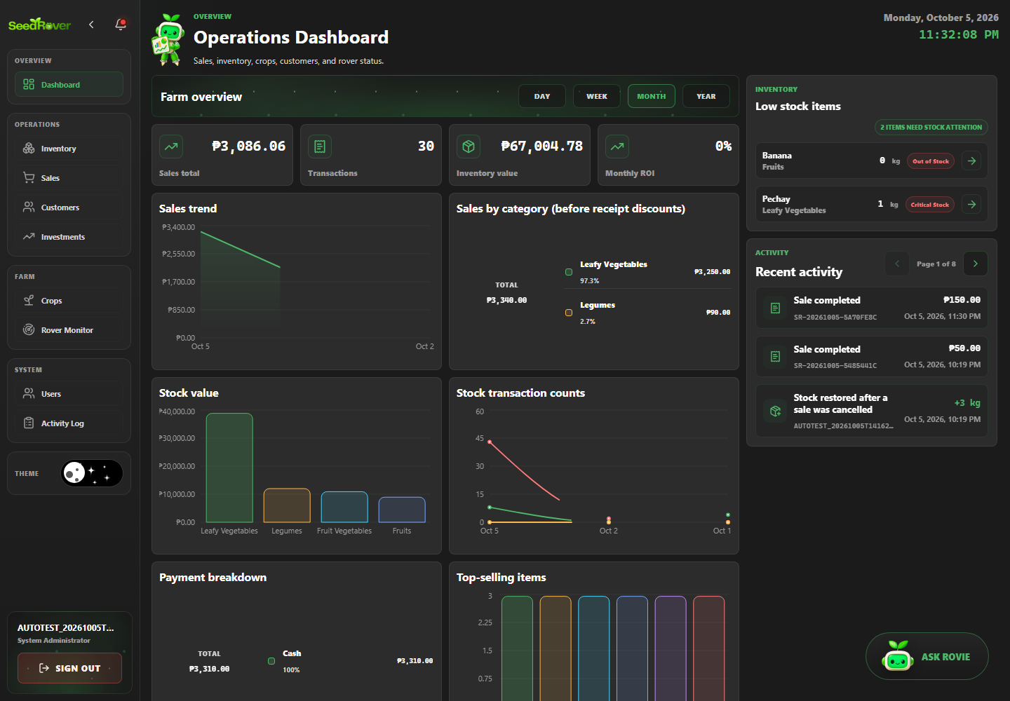
Figure 7. System Administrator receives the correct landing page. Case SR-ROLE-001; Playwright run 20261005T153119448-21704.
SR-ROLE-002 | Farm Planting Manager receives the correct landing page
Objective | Verify that farm Planting Manager receives the correct landing page, then document the visible and persisted result supported by the test assertions.
Preconditions | Local production build running; target database host is the previously verified development/demo project; one Playwright worker; dedicated role session prepared.
Test Data | Synthetic data for run 20261005T153119448-21704; exact related labels and record IDs are listed in run-artifacts/20261005T153119448-21704/records.jsonl. Credentials are excluded.
Numbered Steps | 1. Use the case's declared role session and run-labelled fixture prepared by web-admin/e2e/support.ts.  2. Open the route named in the test and perform: Farm Planting Manager receives the correct landing page.  3. Check the visible or persisted outcome asserted in web-admin/e2e/tests/auth-roles.spec.ts.  4. Compare the outcome with the named scenario; the run-specific fixture IDs are recorded in the run manifest.
Expected Result | Farm Planting Manager receives the correct landing page. The observed behavior must match the specific assertions in web-admin/e2e/tests/auth-roles.spec.ts; any database outcome is claimed only when that test reads it back.
Cleanup | Dedicated test accounts deactivated; labeled transactional/history rows retained under the run's exact-ID cleanup policy. See run-artifacts/20261005T153119448-21704/cleanup.json.
Actual Result | Passed; Playwright assertions completed in the named run. Persisted outcomes were independently checked where the test source performs database reads.
Evidence / Source | Evidence: run-artifacts/20261005T153119448-21704/html/index.html  Playwright source: web-admin/e2e/tests/auth-roles.spec.ts
Case record | Module: Role authorization Role: Farm Planting Manager Priority: High Test type: Functional / authorization / validation as described by the scenario Method: Automated — Playwright Test / Chromium Automation status: Passed  Evidence: run-artifacts/20261005T153119448-21704/html/index.html  Source: web-admin/e2e/tests/auth-roles.spec.ts

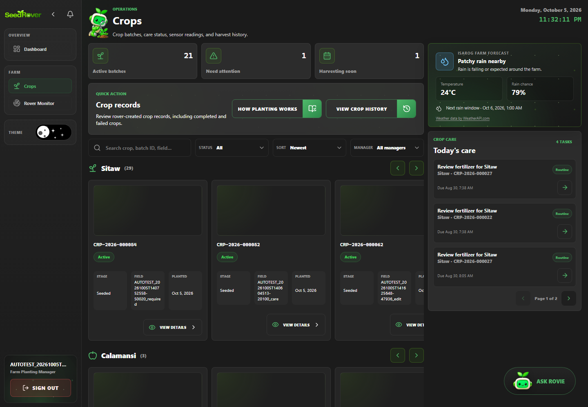
Figure 8. Farm Planting Manager receives the correct landing page. Case SR-ROLE-002; Playwright run 20261005T153119448-21704.
SR-ROLE-003 | Farm Inventory Manager receives the correct landing page
Objective | Verify that farm Inventory Manager receives the correct landing page, then document the visible and persisted result supported by the test assertions.
Preconditions | Local production build running; target database host is the previously verified development/demo project; one Playwright worker; dedicated role session prepared.
Test Data | Synthetic data for run 20261005T153119448-21704; exact related labels and record IDs are listed in run-artifacts/20261005T153119448-21704/records.jsonl. Credentials are excluded.
Numbered Steps | 1. Use the case's declared role session and run-labelled fixture prepared by web-admin/e2e/support.ts.  2. Open the route named in the test and perform: Farm Inventory Manager receives the correct landing page.  3. Check the visible or persisted outcome asserted in web-admin/e2e/tests/auth-roles.spec.ts.  4. Compare the outcome with the named scenario; the run-specific fixture IDs are recorded in the run manifest.
Expected Result | Farm Inventory Manager receives the correct landing page. The observed behavior must match the specific assertions in web-admin/e2e/tests/auth-roles.spec.ts; any database outcome is claimed only when that test reads it back.
Cleanup | Dedicated test accounts deactivated; labeled transactional/history rows retained under the run's exact-ID cleanup policy. See run-artifacts/20261005T153119448-21704/cleanup.json.
Actual Result | Passed; Playwright assertions completed in the named run. Persisted outcomes were independently checked where the test source performs database reads.
Evidence / Source | Evidence: run-artifacts/20261005T153119448-21704/html/index.html  Playwright source: web-admin/e2e/tests/auth-roles.spec.ts
Case record | Module: Role authorization Role: Farm Inventory Manager Priority: High Test type: Functional / authorization / validation as described by the scenario Method: Automated — Playwright Test / Chromium Automation status: Passed  Evidence: run-artifacts/20261005T153119448-21704/html/index.html  Source: web-admin/e2e/tests/auth-roles.spec.ts

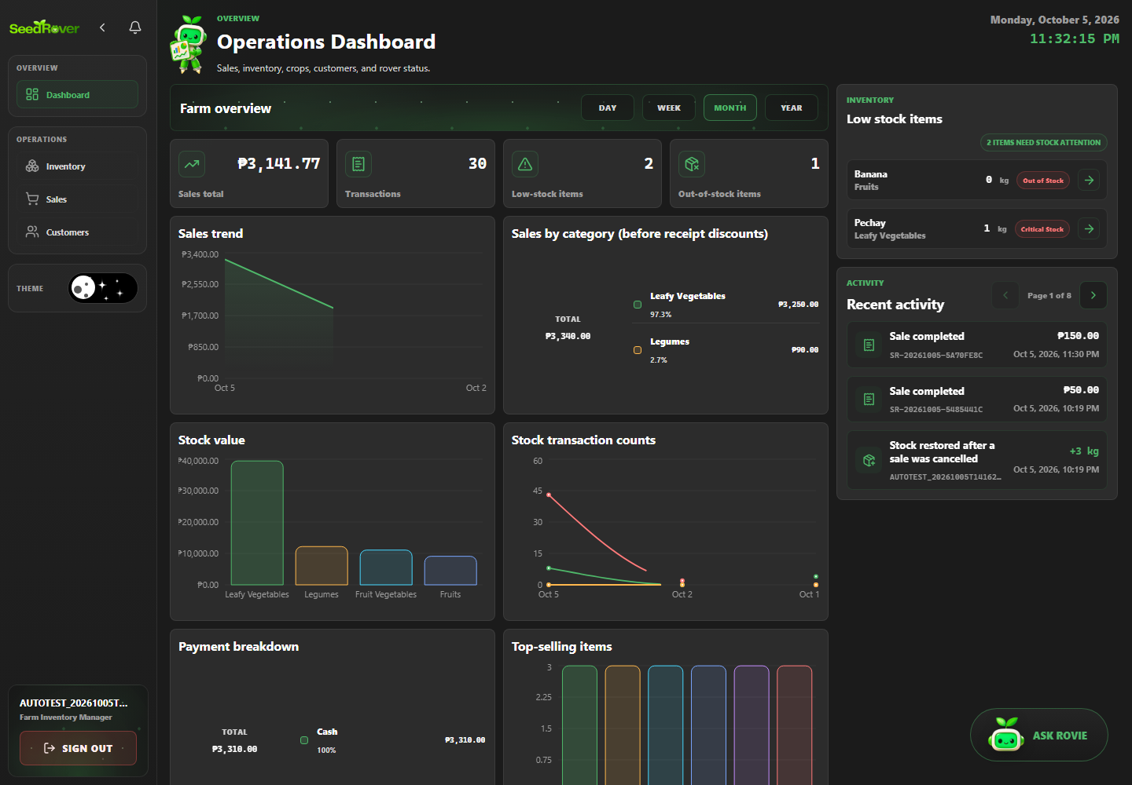
Figure 9. Farm Inventory Manager receives the correct landing page. Case SR-ROLE-003; Playwright run 20261005T153119448-21704.
SR-ROLE-004 | Planting Staff receives the correct landing page
Objective | Verify that planting Staff receives the correct landing page, then document the visible and persisted result supported by the test assertions.
Preconditions | Local production build running; target database host is the previously verified development/demo project; one Playwright worker; dedicated role session prepared.
Test Data | Synthetic data for run 20261005T153119448-21704; exact related labels and record IDs are listed in run-artifacts/20261005T153119448-21704/records.jsonl. Credentials are excluded.
Numbered Steps | 1. Use the case's declared role session and run-labelled fixture prepared by web-admin/e2e/support.ts.  2. Open the route named in the test and perform: Planting Staff receives the correct landing page.  3. Check the visible or persisted outcome asserted in web-admin/e2e/tests/auth-roles.spec.ts.  4. Compare the outcome with the named scenario; the run-specific fixture IDs are recorded in the run manifest.
Expected Result | Planting Staff receives the correct landing page. The observed behavior must match the specific assertions in web-admin/e2e/tests/auth-roles.spec.ts; any database outcome is claimed only when that test reads it back.
Cleanup | Dedicated test accounts deactivated; labeled transactional/history rows retained under the run's exact-ID cleanup policy. See run-artifacts/20261005T153119448-21704/cleanup.json.
Actual Result | Passed; Playwright assertions completed in the named run. Persisted outcomes were independently checked where the test source performs database reads.
Evidence / Source | Evidence: evidence/20261005T153119448-21704/SR-ROLE-004_verified-result.png  Playwright source: web-admin/e2e/tests/auth-roles.spec.ts
Case record | Module: Role authorization Role: Planting Staff Priority: High Test type: Functional / authorization / validation as described by the scenario Method: Automated — Playwright Test / Chromium Automation status: Passed  Evidence: evidence/20261005T153119448-21704/SR-ROLE-004_verified-result.png  Source: web-admin/e2e/tests/auth-roles.spec.ts

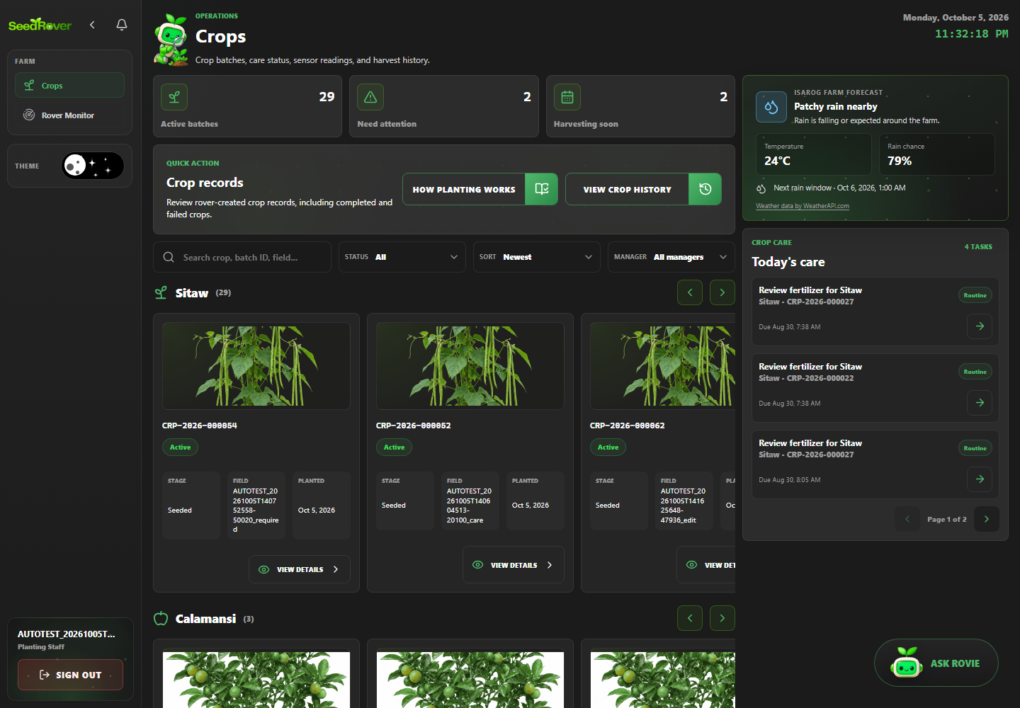
Figure 10. Planting Staff lands on its authorized workspace. Case SR-ROLE-004; Playwright run 20261005T153119448-21704.
SR-ROLE-005 | Inventory Staff receives the correct landing page
Objective | Verify that inventory Staff receives the correct landing page, then document the visible and persisted result supported by the test assertions.
Preconditions | Local production build running; target database host is the previously verified development/demo project; one Playwright worker; dedicated role session prepared.
Test Data | Synthetic data for run 20261005T153119448-21704; exact related labels and record IDs are listed in run-artifacts/20261005T153119448-21704/records.jsonl. Credentials are excluded.
Numbered Steps | 1. Use the case's declared role session and run-labelled fixture prepared by web-admin/e2e/support.ts.  2. Open the route named in the test and perform: Inventory Staff receives the correct landing page.  3. Check the visible or persisted outcome asserted in web-admin/e2e/tests/auth-roles.spec.ts.  4. Compare the outcome with the named scenario; the run-specific fixture IDs are recorded in the run manifest.
Expected Result | Inventory Staff receives the correct landing page. The observed behavior must match the specific assertions in web-admin/e2e/tests/auth-roles.spec.ts; any database outcome is claimed only when that test reads it back.
Cleanup | Dedicated test accounts deactivated; labeled transactional/history rows retained under the run's exact-ID cleanup policy. See run-artifacts/20261005T153119448-21704/cleanup.json.
Actual Result | Passed; Playwright assertions completed in the named run. Persisted outcomes were independently checked where the test source performs database reads.
Evidence / Source | Evidence: run-artifacts/20261005T153119448-21704/html/index.html  Playwright source: web-admin/e2e/tests/auth-roles.spec.ts
Case record | Module: Role authorization Role: Inventory Staff Priority: High Test type: Functional / authorization / validation as described by the scenario Method: Automated — Playwright Test / Chromium Automation status: Passed  Evidence: run-artifacts/20261005T153119448-21704/html/index.html  Source: web-admin/e2e/tests/auth-roles.spec.ts

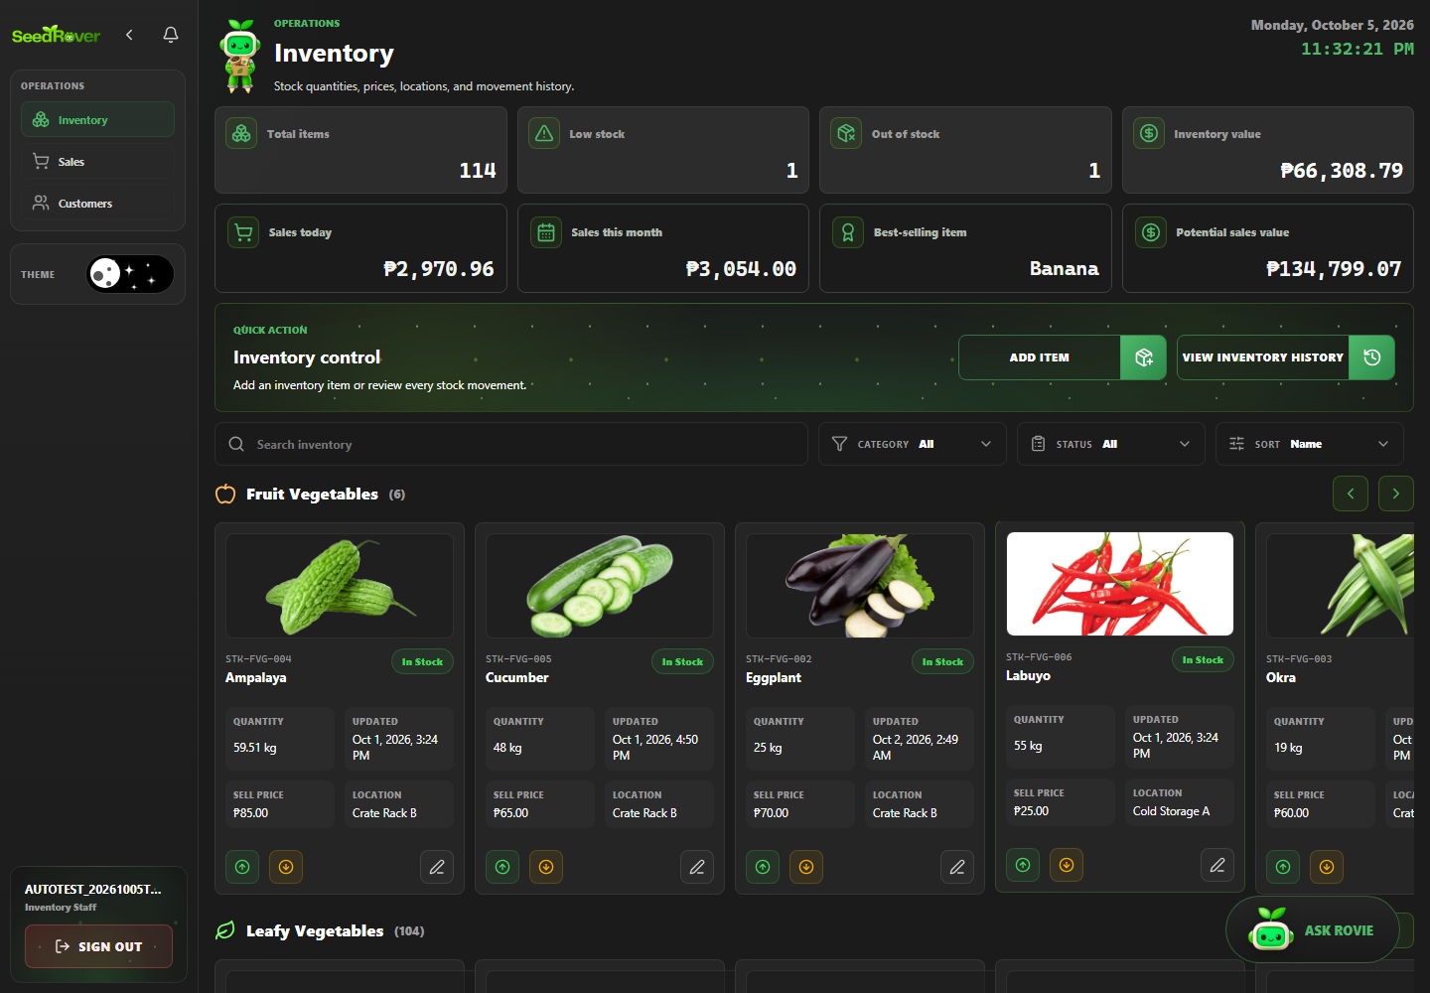
Figure 11. Inventory Staff receives the correct landing page. Case SR-ROLE-005; Playwright run 20261005T153119448-21704.
SR-ROLE-011 | Farm Planting Manager cannot open user administration
Objective | Verify that farm Planting Manager cannot open user administration, then document the visible and persisted result supported by the test assertions.
Preconditions | Local production build running; target database host is the previously verified development/demo project; one Playwright worker; dedicated role session prepared.
Test Data | Synthetic data for run 20261005T153119448-21704; exact related labels and record IDs are listed in run-artifacts/20261005T153119448-21704/records.jsonl. Credentials are excluded.
Numbered Steps | 1. Use the case's declared role session and run-labelled fixture prepared by web-admin/e2e/support.ts.  2. Open the route named in the test and perform: Farm Planting Manager cannot open user administration.  3. Check the visible or persisted outcome asserted in web-admin/e2e/tests/auth-roles.spec.ts.  4. Compare the outcome with the named scenario; the run-specific fixture IDs are recorded in the run manifest.
Expected Result | Farm Planting Manager cannot open user administration. The observed behavior must match the specific assertions in web-admin/e2e/tests/auth-roles.spec.ts; any database outcome is claimed only when that test reads it back.
Cleanup | Dedicated test accounts deactivated; labeled transactional/history rows retained under the run's exact-ID cleanup policy. See run-artifacts/20261005T153119448-21704/cleanup.json.
Actual Result | Passed; Playwright assertions completed in the named run. Route guard and visible-page assertion only; no direct protected-action request is made.
Evidence / Source | Evidence: run-artifacts/20261005T153119448-21704/html/index.html  Playwright source: web-admin/e2e/tests/auth-roles.spec.ts
Case record | Module: Role authorization Role: Farm Planting Manager Priority: High Test type: Functional / authorization / validation as described by the scenario Method: Automated — Playwright Test / Chromium Automation status: Passed  Evidence: run-artifacts/20261005T153119448-21704/html/index.html  Source: web-admin/e2e/tests/auth-roles.spec.ts

SR-ROLE-012 | Farm Inventory Manager cannot open user administration
Objective | Verify that farm Inventory Manager cannot open user administration, then document the visible and persisted result supported by the test assertions.
Preconditions | Local production build running; target database host is the previously verified development/demo project; one Playwright worker; dedicated role session prepared.
Test Data | Synthetic data for run 20261005T153119448-21704; exact related labels and record IDs are listed in run-artifacts/20261005T153119448-21704/records.jsonl. Credentials are excluded.
Numbered Steps | 1. Use the case's declared role session and run-labelled fixture prepared by web-admin/e2e/support.ts.  2. Open the route named in the test and perform: Farm Inventory Manager cannot open user administration.  3. Check the visible or persisted outcome asserted in web-admin/e2e/tests/auth-roles.spec.ts.  4. Compare the outcome with the named scenario; the run-specific fixture IDs are recorded in the run manifest.
Expected Result | Farm Inventory Manager cannot open user administration. The observed behavior must match the specific assertions in web-admin/e2e/tests/auth-roles.spec.ts; any database outcome is claimed only when that test reads it back.
Cleanup | Dedicated test accounts deactivated; labeled transactional/history rows retained under the run's exact-ID cleanup policy. See run-artifacts/20261005T153119448-21704/cleanup.json.
Actual Result | Passed; Playwright assertions completed in the named run. Route guard and visible-page assertion only; no direct protected-action request is made.
Evidence / Source | Evidence: run-artifacts/20261005T153119448-21704/html/index.html  Playwright source: web-admin/e2e/tests/auth-roles.spec.ts
Case record | Module: Role authorization Role: Farm Inventory Manager Priority: High Test type: Functional / authorization / validation as described by the scenario Method: Automated — Playwright Test / Chromium Automation status: Passed  Evidence: run-artifacts/20261005T153119448-21704/html/index.html  Source: web-admin/e2e/tests/auth-roles.spec.ts

SR-ROLE-013 | Planting Staff cannot open user administration
Objective | Verify that planting Staff cannot open user administration, then document the visible and persisted result supported by the test assertions.
Preconditions | Local production build running; target database host is the previously verified development/demo project; one Playwright worker; dedicated role session prepared.
Test Data | Synthetic data for run 20261005T153119448-21704; exact related labels and record IDs are listed in run-artifacts/20261005T153119448-21704/records.jsonl. Credentials are excluded.
Numbered Steps | 1. Use the case's declared role session and run-labelled fixture prepared by web-admin/e2e/support.ts.  2. Open the route named in the test and perform: Planting Staff cannot open user administration.  3. Check the visible or persisted outcome asserted in web-admin/e2e/tests/auth-roles.spec.ts.  4. Compare the outcome with the named scenario; the run-specific fixture IDs are recorded in the run manifest.
Expected Result | Planting Staff cannot open user administration. The observed behavior must match the specific assertions in web-admin/e2e/tests/auth-roles.spec.ts; any database outcome is claimed only when that test reads it back.
Cleanup | Dedicated test accounts deactivated; labeled transactional/history rows retained under the run's exact-ID cleanup policy. See run-artifacts/20261005T153119448-21704/cleanup.json.
Actual Result | Passed; Playwright assertions completed in the named run. Route guard and visible-page assertion only; no direct protected-action request is made.
Evidence / Source | Evidence: run-artifacts/20261005T153119448-21704/html/index.html  Playwright source: web-admin/e2e/tests/auth-roles.spec.ts
Case record | Module: Role authorization Role: Planting Staff Priority: High Test type: Functional / authorization / validation as described by the scenario Method: Automated — Playwright Test / Chromium Automation status: Passed  Evidence: run-artifacts/20261005T153119448-21704/html/index.html  Source: web-admin/e2e/tests/auth-roles.spec.ts

SR-ROLE-014 | Inventory Staff cannot open user administration
Objective | Verify that inventory Staff cannot open user administration, then document the visible and persisted result supported by the test assertions.
Preconditions | Local production build running; target database host is the previously verified development/demo project; one Playwright worker; dedicated role session prepared.
Test Data | Synthetic data for run 20261005T153119448-21704; exact related labels and record IDs are listed in run-artifacts/20261005T153119448-21704/records.jsonl. Credentials are excluded.
Numbered Steps | 1. Use the case's declared role session and run-labelled fixture prepared by web-admin/e2e/support.ts.  2. Open the route named in the test and perform: Inventory Staff cannot open user administration.  3. Check the visible or persisted outcome asserted in web-admin/e2e/tests/auth-roles.spec.ts.  4. Compare the outcome with the named scenario; the run-specific fixture IDs are recorded in the run manifest.
Expected Result | Inventory Staff cannot open user administration. The observed behavior must match the specific assertions in web-admin/e2e/tests/auth-roles.spec.ts; any database outcome is claimed only when that test reads it back.
Cleanup | Dedicated test accounts deactivated; labeled transactional/history rows retained under the run's exact-ID cleanup policy. See run-artifacts/20261005T153119448-21704/cleanup.json.
Actual Result | Passed; Playwright assertions completed in the named run. Route guard and visible-page assertion only; no direct protected-action request is made.
Evidence / Source | Evidence: run-artifacts/20261005T153119448-21704/html/index.html  Playwright source: web-admin/e2e/tests/auth-roles.spec.ts
Case record | Module: Role authorization Role: Inventory Staff Priority: High Test type: Functional / authorization / validation as described by the scenario Method: Automated — Playwright Test / Chromium Automation status: Passed  Evidence: run-artifacts/20261005T153119448-21704/html/index.html  Source: web-admin/e2e/tests/auth-roles.spec.ts

SR-ROLE-020 | Planting role cannot change inventory through database API
Objective | Verify that planting role cannot change inventory through database API, then document the visible and persisted result supported by the test assertions.
Preconditions | Local production build running; target database host is the previously verified development/demo project; one Playwright worker; dedicated role session prepared.
Test Data | Synthetic data for run 20261005T153119448-21704; exact related labels and record IDs are listed in run-artifacts/20261005T153119448-21704/records.jsonl. Credentials are excluded.
Numbered Steps | 1. Use the case's declared role session and run-labelled fixture prepared by web-admin/e2e/support.ts.  2. Open the route named in the test and perform: Planting role cannot change inventory through database API.  3. Check the visible or persisted outcome asserted in web-admin/e2e/tests/auth-roles.spec.ts.  4. Compare the outcome with the named scenario; the run-specific fixture IDs are recorded in the run manifest.
Expected Result | Planting role cannot change inventory through database API. The observed behavior must match the specific assertions in web-admin/e2e/tests/auth-roles.spec.ts; any database outcome is claimed only when that test reads it back.
Cleanup | Dedicated test accounts deactivated; labeled transactional/history rows retained under the run's exact-ID cleanup policy. See run-artifacts/20261005T153119448-21704/cleanup.json.
Actual Result | Passed; Playwright assertions completed in the named run. Persisted outcomes were independently checked where the test source performs database reads.
Evidence / Source | Evidence: run-artifacts/20261005T153119448-21704/html/index.html  Playwright source: web-admin/e2e/tests/auth-roles.spec.ts
Case record | Module: Role authorization Role: As stated in the test title; staff cases use the named role session Priority: High Test type: Functional / authorization / validation as described by the scenario Method: Automated — Playwright Test / Chromium Automation status: Passed  Evidence: run-artifacts/20261005T153119448-21704/html/index.html  Source: web-admin/e2e/tests/auth-roles.spec.ts

SR-ROLE-021 | Inventory role cannot change crops through database API
Objective | Verify that inventory role cannot change crops through database API, then document the visible and persisted result supported by the test assertions.
Preconditions | Local production build running; target database host is the previously verified development/demo project; one Playwright worker; dedicated role session prepared.
Test Data | Synthetic data for run 20261005T153119448-21704; exact related labels and record IDs are listed in run-artifacts/20261005T153119448-21704/records.jsonl. Credentials are excluded.
Numbered Steps | 1. Use the case's declared role session and run-labelled fixture prepared by web-admin/e2e/support.ts.  2. Open the route named in the test and perform: Inventory role cannot change crops through database API.  3. Check the visible or persisted outcome asserted in web-admin/e2e/tests/auth-roles.spec.ts.  4. Compare the outcome with the named scenario; the run-specific fixture IDs are recorded in the run manifest.
Expected Result | Inventory role cannot change crops through database API. The observed behavior must match the specific assertions in web-admin/e2e/tests/auth-roles.spec.ts; any database outcome is claimed only when that test reads it back.
Cleanup | Dedicated test accounts deactivated; labeled transactional/history rows retained under the run's exact-ID cleanup policy. See run-artifacts/20261005T153119448-21704/cleanup.json.
Actual Result | Passed; Playwright assertions completed in the named run. Persisted outcomes were independently checked where the test source performs database reads.
Evidence / Source | Evidence: run-artifacts/20261005T153119448-21704/html/index.html  Playwright source: web-admin/e2e/tests/auth-roles.spec.ts
Case record | Module: Role authorization Role: As stated in the test title; staff cases use the named role session Priority: High Test type: Functional / authorization / validation as described by the scenario Method: Automated — Playwright Test / Chromium Automation status: Passed  Evidence: run-artifacts/20261005T153119448-21704/html/index.html  Source: web-admin/e2e/tests/auth-roles.spec.ts

SR-ROLE-022 | Signed-out and planting-role sales exports are rejected
Objective | Verify that signed-out and planting-role sales exports are rejected, then document the visible and persisted result supported by the test assertions.
Preconditions | Local production build running; target database host is the previously verified development/demo project; one Playwright worker; dedicated role session prepared.
Test Data | Synthetic data for run 20261005T153119448-21704; exact related labels and record IDs are listed in run-artifacts/20261005T153119448-21704/records.jsonl. Credentials are excluded.
Numbered Steps | 1. Use the case's declared role session and run-labelled fixture prepared by web-admin/e2e/support.ts.  2. Open the route named in the test and perform: Signed-out and planting-role sales exports are rejected.  3. Check the visible or persisted outcome asserted in web-admin/e2e/tests/auth-roles.spec.ts.  4. Compare the outcome with the named scenario; the run-specific fixture IDs are recorded in the run manifest.
Expected Result | Signed-out and planting-role sales exports are rejected. The observed behavior must match the specific assertions in web-admin/e2e/tests/auth-roles.spec.ts; any database outcome is claimed only when that test reads it back.
Cleanup | Dedicated test accounts deactivated; labeled transactional/history rows retained under the run's exact-ID cleanup policy. See run-artifacts/20261005T153119448-21704/cleanup.json.
Actual Result | Passed; Playwright assertions completed in the named run. Persisted outcomes were independently checked where the test source performs database reads.
Evidence / Source | Evidence: run-artifacts/20261005T153119448-21704/html/index.html  Playwright source: web-admin/e2e/tests/auth-roles.spec.ts
Case record | Module: Role authorization Role: As stated in the test title; staff cases use the named role session Priority: High Test type: Functional / authorization / validation as described by the scenario Method: Automated — Playwright Test / Chromium Automation status: Passed  Evidence: run-artifacts/20261005T153119448-21704/html/index.html  Source: web-admin/e2e/tests/auth-roles.spec.ts

SR-CROP-001 | Seeded crop batch displays correct details
Objective | Verify that seeded crop batch displays correct details, then document the visible and persisted result supported by the test assertions.
Preconditions | Local production build running; target database host is the previously verified development/demo project; one Playwright worker; dedicated role session prepared.
Test Data | Synthetic data for run 20261005T153119448-21704; exact related labels and record IDs are listed in run-artifacts/20261005T153119448-21704/records.jsonl. Credentials are excluded.
Numbered Steps | 1. Use the case's declared role session and run-labelled fixture prepared by web-admin/e2e/support.ts.  2. Open /crops and perform: Seeded crop batch displays correct details.  3. Check the visible or persisted outcome asserted in web-admin/e2e/tests/crops.spec.ts.  4. Compare the outcome with the named scenario; the run-specific fixture IDs are recorded in the run manifest.
Expected Result | Seeded crop batch displays correct details. The observed behavior must match the specific assertions in web-admin/e2e/tests/crops.spec.ts; any database outcome is claimed only when that test reads it back.
Cleanup | Dedicated test accounts deactivated; labeled transactional/history rows retained under the run's exact-ID cleanup policy. See run-artifacts/20261005T153119448-21704/cleanup.json.
Actual Result | Passed; Playwright assertions completed in the named run. Persisted outcomes were independently checked where the test source performs database reads.
Evidence / Source | Evidence: evidence/20261005T153119448-21704/SR-CROP-001_verified-result.png  Playwright source: web-admin/e2e/tests/crops.spec.ts
Case record | Module: Crops, care and harvest Role: Farm Planting Manager Priority: High Test type: Functional / authorization / validation as described by the scenario Method: Automated — Playwright Test / Chromium Automation status: Passed  Evidence: evidence/20261005T153119448-21704/SR-CROP-001_verified-result.png  Source: web-admin/e2e/tests/crops.spec.ts

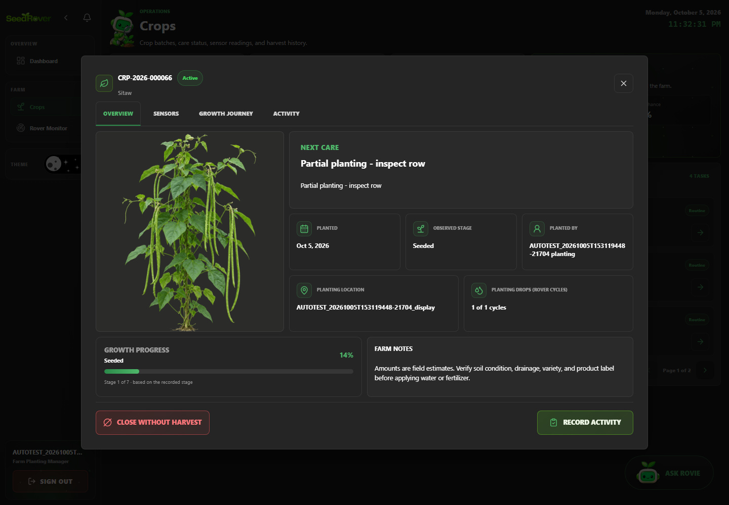
Figure 12. Synthetic crop batch details are visible in the portal. Case SR-CROP-001; Playwright run 20261005T153119448-21704.
SR-CROP-002 | Edit crop details through a reachable UI control
Objective | Verify that edit crop details through a reachable UI control, then document the visible and persisted result supported by the test assertions.
Preconditions | Local production build running; target database host is the previously verified development/demo project; one Playwright worker; dedicated role session prepared.
Test Data | Synthetic data for run 20261005T153119448-21704; exact related labels and record IDs are listed in run-artifacts/20261005T153119448-21704/records.jsonl. Credentials are excluded.
Numbered Steps | 1. Use the case's declared role session and run-labelled fixture prepared by web-admin/e2e/support.ts.  2. Open /crops and perform: Edit crop details through a reachable UI control.  3. Check the visible or persisted outcome asserted in web-admin/e2e/tests/crops.spec.ts.  4. Compare the outcome with the named scenario; the run-specific fixture IDs are recorded in the run manifest.
Expected Result | Edit crop details through a reachable UI control. The observed behavior must match the specific assertions in web-admin/e2e/tests/crops.spec.ts; any database outcome is claimed only when that test reads it back.
Cleanup | Dedicated test accounts deactivated; labeled transactional/history rows retained under the run's exact-ID cleanup policy. See run-artifacts/20261005T153119448-21704/cleanup.json.
Actual Result | Passed; Playwright assertions completed in the named run. Blocked: the current crop details interface exposes no reachable Edit Crop control. The editor scenario is not counted as passed.
Evidence / Source | Evidence: run-artifacts/20261005T153119448-21704/html/index.html  Playwright source: web-admin/e2e/tests/crops.spec.ts
Case record | Module: Crops, care and harvest Role: Farm Planting Manager Priority: High Test type: Functional / authorization / validation as described by the scenario Method: Automated — Playwright Test / Chromium Automation status: Blocked  Evidence: run-artifacts/20261005T153119448-21704/html/index.html  Source: web-admin/e2e/tests/crops.spec.ts

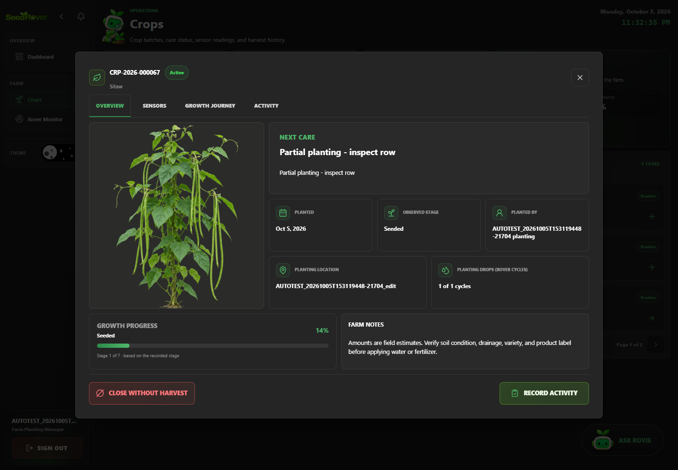
Figure 13. Edit crop details through a reachable UI control. Case SR-CROP-002; Playwright run 20261005T153119448-21704.
SR-CROP-003 | Record field care and verify persisted activity history
Objective | Verify that record field care and verify persisted activity history, then document the visible and persisted result supported by the test assertions.
Preconditions | Local production build running; target database host is the previously verified development/demo project; one Playwright worker; dedicated role session prepared.
Test Data | One synthetic, explicitly non-hardware crop batch; record Looks normal and unique AUTOTEST note.
Numbered Steps | 1. Use the case's declared role session and run-labelled fixture prepared by web-admin/e2e/support.ts.  2. Open /crops and perform: Record field care and verify persisted activity history.  3. Check the visible or persisted outcome asserted in web-admin/e2e/tests/crops.spec.ts.  4. Compare the outcome with the named scenario; the run-specific fixture IDs are recorded in the run manifest.
Expected Result | Record field care and verify persisted activity history. The observed behavior must match the specific assertions in web-admin/e2e/tests/crops.spec.ts; any database outcome is claimed only when that test reads it back.
Cleanup | Dedicated test accounts deactivated; labeled transactional/history rows retained under the run's exact-ID cleanup policy. See run-artifacts/20261005T153119448-21704/cleanup.json.
Actual Result | Passed; Playwright assertions completed in the named run. Persisted outcomes were independently checked where the test source performs database reads.
Evidence / Source | Evidence: evidence/20261005T153119448-21704/SR-CROP-003_verified-result.png  Playwright source: web-admin/e2e/tests/crops.spec.ts
Case record | Module: Crops, care and harvest Role: Farm Planting Manager Priority: High Test type: Functional / authorization / validation as described by the scenario Method: Automated — Playwright Test / Chromium Automation status: Passed  Evidence: evidence/20261005T153119448-21704/SR-CROP-003_verified-result.png  Source: web-admin/e2e/tests/crops.spec.ts

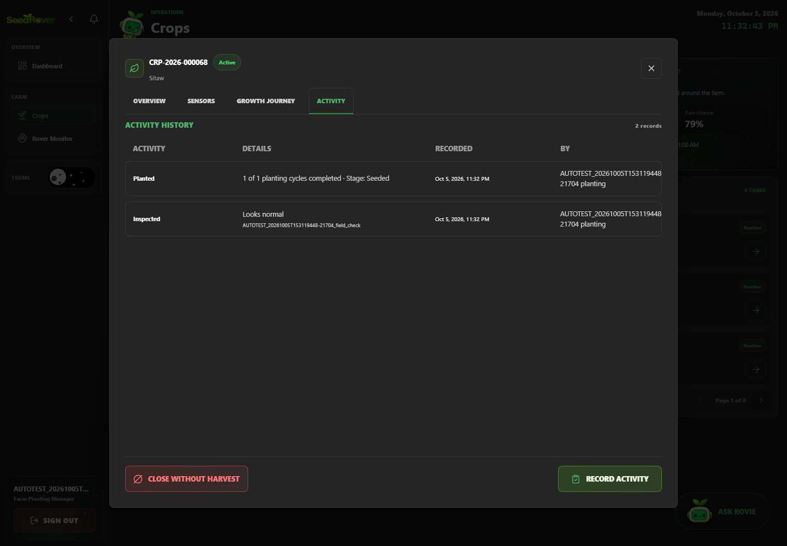
Figure 14. A saved field observation is visible in crop activity history. Case SR-CROP-003; Playwright run 20261005T153119448-21704.
SR-CROP-004 | Missing field observation prevents saving care
Objective | Verify that missing field observation prevents saving care, then document the visible and persisted result supported by the test assertions.
Preconditions | Local production build running; target database host is the previously verified development/demo project; one Playwright worker; dedicated role session prepared.
Test Data | One synthetic crop; omit the required field observation; confirm no activity row is added.
Numbered Steps | 1. Use the case's declared role session and run-labelled fixture prepared by web-admin/e2e/support.ts.  2. Open /crops and perform: Missing field observation prevents saving care.  3. Check the visible or persisted outcome asserted in web-admin/e2e/tests/crops.spec.ts.  4. Compare the outcome with the named scenario; the run-specific fixture IDs are recorded in the run manifest.
Expected Result | Missing field observation prevents saving care. The observed behavior must match the specific assertions in web-admin/e2e/tests/crops.spec.ts; any database outcome is claimed only when that test reads it back.
Cleanup | Dedicated test accounts deactivated; labeled transactional/history rows retained under the run's exact-ID cleanup policy. See run-artifacts/20261005T153119448-21704/cleanup.json.
Actual Result | Passed; Playwright assertions completed in the named run. Persisted outcomes were independently checked where the test source performs database reads.
Evidence / Source | Evidence: run-artifacts/20261005T153119448-21704/html/index.html  Playwright source: web-admin/e2e/tests/crops.spec.ts
Case record | Module: Crops, care and harvest Role: Farm Planting Manager Priority: High Test type: Functional / authorization / validation as described by the scenario Method: Automated — Playwright Test / Chromium Automation status: Passed  Evidence: run-artifacts/20261005T153119448-21704/html/index.html  Source: web-admin/e2e/tests/crops.spec.ts

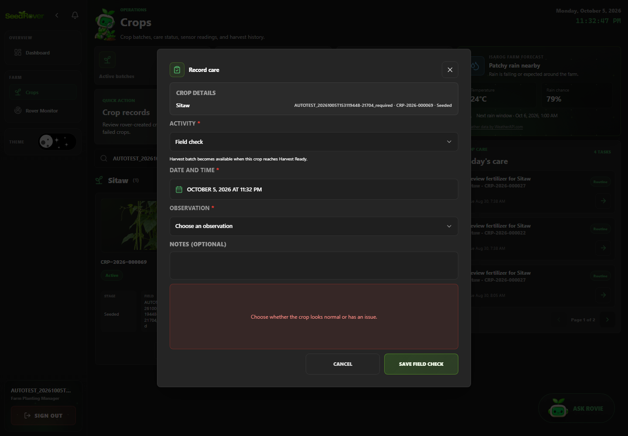
Figure 15. Missing field observation prevents saving care. Case SR-CROP-004; Playwright run 20261005T153119448-21704.
SR-CUST-001 | Completed sale appears in customer purchase history
Objective | Verify that completed sale appears in customer purchase history, then document the visible and persisted result supported by the test assertions.
Preconditions | Local production build running; target database host is the previously verified development/demo project; one Playwright worker; dedicated role session prepared.
Test Data | Synthetic data for run 20261005T153119448-21704; exact related labels and record IDs are listed in run-artifacts/20261005T153119448-21704/records.jsonl. Credentials are excluded.
Numbered Steps | 1. Use the case's declared role session and run-labelled fixture prepared by web-admin/e2e/support.ts.  2. Open /customers and perform: Completed sale appears in customer purchase history.  3. Check the visible or persisted outcome asserted in web-admin/e2e/tests/customers.spec.ts.  4. Compare the outcome with the named scenario; the run-specific fixture IDs are recorded in the run manifest.
Expected Result | Completed sale appears in customer purchase history. The observed behavior must match the specific assertions in web-admin/e2e/tests/customers.spec.ts; any database outcome is claimed only when that test reads it back.
Cleanup | Dedicated test accounts deactivated; labeled transactional/history rows retained under the run's exact-ID cleanup policy. See run-artifacts/20261005T153119448-21704/cleanup.json.
Actual Result | Passed; Playwright assertions completed in the named run. Persisted outcomes were independently checked where the test source performs database reads.
Evidence / Source | Evidence: run-artifacts/20261005T153119448-21704/html/index.html  Playwright source: web-admin/e2e/tests/customers.spec.ts
Case record | Module: Customers, discounts and payment records Role: Farm Inventory Manager, except the explicit staff-authorization case Priority: Medium Test type: Functional / authorization / validation as described by the scenario Method: Automated — Playwright Test / Chromium Automation status: Passed  Evidence: run-artifacts/20261005T153119448-21704/html/index.html  Source: web-admin/e2e/tests/customers.spec.ts

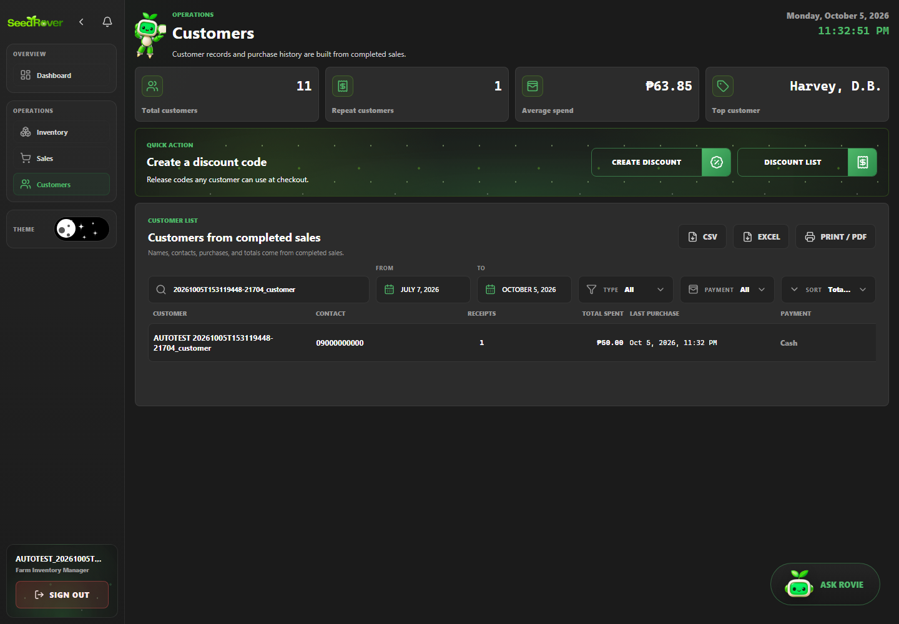
Figure 16. Completed sale appears in customer purchase history. Case SR-CUST-001; Playwright run 20261005T153119448-21704.
SR-CUST-002 | Create and apply a valid discount to a sale
Objective | Verify that create and apply a valid discount to a sale, then document the visible and persisted result supported by the test assertions.
Preconditions | Local production build running; target database host is the previously verified development/demo project; one Playwright worker; dedicated role session prepared.
Test Data | Create and release a 10% discount; apply to a PHP 100 subtotal; expected PHP 10 discount and PHP 90 total.
Numbered Steps | 1. Use the case's declared role session and run-labelled fixture prepared by web-admin/e2e/support.ts.  2. Open /customers and perform: Create and apply a valid discount to a sale.  3. Check the visible or persisted outcome asserted in web-admin/e2e/tests/customers.spec.ts.  4. Compare the outcome with the named scenario; the run-specific fixture IDs are recorded in the run manifest.
Expected Result | Create and apply a valid discount to a sale. The observed behavior must match the specific assertions in web-admin/e2e/tests/customers.spec.ts; any database outcome is claimed only when that test reads it back.
Cleanup | Dedicated test accounts deactivated; labeled transactional/history rows retained under the run's exact-ID cleanup policy. See run-artifacts/20261005T153119448-21704/cleanup.json.
Actual Result | Passed; Playwright assertions completed in the named run. Persisted outcomes were independently checked where the test source performs database reads.
Evidence / Source | Evidence: evidence/20261005T153119448-21704/SR-CUST-002_discounted-receipt.png  Playwright source: web-admin/e2e/tests/customers.spec.ts
Case record | Module: Customers, discounts and payment records Role: Farm Inventory Manager, except the explicit staff-authorization case Priority: Medium Test type: Functional / authorization / validation as described by the scenario Method: Automated — Playwright Test / Chromium Automation status: Passed  Evidence: evidence/20261005T153119448-21704/SR-CUST-002_discounted-receipt.png  Source: web-admin/e2e/tests/customers.spec.ts

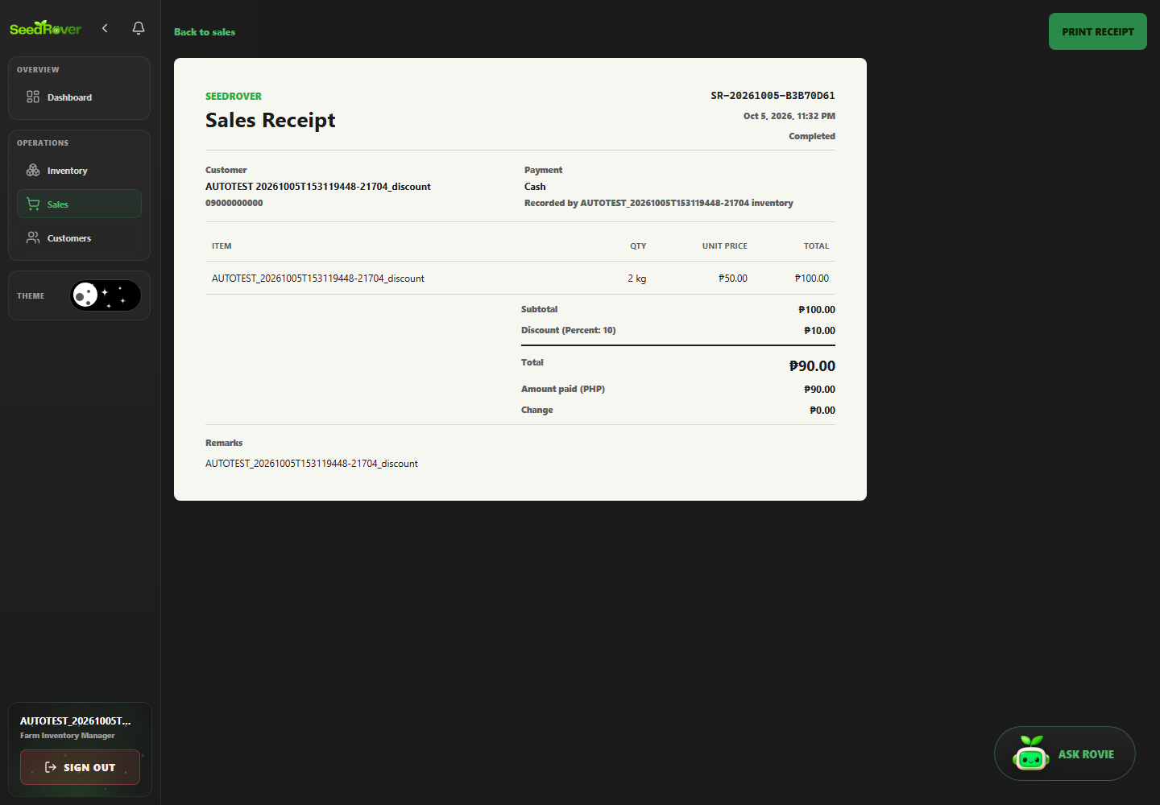
Figure 17. Released ten percent discount appears in the saved receipt. Case SR-CUST-002; Playwright run 20261005T153119448-21704.
SR-CUST-003 | Expired discount cannot be selected for a new sale
Objective | Verify that expired discount cannot be selected for a new sale, then document the visible and persisted result supported by the test assertions.
Preconditions | Local production build running; target database host is the previously verified development/demo project; one Playwright worker; dedicated role session prepared.
Test Data | Synthetic data for run 20261005T153119448-21704; exact related labels and record IDs are listed in run-artifacts/20261005T153119448-21704/records.jsonl. Credentials are excluded.
Numbered Steps | 1. Use the case's declared role session and run-labelled fixture prepared by web-admin/e2e/support.ts.  2. Open /customers and perform: Expired discount cannot be selected for a new sale.  3. Check the visible or persisted outcome asserted in web-admin/e2e/tests/customers.spec.ts.  4. Compare the outcome with the named scenario; the run-specific fixture IDs are recorded in the run manifest.
Expected Result | Expired discount cannot be selected for a new sale. The observed behavior must match the specific assertions in web-admin/e2e/tests/customers.spec.ts; any database outcome is claimed only when that test reads it back.
Cleanup | Dedicated test accounts deactivated; labeled transactional/history rows retained under the run's exact-ID cleanup policy. See run-artifacts/20261005T153119448-21704/cleanup.json.
Actual Result | Passed; Playwright assertions completed in the named run. Persisted outcomes were independently checked where the test source performs database reads.
Evidence / Source | Evidence: run-artifacts/20261005T153119448-21704/html/index.html  Playwright source: web-admin/e2e/tests/customers.spec.ts
Case record | Module: Customers, discounts and payment records Role: Farm Inventory Manager, except the explicit staff-authorization case Priority: Medium Test type: Functional / authorization / validation as described by the scenario Method: Automated — Playwright Test / Chromium Automation status: Passed  Evidence: run-artifacts/20261005T153119448-21704/html/index.html  Source: web-admin/e2e/tests/customers.spec.ts

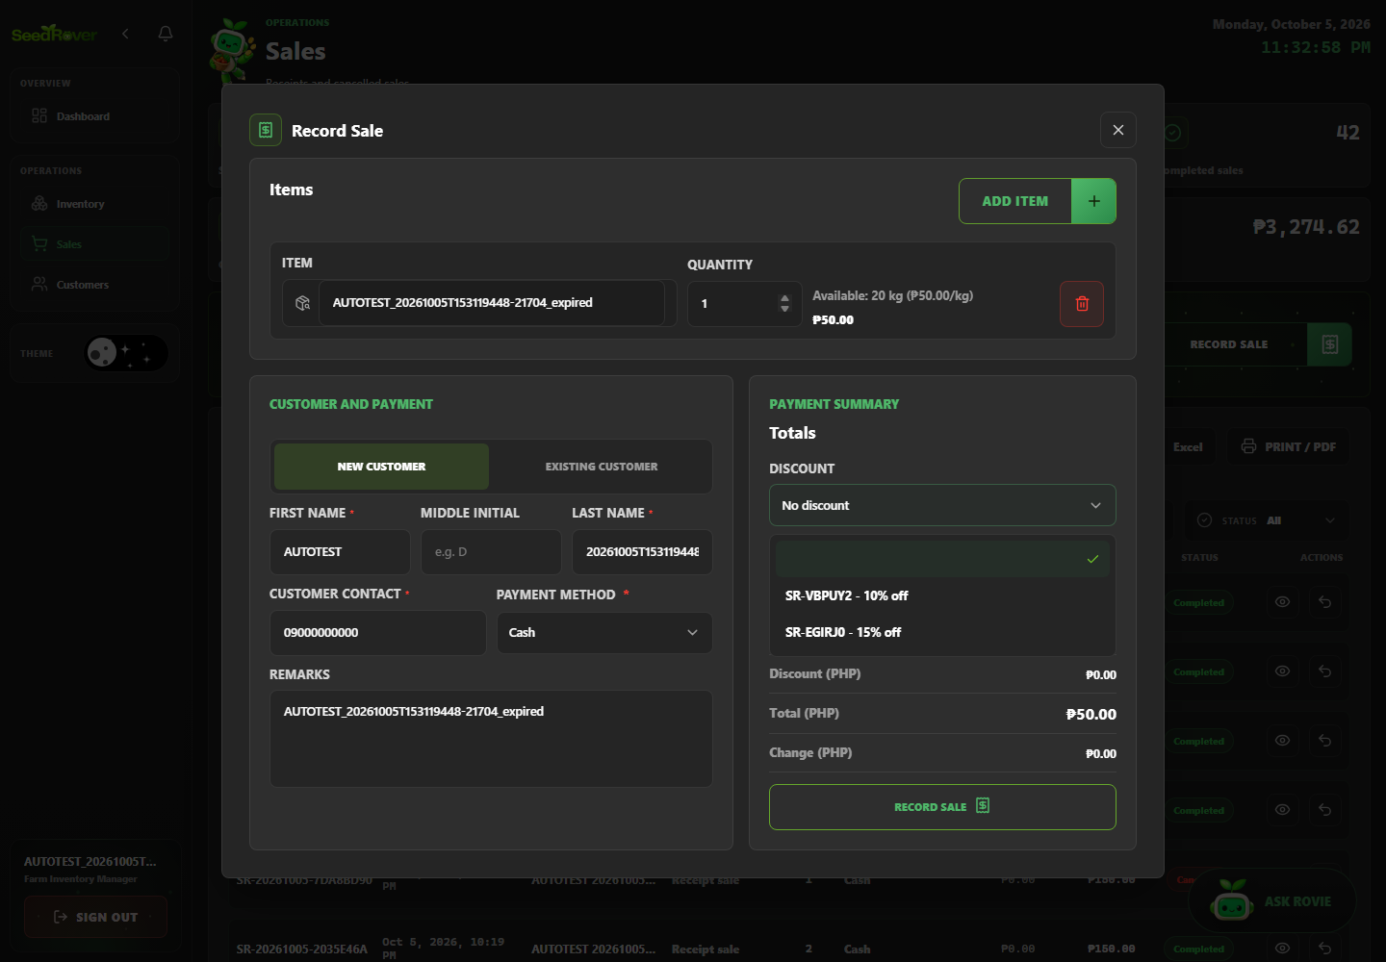
Figure 18. Expired discount cannot be selected for a new sale. Case SR-CUST-003; Playwright run 20261005T153119448-21704.
SR-DASH-001 | @smoke Dashboard loads and all period selectors work
Objective | Verify that @smoke Dashboard loads and all period selectors work, then document the visible and persisted result supported by the test assertions.
Preconditions | Local production build running; target database host is the previously verified development/demo project; one Playwright worker; dedicated role session prepared.
Test Data | Synthetic data for run 20261005T153119448-21704; exact related labels and record IDs are listed in run-artifacts/20261005T153119448-21704/records.jsonl. Credentials are excluded.
Numbered Steps | 1. Use the case's declared role session and run-labelled fixture prepared by web-admin/e2e/support.ts.  2. Open /dashboard and perform: @smoke Dashboard loads and all period selectors work.  3. Check the visible or persisted outcome asserted in web-admin/e2e/tests/dashboard-reports.spec.ts.  4. Compare the outcome with the named scenario; the run-specific fixture IDs are recorded in the run manifest.
Expected Result | @smoke Dashboard loads and all period selectors work. The observed behavior must match the specific assertions in web-admin/e2e/tests/dashboard-reports.spec.ts; any database outcome is claimed only when that test reads it back.
Cleanup | Dedicated test accounts deactivated; labeled transactional/history rows retained under the run's exact-ID cleanup policy. See run-artifacts/20261005T153119448-21704/cleanup.json.
Actual Result | Passed; Playwright assertions completed in the named run. Persisted outcomes were independently checked where the test source performs database reads.
Evidence / Source | Evidence: evidence/20261005T153119448-21704/SR-DASH-001_verified-result.png  Playwright source: web-admin/e2e/tests/dashboard-reports.spec.ts
Case record | Module: Dashboard and analytics Role: System Administrator Priority: Medium Test type: Functional / authorization / validation as described by the scenario Method: Automated — Playwright Test / Chromium Automation status: Passed  Evidence: evidence/20261005T153119448-21704/SR-DASH-001_verified-result.png  Source: web-admin/e2e/tests/dashboard-reports.spec.ts

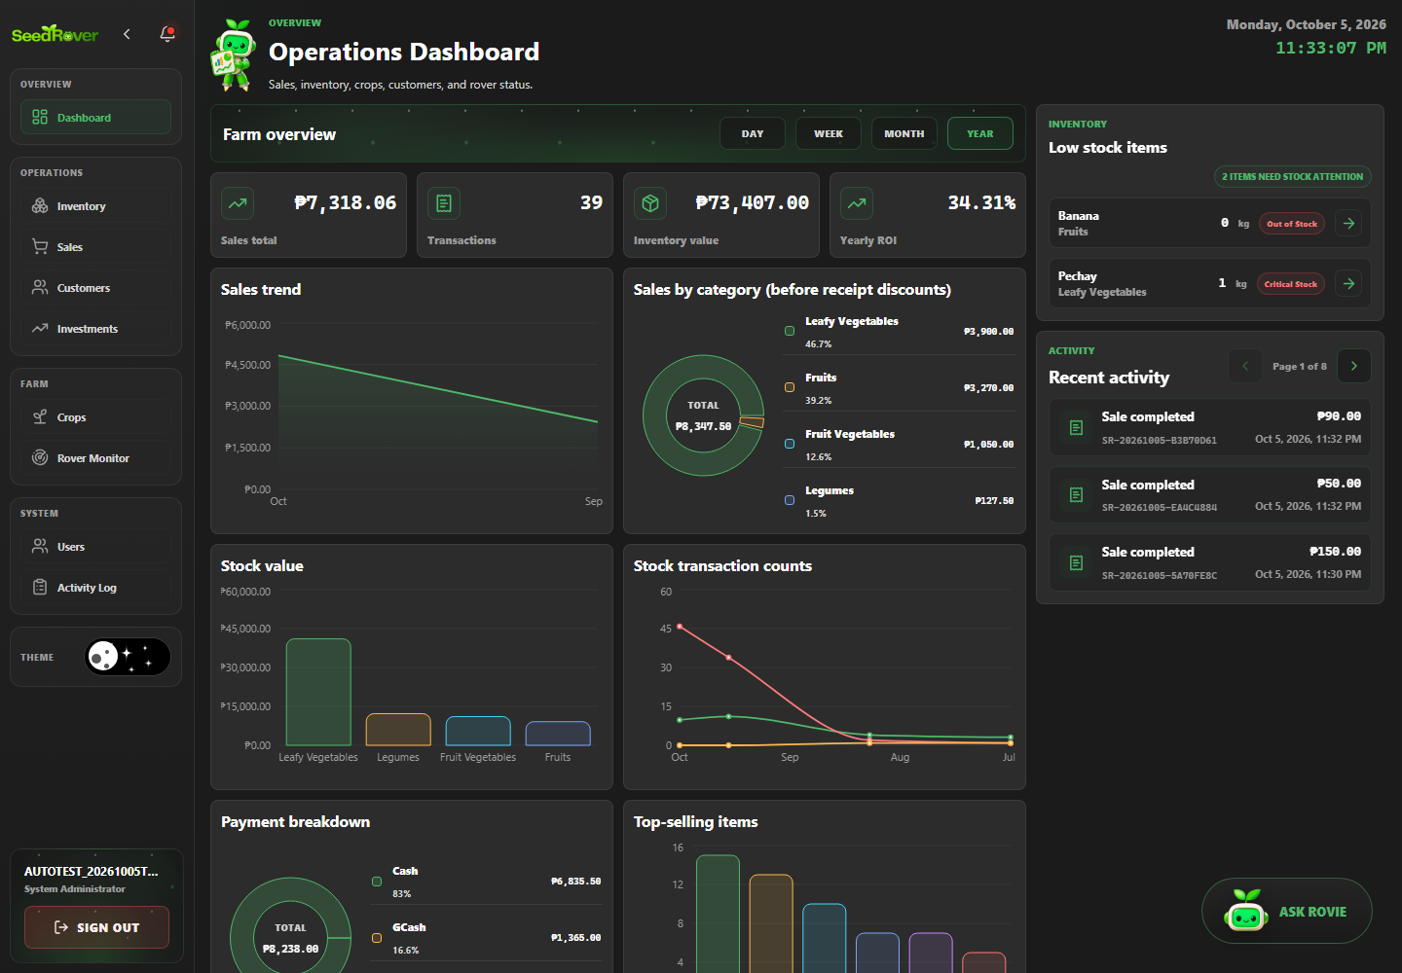
Figure 19. Dashboard period selectors respond in the local timezone. Case SR-DASH-001; Playwright run 20261005T153119448-21704.
SR-DASH-002 | Dashboard sales total increases by the controlled sale amount
Objective | Verify that dashboard sales total increases by the controlled sale amount, then document the visible and persisted result supported by the test assertions.
Preconditions | Local production build running; target database host is the previously verified development/demo project; one Playwright worker; dedicated role session prepared.
Test Data | Capture baseline daily sales total; add a controlled PHP 100 test sale; reconcile the delta.
Numbered Steps | 1. Use the case's declared role session and run-labelled fixture prepared by web-admin/e2e/support.ts.  2. Open /dashboard and perform: Dashboard sales total increases by the controlled sale amount.  3. Check the visible or persisted outcome asserted in web-admin/e2e/tests/dashboard-reports.spec.ts.  4. Compare the outcome with the named scenario; the run-specific fixture IDs are recorded in the run manifest.
Expected Result | Dashboard sales total increases by the controlled sale amount. The observed behavior must match the specific assertions in web-admin/e2e/tests/dashboard-reports.spec.ts; any database outcome is claimed only when that test reads it back.
Cleanup | Dedicated test accounts deactivated; labeled transactional/history rows retained under the run's exact-ID cleanup policy. See run-artifacts/20261005T153119448-21704/cleanup.json.
Actual Result | Passed; Playwright assertions completed in the named run. Persisted outcomes were independently checked where the test source performs database reads.
Evidence / Source | Evidence: evidence/20261005T153119448-21704/SR-DASH-002_verified-result.png  Playwright source: web-admin/e2e/tests/dashboard-reports.spec.ts
Case record | Module: Dashboard and analytics Role: System Administrator Priority: Medium Test type: Functional / authorization / validation as described by the scenario Method: Automated — Playwright Test / Chromium Automation status: Passed  Evidence: evidence/20261005T153119448-21704/SR-DASH-002_verified-result.png  Source: web-admin/e2e/tests/dashboard-reports.spec.ts

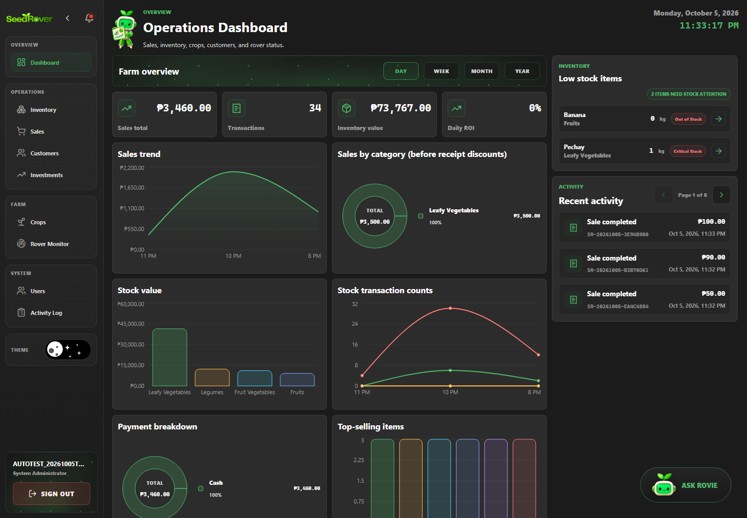
Figure 20. A controlled sale reconciles against the dashboard baseline. Case SR-DASH-002; Playwright run 20261005T153119448-21704.
SR-DASH-003 | Empty customer search displays an explicit empty state
Objective | Verify that empty customer search displays an explicit empty state, then document the visible and persisted result supported by the test assertions.
Preconditions | Local production build running; target database host is the previously verified development/demo project; one Playwright worker; dedicated role session prepared.
Test Data | Synthetic data for run 20261005T153119448-21704; exact related labels and record IDs are listed in run-artifacts/20261005T153119448-21704/records.jsonl. Credentials are excluded.
Numbered Steps | 1. Use the case's declared role session and run-labelled fixture prepared by web-admin/e2e/support.ts.  2. Open /dashboard and perform: Empty customer search displays an explicit empty state.  3. Check the visible or persisted outcome asserted in web-admin/e2e/tests/dashboard-reports.spec.ts.  4. Compare the outcome with the named scenario; the run-specific fixture IDs are recorded in the run manifest.
Expected Result | Empty customer search displays an explicit empty state. The observed behavior must match the specific assertions in web-admin/e2e/tests/dashboard-reports.spec.ts; any database outcome is claimed only when that test reads it back.
Cleanup | Dedicated test accounts deactivated; labeled transactional/history rows retained under the run's exact-ID cleanup policy. See run-artifacts/20261005T153119448-21704/cleanup.json.
Actual Result | Passed; Playwright assertions completed in the named run. Persisted outcomes were independently checked where the test source performs database reads.
Evidence / Source | Evidence: run-artifacts/20261005T153119448-21704/html/index.html  Playwright source: web-admin/e2e/tests/dashboard-reports.spec.ts
Case record | Module: Dashboard and analytics Role: System Administrator Priority: Medium Test type: Functional / authorization / validation as described by the scenario Method: Automated — Playwright Test / Chromium Automation status: Passed  Evidence: run-artifacts/20261005T153119448-21704/html/index.html  Source: web-admin/e2e/tests/dashboard-reports.spec.ts

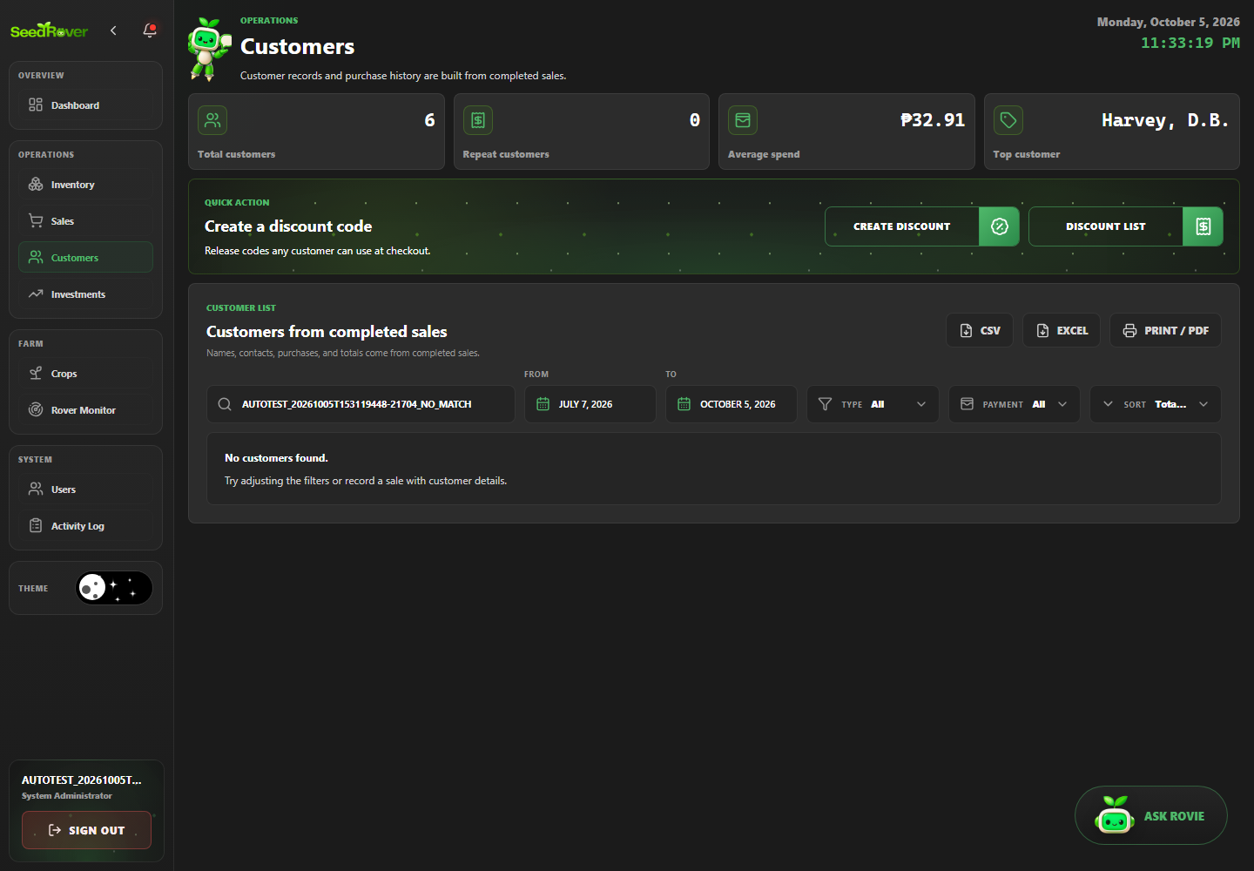
Figure 21. Empty customer search displays an explicit empty state. Case SR-DASH-003; Playwright run 20261005T153119448-21704.
SR-REPORT-001 | Inventory CSV contains headers and exact fixture values
Objective | Verify that inventory CSV contains headers and exact fixture values, then document the visible and persisted result supported by the test assertions.
Preconditions | Local production build running; target database host is the previously verified development/demo project; one Playwright worker; dedicated role session prepared.
Test Data | Synthetic data for run 20261005T153119448-21704; exact related labels and record IDs are listed in run-artifacts/20261005T153119448-21704/records.jsonl. Credentials are excluded.
Numbered Steps | 1. Use the case's declared role session and run-labelled fixture prepared by web-admin/e2e/support.ts.  2. Open authenticated report route and perform: Inventory CSV contains headers and exact fixture values.  3. Check the visible or persisted outcome asserted in web-admin/e2e/tests/dashboard-reports.spec.ts.  4. Compare the outcome with the named scenario; the run-specific fixture IDs are recorded in the run manifest.
Expected Result | Inventory CSV contains headers and exact fixture values. The observed behavior must match the specific assertions in web-admin/e2e/tests/dashboard-reports.spec.ts; any database outcome is claimed only when that test reads it back.
Cleanup | Dedicated test accounts deactivated; labeled transactional/history rows retained under the run's exact-ID cleanup policy. See run-artifacts/20261005T153119448-21704/cleanup.json.
Actual Result | Passed; Playwright assertions completed in the named run. Persisted outcomes were independently checked where the test source performs database reads.
Evidence / Source | Evidence: run-artifacts/20261005T153119448-21704/html/index.html  Playwright source: web-admin/e2e/tests/dashboard-reports.spec.ts
Case record | Module: Reports, exports and print views Role: System Administrator Priority: Medium Test type: Functional / authorization / validation as described by the scenario Method: Automated — Playwright Test / Chromium Automation status: Passed  Evidence: run-artifacts/20261005T153119448-21704/html/index.html  Source: web-admin/e2e/tests/dashboard-reports.spec.ts

SR-REPORT-002 | Sales CSV respects date filters and includes the new receipt
Objective | Verify that sales CSV respects date filters and includes the new receipt, then document the visible and persisted result supported by the test assertions.
Preconditions | Local production build running; target database host is the previously verified development/demo project; one Playwright worker; dedicated role session prepared.
Test Data | Synthetic data for run 20261005T153119448-21704; exact related labels and record IDs are listed in run-artifacts/20261005T153119448-21704/records.jsonl. Credentials are excluded.
Numbered Steps | 1. Use the case's declared role session and run-labelled fixture prepared by web-admin/e2e/support.ts.  2. Open authenticated report route and perform: Sales CSV respects date filters and includes the new receipt.  3. Check the visible or persisted outcome asserted in web-admin/e2e/tests/dashboard-reports.spec.ts.  4. Compare the outcome with the named scenario; the run-specific fixture IDs are recorded in the run manifest.
Expected Result | Sales CSV respects date filters and includes the new receipt. The observed behavior must match the specific assertions in web-admin/e2e/tests/dashboard-reports.spec.ts; any database outcome is claimed only when that test reads it back.
Cleanup | Dedicated test accounts deactivated; labeled transactional/history rows retained under the run's exact-ID cleanup policy. See run-artifacts/20261005T153119448-21704/cleanup.json.
Actual Result | Passed; Playwright assertions completed in the named run. Persisted outcomes were independently checked where the test source performs database reads.
Evidence / Source | Evidence: run-artifacts/20261005T153119448-21704/html/index.html  Playwright source: web-admin/e2e/tests/dashboard-reports.spec.ts
Case record | Module: Reports, exports and print views Role: System Administrator Priority: Medium Test type: Functional / authorization / validation as described by the scenario Method: Automated — Playwright Test / Chromium Automation status: Passed  Evidence: run-artifacts/20261005T153119448-21704/html/index.html  Source: web-admin/e2e/tests/dashboard-reports.spec.ts

SR-REPORT-003 | Receipt and report print views render their fixture data
Objective | Verify that receipt and report print views render their fixture data, then document the visible and persisted result supported by the test assertions.
Preconditions | Local production build running; target database host is the previously verified development/demo project; one Playwright worker; dedicated role session prepared.
Test Data | Synthetic data for run 20261005T153119448-21704; exact related labels and record IDs are listed in run-artifacts/20261005T153119448-21704/records.jsonl. Credentials are excluded.
Numbered Steps | 1. Use the case's declared role session and run-labelled fixture prepared by web-admin/e2e/support.ts.  2. Open authenticated report route and perform: Receipt and report print views render their fixture data.  3. Check the visible or persisted outcome asserted in web-admin/e2e/tests/dashboard-reports.spec.ts.  4. Compare the outcome with the named scenario; the run-specific fixture IDs are recorded in the run manifest.
Expected Result | Receipt and report print views render their fixture data. The observed behavior must match the specific assertions in web-admin/e2e/tests/dashboard-reports.spec.ts; any database outcome is claimed only when that test reads it back.
Cleanup | Dedicated test accounts deactivated; labeled transactional/history rows retained under the run's exact-ID cleanup policy. See run-artifacts/20261005T153119448-21704/cleanup.json.
Actual Result | Passed; Playwright assertions completed in the named run. Persisted outcomes were independently checked where the test source performs database reads.
Evidence / Source | Evidence: evidence/20261005T153119448-21704/SR-REPORT-003_verified-result.png  Playwright source: web-admin/e2e/tests/dashboard-reports.spec.ts
Case record | Module: Reports, exports and print views Role: System Administrator Priority: Medium Test type: Functional / authorization / validation as described by the scenario Method: Automated — Playwright Test / Chromium Automation status: Passed  Evidence: evidence/20261005T153119448-21704/SR-REPORT-003_verified-result.png  Source: web-admin/e2e/tests/dashboard-reports.spec.ts

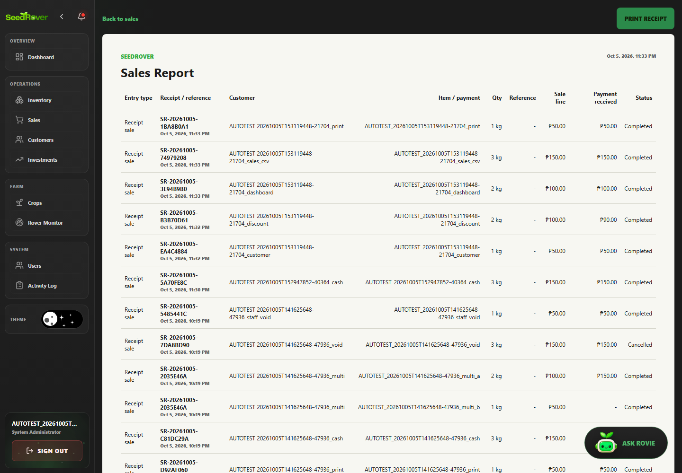
Figure 22. Receipt and sales print view render test sale data. Case SR-REPORT-003; Playwright run 20261005T153119448-21704.
SR-INV-001 | @smoke Inventory displays a persisted test item
Objective | Verify that @smoke Inventory displays a persisted test item, then document the visible and persisted result supported by the test assertions.
Preconditions | Local production build running; target database host is the previously verified development/demo project; one Playwright worker; dedicated role session prepared.
Test Data | Synthetic data for run 20261005T153119448-21704; exact related labels and record IDs are listed in run-artifacts/20261005T153119448-21704/records.jsonl. Credentials are excluded.
Numbered Steps | 1. Use the case's declared role session and run-labelled fixture prepared by web-admin/e2e/support.ts.  2. Open /inventory and perform: @smoke Inventory displays a persisted test item.  3. Check the visible or persisted outcome asserted in web-admin/e2e/tests/inventory.spec.ts.  4. Compare the outcome with the named scenario; the run-specific fixture IDs are recorded in the run manifest.
Expected Result | @smoke Inventory displays a persisted test item. The observed behavior must match the specific assertions in web-admin/e2e/tests/inventory.spec.ts; any database outcome is claimed only when that test reads it back.
Cleanup | Dedicated test accounts deactivated; labeled transactional/history rows retained under the run's exact-ID cleanup policy. See run-artifacts/20261005T153119448-21704/cleanup.json.
Actual Result | Passed; Playwright assertions completed in the named run. Persisted outcomes were independently checked where the test source performs database reads.
Evidence / Source | Evidence: run-artifacts/20261005T153119448-21704/html/index.html  Playwright source: web-admin/e2e/tests/inventory.spec.ts
Case record | Module: Inventory catalogue Role: Farm Inventory Manager, except the explicit staff-authorization case Priority: High Test type: Functional / authorization / validation as described by the scenario Method: Automated — Playwright Test / Chromium Automation status: Passed  Evidence: run-artifacts/20261005T153119448-21704/html/index.html  Source: web-admin/e2e/tests/inventory.spec.ts

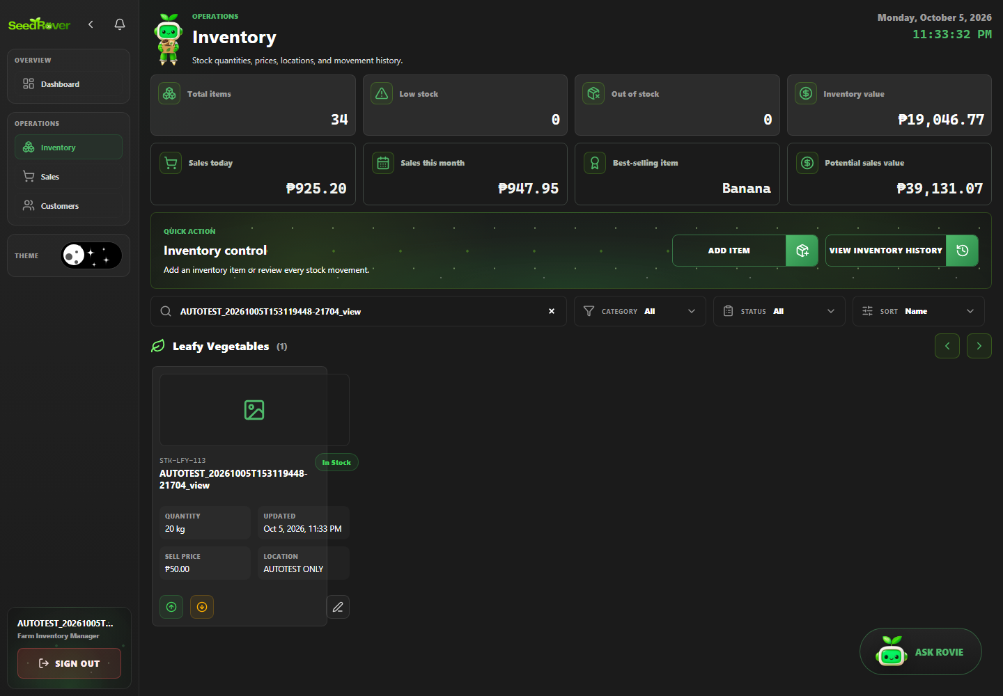
Figure 23. @smoke Inventory displays a persisted test item. Case SR-INV-001; Playwright run 20261005T153119448-21704.
SR-INV-002 | Create inventory item through UI and verify persistence
Objective | Verify that create inventory item through UI and verify persistence, then document the visible and persisted result supported by the test assertions.
Preconditions | Local production build running; target database host is the previously verified development/demo project; one Playwright worker; dedicated role session prepared.
Test Data | Synthetic data for run 20261005T153119448-21704; exact related labels and record IDs are listed in run-artifacts/20261005T153119448-21704/records.jsonl. Credentials are excluded.
Numbered Steps | 1. Use the case's declared role session and run-labelled fixture prepared by web-admin/e2e/support.ts.  2. Open /inventory and perform: Create inventory item through UI and verify persistence.  3. Check the visible or persisted outcome asserted in web-admin/e2e/tests/inventory.spec.ts.  4. Compare the outcome with the named scenario; the run-specific fixture IDs are recorded in the run manifest.
Expected Result | Create inventory item through UI and verify persistence. The observed behavior must match the specific assertions in web-admin/e2e/tests/inventory.spec.ts; any database outcome is claimed only when that test reads it back.
Cleanup | Dedicated test accounts deactivated; labeled transactional/history rows retained under the run's exact-ID cleanup policy. See run-artifacts/20261005T153119448-21704/cleanup.json.
Actual Result | Passed; Playwright assertions completed in the named run. Persisted outcomes were independently checked where the test source performs database reads.
Evidence / Source | Evidence: evidence/20261005T153119448-21704/SR-INV-002_verified-result.png  Playwright source: web-admin/e2e/tests/inventory.spec.ts
Case record | Module: Inventory catalogue Role: Farm Inventory Manager, except the explicit staff-authorization case Priority: High Test type: Functional / authorization / validation as described by the scenario Method: Automated — Playwright Test / Chromium Automation status: Passed  Evidence: evidence/20261005T153119448-21704/SR-INV-002_verified-result.png  Source: web-admin/e2e/tests/inventory.spec.ts

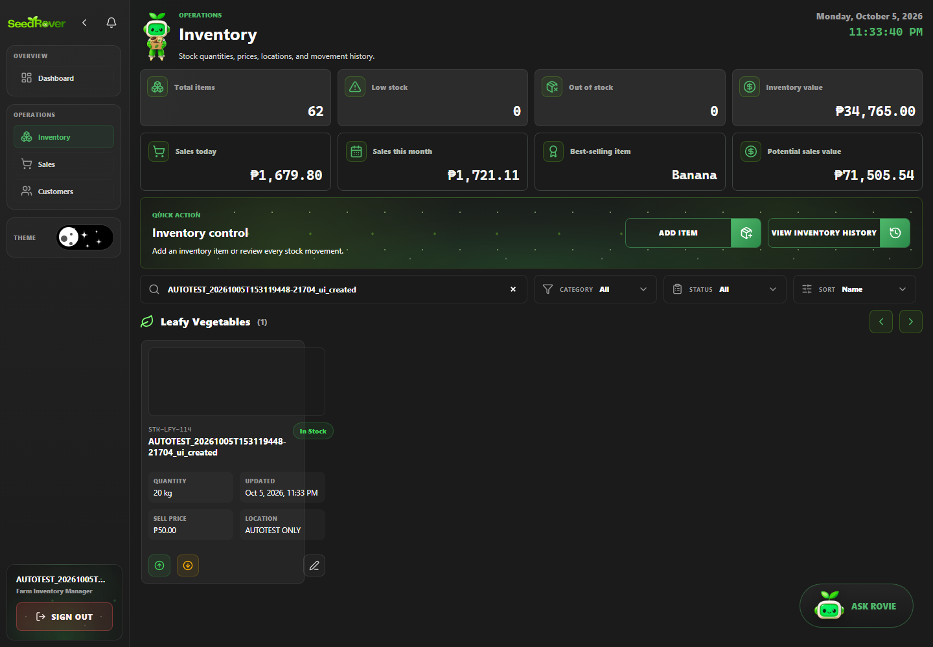
Figure 24. An AUTOTEST inventory item is saved and found after reload. Case SR-INV-002; Playwright run 20261005T153119448-21704.
SR-INV-003 | Edit inventory location and verify after reload
Objective | Verify that edit inventory location and verify after reload, then document the visible and persisted result supported by the test assertions.
Preconditions | Local production build running; target database host is the previously verified development/demo project; one Playwright worker; dedicated role session prepared.
Test Data | Synthetic data for run 20261005T153119448-21704; exact related labels and record IDs are listed in run-artifacts/20261005T153119448-21704/records.jsonl. Credentials are excluded.
Numbered Steps | 1. Use the case's declared role session and run-labelled fixture prepared by web-admin/e2e/support.ts.  2. Open /inventory and perform: Edit inventory location and verify after reload.  3. Check the visible or persisted outcome asserted in web-admin/e2e/tests/inventory.spec.ts.  4. Compare the outcome with the named scenario; the run-specific fixture IDs are recorded in the run manifest.
Expected Result | Edit inventory location and verify after reload. The observed behavior must match the specific assertions in web-admin/e2e/tests/inventory.spec.ts; any database outcome is claimed only when that test reads it back.
Cleanup | Dedicated test accounts deactivated; labeled transactional/history rows retained under the run's exact-ID cleanup policy. See run-artifacts/20261005T153119448-21704/cleanup.json.
Actual Result | Passed; Playwright assertions completed in the named run. Persisted outcomes were independently checked where the test source performs database reads.
Evidence / Source | Evidence: run-artifacts/20261005T153119448-21704/html/index.html  Playwright source: web-admin/e2e/tests/inventory.spec.ts
Case record | Module: Inventory catalogue Role: Farm Inventory Manager, except the explicit staff-authorization case Priority: High Test type: Functional / authorization / validation as described by the scenario Method: Automated — Playwright Test / Chromium Automation status: Passed  Evidence: run-artifacts/20261005T153119448-21704/html/index.html  Source: web-admin/e2e/tests/inventory.spec.ts

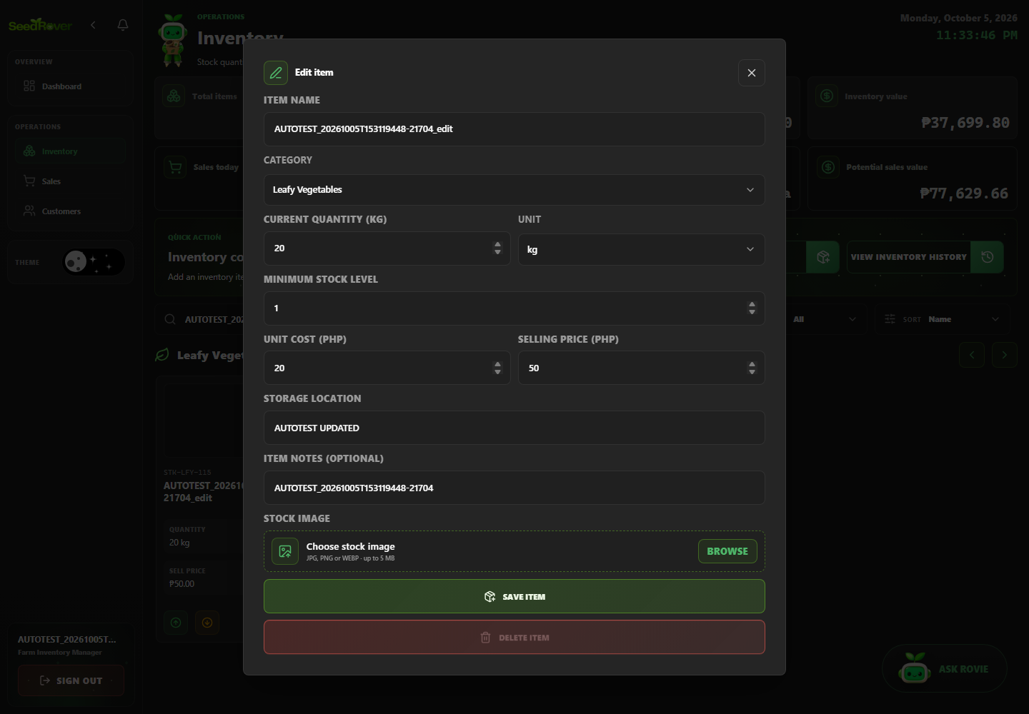
Figure 25. Edit inventory location and verify after reload. Case SR-INV-003; Playwright run 20261005T153119448-21704.
SR-INV-004 | Receive stock updates balance and movement history
Objective | Verify that receive stock updates balance and movement history, then document the visible and persisted result supported by the test assertions.
Preconditions | Local production build running; target database host is the previously verified development/demo project; one Playwright worker; dedicated role session prepared.
Test Data | 20 kg opening balance; receive 5 kg from Field Crate; expected 25 kg and one IN row.
Numbered Steps | 1. Use the case's declared role session and run-labelled fixture prepared by web-admin/e2e/support.ts.  2. Open /inventory and perform: Receive stock updates balance and movement history.  3. Check the visible or persisted outcome asserted in web-admin/e2e/tests/inventory.spec.ts.  4. Compare the outcome with the named scenario; the run-specific fixture IDs are recorded in the run manifest.
Expected Result | Receive stock updates balance and movement history. The observed behavior must match the specific assertions in web-admin/e2e/tests/inventory.spec.ts; any database outcome is claimed only when that test reads it back.
Cleanup | Dedicated test accounts deactivated; labeled transactional/history rows retained under the run's exact-ID cleanup policy. See run-artifacts/20261005T153119448-21704/cleanup.json.
Actual Result | Passed; Playwright assertions completed in the named run. Persisted outcomes were independently checked where the test source performs database reads.
Evidence / Source | Evidence: evidence/20261005T153119448-21704/SR-INV-004_verified-result.png  Playwright source: web-admin/e2e/tests/inventory.spec.ts
Case record | Module: Inventory catalogue Role: Farm Inventory Manager, except the explicit staff-authorization case Priority: High Test type: Functional / authorization / validation as described by the scenario Method: Automated — Playwright Test / Chromium Automation status: Passed  Evidence: evidence/20261005T153119448-21704/SR-INV-004_verified-result.png  Source: web-admin/e2e/tests/inventory.spec.ts

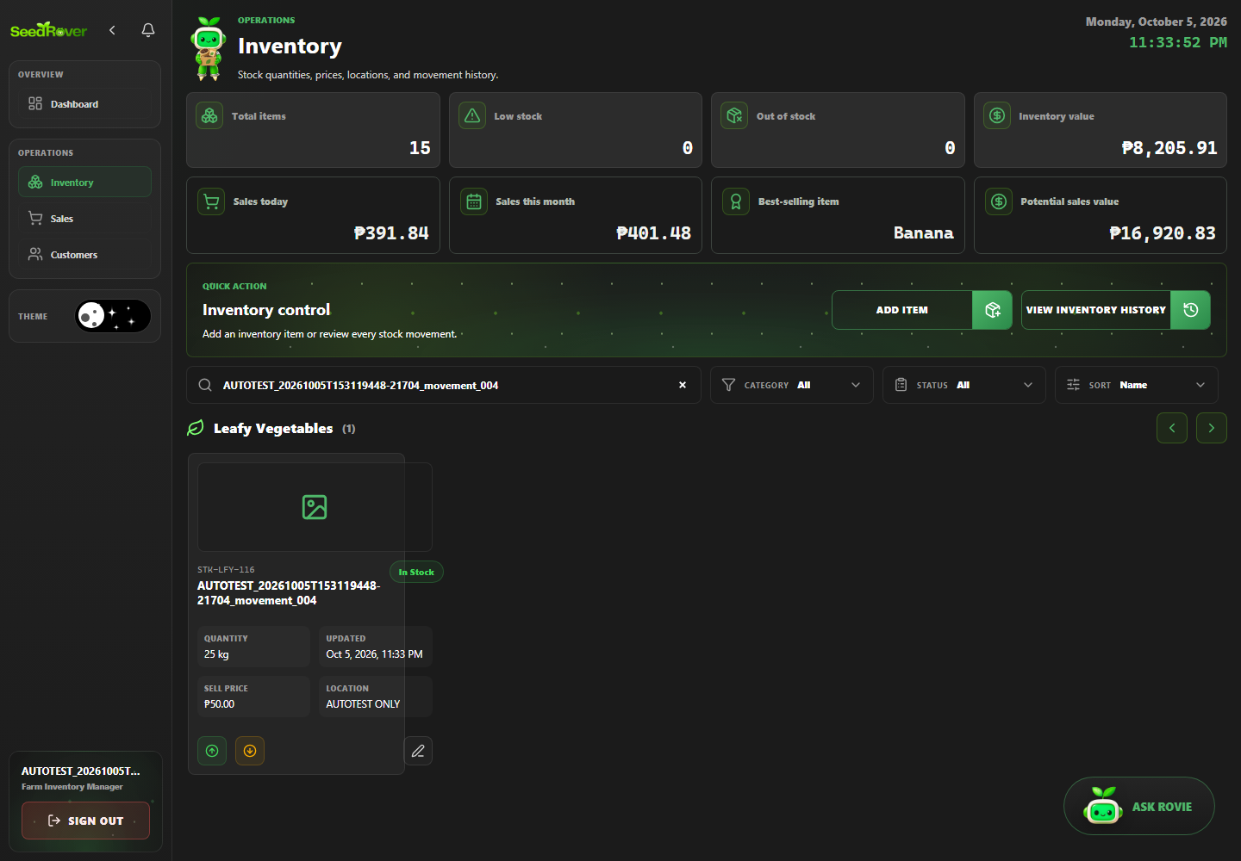
Figure 26. Receiving five kilograms updates stock and movement history. Case SR-INV-004; Playwright run 20261005T153119448-21704.
SR-INV-005 | Issue stock updates balance and movement history
Objective | Verify that issue stock updates balance and movement history, then document the visible and persisted result supported by the test assertions.
Preconditions | Local production build running; target database host is the previously verified development/demo project; one Playwright worker; dedicated role session prepared.
Test Data | 20 kg opening balance; issue 3 kg for Kitchen Preparation; expected 17 kg and one OUT row.
Numbered Steps | 1. Use the case's declared role session and run-labelled fixture prepared by web-admin/e2e/support.ts.  2. Open /inventory and perform: Issue stock updates balance and movement history.  3. Check the visible or persisted outcome asserted in web-admin/e2e/tests/inventory.spec.ts.  4. Compare the outcome with the named scenario; the run-specific fixture IDs are recorded in the run manifest.
Expected Result | Issue stock updates balance and movement history. The observed behavior must match the specific assertions in web-admin/e2e/tests/inventory.spec.ts; any database outcome is claimed only when that test reads it back.
Cleanup | Dedicated test accounts deactivated; labeled transactional/history rows retained under the run's exact-ID cleanup policy. See run-artifacts/20261005T153119448-21704/cleanup.json.
Actual Result | Passed; Playwright assertions completed in the named run. Persisted outcomes were independently checked where the test source performs database reads.
Evidence / Source | Evidence: run-artifacts/20261005T153119448-21704/html/index.html  Playwright source: web-admin/e2e/tests/inventory.spec.ts
Case record | Module: Inventory catalogue Role: Farm Inventory Manager, except the explicit staff-authorization case Priority: High Test type: Functional / authorization / validation as described by the scenario Method: Automated — Playwright Test / Chromium Automation status: Passed  Evidence: run-artifacts/20261005T153119448-21704/html/index.html  Source: web-admin/e2e/tests/inventory.spec.ts

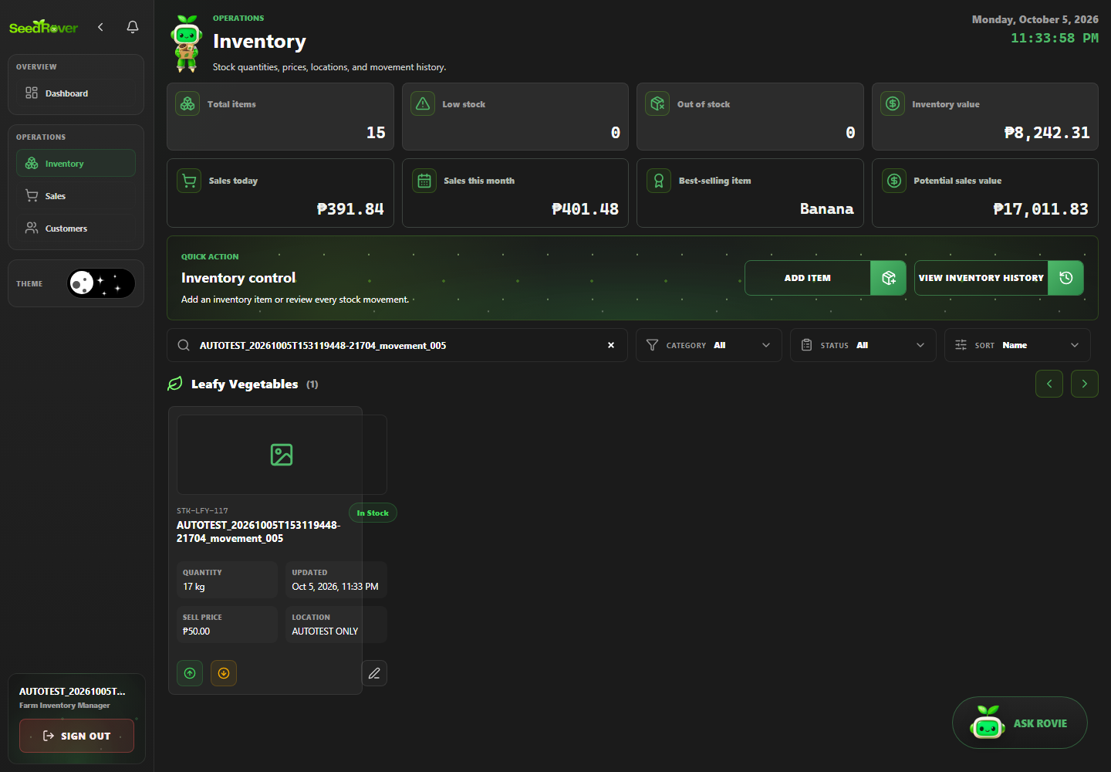
Figure 27. Issue stock updates balance and movement history. Case SR-INV-005; Playwright run 20261005T153119448-21704.
SR-INV-006 | Insufficient stock issue is rejected without changing balance
Objective | Verify that insufficient stock issue is rejected without changing balance, then document the visible and persisted result supported by the test assertions.
Preconditions | Local production build running; target database host is the previously verified development/demo project; one Playwright worker; dedicated role session prepared.
Test Data | 2 kg available; request issue of 3 kg; expected actionable error and persisted balance unchanged.
Numbered Steps | 1. Use the case's declared role session and run-labelled fixture prepared by web-admin/e2e/support.ts.  2. Open /inventory and perform: Insufficient stock issue is rejected without changing balance.  3. Check the visible or persisted outcome asserted in web-admin/e2e/tests/inventory.spec.ts.  4. Compare the outcome with the named scenario; the run-specific fixture IDs are recorded in the run manifest.
Expected Result | Insufficient stock issue is rejected without changing balance. The observed behavior must match the specific assertions in web-admin/e2e/tests/inventory.spec.ts; any database outcome is claimed only when that test reads it back.
Cleanup | Dedicated test accounts deactivated; labeled transactional/history rows retained under the run's exact-ID cleanup policy. See run-artifacts/20261005T153119448-21704/cleanup.json.
Actual Result | Passed; Playwright assertions completed in the named run. Persisted outcomes were independently checked where the test source performs database reads.
Evidence / Source | Evidence: evidence/20261005T153119448-21704/SR-INV-006_verified-result.png  Playwright source: web-admin/e2e/tests/inventory.spec.ts
Case record | Module: Inventory catalogue Role: Farm Inventory Manager, except the explicit staff-authorization case Priority: High Test type: Functional / authorization / validation as described by the scenario Method: Automated — Playwright Test / Chromium Automation status: Passed  Evidence: evidence/20261005T153119448-21704/SR-INV-006_verified-result.png  Source: web-admin/e2e/tests/inventory.spec.ts

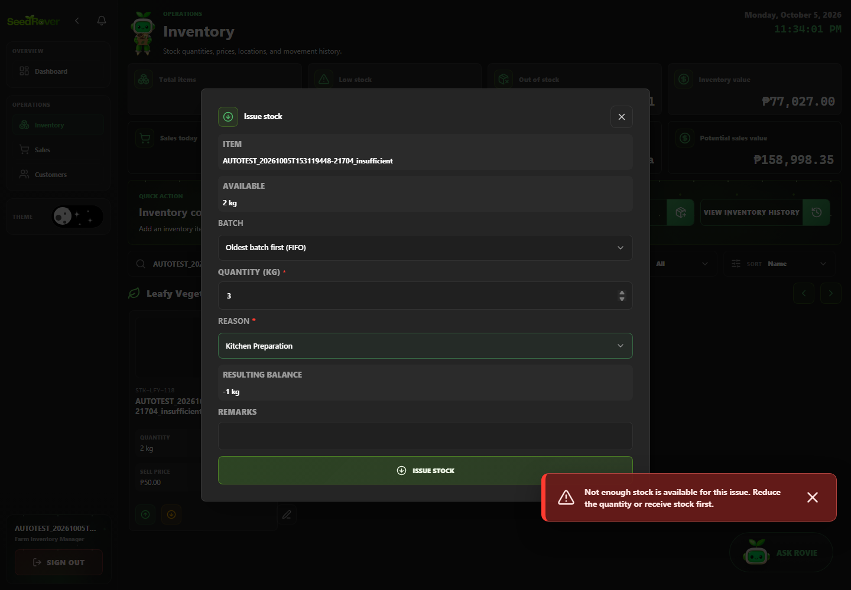
Figure 28. Insufficient stock displays guidance and preserves the two kilogram balance. Case SR-INV-006; Playwright run 20261005T153119448-21704.
SR-INV-007 | Negative selling price is rejected
Objective | Verify that negative selling price is rejected, then document the visible and persisted result supported by the test assertions.
Preconditions | Local production build running; target database host is the previously verified development/demo project; one Playwright worker; dedicated role session prepared.
Test Data | Synthetic data for run 20261005T153119448-21704; exact related labels and record IDs are listed in run-artifacts/20261005T153119448-21704/records.jsonl. Credentials are excluded.
Numbered Steps | 1. Use the case's declared role session and run-labelled fixture prepared by web-admin/e2e/support.ts.  2. Open /inventory and perform: Negative selling price is rejected.  3. Check the visible or persisted outcome asserted in web-admin/e2e/tests/inventory.spec.ts.  4. Compare the outcome with the named scenario; the run-specific fixture IDs are recorded in the run manifest.
Expected Result | Negative selling price is rejected. The observed behavior must match the specific assertions in web-admin/e2e/tests/inventory.spec.ts; any database outcome is claimed only when that test reads it back.
Cleanup | Dedicated test accounts deactivated; labeled transactional/history rows retained under the run's exact-ID cleanup policy. See run-artifacts/20261005T153119448-21704/cleanup.json.
Actual Result | Passed; Playwright assertions completed in the named run. Weak assertion: the test edits the control but does not submit the form. It confirms the UI value is non-negative or HTML validity blocks it, then reads the unchanged database price; it does not prove server-side negative-price rejection.
Evidence / Source | Evidence: run-artifacts/20261005T153119448-21704/html/index.html  Playwright source: web-admin/e2e/tests/inventory.spec.ts
Case record | Module: Inventory catalogue Role: Farm Inventory Manager, except the explicit staff-authorization case Priority: High Test type: Functional / authorization / validation as described by the scenario Method: Automated — Playwright Test / Chromium Automation status: Passed  Evidence: run-artifacts/20261005T153119448-21704/html/index.html  Source: web-admin/e2e/tests/inventory.spec.ts

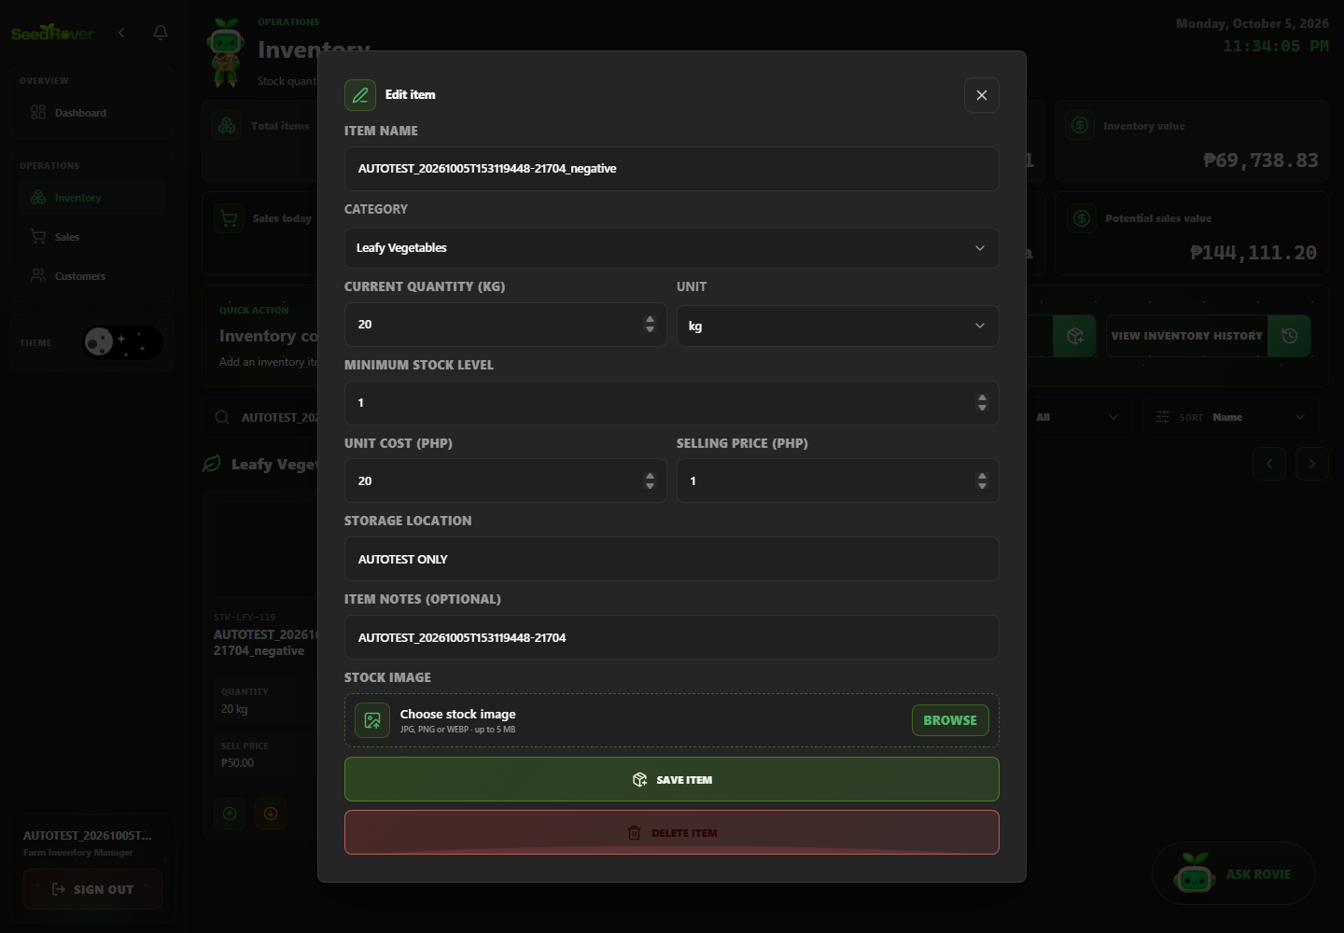
Figure 29. Negative selling price is rejected. Case SR-INV-007; Playwright run 20261005T153119448-21704.
SR-OBS-001 | Mark a dedicated notification read and verify persistence
Objective | Verify that mark a dedicated notification read and verify persistence, then document the visible and persisted result supported by the test assertions.
Preconditions | Local production build running; target database host is the previously verified development/demo project; one Playwright worker; dedicated role session prepared.
Test Data | Synthetic data for run 20261005T153119448-21704; exact related labels and record IDs are listed in run-artifacts/20261005T153119448-21704/records.jsonl. Credentials are excluded.
Numbered Steps | 1. Use the case's declared role session and run-labelled fixture prepared by web-admin/e2e/support.ts.  2. Open notifications, activity log or rover monitor and perform: Mark a dedicated notification read and verify persistence.  3. Check the visible or persisted outcome asserted in web-admin/e2e/tests/monitoring.spec.ts.  4. Compare the outcome with the named scenario; the run-specific fixture IDs are recorded in the run manifest.
Expected Result | Mark a dedicated notification read and verify persistence. The observed behavior must match the specific assertions in web-admin/e2e/tests/monitoring.spec.ts; any database outcome is claimed only when that test reads it back.
Cleanup | Dedicated test accounts deactivated; labeled transactional/history rows retained under the run's exact-ID cleanup policy. See run-artifacts/20261005T153119448-21704/cleanup.json.
Actual Result | Passed; Playwright assertions completed in the named run. Persisted outcomes were independently checked where the test source performs database reads.
Evidence / Source | Evidence: run-artifacts/20261005T153119448-21704/html/index.html  Playwright source: web-admin/e2e/tests/monitoring.spec.ts
Case record | Module: Notifications and activity history Role: System Administrator Priority: Medium Test type: Functional / authorization / validation as described by the scenario Method: Automated — Playwright Test / Chromium Automation status: Passed  Evidence: run-artifacts/20261005T153119448-21704/html/index.html  Source: web-admin/e2e/tests/monitoring.spec.ts

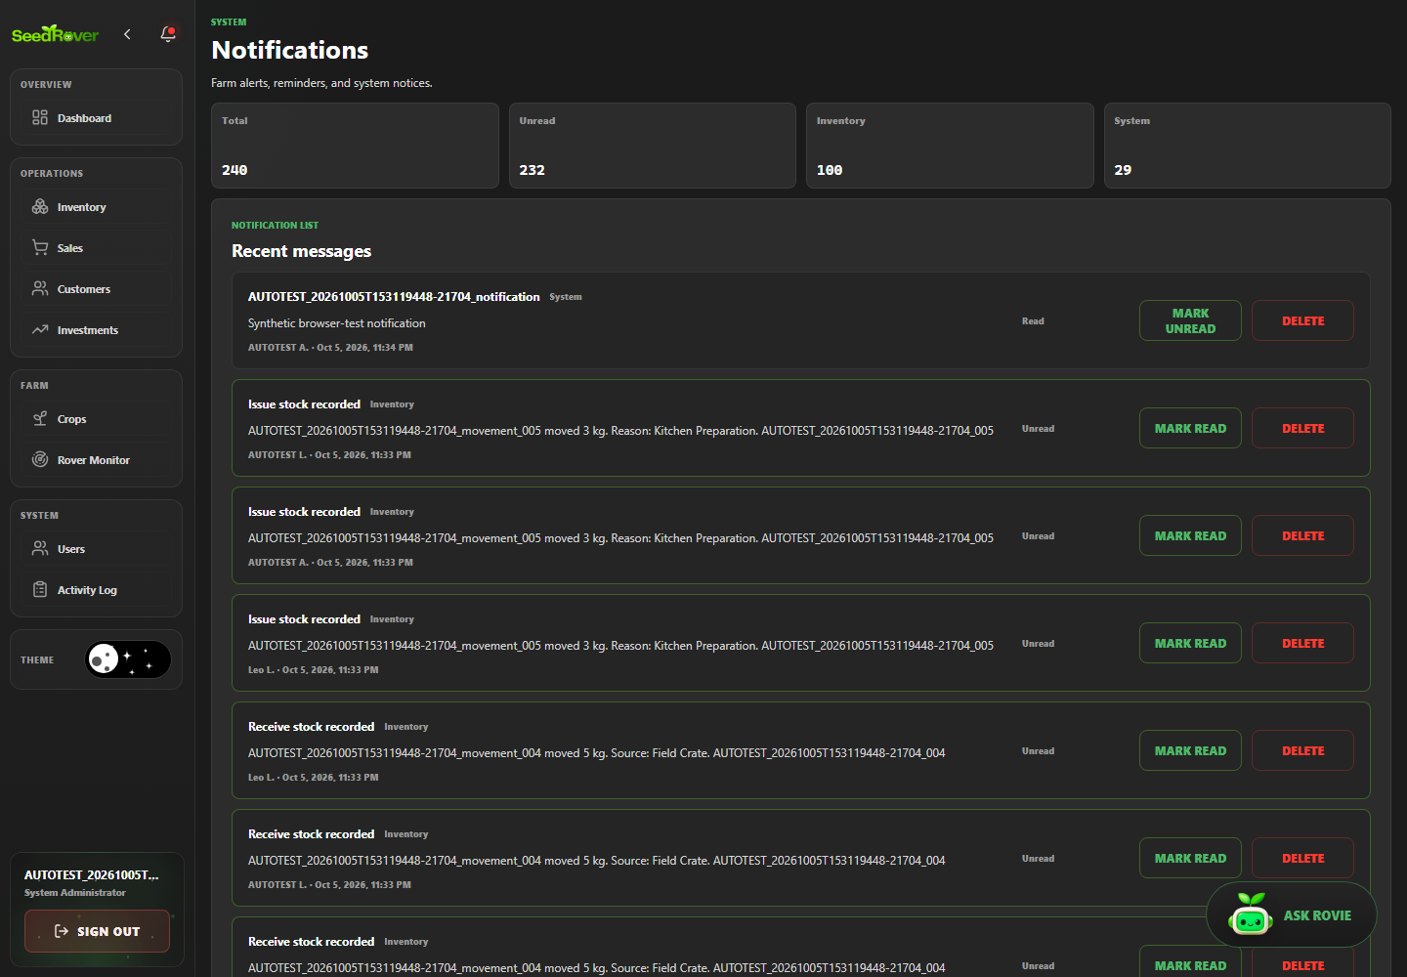
Figure 30. Mark a dedicated notification read and verify persistence. Case SR-OBS-001; Playwright run 20261005T153119448-21704.
SR-OBS-002 | Inventory edit creates an attributable activity record
Objective | Verify that inventory edit creates an attributable activity record, then document the visible and persisted result supported by the test assertions.
Preconditions | Local production build running; target database host is the previously verified development/demo project; one Playwright worker; dedicated role session prepared.
Test Data | Synthetic data for run 20261005T153119448-21704; exact related labels and record IDs are listed in run-artifacts/20261005T153119448-21704/records.jsonl. Credentials are excluded.
Numbered Steps | 1. Use the case's declared role session and run-labelled fixture prepared by web-admin/e2e/support.ts.  2. Open notifications, activity log or rover monitor and perform: Inventory edit creates an attributable activity record.  3. Check the visible or persisted outcome asserted in web-admin/e2e/tests/monitoring.spec.ts.  4. Compare the outcome with the named scenario; the run-specific fixture IDs are recorded in the run manifest.
Expected Result | Inventory edit creates an attributable activity record. The observed behavior must match the specific assertions in web-admin/e2e/tests/monitoring.spec.ts; any database outcome is claimed only when that test reads it back.
Cleanup | Dedicated test accounts deactivated; labeled transactional/history rows retained under the run's exact-ID cleanup policy. See run-artifacts/20261005T153119448-21704/cleanup.json.
Actual Result | Passed; Playwright assertions completed in the named run. Persisted outcomes were independently checked where the test source performs database reads.
Evidence / Source | Evidence: run-artifacts/20261005T153119448-21704/html/index.html  Playwright source: web-admin/e2e/tests/monitoring.spec.ts
Case record | Module: Notifications and activity history Role: System Administrator Priority: Medium Test type: Functional / authorization / validation as described by the scenario Method: Automated — Playwright Test / Chromium Automation status: Passed  Evidence: run-artifacts/20261005T153119448-21704/html/index.html  Source: web-admin/e2e/tests/monitoring.spec.ts

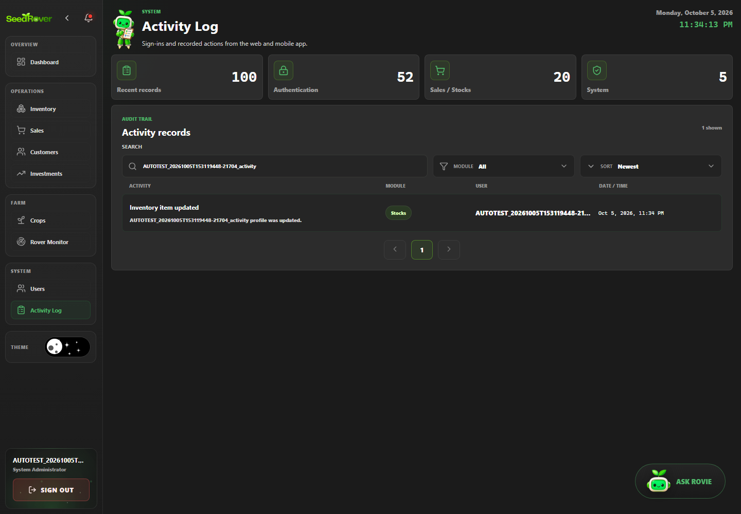
Figure 31. Inventory edit creates an attributable activity record. Case SR-OBS-002; Playwright run 20261005T153119448-21704.
SR-OBS-003 | Rover monitoring presents existing stale or unavailable data honestly
Objective | Verify that rover monitoring presents existing stale or unavailable data honestly, then document the visible and persisted result supported by the test assertions.
Preconditions | Local production build running; target database host is the previously verified development/demo project; one Playwright worker; dedicated role session prepared.
Test Data | Synthetic data for run 20261005T153119448-21704; exact related labels and record IDs are listed in run-artifacts/20261005T153119448-21704/records.jsonl. Credentials are excluded.
Numbered Steps | 1. Use the case's declared role session and run-labelled fixture prepared by web-admin/e2e/support.ts.  2. Open notifications, activity log or rover monitor and perform: Rover monitoring presents existing stale or unavailable data honestly.  3. Check the visible or persisted outcome asserted in web-admin/e2e/tests/monitoring.spec.ts.  4. Compare the outcome with the named scenario; the run-specific fixture IDs are recorded in the run manifest.
Expected Result | Rover monitoring presents existing stale or unavailable data honestly. The observed behavior must match the specific assertions in web-admin/e2e/tests/monitoring.spec.ts; any database outcome is claimed only when that test reads it back.
Cleanup | Dedicated test accounts deactivated; labeled transactional/history rows retained under the run's exact-ID cleanup policy. See run-artifacts/20261005T153119448-21704/cleanup.json.
Actual Result | Passed; Playwright assertions completed in the named run. Blocked: existing rover readings were fresh, so stale/no-data global state was not changed to force this scenario.
Evidence / Source | Evidence: run-artifacts/20261005T153119448-21704/html/index.html  Playwright source: web-admin/e2e/tests/monitoring.spec.ts
Case record | Module: Notifications and activity history Role: System Administrator Priority: Medium Test type: Functional / authorization / validation as described by the scenario Method: Automated — Playwright Test / Chromium Automation status: Blocked  Evidence: run-artifacts/20261005T153119448-21704/html/index.html  Source: web-admin/e2e/tests/monitoring.spec.ts

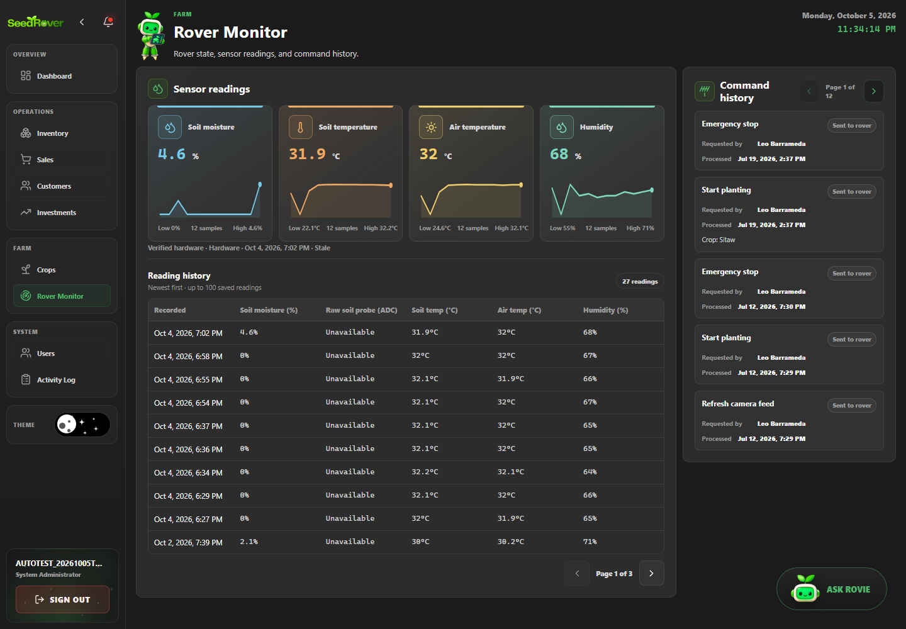
Figure 32. Rover monitoring presents existing stale or unavailable data honestly. Case SR-OBS-003; Playwright run 20261005T153119448-21704.
SR-OBS-004 | Rover monitor exposes no movement or planting controls
Objective | Verify that rover monitor exposes no movement or planting controls, then document the visible and persisted result supported by the test assertions.
Preconditions | Local production build running; target database host is the previously verified development/demo project; one Playwright worker; dedicated role session prepared.
Test Data | Synthetic data for run 20261005T153119448-21704; exact related labels and record IDs are listed in run-artifacts/20261005T153119448-21704/records.jsonl. Credentials are excluded.
Numbered Steps | 1. Use the case's declared role session and run-labelled fixture prepared by web-admin/e2e/support.ts.  2. Open notifications, activity log or rover monitor and perform: Rover monitor exposes no movement or planting controls.  3. Check the visible or persisted outcome asserted in web-admin/e2e/tests/monitoring.spec.ts.  4. Compare the outcome with the named scenario; the run-specific fixture IDs are recorded in the run manifest.
Expected Result | Rover monitor exposes no movement or planting controls. The observed behavior must match the specific assertions in web-admin/e2e/tests/monitoring.spec.ts; any database outcome is claimed only when that test reads it back.
Cleanup | Dedicated test accounts deactivated; labeled transactional/history rows retained under the run's exact-ID cleanup policy. See run-artifacts/20261005T153119448-21704/cleanup.json.
Actual Result | Passed; Playwright assertions completed in the named run. Persisted outcomes were independently checked where the test source performs database reads.
Evidence / Source | Evidence: evidence/20261005T153119448-21704/SR-OBS-004_verified-result.png  Playwright source: web-admin/e2e/tests/monitoring.spec.ts
Case record | Module: Notifications and activity history Role: System Administrator Priority: Medium Test type: Functional / authorization / validation as described by the scenario Method: Automated — Playwright Test / Chromium Automation status: Passed  Evidence: evidence/20261005T153119448-21704/SR-OBS-004_verified-result.png  Source: web-admin/e2e/tests/monitoring.spec.ts

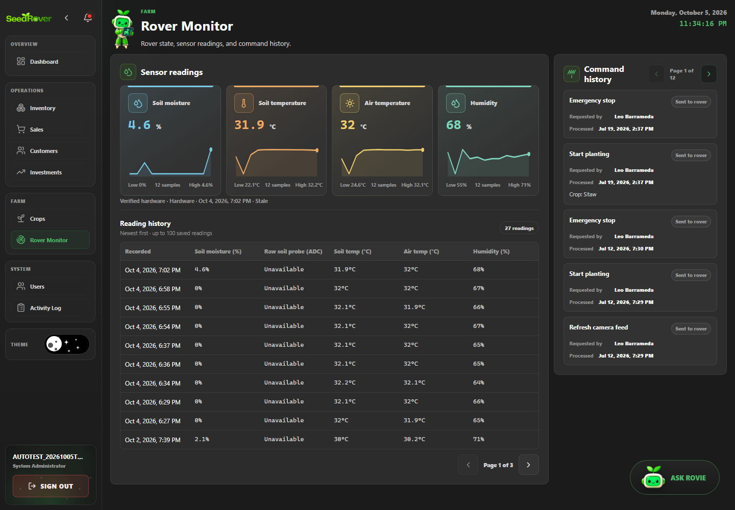
Figure 33. Rover monitor is read-only in the browser interface. Case SR-OBS-004; Playwright run 20261005T153119448-21704.
SR-SALE-001 | @smoke Cash sale saves receipt total change and exact stock deduction
Objective | Verify that @smoke Cash sale saves receipt total change and exact stock deduction, then document the visible and persisted result supported by the test assertions.
Preconditions | Local production build running; target database host is the previously verified development/demo project; one Playwright worker; dedicated role session prepared.
Test Data | 20 kg opening stock; 3 kg at PHP 50/kg; PHP 200 tender; expected PHP 150 sale, PHP 50 change and 17 kg balance.
Numbered Steps | 1. Use the case's declared role session and run-labelled fixture prepared by web-admin/e2e/support.ts.  2. Open /sales and perform: @smoke Cash sale saves receipt total change and exact stock deduction.  3. Check the visible or persisted outcome asserted in web-admin/e2e/tests/sales.spec.ts.  4. Compare the outcome with the named scenario; the run-specific fixture IDs are recorded in the run manifest.
Expected Result | @smoke Cash sale saves receipt total change and exact stock deduction. The observed behavior must match the specific assertions in web-admin/e2e/tests/sales.spec.ts; any database outcome is claimed only when that test reads it back.
Cleanup | Dedicated test accounts deactivated; labeled transactional/history rows retained under the run's exact-ID cleanup policy. See run-artifacts/20261005T153119448-21704/cleanup.json.
Actual Result | Passed; Playwright assertions completed in the named run. Persisted outcomes were independently checked where the test source performs database reads.
Evidence / Source | Evidence: evidence/20261005T153119448-21704/SR-SALE-001_receipt.png  Playwright source: web-admin/e2e/tests/sales.spec.ts
Case record | Module: Sales and receipts Role: Farm Inventory Manager, except the explicit staff-authorization case Priority: High Test type: Functional / authorization / validation as described by the scenario Method: Automated — Playwright Test / Chromium Automation status: Passed  Evidence: evidence/20261005T153119448-21704/SR-SALE-001_receipt.png  Source: web-admin/e2e/tests/sales.spec.ts

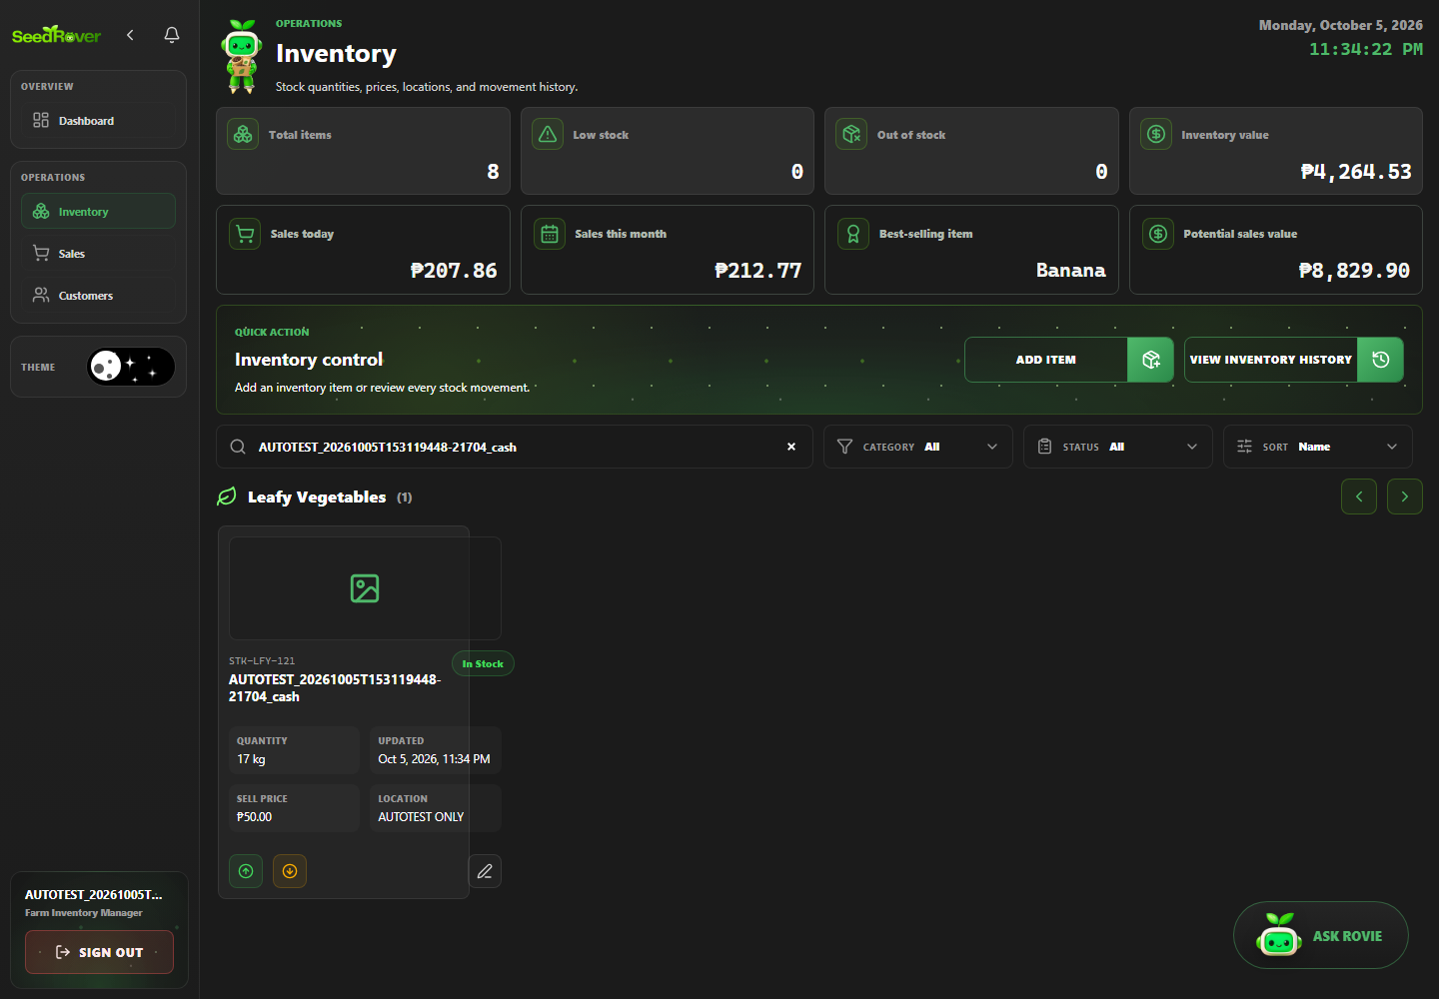
Figure 34. The sale leaves 17 kilograms from a 20 kilogram opening balance. Case SR-SALE-001; Playwright run 20261005T153119448-21704.
SR-SALE-002 | Multi-item sale deducts each stock once
Objective | Verify that multi-item sale deducts each stock once, then document the visible and persisted result supported by the test assertions.
Preconditions | Local production build running; target database host is the previously verified development/demo project; one Playwright worker; dedicated role session prepared.
Test Data | Two dedicated items at PHP 50/kg; sell 2 kg plus 1 kg; expected receipt PHP 150.
Numbered Steps | 1. Use the case's declared role session and run-labelled fixture prepared by web-admin/e2e/support.ts.  2. Open /sales and perform: Multi-item sale deducts each stock once.  3. Check the visible or persisted outcome asserted in web-admin/e2e/tests/sales.spec.ts.  4. Compare the outcome with the named scenario; the run-specific fixture IDs are recorded in the run manifest.
Expected Result | Multi-item sale deducts each stock once. The observed behavior must match the specific assertions in web-admin/e2e/tests/sales.spec.ts; any database outcome is claimed only when that test reads it back.
Cleanup | Dedicated test accounts deactivated; labeled transactional/history rows retained under the run's exact-ID cleanup policy. See run-artifacts/20261005T153119448-21704/cleanup.json.
Actual Result | Passed; Playwright assertions completed in the named run. Persisted outcomes were independently checked where the test source performs database reads.
Evidence / Source | Evidence: run-artifacts/20261005T153119448-21704/html/index.html  Playwright source: web-admin/e2e/tests/sales.spec.ts
Case record | Module: Sales and receipts Role: Farm Inventory Manager, except the explicit staff-authorization case Priority: High Test type: Functional / authorization / validation as described by the scenario Method: Automated — Playwright Test / Chromium Automation status: Passed  Evidence: run-artifacts/20261005T153119448-21704/html/index.html  Source: web-admin/e2e/tests/sales.spec.ts

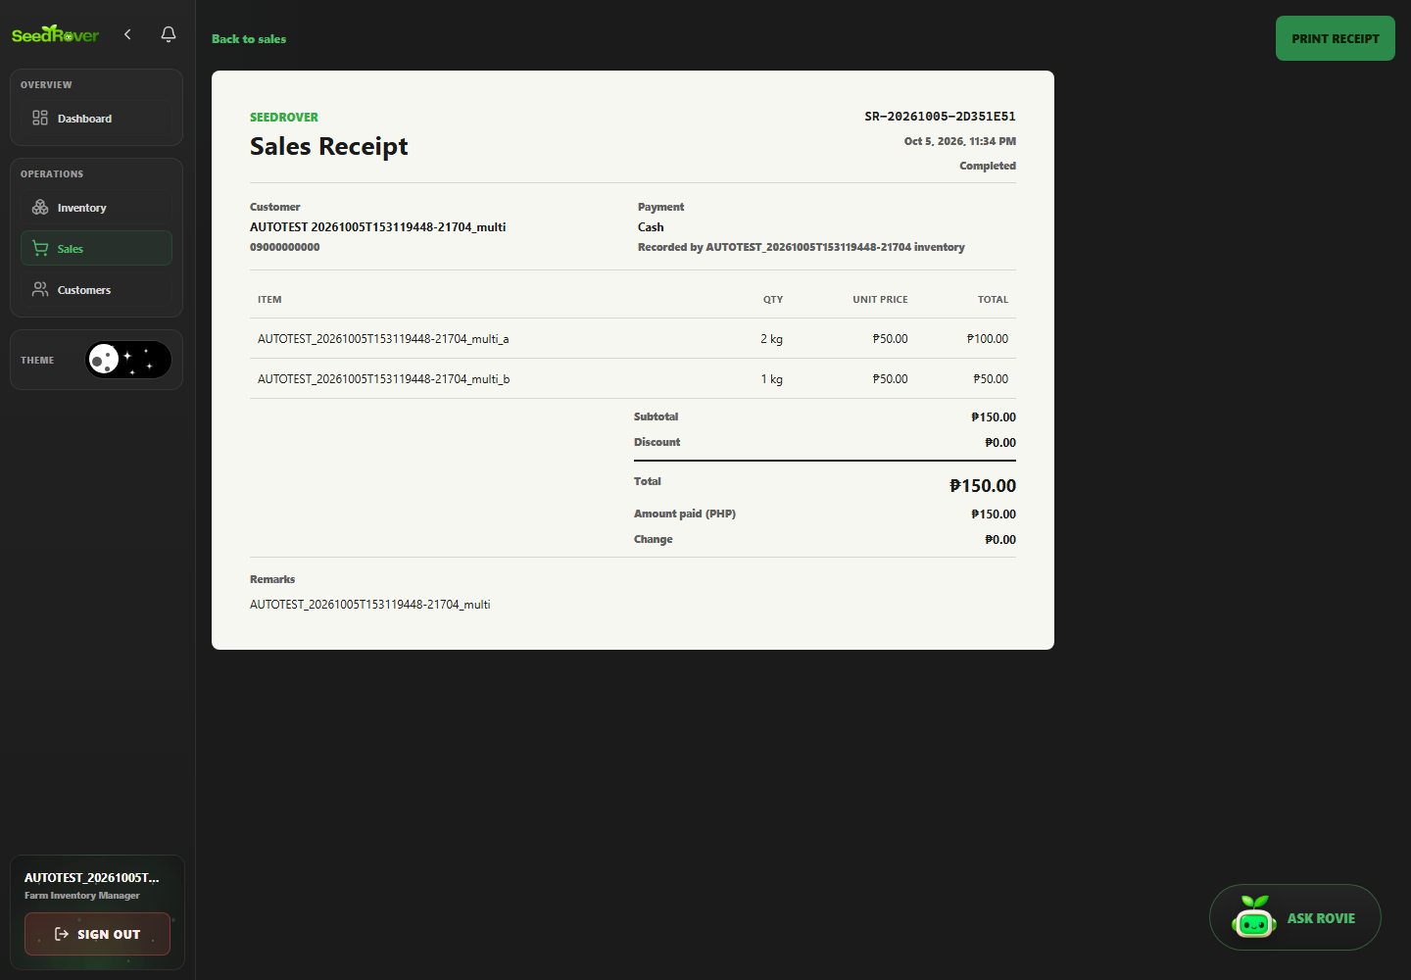
Figure 35. Multi-item sale deducts each stock once. Case SR-SALE-002; Playwright run 20261005T153119448-21704.
SR-SALE-003 | Overselling is rejected and stock remains unchanged
Objective | Verify that overselling is rejected and stock remains unchanged, then document the visible and persisted result supported by the test assertions.
Preconditions | Local production build running; target database host is the previously verified development/demo project; one Playwright worker; dedicated role session prepared.
Test Data | 2 kg stock; request 3 kg; expected rejection and unchanged 2 kg.
Numbered Steps | 1. Use the case's declared role session and run-labelled fixture prepared by web-admin/e2e/support.ts.  2. Open /sales and perform: Overselling is rejected and stock remains unchanged.  3. Check the visible or persisted outcome asserted in web-admin/e2e/tests/sales.spec.ts.  4. Compare the outcome with the named scenario; the run-specific fixture IDs are recorded in the run manifest.
Expected Result | Overselling is rejected and stock remains unchanged. The observed behavior must match the specific assertions in web-admin/e2e/tests/sales.spec.ts; any database outcome is claimed only when that test reads it back.
Cleanup | Dedicated test accounts deactivated; labeled transactional/history rows retained under the run's exact-ID cleanup policy. See run-artifacts/20261005T153119448-21704/cleanup.json.
Actual Result | Passed; Playwright assertions completed in the named run. Persisted outcomes were independently checked where the test source performs database reads.
Evidence / Source | Evidence: evidence/20261005T153119448-21704/SR-SALE-003_verified-result.png  Playwright source: web-admin/e2e/tests/sales.spec.ts
Case record | Module: Sales and receipts Role: Farm Inventory Manager, except the explicit staff-authorization case Priority: High Test type: Functional / authorization / validation as described by the scenario Method: Automated — Playwright Test / Chromium Automation status: Passed  Evidence: evidence/20261005T153119448-21704/SR-SALE-003_verified-result.png  Source: web-admin/e2e/tests/sales.spec.ts

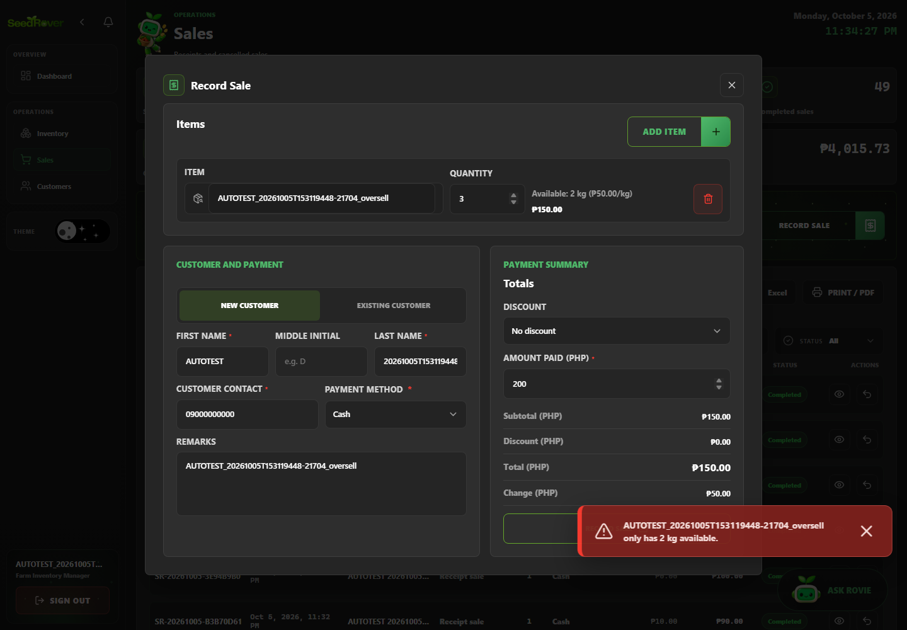
Figure 36. Overselling is rejected without a stock deduction. Case SR-SALE-003; Playwright run 20261005T153119448-21704.
SR-SALE-004 | Non-cash payment requires a transaction reference
Objective | Verify that non-cash payment requires a transaction reference, then document the visible and persisted result supported by the test assertions.
Preconditions | Local production build running; target database host is the previously verified development/demo project; one Playwright worker; dedicated role session prepared.
Test Data | One 3 kg line at PHP 50/kg; select GCash without a transaction reference.
Numbered Steps | 1. Use the case's declared role session and run-labelled fixture prepared by web-admin/e2e/support.ts.  2. Open /sales and perform: Non-cash payment requires a transaction reference.  3. Check the visible or persisted outcome asserted in web-admin/e2e/tests/sales.spec.ts.  4. Compare the outcome with the named scenario; the run-specific fixture IDs are recorded in the run manifest.
Expected Result | Non-cash payment requires a transaction reference. The observed behavior must match the specific assertions in web-admin/e2e/tests/sales.spec.ts; any database outcome is claimed only when that test reads it back.
Cleanup | Dedicated test accounts deactivated; labeled transactional/history rows retained under the run's exact-ID cleanup policy. See run-artifacts/20261005T153119448-21704/cleanup.json.
Actual Result | Passed; Playwright assertions completed in the named run. Persisted outcomes were independently checked where the test source performs database reads.
Evidence / Source | Evidence: run-artifacts/20261005T153119448-21704/html/index.html  Playwright source: web-admin/e2e/tests/sales.spec.ts
Case record | Module: Sales and receipts Role: Farm Inventory Manager, except the explicit staff-authorization case Priority: High Test type: Functional / authorization / validation as described by the scenario Method: Automated — Playwright Test / Chromium Automation status: Passed  Evidence: run-artifacts/20261005T153119448-21704/html/index.html  Source: web-admin/e2e/tests/sales.spec.ts

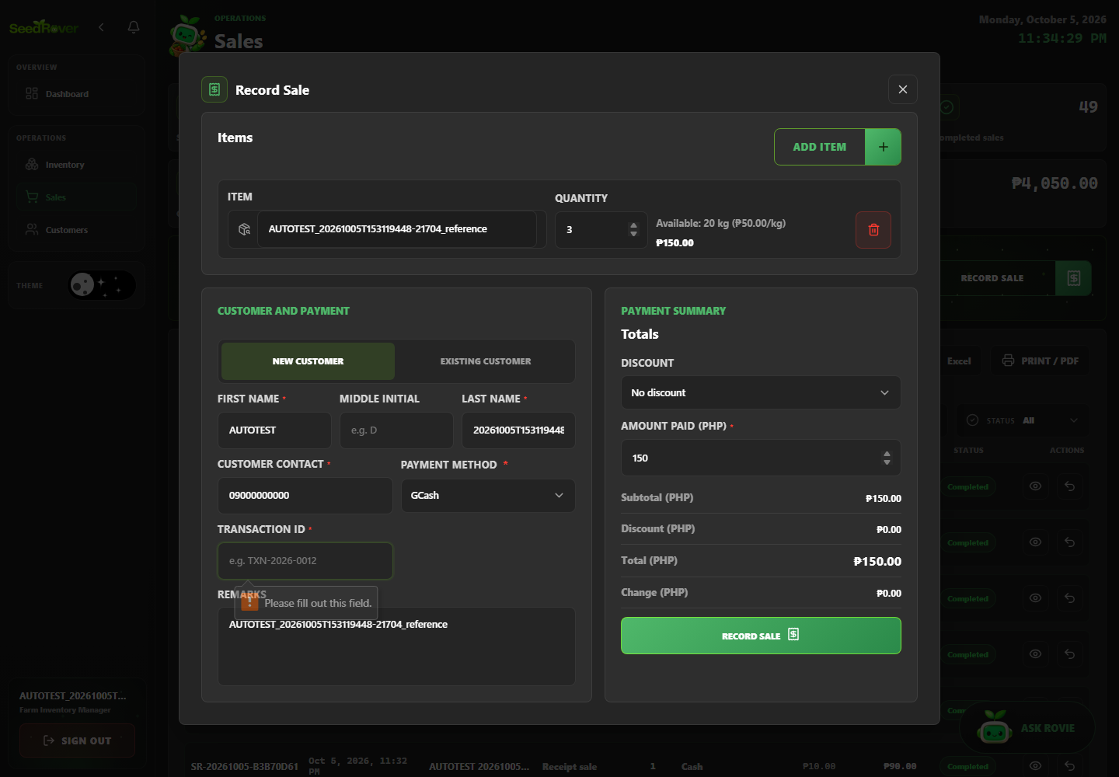
Figure 37. Non-cash payment requires a transaction reference. Case SR-SALE-004; Playwright run 20261005T153119448-21704.
SR-SALE-005 | Authorized cancellation restores inventory exactly once
Objective | Verify that authorized cancellation restores inventory exactly once, then document the visible and persisted result supported by the test assertions.
Preconditions | Local production build running; target database host is the previously verified development/demo project; one Playwright worker; dedicated role session prepared.
Test Data | 20 kg opening stock; sale of 3 kg; void only its receipt; expected balance returns to 20 kg once.
Numbered Steps | 1. Use the case's declared role session and run-labelled fixture prepared by web-admin/e2e/support.ts.  2. Open /sales and perform: Authorized cancellation restores inventory exactly once.  3. Check the visible or persisted outcome asserted in web-admin/e2e/tests/sales.spec.ts.  4. Compare the outcome with the named scenario; the run-specific fixture IDs are recorded in the run manifest.
Expected Result | Authorized cancellation restores inventory exactly once. The observed behavior must match the specific assertions in web-admin/e2e/tests/sales.spec.ts; any database outcome is claimed only when that test reads it back.
Cleanup | Dedicated test accounts deactivated; labeled transactional/history rows retained under the run's exact-ID cleanup policy. See run-artifacts/20261005T153119448-21704/cleanup.json.
Actual Result | Passed; Playwright assertions completed in the named run. Persisted outcomes were independently checked where the test source performs database reads.
Evidence / Source | Evidence: evidence/20261005T153119448-21704/SR-SALE-005_verified-result.png  Playwright source: web-admin/e2e/tests/sales.spec.ts
Case record | Module: Sales and receipts Role: Farm Inventory Manager, except the explicit staff-authorization case Priority: High Test type: Functional / authorization / validation as described by the scenario Method: Automated — Playwright Test / Chromium Automation status: Passed  Evidence: evidence/20261005T153119448-21704/SR-SALE-005_verified-result.png  Source: web-admin/e2e/tests/sales.spec.ts

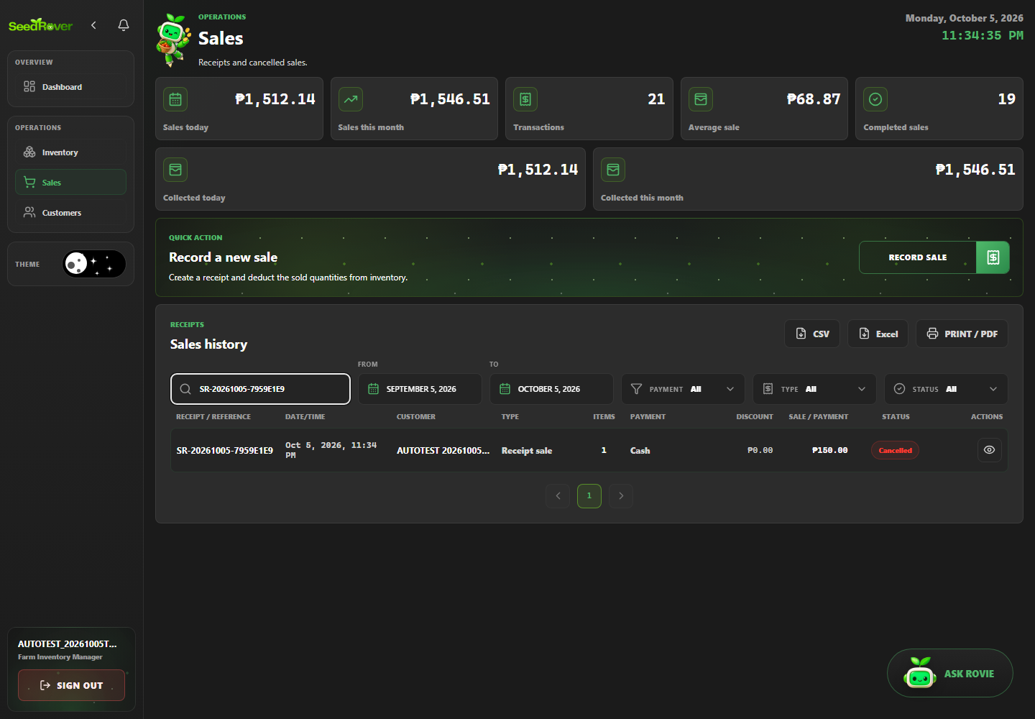
Figure 38. Authorized void restores stock to its original balance. Case SR-SALE-005; Playwright run 20261005T153119448-21704.
SR-SALE-006 | Inventory staff cannot cancel a completed sale
Objective | Verify that inventory staff cannot cancel a completed sale, then document the visible and persisted result supported by the test assertions.
Preconditions | Local production build running; target database host is the previously verified development/demo project; one Playwright worker; dedicated role session prepared.
Test Data | Synthetic data for run 20261005T153119448-21704; exact related labels and record IDs are listed in run-artifacts/20261005T153119448-21704/records.jsonl. Credentials are excluded.
Numbered Steps | 1. Use the case's declared role session and run-labelled fixture prepared by web-admin/e2e/support.ts.  2. Open /sales and perform: Inventory staff cannot cancel a completed sale.  3. Check the visible or persisted outcome asserted in web-admin/e2e/tests/sales.spec.ts.  4. Compare the outcome with the named scenario; the run-specific fixture IDs are recorded in the run manifest.
Expected Result | Inventory staff cannot cancel a completed sale. The observed behavior must match the specific assertions in web-admin/e2e/tests/sales.spec.ts; any database outcome is claimed only when that test reads it back.
Cleanup | Dedicated test accounts deactivated; labeled transactional/history rows retained under the run's exact-ID cleanup policy. See run-artifacts/20261005T153119448-21704/cleanup.json.
Actual Result | Passed; Playwright assertions completed in the named run. Confirms the void control is hidden and inventory is unchanged; this is interface authorization evidence, not a direct forged server-action attempt.
Evidence / Source | Evidence: run-artifacts/20261005T153119448-21704/html/index.html  Playwright source: web-admin/e2e/tests/sales.spec.ts
Case record | Module: Sales and receipts Role: Farm Inventory Manager, except the explicit staff-authorization case Priority: High Test type: Functional / authorization / validation as described by the scenario Method: Automated — Playwright Test / Chromium Automation status: Passed  Evidence: run-artifacts/20261005T153119448-21704/html/index.html  Source: web-admin/e2e/tests/sales.spec.ts

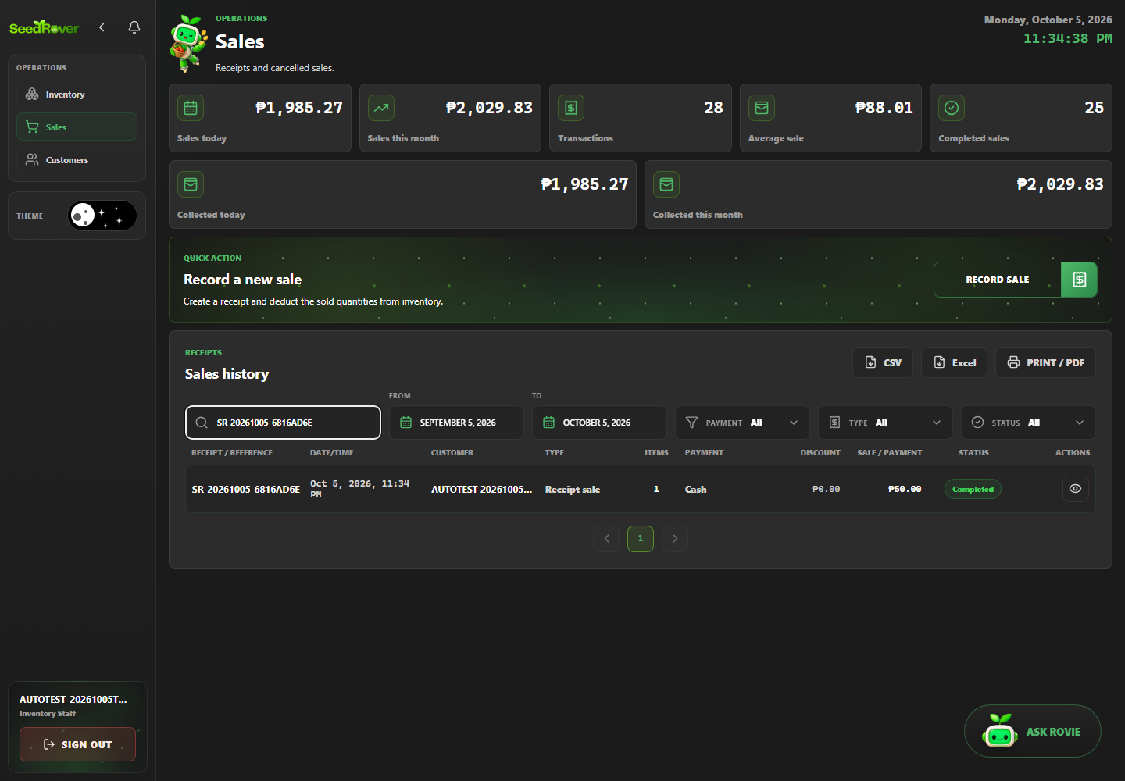
Figure 39. Inventory staff cannot cancel a completed sale. Case SR-SALE-006; Playwright run 20261005T153119448-21704.
SR-USER-001 | Administrator creates a user through UI
Objective | Verify that administrator creates a user through UI, then document the visible and persisted result supported by the test assertions.
Preconditions | Local production build running; target database host is the previously verified development/demo project; one Playwright worker; dedicated role session prepared.
Test Data | Synthetic data for run 20261005T153119448-21704; exact related labels and record IDs are listed in run-artifacts/20261005T153119448-21704/records.jsonl. Credentials are excluded.
Numbered Steps | 1. Use the case's declared role session and run-labelled fixture prepared by web-admin/e2e/support.ts.  2. Open /users and perform: Administrator creates a user through UI.  3. Check the visible or persisted outcome asserted in web-admin/e2e/tests/users.spec.ts.  4. Compare the outcome with the named scenario; the run-specific fixture IDs are recorded in the run manifest.
Expected Result | Administrator creates a user through UI. The observed behavior must match the specific assertions in web-admin/e2e/tests/users.spec.ts; any database outcome is claimed only when that test reads it back.
Cleanup | Dedicated test accounts deactivated; labeled transactional/history rows retained under the run's exact-ID cleanup policy. See run-artifacts/20261005T153119448-21704/cleanup.json.
Actual Result | Passed; Playwright assertions completed in the named run. Persisted outcomes were independently checked where the test source performs database reads.
Evidence / Source | Evidence: run-artifacts/20261005T153119448-21704/html/index.html  Playwright source: web-admin/e2e/tests/users.spec.ts
Case record | Module: User management Role: System Administrator Priority: High Test type: Functional / authorization / validation as described by the scenario Method: Automated — Playwright Test / Chromium Automation status: Passed  Evidence: run-artifacts/20261005T153119448-21704/html/index.html  Source: web-admin/e2e/tests/users.spec.ts

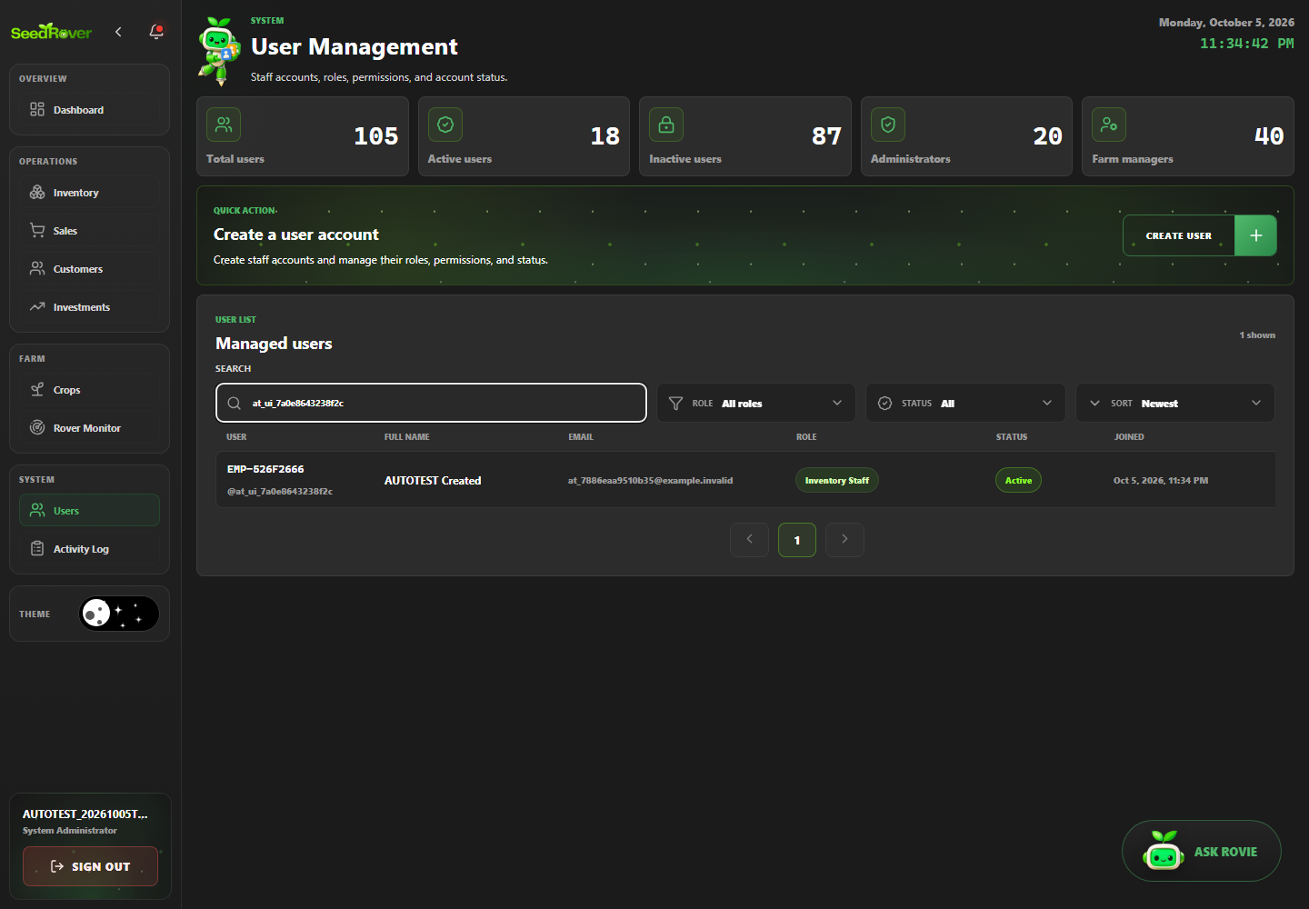
Figure 40. Administrator creates a user through UI. Case SR-USER-001; Playwright run 20261005T153119448-21704.
SR-USER-002 | Duplicate username is rejected
Objective | Verify that duplicate username is rejected, then document the visible and persisted result supported by the test assertions.
Preconditions | Local production build running; target database host is the previously verified development/demo project; one Playwright worker; dedicated role session prepared.
Test Data | Synthetic data for run 20261005T153119448-21704; exact related labels and record IDs are listed in run-artifacts/20261005T153119448-21704/records.jsonl. Credentials are excluded.
Numbered Steps | 1. Use the case's declared role session and run-labelled fixture prepared by web-admin/e2e/support.ts.  2. Open /users and perform: Duplicate username is rejected.  3. Check the visible or persisted outcome asserted in web-admin/e2e/tests/users.spec.ts.  4. Compare the outcome with the named scenario; the run-specific fixture IDs are recorded in the run manifest.
Expected Result | Duplicate username is rejected. The observed behavior must match the specific assertions in web-admin/e2e/tests/users.spec.ts; any database outcome is claimed only when that test reads it back.
Cleanup | Dedicated test accounts deactivated; labeled transactional/history rows retained under the run's exact-ID cleanup policy. See run-artifacts/20261005T153119448-21704/cleanup.json.
Actual Result | Passed; Playwright assertions completed in the named run. The test asserts the duplicate-username message. It does not query the profile count after rejection, so the evidence establishes the visible response but not an independent persistence check.
Evidence / Source | Evidence: run-artifacts/20261005T153119448-21704/html/index.html  Playwright source: web-admin/e2e/tests/users.spec.ts
Case record | Module: User management Role: System Administrator Priority: High Test type: Functional / authorization / validation as described by the scenario Method: Automated — Playwright Test / Chromium Automation status: Passed  Evidence: run-artifacts/20261005T153119448-21704/html/index.html  Source: web-admin/e2e/tests/users.spec.ts

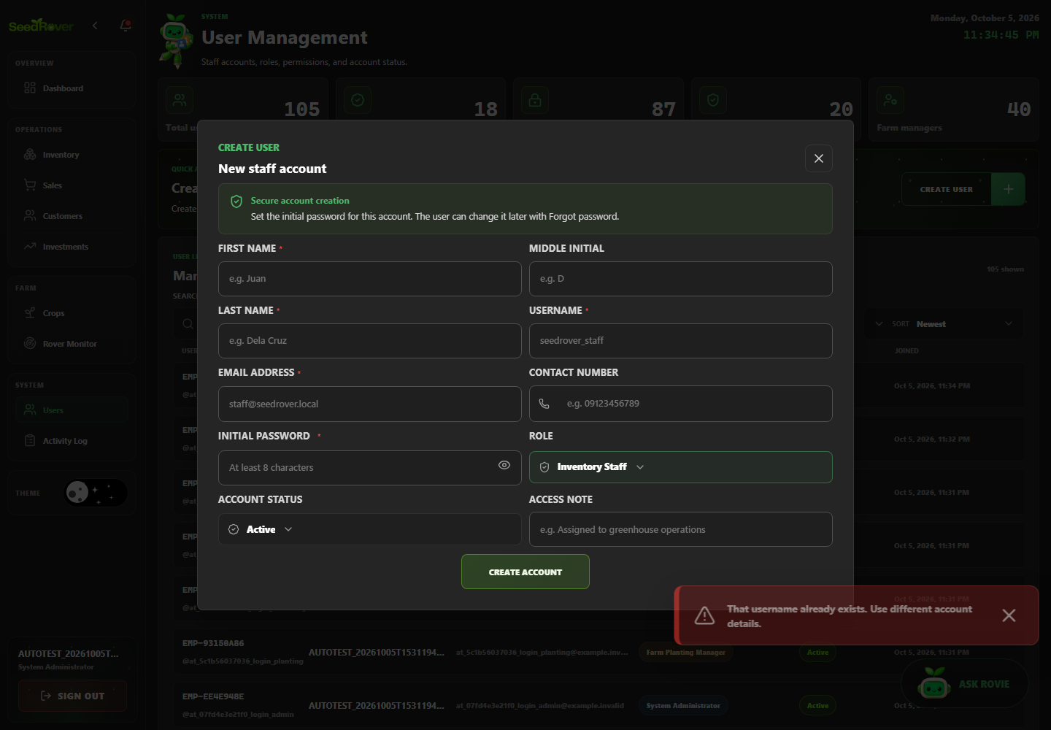
Figure 41. Duplicate username is rejected. Case SR-USER-002; Playwright run 20261005T153119448-21704.
SR-USER-003 | Update account details and role persists
Objective | Verify that update account details and role persists, then document the visible and persisted result supported by the test assertions.
Preconditions | Local production build running; target database host is the previously verified development/demo project; one Playwright worker; dedicated role session prepared.
Test Data | Synthetic data for run 20261005T153119448-21704; exact related labels and record IDs are listed in run-artifacts/20261005T153119448-21704/records.jsonl. Credentials are excluded.
Numbered Steps | 1. Use the case's declared role session and run-labelled fixture prepared by web-admin/e2e/support.ts.  2. Open /users and perform: Update account details and role persists.  3. Check the visible or persisted outcome asserted in web-admin/e2e/tests/users.spec.ts.  4. Compare the outcome with the named scenario; the run-specific fixture IDs are recorded in the run manifest.
Expected Result | Update account details and role persists. The observed behavior must match the specific assertions in web-admin/e2e/tests/users.spec.ts; any database outcome is claimed only when that test reads it back.
Cleanup | Dedicated test accounts deactivated; labeled transactional/history rows retained under the run's exact-ID cleanup policy. See run-artifacts/20261005T153119448-21704/cleanup.json.
Actual Result | Passed; Playwright assertions completed in the named run. Persisted outcomes were independently checked where the test source performs database reads.
Evidence / Source | Evidence: run-artifacts/20261005T153119448-21704/html/index.html  Playwright source: web-admin/e2e/tests/users.spec.ts
Case record | Module: User management Role: System Administrator Priority: High Test type: Functional / authorization / validation as described by the scenario Method: Automated — Playwright Test / Chromium Automation status: Passed  Evidence: run-artifacts/20261005T153119448-21704/html/index.html  Source: web-admin/e2e/tests/users.spec.ts

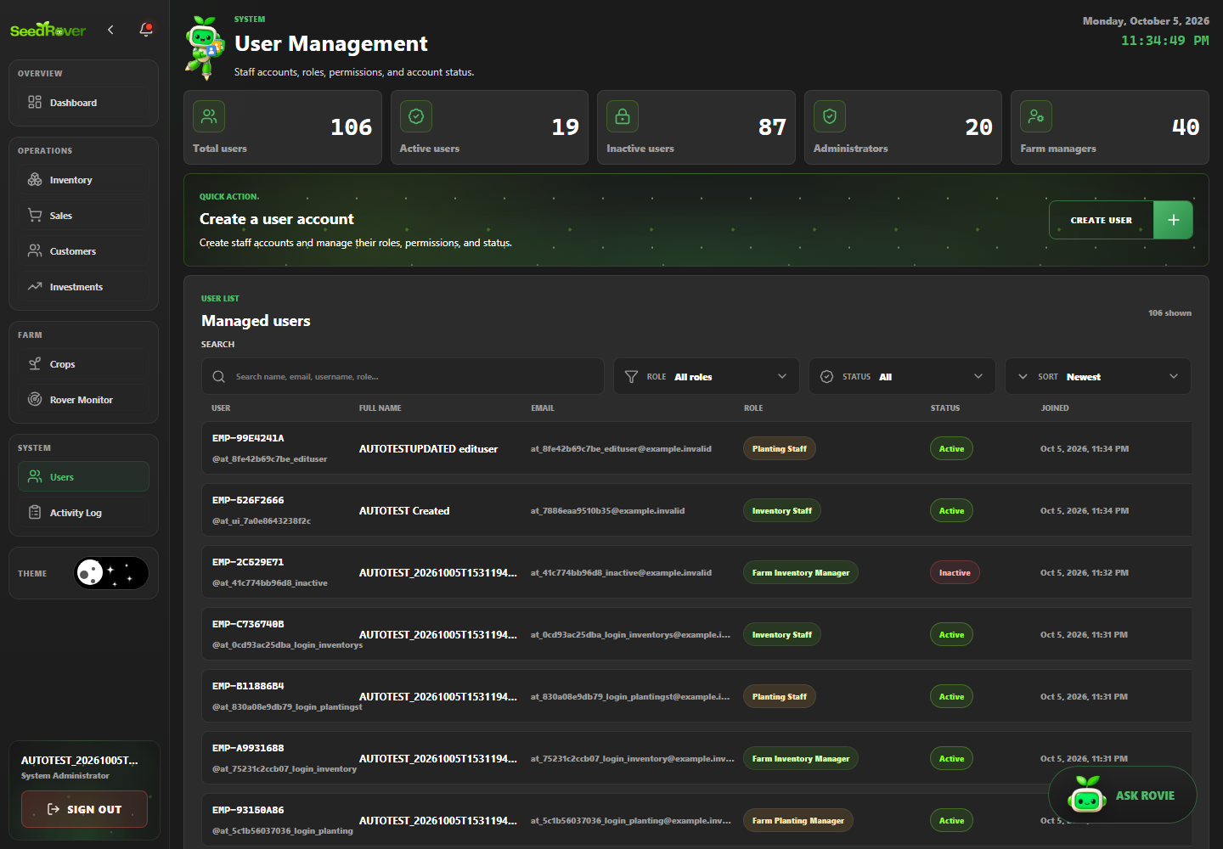
Figure 42. Update account details and role persists. Case SR-USER-003; Playwright run 20261005T153119448-21704.
SR-USER-004 | Deactivate account through UI and deny its login
Objective | Verify that deactivate account through UI and deny its login, then document the visible and persisted result supported by the test assertions.
Preconditions | Local production build running; target database host is the previously verified development/demo project; one Playwright worker; dedicated role session prepared.
Test Data | Synthetic data for run 20261005T153119448-21704; exact related labels and record IDs are listed in run-artifacts/20261005T153119448-21704/records.jsonl. Credentials are excluded.
Numbered Steps | 1. Use the case's declared role session and run-labelled fixture prepared by web-admin/e2e/support.ts.  2. Open /users and perform: Deactivate account through UI and deny its login.  3. Check the visible or persisted outcome asserted in web-admin/e2e/tests/users.spec.ts.  4. Compare the outcome with the named scenario; the run-specific fixture IDs are recorded in the run manifest.
Expected Result | Deactivate account through UI and deny its login. The observed behavior must match the specific assertions in web-admin/e2e/tests/users.spec.ts; any database outcome is claimed only when that test reads it back.
Cleanup | Dedicated test accounts deactivated; labeled transactional/history rows retained under the run's exact-ID cleanup policy. See run-artifacts/20261005T153119448-21704/cleanup.json.
Actual Result | Passed; Playwright assertions completed in the named run. Persisted outcomes were independently checked where the test source performs database reads.
Evidence / Source | Evidence: run-artifacts/20261005T153119448-21704/html/index.html  Playwright source: web-admin/e2e/tests/users.spec.ts
Case record | Module: User management Role: System Administrator Priority: High Test type: Functional / authorization / validation as described by the scenario Method: Automated — Playwright Test / Chromium Automation status: Passed  Evidence: run-artifacts/20261005T153119448-21704/html/index.html  Source: web-admin/e2e/tests/users.spec.ts

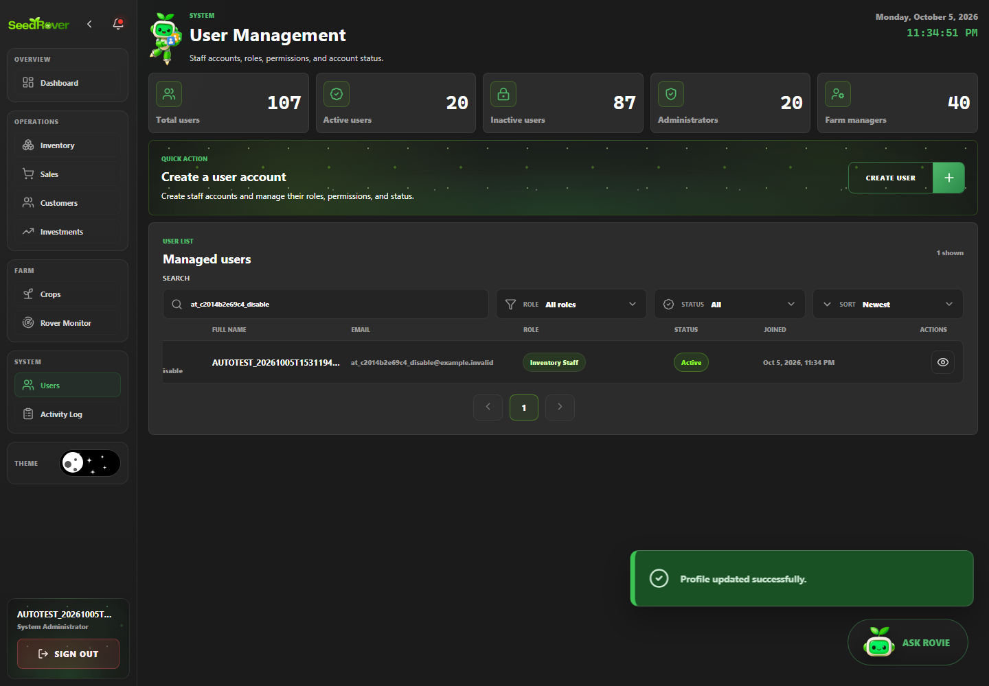
Figure 43. Deactivate account through UI and deny its login. Case SR-USER-004; Playwright run 20261005T153119448-21704.

10. Test Data Management
Data Type | Source | Owner
User Accounts | Dedicated role accounts in existing development/demo Supabase | Test runner; credentials excluded
Inventory and sales fixtures | Run-labelled AUTOTEST records with exact IDs in run manifest | Playwright fixture helpers
Crop, activity and history records | Synthetic labels; retained history identified by run | Playwright fixture helpers
Login shell proof | Local test server and browser page; no database fixture required | Terminal-proof Playwright test
The database was not reset. A conservative cleanup preview identified 121 exact inventory IDs in 11 local run manifests, but the live inventory lookup failed with a network fetch error before any row could be verified. No database rows were changed. Unrelated demonstration data and existing audit/history records remain untouched; rerun the preview after Supabase connectivity is restored.

Isolation and Cleanup Rules
- Run one browser worker and one formal run at a time.
- Use run ID labels and exact database IDs; never delete by a broad name prefix.
- Capture report evidence before cleanup; retain audit history created by the application when deletion would break relationships.
- Reconcile dashboard changes against a recorded baseline plus controlled test transactions.

11. Defect Tracking
Severity Classification:
- Critical
- High
- Medium
- Low
Table 5. Observed fixes and current coverage blockers.
Defect ID | Summary | Severity | Status
DEF-001 | Insufficient-stock rejection previously displayed a generic server error; corrected and retested. | Medium | Fixed; focused and current regression evidence
DEF-002 | Sales receipt query had an ambiguous profile relationship; corrected and retested. | Medium | Fixed; receipt case passed
GAP-001 | Crop details interface has no reachable Edit Crop control for the edit scenario. | Medium | Blocked; no fix claimed
GAP-002 | Shared rover values were fresh; stale/no-data state was not forced against shared data. | Low | Blocked by safe test-data precondition

Assertion Scope Notes
Case | Observed limitation or blocker
SR-INV-007 | Weak assertion: the test edits the control but does not submit the form. It confirms the UI value is non-negative or HTML validity blocks it, then reads the unchanged database price; it does not prove server-side negative-price rejection.
SR-USER-002 | The test asserts the duplicate-username message. It does not query the profile count after rejection, so the evidence establishes the visible response but not an independent persistence check.
SR-ROLE-011 | Route guard and visible-page assertion only; no direct protected-action request is made.
SR-ROLE-012 | Route guard and visible-page assertion only; no direct protected-action request is made.
SR-ROLE-013 | Route guard and visible-page assertion only; no direct protected-action request is made.
SR-ROLE-014 | Route guard and visible-page assertion only; no direct protected-action request is made.
SR-SALE-006 | Confirms the void control is hidden and inventory is unchanged; this is interface authorization evidence, not a direct forged server-action attempt.
SR-CROP-002 | Blocked: the current crop details interface exposes no reachable Edit Crop control. The editor scenario is not counted as passed.
SR-OBS-003 | Blocked: existing rover readings were fresh, so stale/no-data global state was not changed to force this scenario.
These notes qualify the strength of the recorded assertion. A UI-level permission check is not described as a forged-request or server-side authorization test; a blocked case is not a defect pass.

12. Test Execution Summary

Formula
Pass Rate (%) = (Passed / Executed) x 100
Table 6. Formal test execution totals and pass-rate denominator.
Metric | Value
Total Test Cases | 52
Automated Test Cases | 52
Executed Test Cases | 50
Passed | 50
Failed | 0
Blocked | 2
Pass Percentage | 100.0%
The formal Playwright run 20261005T153119448-21704 scheduled 52 automated cases. 2 were blocked and excluded from the executed-case denominator. All cases in this report’s test catalogue are automated cases.
Run | Type | Cases | Passed | Failed | Blocked | Use in metrics
20261005T153119448-21704 | Current full regression | 52 | 50 | 0 | 2 | Primary
20261005T152947852-40364 | Current smoke subset | 5 | 5 | 0 | 0 | Supporting; not added as unique cases
20261005T144631592-7060 | Focused stock rejection retest | 1 | 1 | 0 | 0 | Supporting; not added as unique cases
20261005T141625648-47936 | Historical formal baseline | 52 | 50 | 0 | 2 | Supporting; not added as unique cases
Terminal proof | Login screen render check | 1 | 1 | 0 | 0 | Supplementary; excluded from 52-case formal suite
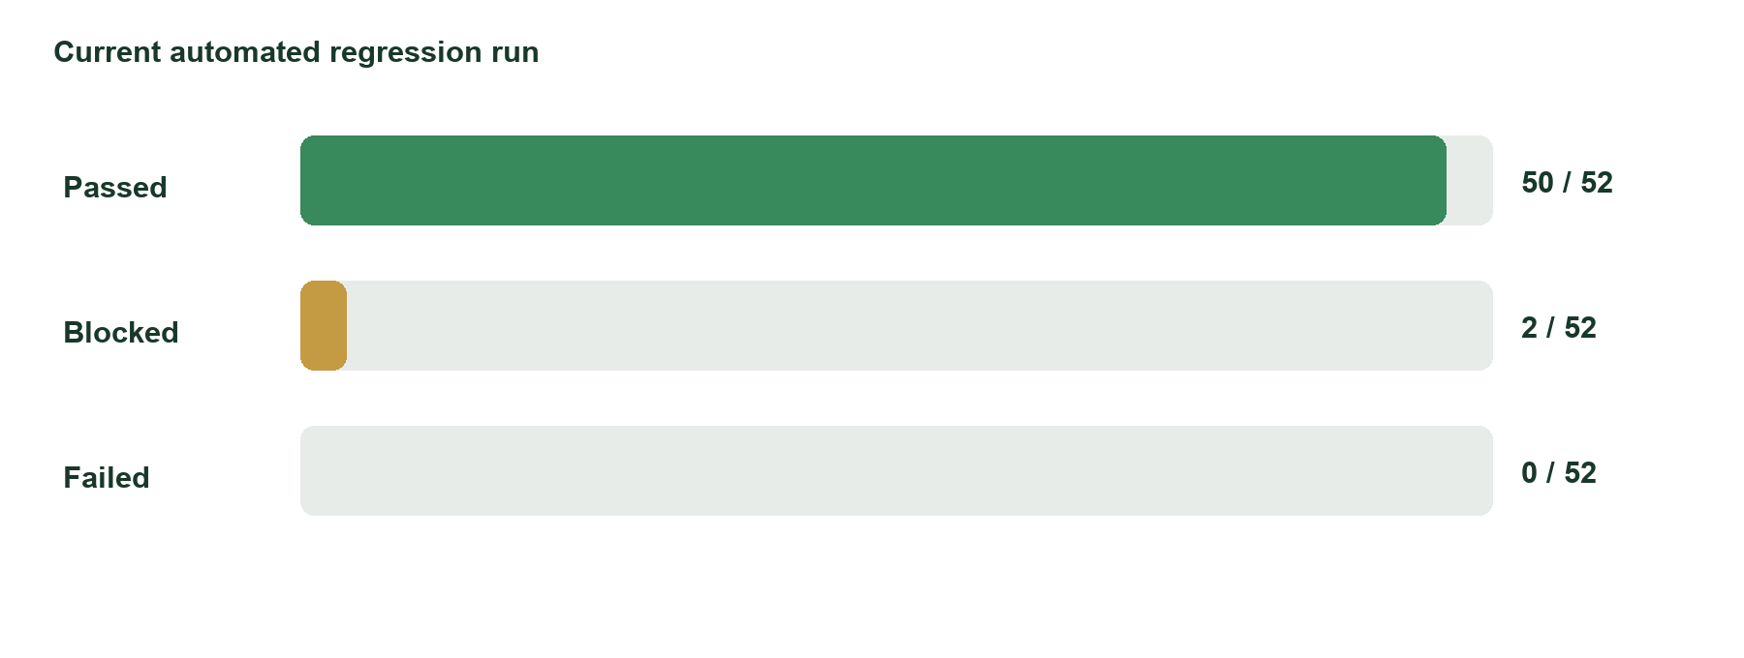
Figure 44. Formal regression results for run 20261005T153119448-21704: 50 passed, 0 failed, and 2 blocked.

Result Calculation
Pass rate = Passed ÷ (Passed + Failed) = 50 ÷ (50 + 0) = 100.0%. The two blocked cases are reported separately. The terminal proof is a separate one-test run and does not change this calculation.

13. Automation Coverage
Table 7. Playwright implementation coverage by module.
Module | Total TC | Automated | Coverage %
Authentication and recovery | 6 | 6 | 100.0%
Crops, care and harvest | 4 | 4 | 100.0%
Customers, discounts and payment records | 3 | 3 | 100.0%
Dashboard and analytics | 3 | 3 | 100.0%
Inventory catalogue | 7 | 7 | 100.0%
Notifications and activity history | 4 | 4 | 100.0%
Reports, exports and print views | 3 | 3 | 100.0%
Role authorization | 12 | 12 | 100.0%
Sales and receipts | 6 | 6 | 100.0%
User management | 4 | 4 | 100.0%
Automation coverage is 52/52 (100.0%) against the automated-only catalogue. Execution coverage is 50/52 (96.2%), and pass rate is calculated separately among executed cases.
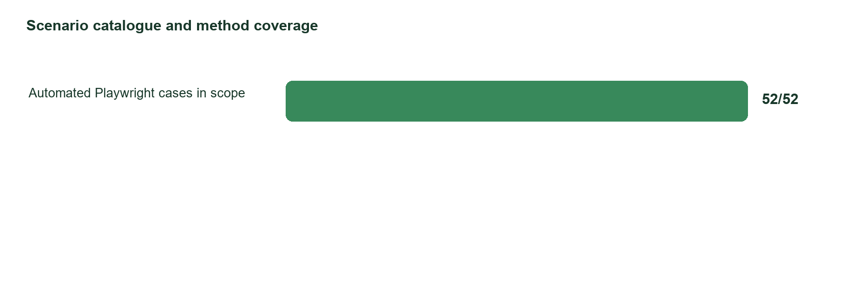
Figure 45. All 52 in-scope cases have Playwright implementations.

14. Risks and Assumptions

Risks
- Unstable environments
- Test data issues
- Third-party dependency failures
- Frequent requirement changes

Assumptions
- Test environments remain available
- Business requirements are finalized
- APIs are accessible during execution
The existing shared development/demo database contains unrelated records. Run-labelled fixtures and a single worker reduce interference; dashboard totals can still reflect prior activity.
Risk | Potential effect | Control / response
Shared demo data | Dashboard totals include unrelated existing activity | Record baseline and compare only the controlled transaction delta
Supabase reachability | Setup can fail before a case begins | Keep setup failures separate from test failures; rerun only after connectivity is restored
Unavailable UI state | Case cannot reach its expected action | Keep it Blocked and document the precise missing precondition
External or hardware integration | Browser checks cannot prove live service or rover behavior | Label as out of scope and verify in an isolated integration/hardware cycle

15. Reporting and Dashboard

Daily Metrics
- Build Status
- Execution Status
- Defect Trend
- Automation Coverage
- Failed Tests
- Execution Duration
Formal run: 50 passed, 0 failed, 2 blocked; automation coverage 100.0%; execution duration 218.2 seconds.

Recommended Reports
- Playwright HTML Report — produced for the formal run and terminal proof
- Playwright JSON results — produced for the formal run
- Allure Report — not configured
- Extent Report — not configured
- Azure DevOps Dashboard — not used
- Power BI Test Dashboard — not used
Terminal proof files: docs/automation/terminal-proof/playwright-login-shell-run.txt and docs/automation/terminal-proof/html/index.html. The terminal proof is a separate local login-shell check and is not included in the formal suite denominator.

Report Artifacts
Artifact | Location | Purpose
Formal HTML report | docs/automation/run-artifacts/20261005T153119448-21704/html/index.html | Interactive 52-case report
Formal JSON result | docs/automation/run-artifacts/20261005T153119448-21704/results.json | Machine-readable case results
Terminal transcript | docs/automation/terminal-proof/playwright-login-shell-run.txt | Shows the Playwright command and one passing browser test
Terminal HTML report | docs/automation/terminal-proof/html/index.html | Standalone supplementary login-screen run

Playwright Terminal Proof
PS> npx.cmd playwright test --config=playwright.terminal-proof.config.ts
Running 1 test using 1 worker
ok 1 e2e\terminal-proof.spec.ts:3:5 > Supplementary terminal proof: SeedRover login screen renders (704ms)
1 passed (1.6s)
Exit code: 0
Terminal output from the separately recorded one-test Playwright login-shell proof.

16. CI/CD Integration Checklist
Item | Status
Source Code in Git | ☒
Build Pipeline Configured | ☒ Manual GitHub Actions workflow exists
Automated Execution Triggered | ☒ Local Playwright terminal run recorded
Test Reports Published | ☒ Local HTML/JSON reports saved; no remote publication
Notifications Enabled | ☐
Quality Gates Configured | ☐

17. Test Sign-Off
Role | Name | Signature | Date
QA Lead | [Enter name]
Test Manager | [Enter name]
Development Lead | [Enter name]
Business Owner | [Enter name]

Final Recommendation
Conditional Go for the tested web workflows, subject to review of blocked cases and completion of human sign-off. This recommendation is based on recorded automated results only.
Go Live Status:
- ☐ Go
- ☒ Conditional Go
- ☐ No-Go
Review note: this report records test evidence and a conditional recommendation. Final approval remains with the named human reviewers.

