KNOWLEDGE INSTITUTE OF TECHNOLOGY

(Autonomous)
SALEM–637504


RECORD NOTE BOOK
Register Number:

Certified that this is the bonafide record of work done by Selvan / Selvi of the IV Semester
Branch during the Year in BE23AD551 – IT INFRASTRUCTURE

LABORATORY.

Staff In-charge Head of the Department

Submitted for the University Practical Examination held on …………………………..

Internal Examiner External Examiner

CONTENT

Ex. No. | Date | Name of the Exercise | Marks | Signature
1 |  | Assemble a PC and Verify Hardware via BIOS/UEFI
2 |  | Upgrade RAM and Clone HDD/SSD to NVMe
3 |  | Install and configure printer and scanner and troubleshooting driver and connectivity issues
4 |  | Create dual-boot Vm with windows and Linux using Partioning
5 |  | Installation and Basic Commands of Linux Operating System
6 |  | Install and update and roll back while software checking application compatibility
7 |  | Configure windows update and WSUS for patch management
8 |  | Deploy antivirus and endpoint security agents configure scanning policies
9 |  | Enter assets ITSM tool and manage tickets with sla tracking
10 |  | Implement backup and restore policies for endpoints to ensure data integrity

EX:NO: 1 | Assemble a PC and Verify Hardware via BIOS/UEFI

AIM:
To assemble a desktop computer system from individual hardware components and verify proper installation and functioning using BIOS/UEFI settings.

Apparatus / Requirements
- Motherboard
- CPU (Processor)
- RAM (Memory modules)
- SMPS (Power Supply Unit)
- Storage Device (HDD/SSD)
- Cabinet (Case)
- Monitor, Keyboard, Mouse
- Thermal paste
- Screwdriver set

PROCEDURE

Step 1: Preparation
- Ensure all components are available and working.
- Work on a non-static surface (use anti-static precautions).

Step 2: Install CPU
- Place the motherboard on a flat surface.
- Open CPU socket latch.
- Align CPU with socket (check notch/triangle mark).
- Gently place CPU and lock the latch.
- Apply thermal paste and fix CPU cooler.

Step 3: Install RAM
- Open RAM slot clips.
- Align RAM notch with slot.
- Insert RAM firmly until clips lock automatically.

Step 4: Mount Motherboard
- Place motherboard inside cabinet.
- Align with screw holes.
- Secure using screws.

Step 5: Install Power Supply (SMPS)
- Fix SMPS in cabinet.
- Connect main power cable (24-pin) to motherboard.
- Connect CPU power cable (4/8-pin).

Step 6: Install Storage Device
- Mount HDD/SSD in drive bay.
- Connect SATA cable to motherboard.
- Connect power cable from SMPS.

Step 7: Connect Front Panel & Peripherals
- Connect power switch, reset switch, LEDs.
- Attach keyboard, mouse, and monitor.

Step 8: Power On System
- Switch on power supply.
- Press power button.
- Observe system startup.

Step 9: Enter BIOS/UEFI
- Press Del / F2 / F10 during boot.
- Enter BIOS/UEFI setup.

Step 10: Verify Hardware
- Check CPU details.
- Verify installed RAM capacity.
- Confirm storage detection.
- Check system temperature and fan status.

Diagram
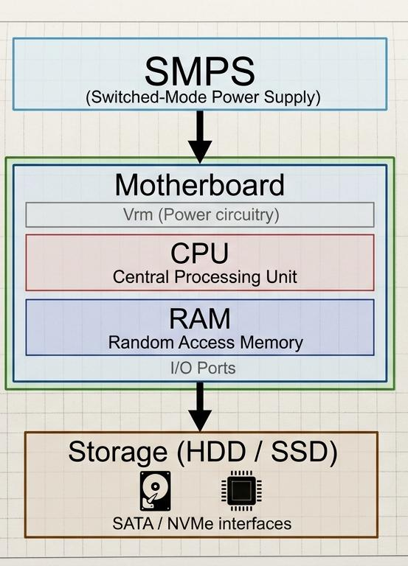

Result
The PC was successfully assembled, and all hardware components were verified using BIOS/UEFI. The system is functioning properly.

EX: NO: 2 | Upgrade RAM and Clone HDD/SSD to NVMe

AIM:
To upgrade system RAM and clone an existing HDD/SSD to an NVMe SSD for improved system performance.

Apparatus / Requirements
- Desktop/Laptop system
- RAM module (compatible)
- NVMe SSD
- Screwdriver set
- Cloning software (e.g., Macrium Reflect / Clonezilla)
- SATA/NVMe connectors

PROCEDURE

RAM Upgrade
- Shut down the system and disconnect power.
- Open the cabinet/laptop back panel.
- Locate RAM slots on the motherboard.
- Open the slot clips.
- Align RAM notch with slot.
- Insert RAM firmly until clips lock.
- Close the system and power it on.
- Verify RAM in system properties or BIOS.

NVMe Installation
- Locate M.2 slot on motherboard.
- Insert NVMe SSD at a 30° angle.
- Gently press and secure with screw.
- Boot the system.

Part C: Disk Cloning
- Install cloning software (e.g., Macrium Reflect / Clonezilla).
- Launch the software.
- Select source disk (HDD/SSD).
- Select destination disk (NVMe SSD).
- Start cloning process.
- Wait until cloning completes.
- Restart system.

Part D: Set Boot Priority
- Enter BIOS/UEFI (Del/F2 key).
- Go to Boot settings.
- Set NVMe SSD as primary boot device.
- Save and exit.

DIAGRAM

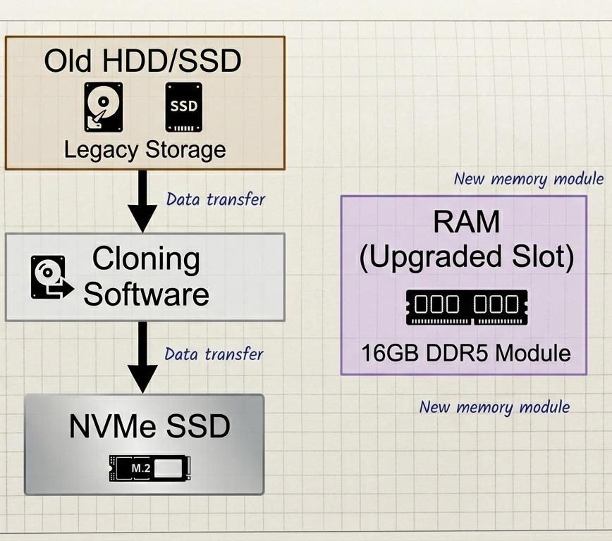

RESULT
The RAM was successfully upgraded and the existing system was cloned to NVMe SSD. The system performance improved significantly.

EX: NO: 3 | INSTALL AND CONFIGURE PRINTER AND SCANNER AND TROUBLESHOOTING DRIVER AND CONNECTIVITY ISSUES

AIM:
To install, configure, and test a printer/scanner, and troubleshoot common driver and connectivity issues.
Apparatus / Requirements
- Desktop/Laptop (Windows/Linux OS)
- Printer or All-in-One Printer/Scanner
- USB cable / Wi-Fi network connection
- Device drivers (CD/downloaded from manufacturer website)
- Internet connection
- Paper for test print
PROCEDURE
Printer Installation (USB Method)
- Connect the printer to the computer using a USB cable.
- Power ON the printer.
- Open Control Panel → Devices and Printers.
- Click Add a Printer.
- Select the detected printer from the list.

- If not detected, choose Add manually and select the correct port.
- Install drivers (automatic or from CD/download).
- Complete the setup.
Printer Installation (Wi-Fi Method)
- Connect the printer to the Wi-Fi network using its control panel.
- Ensure the computer is on the same network.
- Go to Settings → Printers & Scanners → Add Device.
- Select the wireless printer.
- Install required drivers.
- Finish setup.
Scanner Setup
- Install scanner drivers/software.
- Open scanning software (e.g., Windows Scan).
- Place document on scanner glass.
- Select scan type (color/grayscale).
- Click Scan and save the file.
Testing
- Right-click the printer → Printer Properties.
- Click Print Test Page.
- Verify output quality.
Troubleshooting
- Check power and cable connections
- Restart printer and system
- Clear print queue
- Update/reinstall drivers
- Check network connectivity (for Wi-Fi printers)
- Set printer as default

Result
The printer/scanner was successfully installed and configured. Test print and scanning operations were performed, and common issues were identified and resolved

EX: NO: 4 | CREATE DUAL-BOOT VM WITH WINDOWS AND LINUX USING PARTIONING

AIM:

To install and configure a dual boot system with Windows and Linux using disk partitioning.

Apparatus / Requirements
- Computer/Laptop (or Virtual Machine software like VirtualBox / VMware Workstation)
- Windows OS (pre-installed or ISO file)
- Linux distribution ISO (e.g., Ubuntu)
- Minimum 4 GB RAM (8 GB recommended)
- Minimum 40 GB free disk space
- Bootable USB (for physical system)
Procedure
Prepare Disk Partition
- Boot into Windows.
- Open Disk Management.
- Select main drive → Right-click → Shrink Volume.
- Create free unallocated space (at least 20 GB for Linux).

Create Virtual Machine (Optional Method)
- Install VirtualBox.
- Create a new VM:
  - Name: Linux
  - Type: Linux
  - RAM: 2–4 GB
- Create virtual hard disk (40 GB).
Install Linux
- Boot system (or VM) using Linux ISO (e.g., Ubuntu).
- Select Install Ubuntu.
- Choose “Install alongside Windows” OR “Something else”.
- Create partitions:
  - Root / (20 GB)
  - Swap (2–4 GB)
- Proceed with installation.

Install Bootloader
- GRUB bootloader installs automatically.
- Restart system after installation.

Boot Selection
- On startup, GRUB menu appears.
- Select:
  - Ubuntu (Linux)
  - Windows
Diagram
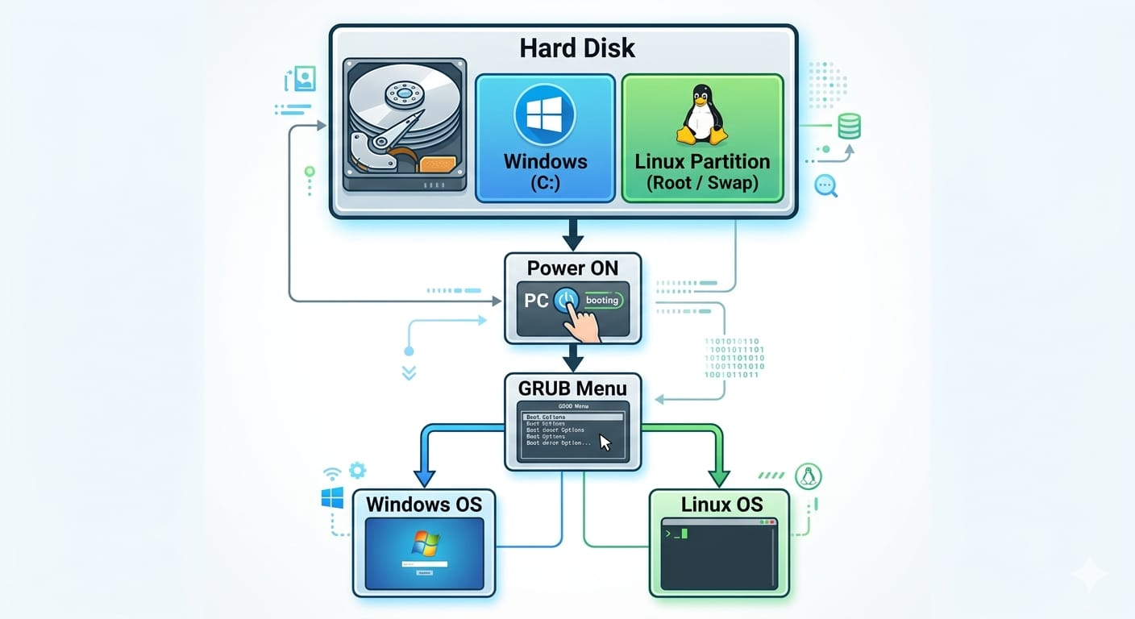

Result
A dual boot system with Windows and Linux was successfully created using disk partitioning, and both operating systems were accessed through the GRUB bootloader
EX: NO: 5 | PERFORM LINUX TERMINAL COMMANDS AND WRITE BASIC SHELL SCRIPTS FOR AUTOMATION

Aim
To install a Linux operating system and perform basic file and directory management commands.

Apparatus / Requirements
- Computer/Laptop
- Linux ISO (e.g., Ubuntu)
- Virtualization software like VirtualBox (optional)
- Minimum 4 GB RAM
- Internet connection

Basic Linux Commands

- Check current directory

Pwd

- List files and directories

ls
- Change directory

cd folder_name

- Create directory

mkdir test

- Create file

touch file.txt

- View file content

cat file.txt

- Copy files

cp file.txt copy.txt

- Move/Rename file

mv file.txt newfile.txt

- Delete file

rm file.txt

- Clear screen

clear

Result
Linux OS was successfully installed, and basic commands were executed to manage files and directori
EX: NO:6 | INSTALL AND UPDATE AND ROLL BACK WHILE SOFTWARE CHECKING APPLICATION COMPATIBILITY

Aim
To install software, perform updates, roll back to a previous version, and verify application compatibility with the system.

Apparatus / Requirements
- Computer/Laptop (Windows/Linux)
- Software application (e.g., Google Chrome or VLC Media Player)
- Internet connection
- Administrator access
PROCEDURE
Software Installation
- Download software (e.g., VLC Media Player).
- Run the installer file.
- Follow installation steps (Next → Install → Finish).
- Launch the application to verify installation.
Software Update
- Open the installed application.
- Go to Help → Check for Updates (if available).
- Download and install updates.
- Restart application after update.
Compatibility Check
- Right-click application → Properties.
- Go to Compatibility tab.
- Run in compatibility mode (if needed).
- Check performance and functionality.

Rollback Process
- Open Control Panel → Programs and Features.
- Select the installed software.
- Click Uninstall/Change.
- Reinstall previous version (older setup file).
- Verify system stability.
.

Result
Software was successfully installed, updated, and tested for compatibility. Rollback was performed to restore a stable version when required.

EX: NO: 7 | CONFIGURE WINDOWS UPDATE AND WSUS FOR PATCH MANAGEMENT

Aim
To configure Windows Update settings and set up WSUS (Windows Server Update Services) for centralized patch management in a network.

Apparatus / Requirements
- Windows Server system (for WSUS)
- Client Windows PCs
- Internet connection
- Administrator privileges
- Windows Server
- Windows Update
- WSUS

Procedure
Configure Windows Update (Client System)
- Open Settings → Update & Security.
- Go to Windows Update.
- Click Check for Updates.
- Enable:
  - Automatic updates
  - Active hours configuration
- Restart system after updates are installed.

Install WSUS (Server Side)
- Open Server Manager.
- Click Add Roles and Features.
- Select WSUS role.
- Choose required components:
  - Windows Internal Database
  - Update Services
- Specify update storage location.
- Complete installation and restart server.
Configure WSUS Server
- Open WSUS Console.
- Configure synchronization settings:
  - Microsoft Update source
  - Language and products selection
- Start synchronization process.
- Approve required updates manually.

Connect Client Machines to WSUS
- Open Group Policy Editor (gpedit.msc).
- Navigate to:
Computer Configuration → Administrative Templates → Windows Components → Windows Update
- Enable: Specify intranet Microsoft update service location.
- Enter WSUS server URL:
http://<WSUS_Server_IP>:8530
- Apply policy and restart client system.

Testing
- Run command on client:
gpupdate /force
- Open Windows Update.
- Verify updates are coming from WSUS server.

Result
Windows Update was configured successfully on client systems and WSUS was installed and configured on the server for centralized

EX: NO: 8 | DEPLOY ANTIVIRUS AND ENDPOINT SECURITY AGENTS CONFIGURE SCANNING POLICIES

Aim
To install and deploy antivirus/endpoint security agents on systems and configure scanning policies for malware protection.

Apparatus / Requirements
- Windows/Linux computer systems
- Internet connection or offline installer
- Administrator privileges
- Central management console (if available)
- Antivirus software such as Windows Defender or enterprise endpoint tools like Microsoft Defender for Endpoint

Procedure
Install Antivirus / Endpoint Agent
- Download or access antivirus installer (e.g., Windows Defender or endpoint agent).
- Run installer as Administrator.
- Accept license agreement.
- Complete installation.
- Restart system if required.

Enable Real-Time Protection
- Open Windows Security / Antivirus Console.
- Go to Virus & Threat Protection.
- Turn ON:
  - Real-time protection
  - Cloud-delivered protection
  - Automatic sample submission

Configure Scanning Policies
- Open Security Settings / Policy Manager.
- Select Scan Options.
- Configure:
  - Quick Scan schedule (daily)
  - Full Scan schedule (weekly)
  - Custom scan paths (important folders)
- Enable automatic updates for virus definitions.

Deploy Endpoint Security Agent (Network Setup)
- Access central management console (e.g., Microsoft Defender for Endpoint).
- Create device group.
- Generate installation package/script.
- Deploy agent to client machines using:
  - Group Policy
  - Script deployment
  - Manual installation
- Verify agent connectivity in dashboard.

Testing
- Run Quick Scan and Full Scan.
- Check threat detection logs.
- Verify endpoint status in management console.

Result
Antivirus and endpoint security agents were successfully installed and configured. Scanning policies were applied, and system security was verified through scanning and monitoring

EX: NO: 9 | ENTER ASESSETS ITSM TOOL AND MANAGE TICKETS WITH SLA TRACKING

Aim
To explore an IT Service Management (ITSM) tool, manage IT assets, create and track service tickets, and monitor them using SLA (Service Level Agreement) tracking.

Apparatus / Requirements
- Computer/Laptop with internet access
- ITSM tool (e.g., ServiceNow or similar ITSM platform)
- Admin/User credentials
- Web browser
Procedure
Login to ITSM Tool
- Open browser and access ITSM portal (e.g., ServiceNow).
- Enter username and password.
- Navigate to the dashboard.

Asset Management
- Go to Asset Management module.
- Add new asset:
  - Asset name (Laptop/Printer)
  - Serial number
  - Category (Hardware/Software)
- Assign asset to user or department.
- Save and verify asset entry.

Ticket Creation
- Go to Incident Management / Service Desk.
- Click Create New Ticket.
- Fill details:
  - Issue description
  - Priority (Low/Medium/High/Critical)
  - Category (Hardware/Software/Network)
- Submit ticket.

Ticket Assignment and Tracking
- Assign ticket to support team or technician.
- Monitor ticket status:
  - Open
  - In Progress
  - On Hold
  - Resolved

SLA Configuration and Monitoring
- Define SLA rules:
  - Response time (e.g., 2 hours for high priority)
  - Resolution time (e.g., 24 hours)
- Apply SLA to ticket categories.
- Monitor SLA compliance dashboard.
- Check alerts for SLA breach warnings.

Result
ITSM tool was successfully accessed. IT assets were managed, tickets were created and tracked, and SLA monitoring was implemented for service performance evaluation
EX: NO: 10 | IMPLEMENT BACKUP AND RESTORE POLICIES FOR ENDPOINTS TO ENSURE DATA INTEGRITY

Aim

To configure backup and restore policies on endpoint systems to ensure data integrity and recovery in case of data loss or system failure.

Apparatus / Requirements
- Windows/Linux endpoint system
- External storage device / cloud storage
- Administrator privileges
- Backup software or built-in tools
- Windows Backup and Restore or similar tool
- Optional cloud backup service

PROCEDURE

Configure Backup Policy
- Open backup tool (e.g., Windows Backup and Restore).
- Click Set up Backup.
- Select backup location:
  - External drive OR
  - Network location OR
  - Cloud storage
- Choose data to back up:
  - Files and folders
  - System image (optional)
- Set backup schedule:
  - Daily / Weekly / Monthly
- Save and start backup process.

Verify Backup
- Check backup completion status.
- Ensure backup files are stored in selected location.
- Confirm file integrity by opening sample files.

Restore Data
- Open backup utility.
- Select Restore Files option.
- Choose backup version/date.
- Select files/folders to restore.
- Restore to original or new location.
- Verify restored data integrity.

System Restore (Optional)
- Open System Restore option.
- Select restore point.
- Confirm restore operation.
- Restart system after completion.

Result
Backup and restore policies were successfully implemented on endpoint systems, ensuring data integrity and enabling recovery of data in case of failure or loss

