|  |  |  |
| --- | --- | --- |
| **Trainee Name**: John Byrne | **Subject**: SQL | **Trainer**: Astha Shaw |

**Mini-Project**

|  |  |
| --- | --- |
| **Set:** 26/06/2020 | **Due:** 29/06/2020 |

**Following Aspects of SQL are included in exercises**

|  |
| --- |
| **Exercise 1 – Northwind Queries (40 marks: 5 for each question)** |

|  |  |
| --- | --- |
| **1.1** | Write a query that lists all Customers in either Paris or London. Include Customer ID, Company Name, and all address fields. |



|  |
| --- |
| Answer |



|  |
| --- |
| Marks: 5 / 5 |

|  |  |
| --- | --- |
| **1.2** | List all products stored in bottles. |



|  |
| --- |
| Answer |



|  |
| --- |
| Marks: 5 / 5 |

|  |  |
| --- | --- |
| **1.3** | Repeat question above but add in the Supplier Name and Country. |



|  |
| --- |
| Answer |



|  |
| --- |
| Marks: 5 / 5 |

|  |  |
| --- | --- |
| **1.4** | Write an SQL Statement that shows how many products there are in each category. Include Category Name in result set and list the highest number first. |

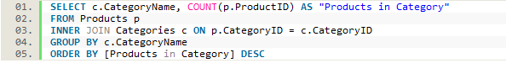

|  |
| --- |
| Answer |

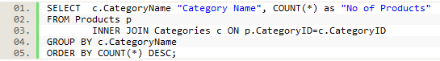

|  |
| --- |
| Marks: 5 / 5 |

|  |  |
| --- | --- |
| **1.5** | List all UK employees using concatenation to join their title of courtesy, first name and last name together. Also include their city of residence. |



|  |
| --- |
| Answer |



|  |
| --- |
| Marks: 5 / 5 |

|  |  |
| --- | --- |
| **1.6** | List Sales Totals for all Sales Regions (via the Territories table using 4 joins) with a Sales Total greater than 1,000,000. Use rounding or FORMAT to present the numbers. |

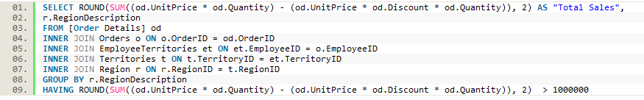

|  |
| --- |
| Answer |

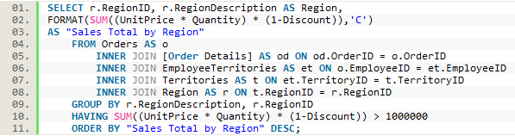

|  |
| --- |
| Marks: 5 / 5 |

|  |  |
| --- | --- |
| **1.7** | Count how many Orders have a Freight amount greater than 100.00 and either USA or UK as Ship Country. |



|  |
| --- |
| Answer |



|  |
| --- |
| Marks: 5 / 5 |

|  |  |
| --- | --- |
| **1.8** | Write an SQL Statement to identify the Order Number of the Order with the highest amount(value) of discount applied to that order. |



|  |
| --- |
| Answer |



|  |
| --- |
| Marks: 5 / 5 |

**Exercise 2 - Create Spartans Table (20 marks – 10 each)**

|  |  |
| --- | --- |
| **2.1** | Write the correct SQL statement to create the following table:   * Spartans Table – include details about all the Spartans on this course. Separate Title, First Name and Last Name into separate columns, and include University attended, course taken, and mark achieved. * Add any other columns you feel would be appropriate. |

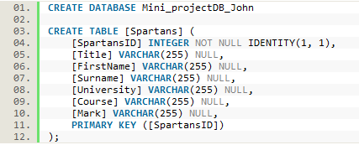

|  |
| --- |
| Marks: 10 / 10 |

|  |  |
| --- | --- |
| **2.2** | Write SQL statements to add the details of the Spartans in your course to the table you have created. |

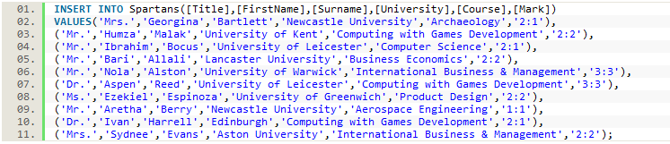

|  |
| --- |
| Marks: 10/ 10 |

**Exercise 3 – Northwind Data Analysis linked to Excel (30 marks)**

|  |  |
| --- | --- |
| **3.1** | List all Employees from the Employees table and who they report to. No Excel required. (5 Marks) |



|  |
| --- |
| Answer |

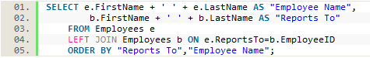

|  |
| --- |
| Marks: 5 / 5 |

|  |  |
| --- | --- |
| **3.2** | List all Suppliers with total sales over $10,000 in the Order Details table. Include the Company Name from the Suppliers Table and present as a bar chart as below: (5 Marks) |



|  |
| --- |
| Answer |

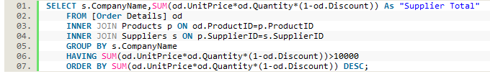

|  |
| --- |
| Marks: 5 / 5 |

|  |  |
| --- | --- |
| **3.3** | List the Top 10 Customers YTD for the latest year in the Orders file. Based on total value of orders shipped. No Excel required. (10 Marks) |

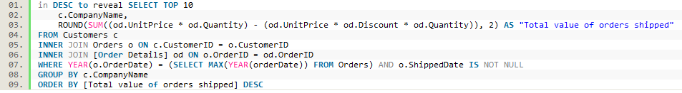

|  |
| --- |
| Answer |

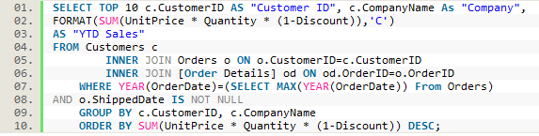

|  |  |
| --- | --- |
| Marks: 10/10 | |
| **3.4** | Plot the Average Ship Time by month for all data in the Orders Table using a line chart as below. (10 Marks) |

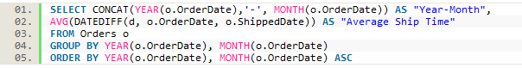

|  |
| --- |
| Answer |

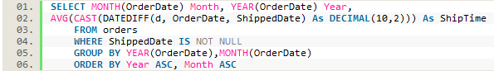

|  |
| --- |
| Marks: 10 / 10 |