***Nombre_Alumno: Juan Carlos Sánchez Martínez***

***Nombre_Docente: Dulce Fátima Aguilar Juárez***

***Instituto Tecnológico de Apizaco***

***Ing_Mecatrónica***

***Ingles Four Corners***

***Unidad 4***

***Portafolio de Evidencias***



Actividad 1:

Description of the activity:  
This activity was based on making the pseudocode or a detailed instruction so that a person can be guided on how to correctly send a message, and can do it consecutively as many times as necessary.

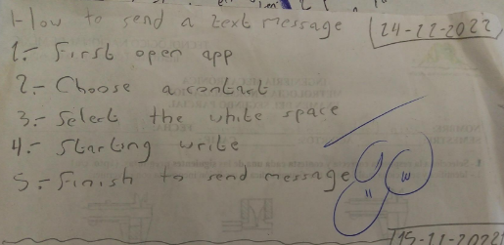

Actividad 2:

Description of the activity:

This activity consisted of converting different words to their corresponding forms in verb and noun, dividing them in such a way that it was seen legible and understood in such a way that the noun of each verb is distinguished and vice versa (the verb from the noun), all in one table.

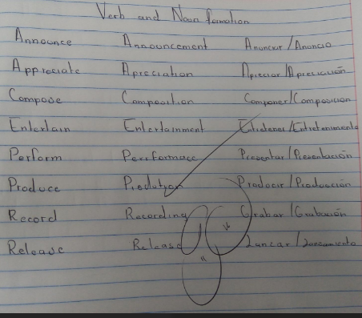

Actividad 3:

Description of the activity:

This activity dates from putting into practice what the already and the yet are, to be able to compose different sentences that require or involve questions in relation to topics that may have already happened or things that you ask a person or friend and wonder if it is that he or she has finished a certain important activity.

