Link for github: <https://github.com/JohnCard/backend_repositories/blob/master/modulo_25/Homework/HomeWork.ipynb>

Code function view:

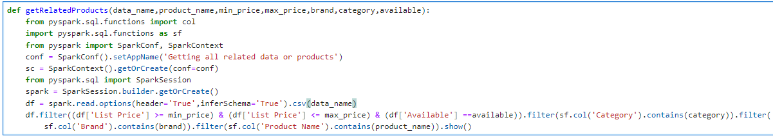

File with csv format view:

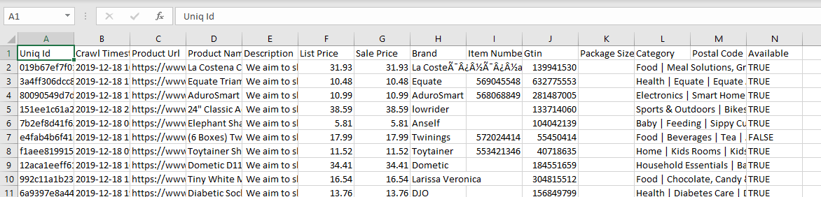

Trying our function:



OutPut:

