3D: Shape from Focus

Johnny Torres

# Multi-focus representation

After reading the images, a transformation was performed to make them gray, and the same size, then packing into an array of images where each channel correspond to a image in gray levels.

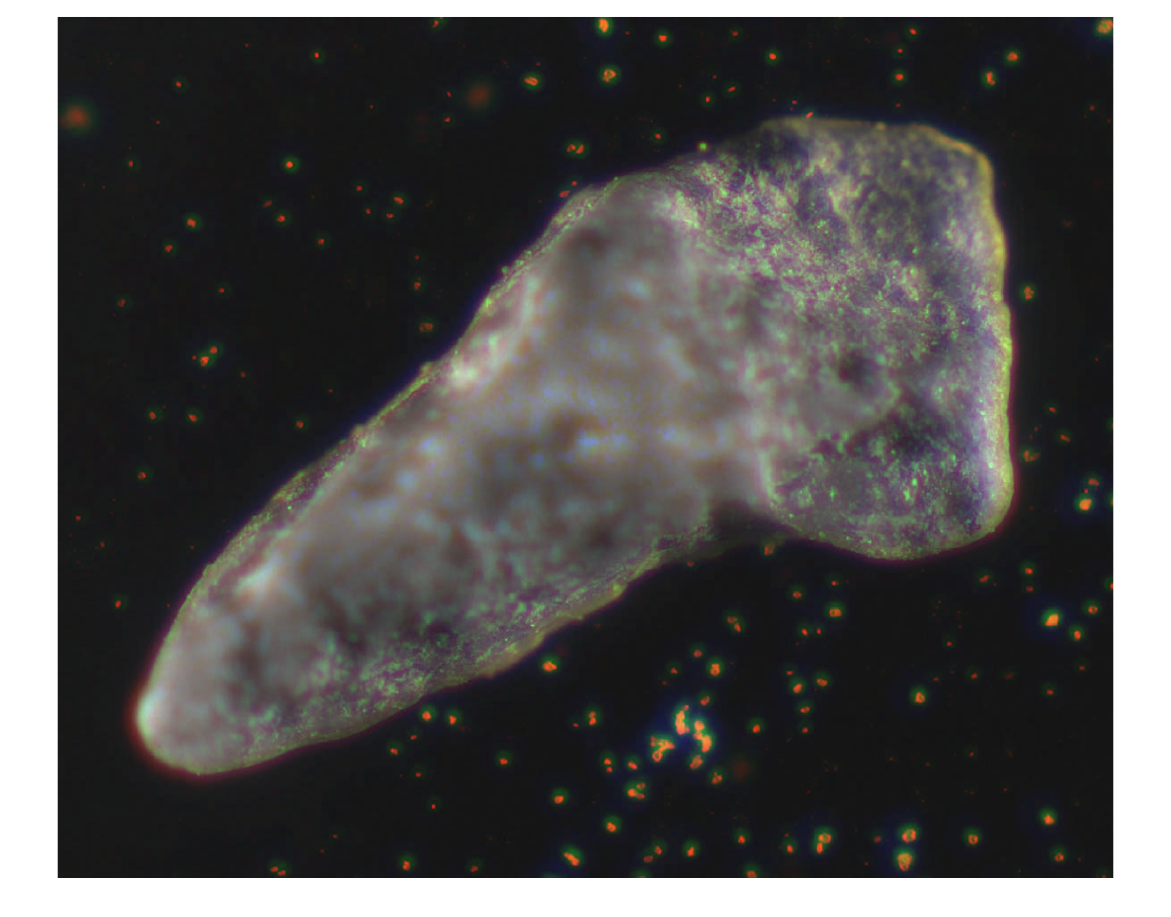

# 3D representation

After the multi-focus representation, it was calculated the focus measurement by converting to double type images representation for each channel and for each of those images it was calculated the gray level variance.

