By: John Carter | 602-697-3008 | [303visuals@gmail.com](mailto:303visuals@gmail.com)

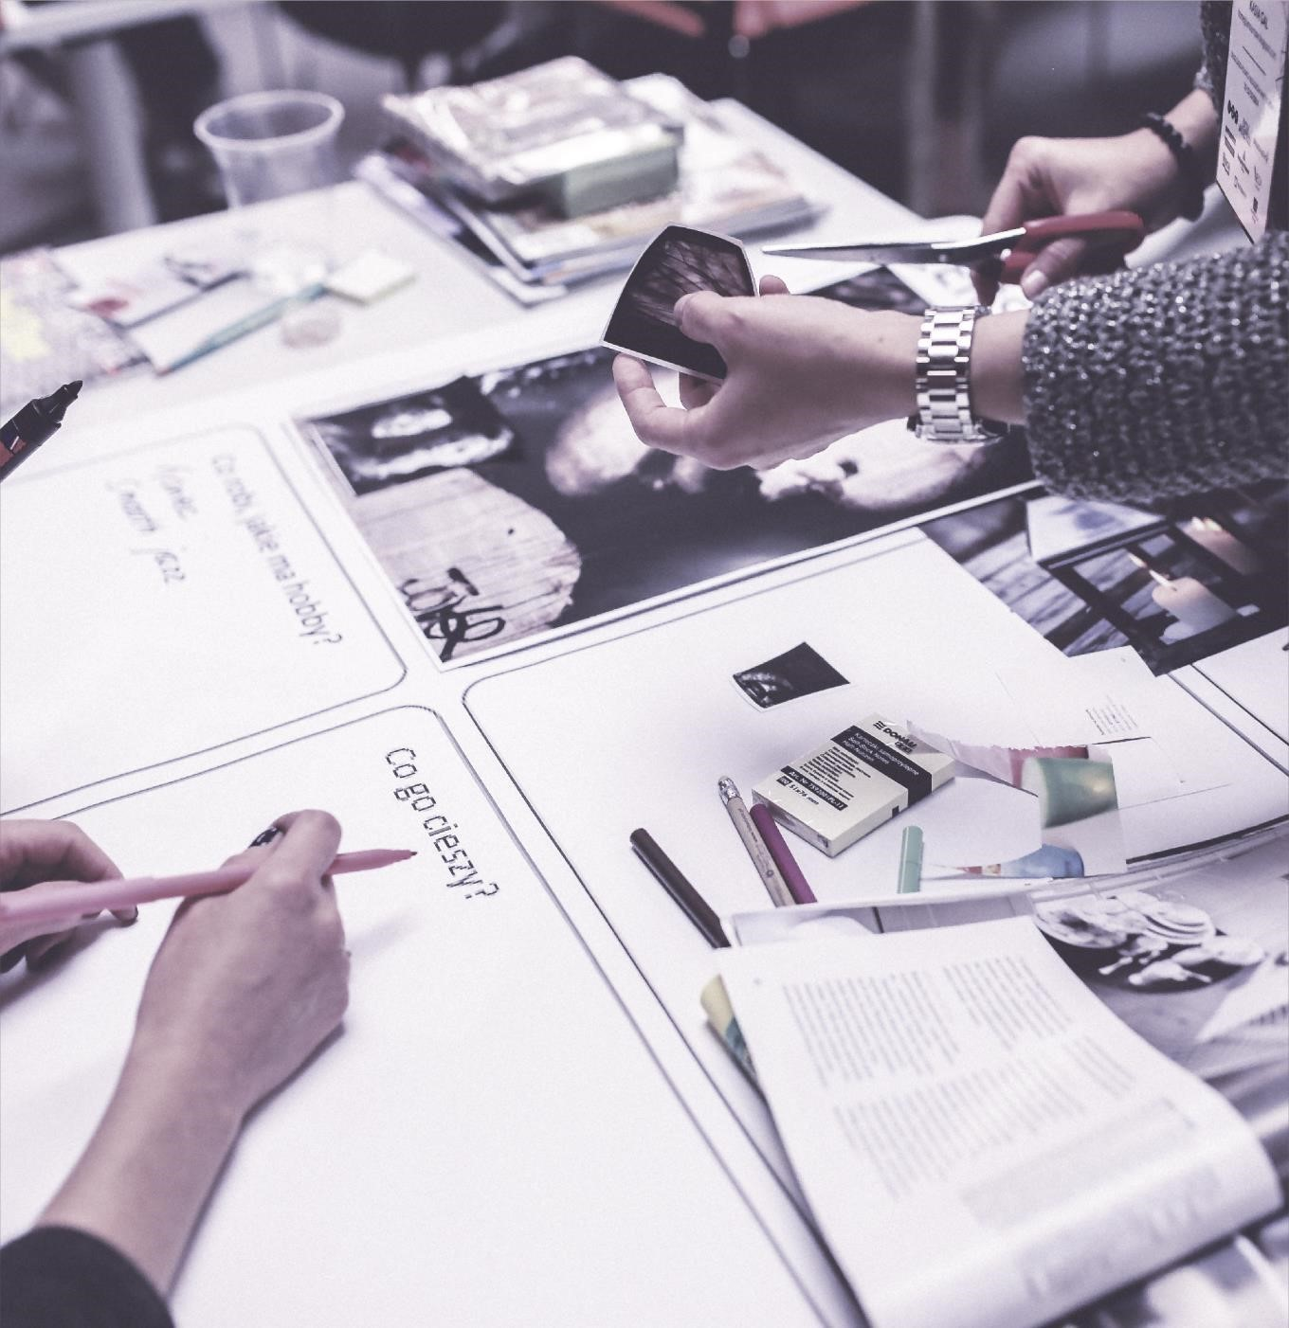

**UI /**

**UX Design**



**Process 2018**

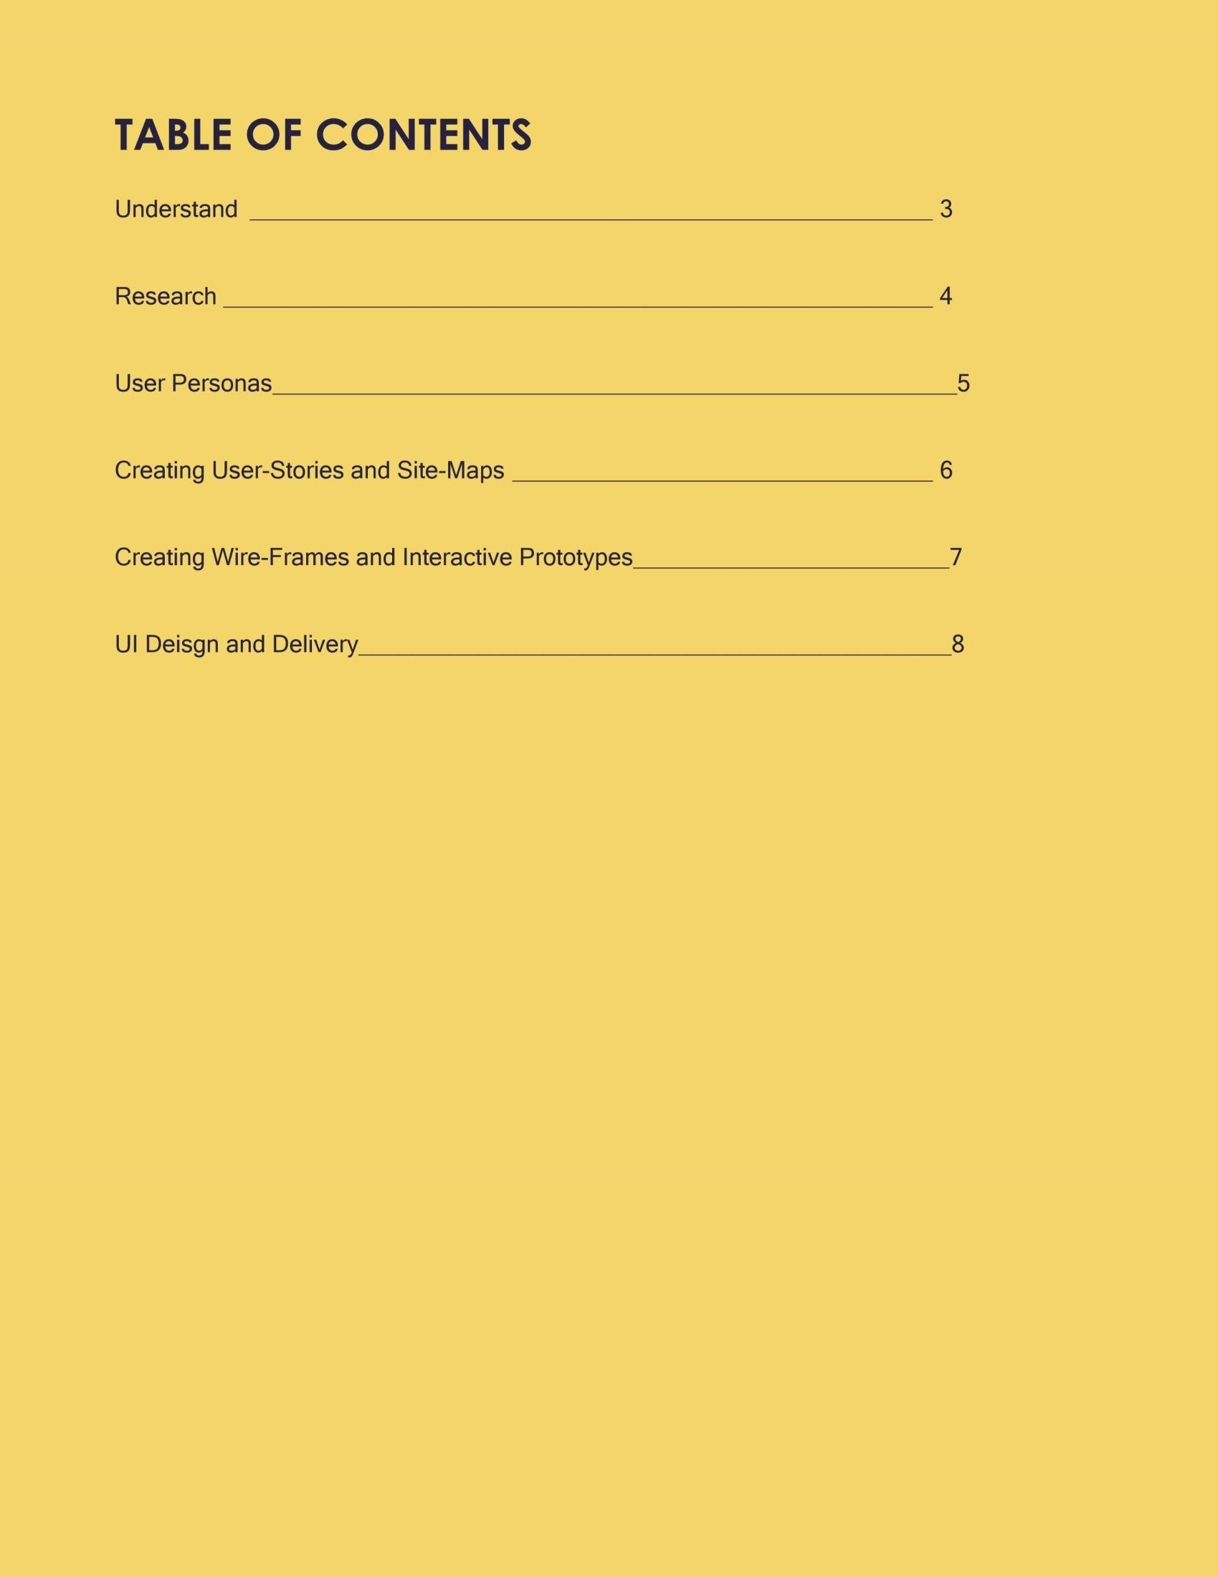

# UNDERSTAND

Define the problem first. My main focus us to fully understand what the user is trying to solve. UX design is the process of solving a problem for a user, helping them achieve their goals with ease and more than that, make them feel delighted while doing so. This very first step is the principle of whatever method you may use in the process, understanding the problems and the objectives before working on it. We can often overlook this crucial step, this is where I like to start, just to gain a better idea of the requirements and user goals.

“If I had only one hour to solve a problem, I would spend up to two-third of that hour in attempting to define what the problem is.”

# RESEARCH

I Conduct Real Research from Real Users.

I start thinking about the users. Who are they, where are they from? How old are they? Where do they live? What sex, gender, race and ethnicity are they? Where can I find them? The more information I can gather to make specific personas the better off I will be, especially when I get to the maps and design phase of my process. Generally, I will take a look at all the requirements first, then list out the questions I have about specific things, even things that I’m are sure about. Then I would give it to the users and other parties involved in the process to test and give feedback.



# USER PERSONAS

***“Personas*** *are fictional characters created to represent the different user types that might use a site, brand, or product in a similar way. The purpose of personas is to create reliable and realistic representations of your key audience segments for reference”*

These 2 sentences can simply explain what persona is and why user personas are so important to the process of creating the best experience possible. We will build our products based on those personas. Creating solutions for the needs of those “people” — our targeted users. My user personas focus on delivering the **user goals**, the pattern and often represent a group of **people sharing similar goals** and their obstacle that prevent them from achieving their goals — which is the product’s main purpose.

# CREATING USER STORIES / SITEMAPS / & FLOW CHARTS

**“stick” to my ideas about user personas.**

Every user has a goal to achieve, as a team, our job is to define the step that the user will go through to get to the final goal.

**Team work & Collaboration is CRUCIAL.**

As we create the user scenario map, as a team we need to be focus on the goals of the user. I like to stick together in this process and really brainstorm the best and worst case scenarios that a user will encounter when trying to achieve these goals. Asking every person on the team to define the user goals based on the product requirements. I like to write all the goals on sticky notes and place them on to a whiteboard where everyone can collaborate and brainstorm together.

**Build the Site-map**

Every website needs a sitemap, for the user who gets lost. And we need a sitemap for a great product that can help prevent users from getting lost. Based on the criteria above from the user personas and the scenario map & the user flow, I then create a page for one or some main tasks, then link it together. If I’m designing for apps, I like to create something similar like screens flow, a collections of screens connected together. And I enjoy using LucidChart for these site maps.

“Pay attention to what users DO, not what they say”

# CREATE WIRE-FRAMES AND INTERACTIVE PROTOTYPES

Now comes the most fun part for me, UI design. I love giving people a visual representation of the ideas we had been putting together previously with our personas, maps and flows.

Many designers like to do high fidelity wireframes, but in my process, I like to stick the lo-fi first. My reason for this is, I don’t want to spend too much time on drawing, but to spend more time on **exploring the designs.**

Wireframes help me do that. Don’t think too much about the pixels, how big or small the text is, I just want to explore different design approaches and see what is the best solution from a user prospective and from an aesthetically pleasing prospective. The main point of wireframes is to let everyone give their idea, exploring options and once everyone agrees on one, we can start furthering the design process without any changes or confusion. This saves a lot of time in the future when we start iterations on the wireframes.

**What tools I use.**

For finding ideas, paper and pencils are enough. For more details and put into prototype, I prefer Sketch as my main tool, or Adobe XD (Experience Design). It’s also helpful when you start doing mockups and UI. Sketch also has SO many available plugins for Marvelapp, Invision, or using mirror tool to see the design right away on your mobile device.

Once I have the initial wireframes, I like to move the designs to my prototype tools and see if it really works. At this point I like to bring the prototype to real users, do some testing and see how they react, fix and create a new prototype, based on their use case and start iterations.

**UI / VISUAL DESIGN & DELIVER**

My favorite part of the UI / UX process. Creating the visuals and tying everything together. This can be no easy task as there are lots of things for me to keep in mind here. UI is about beauty, UX sometimes has a different approach, so the two need to agree on one another. Each should be open, but strict on colors, spacing, padding, font size, weight etc. What I often times do, is create a UI style guide, a good way to keep consistency within designs. The UX part is not finished here though, we still need to think about the usability of each UI elements (form label placements, buttons size…). The UI style guide is a main part of design work later on and will help us keep things consistent.

If you have any questions for me while you were reviewing this process, or any questions at all, please shoot me a note.

Thanks again for stopping by 😊

- John