

UNIVERSIDAD DE DAGUPAN
SCHOOL OF INFORMATION TECHNOLOGY EDUCATION
ITP10 | EVENT-DRIVEN PROGRAMMING
MIDTERM | LABORATORY ACTIVITY 3

Name : Jenielle Kyle V Agravante
Year, Course & blk : 31-ITE-02
Subject : EVENT-DRIVEN PROGRAMMING
Date : _______________________________________

SCORE:

Laboratory Activity #3: Student Registration Form with Input Validation

Objective: At the end of this activity, students should be able to create an HTML form with appropriate controls and labels, use JavaScript events to validate user input, and apply regular expressions to check input formats. They should also be able to display clear, accessible error and success messages and safely display user input using textContent.

Scenario
Your university needs a registration form for an upcoming IT seminar. Develop a form that checks student information before displaying a registration summary.

Part A — Create the Registration Form
Create these files:
- index.html
- css/style.css
- js/app.js

Include the following fields and controls:
Field or Control | Requirement
Full name | Text input; required id="fullName"
Student number | Text input; required id="studentNumber"
Email address | Email input; required id="email"
Mobile number | Telephone input; required id="mobileNumber"
Password | Password input; required id="password"
Confirm password | Password input; required id="confirmPassword"
Course | Dropdown with BSIT and BSCS options; required id="course"; option values must be BSIT and BSCS
Terms agreement | Checkbox; required id="terms"
Register | Submit button; required id="registerBtn"
Reset | Reset button; required id="resetBtn"

Every field must have a visible label. The course dropdown must begin with an unselected placeholder such as “Select your course.” The form itself must use id="registrationForm" so the automated browser tests can submit it consistently.

Part B — Apply Validation Rules
Use HTML attributes and JavaScript checks where appropriate. Use regular expressions for the student number, email, mobile number, and password.

Field | Validation Rules
Full name | Required; at least two characters after trimming; reject input containing only spaces.
Student number | Required; follow the format 24-1234-123: two digits, a hyphen, four digits, a hyphen, and three digits.
Email address | Required; use the module’s simplified email pattern: text before @, a domain containing a dot, and text after that dot; no whitespace.
Mobile number | Required; accept 09 followed by nine digits or +639 followed by nine digits; no spaces or hyphens.
Password | Required; at least eight characters, one uppercase letter, one digit, and one of @, $, or !; no whitespace.
Confirm password | Required; must match the password exactly.
Course | Must select BSIT or BSCS.
Terms agreement | Must be checked.

Important: Trim leading and trailing spaces from the name, student number, email, and mobile number before checking them. Do not trim passwords or remove spaces from the middle of an entry.

Autograder Compatibility Requirements
To make the activity compatible with the Programming Classroom function and browser tests, follow these exact names and rules:
- Create a pure function named isValidStudentNumber(value). It must return true only when the trimmed value matches the required student-number format; otherwise return false.
- Create a pure function named isValidPassword(value). It must return true only when the password satisfies all password rules; otherwise return false.
- The two validation functions must not read from document, window, or any HTML element. They must work only from the argument passed to them.
- Keep js/app.js safe to load in Node for the function tests. Do not access document or window at file load time unless the access is guarded with typeof document !== "undefined".
- When CommonJS is available, export the two functions using module.exports so the autograder can call them.
- Use textContent when writing user-entered values into the registration summary. Do not use innerHTML for user-entered values.
Required feedback and summary element IDs
Purpose | Required ID
Full-name error | fullNameError
Student-number error | studentNumberError
Email error | emailError
Mobile-number error | mobileNumberError
Password error | passwordError
Confirm-password error | confirmPasswordError
Course error | courseError
Terms error | termsError
Live password feedback | passwordFeedback
Success message | successMessage
Registration summary container | registrationSummary
Summary full name | summaryName
Summary student number | summaryStudentNumber
Summary email | summaryEmail
Summary mobile number | summaryMobileNumber
Summary course | summaryCourse
Initial-state requirement: successMessage and registrationSummary must be empty or hidden before a successful registration. Reset must return them to that initial state.

Part C — Add Event Handling and Feedback
Implement the following behavior:
- On form submission
  - Use the form’s submit event.
  - Call event.preventDefault() because this activity processes the form locally.
  - Check every field and show all relevant errors.
  - Display a success message only when all fields pass validation.
- While entering a password
  - Use the input event.
  - Show feedback explaining whether the password meets the stated rules.
- After leaving the full-name field
  - Use the blur event.
  - Show an error if the trimmed name is empty or too short.
- When changing the course or terms agreement
  - Use the change event.
  - Update the corresponding feedback.
- When resetting the form
  - Restore the controls to their initial values.
  - Clear error messages, password feedback, the success message, and the registration summary.

Display errors beside or below the relevant field. Use specific messages, such as:
“Enter a student number in the format 24-1234-123.”
When the user corrects an entry and it is checked again, remove its error message.

Part D — Display the Registration Summary
After successful validation, display: Use the required summary IDs listed in the Autograder Compatibility Requirements.
- Full name
- Student number
- Email address
- Mobile number
- Course

Show this message:
Registration details validated successfully!
Use textContent to display user-entered information. Do not display either password.
This activity requires no database or server connection. The message confirms that the browser checks passed.

Part E — Accessibility and Testing
Accessibility requirements
- Connect each label to its control using matching for and id values.
- Use descriptive error text alongside any error colors.
- Set aria-invalid="true" on fields that fail validation; clear or change it to "false" when corrected.
- Connect fields to their error messages using aria-describedby.
- Ensure the form can be operated using the keyboard.

Automated testing note
The Programming Classroom autograder will check required files, source-code structure, the two pure validation functions, invalid submission behavior, successful registration, and reset behavior. Keep the required file paths, IDs, option values, and function names exactly as written in this activity.
Required test cases
Test | Expected Result
Submit all fields empty | Show required-field errors; no success summary.
Enter a full name containing only spaces | Reject the name.
Enter 24-1234-12 as the student number | Reject the incorrect format.
Enter student@email as the email | Reject it under the stated simplified rule.
Enter 0917-123-4567 as the mobile number | Reject the hyphenated format.
Enter student123 as the password | Reject it for missing an uppercase letter and required symbol.
Enter different passwords | Show a password-mismatch error.
Leave the course unselected or terms unchecked | Prevent successful registration.
Complete all fields correctly | Show the success message and summary.
Click Reset after successful registration | Restore the initial form and clear all feedback and output.

Submission Requirements
- Create a personal GitHub repository for the activity. The repository root must contain index.html, css/style.css, and js/app.js.
- Recommended repository name: Lastname-Firstname-Module6-Lab.
- Include a screenshots folder in the repository containing:
  - The form with validation errors.
  - A successful registration summary.
- Ensure the activity works by opening index.html in a browser, then push the final version to GitHub.
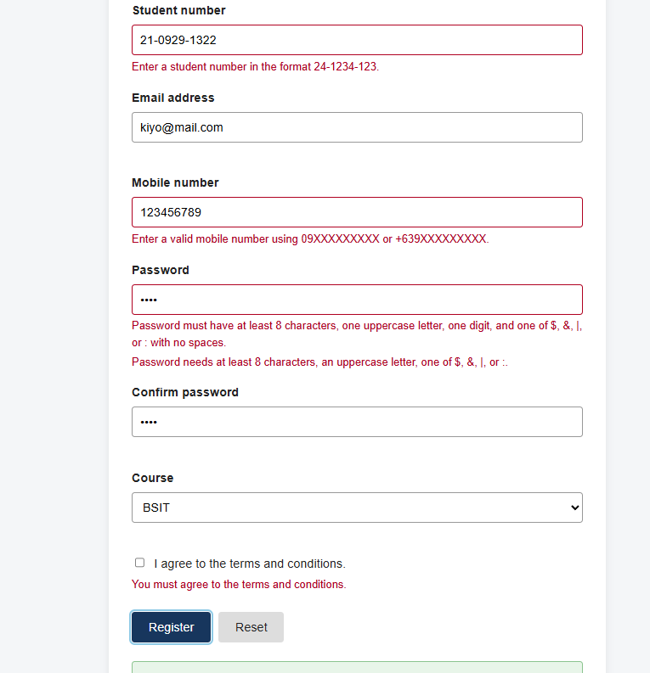
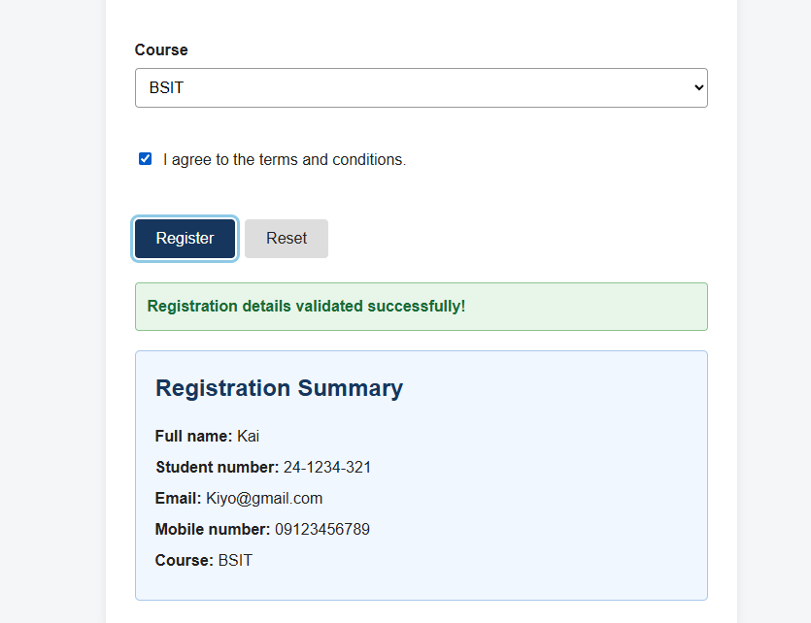
- Use fictional information and passwords. In GradeVision Programming Classroom, connect the repository and submit the final commit SHA for grading.

Grading Rubric per Part and Function
Part | Function or Requirement | Points
A — Form Structure | Includes all eight required fields and Register and Reset buttons. | 10
 | Uses appropriate input types, connected labels, and working CSS/JavaScript file links. | 5
B — Input Validation | Validates full name: required, trimmed, and at least two characters. | 4
 | Validates student number using the required format. | 4
 | Validates email using the specified simplified format. | 4
 | Validates both accepted Philippine mobile number formats. | 4
 | Enforces all stated password requirements. | 6
 | Checks that confirm password matches exactly. | 3
 | Requires a valid course selection. | 2
 | Requires the terms agreement to be checked. | 3
C — Events and Feedback | Handles submission, prevents page reload, checks all fields, and blocks success when input is invalid. | 6
 | Uses input for password feedback. | 3
 | Uses blur for full-name validation. | 3
 | Uses change for course and terms feedback. | 3
 | Reset restores initial values and clears all messages and output. | 5
D — Registration Summary | Displays all five required details only after successful validation. | 6
 | Uses textContent, excludes passwords, and displays the success message. | 4
E — Accessibility and Testing | Displays specific field-level errors and clears them when corrected and rechecked. | 5
 | Uses aria-invalid and aria-describedby correctly. | 5
 | Supports keyboard operation and communicates errors through text alongside colors. | 5
 | Passes the required test cases. | 7
 | Submits a complete GitHub repository with the required files/screenshots and the final commit SHA. | 3
Total |  | 100
Award full points when a function meets all requirements, partial points when it works incompletely, and zero when it is missing or does not work. Automated test results may be used as evidence for the matching rubric items; requirements not covered by the automated tests remain subject to faculty review.

Time Deduction
Time is measured from the official activity start to the recorded submission time.

Submission Time | Deduction
Within 40 minutes | 0 points
More than 40 minutes, up to 60 minutes | −10 points
More than 60 minutes, up to 90 minutes | −20 points
More than 90 minutes, up to 120 minutes | −30 points
More than 120 minutes | −40 points

Final Score = Rubric Score − Time Deduction
Apply only one time deduction based on the submission time.

PREPARED BY:

ROCHELLE S. LANTO, MIT
SITE, FACULTY
JELSON V. LANTO, MIT
SITE, FACULTY

