**消息格式：**

|  |  |  |
| --- | --- | --- |
| HEAD | BODY | CHECKBYTE |

|  |  |  |  |  |
| --- | --- | --- | --- | --- |
| SZTEAM | TYPE | LENGTH | BODY | CHECKBYTE |

|  |  |  |  |
| --- | --- | --- | --- |
| 字段 | 长度（单位：Byte） | 说明 | 备注 |
| SZTEAM | 6 | 消息开始标志 | 字符串 “SZTEAM” |
| TYPE | 4 | 消息类型 |  |
| LENGTH | 4 | 表示BODY长度 |  |
| BODY | 不定 | 消息内容 |  |
| CHECKBYTE | 1 | 校验位 | 校验算法待定 |

**TYPE字段分类：**

|  |  |  |  |  |
| --- | --- | --- | --- | --- |
| 类型 | 编号 | 说明 | 发送方向 | 备注 |
| CONNECT_REQ | 1 | 建立连接请求 | C —— > S |  |
| CONNECT_RSP | 2 | 建立连接回应 | C < —— S |  |
| DISCONNECT | 3 | 中断连接 | C <——> S |  |
| BEATING | 4 | 心跳包 | C —— > S |  |
|  |  |  |  |  |
| FILE_DATA_REQ | 11 | 文件传输请求 | C —— > S |  |
| FILE_DATA_RSP | 12 | 文件传输回应 | C < —— S |  |
| DATA_PUSH | 13 | 文件数据推送 | C < —— S |  |
| DATA_PUSH_RSP | 14 | 文件接收回应 | C —— > S |  |
| SEND_FIN | 15 | 传输终止 | C <——> S |  |
|  |  |  |  |  |

**时序图：**

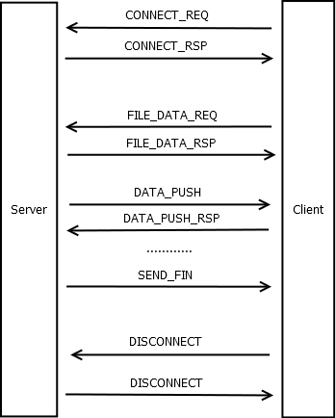

**各消息类型中DATA部分的数据结构：**

|  |  |  |  |
| --- | --- | --- | --- |
| 类型 | 编号 | DATA字段数据结构 | 备注 |
| CONNECT_REQ | 1 | NULL |  |
| CONNECT_RSP | 2 | {  int new_port;  } |  |
| DISCONNECT | 3 | NULL |  |
| BEATING | 4 | NULL |  |
|  |  |  |  |
| FILE_DATA_REQ | 11 | {  char * file_name;  int seek_num;  } |  |
| FILE_DATA_RSP | 12 | {  long file_size;  int block_count;  } |  |
| DATA_PUSH | 13 | {  int block_num;  char * content;  } |  |
| DATA_PUSH_RSP | 14 | {  int block_ok;  } |  |
| SEND_FIN | 15 | NULL |  |
|  |  |  |  |