ENVIRONMENTAL PROTECTION

Air Pollutants

Carbon monoxide 一氧化碳

Nitrogen oxide 氮氧化物

Ground-level ozone 地表臭氧

Hydrocarbon 碳氢化合物

Sulfur dioxide 二氧化硫

Particulate matter 微粒物质

Carbon dioxide 二氧化碳

Symptoms

Bronchitis 支气管炎

Eye irritation 眼睛刺激性

Respiratory ailment 呼吸器官疾病

Asthma 哮喘

Chest tightness 胸闷

Pneumonia 肺炎

Burning eyes 眼睛发热

Environmental Pollution

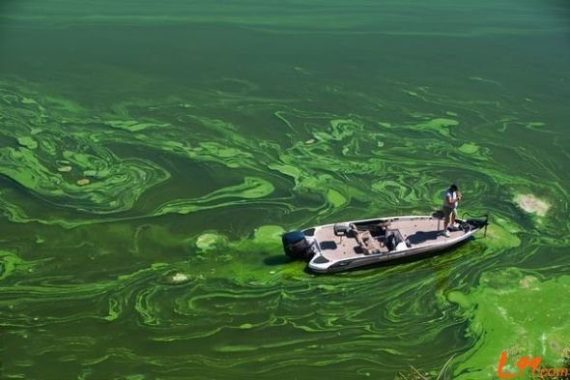

Water Pollution 水污染

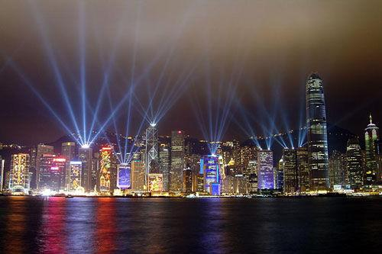

Light Pollution 光污染

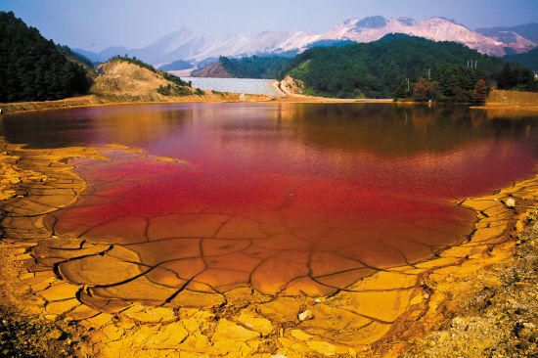

Soil Pollution 土壤污染

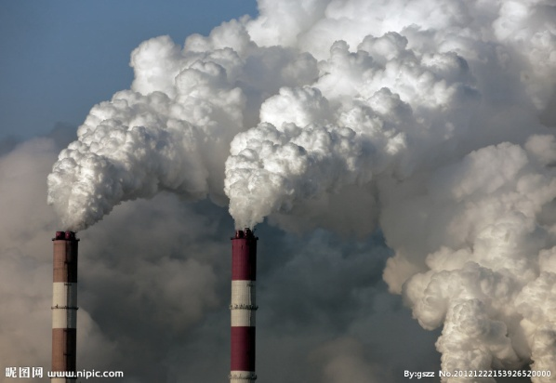

Air Pollution 空气污染

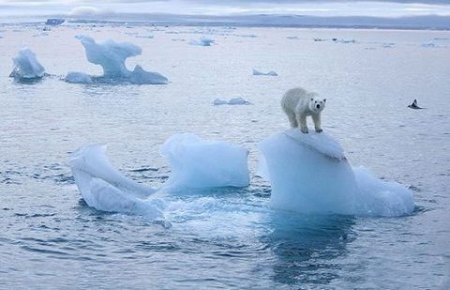

Global Warming 全球变暖

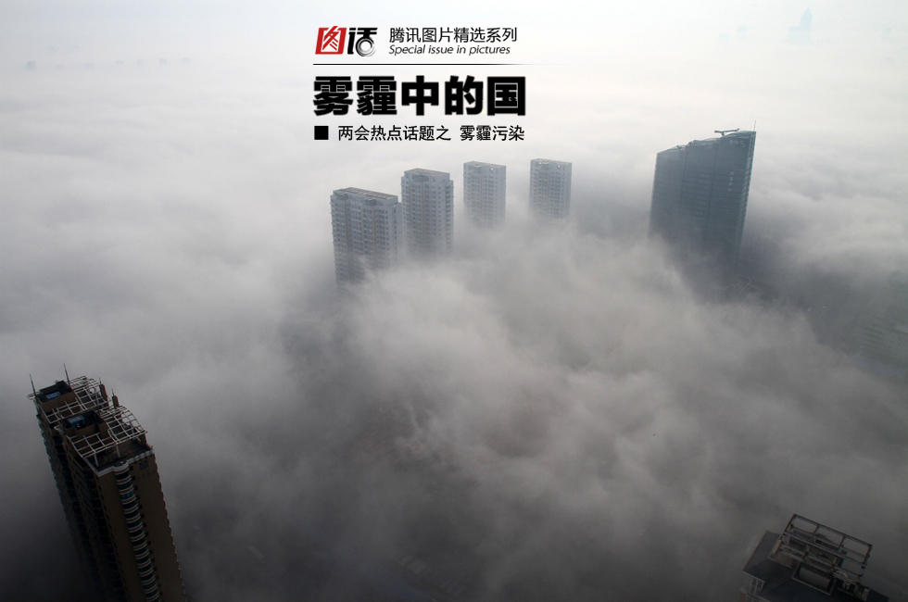

Haze 雾霾

Accumulation

1. The biggest air pollutants are sulfur dioxide, carbon monoxide, carbon dioxide, nitrogen oxides, and particulate matter.

主要的空气污染物有二氧化硫，一氧化碳，二氧化碳，氮氧化物和微粒物质。

2. The pollutants derive from a wealth of sources, including agriculture, factory discharges, consumer products, urban runoff and wastewater treatment plants.

污染物质的来源广泛，包括农业，工厂排放物，消费产品，城市河道和污水处理工厂。

3. The burning of fossil fuels such as coal, petroleum, and gasoline is found to be the main contributing factor in air pollution.

化石燃料的燃烧，如煤炭，石油和汽油被认为是导致空气污染的主要致因。

4. Air pollution is known to cause respiratory ailments and irritation of the eyes and throat.

空气污染物可以导致呼吸道疾病以及咽喉刺激。

5. Common symptoms observed after exposure to high levels of air pollution are chest tightness, burning eyes, and cough.

暴露在严重空气污染后的常见症状有胸闷，火眼和咳嗽。

6. Prolonged exposure to air pollution can lead to ear-ache, bronchitis, and asthma.

长期暴露在空气污染下可以导致耳痛，支气管炎和哮喘。

Ways to Prevent Air Pollution

1. Sharing car rides will reduce the number of cars on the road, thereby cutting down on the use of fossil fuels. (Car-pooling)

合伙用车能够减少路面车辆，从而降低化石燃料的使用。

2. Timely vehicle care both saves money and maximizes fuel efficiency.

定期车辆养护不但可以省钱，而且可以最大化能效。

3. If you are going to a nearby place, go by foot or bicycle instead of using your vehicle.

如果去周边地区，请你步行或者骑自行车，而不开车。

4. Another effective way to prevent air pollution is to use alternative energy sources such as solar energy, hydroelectric energy, and wind energy.

另外一种有效减少空气污染的办法就是利用可替代能源，比如太阳能，水利电能和风能。

5. We should switch off lights, fans, air conditioners, televisions, and other household appliances when they are not in use.

当电灯，电扇，空调，电视以及其它家用电器不在使用中的时候，我们应该关掉它们。

6. Carbon dioxide is required by plants for photosynthesis.

二氧化碳被植物吸收进行光合作用。

7. Odd-even traffic restriction, which makes cars with odd and even license plates drive on alternate days, will cut automobile emissions by more than 60% and take half of the city’s 4.2 million cars off the road.

单双号限行允许汽车根据日期的单双号出行，将减少不止60%的汽车尾气，同时减少城市420万汽车中的一半。（北京2011年12月5日统计全市机动车保有量471.1万辆）

8. However, cholera continues to pose a major threat in developing countries that lack efficient sewage treatments and clean water.

然而，在发展中国家，霍乱继续造成重大威胁，原因是缺乏有效的污水处理和干净的水。

TOEFL TEST INDEPENDENT TASKS

TASK ONE

***1. We are facing very serious environmental problems. Describe several ways to save our planet.-122***

**Sample Answer:**

Nowadays, we’re facing very serious environmental problems such as air pollution, water pollution and soil pollution. I personally suggest the following several ways to save our planet.

The first way is to institute and promulgate new policies. For example, odd-even traffic restriction which makes cars with odd and even license plates drive on alternate days, will cut automobile emissions by more than 60%. It’ll help reduce air pollution.

As to water pollution, I suggest to develop the work of sewage water treatment, use less plastic bags, clean and pure industrial effluents before releasing them. (94)

***2. What should universities do to protect environments?-145***

**Sample Answer:**

I personally suggest the following two things that universities should do to protect environment.

The first thing is to plant more trees. Carbon dioxide, the main contributing factor in air pollution, is required by plants for photosynthesis.

Second, cutting back on-campus parking lots will help. As we all know that haze, one of the most serious environmental problems, is mainly caused due to excessive use of fossil fuels such as coal, petroleum and gasoline. So reducing parking spaces on campus will encourage students to go to nearby places on foot or by bicycle instead of driving, thereby cutting down on the use of fossil fuels. (105)

***3. What do you think we should do to decrease the usage of car or other vehicle and solve the traffic problems?-159***

**Sample Answer:**

Personally, I suggest the following two ways to decrease the usage of car and solve the traffic problems.

The first way is by legislation. For example, recently, Chinese government’s instituted and promulgated odd-even traffic restriction which makes cars with odd and even license plates drive on alternate days. It has successfully cut automobile emissions by more than 60% and taken half of the city’s 4.2 million cars off the road.

The second way is to develop public transportation system, such as encouraging Car-pooling and establishing more bicycle stations. Sharing car rides can effectively reduce the number of cars on the road thereby solving the traffic problems. (106)

***4. Currently, air pollution is a serious problem. Describe several ways to reduce air pollution.-172***

**Sample Answer:**

I personally recommend the following two ways to reduce air pollution.

The first way is to plant more trees. As we all know carbon dioxide the main contributing factor in air pollution is required by plants for photosynthesis.

The second way is to institute and promulgate new policies. For example, in the past, haze as the result of excessive use of fossil fuels posed the major threat in China. But after APEC, Chinese government’s instituted and promulgated odd-even traffic restriction which makes cars with odd and even license plates drive on alternate days. It has successfully cut automobile emissions by more than 60%. (103)