SPORTS

Chinese Traditional Sports

Kongfu 中国功夫

Lion dance舞狮

Chinese chess 中国象棋

Dragon boat 龙舟

Diabolo 空竹

Chuiwan 捶丸

Cuju 蹴鞠

INDOOR SPORTS (anaerobic)

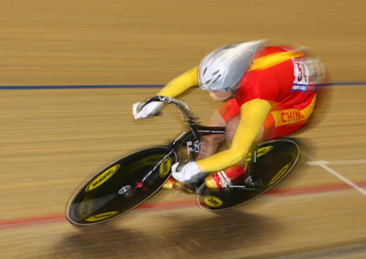

Indoor Cycling 室内自行车

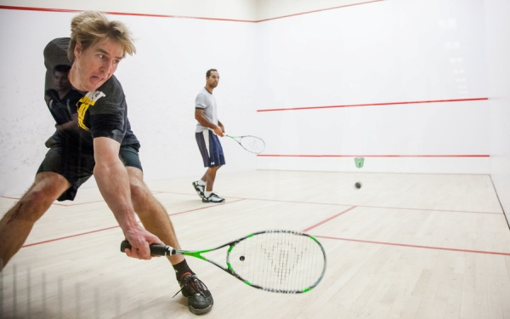

Squash 壁球

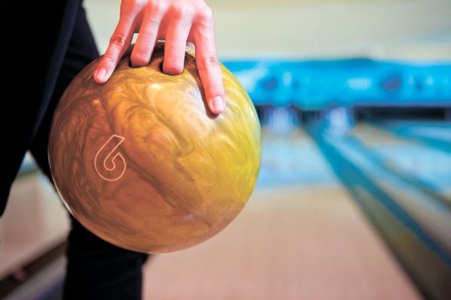

Bowling 保龄球

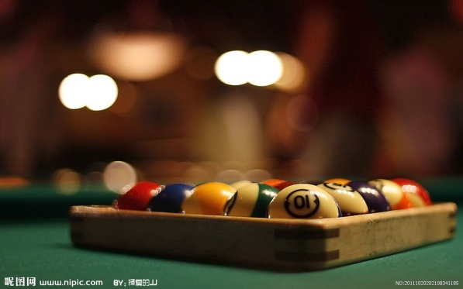

Billiards 台球



Yoga 瑜伽

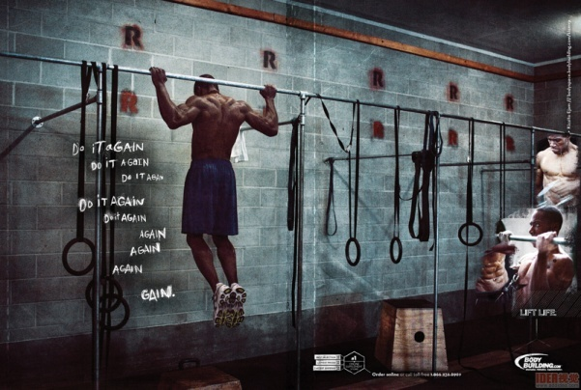

Body building 健美运动

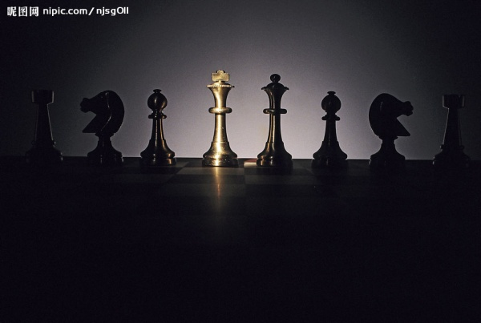

Chess 国际象棋

OUTDOOR SPORTS (aerobic)

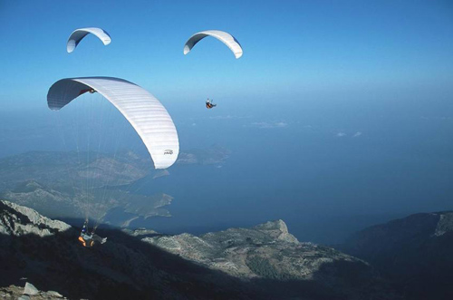

Paragliding 滑翔伞

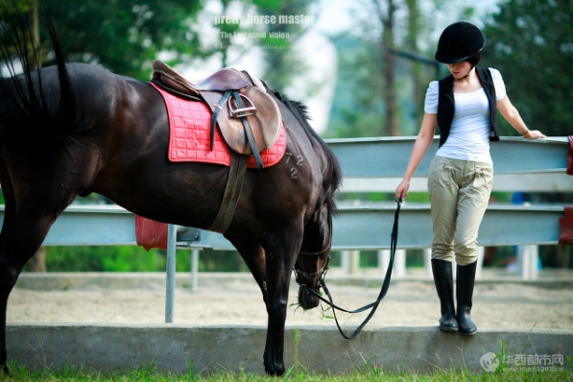

Horsemanship 马术

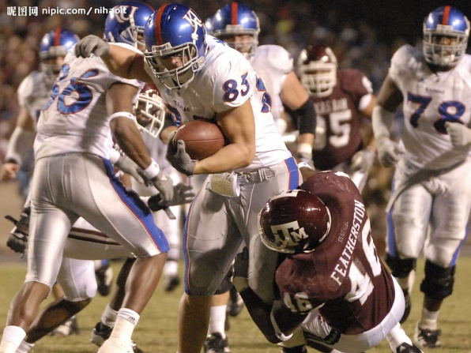

American football 美式橄榄球

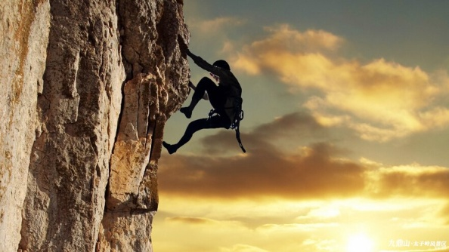

Rock climbing 攀岩

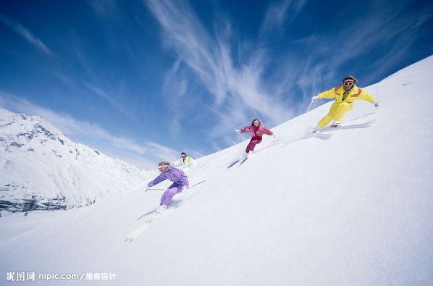

Skiing 滑雪

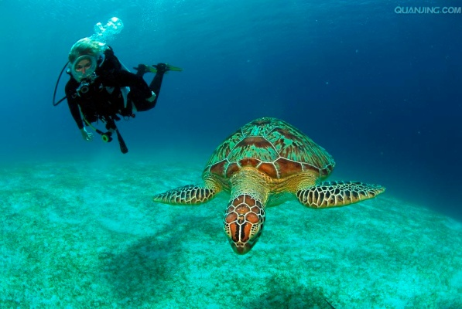

Scuba diving 戴水肺潜水

ACCUMULATION

1. Most of us are in the state of sub-health mainly due to working pressure, irregular diet and lack of exercise.

我们大多人都处于亚健康状态，主要由于工作压力，饮食不规律和缺乏锻炼。

2. Exercise is just as important to health as good food.

锻炼与合理膳食同等重要。（柯林斯词典）

3. About 30% of cancer deaths are due to the five leading behavioral and dietary risks: high body mass index, low fruit and vegetable intake, lack of physical activity, tobacco use, alcohol use.

大约有30%的癌症死亡源自五种主要行为和饮食危险因素：高体重指数，水果和蔬菜摄入量低，缺乏运动，使用烟草以及饮酒。

4. Lack of exercise can lead to feelings of depression and exhaustion.

缺乏锻炼会导致抑郁和疲劳。（柯林斯词典）

5. High levels of stress may lower your immunity to common illnesses.

压力过大可能会降低对常见疾病的免疫力。（简明英汉词典）

PROS

1. Running is considered one of the top activities for burning fat.

跑步被认为是减肥的最好运动之一。

2. Running is a great way to clear my head and sort out my thoughts.

跑步能够使我头脑清醒，理清思绪。

3. Running helps train my muscle, especially leg muscles, and improve my fitness level and overall physical appearance, which can greatly increase my confidence.

跑步能够帮助锻炼我的肌肉，尤其是腿部肌肉，能够提高我的健康水平，改善我的外貌，使我更加的自信。

4. Running regularly reduces the risk of stroke, breast cancer, and the early stages of osteoporosis, diabetes and hypertension.

坚持跑步可以减少很多疾病风险，比方中风，乳腺癌，早期骨质疏松症，糖尿病和高血压。

5. Running helps strengthen my immune system by creating additional lymphocytes.

跑步可以帮助提高免疫系统，通过制造更多的淋巴细胞。

6. Being in the sun is healthy, since humans have developed the ability to extract vitamin D from the sunlight, which increases the absorption of calcium from food.

晒太阳有益健康，因为人类具有从阳光中获得维他命D的能力，能够促进食物中钙质的吸收。

7. Outdoor games offer many advantages such as fresh air, physical exertion, and improving hand-eye coordination.

户外运动有很多好处，比方说新鲜空气，体力活动和提高手眼协调能力。

8. Outdoor games also tend to sharpen your mind since they require you to think on your feet and strategize.

户外运动能够使你的思维更加敏捷，因为需要你反映迅速且制定策略。

9. Outdoor games are a fun way to stay fit and healthy, and have great antidepressant effects.

户外运动是一种保持健康的有趣方式，且有抗抑郁效果。

10. Team sports help cultivate collectivity spirit and cooperation consciousness.

集体运动有助于培养集体精神和合作意识。

11. Exercising the body does a great deal to improve one’s health.

锻炼身体对增进健康大有益处。(柯林斯词典)

12. Exercise stimulates the digestive and excretory systems.

锻炼能促进消化和排泄系统的活动。（柯林斯词典）

13. Exercise is a good safety valve for the tension that builds up at work.

锻炼身体是排解工作压力的好办法。（权威词典）

14. Indoor games, for example chess, can challenge one’s intellect, making them smarter by forcing them to think.

室内运动，比方说国际象棋，可以挑战一个人的智力，通过迫使人思考使人变得更加聪明。

Cons

1. Prolonged exposure to environments without any sunlight can lead to a host of physical and emotional conditions.

长期处于没有阳光的环境下会导致一系列身心疾病。

TRADITIONAL CHINESE SPORTS CULTURE

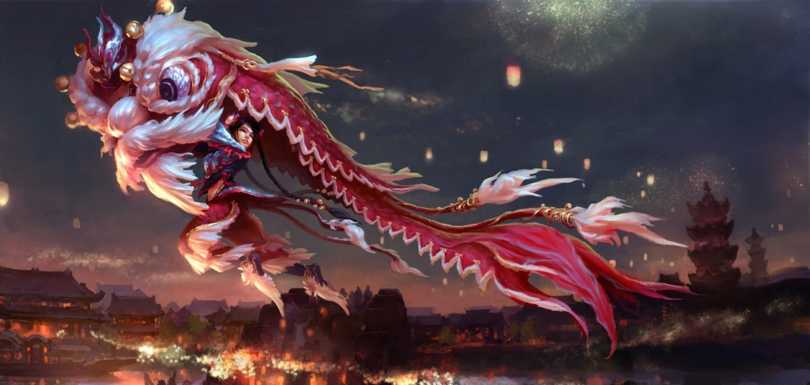

The lion dance is one of China’s most distinctive cultural arts. The tradition dates back thousands of years. It is believed to have appeared in either the Tang, Han, or Ch’in dynasties, possibly in different forms. Other legends associated with lion dance include using the dance to chasing away the monster “Nian.” Often performed by kungfu schools, it brings with it good fortune, prosperity, and longevity. The lion dance appears in western countries mainly during celebrations such as Chinese New Year, the August Moon Festival and other multi-cultural events. It is also often seen at the opening of new shops, weddings, births, or where good fortune and prosperity is wished.

While lions are not native to China and were rarely seen in Ancient China, the lion somehow became a part of the Chinese culture. They are often seen carved outside of temples and of course there is the lion dance. Often, the lion’s statues and costumes for lion dancing have no resemblance to an actual lion, probably due to the fact that actual lions were rarely seen and the bright colors were used to chase away evil spirits and bad luck. There are two major types of lion dancing evolved from Northern and Southern China with the lion of the Northern style resembles an actual lion more. However, both styles produce a very realistic portrayal of the lion. The dance can be performed freestyle or choreographed. The freestyle is used mostly in parades. The choreographed dances are used in shows coordinated to a drum, gong, and cymbals.

TOFEL TEST INDEPENDENT TASKS

Task ONE

***1. If high school is planning to organize an after-school activity for its students, what kind of activity would you recommend and explain why?-61***

**Sample Answer:**

Personally speaking, the after-school activity I recommend would be basketball match. It has a number of benefits.

First, playing basketball is a good safety valve for the tension that builds up at work. High school students are under great pressure of preparing for college entrance examination. High levels of stress may lower one’s immunity to common illnesses or even worse.

On top of that, basketball match can not only help cultivate students’ collectivity spirit and cooperation consciousness, but also do a great deal to improve their health. Playing basketball provides many advantages such as fresh air, physical exertion and improving hand-eye coordination. (103)

***2. What activities did you like when you were a child？-64***

**Sample Answer:**

Personally, when I was a child, specifically, when I was at the age of 17 in high school, the activity I liked most was basketball.

First, playing basketball is a good safety valve for the tension that builds up at work. Back then, I was under great pressure of preparing for college entrance examination. High levels of stress might lower my immunity to common illnesses or even worse.

On top of that, playing basketball could not only help cultivate my collectivity spirit and cooperation consciousness, but also do a great deal to improve my health. It provided many advantages such as fresh air, physical exertion and improving hand-eye coordination. (109)

知识拓展

“儿童”一词在联合国《儿童权利公约》中，指的是“18岁以下的任何人，除非对其适用之法律规定成年年龄低于18岁。”

儿童阶段，粗放一点可以分为学龄前（0-6岁），小学（6-12岁）和中学（12-18岁）三个年龄阶段；细分可分为：婴儿（0-1岁），幼童（1-3岁），小童（4-6岁），中童（7-12岁），大童（13-18岁）；从性别上分为男孩和女孩。

***3. Which of the following three activities you would most prefer to do on a weekend afternoon? Play a sport, visit a friend or cook at home.-85***

**Sample Answer:**

Personally speaking, I prefer to play a sport on a weekend afternoon. My reasons are as follows.

First, doing sports in a sunny afternoon does a great deal to improve my fitness level. It is shown that being in the sun is healthy, since humans have developed the ability to extract vitamin D from sunlight which can improve the absorption of calcium from food that prevents us from rickets and osteoporosis.

On top of that, I’m sick and tired of cooking. It is very troublesome. And as for visiting a friend, don’t bother. It’s unnecessary, because me and my friends always get together to do sports on weekends such as basketball, soccer or sometimes paintball game. (116)

***4. Talk about an activity you would like to participate in the near future, explain your answer in details.-93***

**Sample Answer:**

Personally speaking, in the near future, I would like to participate in a basketball match. My reasons are as follows.

First, playing basketball is a good safety valve for the tension that builds up at work. As a high school student I’m under great pressure of preparing for college entrance examination. High levels of stress may lower my immunity to common illnesses or even worse.

On top of that, basketball match can not only help cultivate my collectivity spirit and cooperation consciousness, but also do a great deal to improve my health. It provides many advantages such as fresh air, physical exertion and improving hand-eye coordination. (106)

***5. Which of the following activities do you think benefits young people the most? Doing team sports, talking to seniors of the community, or traveling to other cities or countries.-118***

**Sample Answer:**

Personally speaking, I think doing team sports would benefit young people the most. My reasons are as follows.

First, doing team sports does a great deal to improve their heath. Nowadays, a lot of young people are in the state of sub-health due to working pressure, irregular diet and lack of exercise. Doing sports is a good safety valve for the tension that builds up at work. And doing sports can reduce the risks of lumbar disc herniation, heart attack and death by overwork.

On top of that, doing team sports helps cultivate their collectivity spirit and cooperation consciousness which will benefit their future growth. (105)

***6. Which of the following activity do you enjoying doing at noon: doing exercise, watching TV, staying with family.-217***

**Sample Answer:**

Personally speaking, I prefer to play a sport at noon. My reasons are as follows.

First, doing sports at noon on a sunny day does a great deal to improve my fitness level. It is shown that being in the sun is healthy, since humans have developed the ability to extract vitamin D from sunlight which can improve the absorption of calcium from food that prevents us from rickets and osteoporosis.

On top of that, I’m sick and tired of watching TV. I don’t want to be called sofa potato. And as for staying with family, I’m a grown-up. I hope to make an independent life but not cling to my parents. (112)

***7. Talk about a game, sport or other group activity that is played in your country. Explain why that you think the activity is enjoyable.-TPO13***

**Sample Answer:**

Personally speaking, lion dance is a very popular and enjoyable group activity in China.

During celebrations such Chinese New Year, the August Moon Festival and other multi-cultural events, people will put on costumes to resemble a lion and start dancing to chase away evil spirits and bad luck. And people believe it’ll bring with it fortune, prosperity and longevity.

In addition, the tradition of lion dance can date back to Han Dynasty. And there is a story that Nian, a legendary monster, climbs ashore to destroy crops and animals at the eve of every New Year, so people play the lion dance and set off firecrackers to chase it away. (110)

TASK TWO

***1. Some people prefer to watch a sport game from the audience seat, others prefer to be in the sport field and compete with others. Which do you prefer to do?-30***

**Sample Answer:**

Personally, I prefer to be in the sport field and compete with others rather than sitting in the stands and watching.

First, doing sports is a good safety valve for the tension that builds up at work. As a high school student, I’m under great pressure of preparing for college entrance examination. And being pretty stressed out will lower my immunity to common illnesses or even worse.

On top of that, competing with others can not only help cultivate my collectivity spirit and cooperation consciousness, but also do a great deal to improve their health. And if I win the match, I’ll get a sense of honor, pride and achievement. (110)

***2. Some people prefer to do team sports, others prefer to do individual sports. Which do you prefer?-31***

**Sample Answer:**

Personally speaking, I prefer to do team sports rather than individual sports. My reasons are as follows.

First, doing team sports such as basketball, soccer or dragon boat helps cultivate my collectivity spirit and cooperation consciousness which will benefit my future growth. Team sports also tend to sharpen my mind since they require me to think on my feet and strategize.

On top of that, doing team sports gives me more chances to meet people. I long for companionship and strive to enlarge my social circle, because I believe I cannot realize my dreams single-handedly. When I fall on evil days, I will need a shoulder to cry on. (109)

***3. Do you agree or disagree that team sports develop children's competition or collaboration consciousness?-34***

**Sample Answer:**

Personally, I’m strongly for the statement. It is as plain as the nose on my face.

Have you ever seen a football team with its goalkeeper laying aside the goal snoring aloud won the game? Have you ever seen a basketball team with its center sipping a cup of coffee in the stands taken the crown? Have you ever seen a relay race team with only one racer defeated its opponent? Never!

Additionally, take my story as a good example. I was a good pitcher in my school basketball team. Modesty aside, I was second-to-none, but individualistic heroism made me eventually taste the bitter fruit of failure. (107)

***4. When you are taking part in a game or sport, do you want to win or only enjoy the process?-35***

**Sample Answer:**

Personally speaking, I take part in a game or sport mainly for enjoying the process.

Admittedly, no one wants to be a loser. But the truth is no one can always be a winner. Life is all about ups and downs, and in turn so is the sport. So the most important thing is apart from the result, victory or defeat, what else can we remain: friendship, health and hope, or just only despair.

Additionally, take my story as a good example. I was a good pitcher in my high school. But my individualistic heroism made us lose the game. However, there was no criticizing or complaining but only forgiveness and comfort. I obtained nothing but solid friendship. (118)

***5. Do you agree or disagree with the following statement that parents should not allow their children to participate any form of sport (football, basketball, ice hockey) in order to protect their health and from any form of injuries.-111***

**Sample Answer:**

Personally, I’m strongly against the statement. It is just like drinking poison to quench thirst.

Statistically, about 30% of cancer deaths are mainly due to high body mass index, low fruit and vegetable intake, lack of physical activity, tobacco use and alcohol use. So forbidding doing sports doesn’t make any sense.

Instead of causing injuries, doing sports can promote blood circulation and metabolism and stimulate the digestive and excretory systems. It can also reduce the risks of obesity, diabetes and cardiovascular disease.

Admittedly, doing sports will inevitably lead to injuries, but do not throw away the apple because of the core. (101)