Music

Music genres:

Heavy metal music 重金属音乐

Light music 轻音乐

Classical music 古典音乐

Pop music 流行音乐

Folk music 民族音乐

Country music 乡村音乐

Rap music 饶舌音乐

Rock and roll 摇滚乐

Acappella 无乐器伴奏音乐

Musicians and Musical Works

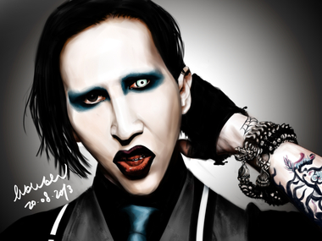

**Musical Work:** This is the New Shit

**Musician:** Marilyn Manson

**Music Genre:** Heavy Metal Music—Industrial Metal



**Musical Work:** The Hanging Tree by James Newton Howard

**Musician:** Jennifer Lawrence

**Music Genre:** Acappella

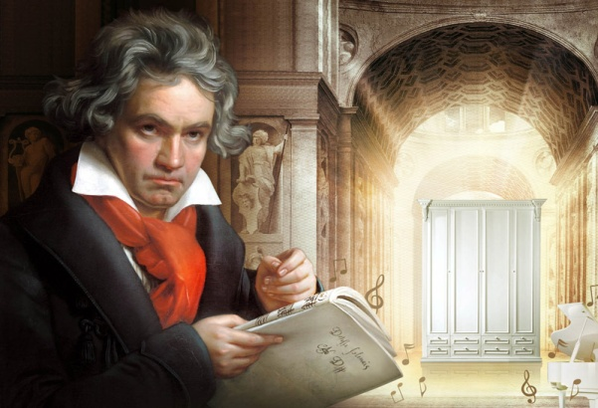

**Musical Work:** Moonlight Sonata

**Musician:** Beethoven

**Music Genre:** Classical Music

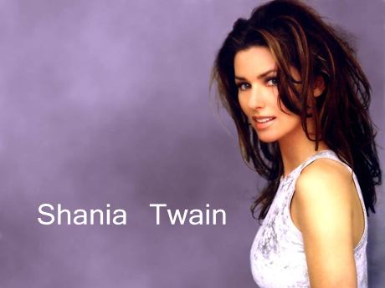

**Musical Work:** I'M Gonna Getcha Good!

**Musician:** Shania Twain

**Music Genre:** Country Music



**Musical Work:** Gimme More

**Musician:** Britney Spears

**Music Genre:** Pop music

Musical Instruments

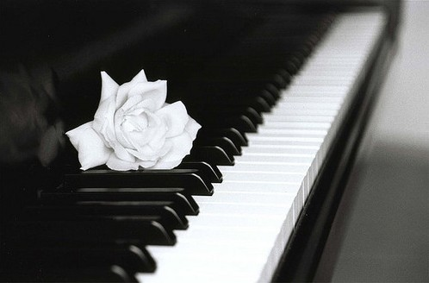

Piano 钢琴

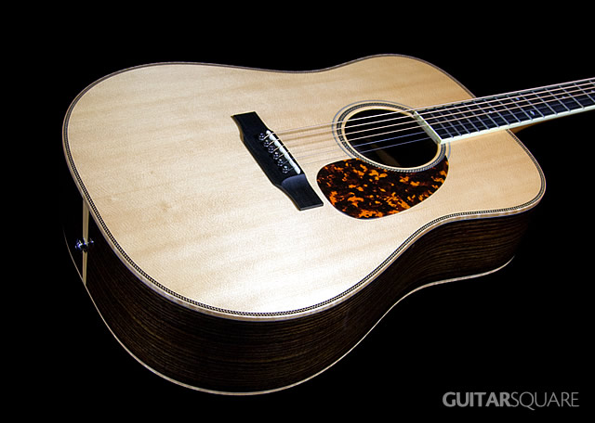

Acoustic Guitar　原声吉他

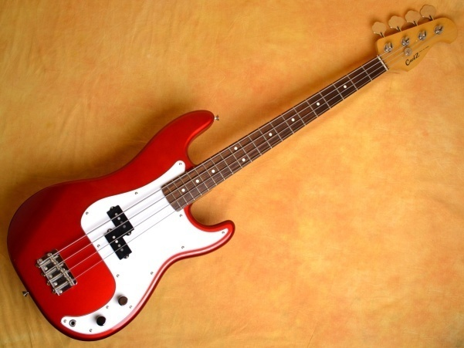

Electric Guitar 电吉他

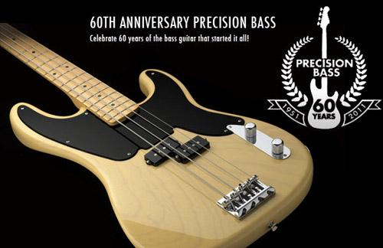

Bass 贝斯



Keyboard　电子琴

Accumulation

1. I have no more than a superficial knowledge of music.

我对音乐只懂一点皮毛。（柯林斯词典）

2. I have a singular ear for music.

我对音乐有非凡的欣赏力。（简明英汉词典）

3. At the age of six I took up the study of music.

我6岁开始学习音乐。（简明英汉词典）

4. Music is the speech of angels.

音乐是天使的语言。（互联网）

5. The music brings me a feeling of plentitude and freedom.

这音乐带给我一种完满和自由的感觉。（柯林斯辞典）

6. The music invokes the wide open spaces of the prairies.

该音乐营造出了一幅大草原上宽广辽阔的景象。（柯林斯词典）

7. His music conjures up a warm night in the tropics.

他的音乐让人想起热带地区温暖的夜晚。（柯林斯词典）

8. The music is purer poetry than a poem in words.

这音乐比真正的诗歌更具诗意。（柯林斯词典）

9. The music has a dreamy, elegiac quality.

该音乐有一种梦幻般的哀伤。（柯林斯词典）

10. His music is sheer delight.

听他的音乐完全是一种享受。（柯林斯词典）

11. The music soared to the rafters, carrying its listeners’ hearts.

音乐响彻屋宇，震撼人心。（柯林斯词典）

12. The music is pulsating and the atmosphere is intoxicating.

音乐在有节奏地响着，气氛令人陶醉。（柯林斯词典）

13. I get into the music, the lights and the people around me.

我融入到音乐,灯光以及身边的人群中。（柯林斯词典）

14. My body swayed in time with the music.

我的身体随着音乐节拍摆动。（柯林斯词典）

15. They wiggled their hips to the sound of pop music.

他们随着流行音乐的声音摇摆着臀部。（简明英汉词典）

Pros

1. When I feel sad, music has a therapeutic effect.

我悲伤的时候，音乐有治疗效力。（简明英汉词典）

2. I’ve got a spiritual sublimation.

我得到了精神上的升华。（自编）

3. It cleanses the soul.

它净化灵魂。（柯林斯词典）

4. I listen to music for a boost on a tough day.

我以听音乐来在繁忙的一天中找点乐趣。（维基百科）

5. Plugging into my favorite music could help melt away a bad mood.

听我喜欢的音乐有助于改善心情。（维基百科）

6. Up-beat songs that match the tempo of my running stride enable me to run for longer.

轻快的，节奏感强的，且符合我跑步步调的音乐能够使我跑的更远。（维基百科）

7. When I am very withdrawn, music can act as an outlet for expressing things that I’m unable to put into words.

当我感到孤独的时候，音乐是用来宣泄无法言表的情感的方式。（维基百科）

8. Music can act as a stimulus to awaken buried memories or evoke emotional responses.

音乐能够激起过去的回忆，唤起当时的情感。（维基百科）

9. Music can be a great pick-me-up when I’m feeling stressed.

当我疲惫不堪的时候，音乐就像一剂强心针。（维基百科）

10. It makes me feel at peace with the world.

它让我觉得与世无争。（柯林斯词典）

11. It uplifts the mind and the spirit.

它能够陶冶情操。（柯林斯词典）

12. The music sounds like from deep in the soul.

它听上去仿佛像是来自灵魂深处的呼唤。（自编）

Cons

1. I don’t like music playing when I’m working. It puts me off.

我不喜欢工作时放音乐，那会使我分心。（简明英汉词典）

2. Very loud music can disturb the symmetry between the right and left halves of the brain.

音乐音量过大会影响左右脑的协调。(维基百科)

3. Loud music results in a disturbed state of mind.

音乐音量过大会导致精神失常。（维基百科）

4. Exposure to harsh or disruptive music at an early age leads to learning disabilities and behavior problems in children.

儿童过早地接触刺耳的音乐会导致学习障碍和行为问题。（维基百科）

5. Shrill frequencies and irregular beats are harmful to the mind and body.

刺耳的频率和不规则的节拍对身心有害。（维基百科）

6. Disharmony in music has been shown to reduce retention levels of the brain and lead to aggression and hyperactivity.（维基百科）

不和谐的音乐会使得大脑记忆力下降，还会导致暴力行为和亢奋。

7. There is a tint of death, a flavor of mortality in his songs.

歌声中有死亡的色彩，命运的意味。（维基百科）

8. The song sings of bitterness, blood and violence.

这首歌唱出了痛苦，血腥和暴力。（自编）

9. The song is thick with crime, sex and drug.

这首歌充斥着犯罪，色情和毒品。（自编）

TOEFL TEST INDEPENDENT TASKS

Task One

***1. Describe your favorite way to relax.-1***

**Sample Answer:**

For me, it is sheer paradise to relax in a hot bath listening to Moonlight sonata and taking a sip of a cup of whiskey.

First, hot bath helps relax muscles, relieve stress and improve blood circulation. After a hard day’s work—receiving clients, telephone switchboard and administrative duties, I just wanna lean back in a hot bath and forget all the cares of the day.

Second, I’m a big fan of music, especially classical music. Music can be a great pick-me-up when I feel stressed. And when I am very withdrawn, music can act as an outlet for expressing things that I’m unable to put into words. (108)

***2. Talk about a skill or ability that you are good at or would like to learn. Use details and examples to explain your answer.-2***

**Sample Answer:**

Personally speaking, if I have a chance to learn something new, I would like to learn playing a musical instrument like keyboard, electric guitar or bass.

Firstly, even I have no more than a superficial knowledge of music, but I really love music. Britney Spears’ Gimme More, Shania Twain’s I’m Gonna Getcha Good and Beethoven’s Moonlight Sonata are my favorite.

On top of that, playing a musical instrument is not only cool but also wholesome. It could be a great pick-me-up when I’m feeling stressed and help melt away a bad mood. And most importantly, music uplifts the mood and the spirit. (102)

***3. If you have a chance to learn something new, which of the following activities do you enjoy most? Flying an airplane; playing a sport or playing a musical instrument.-4***

**Sample Answer:**

Personally speaking, if I have a chance to learn something new, I would like to learn playing a musical instrument like keyboard, electric guitar or bass.

Firstly, even I have no more than a superficial knowledge of music, but I really love music. Britney Spears’ Gimme More, Shania Twain’s I’m Gonna Getcha Good and Beethoven’s Moonlight Sonata are my favorite.

On top of that, playing a musical instrument is not only cool but also wholesome. It could be a great pick-me-up when I’m feeling stressed and help melt away a bad mood. And most importantly, music uplifts the mood and the spirit. (102)

***4. Describe a subject that you have interest in.-16***

**Sample Answer:**

To be honest, I’m really interested in music. My reasons are as follows.

Firstly, at the age of six I took up the study of music, but I stopped halfway for some reasons, but I really love music. Britney Spears’ Gimme More, Shania Twain’s I’m Gonna Getcha Good and Beethoven’s Moonlight Sonata are my favorite. It is sheer paradise for me to relax in a hot bath listening to Moonlight Sonata after a hard day’s work.

On top of that, playing a musical instrument is not only cool, but also wholesome. It could be a great pick-me-up when I’m feeling stressed and help melt away a bad mood. (108)

***5. Describe the differences between two singers or musicians in your country. Include reasons and examples to support your response.-27***

**Sample Answer:**

Personally, I want to compare Tian Kui and Song Zuying. The differences between them are as follows.

Firstly, they are different in their music genres. Tian Kui is the initiator of death metal and Song Zuying is the representative of folk music in China.

Secondly, their music gives totally different feelings.

Tian Kui’s music is thick with crime, blood and violence. There is a tint of death, a flavor of mortality in his songs. Listening to his music gives one a decadent, aggressive and chaotic feeling.

Compared to that, Song Zuying’s music sounds like from heaven. Listening to her music makes one feel at peace. (105)

***6. Talk about a skill that you do not know but you want to learn. Use details and examples to explain your answer.-34***

**Sample Answer:**

Personally speaking, the skill that I do not know but want to learn is playing a musical instrument like keyboard, electric guitar or bass.

Firstly, even I have no more than a superficial knowledge of music, but I really love music. Britney Spears’ Gimme More, Shania Twain’s I’m Gonna Getcha Good and Beethoven’s Moonlight Sonata are my favorite.

On top of that, playing a musical instrument is not only cool but also wholesome. It could be a great pick-me-up when I’m feeling stressed and help melt away a bad mood. And most importantly, music uplifts the mood and the spirit. (100)

***7. What type of music do you enjoy most? Explain why you enjoy this type of music including specific reasons and details in you explanation.-84***

**Sample Answer:**

Personally speaking, my favorite music genre is acappella like the hanging tree sung by Jennifer Lawrence in Hunger Games. It is purer poetry than a poem in words and has a dreamy, elegiac quality. Without accompaniment, acappella sounds like the voice from deep in the soul.

Most importantly, I listen to acappella for a boost on a tough day and take it as an outlet for expressing things that I'm unable to put into words. For example, after a hard day's work--receiving clients, telephone switchboard and administrative duties, listening to accapella can be a great refreshment and makes me feel at peace. (103)

***8. Talk about a kind of music you dislike, explain why you don’t like this kind of music.-117***

**Sample Answer:**

Personally speaking, I’m not in favor of heavy metal music, specifically, industrial metal and death metal.

Firstly, music is the speech of angels, but not the crying of evils.

Heavy metal music like Marilyn Manson’s This is the New Shit sings of bitterness, blood and violence. There is a tint of death, a flavor of mortality in his songs.

On top of that, heavy metal music is loud and noisy that is harmful to the mind and body.

Shrill frequencies and irregular beats have been shown to reduce retention levels of the brain and lead to aggression and hyperactivity, and even result in a disturbed state of mind. (108)

Task Two

***1. Do you agree or disagree with the statement: employees should be allowed to listen to music at work? -135***

**Sample Answer:**

Every coin has two sides. Personally I think whether listening to music at work should be allowed depends on what music they’re listening to.

On one hand, some music like Britney Spears’ Gimme More can be a great pick-me-up when employees feel stressed. And plugging into their favorite music could help melt away a bad mood.

On the other hand, some specific music should be forbidden such as Marilyn Manson’s ‘This is the New Shit’ which is loud and noisy, filled with blood and violence. It’ll significantly jeopardize employees’ work efficiency, since it is shown that loud music will result in a disturbed state of mind. (106)

***2. Some people prefer to listen to live music, while others prefer to listen to recorded music. Which do you prefer and why? Include reasons and examples to support your response.-44***

**Sample Answer:**

Personally, I prefer live music. Records are definitely second-best.

Undoubtedly, records are more economical and accessible and even have higher sound quality than live music. But the irreplaceable part of live music is the atmosphere which gives me a strong sense of pleasure. For example, last year, I went to Jay Chou’s gig that was a sell-out. The music was pulsating and the atmosphere was intoxicating. I totally got into the music, the lights and the people around me who were swaying their bodies, and wiggling their hips to the music beat. At last, I even got Jay Chou’s autograph and took a photo with him. (106)