Books

Vocabulary

Mystery 神秘小说；推理小说

Science fiction 科幻小说

Biography 传记

Romance 浪漫；爱情小说

Fairy tale 童话小说

Fiction 小说

Non-fiction 纪实文学

Horror fiction 恐怖小说

Magic novel (fiction) 魔幻小说

Electronic book 电子书籍

Paper book 纸质图书

Audio book 有声读物

Authors and Their Works

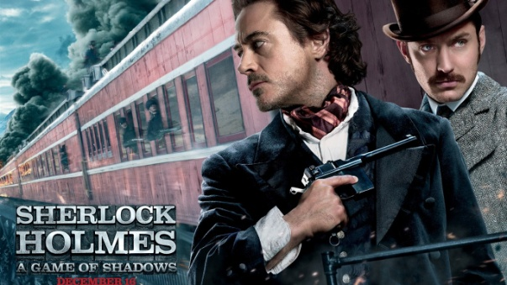

**Type**: Mystery (Fiction)

**Name:** Sherlock Holmes 福尔摩斯

**Author:** Arthur Conan Doyle （英）阿瑟.柯南道尔

**Description:** The book depicts a famous detective, Sherlock Holmes, who is gregarious, a great wit, a man of wide interests, detecting a series of bizarre cases. The plot is gripping and thrilling.

本书刻画了一名著名侦探，福尔摩斯，一位擅长交际，风趣，兴趣广泛的人，如何侦破一系列离奇案件。故事情节扣人心弦，惊心动魄。

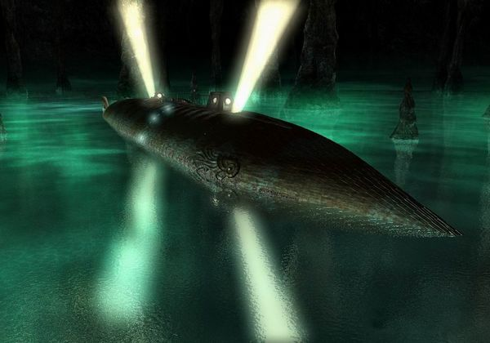

**Type:** Science Fiction (Fiction)

**Name:** 20,000 Leagues Under the sea 海底两万里

**Author:** Jules Verne （法）儒勒.加布里埃尔.凡尔纳

**Description:** The story is about the adventures of Captain Nemo and his crew aboard the submarine, Nautilus. The most interesting part of this book was probably the Nautilus itself. It is shaped to look like a fish, with a large metal fin on top used to ram and sink the ships.

故事讲述了尼莫船长和他的潜艇船员的冒险故事。本书最吸引人的地方莫过于鹦鹉螺号了。它的形状酷似一条鱼，有巨大的金属鳍在顶部，用于行驶或者下沉。

Twenty Thousand Leagues is probably his most prescient work, anticipating submarine warfare (not for nothing was the first nuclear submarine called Nautilus), scuba diving and even the taser.

《海底两万里》是凡尔纳最具预见性的作品，其中的潜水艇，水肺潜水甚至泰瑟枪之后都成为现实。美国建造的第一艘核动力潜艇的名字“鹦鹉螺号”就源自《海底两万里》。

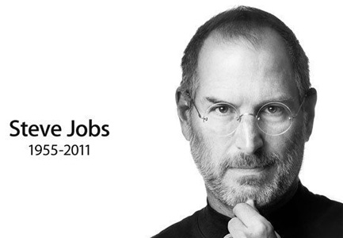

**Type:** Biography (Non-fiction)

**Name:** Steve Jobs 乔布斯传

**Author:** Walter Isaacson （美）沃尔特.艾萨克森

**Description:** Walter Isaacson has written a riveting story of the roller-coaster life and searingly intense personality of a creative entrepreneur whose passion for perfection and ferocious drive revolutionized six industries: personal computers, animated movies, music, phones, tablet computing, and digital publishing.

沃尔特.艾萨克森撰写了乔布斯跌宕起伏的人生和其强大的人格魅力。乔布斯作为一个富有创意的企业家，他对完美的执著和惊人的耐力使其在完成了六个领域的创新：个人电脑，动画电影，音乐，电话，平板电脑和数字出版。

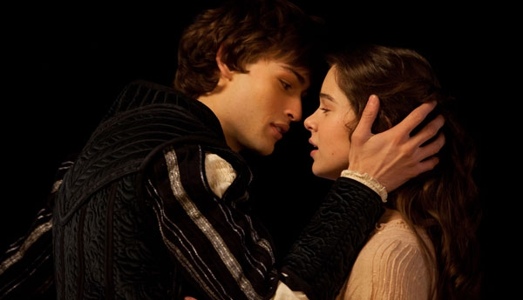

**Type:** Romance (Fiction)

**Name:** Romeo and Juliet 罗密欧与朱丽叶

**Author:** W. William Shakespeare （英）威廉.莎士比亚

**Description:** It represents a sweet and sorrow legend of love that defies the limits of heaven and earth.

它讲述了一段跨越两界的生死之恋，充满了甜蜜和悲伤。



**Type:** Fairy Tale

**Name:** Beauty and the Beast 美女与野兽

**Author:** Beaumont, M de （法）博蒙夫人

**Description:** It tells about a story that an arrogant young prince and his castle’s servants fall under the spell of a wicked enchantress, who turns him into the hideous Beast until he learns to love and be loved in return. And the spirited, headstrong village girl Belle enters the Beast’s castle by force and eventually draws the cold-hearted Beast out of his isolation.

故事讲述了一名年轻傲慢的王子和他城堡的仆人们受到了邪恶的女巫诅咒。王子被变成了丑陋的野兽，直到他懂得去爱并且获得他人的爱才可以复原。然后勇敢的，坚强的村庄女孩贝拉被迫进入城堡，最终将冷漠的王子从孤独中解脱出来。



**Type:** Horror Fiction (Fiction)

**Name:** Frankenstein

**Author:** Mary Shelley （英）玛丽.雪莱

**Description:**

The book tells about a story that when the brilliant but unorthodox scientist Victor Frankenstein rejects the artificial man that he has created, the Creature escapes and later swears revenge.

这本书讲述了一位疯狂的天才科学家维克多.弗兰肯斯坦排斥他亲手创造的人造人之后，创造出的可怕生物逃走并发誓复仇的故事。

Accumulation

1. It is easy to imagine a near future in which paper books are the exception, not the norm.

显而易见，在不久的将来，纸质书将不再是主流，而是非主流。

2. There are always advantages in opening a book.

开卷有益。（现代英汉综合大辞典）

3. Do not judge a book by its cover.

不要以貌取人。

4. Reading provides an opportunity to temporarily escape from one’s dull, uneventful life.

阅读提供了一个逃离鼓噪平淡生活的机会。

5. Reading enriches one’s knowledge.

阅读丰富人们的知识体系。

**Paper Books**

**Pros**

1. Reading paper books is good for one’s eyes.

阅读纸质书对眼睛有好处。

2. Paper books are a joy to hold and read.

纸质书具有良好的手感，可以带来阅读的快感。

3. A paperback is very cheap and portable and takes a very low level of care to keep it working order.

纸质简装本非行便宜且便携，而且不需要花太多精力去使用。

4. The handwriting on the pages witnesses the experience of your spiritual growth.

书上的笔迹见证了你心灵成长的历程。

**Cons**

1. It will take a lot of cost and space to preserve the fragile paper books.

保存容易损坏的纸质书会消耗大量的成本和空间。

**Electronic Books**

**Pros**

1. Being able to highlight quotes and passages and easily find them again is a key feature that eBooks have over paper books.

电子书相对于纸质书的关键优势之一是可以为引用内容和段落标记重点，并且可以很容易再次找到。

2. Instead of scribbling in small writing in the margins of a paper book, you can type a clear note in your eReader.

有了电子书，你无须在纸质书的边角位置添加密密麻麻的小字了，直接在电子阅读器里填写清楚注释即可。

3. No trees are required to manufacture paper for the pages of eBooks.

电子书不需要用树木制成的纸张作为书页。

4. When you need certain information, you can get it immediately, by downloading an eBook.

当你需要某些信息时，你可以通过下载电子书立刻获取。

5. EBooks are portable. You can carry a whole library of hundreds of books with you, on a CD, in a laptop, notebook or any eBook reader, without worrying about their weight.

电子书可以随身携带。你可以将整个图书馆数以百计的书存到CD里，便携式电脑里，笔记本里或者其他电子书阅读器里，不用担心重量问题。

6. EBooks are searchable. You can easily search for any information in an eBook, instead of turning page after page.

电子书具有可检索功能。你能很轻松的在电子书里查询信息，不用一页一页的翻书。

7. EBooks can be interactive and contain audio, video and animations, which can enhance the message that the author is trying to convey.

电子书可以用来交流。他通过自身带有的录音，影响，动画，使作者试图传递的信息更加明确生动。

8. As eBooks are delivered through the Internet, there are no packing and shipping expenses.

由于电子书可以通过网络传递，因此没有打包和快递费用。

**Cons**

1. Prolonged exposure to electronic screen might lead to a host of visual problems such as myopia, blurred vision and dry eyes.

长期暴露于电子屏幕下会导致一系列的视力问题，如近视眼，视力模糊和干眼症。

**Audio Books**

**Pros**

1. Personally, I have found audio books to be the best way to beat traffic jams.

我个人发现有生读物是堵车时打发时间的最好方法。

2. Audio books present the ideal solution to learners, who are suffering from dyslexia, blindness and paralysis.

电子书为那些阅读困难症患者，盲人和瘫痪者提供了理想的解决方法。

3. One of the distinct advantages of audio books over its more physical form is that it saves time. Audio books take away a silver of fun from the enjoyment of a book, but if the voiceover is well done, it makes up for it.

有声读物相比纸质书有个明显优势就是省时，它损失了一点点享受读书的乐趣，但如果有声书的发音动听，则可以弥补这种损失。

4. I like to listen to audio books on personal development while riding the bus and doing the dishes.

当我在公共汽车上或洗餐具的时候，喜欢去听关于个人发展的有声读物。

5. You can lie back, close your weary eyes and allow your audio books to tell the tale.

你可以依靠在沙发上，闭上疲倦的双眼，悠然地倾听有声书本为你讲述的故事。

Cons

1. Audio books could reduce your reading and writing abilities.

有声书籍可能会降低你的阅读和书写能力。

2. Prolonged exposure to moderate noise would damage hearing or lead to hearing impairment.

长期暴露于中度噪音下会损害听力或者导致听力障碍。

TOEFL INDEPENDENT TASKS

Task One

***1. Which type of books you dislike the most: mystery, science fiction, biography?-76***

**Sample Answer:**

Well, it is indeed a complicated question. To be honest, I love them all. But in comparison, I dislike mystery a little bit.

Look, science fiction, for example, 20,000 Leagues which tells about the adventures of Captain Nemo and his crew aboard the submarine, Nautilus. That is very eye-opening. It provides me a chance to escape from the dull, uneventful life.

And biography such as Steve Jobs which tells about his roller-coaster life. That is very inspirational from which I’ve learnt that all adversities are just trials to succeed.

Finally, mystery such as Sherlock Holmes. Who doesn’t like it!? But, well, I must say I don’t, right? Because, it is too long to read. (114)

***2. Describe your favorite book in your childhood.-161***

**Sample Answer:**

Personally speaking, my favorite book in my childhood is 20,000 Leagues. My reasons are listed below.

Firstly, it is an absorbing read. The story is about the adventures of Captain Nemo and his crew aboard the submarine, Nautilus. The most interesting part of this book was probably the Nautilus itself. It is shaped to look like a fish, with a large metal fin on top used to ram and sink. And it is an unbelievably prescient work. Submarine warfare, scuba diving and even the taser had eventually come into being.

Second, this book provided me, a little kid, a chance to escape from the dull, uneventful life and sail with Captain Nemo. (112)

***3. Your university is planning to use electronic books to replace paper books and magazines in its library. What is your opinion about this plan? What are the advantages and disadvantages of replacing paper books or magazines? Include reasons and examples to support your response.-203***

**Sample Answer:**

Well, every coin has two sides.

To begin with the advantages, eBooks are searchable. You can easily search for any information in an eBook, instead of turning page after page. And eBooks can be interactive and contain audio, video and animations, which can enhance the message that the author is trying to convey. Most importantly, eBooks don’t require a lot of cost and space to preserve.

As for disadvantages, students’ health should be taken into consideration. Prolonged exposure to electronic screen would lead to a host of visual problems such as myopia, blurred vision and dry eyes. And plus, eBooks would take away a silver of fun from the enjoyment of a book. (113)

***4. Talk about a book you have read that was important to you for some reason. Explain why the book was important to you. Give specific details and examples to explain your answer.-T1***

**Sample Answer:**

Well, the book I’ve ever read which was important to me is the beauty and beast.

It tells about a story that an arrogant young prince fell under the spell of a wicked enchantress, who turned him into a hideous Beast until he learnt to love and be loved in return. And the brave and virtuous village girl Belle eventually drew the cold-hearted Beast out of his isolation.

This book made me introspected myself. I was an arrogant creature, always showering venomous verbs upon others. This made me a beast, as isolated as the one in the story. From this book, I realized, arrogance is nothing but a defense of the weak. (112)

***5. Talk about an interesting book you have read. Explain why you thought the book was interesting. Give specific details and examples to explain your answer.-T11***

**Sample Answer:**

Personally speaking, 20,000 Leagues is an interesting book I’ve ever read.

The book is about the adventures of Captain Nemo and his crew aboard the submarine, Nautilus. The most interesting part of this book was probably the Nautilus itself. It is shaped to look like a fish, with a large metal fin on top used to ram and sink the ship.

And plus, it is an unbelievably prescient work. Submarine warfare, scuba diving and even the taser had eventually come into being. How interesting and eye opening it is! This made me so excited! Now I’m eager for seeing time machine come true; and parallel world verified. (107)

***6. People enjoy reading many different types of books such as mystery, biography, romance, etc. Of all the different types of books that there are, what type do you most enjoy. Explain why.-T14***

**Sample Answer:**

Personally speaking, I enjoy biography the most, because Biography is very inspirational.

For example, the book, Steve Jobs, tells about his roller coaster life. Even he was abandoned by his birth parents and adopted by a nice but not rich family; even he was forced to leave Reed due to poor financial condition; even he experienced the ups and downs in his career; and even he suffered pancreatic cancer, but nothing could prevent him from becoming a hero of our time. From his story, I’ve learned that all adversities are just trials to succeed. And excuse is nothing but a defense of the weak. (104)

***7. Think of a book that you have not read but are interested in reading. Explain why you are interested in reading this book.-T26***

**Sample Answer:**

Well, I’ve not read Steve Jobs but am interested in reading it.

I’ve ever heard something about Steve Jobs’ life. It is very inspirational. Even he was abandoned by his birth parents and adopted by a nice but not rich family; even he was forced to leave Reed due to poor financial condition; even he experienced the ups and downs in his career; and even he suffered pancreatic cancer, but nothing could prevent him from becoming a hero of our time. From his story, I’ve learned that all adversities are just trials to succeed. And excuse is nothing but a defense of the weak. So that’s why I want to know more about him. (114)

Task Two

***1. Some people prefer to own books and movies, others prefer to borrow or rent them from libraries and stores. Which do you prefer?-128***

**Sample Answer:**

Personally speaking, I prefer to own books and movies. My reasons are listed below.

First, I love to collect books as a hobby. I have three shelves stuffed with approximately 500-600 various types of books. A huge collection of books could not only represent my life taste but also be used to decorate my study. By the way, I indeed read all these books. So do not call diligence vanity.

Second, borrowing or renting books is very inconvenient. I have to spend quite a lot of time on the road to go to a library or a store, and ensure to finish reading the borrowed books within a limited time. (110)

***2. Do you agree or disagree that electronic material will replace printed material?-129***

**Sample Answer:**

Well, I guess tens of thousands of years later, electronic material will eventually replace printed material. By then printed materials would be only for collection but not for use.

From the current situation, electronic material has a large number of advantages over printed version. It is more portable. You can carry a whole library of hundreds of books with you, in a laptop, a notebook or any eBook reader, without worrying about their weight.

In the long term, some day, people might only need to speak to their watch to activate an eBook and move their fingers across the air, and get any information they want. (106)

***3. Do you agree or disagree with the following statement that people will read less in the future? Give examples and details in your answer.-130***

**Sample Answer:**

It doesn’t make any sense to say that people will read less in the future.

The simple truth is that only if all the people around the world are in the same financial condition and share the same social status, then people might stop their pursuing. Then knowledge and information would no longer be as necessary to survive as it is now. But it will never come true. Without competition, there would be no revolution. Without revolution, our societies would eventually perish.

In addition, reading is not only for survival, but also for entertainment. There’s nothing more blissful than lying back and having a book in your hands. (108)

***4. Someone likes to read science fiction like novel, others like to read non-fiction, which do you like?-136***

**Sample Answer:**

Personally speaking, I like to read non-fiction such as biography, because it is very inspirational.

For example, the book, Steve Jobs, tells about his roller coaster life. Even he was abandoned by his birth parents and adopted by a nice but not rich family; even he was forced to leave Reed due to poor financial condition; even he experienced the ups and downs in his career; and even he suffered pancreatic cancer, but nothing could prevent him from becoming a hero of our time. From his story, I’ve learned that all adversities are just trials to succeed. And excuse is nothing but a defense of the weak. (107)

***5. Some people like to buy new but expensive books while others prefer to buy old but cheap ones. Which would you prefer?-206***

**Sample Answer:**

Well, it is very complicated. My decision actually depends on the types of the book.

On one hand, if I want to buy textbooks or reference books, no matter how expensive they are, I must buy new ones, because old ones might have their previous owners’ notes or marks on them. Or if the old books are not carefully preserved, they might be too well-worn to read.

On the other hand, if I want to buy novels, I prefer to buy old and cheaper ones, because mostly, I just read them once and then sell them out. So there is no reason to waste a big sum on one-off things. (110)

***6. Which do you prefer? Listening to audio books or reading ordinary books.-209***

**Sample Answer:**

Personally speaking, I’d like to listen to audio books. My reasons are as follows.

The most important thing is that audio books free my hands again. I am a busy man, busy at making a living. The stress of life makes me feel like a mule. If we say that bipedalism made apes human; then audio books have made me live as a human. I can listen to audio books while driving, typing on my laptop or doing the dishes.

Second, listening to audio books is a good way to relax. After a hard day’s work, I can lie back, close my weary eyes and allow my audio books to tell the tale. That is a mere pleasure. (118)

***7. Someone thinks you should finish reading a book at one sitting, while someone think you can read a book in several times, what do you think?-212***

**Sample Answer:**

Well, reading a book at one sitting is absolutely unrealistic. I support the latter stand.

First, as far as capacity limit is concerned, Das Kapital can’t be finished reading at one sitting, unless you have a digital brain.

And plus, for the health’s sake, reading a book in one breath will lead to a host of physical conditions. Sitting for a long time might cause lumber disc herniation; and staring at the pages without blinking will give rise to blurred vision, double vision or dry eyes.

So in a nutshell, reading a book in several times is not only healthy but also feasible. (103)