ANIMALS

VOCABULARY

Commercial ad 商业广告

Noncommercial ad 非商业广告

Public-service ad 公益广告

Ivory product 象牙制品

Fur product 毛皮制品

Animal test 动物实验

PETS



Dog 狗

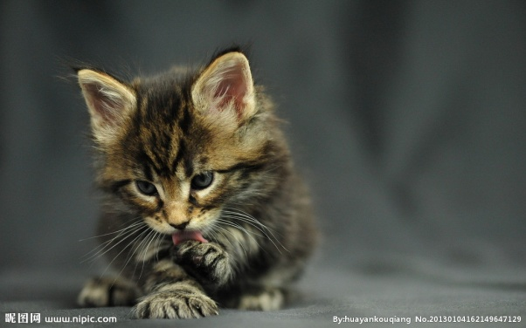

Cat 猫

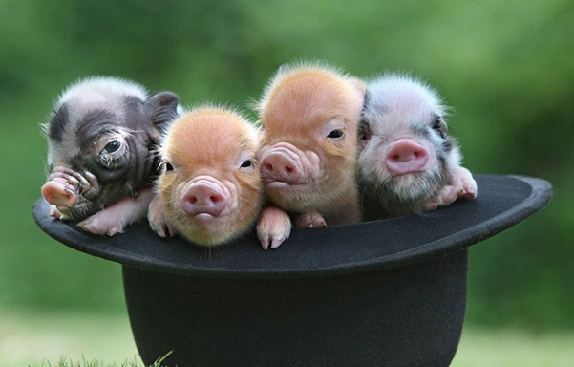

Pig 猪

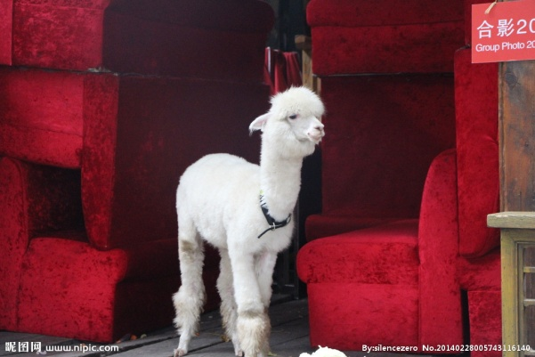

Grass mud horse 草泥马

KEEPING PETS

**PROS**

1. Many people consider their pets to be members of their family, and treat them with love and respect.

很多人将宠物是为家人，待其以爱和尊重。

2. The feeling often appears to be mutual, as our dogs and cats seek us out to play, to be petted, or to just simply sit in our laps.

这种情感是相互的，当你的猫或狗来找你出去玩，或者来撒娇，或者坐在你腿上的时候。

3. They provide unconditional love and devotion.

宠物为人们付出无条件的爱和奉献。

4. We rejoice in their companionship.

人们从宠物的陪伴中获得快乐。

5. They can teach us about humility, empathy and loyalty.

宠物教会了人们谦虚，同情和忠诚。

6. Essentially, a pet gives a person a sense of fulfillment.

重要的是，宠物给人以满足感。

7. We derive joy playing with and talking with a pet. This is especially true for the elderly or those who live a lonely existence.

我们可以和同宠物聊天中获得快乐。尤其是对老人和孤独的人来讲。

**CONS**

1. For a child the death of a pet can be traumatic.

对孩子来说，一只宠物的死亡可能会造成心理创伤。（柯林斯辞典）

2. These pets require a lot of care and attention.

这些宠物需要悉心照顾。（权威词典）

3. Pets can be a tie when you want to go away on holiday.

要想外出度假时，宠物会成为牵累。

4. Certainly, birds have wings for a reason and their place is not in a cage.

事实上，鸟儿长有翅膀是有原因的，它们不属于牢笼。

5. Cats, dogs and other pets suffer too much at our hands.

猫狗在人们身上经受太多的痛苦了。

6. However, in the real world, animals suffer abandonment, cruelty, and neglect.

然而，事实上，动物们经受着抛弃，残忍和忽视。

7. They are dependent on us for their survival and it would be cruel to turn them loose on the streets or in the wilderness.

动物依靠我们生存，因此将他们抛弃到野外或大街上太残忍。

8. Because of pet overpopulation, we should spay and neuter our cats and dogs.

由于宠物数量太多，我们应该阉割猫狗。

9. People might in fact be harming or impeding the freedom of the animal in some way.

事实上人们总会以某种方式侵犯或妨碍宠物的自由。

ANIMAL PROTECTION

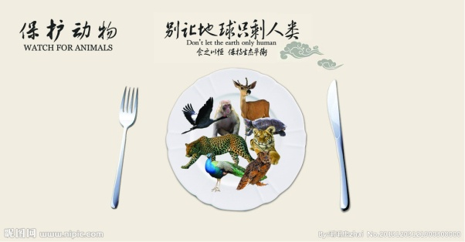

Don’t let the earth only human.

不要让地球只剩下人类。

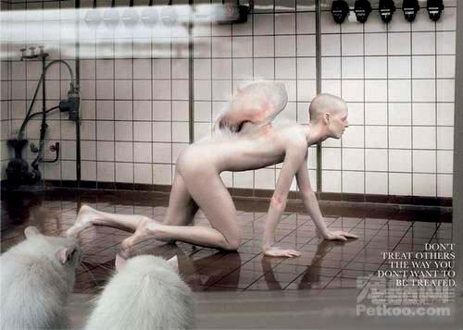

Don’t treat others the way you don’t want to be treated.

己所不欲，勿施于人。

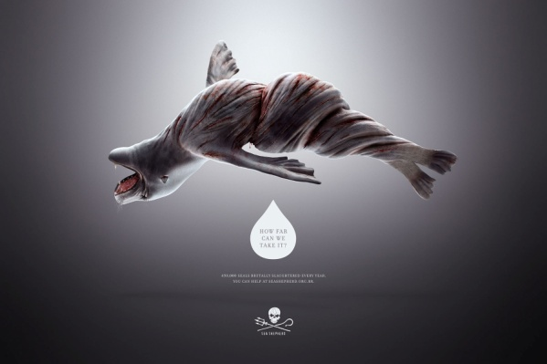

How far can we take it?

我们还能坚持多久？

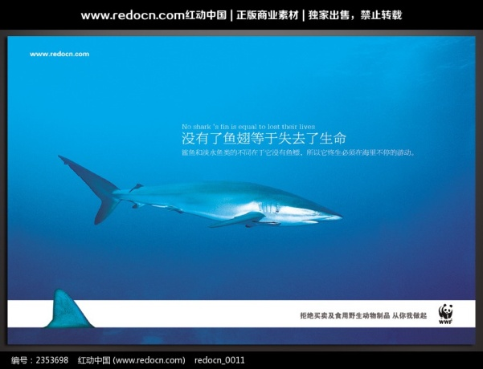

No shark’s fin is equal to lost their lives.

鲨鱼没有了鳍就等于失去了生命。



Don’t buy exotic animal souvenirs.

不要购买奇特动物纪念品。

TOEFL TEST INDEPENDENT TASKS

TASK ONE

***1. Is that good to feed a dog or a cat. What can you benefit from such an experience?-135***

**Sample Answer:**

Well, it is extremely complicated. Whether feeding a dog or a cat is good depends on us humans.

Pets require a lot of care and attention, and can be a tie when you want to go away on holiday. The responsible settle their pets temporarily in the cozy pet nursery when they go away; the irresponsible cruelly fasten their pets to the fence and leave them alone in the yard for the whole holiday.

So, for the responsible, feeding a pet gives them a sense of fulfillment and happiness; for the irresponsible, pets, like mirrors, reflect their ugly sides of human nature-selfishness, ruthlessness and indifference. (105)

***2. Do you think college students should not be allowed to keep pets in their dormitories?-143***

**Sample Answer:**

Personally, I think college students should not be allowed to keep pets in their dorms. My reasons are listed below.

First, keeping pets require a lot of care and attention. But college students are busy at doing research, writing papers or taking internships. They have no time to waste. By the way, for college students, trying to arm themselves with more practical skills and get a foothold in this competitive society after they graduate is of uppermost priority.

Second, keeping pets in dorms will be very distractive and dangerous. Image that if a student’s trying to sleep or study, his roommate’s pet dog suddenly start barking, it’ll be very annoying. (110)

***3. A friend of yours wants to keep a pet. What's your suggestion?-205***

**Sample Answer:**

Personally, if one of my friends wants to keep a pet, I’m gonna suggest him to think twice.

First, Pets require a lot of care and attention, and can be a tie when you want to go away on holiday. The irresponsible will cruelly fasten their pets to the fence and leave them alone in the yard for the whole holiday.

Second, pets like humans have birth, senility, illness and death. The irresponsible will turn them loose on the streets or in the wilderness when they get tired of taking care of their sick and senile pets.

I want to ask my friend, what will you do if you were in the same situation? (114)

TASK TWO

***1. Do you agree or disagree that advertisements have influence on people purchasing.-16***

**Sample Answer:**

Personally, I agree that advertisements have influence on people’s purchasing.

Advertisements are classified into two categories, commercial ads and noncommercial ads or public service ads.

To begin with commercial ads, it adopts various techniques such as hypnosis, consumer psychology and audio-visual technology to locate prospective customers. Most people unconsciously yield to the temptation of clever ads.

Besides, noncommercial ads have most persuading power. For example, after seeing the public-service ad—No shark’s fin is equal to lost their life—most people will introspect and eat less or even give up Shark’s fin. (92)

***2. Should government spend funding to save the animals which on the verge of extinction or only private sources?-36***

**Sample Answer:**

Nowadays, lots of animals are on the verge of extinction mainly due to rapid urban expansion, environmental disruption and illegal hunting. So personally I think everyone bears his share of the responsibility for the protection of endangered species.

On one hand, government can appropriate special funds to set up protected land where no one is allowed to hunt, and work out a reasonable, feasible, good for sustainable development comprehensive unban plan.

On the other hand, private sources are very worthwhile in protecting animals. Refusing to buy ivory and fur products will cut off the economic artery of poachers; driving less can reduce air pollution and then leave ice bears somewhere to live. (112)