Places

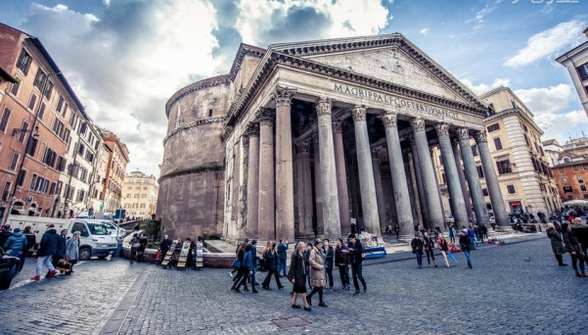

Pantheon 万神殿

1. I’ve had a lifelong fascination with Greek mythology.

我一生都对希腊神话非常着迷。

2. Pantheon was dedicated to all the Olympian Gods.

万神殿献给奥林匹亚众神。

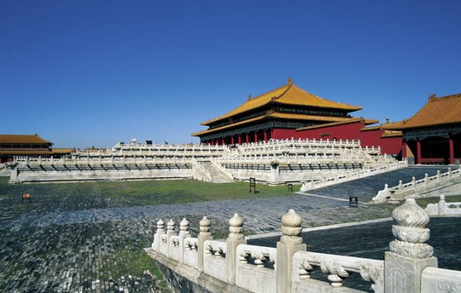

Forbidden City 紫禁城

1. Forbidden City witnessed the wax and wane of Chinese history.

紫禁城见证了中国历史的兴衰。

2. Forbidden City is carrying the heritage of Chinese culture.

紫禁城承载着中文文化的传承。

3. Forbidden City is the symbol of the Chinese civilization.

紫禁城是中华文明的象征。

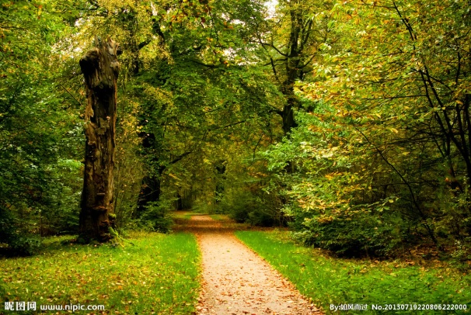

Forest park 森林公园

1. I feel freed from all cares in the world.

我感觉摆脱了一切世间烦恼。

2. Strolling down the path through the woods, with an eyeful of green, I feel at peace with the world.

漫步在林间小道，满目绿色，让我觉得与世无争。

3. The fresh air blended with the fragrance of earth is intoxicating.

清新的空气混杂着泥土的芬芳令人陶醉。

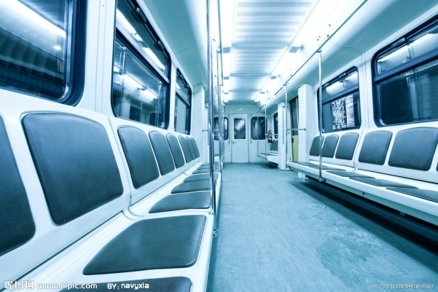

Subway 地铁

1. Subway can ensure your punctuality to work.

乘坐地铁能够确保你准时上班。

2. Taking subway is an eco-friendly way to travel.

坐地铁是一种环保的出行方式。

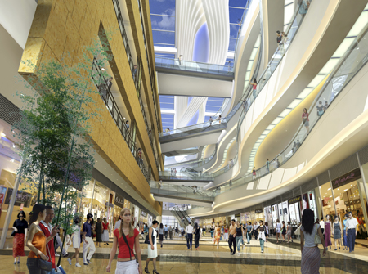

Shopping mall 大型购物中心

1. In a shopping mall, you can check the quality of goods with your own eyes.

在大型购物中心里，你可以亲自检查商品质量。

2. This general store has just about everything you could wish for.

这家商店日用品应有尽有。

TOEFL TEST INDEPENDENT TASKS

Task One

***1. Describe a popular gathering place where people in your town usually go for relaxation. Explain why people in your town like to go there. Include reasons and examples to support your response.-11***

**Sample Answer:**

Well, one of the most popular gathering places for relaxation in my town Beijing is Olympic Forest Park.

First, it provides us a chance to get away from the noise of the city. Strolling down the path through woods, with an eyeful of green, beautiful beyond words, one feels at peace with the world. That sense is beyond words.

Second, it is a good place to do exercise. Lots of people like doing jogging there, while breathing fresh air blended with the fragrance of the earth. That atmosphere is so relaxing and intoxicating. It makes us feel freed from all cares of life. (103)

***2. What place you never visited before do you want to visit most? -20***

**Sample Answer:**

Personally speaking, the place I never visited before but I want to visit the most is Pantheon which is dedicated to all the Olympian Gods.

I’ve had a lifelong fascination with Greek mythology. Like, when Uranus spread himself over the earth, Cronus leapt up and swung his scythe. He seriously wounded Uranus by cutting off a vital organ. This organ fell into the ocean, where it created the goddess of love, Aphrodite. How amazing that is.

In addition, ancient Greece is known to be the cradle of Western culture. As a big fan of astrology, theology and religious studies, Rome and Jerusalem are the two cities I must visit. (110)

***3. Which place would you like to live in: desert, forest or plain?-30***

**Sample Answer:**

Personally, I would like to live on a plain.

Plain has pleasant climates and convenient living conditions. Most of the big cities around the world set on plains or stand by rivers where there’s sufficient water source for drinking and bathing. And the landform of plains allows the rapid development of railway constructions which enables a city to grow larger. Who doesn’t want to live in a metropolis?

In comparison, desert and forest are not ideal places to make a living. Harsh climates, extremely hot weather and terrible shortage of water make deserts a living hell. And as to forest, I’m a social being who can’t live in solitude. (109)

***4. In a good day, which outdoor place would you like to do sports in?-41***

**Sample Answer:**

Well, in a good day, I would like to do sports in Olympic Forest Park.

First, it provides me a chance to get away from the nose of the city. Strolling down the path through woods, with an eyeful of green, beautiful beyond words, I feel at peace with the world.

Second, it is a good place to do exercise. I love to go jogging there, while breathing fresh air blended with the fragrance of the earth. That atmosphere is so relaxing and intoxicating. It makes me feel freed from all cares of life. That is what doing sports for, refreshment and relaxation. (103)

***5. Where do you prefer to go shopping?-107***

**Sample Answer:**

Personally speaking, as opposed to the mainstream trend of on-line shopping, I would like to shop in a traditional shopping mall.

First, in a big mall, the quality of goods is guaranteed, and you can check it with your own eyes. This is what any type of purchase cannot hope to match. I remember, last month, I bought a shirt online on a whim. When I got the thing, I finally understood, “pictures are for reference only.” I couldn’t resist spitting out four letter words at that moment.

By the way, if someone is worried about the prices of products in a mall, commercial discount would be a nice choice. (110)

***6. Describe your favorable place to study.-130***

**Sample Answer:**

Well, library is my favorable place to study.

First, every reader in the library has to abide by the norm of being absolutely quiet. So with less distractions, I can get more work done in less time. And lots of reference books are available there. I can go off to the stack whenever I need to.

And plus, there is free Internet connect in a library. I need Internet to do research, send emails or browse the Web. I don’t need to pay for the Internet service. It might make me sound like a miser. But money doesn’t grow on trees. I have to put aside some money for a rainy day. (112)

***7. Talk about a place you prefer to live. Near the school, near your parents' place or near a major transportation hub?-200***

**Sample Answer:**

Personally speaking, I prefer to live near a subway station. I have two reasons to support my stand.

First, traffic jam is an acute problem in Beijing. So subway is the only choice to ensure punctuality. For example, it is geographically about only 20 minutes drive from my apartment to my workplace. But in fact, getting stuck in traffic for hours is what I’ve experienced.

On top of that, subway is an environmental friendly way to travel. Nowadays, Beijing is troubled with haze and particulate matter that is mainly caused due to automobile emission. I want to do my bit to save our planet. (104)

***8. Talk about a place you go to often and explain why it is important to you? Please include specific details in your explanation.-T2***

**Sample Answer:**

Well, personally, I go to Olympic Forest Park very often. It is important to me.

First, it provides me a chance to get away from the noise of the city. Strolling down the path through woods, with an eyeful of green, beautiful beyond words makes me feel at peace with the world.

Second, it is a good place to do exercise. I love to go jogging there, while breathing fresh air blended with the fragrance of the earth. That atmosphere is so relaxing and intoxicating. It makes me feel freed from all cares of life. That is what doing sports for, refreshment and relaxation. (104)

***9. Talk about a place you enjoy going to or visiting when you were a child, describe the place, explain why you enjoy it.-T5***

**Sample Answer:**

Well, when I was in secondary school, I enjoyed going to the Olympic Forest Park.

First, it provided me a chance to get away from the noise of the city. Strolling down the path through woods, with an eyeful of green, beautiful beyond words made me feel at peace with the world.

Second, it was a good place to do exercise. I loved to go jogging there, while breathing fresh air blended with the fragrance of the earth. That atmosphere was so relaxing and intoxicating. It made me feel freed from all cares of life and helped release the pressure that built up at work. (105)

***10. Talk about a popular gathering place in your town where people like to go. Describe the place and explain why people enjoy going there.-T24***

**Sample Answer:**

Well, one of the most popular gathering places where people like to go in my town Beijing is Olympic Forest Park.

First, it provides us a chance to get away from the noise of the city. Strolling down the path through woods, with an eyeful of green, beautiful beyond words, one feels at peace with the world. That sense is beyond words.

Second, it is a good place to do exercise. Lots of people like doing jogging there, while breathing fresh air blended with the fragrance of the earth. That atmosphere is so relaxing and intoxicating. It makes us feel freed from all cares of life. (106)

***11. A friend of yours is looking for a new place to live and has asked for your advice. What do you think is the most important characteristic of a good neighborhood? Use details and examples to explain your answer.-T30***

**Sample Answer:**

Personally, an apartment set close to a subway station and with a forest park nearby is great place to live.

To begin with subway station, traffic jam is an acute problem in Beijing. So subway is the only choice to ensure punctuality. For example, it is geographically only about 20 minutes drive from my apartment to my workplace. But in fact, getting stuck in traffic for hours is what I’ve experienced.

And as to forest park, it provides us a chance to temporarily get away from the noise of the city. Strolling down the path through woods, with an eyeful of green, beautiful beyond words, one feels at peace with the world. (112)

Task Two

***1. Which do you prefer: spending time with friends in restaurant or at home?-176***

**Sample Answer:**

Well, it is a fucking brain-numbing moronic question. (这就是他妈一个煞笔脑残问题!)

Well, it is very complicated. It depends.

For one thing, if we are celebrating someone’s birthday, then restaurant would be an ideal place. Image that me and my friends are sitting around a big table, gobbling down delicious food, drinking a toast and speaking out freely. How intoxicating the atmosphere is! And most importantly, I’m freed from having to do the dishes.

For another, if we get together to work on a group project or assignment, my study at home is absolutely a solid choice. It goes without saying that a study, fifteen meters by ten, must be a better place for study than a restaurant. (106)