EDUCATION

VOCABULARY

Primary education 小学教育

Secondary education 中学教育

University education 大学教育

Exam-oriented education 应试教育

Test-oriented education 应试教育

Quality-oriented education 素质教育

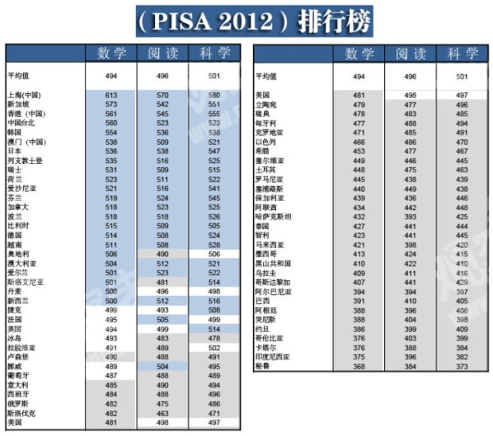

PISA (the Program for International Student Assessment) 国际学生评估项目



Elementary school students are enthusiastic, pure and innocent.

小学生热情，单纯且无知。

Elementary education purpose is to teach kids how to write, read and understand that transforms them into a literate person.

小学教育是教孩子读写以及理解能力，使孩子们接受教育。

Elementary education helps tap into their creativity and cultivate interests.

小学教育帮助孩子开发创造力和培养兴趣。

A qualified primary school teacher must be positive, optimistic and patient.

一个合格的小学老师必须积极，乐观，有耐心。

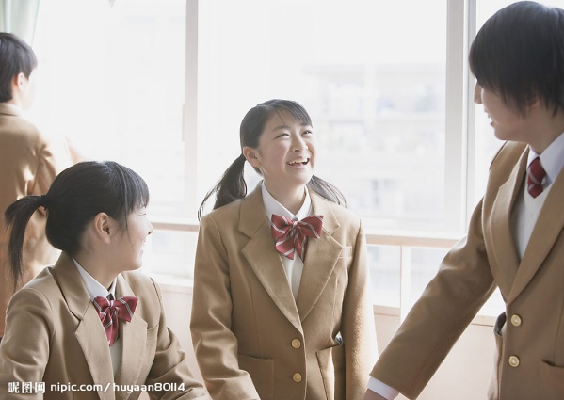

Middle school students are preparing for college entrance examination.

中学生在准备高考。

Middle school students are frivolous, self-centered and rebellious.

中学生率真，自我且叛逆。

Secondary education aims at cultivating positive values, world outlook and philosophy.

中学教育旨在培养正确的价值观，世界观和人生观。

The purpose of secondary education is to cultivate human minds with values and principles that help to distinguish between right and wrong.

中学教育旨在培养正确的价值观和原则，以帮助辨别是非对错。

To become a qualified secondary school teacher requires one to be open-minded, intelligent and caring.

成为一名合格的中学老师需要思想开明，有智慧，有爱心。



University students are independent-minded, self-respected and aspiring.

大学生思想独立，自尊，且有抱负。

The purpose of university education is to give people the tools to survive and to struggle within the society.

大学教育的目的是传授学生在今后社会中生存的方法。

University students have to arm themselves with more practical skills in order to get a foothold in this competitive society after they graduate.

大学生需要用更多的实用技能武装自己，以便在毕业之后能够在这竞争激烈的社会中赢得一席之地。

Apart from being selfless, academic and enthusiastic, having rich life experience and having succeeded in a certain field are also very important requisite qualities to a university professor.

除了无私，博学和热情之外，拥有丰富的生活阅历，以及已经在某一领域取得成功也是成为一名大学老师的必备条件。



One is never too old to learn.

活到老学到老。

While life passes education never ends, so education purpose entails a continuous change in direction.

生命不息，学习不止，因此教育的目的包括一个方向的持续变化。

While we grow up and become more mature we begin to realize what education purpose is in reality. We start to understand its importance only when we meet difficulties in our personal and professional development.

当我们长大，变得更加成熟的时候，会发现教育的实际目的。我们只有在我们个人或专业发展道路上遇到挫折的时候，才会意识到教育的重要性。

As mentioned above education represents the process of gathering knowledge, but knowledge has no end so does education and one can never affirm that he or she knows everything.

综上所述，教育代表求知的过程，但是知识是没有止境的，教育亦然，因此任何人可以肯定地说他懂得一切。

Confucius says, “Having heard the Way in the morning, one may die content in the evening.”

孔子曰：“朝闻道，夕可死”。

Cease to struggle and you cease to live. (Thomas Carlyle)

生命不息，奋斗不止。（卡莱尔）

ACCUMULATION

1. An international study PISA (the Program for International Student Assessment) published in 2012 looked at how students in 65 countries performed in math, science and reading. The winner was: Confucianism!

载2012年，一项国际研究调查了来自65个国家的学生的数学，科学和阅读成绩。胜出者是：受儒家思想影响的国家学生。

2. At the very top of the charts, in all three fields and by a wide margin, was Shanghai. Three of the next top four performers were also societies with a Confucian legacy of reverence for education: Hong Kong, Singapore and South Korea. The only non-Confucian country in the mix was Finland.

在所有的三个领域及广泛的周边学科，占据榜首的是上海学生。接下来的四个拔尖者中有三个来自于尊崇教育的儒家社会：香港，新加坡和韩国。剩下的一个学生来自芬兰。

3. In recent years, the test-oriented education has turned into the quality-oriented education with the development of the new curriculum.

近年来，随着新一轮课程改革的深入，应试教育逐渐向素质教育转变。

4. The larger issue is that the greatest strength of the Chinese system is the Confucian reverence for education that is steeped into the culture. In Chinese schools, teachers are much respected, and the most admired kid is often the brain rather than the jock or class clown.

更大的议题是，中国教育模式的最大优点是其深深植根于中华文化中的孔夫子式的对教育的尊崇。在中国的学校，教师备受尊敬，最受羡慕的孩子也是最聪明的那个，而不是爱开玩笑的“班级小丑”。

5. Education thrives in China and the rest of Asia because it is a top priority.

教育在中国以及其他亚洲国家兴盛的原因是教育被排在最优先的位置。

6. Yet it is also true that China has made remarkable improvements in the once-awful schools in peasant areas.

但是必须承认，中国已经在那些过去是糟糕的农村地区取得了令人瞩目的进步。

7. Just 20 years ago, children often dropped out of elementary school in rural areas. Teachers sometimes could barely speak standard Mandarin, which, in theory, is the language of instruction.

仅仅在20年前，那些农村的孩子还经常从小学辍学；有时，老师们还不能用标准的普通话授课。

8. These days, even in backward rural areas, most girls and boys alike attend high school. College isn’t unusual. And the teachers are vastly improved.

现在，甚至在落后的农村地区，大多数的女孩和男孩们一样有学可上；大学也不是不同寻常的事物；而且教师的水平也大幅提高。

9. “Bad teachers can always be made gym teachers,” a principal in the city of Xian explained to me as she showed me around her kindergarten. In China, school sports and gym just don’t matter.

“不好的老师总是可以去当体育老师”，一所西安的幼儿园园长在领我参观时对我这样说。在中国学校，运动和健身无关紧要。

10. That kindergarten exemplified another of China’s strengths: excellent early childhood education, typically beginning at age 2. Indeed, the only element of China’s education system that really falters badly is the university system. Colleges are third-rate and should be a national disgrace.

这所幼儿园是另一个中国优势的缩影：极好的儿童早期教育，典型的是开始于两岁。确实，制约中国教育的唯一因素是中国的大学教育。大学是三流的，这应该成为这个国家的耻辱。

TASK ONE

***1. Describe a particular strength of the education system in your country.-179***

**Sample Answer:**

Personally speaking, the greatest strength of the Chinese education system is the Confucian reverence for education that is steeped into the culture. In Chinese schools, teachers are much respected, and the most admired kid is often the brain rather than the jock or class clown.

Additionally, the strength is reflected in educational outcome. An international study, PISA, published in 2012 looked at how students in 65 countries performed in math, science and reading. The winner was: Confucianism! At the very top of the charts, in all three fields and by a wide margin, was Shanghai. (95)

***2. What are some ways that education has been improved in your country?-207***

**Sample Answer:**

Personally, I want to talk about two ways that education has been improved in China.

First, China has made remarkable improvements in the once-awful schools in peasant areas.

Just 20 years ago, children often dropped out of elementary school in rural areas. Teachers sometimes could barely speak standard Mandarin. But these days, even in backward rural areas, most girls and boys alike attend high school. College isn’t unusual.

Second, in recent years, the test-oriented education has turned into the quality-oriented education. In the past, the ignorance to improve students’ ability resulted in high marks but poor competence. But now, quality education has become the top priority. (106)

TASK TWO

***1. Do you agree or disagree with the following statement? It's easier to teach children in primary schools than students in universities. Include reasons and details in your explanation.-76***

**Sample Answer:**

Basically, I agree with the statement.

First, speaking from elementary education, it helps tap into children’s creativity and cultivate interests. And since elementary school students are enthusiastic, pure and innocent, a qualified primary school teacher must be positive, optimistic and patient.

Well, as to university education, it gives students the tools to survive and to struggle within this competitive society. Besides, university students are independent-minded, self-respected and aspiring. So apart from being selfless, academic and enthusiastic, having rich life experience and having succeeded in a certain field are also very important requisite qualities to a university teacher.

Thus, to teach students in universities sounds harder from competency requirements. (108)

***2. Do you agree or disagree with the following statement? It is never too late for an old people to receive high education and to get a university degree. Use specific reasons to support your answer.-77***

**Sample Answer:**

One is never too old to learn. I believe so.

First, the reason why old people want to receive high education may because, pathetically, for most people, the only time they start to learn is when they step into the competitive society; when they meet difficulties in their personal or professional development; or when they grow up and become more mature.

Second, theoretically, education represents the process of gathering knowledge, but knowledge has no end so does education and one can never affirm that he knows everything, so he has to keep learning no matter how old he is. It is only too late to learn for a dead man. (110)

***3. Do you agree or disagree that students should be required to go to school before they're 16.-123***

**Sample Answer:**

Well, I’m strongly for the statement.

The purpose of elementary education is to teach children how to write, read and understand that transforms them into a literate person and help students develop creativity and find out their interests; secondary education aims at the cultivation of correct values, world outlook and proper philosophy which helps students distinguish between right and wrong; and college entrance examination provides students a chance to enter a good university and have a splendid life.

Can you imagine the future of a person rude, illiterate and ignorant, lack of creativity and productivity, being in the low-socio economic status? Rapist, robber, murderer, all the social unstable factors. (109)

***4. Some students prefer to study nine or ten months a year, others choose to be in school the whole year. Which do you think is better? Explain why?-153***

**Sample Answer:**

I personally think studying nine or ten months a year would be better.

First, students must mix work with adequate rest. They can go for a travel for relaxation, or visit their parents to fulfill their filial duties during summer or winter breaks. Study and work are the means to survive, but not the goal of life. Take time to stop and admire the view along your life path.

Second, Bruce Lee said, knowing is not enough, you must apply; and willing is not enough, you must do. Students can take a part-time job or internship during the holidays to apply the knowledge acquired from classes in their workplace. (109)

***5. Someone thinks university education is important, someone thinks not, what do you think?-175***

**Sample Answer:**

The fool despise wits; the lazy disregard diligence; outlaws disdain order. I deem university education important. Who thinks not?

First, universities cultivate talents and develop professionals like artists, astronomers or scientists etc. which form the backbone of a free, open and pluralistic society. I can’t image what the world will look like without university.

Second, university isn’t only the place where you can arm yourself with professional knowledge and practical skills in order to get a foothold in this competitive society after you graduate, but also the place where you enlarge your social circle which will benefit your future career especially if you were a member of Skull and Bones. (110)