Clothes

Vocabulary

Persistence 坚持

Optimism 乐观

Generosity 豁达

Passion 热情

Rational 理性的

Self-control 自控力

Tolerance 包容

Sentimentality 多愁善感

Anxiety 焦虑

Observation 洞察力

Strict 严谨的

Unrestraint 潇洒

Fearlessness 无畏

Creativity 创造力

Curiosity 好奇心

Color

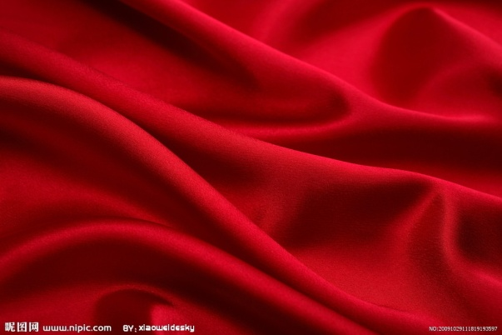

Red (extroverted)

Red represents joy, sexuality, passion, sensitivity and love.

红色代表喜悦，性，热情，感性和爱。

People who like red color are of persistence, optimism, generosity and passion.

喜欢红色的人具备坚持，乐观，豁达和热情的性格。

They are willing to satisfy their curiosity and desires at all cost. But due to lack of patience, they are easy to blow up. And they always tend to blame others when trouble comes.

他们不管需付出多少代价也要满足自己的好奇心和欲望。但是由于缺乏耐性，其稍不如意就会生气，且遇事通常先怪罪别人。

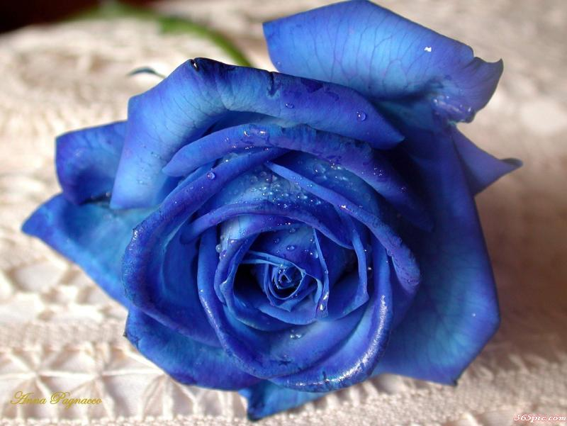

Blue (introverted)

Blue represents tranquility, equanimity and carefreeness.

蓝色代表宁静，镇定，无忧无虑。

People who like blue color are rational, responsible and good at self-control.

喜欢蓝色的人非常理性，有责任感，善于自控。

But due to lack of tolerance, when expostulate with others, they will take it to heart.

由于缺乏包容，当他们的意见与他人向左的时候，会非常介怀。

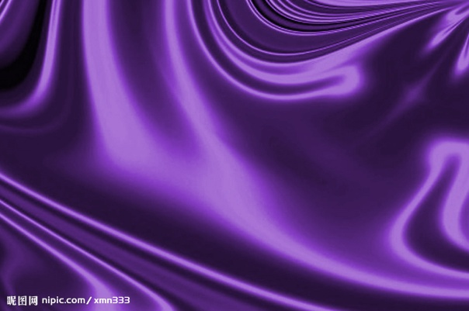

Purple (introverted)

Purple represents sentimentality and anxiety.

紫色代表多愁善感和焦虑。

People who like purple have acute observation, but tend to abuse feelings.

喜欢紫色的人有敏锐的观察力，但是容易滥用感情。

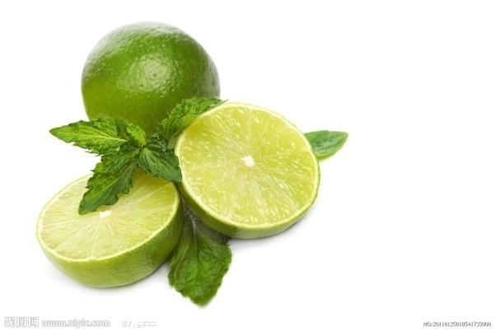

Green (introverted)

Green represents calmness, peacefulness, restraint and optimism.

绿色代表冷静，和平，克制和乐观。

People who like green color are afraid of loneliness and good at socializing.

喜欢绿色的人害怕孤独，善于交际。

They have very strong desire to advance. But they might be considered to be smooth and slick in establishing social relations for their equal attitude towards others.

他们有很强的上进心。但是由于对他人平等的态度，容易被认为在社交关系方面八面玲珑。

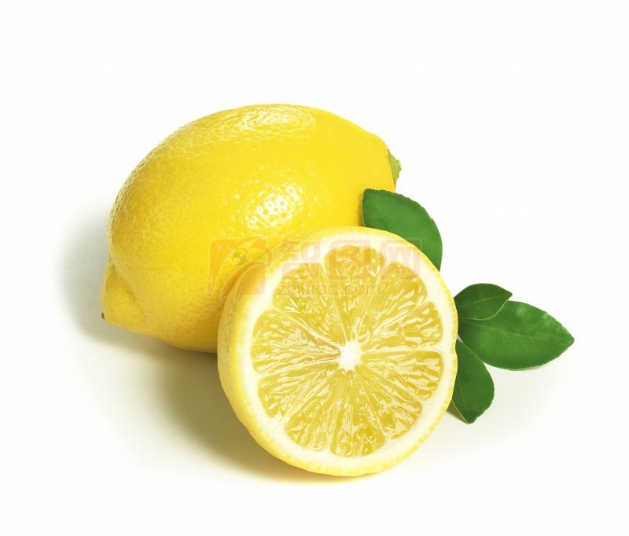

Yellow (extroverted)

Yellow represents fearlessness, passion and unrestraint.

黄色代表无畏，热情和潇洒。

People who like yellow color are of creativity and curiosity.

喜欢黄色的人富有创造力和好奇心。

They are well-learned and self-affirmative. They’ll never betray their friends and avoid any risk-taking activities in their life. But sometimes they speak unscrupulously, not consider the well-being of others.

他们博学且自信。绝对不会背叛朋友，也不会做没有把握的事情。但是他们说话肆无忌惮，不考虑他人感受。

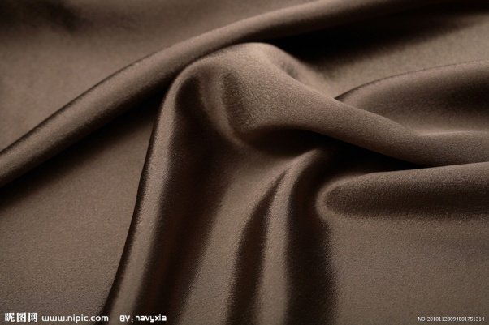

Gray (introverted)

Gray represents deep, restraint and calmness.

灰色代表深沉，自制和平静。

People who like gray color are undemonstrative, and likely to avoid forging profound friendship.

喜欢灰色的人戏弄不形于色，往往回避过深的友谊。

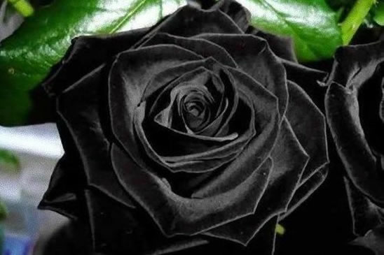

Black (introverted)

Black represents self-close, pessimism and desire for control.

黑色代表自我封闭，悲观和控制欲。

People who like black color are often lack of confidence.

喜欢黑色的人往往缺乏自信。

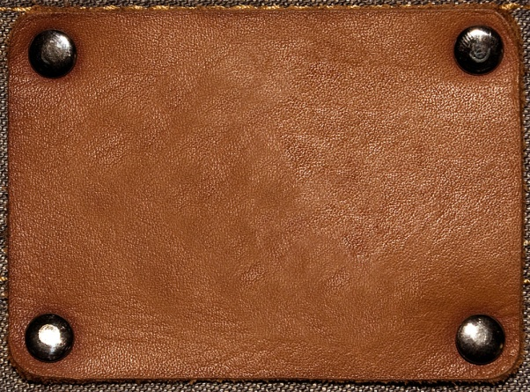

Brown (introverted)

Brown represents conservatism and cautiousness.

棕色代表保守和拘谨。

People who like brown color are of self-esteem, integrity and trustworthiness. But they give people a distant and indifferent feeling.

喜欢棕色的人有很强的自尊，耿直，值得信赖。但是容易给人一种冷漠，距离感。

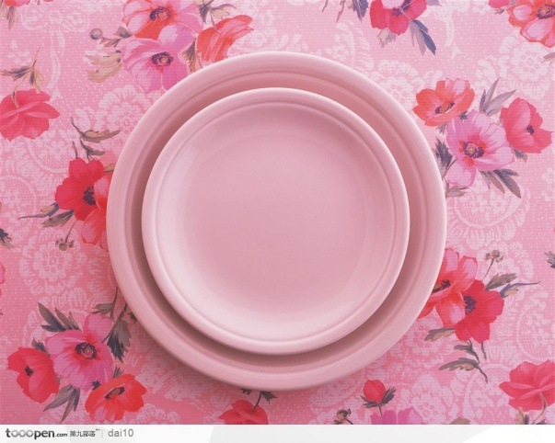

Pink (extroverted)

Pink represents sensibility, mildness and youthfulness.

粉色代表感性，温和，朝气。

People who like pink color need not a sounding board and dislike disputing with others, so they are often considered indecisive. They have a strong tendency to escape from reality.

喜欢粉色的人不容易接受他人意见，也不喜欢与人争论，因此常被认为优柔寡断。他们又强烈地逃避现实的倾向。

Wearing

People who prefer to dress up have a fervent desire to show off. They are either self-abased, hoping to get satisfaction by dressing up, or supremely self-confident, insisting that only finery gauderies can match up with them. These people have a much stronger desire for money.

喜欢华丽服饰的人，往往有着很强的表现欲望。通常这类人要么很自卑，希望通过着装获得满足感；要么极其自信，认为只有华丽的服饰才能配得上自己。这类人对金钱的欲望更加强烈。

People who prefer to dress down are strict, low-key; don’t want to engage the attention of others. But sometimes they are a little overtaken by misgivings and fear and timid in responding to others’ criticism or judgment.

喜欢朴素服装的人，处事严谨，为人低调，不希望引起他人注意。但是有时做事瞻前顾后，而且还怕别人批评。

Formal wear

People who would like to dress formally are traditional, dutiful, but generally manipulative and very fussy about others’ opinions and evaluations.

喜欢穿正装的人比较传统，循规蹈矩。但是往往控制欲较强，很在意他人对自己的评价。

Casual wear

People who would like to dress casually are independent, strong-minded. They are used to going their own way and hardly be affected by outside interference.

喜欢穿便装的人独立，有主见；我行我素，不容易受到外界干扰。

Chase after fashion

People who chase after fashion are afraid of loneliness, emotional and indecisive.

喜欢追求潮流的人害怕孤独，情绪不稳定，没有主见。

People who don’t go with the fashion are perseverant, self-centered and arbitrary. They often get to an argument with others because of their stubbornness.

不追求潮流的人性格比较坚韧，以自我为中性，行事武断。与人相处时常常会因固持己见而与他人产生争执。

People who constantly change their dress styles are afraid of being fettered. They are fond of the new and tired of the old. They have immature mentality and tend to escape from reality.

随时改变服饰风格的人不喜欢一成不变，害怕被拘束；喜新厌旧，心智不成熟；且容易逃避现实。

Clothing

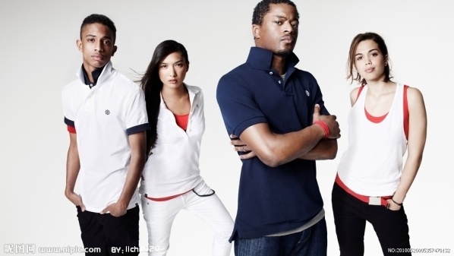

Sportswear 运动服

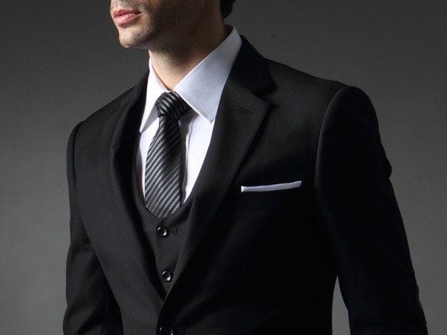

Business suit 西装

Dress-down Friday 便装星期五

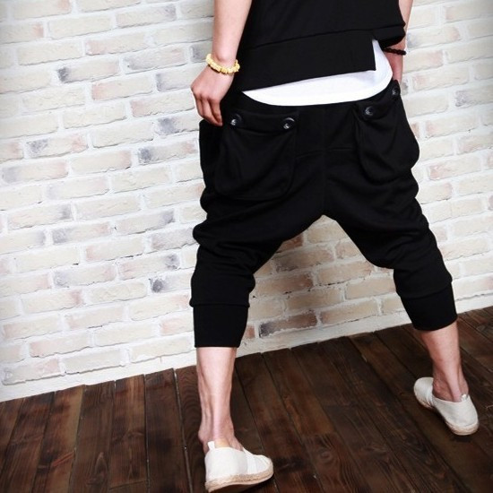

Harem Pants哈伦裤

Drop-crotch pants 吊裆裤

The crotch drops low to the knees.

裤裆低垂至膝盖。

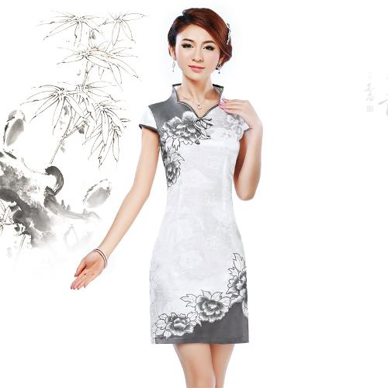

Cheongsam 旗袍

TASK ONE

**1. What kind of clothes do you most like to wear? Please include specific examples and details in your explanation.-35**

Talk about a type of clothing that is popular in your country. Why do you like it?-69

Describe the most popular and interesting clothes in your country.-88

What is the one style of clothing that the students in your school tend to wear? Why you like this style of clothing ? Include specific reasons and details in your response.-189

people dress can express their personality or not-13

Do you agree or disagree: Students should wear uniform in school?-14

Do you agree or disagree with the following statement: bosses should require employee to wear the formal cloth instead of the casual cloth. Use specific reasons and details to support your response.-201

Do you agree or disagree that people should always wear fashionable clothes?-221