MOBILE PHONE

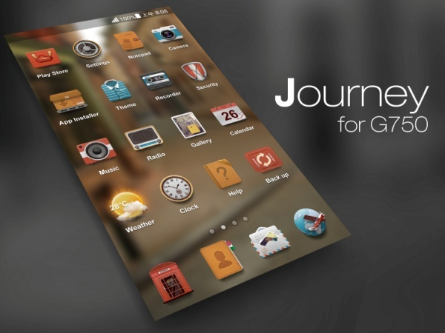

Mobile phone 移动电话

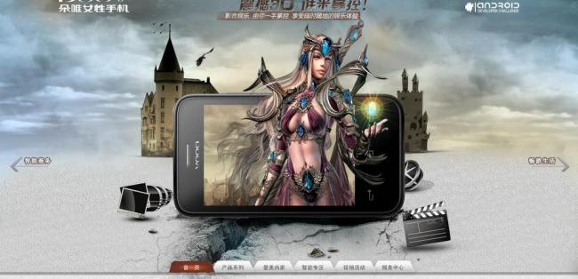

Mobile game 手机游戏



Don’t talk while she drives. 开车时不要打电话.

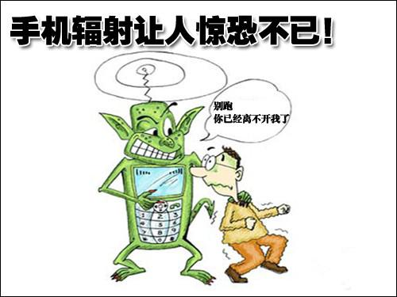

Cellular radiation 手机辐射

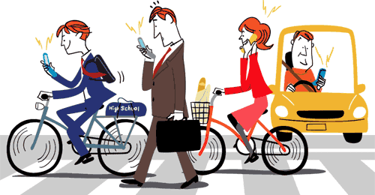

Smartphone addicts 低头族

ACCUMULATION

**PROS**

1. The mobile phone is now a must-have for children.

收集现在已经成了孩子们的必备品。（柯林斯辞典）

2. You can dial 911 on your mobile in an emergency.

当你遇到紧急情况时，可以用手机拨打911。

3. You can pinpoint your precise location on your mobile map.

你可以用手机地图精确定位自己的位置。

4. With mobile phones, an important conversation can take place anywhere, which puts less restriction on time and location.

有了手机，无论在任何地点都可以进行重要的谈话，这就减弱了时间和地域的限制。

5. A mobile phone allows you to send and receive e-mails more easily and check on appointments instantly.

手机可以让你随时收发邮件，快速查看行程。

6. Mobile phone has shortened the distance between people.

移动电话缩短了人与人之间的距离。

**CONS**

1. Mobile phones use microwave radiation to communicate.

手机利用微波辐射进行通讯。

2. The health effect of mobile phone radiation on children is worrisome.

手机辐射对孩子的影响是令人担忧的。

3. Preadolescent children are especially vulnerable to microwave radiation because of their thinner skulls, still developing nervous systems, their increased levels of cell division, and their less robust immune systems.

青春期前的儿童对微波辐射尤其脆弱，因为他们薄薄的头骨，仍在发展的神经系统，以及他们不断加快的细胞分裂速度，还有脆弱的免疫系统。

4. There are fears that mobile phone use could be linked to memory loss, and even Alzheimer’s Disease.

有人担忧，手机使用与失忆，以及老年痴呆症有关。

TOEFL TEST INDEPENDENT TASKS

TASK ONE

***1. What are some of the benefits that cell phones bring to people?-127***

**Sample Answer:**

Cell phones have brought us a number of benefits.

You can instantly pinpoint your precise location on the mobile map when you get lost in a strange city; you can dial 911 on your mobile in an emergency and you can play mobile games to kill time during a long journey.

Most importantly, cell phones have significantly changed business modes and promoted business development. With cell phones, businessmen can send and receive e-mails easily and check on their appointment instantly. And an important conversation can take place anywhere, which puts less restriction on time and location. For businessmen, cell phones are as necessary to life as bread. (107)

TASK TWO

***1. Do you agree or disagree with the following statement? Cell phone should be forbidden in some places. Use specific reasons and examples to support your answer.-2***

**Sample Answer:**

Personally speaking, I agree that cell phone should be forbidden in some places like primary school or on the highway.

First, cell phones use microwave radiation to communicate. Prolonged exposure to microwave radiation will lead to a host of physical and emotional conditions such as memory loss or hyperactivity. Preadolescent children are especially vulnerable to microwave radiation because of their thinner skulls, still developing nervous systems, their increased levels of cell division, and their less robust immune systems.

On top of that, in modern society, the increasing number of Smartphone Addicts has brought many social problems. They bury their head in the mobile while they’re walking, eating or driving on the highway. (112)

***2. Do you agree or disagree with the statement that students should be allowed to carry their cell phones at all times. Give details and examples in your response.-4***

**Sample Answer:**

Personally, I disagree with the statement.

It is undeniable that cell phone makes our life more convenient. You can instantly pinpoint your precise location on the mobile map when you get lost in a strange city; or you can dial 911 on your mobile in an emergency.

But enough is enough. Cell phones use microwave radiation to communicate. Prolonged exposure to microwave radiation will lead to memory loss or hyperactivity. Preadolescent children are especially vulnerable to microwave radiation because of their thinner skulls, still developing nervous systems, their increased levels of cell division, and their less robust immune systems.

So I think students need to put their cell phones aside sometimes. (111)

***3. Agree or disagree: cell phone changes our lives greatly-61***

**Sample Answer:**

Personally, I agree that cell phone changes our lives greatly.

You can instantly pinpoint your precise location on the mobile map when you get lost in a strange city; you can dial 911 on your mobile in an emergency and you can play mobile games to kill time during a long journey.

Most importantly, cell phones have significantly changed business modes and promoted business development. With cell phones, businessmen can send and receive e-mails easily and check on their appointment instantly. And an important conversation can take place anywhere, which puts less restriction on time and location. For businessmen, cell phones are as necessary to life as bread. (108)

***4. Do you agree that it's necessary to have a mobile phone in order to achieve success in business.-146***

**Sample Answer:**

Well, I’m strongly for the statement.

For businessmen, mobile phone is as necessary to life as bread. When they are on business trips, businessmen can simply click on several icons to book an air ticket or reserve a hotel. And they can use their mobile phone to send and receive e-mails easily and check on an appointment instantly. Moreover, mobile phone puts less restriction on time and location. An important conversation can take place anytime and anywhere.

And plus, to succeed in business, one must outsmart the competition to find out the most cost-efficient way to reach and persuade potential customers. Wechat has 650 million users. (106)

***5. State whether you agree or disagree with the following statement. Then explain your reasons using specific details in your explanation. Students should not be allowed to bring cell phones or mobile phones into the classroom.-TPO17***

**Sample Answer:**

Personally, I disagree with the statement. I think students should be allowed to bring cell phones into the classroom but not call a phone there.

Firstly, cell phone is as necessary to life as bread for students. First year students can instantly pinpoint their precise location on the mobile map when they get lost on campus; or they can dial 911 on their mobile in an emergency; or they can play mobile games to relax during class breaks. OK, the point is that cell phones can’t be thoroughly banned on campus. So where could the students place their cell phones before entering into the classroom? (105)

***6. Some people like to have their cell or mobile phone with them all the times. Other people prefer not to bring their cell or mobile phone with them everywhere they go, or they choose not to own one at all. Which do you prefer? Explain why.-TPO26***

**Sample Answer:**

Personally, I would like to carry with my mobile phone all the time.

I am a business man. For me, mobile phone is as necessary to life as bread. When I’m on business trips, I can simply click on several icons to book an air ticket or reserve a hotel. When I get lost in a strange city, I can instantly pinpoint my precise location on the mobile maps.

In addition, I can use my mobile phone to send and receive e-mails easily and check on an appointment instantly. Moreover, mobile phone puts less restriction on time and location. An important conversation can take place anytime and anywhere. (108)