OCCUPATIONS

OCCUPATIONS



**Doctor 医生**

Pros

I yearn to be a doctor, an angel in white, to heal the wounded and rescue the dying. Without doctors, the sick can’t be treated and disease will be prevalent.

Cons

A doctor without medical ethics equates an executioner, a demon, a vampire. Unethical doctors regard patients as lambs taken for slaughter, bleed them dry before they die.



**Nurse 护士**

Pros

I yearn to be a nurse, an angel in white, to head the wounded and rescue the dying. If we say doctors create the chances to extend life, then nurses make it real. Although nursing is hard work, it is very fulfilling.

Cons

Being a nurse is quite a slog. A nurse has to fulfill many duties in caring for the sick and is always threatened with venomous personal attacks from the family members of patients.



**Teacher 老师**

Pros

I yearn to be a teacher to replace students’ empty minds with open ones, to help people to get rid of fatuity, poverty and violence. Parents only gave us lives, but teachers who teach us well gave us the art of living.

Give a man a fish and you feed him for a day.

授之以鱼不如授之以渔。

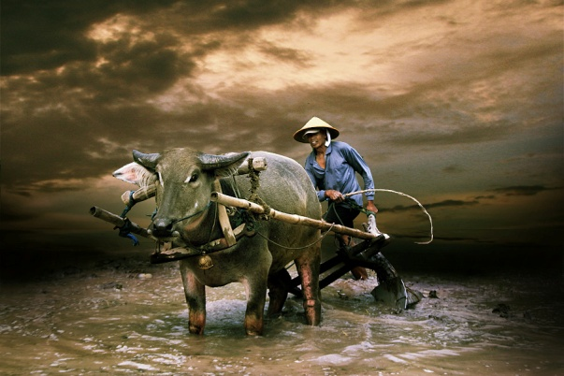

**Farmer 农民**

Pros

I’d like to be a farmer growing crops to feed people.

Cons

I don’t want to be a farmer which earns the lowest return on the investment during peacetime. For example, my uncle has been a farmer for 40 years, man and boy, growing crops and raising pigs or chickens to feed people. But till now, my uncle is still living a hand-to-mouth existence without medical or other benefits. In part, farmers put in their whole effort to serve their country, but still run the most serious survival risks.



**Artist 艺术家**

Pros

I yearn to be an artist. Arts uplift the mind and the spirit; arts enrich people’s lives; art and life are inextricable. Without arts, Hamlet, ballet or Louvre, etc., the world would be no more than a pale, dull dreamland.

Arts include literature, paintings, sculpture, architecture, music, dance, drama, film, craft, etc.

艺术包括文学，绘画，雕塑，建筑，音乐，舞蹈，电影和工艺等。

Cons

I don’t want to be an artist. It is very risky. My uncle earned a precarious living as an artist. He was a dreamer. He told me that dreams can be a rich source of inspiration for an artist. But eventually, my uncle’s dream was shattered by failing eyesight.

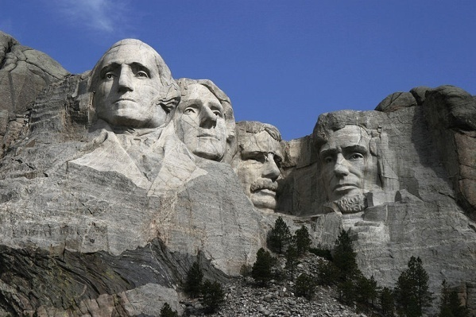

**Government leader 政府领导人**

Pros

I yearn to be a government leader to combat corruption and build a clean government for the well-being of the underprivileged.

Cons:

I don’t want to be a government leader. It is impossible to keep my nose clean in politics. Corruption is often at the very root of why governments failed to work. A new country is born in rooting out corruption; a country is dying in corruption breeding. I don’t want to be drawn into the vortex of politics.

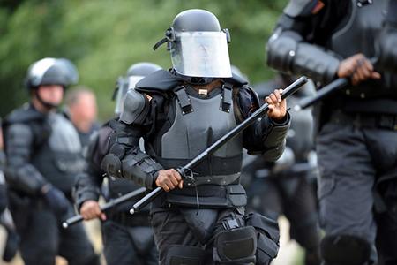

**Policeman 警察**

Pros

I yearn to be a policeman to preserve public order. Nothing can be accomplished without norms or standards. Law guards the liberty of people and policemen uphold the majesty of law.



**Photographer 摄影师**

Pros

Photographers capture the beautiful moments of life and record them on photos.

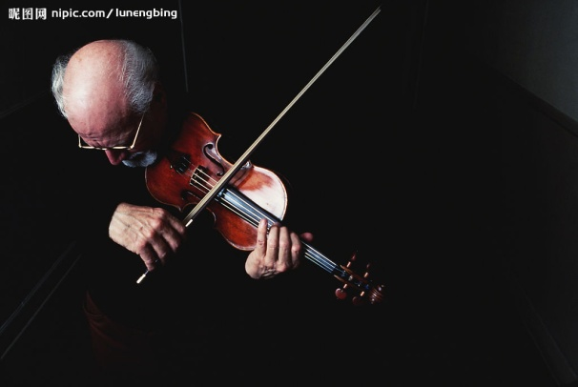

**Musician 音乐家**

Pros

I yearn to be a musician as famous as Beethoven. Music uplifts the mind and the spirit and cleanses the soul. I’ve taken on the study of music since I was at the age of 6. And now I’m still working on it.

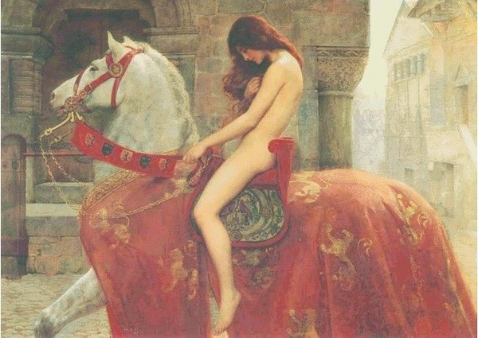

**Painter 画家**

Pros

I want to be a painter, using paint to communicate concepts and emotions. Painting is not only a scholarship, but also a culture and a life style. Paintings can also improve the image of a city and promote the economic development.

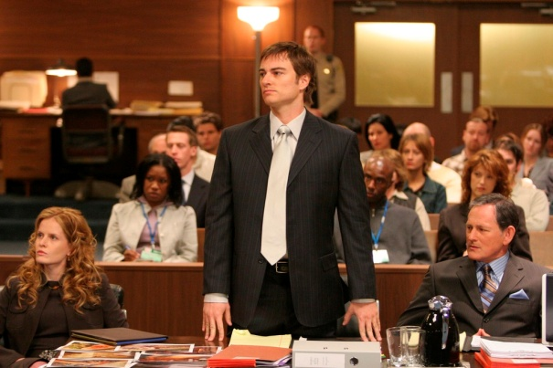

**Lawyer 律师**

Pros

I yearn to be a lawyer to uphold the equity of the law, and to fight for justice for the vulnerable group.

Cons

It is not easy to be a lawyer. To be a lawyer requires a precise mind. And it is almost impossible to find a lawyer that is not a shyster.



**Veterinarian 兽医**

Pros

I’d like to be a vet to help animals. Animals suffer too much at our hands. They suffer neglect, cruelty and abandonment. When pets get really injured and irrecoverable, vets help put them to sleep to relieve pain.



**Restaurant owner 酒店老板**

Pros

I want to run a restaurant as an ideal place for the overworked to relieve fatigue. And restaurants carry forward the traditional dietetic culture.



**Building designer 建筑设计师**

Pros

I yearn to be a building designer who provides people with a warm and comfortable home to withstand strong winds and furious storm. Without building designers, our cities would be filthy and choked with exhaust fumes. Pantheon, pyramid and Forbidden City, these magnificent ancient buildings demonstrate the great intelligence of building designers.

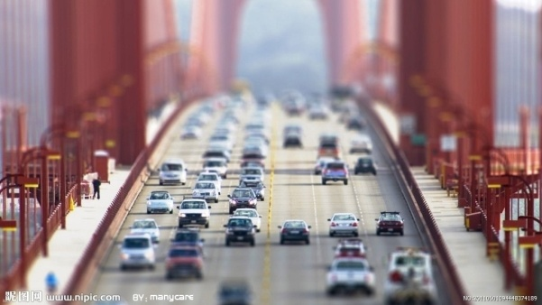

**Transport worker 交通工作者**

Pros

I yearn to be a transport worker to maintain the normal operation of urban transport system. Transport workers carry out routine maintenance of transport and meet with requirements for the safety of passengers and property.

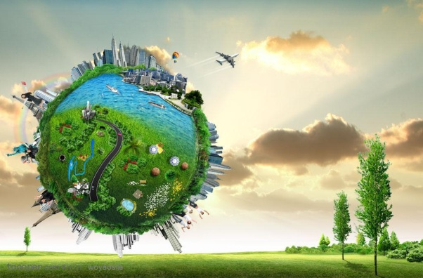

**Environmental scientist 环境科学家**

Pros

I yearn to be an environmental science technician to find new ways to alleviate environmental stress on the planet. Now we’re facing serious environmental problems like air pollution, water pollution and soil pollution.

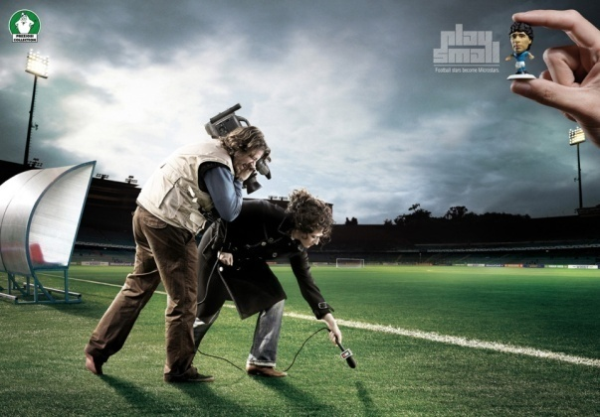

**Newspaper journalist 新闻记者**

Pros

I yearn to be a newspaper journalist to discover and tell the truth. A journalist should always live up to the ideas of truth, decency and justice.

Cons

I don’t want to be a newspaper journalist. The press invades people’s privacy unfairly and unjustifiably every day. In order to cater to popular taste, the media is full of shock-horror headlines about under-age crime. And rape has been unacceptably made a good news story.

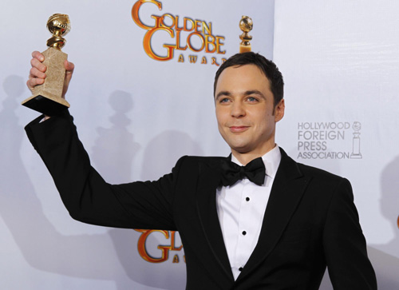

**Actor 演员**

Pros

I yearn to be a movie actor to make people’s lives picturesque. My uncle is an actor. He played a role in the movie Curse of the Golden Flower. This is an ambitious and intriguing movie, full of striking imagery. It is destined to become a cult classic.



**Athlete 运动员**

Pros

I yearn to be an athlete to sweat on the pitch. I admire my uncle, an instinctive athlete. An Olympic gold medal has led him to untold riches.

TOEFL TEST INDEPENDENT TASKS

TASK ONE

***1. Which job do you think is the most important to your society: doctor，teacher or farmer? Give specific reasons to support your answer.***

**Sample Answer:**

Personally speaking, I think teacher is the most important occupation to the society.

Teachers replace students’ empty minds with open ones, help people to get rid of fatuity, poverty and violence. Parents only gave us lives, but teachers who teach us well gave us the art of living.

Most importantly, teachers help establish moral standards. A doctor without medical ethics equates an executioner, a demon, a vampire, regards patients as lambs taken for slaughter, bleed them dry before they die. A farmer without ethical standards would seek excessive profits at the expense of people’s health. A society without moral standards cannot stand longer. (103)

***2. Describe a job that you did in the past or want to take in the future.***

**Sample Answer:**

To be honest, I yearn to be a teacher in the future.

Teachers replace students’ empty minds with open ones, help people to get rid of fatuity, poverty and violence. Parents only gave us lives, but teachers who teach us well gave us the art of living.

Most importantly, teachers help establish moral standards. A doctor without medical ethics equates an executioner, a demon, a vampire, regards patients as lambs taken for slaughter, bleed them dry before they die. A company without ethical standards would seek excessive profits at the expense of people’s interests. Doctors cure diseases; teachers enlighten hearts. (100)

***3. Which of the following occupations do you think is most important to society? Being a nurse, being a teacher, or being an artist?***

**Sample Answer:**

Personally speaking, I think teacher is the most important occupation to the society.

Teachers replace students’ empty minds with open ones, help people to get rid of fatuity, poverty and violence. Parents only gave us lives, but teachers who teach us well gave us the art of living.

Most importantly, teachers help establish moral standards. A nurse without medical ethics equates an executioner, a demon, a vampire, regards patients as lambs taken for slaughter, bleed them dry before they die. Without ethical standards, an artist is little more than a psychotic like Zhu Yu, a performance artist in China, who calls eating human and feeding a dog with his dead baby art. (112)

***4. Which career is the hardest one do you think? Government leader, doctor or police?***

**Sample Answer:**

In comparison, I believe government lead is the hardest career.

Doctors heal the wounded and rescue the dying. Without whom, the sick can’t be treated and disease will be prevalent. Policemen preserve public order and uphold the majesty of law. Without whom, our societies will be plunged into chaos. So it is undeniable that doctor and police are not easy works.

But a government leader should not only ensure social stability and economic development amid the rigorous domestic situation, but also contend with international competitors. A domestic policy mistake will lead to economic recession; a foreign policy stumble can result in a return to war. (105)

***5. Which career do you respect the most: photographer, musician or painter?***

**Sample Answer:**

Music is the speech of angels. A good music, like Beethoven’s Moonlight Sonata, makes me feel at peace. So I respect musician. Paintings improve the image of a city and promote the economic development. I’ve ever seen the countless treasures of art in the Louvre galleries. So I respect painter.

But in comparison, I respect photographer the most. My father is a keen amateur photographer. He captured every beautiful moments of my life—my birth, my childhood and my growth—and recorded them on photos which are reminiscent of my beloved past. Photos can not only bring me a very touching feeling, but also loving and being loved. (108)

***6. Which of the following would you rather be, lawyer, veterinarian, or the restaurant owner?***

**Sample Answer:**

Well, I don’t want to be a lawyer, because it is almost impossible to find a lawyer that is not a shyster. And I’m not able to be a vet, because my heart is too vulnerable to have injured animals put to sleep.

So I would rather be a restaurant owner running a special restaurant at a place leaning to mountains and rivers with steady climates to provide busy people with an ideal place to temporarily get away from the worries of life. Every morning, when you wake up, you can smell the gentle fragrance of the earth, trees, grass and the water in the creek. The scent will intoxicate your heart. (112)

***7. Among the following professions, which do you think is the most important to a city? Police officer, building designer or transport worker.***

**Sample Answer:**

Well, building designers provide people with a warm and comfortable home to withstand strong winds and furious storm. Without building designers, our cities would be filthy and choked with exhaust fumes. And Transport workers carry out routine maintenance of transport and meet with requirements for the safety of passengers and property. It is undeniable that they are important.

But to a city, I believe police officer is the most important profession. Policemen preserve public order and uphold the majesty of law. Law guards the liberty of people. Without law, without liberty, buildings would be destroyed and public transport would be paralyzed. People lives would be filled with untold suffering. (109)

***8. If you could have any job or career you wanted, which would you choose and why? Give specific details to explain your response.***

**Sample Answer:**

To be honest, I yearn to be a teacher in the future.

Teachers replace students’ empty minds with open ones, help people to get rid of fatuity, poverty and violence. Parents only gave us lives, but teachers who teach us well gave us the art of living.

Most importantly, teachers help establish moral standards. A doctor without medical ethics equates an executioner, a demon, a vampire, regards patients as lambs taken for slaughter, bleed them dry before they die. A company without ethical standards would seek excessive profits at the expense of people’s interests. Doctors cure diseases; teachers enlighten hearts. (100)

***9. Which of the following jobs or careers do you think would be most rewarding? University professor; Environmental scientist; Newspaper journalist. Choose one career and explain why you think it would be most rewarding. Use details and examples to support your answer.***

**Sample Answer:**

Personally, I think university professor is the most rewarding profession.

Professors replace students’ empty minds with open ones, help people to get rid of fatuity, poverty and violence. Parents only gave us lives, but professors who teach us well gave us the art of living.

Most importantly, professors help establish moral standards. One without ethical standards accelerates the speed of deforestation by using more disposable chopsticks and paper cups; one without moral standards has a taste for petrol-guzzling cars for a selfish desire; one without ethics is in favor of the media full of shock-horror headlines about under-age crime. The reward for being a university professor might be a peaceful, clean world. (112)

TASK TWO

***1. Do you agree or disagree that celebrities, such as musician, actors, athlete, could give a good example to young people.***

**Sample Answer:**

Well, it is very complicated. Every coin has two sides.

On one hand, Beethoven, regarded as one of the immortals of classic music, created the ninth symphony even though he could hear nothing; the athletes in Paralympics use strong wills to write the miracle of life. Their stories are inspiring young people. They teach us that cease to struggle and you cease to live.

One the other hand, Marilyn Manson, a very famous singer in America, has negative influence on young people’s mind and behavior. There is a tint of death, a flavor of mortality in his songs. And his songs are thick with death, blood and violence. (108)