Diet

Food Additives

Sudan red 苏丹红 (magdala red 马格达拉红)

Lean meat powder 瘦肉精 (clenbuterol 双氯醇胺)

Preservative 防腐剂

Hogwash oil 地沟油

Melamine 三聚氰胺

Chemical fertilizer 化肥

Nitrite 亚硝酸盐

Expired food 过期食品

Diseases

Obesity 肥胖症

Diabetes 糖尿病

Hypertension 高血压

Indigestion 消化不良

Malnutrition 营养不良

Cardiovascular disease 心血管疾病

Multiple organ failure 多器官功能衰竭

COMMON EXPRESSIONS

Crispy outside and juicy inside 外焦里嫩

Perfect combination of color aroma taste and appearance 色香味俱全

Fat but not greasy 肥而不腻

Suitable for all ages 老少皆宜

Leave a lingering numbing kick 齿间留香，回味无穷(麻辣)

Leave a sweet taste in one's mouth 齿间留香

Lead a person to endless aftertastes 回味无穷

Food Safety Issues

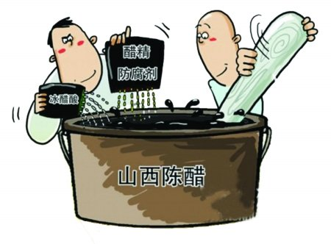

Eleven people have died and nearly 150 have been sickened by vinegar stored in barrels that may have previously contained antifreeze.

十一人死亡，150人健康受损，由于食用了曾经用于存放抗冻液的桶中的醋。

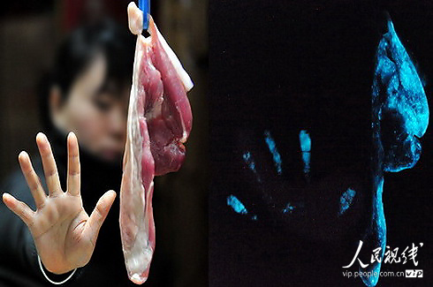

Uncooked pork was found glowing in the dark due to a phosphorescent bacteria.

未烹饪过的猪肉被发现在黑暗中闪闪发光，由于涂抹了一层能发出磷光的细菌。

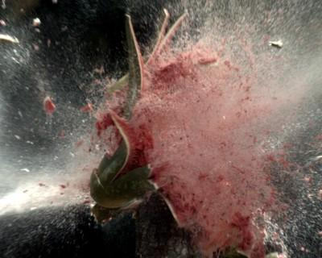

Some unethical farmers over-sprayed their watermelons with growth-promoting chemicals that caused the watermelons to start exploding.

一些无德的农民向西瓜上过度喷洒膨大剂，结果导致西瓜爆炸。

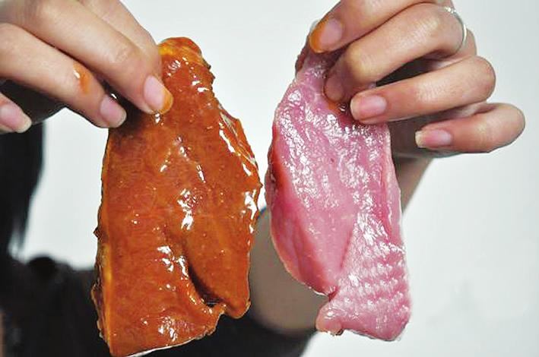

A liquid used to disguise pork as beef was found for sale in the market this spring.

一种能够把猪肉变成牛肉的液体在市场上出售。

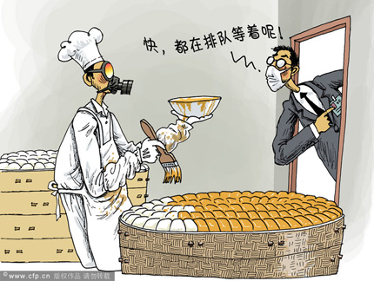

A workshop was adding banned artificial lemon-yellow dye to steamed buns so that the cheap wheat buns look like more expensive corn flour buns.

某作坊用人工柠檬黄染料来给馒头染色，目的是让便宜的小麦面馒头看上去像玉米面馒头。

ACCUMULATION

1. "Take care of your body. It's the only place you have to live." (Jim Rohn)

照顾好你的身体，因为那时你唯一生存的地方。

2. "Those who think they have no time for healthy eating, will sooner or later have to find time for illness." (Edward Stanley)

那些没有时间健康饮食的人们，早晚会挤出时间去看病。

3. “Today, more than 95% of all chronic disease is caused by food choice, toxic food ingredients, nutritional deficiencies and lack of physical exercise.” (Mike Adams, author, investigative journalist, educator)

当今，超过95%的慢性疾病是由于饮食导致的，比方说有毒的食材，营养不良以及缺乏锻炼。

4. Good nutrition is not about strict, faddy diets, health foods and vitamin supplements. It's about helping your body get the nutrients it needs to work properly in the world we live in--a busy, demanding and at times, stressful place.

好的营养并不意味着苛刻，挑剔的饮食，或者健康食品，亦或是补充维他命。它仅仅是帮助你的身体获得足够的营养，能够让你在这个繁忙，劳累，压力重重的社会好好生存。

5. Green salad is rich in Vitamin C.

蔬菜沙拉富含维他命C。(简明英汉词典)

6. Vitamin B assists in red-blood-cell regeneration.

维生素B可以促进红细胞再生。(柯林斯词典)

7. Vitamin C helps to detoxify pollutants in the body.

维生素C可以帮助解除体内污染物的毒性。(柯林斯词典)

8. Vitamin C increases the absorption of iron from food.

维生素C促进食物中铁的吸收。(柯林斯词典)

9. A diet deficient in vitamin D may cause the disease rickets.

缺少维生素D的饮食可能导致软骨病。(简明英汉词典)

10. Vitamin C deficiency can ultimately lead to scurvy.

缺乏维生素C最终能导致坏血病。(简明英汉词典)

11. Beef is nutritional food for its high content of the amino acid and vitamin B6.

牛肉营养丰富，富含氨基酸，维生素B6。

12. Beef also contains Zinc, which helps with memory.

牛肉也富含锌元素，有助记忆。

13. Among its many advantages, B6 assists the blood in carrying oxygen throughout the body.

他有很多种益处，维生素B6有助于血液输送氧气到人体各处。

14. Inadequate amounts of B6, B12, folate, thiamin and niacin can leave you feeling depressed and fatigued, slow the body’s metabolism and increase your risk for chronic diseases.

如果人体缺乏维生素B6，B12，叶酸，硫胺和烟酸等物质，人会感到困乏和无精打采，人体的新陈代谢会降低并增大患慢性病的风险。

CHINESE FOOD CULTURE

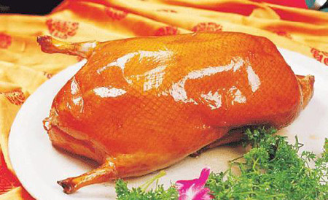

**China Culture--History of Peking Duck**

Peking duck is thought to be one of the most delicious dishes all over the world. As far back to 400 AD in the South-North Dynasty, Jiu Duck was recorded in Shi Zhen Lu (the Complete Recipes for Dishes and Beverages). In the South Song Dynasty, roasted ducks was ever a renowned dish among the restaurants. Then, they were not only the foods for the households but also the gourmet for official dinner. The recipe of roasted duck was introduced from the southern China to Dadu, capital of the Yuan Dynasty (1206-1368), and then roasted duck was in the royal menu for the royal family. In the periods of Ming and Qing Dynasty, roasted duck was one of the favorable dishes of royal families. It is said that the roasted duck was named Peking duck for it was the favor of Emperor Qianlong and Empress Dowager Cixi.

Peking duck is always served in well-cut slices. The whole duck must be sliced into pieces and every piece has to be perfect with the complete layers of the meat. Normally there are many dishes served with the duck, including a dish of fine-cut shallot bars, a dish of cucumber bars and finally a dish of paste-like soy of fermented wheat flour.

TOEFL TEST INDEPENDENT TASKS

TASK ONE

***1. Describe the advantages and disadvantages of only serving low-calorie healthy food in school.-149***

**Sample Answer:**

Well actually, I can hardly see any advantages about the saying. Maybe just low-calorie food is cheap. But the disadvantages are obvious. See, low-calorie food such as green salad is rich in vitamine C which can not only help detoxity pollutants in the body, but also increase the absorption of iron from food; And high-calorie food such as beef is nutritional food for its high content of amino acid, vitamin B6 and Zinc, etc. Vitamin B6 assists the blood in carrying oxygen throughout the body which makes students more energetic and concentrating. And Zinc helps with memory. So the point is about how to maintain balanced diet but not being drastic. (111)

**Sample Answer2:**

Well actually, I can hardly see any advantages about the saying. Maybe just low-calorie food is cheap. But the disadvantages are obvious. For instance, when I was in high school, they only served low-calorie foods. I ate vegetables, fruits and cereals all through the day. Then I felt very fatigued and absent-minded in class and my acdemic performance failed dramatically. Later on, I went to the doctor. I was told that I got a chronic disease mainly caused due to inadequate amounts of vitamin B6 and amino acid. This is what low-calorie foods broungt me. So I dare to say that the point is about how to maintain balanced diet but not being drastic. (114)

***2. Eating at home or in a restaurant. Which one is better? And explain the advantages and disadvantages of your choice.-178***

**Sample Answer:**

Personally, I confirm that eating at home must be better than in a restaurant.

Eating at home, you can monitor your diet. And most importantly, you can eat a balanced and healthy diet with less fat, salt and oil. By contrast, eating in a restaurant is more risky. You don’t know what ingredients or additives they put in the food such as Sudan red, perservatives or hogwash oil which will lead to serious injuries. For instance, recently in China, 11 people have died and nearly 150 have been sicken by the vinegar stored in barrels which might previously contained antifreeze. That is so horrible and sensational. (106)

***3. What kind of food do you recommend to add to food menu on campus cafeteria? Use Examples and details to support your response.-204***

**Sample Answer:**

Personally, I recommend to add green salad to the food menu on campus cafeteria.

First, junk foods flood campus such as hamburger, cheese and fried food which contain a lot of calories. Over intake of calories will lead to a host of illnesses like obesity, hypertension and cardiovascular disease. For example, my school mate Bob who weighs up to 200 pounds more or less was eventually forced to drop out of school because of diabetes.

On top of that, green salad is rich in vitamins. Vitamin C helps detoxify pollutants in the body and improve the absorption of iron from food. That will do a great deal to improve students’ health. (111)

***4. do you agree or disagree the university's decision to allow food during the class.-208***

**Sample Answer:**

Personally, I don’t believe allowing food during the class is a wise choice.

First, eating in class will make a lot of noise and smell that’ll disturb other students. For example, once in my physics class, my deskmate Bob was munching on a durian which gave off very stinky, unendurable smell that made me cover my nose all the time and in too vile a mood to study.

On top of that, eating in class is not respectful. Respect is mutual. Imagine that if everyone is eating in class. Tom is chewing on an apple; Mary is eating hot pot; the professor is drinking alcohol. Don’t you see any problem? (110)

***5. Parents need to make sure their children lead healthy lives. What can parents do to help their children have healthy lifestyles?-TPO31***

**Sample Answer:**

Nowadays, many young people are in the state of sub-health mainly due to improper diet and lack of physical exercise. So I suggest children to eat healthy diet and do more exercise to lead a healthier lifestyle.

First, life is movement. Doing more sports like swimming or jogging can not only promote blood circulation and metabolism, but also stimulate digestive and excretory systems. Doing sports can also reduce the risks of obesity, diabetes and hypertension.

On top of that, Today, more than 95% of all chronic disease is caused by food choice, toxic food ingredients, nutritional deficiencies. So eating healthy diet with less fat, salt and oil seems particularly important. (110)

***6. If one of your foreign friends visit your country. What food do you recommend him to take and why?-10***

**Sample Answer:**

Personally, if one of my foreign friends visit China, I’m going to treat him with Peking duck.

First, Peking duck has great diet culture. The recipe of roasted duck was introduced from the southern China to Dadu, capital of the Yuan Dynasty, and then roasted duck was in the royal menu for the royal family.

And plus, Peking duck is very delicious. The whole duck must be sliced into pieces and every piece has to be perfect with the complete layers of the meat. And it has perfect combination of color aroma taste and appearance, crispy outside and juicy inside. (100)

TASK TWO

***1. Do you prefer to have fast food in the fast-food restaurant?-42***

**Sample Answer:**

Personally speaking, I don’t like having fast food in a fast-food restaurant.

First, I don’t know what ingredients or additives they put in the food such as preservatives, hogwash oil or expired chicken. I don’t want to risk being poisoned. For instance, recently in China, 11 people have died and 150 have been sickened by the vinegar stored in barrels that may have previously contained antifreeze.

On top of that, apart from food safety problems, I’m also concerned about my health condition. Fast foods are mostly hamburgers, cheeze and fried food which contain a lot of calories. Over intake of calories will lead to a host of diseases such as obesity and diabetes. (113)

***2. Do you prefer to cook on your own or buy food from restaurants?-43***

**Sample Answer:**

Personally, I prefer to cook on my own rather than buying food from restaurants.

Eating at home, I can monitor my diet. And most importantly, I can eat a balanced and healthy diet with less fat, salt and oil. By contrast, eating in a restaurant is more risky. I don’t know what ingredients or additives they put in the food such as Sudan red, perservatives or hogwash oil which will lead to serious injuries. For instance, recently in China, 11 people have died and nearly 150 have been sicken by the vinegar stored in barrels which might previously contained antifreeze. That is so horrible and sensational. (106)

***3. Schools should ban on all junk food, such as hamburgers, soda, and sugar from school property.-180***

**Sample Answer:**

Personally speaking, I don’t think a ban on all junk foods is necessary.

Admittedly, overeating junk food is a detriment to one’s health is beyond any doubt. It may cause obesity, diabetes or endocrine disturbance. But moderation is the key to health. For example, opium can not only be used as a sedative, but also a drug. The point is moderation.

Look, junk food plays an irreplacable role in schools. When the students, staying up late doing reviews during the exam periods, feel exhausted and starving, hamburgers or a piece of candy can refuel their belly. So don’t throw away the apple because of the core. (106)

***4. Do you prefer to try some new food you've never had.-214***

**Sample Answer:**

Well, it is very complicated. Actually, whether I try or try not depends on new foods.

We were born with no knowing, no recognition, nor any remembrance. Everything seemed new to us. And we tried crabs, tomato and dumpling. They are yummy and delicious.

But, one man’s food is another man’s poison.

Till now, I’ve never had roasted grasshoppers with guacomole in Mexico, Waterbug shashlik in China or Young Girl’s Excrement in Japan which is unbelievably priced up to 10, 000 dollars. These new foods sound sick can gross. I will never ever try any of them unless I lost my mind. (101)