

Wollo University

Kombolcha Institute of Technology

College of Informatics

Department of Information Technology

Postgraduate (MSc) program in Computer Network and Communication

Thesis Proposal on:

**Title:** Leveraging IoT for Real Time Crop Health Monitoring and Predictive Analytics in Precision Agriculture Using Machine Learning

February 2017E.C

Kombolcha Ethiopia

**Thesis Proposal Approval Sheet**

# **Table of Contents**

Table of Contents ii

List of Figure iii

List of Table iii

List of Abbreviations iv

CHAPTER 1: INTRODUCTION 1

1.1 Background of the Study 1

1.2 Statement of the problem 5

1.3 Objectives of the study 6

1.3.1 General Objective 6

1.3.2 Specific Objectives 6

1.4 Scope of the study 7

1.5 Significance of the study 7

CHAPTER 2: LITERATURE REVIEW 8

2.1 Overview of the Literature Review 8

2.2 Related works 9

CHAPTER 3: MATERIALS AND METHODS 13

3.1 Overview 13

3.2 Research Approach 13

3.3 Methods of Data Collection 14

3.4 Method(s) of Data Analysis 16

4. Work Plan 17

5. Logistics 18

References 18

List of Figure

Figure 1: Sensor Node architecture [6] 2

Figure 2: IoT system model architecture for precision agriculture [1] 3

Figure 3: IoT system Architecture for crop health monitoring in precision agriculture. 4

List of Table

Table 1 : Summary of literature review 11

Table 2: Time schedule and Plan of Action for research 17

Table 3: Budget plan for the research 17

# List of Abbreviations

6lowPAN: Ipv6 over Low-power Wireless Personal Area Networks

APIs: Application Programming Interface

CNN: Deep Convolution Neural Networks

COAP: Constrained Application Protocol

CPU: Central Processing Unit

GPS: Global Positioning System

IEEE: Institute of Electrical and Electronics Engineers

IoT: Internet of Things

ML: Machine Learning

NIR LIGHT: Near-Infrared Light

PA: Precision Agriculture

RPL: Routing Protocol for Low-Power and Lossy Networks

SVM: Support Vector Machine

UAV: Unmanned Aerial Vehicle

WSN: Wireless Sensor Network

# CHAPTER 1: INTRODUCTION

The Internet of Things (IoT) has advanced significantly in the agriculture sector. The IoT integrations with several commercial applications, such as supply chain and food waste management, animal infiltration, weed and pest detection, irrigation control, and weather, soil moisture, temperature, fertility, and crop growth monitoring, serves as evidence of this. IoT is an environment where objects, animals or people are equipped with unique identifiers capable of data transmission over the internet without the need for human or computer interactions. It intends to connect the physical and virtual worlds by interacting and exchanging data via the internet. It`s a promising set of technologies that may be used to provide a variety of agricultural modernization solutions. Scientific institutions, research institutes, and the agricultural sector are racing to provide more and more IoT solutions to agricultural business stakeholders, laying the foundation for a clear role when IoT becomes a mainstream technology.

# 1.1 Background of the Study

The existing technologies such as ad-hoc systems, pervasive and embedded systems, wearable technology and machine learning techniques are founded new concept by emerging of IoT [6]. By using IoT devices, farmers can monitor their health crops more effectively and with fewer laborers. Additionally, sensors use communication channels to transfer the obtained status data into unified, scalable data warehouses [1]. By applying data-processing algorithms to collected data, new ideas and data-driven services can be developed. When many sensor devices are integrated into industrial-scale frameworks, a wireless sensor network (WSN) is created that is self-contained [2, 5].

WSNs are collect information from different sensors in large and small networks so end users can get and process data. It consists of multiple many sensor nodes in a wireless communication-based environment. WSNs have recently been used to enable IoT applications for precision agriculture, including irrigation sensor networks, frost event prediction, precision agriculture and soil farming, smart farming, and unsighted object recognition, among others [8-10]. The sensor node is to detect physical phenomena such as temperature, humidity, and moisture with limited energy and memory [7]. In WSNs, four constrained elements are used to organize the internal structure of any sensor device: (1) sensing element (such as a signal sensor); (2) limited computation power (e.g., main memory and central processing unit (CPU)); (3) short-distance, limited-bandwidth radio transceiver; and (4) limited battery power. These constraints make it challenging to integrate such a sensor network into the agriculture sector, in terms of meeting the scalability and performance requirements of the harsh environments of agricultural farms [8-10].

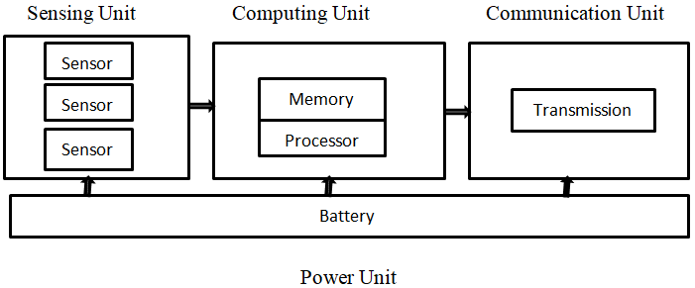

**Figure 1**: Sensor node architecture [6]

The 6LowPAN and the Routing protocol for low-power and lossy networks (RPL) were taken into account in this study when developing the WSN's performance. Using COOJA, a realistic WSN simulator, the development outcomes of the RPL protocol in the agricultural situations were modeled and simulated. The IoT system model crop health monitoring for precision agriculture comprises three main layers, as shown in Figure 2: devices and platforms, communication layers, and application layers.

(I), the application layer include user applications, data analysis, and dashboards used to monitor and optimize precision operations. The Big Data and analytics module consist of a data warehouse storage, which runs at the application layer. This component contains the technology and services necessary to integrate and archive data from multiple sensors and applications, enabling the IoT system to derive and deliver value from its data assets.

(II), the communication layer offers real-time connectivity and enables communication between devices and platforms. This includes sensors to sensors, sensors to gateways, and gateways to servers within the IoT ecosystem. It also includes the network protocols required to transfer digital information from the sensor to the application layer. The framework combines several heterogeneous communication technologies, such as IEEE 802.4.15, 6lowPAN, and COAP.

(III), the devices and platforms layer is the foundation of the IoT ecosystem infrastructure. These layers include system components such as sensors, gateways, and server platforms. Sensors are devices that capture the status information about physical world objects and convert them into digital data for transmission and processing.

The main goal of the gateway’s platform is to aggregate heterogeneous data sources with different communication standards, given that an array of sensor devices is required to collect data about plants, water, environments, animals, and soil, among others. Servers host user applications and data repositories and provide unified access APIs for other systems and users. These three layers are existing system model, interact to perform the high-level operations of precision agriculture. The communication layer offers real-time connectivity and enables communication between devices and platforms. Remote Sensing hosts applications to analyze images coming from satellites and drones. All these layers work together to enable farmers to monitor their crops, leading to more efficient and productive farming operations [1].

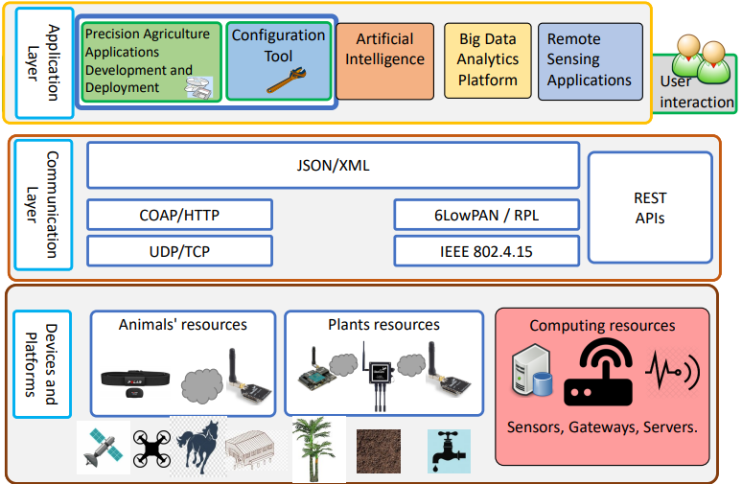

Figure 2: IoT system model architecture for precision agriculture [1]

This figure shows the relationship between various entities such as sensors, network-enabling technologies, and agricultural resources for real-time monitoring.

The study develops performance metrics such as network graph connectivity and power consumption for crop monitoring scenario in 6LowPAN networks and proposes a new approach for simulating crops within the COOJA simulator. Additionally, the paper introduces a novel holistic IoT ecosystem suitable for precision agriculture that satisfies the requirements for crop health monitoring studied scenario [7].

An unmanned aerial vehicle (UAVs) can monitor the health of crops, apply pesticides, and take hyper spectral images in precision agriculture. Drones can scan a crop for issues in plants using visible and near-infrared light, and they can determine which plants reflect what quantities of green and NIR light. Photosynthetic activity diminishes when a plant is stressed. This data may be used to create numerous images that track plant changes and indicate their health. As a result, farmers can more accurately administer treatments after a disease has been identified. Drones are also utilized for surveillance, traffic monitoring, and weather monitoring in agriculture. Crop management has benefited from the IoT, remote sensing, and analytic data approaches. Pests may be identified, targeted, and managed to utilize remote sensing using UAVs. UAVs can fly in tough and harsh terrains to take high-resolution images that allow pests to be identified and controlled. Many crop security concerns may be solved using UAVs equipped with cameras, which are not possible with traditional pest management methods. UAVs have been used to automate insect damage in agricultural areas [33, 34].

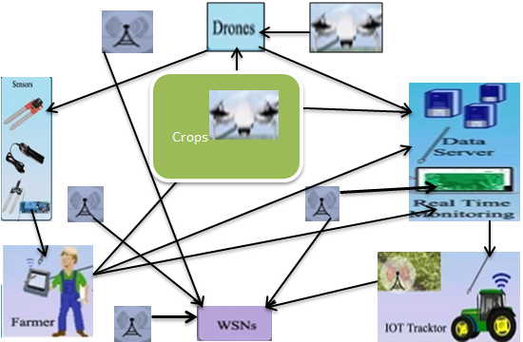

**Figure 3**: IoT system Architecture for crop health monitoring in precision agriculture.

## 1.2 Statement of the problem

The recent advancement of IoT represents a paradigm shift of modern global communication infrastructure. The research problems in precision agriculture systems primarily involve developing more accurate and reliable sensors, improving data analytics and modeling techniques, and addressing issues related to data privacy and security [1, 7]. Additionally, there is ongoing research in developing more advanced autonomous equipment and integrating multiple systems for a more comprehensive approach to precision agriculture.

The IoT-based system requires a constant source of electricity. Depending on the size, a lot of electricity may be required. However, in rural and village communities, obtaining such electricity is challenging. To meet the energy requirement, alternative energy sources, such as solar and wind, must be employed. This will also raise the price significantly. It is necessary to have a dependable internet connection in rural and village regions. It is the most crucial aspect of establishing an IoT-based system. The connection must have a sufficient bandwidth to transport data in accordance with the application’s requirements. Farmers need basic computer/tablet (HID device) training and an understanding of how the IoT system operates. It is also necessary to provide proper education on the unique IoT deployment in their farm [35].

Real-time crop monitoring requires a robust and reliable network infrastructure to transmit data from the field to the analytics platform. In remote or rural areas, connectivity issues can hinder the real-time nature of the monitoring. The collection and storage of sensitive agricultural data through IoT devices raise privacy and security concerns. Farmers need to ensure that their IoT data is protected from unauthorized access or misuse. Implementing IoT for real-time crop health monitoring in precision agriculture requires significant investment in IoT devices, connectivity, software, and skilled personnel. The initial costs and ongoing maintenance can be a barrier for many farmers. Addressing these challenges will be crucial for the successful implementation of IoT for real-time crop health monitoring and predictive analytics in precision agriculture, ultimately leading to improved crop yields, resource efficiency, and sustainable farming practices. The following research **questions** that we are going to answer them in the progress of this research work.

* How can IoT sensors and devices be used to monitor environmental conditions and crop health in real time?
* What types of data can be collected through IoT devices for crop health monitoring and predictive analytics in precision agriculture?
* What are the key benefits of using IoT for real-time crop health monitoring in agriculture?
* How can predictive analytics based on IoT data help in early detection of crop diseases, pest infestations, or nutrient deficiencies?
* Which IoT network/communication protocols are used IoT crop health monitoring in precision agriculture?

## 1.3 Objectives of the study

### 1.3.1 General Objective

The main aim of this study is to develop crop health monitoring and predictive analytics in precision agriculture using machine learning technique.

### 1.3.2 Specific Objectives

To achieve the main objective the following specific task will be realize:

* To analyze the existing IoT sensors (WSNs) to collect real-time data on key crop health indicators such as soil moisture, temperature, humidity, and nutrient levels.
* To integrate IoT sensor data with historical and environmental data to develop predictive analytics models for forecasting crop diseases, pest infestations, and yield potential.
* To design automated alerts and notifications based on IoT sensor data to enable timely intervention for any deviations from optimal crop health conditions.
* To simulate the designed algorithms and collect statistical data from simulation.
* To evaluate the economic impact including cost savings and yield improvements.
* To develop training programs and resources for farmers to effectively utilize IoT data and predictive analytics for precision agriculture practices.
* To conduct simulation that proves effectiveness and efficiency of proposed methods with existing studies.

## 1.4 Scope of the study

The Scope of this research will be monitoring and predictive analytics the health of the crops using IoT in precision agriculture. It focuses on supervised machine learning techniques to analyze historical data collected from IoT sensors to predict future crop health, yield and to help farmers to optimize their farming practices and maximize productivity.

## 1.5 Significance of the study

After conducting this research, we will get the following significance of crop health monitoring in precision agriculture lies in its potential to revolutionize the way farmers manage their crops, leading to several important benefits: It will improve Resource Management- IoT enabled crop health monitoring can help farmers optimize the use of water, fertilizers, and pesticides by providing real-time data on crop conditions. This can lead to more efficient resource allocation and reduced environmental impact. It will reduce labor costs- The system allows farmers to automate many of their tasks, such as irrigation and pest control, which reduces the need for labor-intensive manual work. It will improve crop and animal health- The system allows farmers to monitor the health of their crops and animals more closely, which enables them to identify and address issues more quickly. It will increase yield and revenue- By using precision agriculture techniques, farmers can improve their crop yields and animal health, leading to increased revenue. It will enhance Crop Yields- By leveraging IoT for real-time monitoring and predictive analytics, farmers can identify issues such as pest infestations, nutrient deficiencies, or disease outbreaks early on, allowing for timely intervention and improved crop yields. It will Data-Driven Decision Making- By leveraging IoT and predictive analytics, farmers can make more informed decisions based on real-time data, leading to better crop management and higher productivity. Overall, the significance of leveraging IoT for real-time crop health monitoring and predictive analytics in precision agriculture is in its potential to transform farming practices, leading to improved sustainability, productivity, and profitability for farmers while contributing to global food security.

# CHAPTER 2: LITERATURE REVIEW

# 2.1 Overview of the Literature Review

Researchers have proposed different IoT-based technologies in the agriculture field that are increasing the production with less workforce effort. It have also worked on different IoT-based agriculture projects to improve the quality and increase agricultural productivity. Some IoT-based agricultural techniques have been identified from the literature, which have been summarized in this section. Precision Agriculture has been pervasively used to improve farm management processes from plant [11] perspectives, which is the main focus of this research, PA enables accurate data collection regarding crop, soil, and weather to improve the farm yield while minimizing the use of required resources.

Despite the limitations imposed by the constrained nature of WSNs, extending their lifespan remains a critical challenge. Various techniques, such as power optimization algorithms, low-power communications, and reactive sensor networks, have been proposed to address this issue [24-27]. However, studies that compare the performance of WSNs in fixed and mobile deployment scenarios in the agriculture sector are limited. Furthermore, the implementation of IoT technologies such as WSNs in the agriculture industry has been slower compared to other domains, indicating a need for further research in this area to promote wider and faster diffusion of IoT in the sector [28-32].

The proposed system builds upon these existing technologies by incorporating machine learning and data analysis techniques to provide farmers with real-time recommendations on crop health management practices. By providing easy-to-understand recommendations through a user-friendly interface, we aim to make precision agriculture more accessible to a wider range of farmers. In conclusion, our proposed system builds upon the strengths of existing precision agriculture systems while addressing their limitations, with the ultimate goal of improving efficiency, reducing costs, and increasing crop yields for farmers. The state-of-the-art precision agriculture systems involve the use of advanced technologies such as sensors, GPS, robotics, and data analytics to optimize crop production and reduce costs. Remote sensing and ground-based sensor systems are commonly used to monitor crop health, soil moisture, and other environmental factors. Variable rate application systems use this data to adjust inputs such as fertilizers, pesticides, and water according to the specific needs of different parts of a field. Autonomous agricultural equipment, such as drones and robots, are also being developed and used to automate planting, harvesting, and other tasks. In addition to these technologies, precision agriculture systems are also integrating machine learning and AI algorithms to analyze large volumes of data and make predictions about crop health and yield. This allows farmers to make data-driven decisions and optimize their operations for maximum efficiency and profitability.

The state-of-the-art is driven by a focus on improving efficiency, reducing waste, and increasing yields through the use of advanced technologies and data-driven decision making. The system advances the state of the art in precision agriculture by combining the benefits of both remote sensing and ground-based sensor systems. By using both satellite imagery and ground-based sensors, the system can provide a more comprehensive view of crop health and environmental factors, with greater detail and accuracy than either system alone. Additionally, our system utilizes machine learning algorithms to analyze the data and provide real-time recommendations for crop management, further improving efficiency and offers a more advanced and integrated approach to precision agriculture that can help farmers make more informed decisions and optimize crop production [7].

# 2.2 Related works

Before initiating this research work, many past studies and research articles were studied by us. Especially, those pertaining are to WSN, IoT, and agriculture precision. Brief description of some them is given ahead: Paper [12] presented in this work, agricultural application scenarios and experimental testing were analyzed in order to uncover acceptable, realistic, precision agriculture relies on wireless communication technologies that are both effective and practical. Wireless sensor networks for precision agriculture such as IoT narrowband, LoRa long-range, and ZigBee were shown. An evaluation of the feasibility of three WSN designs was performed. Timer communications were used to compare three distinct wireless communication systems for power usage. LoRa and NB-IoT were identified as two appropriate wireless communication technologies for field farming circumstances, while ZigBee was demonstrated to be a preferable alternative for monitoring facilities in agriculture. Saha et al. [13] focused on IoT-based aerial sensing, where they used a multi-rotor UAV to provide real-time hyperspectral images from a farm. Such an IoT-based aerial sensing approach enables real-time monitoring of the plant health status of an entire farm using only one sensor node deployed on the UAV.

In paper [14].Studies have proposed solutions such as support systems for disease diagnosis and treatment, non-contact temperature measurement for early disease detection, and IoT monitoring systems for tracking plant behavior and crop health in large-scale farms. The sensors were used to monitor the physical condition of the plants, aiming to improve their health and well-being while also collecting high-precision measurements. The paper proposed a new approach for simulating fixed plants using the COOJA simulator.

In paper [15]introduced wireless sensor networks may be used to create a multi-parameter monitoring system in precision agriculture. Utilizing Intel's Galileo Gen-2 low-power platform, proposed infrastructure is designed to monitor, manage, and assist decision-making using IoT. Sensor nodes will be put in the farmland to collect various agricultural field characteristics. In order to gather data, a wireless Tran’s receiver hardware platform connects each node to the base station wirelessly. The computer then displays information. IoT may be used to make and control decisions based on the information gathered.

In Paper [16]expressed sensor devices that could monitor and wirelessly propagate information to producers have been integrated into the agricultural realm as a result of the development of the IoT. Intelligent decision-making was made possible by these WSNs, which enable for real-time monitoring. According to the context in which it will be used, designing and installing a WSN was a difficult and complex process. In such networks, for example, there is a requirement for network synchronization in order to correlate the obtained data. The goal of this study was to create and deploy a WSN for use in smart and precision agriculture. A system's design and implementation were focused on meeting the unique challenges posed by the context in which it will be used. Clock of sink node was used as a reference to give time correlated metrics. As a low-cost system that can acquire synchronized measurements, the suggested system has been placed on an olive grove. There was only a slight but predicted discrepancy in the collected measures' temporal correlation due to serial transmission delays, but the findings show that the system as a whole is quite successful, and they also provide a wealth of information about a variety of important environmental circumstances.

In paper [17] developed an IoT-enabled ground-based sensing solution for the real-time visualization of soil moisture and temperature that was used to apply timely variable-rate irrigation. Paper [18]designed an IoT-based platform called SmartFarmNet, which can automate the collection of environmental, soil, fertilization, and irrigation data from ground-based sensors. SmartFarmNet automatically correlates such data and filters out invalid data from the perspective of assessing crop performance. It also computes crop performance forecasts and provides personalized crop recommendations for any farm. In paper [19] collected soil, crop, and weather data and used an IoT platform to analyses, visualize, and correlate data that can trigger an irrigation system. In paper [20] proposed an IoT-based irrigation system that reduces the use of fresh water while maintaining constant soil moisture across an entire farm. In paper [21] used an in-field sensing station to measure soil moisture and temperature and also air temperature. They send this data to a base station, where meteorological information is also collected from a weather station. Such a combination of real-time in-field data and predictive data of future weather conditions provides remarkable information for an efficient and effective irrigation approach. Paper [22] analyzed crop health status variations using aerial and ground-based sensing. However, they did not investigate the integration of these two sensing approaches to improve the aerial data quality.

Yang et al. [23] Machine learning is being used to uncover plant resistance genes and classify plant diseases. To achieve the best classification accuracy, a careful selection of preprocessing data approaches and machine learning technologies was applied. To forecast essential plant resistance genes, more machine learning-based methods are required. To identify bacterial pathogens with high prediction precisions, ML methods such as SVM, Bayesian classifier, and RF were used. Deep convolution neural networks (CNN), the most recent generation of machine learning technologies, were used.

Table 1 : Summary of literature review

|  |  |  |  |  |
| --- | --- | --- | --- | --- |
| **Citation** | **Author/Year** | **Description** | **Methodology** | **Gaps/Limitations** |
| [13] | Saha, A.K. (2018) | focused on IoT-based aerial sensing, where they used a multi-rotor UAV to provide real-time hyperspectral images from a farm | Crop Quality in Agriculture | Lack of use d/t ML methods and improve crop quality |
| [14] | Palanca, S/2021 | Study examined the performance of WSN in two different agricultural scenarios. | Precision Agriculture | There is lack of automatic identify patterns and anomalies in the sensor data. |
| [15] | Pinna, W/2018 | Introduced wireless sensor networks may be used to create a multi-parameter monitoring system in precision agriculture. | Soil moisture | There is lack of increases the quality of the yield. |
| [16] | A.Zervopoulos et al/2020 | Used to create and deploy a WSN for use in smart and precision agriculture. | Smart agriculture | There is lack of accuracy. |
| [17] | Heble, S/2018 | Developed an IoT-enabled ground-based sensing solution for the real-time visualization of soil moisture and temperature. | Smart agriculture | There is lack of use drone to remote monitoring. |
| [18] | Yavari, A./2016 | Computes crop performance forecasts and provides personalized crop recommendations for any farm. | Smart farming | There is lack of interoperability. |
| [20] | Keswani, B./2019 | Proposed an IoT-based irrigation system that reduces the use of fresh water. | Smart Irrigation Systems | There is Lack of water quality to evaluate prior to irrigation. |
| [23] | Yang X, Guo T/2019 | Used to uncover plant resistance genes and classify plant diseases. | Smart Farming | There is lack of accuracy yield prediction. |

# CHAPTER 3: MATERIALS AND METHODS

## 3.1 Overview

Materials and methods (Research methodology) defines the methods and the steps we should follow for better and logical research [19]. To enhance the productivity of the crop there by supporting both farmer and nation we have to use the technology which estimates the quality of crop and giving suggestions. WSN are sensors of different types are used to collect the information of crop conditions and environmental changes these information is transmitted through network to the farmer or devices that initiates corrective action. The goal of this research is to investigate and provide a review of existing IoT-based agricultural monitoring applications, sensors/devices, and communication protocols.

## 3.2 Research Approach

In this research, we will design and implement leveraging IoT for real time crop health monitoring and predictive analytics in precision agriculture using ML and this method will follow a design science approach. The design science research approach by itself is a problem-solving paradigm because we will simulate and evaluate IT artifacts intended to solve identified problems. The design science approach for leveraging IoT for real-time crop health monitoring and predictive analytics in precision agriculture involves the following steps:

1. **Problem Identification**: Identify the specific challenges and problems faced in precision agriculture, such as inefficient use of resources, lack of real-time monitoring, and the need for predictive analytics to optimize crop health and motivated to do on it.

2. **Literature Review**: Conduct a comprehensive review of existing research and technologies related to IoT, crop health monitoring, and predictive analytics in agriculture to understand the current state of the art and potential solutions.

3. **Define objectives of a solution**: In this step we will set the objective we want achieve after the end of the study, which is the solution for the identified problem. Our general objective is developing leveraging IoT for real time crop health monitoring and predictive analytics in precision agriculture using machine learning techniques.

4. **Design and development**: Develop a conceptual framework for integrating IoT devices, sensors, and data analytics platforms to monitor crop health in real time and predict potential issues.

5. **Implementation and Deployment**: Deploy the refined IoT system in real-world precision agriculture settings, working closely with farmers and agricultural experts to ensure seamless integration and usability.

6. **Evaluation**: after Implement we will evaluate the impact of the IoT-enabled crop health monitoring system on key performance indicators such as network graph connectivity and power consumption for crop monitoring scenario in 6LowPAN networks and proposes a new approach for simulating fixed crops within the COOJA simulator.

7. **Communication**: At the end we will write a report about our work for final defense and as much as possible to publish it. By following this design science approach, researchers and practitioners can develop a robust IoT-based solution for real-time crop health monitoring and predictive analytics in precision agriculture, leading to more efficient and sustainable farming practices.

## 3.3 Methods of Data Collection

We will use different data collection techniques to meet the research goals. Utilizing IoT devices to gather and transmit data on crop health, soil conditions, weather patterns, and other relevant parameters to a central data management system.

* IoT Sensors: Deploying IoT sensors in the field to measure soil moisture, temperature, humidity, and other environmental parameters. Sensors may be instantly placed and begin collecting data, which is then immediately available for further analysis over the internet. By enabling reliable data gathering at each place, sensor technology allows crop and site-specific agriculture [7]. Using advanced control methods to automate agricultural activities has increased crop production while also improving soil fertility. The suggested method entails building a distributed WSN, with multiple sensor modules covering each part of the farm and transferring data to a central server.
* Farmers: May use IoT solutions to put sensors in the field, including humidity sensors, temperature sensors, rainfall sensors, and water level sensors, to collect real-time data from the environment. These sensors monitor the state of crops and the environment in which they grow. If a worrying environmental situation is discovered, it is either automatically corrected or a warning is sent to the farmer.
* Tractors: Have been serving us in many different ways. Used in the farms or farming-related works like tilling, planting, ploughing, harvesting & cultivating crops.
* Drones and UAVs: Utilizing drones equipped with sensors and cameras to capture high-resolution imagery for crop health assessment. Drones can scan a crop for issues in plants using visible and near-infrared light, and they can determine which plants reflect what quantities of green and NIR light. Drones are also utilized for surveillance, traffic monitoring, and weather monitoring in agriculture. UAV is an aircraft that carries no human pilot or passengers. UAVs can monitor the health of crops, apply pesticides, and take hyper spectral images in precision agriculture. UAVs are used for observation and tactical planning. This technology is now available for use in the emergency response field to assist the crew members [33].
* Satellite Imagery: Leveraging satellite-based remote sensing to gather data on crop conditions, vegetation indices, and environmental factors.
* Mobile Apps: Developing mobile applications that allow farmers to input and track field observations and crop health data in real time.

We will also focus on secondary data sources. Such as:

* Literature review: reviewing different recent articles and conference papers related to our research that is previously done.
* Asking experts and scholars: asking experts and scholars in this area to get more information.
* Image dataset: Images captured by drones or cameras installed in the field can provide visual information about crop health, pest infestations, disease symptoms, and growth patterns. Image data can be processed using computer vision techniques to extract valuable insights. In this study, we use different tools that are used to prepare and simulate our research. By combining these datasets and applying machine learning algorithms for predictive analytics, farmers can achieve real-time crop health monitoring, early detection of issues, and data-driven decision-making in precision agriculture using IoT technology.

**Software tools:**

* OS: ubuntu 20.04
* Latex and TexMaker: used for writing research document and Preparing PowerPoint presentation.
* Mendeley software: for reference preparation, this provides products and services for academic researchers.
* Edraw-max: used for drawing different diagrams.
* Microsoft Office product: To prepare our documents.

**Hardware tools**

* Personal computer/Laptop
* Flash Disk
* External Hard Disk

## 3.4 Method(s) of Data Analysis

Methods of Data Analysis for Leveraging IoT for Real-Time Crop Health Monitoring and Predictive Analytics in Precision Agriculture:

* Machine Learning Algorithms: Utilizing machine learning models to analyze the data collected from IoT devices and make predictions about crop health, disease outbreaks, and yield forecasts.
* CNN: Is a feed-forward neural network that is generally used to analyze visual images by processing data with grid-like topology. It`s used to detect and classify objects in an image. CNN is also a special type of Neural Networks, which has shown exemplary performance on several competitions related to Computer Vision and Image Processing. Some of the exciting application areas of CNN include Image Classification and Segmentation, Object Detection, Video Processing, Natural Language Processing, and Speech Recognition. The powerful learning ability of deep CNN is primarily due to the use of multiple feature extraction stages that can automatically learn representations from the data. The availability of a large amount of data and improvement in the hardware technology has accelerated the research in CNNs, and recently interesting deep CNN architectures have been reported [36].
* Statistical Analysis: Employing statistical methods to identify patterns, trends, and correlations in the IoT data to make informed decisions about crop management.
* Image Processing: Using computer vision and image processing techniques to analyze the high-resolution imagery captured by drones and UAVs to assess crop health and detect anomalies. After collecting the data, a Python script will develop using the Pandas library for data analysis and Matplotlib for plotting charts. The collected data from the simulation was processed and analyzed using statistical methods to obtain the necessary metrics for further analysis.

# 4. Work Plan

We planned to conduct this research by the following specified duration. The overall duration of the research will be listed in the following table.

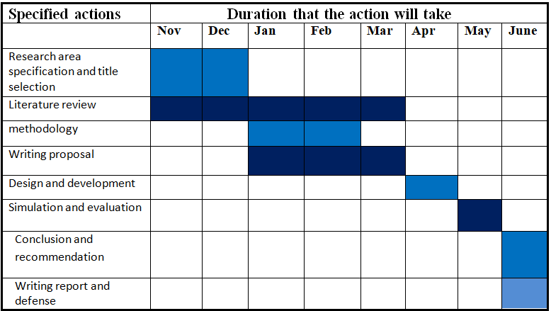Table 2: Time schedule and Plan of Action for research

# 5. Logistics

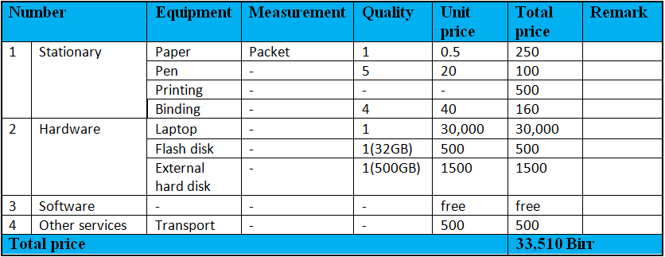

Table 3: Budget plan for the research

# References

[1]. Arreaga, N.X.; Blanc, S.; Rivas, L.V.; Palanca, S. Implementation of choreography services for precision agriculture based on real-time monitoring and control system using WSN. J. Wirel. Commun. Netw. 2021, 2021, 1–20. [2]. Ashton, K. That ‘Internet of Things’ thing. RFID J. 2009, 22, 97–114. [3]. Sreekantha, D.; Kavya, A. Agricultural crop monitoring using IOT-a study. In Proceedings of the 2017 11th International Conference on Intelligent Systems and Control (ISCO), Coimbatore, India, 5–6 January 2017; pp. 134–139. [4]. Aziz, K.; Tarapiah, S.; Alsaedi, M.; Ismail, S.H.; Atalla, S. Wireless sensor networks for road traffic monitoring. Int. J. Adv. Comput. Sci. Appl. 2015, 6, 265–270. [5]. El Hendy, M.; Atalla, S.; Miniaoui, S.; Daradkeh, M.; Mansoor, W.; Bin Hashim, K.F. Hybrid Approach for Developing Strategic ICT Framework for Smart Cities—A Case Study of Dubai’s Toll Gates (Salik). Smart Cities 2022, 5, 1554–1573. [6]. Sanjeevi, P.; Prasanna, S.; Siva Kumar, B.; Gunasekaran, G.; Alagiri, I.; Vijay Anand, R. Precision agriculture and farming using Internet of Things based on wireless sensor network. Trans. Emerg. Telecommun. Technol. 2020, 31, e3978. [7]. S. Lachure, A. Bhagat and J. Lachure, J. “Review on precision agriculture using wireless sensor network”. International Journal of Applied Engineering Research, 10(20), pp.16560-16565, 2015. [8]. Mahajan, H.B.; Badarla, A.; Junnarkar, A.A. CL-IoT: Cross-layer Internet of Things protocol for intelligent manufacturing of smart farming. J. Ambient. Intell. Humaniz. Comput. 2021, 12, 7777–7791. [9]. Zamora-Izquierdo, M.A.; Santa, J.; Martínez, J.A.; Martínez, V.; Skarmeta, A.F. Smart farming IoT platform based on edge and cloud computing. Biosyst. Eng. 2019, 177, 4–17. [10]. Sun, Y.; Ding, W.; Shu, L.; Li, K.; Zhang, Y.; Zhou, Z.; Han, G. On enabling mobile crowd sensing for data collection in smart agriculture: A vision. IEEE Syst. J. 2021, 16, 132–143. [11].Say, S.M.; Keskin, M.; Sehri, M.; Sekerli, Y.E. Adoption of precision agriculture technologies in developed and developing countries. Online J. Sci. Technol. 2018, 8, 7–15. [12] X. Feng, F. Yan, and X. Liu, “Study of Wireless Communication Technologies on Internet of Things for Precision Agriculture,” Wirel. Pers. Commun., vol. 108, no. 3, pp. 1785–1802, 2019, doi: 10.1007/s11277-019-06496-7. [13]. Saha, A.K.; Saha, J.; Ray, R.; Sircar, S.; Dutta, S.; Chattopadhyay, S.P.; Saha, H.N. IOT-based drone for improvement of crop quality in agricultural field. In Proceedings of the 2018 IEEE 8th Annual Computing and Communication Workshop and Conference (CCWC), Las Vegas, NV, USA, 8–10 January 2018; pp. 612–615. [14]. Jayaraman, P.P.; Yavari, A.; Georgakopoulos, D.; Morshed, A.; Zaslavsky, A. Internet of things platform for smart farming: Experiences and lessons learnt. Sensors 2016, 16, 1884. [CrossRef] [15]. A. M. Patokar and V. V. Gohokar, “Precision agriculture system design using wireless sensor network,” Adv. Intell. Syst. Comput., vol. 625, pp. 169–177, 2018, doi: 10.1007/978-981-10-5508-9_16. [16]. A. Zervopoulos et al., “Wireless sensor network synchronization for precision agriculture applications,” Agric., vol. 10, no. 3, pp. 1–20, 2020, doi: 10.3390/agriculture10030089. [17]. Heble, S.; Kumar, A.; Prasad, K.V.D.; Samirana, S.; Rajalakshmi, P.; Desai, U.B. A low power IoT network for smart agriculture. In Proceedings of the 2018 IEEE 4th World Forum on Internet of Things (WF-IoT), Singapore, 5–8 February 2018; pp. 609–614. [18]. Bagha, H.; Yavari, A.; Georgakopoulos, D. Hybrid Sensing Platform for IoT-Based Precision Agriculture. Future Internet 2022, 14, 233. [19]. Popovi´c, T.; Latinovi´c, N.; Peši´c, A.; Zeˇcevi´c, Ž.; Krstaji´c, B.; Djukanovi´c, S. Architecting an IoT-enabled platform for precision agriculture and ecological monitoring: A case study. Comput. Electron. Agric. 2017, 140, 255–265. [CrossRef] [20]. Keswani, B.; Mohapatra, A.G.; Mohanty, A.; Khanna, A.; Rodrigues, J.J.; Gupta, D.; De Albuquerque, V.H.C. Adapting weather conditions based IoT enabled smart irrigation technique in precision agriculture mechanisms. Neural Comput. Appl. 2019, 31, 277–292. [CrossRef] [21]. Kim, Y.; Evans, R.G.; Iversen, W.M. Remote sensing and control of an irrigation system using a distributed wireless sensor network. IEEE Trans. Instrum. Meas. 2008, 57, 1379–1387. [22]. Pathak, R.; Barzin, R.; Bora, G.C. Data-driven precision agricultural applications using field sensors and Unmanned Aerial Vehicle. Int. J. Precis. Agric. Aviat. 2018, 1, 19–23. [CrossRef] [23]. Yang X, Guo T (2019) Machine learning in plant disease research. [24]. Dunkels, A.; Gronvall, B.; Voigt, T. Contiki-a lightweight and flexible operating system for tiny networked sensors. In Proceedings of the 29th Annual IEEE International Conference on Local Computer Networks, Tampa, FL, USA, 16–18 November 2004; pp. 455–462. [25]. Keswani, B.; Mohapatra, A.G.; Keswani, P.; Khanna, A.; Gupta, D.; Rodrigues, J. Improving weather dependent zone specific irrigation control scheme in IoT and big data enabled self-driven precision agriculture mechanism. Enterp. Inf. Syst. 2020, 14, 1494–1515. [26]. Radoˇcaj, D.; Juriši´c, M.; Gašparovi´c, M. The role of remote sensing data and methods in a modern approach to fertilization in precision agriculture. Remote Sens. 2022, 14, 778. [27]. Bagha, H.; Yavari, A.; Georgakopoulos, D. Hybrid Sensing Platform for IoT-Based Precision Agriculture. Future Internet 2022, 14, 233. [28]. Brewster, C.; Roussaki, I.; Kalatzis, N.; Doolin, K.; Ellis, K. IoT in agriculture: Designing a Europe-wide large-scale pilot. IEEE Commun. Mag. 2017, 55, 26–33. [29]. Cavaliere, D.; Loia, V.; Senatore, S. Towards a layered agent-modeling of IoT devices to precision agriculture. In Proceedings of the 2020 IEEE International Conference on Fuzzy Systems (FUZZ-IEEE), Glasgow, UK, 19–24 July 2020; pp. 1–8. [30]. Gaikwad, S.V.; Vibhute, A.D.; Kale, K.V.; Mehrotra, S.C. An innovative IoT based system for precision farming. Comput. Electron. Agric. 2021, 187, 106291. [31]. Dunkels, A.; Gronvall, B.; Voigt, T. Contiki-a lightweight and flexible operating system for tiny networked sensors. In Proceedings of the 29th Annual IEEE International Conference on Local Computer Networks, Tampa, FL, USA, 16–18 November 2004; pp. 455–462. [32]. Keswani, B.; Mohapatra, A.G.; Keswani, P.; Khanna, A.; Gupta, D.; Rodrigues, J. Improving weather dependent zone specific irrigation control scheme in IoT and big data enabled self-driven precision agriculture mechanism. Enterp. Inf. Syst. 2020, 14, 1494–1515. [33]. Dutta, J.; Dutta, J.; Gogoi, S. Smart farming: An opportunity for efficient monitoring and detection of pests and diseases. J. Entomol. Zool. Stud. 2020, 8, 2352–2359. [34]. Maslekar, N.V.; Kulkarni, K.P.; Chakravarthy, A.K. Application of Unmanned Aerial Vehicles (UAVs) for Pest Surveillance, Monitoring and Management. In Innovative Pest Management Approaches for the 21st Century; Springer: Berlin, Germany, 2020; pp. 27–45 [35]. Rahaman, S.H.; Biswas, S. Advantages of Internet of Things (IoT) and It’s Applications in Smart Agriculture System. Int. Res. J. Adv. Sci. Hub 2020, 2, 4–10. [CrossRef] [36]. Xia Zhao.; Limin Wang, Yufei Zhang , Xuming Han, Muhammet Deveci, Milan Parmar. (2024) 57:99 https://doi.org/10.1007/s10462-024-10721-6