**CREDENTIAL FRAME**

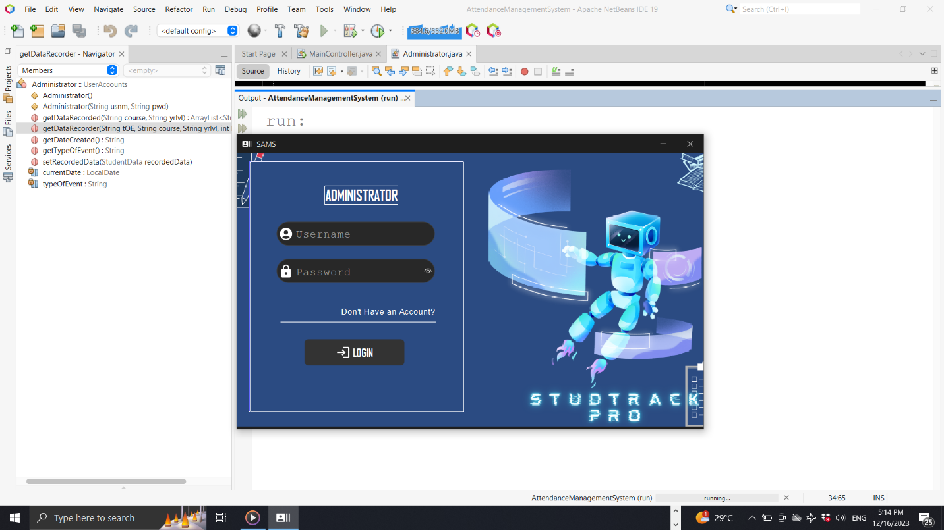 ▶ LoginPanel

**CONDITION**

▶ If default credentials are used, a notification will prompt in the main frame, stating:

“Please create a new account.”

**Clicking it will terminate the system.**

**VALIDATION**

**SANITATION**

▶ Accepted Characters:

✔ Letters

✔ Digits

✔ Some special characters

✔ Maximum 9 characters

▶ Checks if fields are/is empty.

▶ 2 Types of Credentials

✔ Default

✔ Own

▶ Valid credentials proceed to main frame.

▶ Invalid credentials trigger a notification.

* A computer screen shot of a computer screen

  Description automatically generated ▶ Signup Panel

**CONDITION**

▶ Upon creating a new account, default credentials become invalid.

▶ Successful account creation redirects to login with confirmation.

**MAIN FRAME**

* 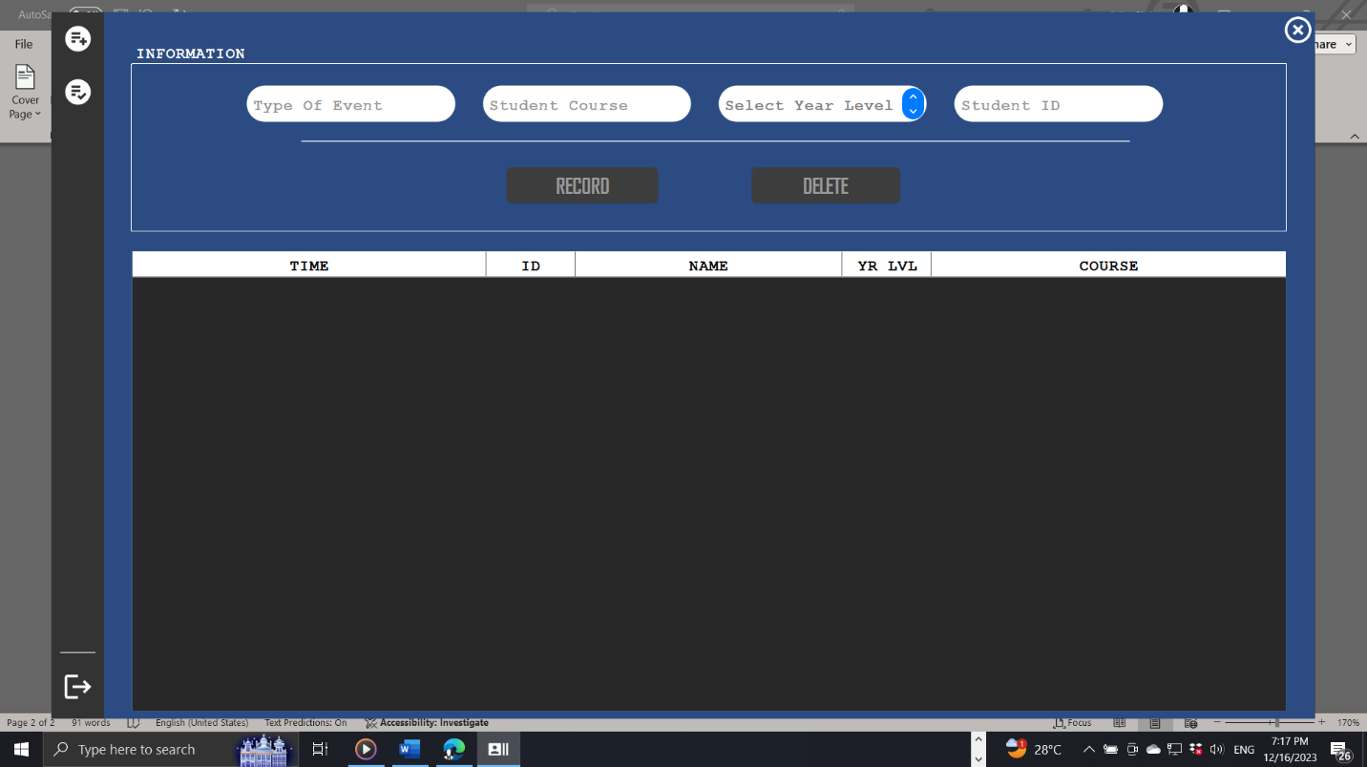Record attendance Panel

**Clicking the icon proceeds to recorded data panel.**

**Clicking it will return to the**

**credential frame.**

▶ Disable buttons if guide text is selected.

**CONDITION**

▶ Empty required fields trigger warning message, highlighting the empty field.

▶ Validate course and ID; display “Data not found in the database” if invalid.

▶ After recording the first student, disable 'event type' field for one-time event.

**INFORMATION**

▶ The system is designed for one-time event, meaning that previously recorded events cannot be recovered.

**DELETION LOGIC**

▶ Delete selected row(s) in the table.

▶ Display “Table is empty” if the table has no entries.

▶ Display “Please select desired row to delete” if no row is selected upon clicking.

▶3 key pieces of information to record the specified student.

**VALIDATION**

**STUDENT RECORD LOGIC**

**SANITATION**

▶ Accepted Characters:

✔ Digits

▶ Maximum 4 characters

* A computer screen shot of a computer

  Description automatically generatedRecorded Data Panel

**Clicking it will return to the**

**credential frame.**

**These fields are for displaying inputted data only.**

**CONDITION**

▶ Disable buttons if guide text is selected.

**VALIDATION**

▶ Validate input in the course field; display “No recorded data at the moment” if invalid.

▶ If the inputted string in the course field is valid, display recorded data in the table, sorted by name, with specific information above the table.

**If duplicate data is accidentally recorded, it will be sanitized, and only the first recorded data will be displayed.**

**Accepted courses in the course field:**

**[ BSCS, BSIT, BSCE ]**

**regardless of typing format**

**(uppercase, lowercase, or mixed case).**

* **SYSTEM OVERVIEW**

**Occasional malfunction of the icons is due to rendering issues. SVG images are used, and an external library handles rendering.**

**ID number ranges per course, organized by corresponding year level, are as follows:**

▶ BSCS

[1] 1001 - 1013 (ending range: 1100)

[2] 1101 – 1113 (ending range: 1200)

[3] 1201 – 1213 (ending range: 1300)

[4] none

▶ BSIT

[1] 2001 - 2013 (ending range: 2100)

[2] 2101 – 2113 (ending range: 2200)

[3] 2201 – 2213 (ending range: 2300)

[4] none

▶ BSCE

[1] 3001 - 3013 (ending range: 3100)

[2] 3101 – 3113 (ending range: 3200)

[3] 3201 – 3213 (ending range: 3300)

[4] none

**If the inputted characters exceed the assigned maximum limit or contain unrecognized characters, the field will be highlighted in red.**