Slow Fighter

Try to predict the other player’s action and counter it!
Both players have 1 second to input an action.
When the time is up, the interaction will be processed.
Strong attacks can only be blocked by a certain block,
Jabs take priority and cancel out strong attacks, but are blocked by either block.
Successfully blocking heals.
Grabs damage through blocks.
If both players attack with matching strength, they will both deal reduced damage.

To start, both players press Start.

Icon | Action | Input | Description
 | Block High | Stick Up | Blocks jabs and overheads. Successful blocks heal.
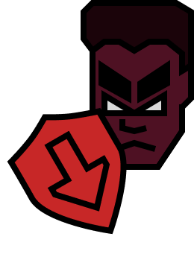 | Block Low | Stick Down | Blocks jabs and low kicks. Successful blocks heal.
 | Overhead | Y | Strong attack.
 | Low Kick | A | Strong attack.
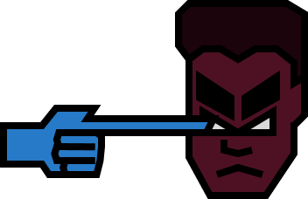 | Jab | X | Weak attack that takes priority over strong attacks and grabs.
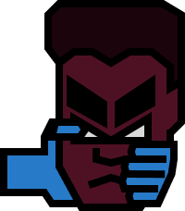 | Grab | B | Medium attack that damages through block.
 | Stand |  | Default action, vulnerable to everything.
