|  |  |
| --- | --- |
| Generative Design Colour Experiment  Git Repository: https://github.com/JohnCostales/GenerativeDesignColours.git | John Costales  Creative Computing |

# Introduction

This documentation follows the code and development of Graphic designed for a book cover using a JavaScript library called p5. Generative Graphics using p5 allows for artist, designers, and beginner JavaScript develops to create a visual graphics using JavaScript. The graphic is an experimental colour images controlled by parameters. The image generates a natural spiral pattern commonly found in flowers called phyllotaxis. This pattern develops spirals using a pattern that are predominantly integers of the Fibonacci sequence. Using p5, the image represents this pattern using shapes and colours. This document discusses the mathematical relationship of Phyllotaxis, the experimental colour sequence of the image, and the iteration of the code.

# Phyllotaxis

Phyllotaxis is the arrangement of lateral organs (leave on stems, scales on cone axis, and the florets of flowerheads). This pattern can be noticed in sun flower heads which generally has a composite floret. The sequence is related to Fibonacci sequence for example the final graphical sequence uses the Fibonacci angle 360° r -2 which is approximately equal to 137.5°. This chapter discusses the formula proposed in Vogel’s Rule φ = n ∗ 137.5◦, r = c √n, where: n is the ordering number counting outward form the centre. Φ is the angle between a referenced direction and the position vector to the nth number of the sequence in an opposite coordinate system that originates from the centre. R is the distance between the centre position of the pattern and the centre of the nth floret given a constant scaling parameter called c (algorithmicbotany.org, 1990).

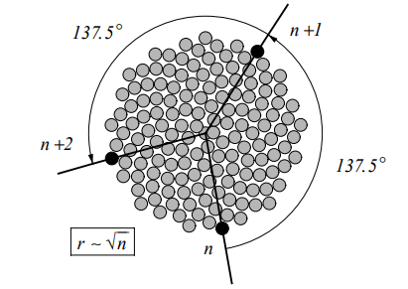

Figure 2:1 - Pattern of florets in a sun flower head

# Colour Sequence

P5.js uses the function colorMode() to change the way the program interepets color data. The default values 0 to 255 using the RGB colour models. The colour mode set for the program using the HSB system instead using colour mode values of colorMode(HSB, 360, 100, 100, 1). Along with Phyllotactic formula, colour sequences can be generated using the nth product of the sequence. With this different colour patterns can be generated changing the values of the HSB colour mode using the sum of the nth term. The sequence can also be altered using other variables of the formula such as the sum of angle minus the radius. For example, figure 3:1 displays a more radial colour scheme where the hue value is the nth term modulo to 360 (remainder of nth integer and 360). Figure 3:2 displays a spiral sequence where the hue value is the sum of the angle minus radius modulo to 360.

Figure 3:1 - nth  term modular to 360

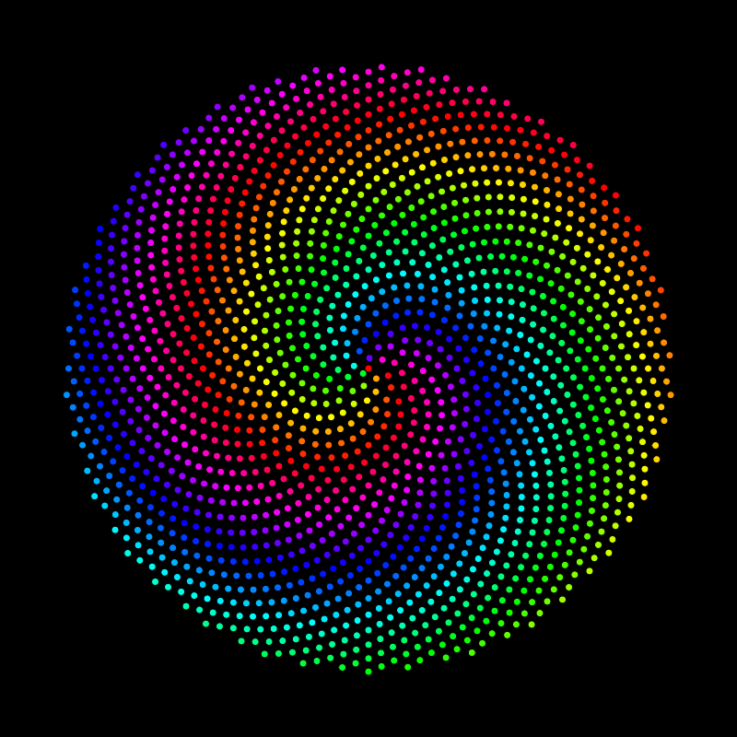

Figure 3:2 - Angle - Radius Modular to 360

The program uses further manipulates this pattern by using Perlin noise to generate random controlled values of the sum of n multiply by 360. It produces a controlled randomness to the hue. Every time the application refreshes a new pattern of colours emerge.

# Code Construct

This section discusses the use of the phyllotactic formula in incrementing it in to an experimental colour pattern using p5.js by alternating values in HSB colour mode and producing different types of pattern with the same formula. The formula mentioned in chapter 2 can be translated in to JavaScript. Normally radius travels out from the centre point of the coordinate (0,0). Using polar to cartesian coordinate transformation in short definition using cosine and sin to navigate the radius and phi in to the canvas as its x and y axis starts from the top right rather than the centre.

N represents each dot made or in this case ellipses in the canvas. Φ is represented by the angle where it is equal to the value of N and the angle used (137.5). Radius is the sum of the scaling parameter multiplied by the square root of the n value. To translate his to an x and y coordinates of the canvas the cosine and sin of the angle is multiplied to the radius. The x and y axis are the coordinates for where the ellipse will be draw. Figure 4:1 is the output of the canvas.

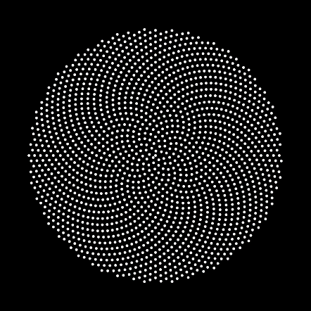

Figure 4:1 - First output

The pattern is experimented with colours by manipulating each point drawn on the canvas. This can produce different types of pattern in which in this case, using Perlin noise created a radial pattern that produces different flows of colours. The alpha is also changed for each nth point giving it a fading effect the more the circumference increases (Figure 4.2).

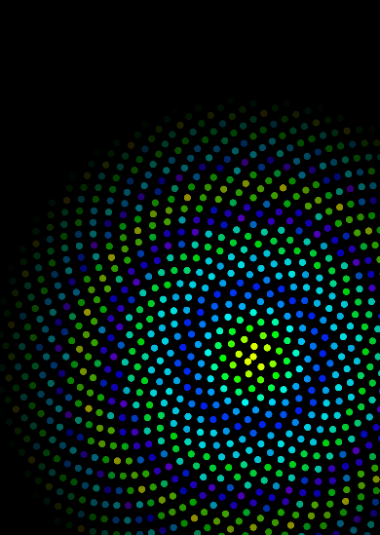 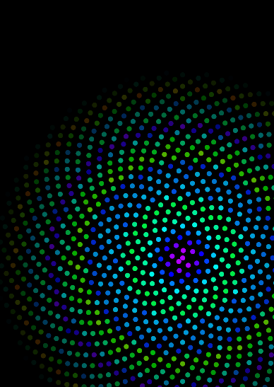 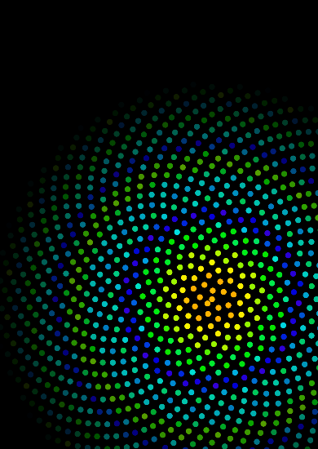

Figure 4:2 Radial patterns

# Conclusion

Phyllotaxis is a great example of manipulation of colour patterns by only using a simple natural formula. This pattern is very interlinked with nature where it can be seen in flowers which uses colours for attraction. By adding this pattern with colour, it almost emphasizes the its colours even more. The radial spirals are manipulated in a way that it is not constant with just a bunch of points that spread outwards with a constant diameter but developed spirally in a wavy sort of flow.