THE COLOUR OF CLOTHES IN MEDIEVAL PAINTINGS OF THE BIBLE STORIES

Paintings illustrating Bible stories are sometimes not understood these days, whether or not there is a label underneath. A few years ago the stories would have been taught more widely so that most people would recognise at least the basic facts. Today we can certainly learn to recognise individual saints quite easily by what they carry, or by something shown close to them, known as their attribute, but it is worth having a look at the quality and colour of their clothes or indeed the clothes of anyone in a medieval picture. They can give us a bit more information about the person the artist was painting: his or her activity in life, their character perhaps, and in the illustration of a story, which moment is being described. In the case of a portrait, the colouring of the person's clothes will give an idea of the character that the artist or his patron had wished to convey. As artists in later years tended to keep to the ancient traditions, they will provide some of our illustrations.
Our first question may well be: is the colour rich and deep? In daily life the richer and deeper the colour of cloth, the more expensive it had been to dye, and clothes made from it were the most expensive, and a sign that the person wearing them was wealthy. Accordingly the artist may use paint made up from very expensive ingredients that produce a suitably deep rich colour. Furthermore, this 'wealthy' aspect is to be seen both in scenes of the everyday earthly world ruled by medieval kings and princes, as well as those of the heavenly world of the Bible stories, where wealth comes from a God of infinite goodness and mercy.
Living in this heavenly world ruled by God, together with God's son Jesus, are all those of exceptional holiness and influence who are named 'saints'. That is to say, the faithful followers of Jesus who had known him during his life on earth (his twelve disciples and three devoted women friends known as The Three Marys), the vast number of the faithful who have followed through the ages, and those who preach the holy Word and provide day by day the spiritual leadership of the Christian community. In medieval paintings the clothes of all these individuals are a deep rich colour, and the particular colour chosen can tell us a little more, as tradition evolved over time. The three most important are RED, BLUE, and WHITE. Plenty of examples are to be found in paintings of the life of Jesus.
RED was the first colour to be given a name, and in those days 'red' included colours that we now call scarlet, purple, vermilion, or crimson. In a painting red clothing stood for blood, the blood of the sacrifice made by the crucified Jesus, and was for martyrs - those whose deep faith had led them to sacrifice their earthly lives, and for those whose earthly life was spent in devotion to him. It was a sacrifice with positive meanings of sacredness, of festivity, and the certainty of God's blessing.
The colour BLUE had been associated with the Virgin Mary, mother of Jesus, for hundreds of years, and devotion to her was becoming increasingly strong. It was said that just as in nature the blue sky was the bridge between earth and heaven, in the spiritual world Mary was the intermediary between earthly sinners and the spiritual world of heaven. A new, richer, more brilliant blue paint was discovered by adding to the pigment some lapis lazuli (a powder made by crushing pieces of a particular type of rock), and it was used in Europe from the early thirteenth century. From then onwards Mary's clothes could truly demonstrate the brilliance of her steadfast and eternal faith.
It is worth remembering here that medieval paintings are hundreds of years old: if an artist chose paint of a deep rich colour, made up with a mix of expensive ingredients, to match the importance of the person, colours do change over time. Some colours fade, and a deep expensive blue might have become almost black. There are fourteenth century examples of the latter within the church of Or S. Michele in Florence: Orcagna's painting of the Tabernacle, and Bernardo Daddi's altarpiece of The Mother and Child With Angels.
Very soon blue became the rival of red, and red and blue were often used as complimentary to each other. We see this in many versions of Mary with the child Jesus, and different areas of a person's clothing often alternate between red and blue. In a group of holy people their undergarments and the robes slung over them sometimes make a pattern of alternative areas of red and blue across a picture.

STRIPES: When just one garment is shown striped, this catches the eye. In one way or another the person concerned is being shown in a negative light. This does not necessarily mean that he or she is evil or a traitor, or even just selfish or disloyal – that is to say not a 'bad' person. They may be thought of as simply out of tune with others in some way. An example of this is sometimes seen in illustrations of the Holy Family – Mother and Child and Joseph. The figure of Joseph, who is not his natural father, may be placed a little apart from the mother and child: his breeches may be striped to indicate his 'separateness'.

WHITE stands for purity and cleanliness, and in the context of the Bible stories it expresses the purity and eternity of divine revelation. Jesus is accordingly clothed in white when conveying his divinity. This occurs when appearing to his apostles after he has risen from the dead, and there is an occasion during his time on earth in the company of his apostles Peter, James and John that is known as the Transfiguration, when he shows himself to them clothed in shining white to demonstrate his divine nature. And when he resuscitates his dead friend Lazarus, Lazarus appears wrapped in a white winding cloth, conveying the divine nature of Jesus' action.
Angels may be clothed in white. Over the surface of a white garment there may be decorations in gold.

In parenthesis, and not actually relevant to clothing, it is no surprise that BLACK was for the devil. Thick black paint may be used for his whole figure, wings and all. Or he may be painted green, the traditional colour worn by a hunter, the devil being referred to as the 'hunter of souls'.

Being aware of these traditions can deepen our understanding of a story, and the following titles from the life of Jesus provide examples:-

(1) THE ANNUNCIATION : Rogier van der Weyden, c. 1450.
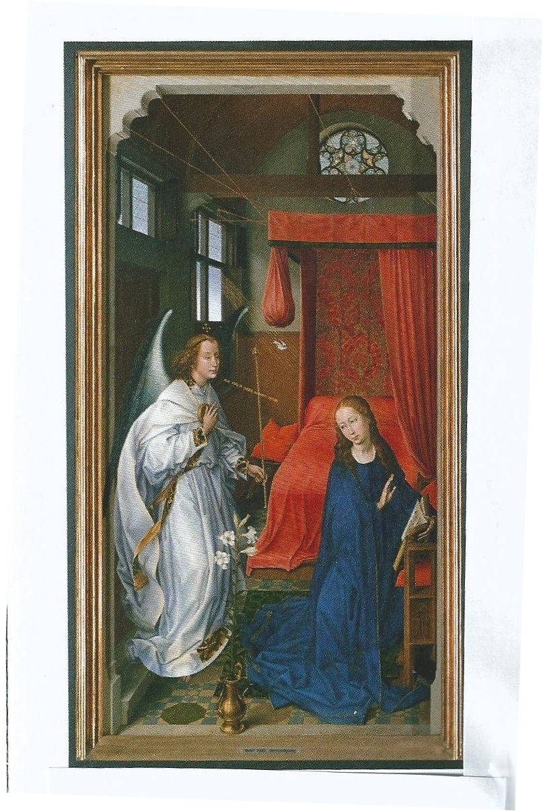
The Archangel Gabriel is sent by God to Mary saying “Greetings, most favoured one, the Lord is with you.. Do not be afraid...”, and tells her that she has been blessed, that she will give birth to a son, and that she will call him Jesus. Mary replies “As you have spoken, so be it.”

(2) THE ADORATION OF THE MAGI: Domenico Ghirlandaio, 1488.

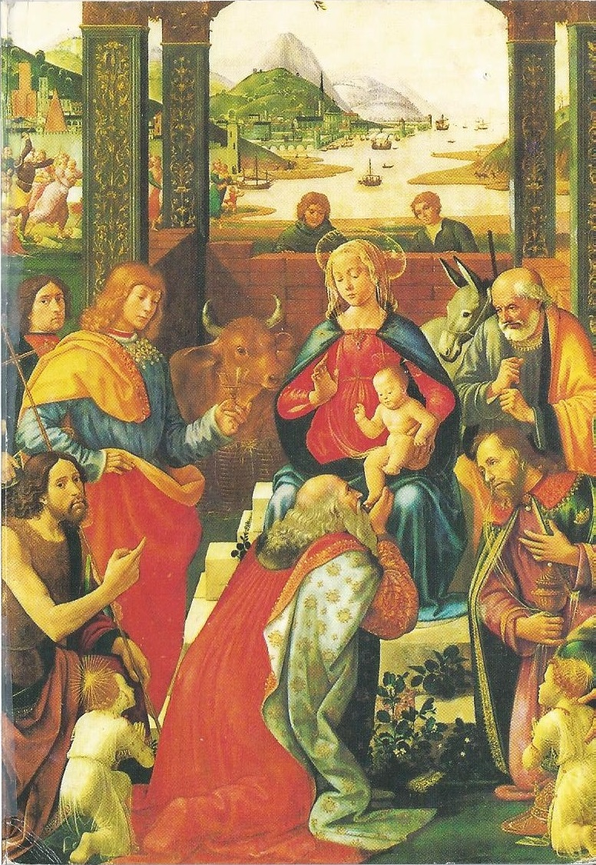
Three Magi ('wise men') have come to worship the baby Jesus. Amongst the crowd are saints shown clothed in red. St. John the Baptist, also known as John the Forerunner, is unique: his clothes are a neutral brown colour, referring to his earlier period in the desert, when he preached the coming of a new Word of God, in readiness for Jesus' imminent arrival. Those who came to him he baptised in the River Jordan, in token of their repentance and the forgiveness of their sins. He indicates to us the new-born Child.

(3) THE BAPTISM OF JESUS: Adam Elsheimer, 1578-1610.

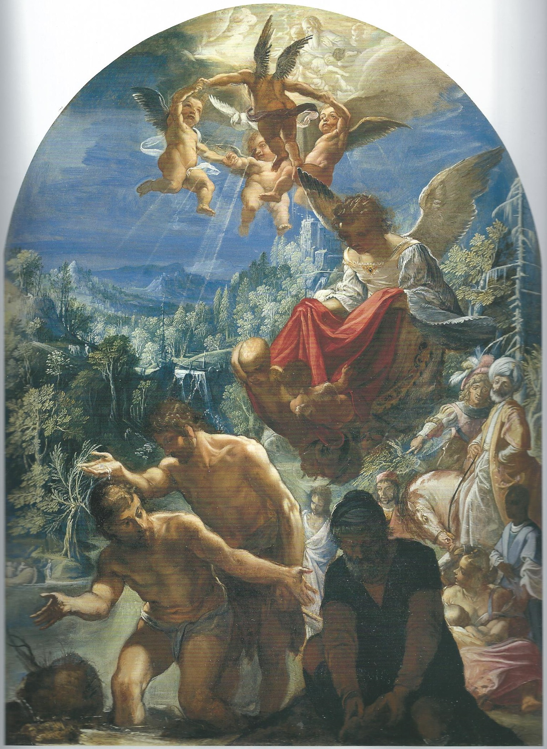

Jesus is being baptised by his cousin John, known as John the Baptist. Jesus is shown unclothed, leaning forward over the River Jordan. It is the sacred moment, when John pours over him the holy water. This painting is a good example of the fact that in an otherwise quiet mix of variegated shades there is a patch of deep colour that forms part of the story. In this case it is a red patch, and seen in the sky: it is a cloak being flown down to Jesus from heaven by an angel, bringing God's blessings and divine protection. A voice speaks from heaven: “Thou art my son, my Beloved; on thee my favour rests”.

(4) THE MARRIAGE AT CANA: Paolo Veronese, 1563 (detail).
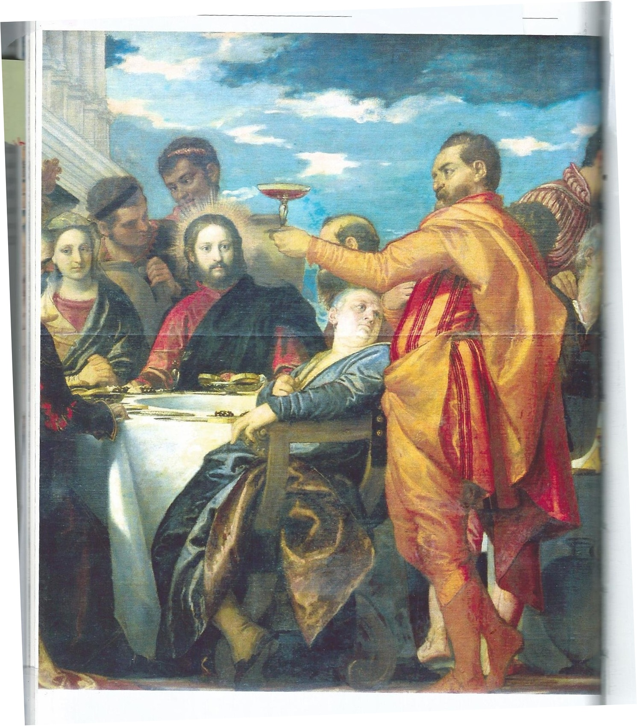
Here we notice a patch of blue for the clothing of a figure seated with the crowd of guests at a wedding feast. It is Mary, the mother of Jesus. The story is that when the best wine came to an end Jesus saved the situation by changing some water into wine, and it was Jesus' mother who had asked him to do this. This is said to be Jesus' first miracle.

(5) THE RAISING OF LAZARUS: Duccio di Buonsegna, 1388-1300.

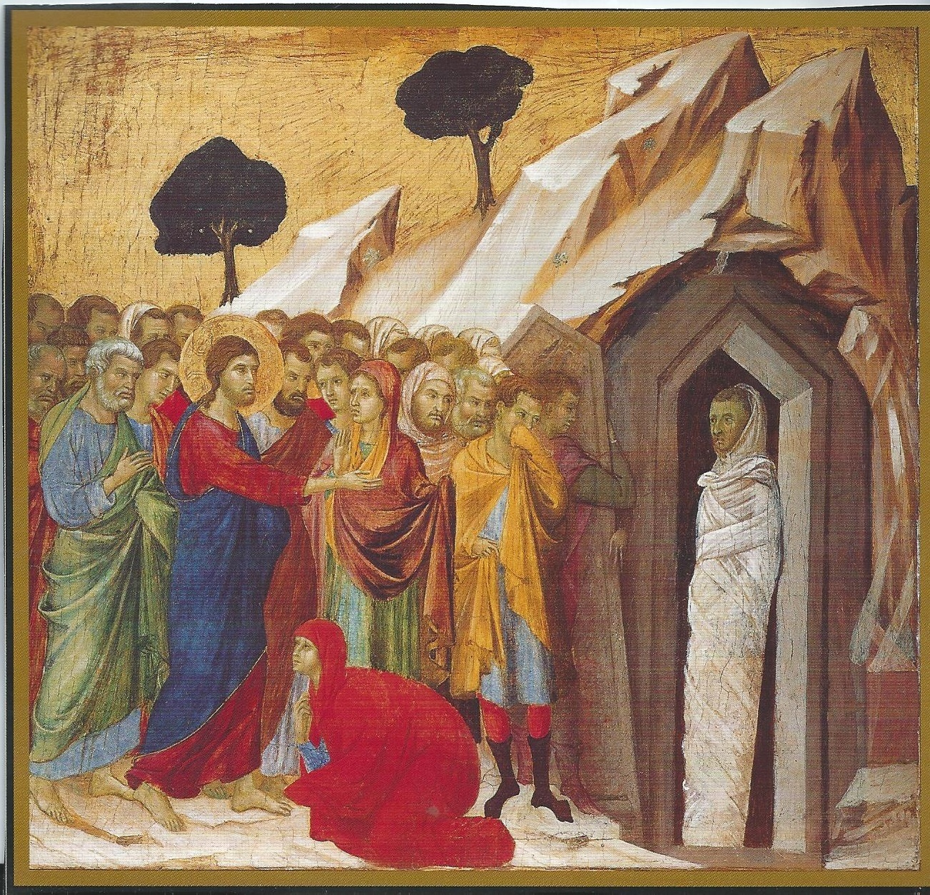

Jesus had heard from Martha and Mary, the sisters of Lazarus, that Lazarus was dying, but he had arrived too late – his good friend had already died. The sisters had wrapped his body and placed him in a tomb. They were distraught, standing nearby with a crowd of friends. Jesus ordered the tomb to be opened. He then called to Lazarus to come out, stretching out his hand. Lazarus appears at the entrance, resusitated, wrapped in his burial clothing: and the divine nature of Jesus' action has prompted the artist to show this wrapping in pure white.

(6) THE TRANSFIGURATION: Sandro Botticelli, c. 1500.
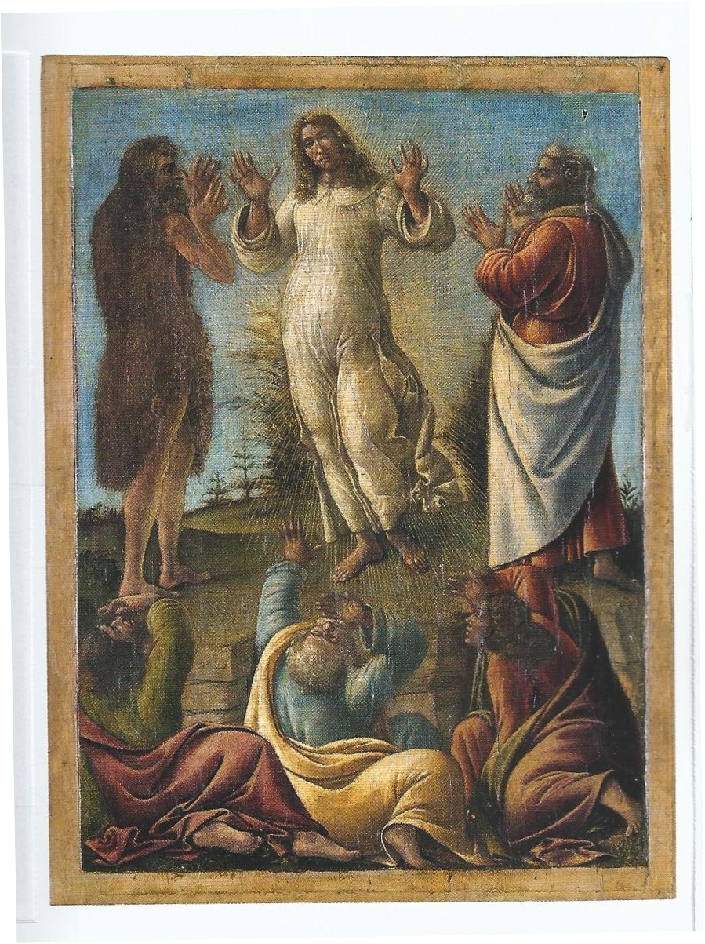
This title refers to the occasion when Jesus led Peter, James and John up a high mountain, where they were alone. Jesus became transfigured: we are told “his face shone like the sun, and his clothes became white as the light”. Moses and Elijah appeared, one on each side of him, and they spoke to eachother. Peter, James and John were stupefied, overwhelmed. Then a cloud cast a shadow over them, and out of the cloud came a voice saying “This is my Son, my Beloved; listen to him”. When the cloud lifted, the three of them were alone with Jesus just as before.

(7) NOLI ME TANGERE (Do Not Touch Me): Fra Angelico, 1440-1

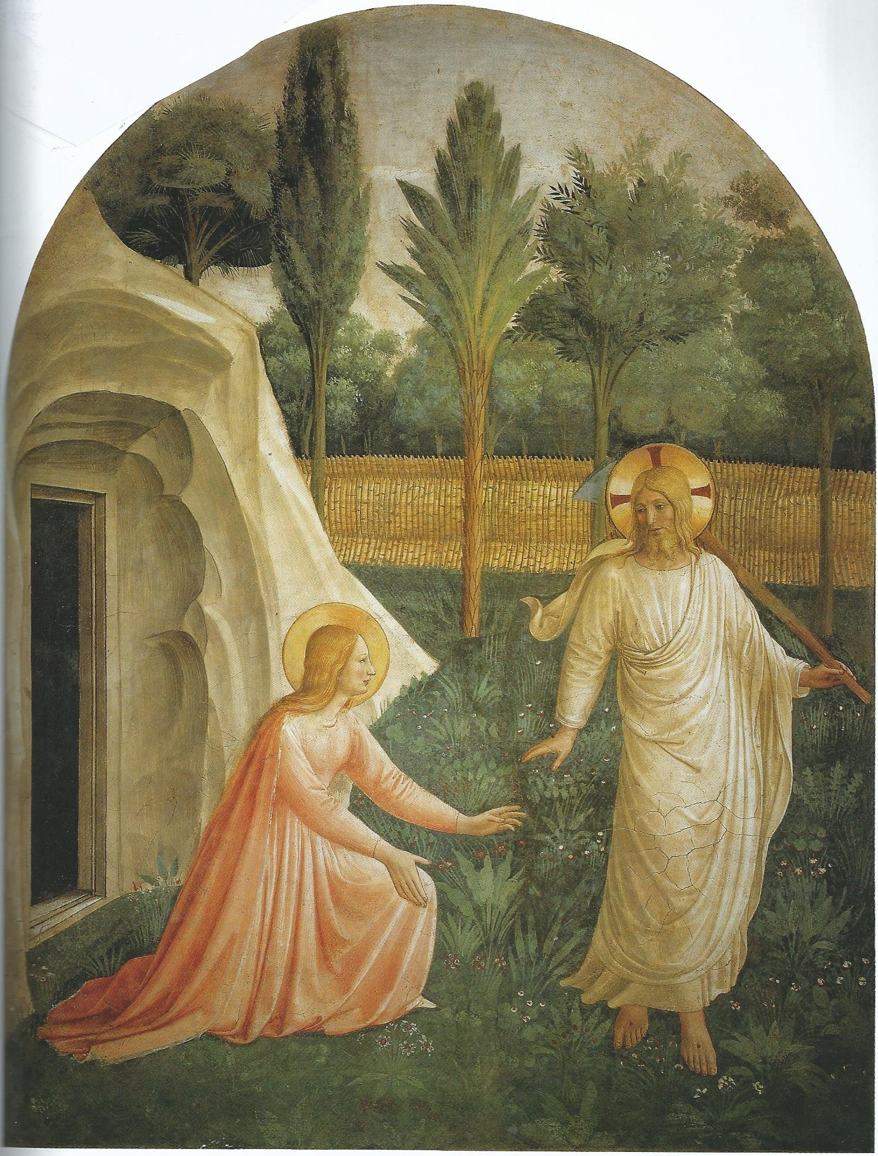

The morning after Jesus' crucifixion and burial his tomb was found to be empty. His friend Mary went searching all over the burial garden, thinking his body had been stolen. She thought she saw the gardener, and asked him where Jesus was. This shows the moment when Jesus called her by her name, and she suddenly realised that this person was Jesus himself. She went down on her knees and reached out to him. “Noli me tangere” he said, “I am the dead and risen Jesus, and I have not yet ascended to Heaven. Go and tell my friends that this will happen.”
(8) FEED MY SHEEP: Raphael c. 1520 (detail).

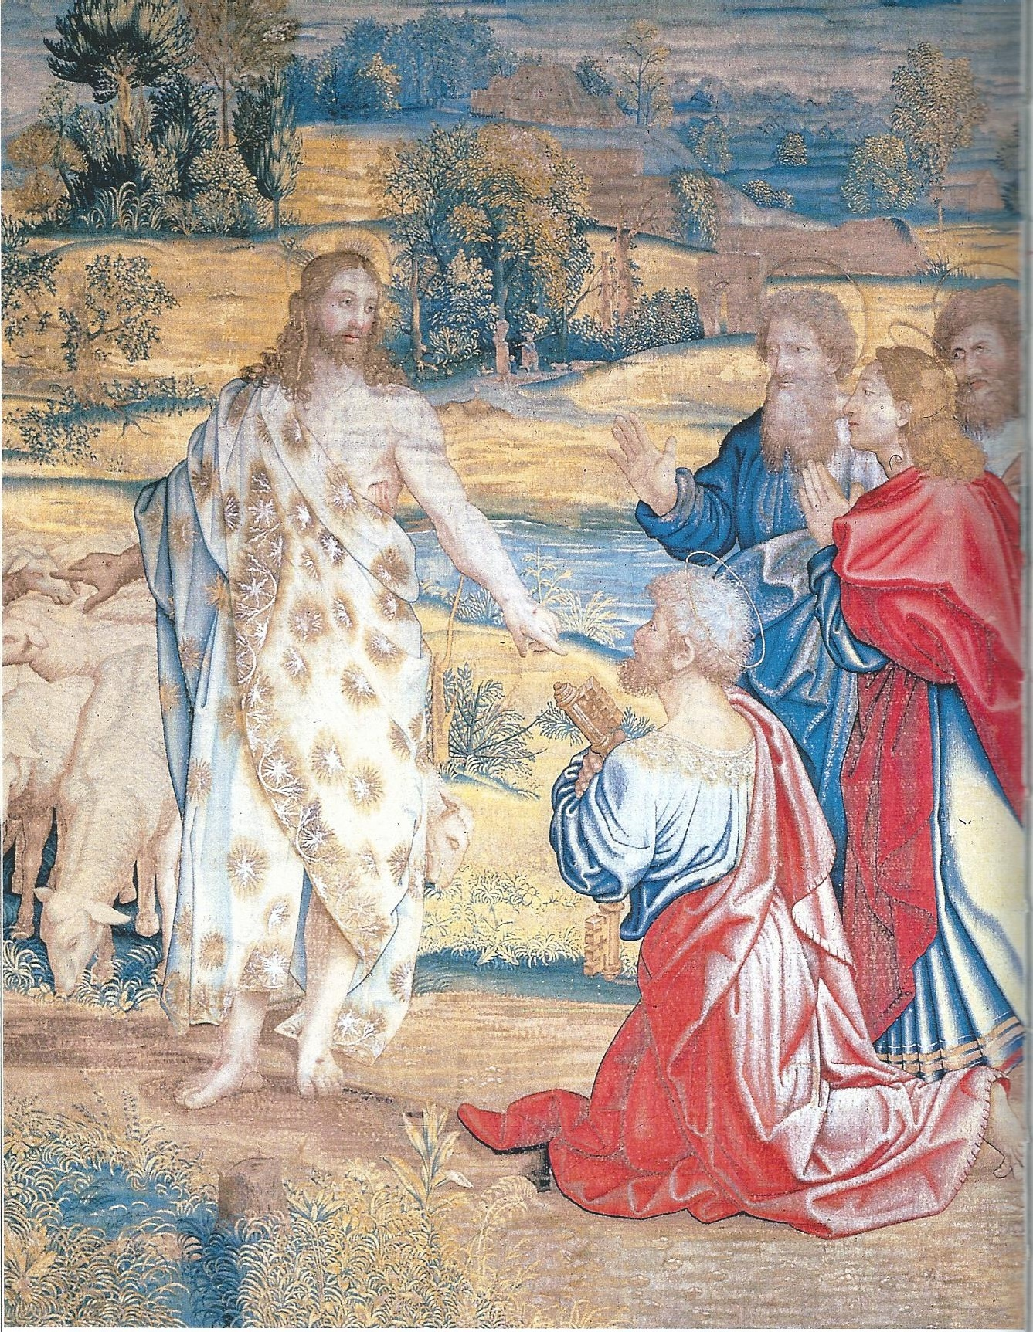
Jesus has risen from the dead and appears to his disciples. These are led by Peter, to whom Jesus had given authority as leader while he had been on earth. Jesus is telling them that they must preach the Good News on his behalf after he has left them. Jesus will be as a shepherd: all the world over, those who follow his disciples will be his lambs, his sheep, and his disciples must care for them.

-------

Finally it must be said that medieval traditions regarding the colour of clothing can help interpret a painting when explanation or even the title is lacking. People moving around in certain clothing may be a reminder of a story once heard, but forgotten. At the very least, one's imagination can play a part.

-------------------------------------------------

