Compiling and setting it up.

Hello fellow coders, I'm Dragoon and I'm going to show you how to compile the client and the dll's.

What can be compiled?
- All the 3rd party libraries
- TriggerVFS (now TSVFS)
- TriggerInfo (now TSHWI)
- TGameCtrl (now TSGUI)
- Client

What can't be compiled yet?
- The server

Installing and setup of your environment.
So before we can compile anything we are going to need a compiler.
The compiler we use is visual studio 200 professional or higher. The Express edition will NOT work.
So install visual studio 2005 professional and open the program at least once.
So now we have to setup our ROSE_ROOT variable.
Click the start button and right click "My Computer" (Computer on vista or higher).
If you are on vista or higher a window will open with basic specifications on your computer.
In the left area click "Advanced System Settings" and they will popup.
When it's open click on the "Advanced" tab and it should look like this:
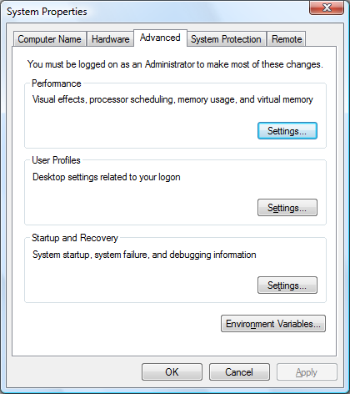
Now click on the "Environment Variables..." button.
A screen that looks like this will pop up:
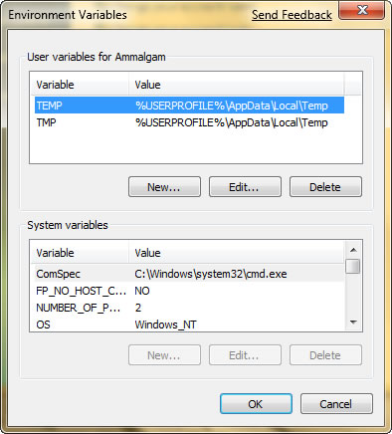
Click the new button on the "User Variables" section if you want only your user to have that variable defined.
Click the new button on the "System Variables" section if you want your whole computer to have that variable defined.
In the box that says "Variable name" fill in "ROSE_ROOT".
In the box that says "Variable value" fill in the path to your "Rose_Engine" directory,
for example: "D:\TriggerSoft\ROSEProject\Rose_Engine".
When you have this part done, you should reboot your computer to make the changes take effect.
According to Vetyst you don't have to reboot, when creating the variable. But if you run in errors, reboot anyway.

Building
You are lucky, I have made building very easy for you.
If you have configured everything correctly you should be able to build everything correctly.
So at first we have to build the 3rdparty libraries.
So go ahead and open 3rdpaty.sln and hit that build button!
Now when that's done we have to build TRose.
Open TRose.sln and once again, HIT THAT BUILD BUTTON!
Now everything should be compiled and being able to run. Isn't that fun!

Trouble shooting
- I' m getting __RPC__out_count_part errors.
Your windows sdk conflicts with visual studio 2005, set it back to the original platform sdk directory (C:\Program Files\Microsoft Visual Studio 8\VC\PlatformSDK) via tools->options->Projects and solutions->VC++ Directories.
Then modify it for executable files, include files, library files and exclude directories.

TODO
- Be able to build the server
- Database setup guide

