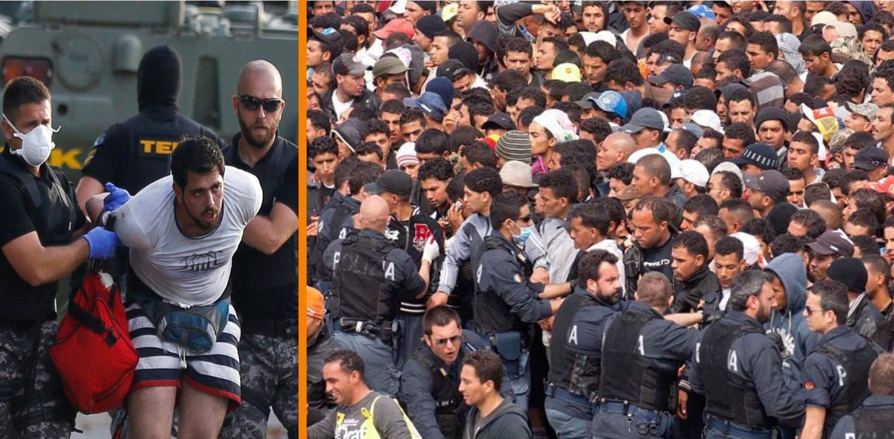

Cole Garr ’18  
Yanet Gonzalez ’17

Catherine Gregg ’17  
Rachel Haskins ’17  
Jeffrey Lauck ’18  
Abigail Major ’19  
Jared McCully ’19

**Make America Safe Again?**

*A Panel on the National Security Risk of Refugees***.**

Featuring:  
**Amer Alfayadh  
Stacie Blake  
Dr. Chris Bolan**

**Thursday, February 9, 2017 – Joseph Theater, Breidenbaugh Hall**

Anthony Citarella ’17  
Gregory Dachille ’17  
John Duncan, III ’17

Yanet Gonzalez ’17

Lynn Hatcher’17  
Katerina Krohn ’17  
Piper O’Keefe ’17

Alyssa Waaramaa ’17

**The Eisenhower Institute**

Grounded in President Dwight D. Eisenhower’s legacy of leadership, The Eisenhower Institute at Gettysburg College promotes nonpartisan discourse and critical analysis of issues of long-term importance through competitive fellowships, access to renowned experts, and symposia.

The Institute prepares undergraduates to assume their responsibility as global citizens in public, private, and nonprofit sectors—students learn how to lead with integrity, build capital to garner influence, and translate knowledge into action.

**Eisenhower Institute Undergraduate Fellowship**

The Undergraduate Fellowship offers a select group of Gettysburg College seniors the opportunity to develop their leadership skills and enhance their understanding of public policy. The Fellows also engage in the planning and promotion of specific programs and projects. They are responsible for selecting, developing, and promoting a public policy theme. Fellows meet with high-level elected officials and public servants.

**2016-2017 Undergraduate Fellows**

**EI Professional Staff**_Susan Eisenhower, Chairman Emeritus  
Robert E. Bohrer II, Ph.D., Associate Provost & Dean of Public Policy Programs  
Jeffrey M. Blavatt ’88, Executive Director  
Benjamin R. Hill, Assistant Director  
David Wemer ’14, Program Coordinator  
  
**EI Office Assistants & Campus Communications Team**

Dr. Shirley Anne Warshaw, Harold G. Evans Chair of Eisenhower Leadership Studies

Elizabeth Miller ’19  
Konrad Neptun ’17  
Khun Minn Ohn ’19  
Claire Quinn ’18  
Charlotte Scheper ’17  
Maja Thomas ’17

Mariam Aghayan ’17  
Taylor Beck ’17  
Thomas Calbos ’19  
Corinne Day ’17  
Guilia DiGuglielmo ’18

Marley Dizney Swanson ’18  
Alex Engelsman ’18

UNDERGRADUATE FELLOWS

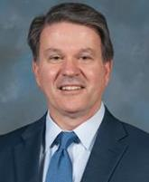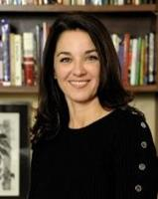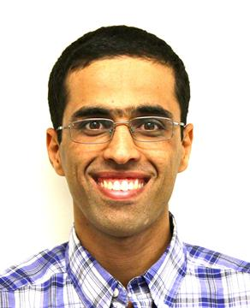

**Stacie Blake** is the Director of Government and Community Relations for the U.S. Committee for Refugees and Immigrants, a position she has held since 2014. Previously, she led the USCRI Vermont field office where she was recognized by the Vermont Legislature with a Joint Resolution of Appreciation for her work with refugees and immigrants across the state. Prior to rejoining USCRI, Stacie led a Florida program to end discrimination and the Florida Center for Survivors of Torture where she developed the National Partnership for Community Training, a collaborative program meant to share best practices for communities with torture survivors. Stacie holds two degrees from the University of Vermont and was elected twice as a member of the Mount Mansfield Union School District. She is a graduate of the Vermont Leadership Institute and Leadership Florida.

**Dr. Chris Bolan** is currently a professor of Middle East Security Studies at the Strategic Studies Institute of the U.S. Army War College where he researches and teaches graduate-level courses on contemporary national security issues and the Middle East.  Prior to his time at the U.S. Army War College, he served thirty years in the U.S. Army in various command, staff, and instructor positions. After his time in the military, Chris went on to gain both his Master’s degree and Ph.D. in international relations from Georgetown University. After Georgetown, he served six years as a senior foreign policy advisor and analyst on Middle Eastern and South Asian affairs for Vice Presidents Gore and Cheney. During that time, he participated in senior interagency deliberations at the level of Assistant Secretary and regularly attended Principals and Deputies Committee meetings of the National Security Council. Chris has also prepared hundreds of policy briefings/papers for senior officials at the White House, Pentagon, Congress, and U.S. embassies overseas. In addition to currently teaching at the U.S. Army War College, he frequently writes about U.S. foreign policy and has had his work published by many different media outlets, including *The Washington Post*, *Foreign Policy in Focus*, and *Divergent Options*.

**Amer Alfayadh** moved to the United States in 2010 from Iraq as an immigrant. His passion for helping other refugees and immigrants led him to volunteer at Church World Service (CWS) where he currently works as a Senior Case Manager in Lancaster, PA. Amer graduated from the University of Technology in Baghdad-Iraq with B.Sc. in production engineering, and he is currently an MPA student at the University of Roehampton-England. Outside of work, Amer enjoys exploring the rich heritage of the Lancaster area with his small family.

**About the Speakers**

**About the Discussion**

The Eisenhower Institute Undergraduate Fellows welcome you to the second in a series of expert panels on domestic refugee policy. In this panel, the Undergraduate Fellows seek to learn more about the true impact of refugees on National Security. Are there risks to National Security by admitting refugees? Is there a greater risk to National Security if we were to ban entry into the United States for refugees? Join our Undergraduate Fellows and esteemed panelists as we explore these important questions.

**Program**

**Welcome**

Jeffrey Blavatt ’88  
*Executive Director  
Eisenhower Institute at Gettysburg College*

**Performance of the National Anthem**Drop the Octave

**Introduction**

Anthony Citarella ’17 & Yanet Gonzalez ’17   
*Eisenhower Institute Undergraduate Fellows*

**Panel Discussion**

“Make America Safe Again –   
A Panel on the National Security Risk of Refugees”

**Part One: Implications on National Security  
Moderators**

Anthony Citarella ’17 & Yanet Gonzalez ’17   
*Eisenhower Institute Undergraduate Fellows*

**Part Two: Implications on Community Security  
Moderators**

Piper O’Keefe ’17 & Alyssa Waaramaa ’17   
*Eisenhower Institute Undergraduate Fellows*

**Panelists**

Amer Alfayadh, Sr. Match Grant Case Manager /   
Immigration & Refugee Program, Church World Service  
Stacie Blake, Director of Government & Community Relations, U.S. Committee for Refugees & Immigrants   
Dr. Chris Bolan**,** Professor of Middle East Security Studies at the Strategic Institute, U.S. Army War College

**Question & Answer Session**

**Closing Remarks**

Piper O’Keefe ’17 & Alyssa Waaramaa ’17   
*Eisenhower Institute Undergraduate Fellows*

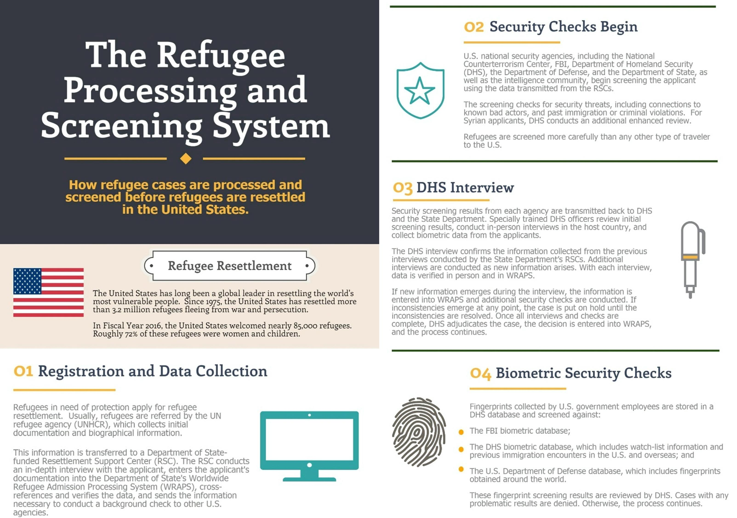

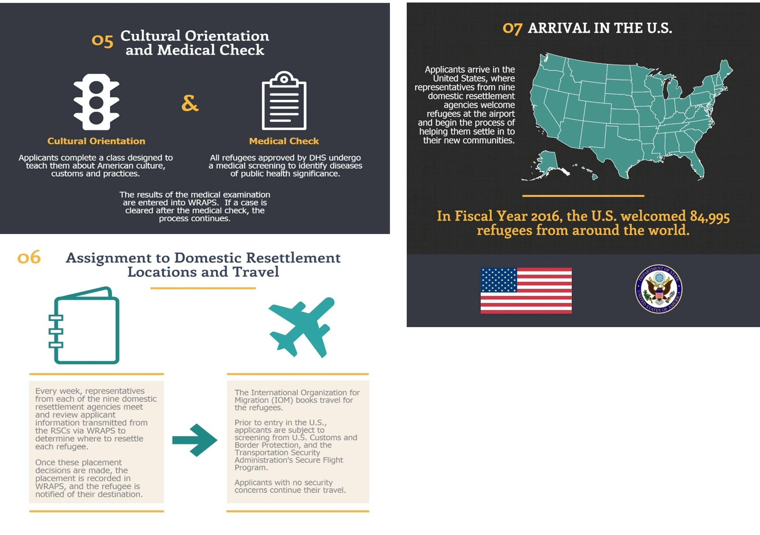

**For Additional Information, Visit:**

[**https://www.state.gov/j/prm/ra/admissions/**](https://www.state.gov/j/prm/ra/admissions/)