Name: Dajun Xue
Email: XUEDY002@mymail.unisa.edu.au
ID: 110290500

Werdle Design
First Step: UML Class Diagram
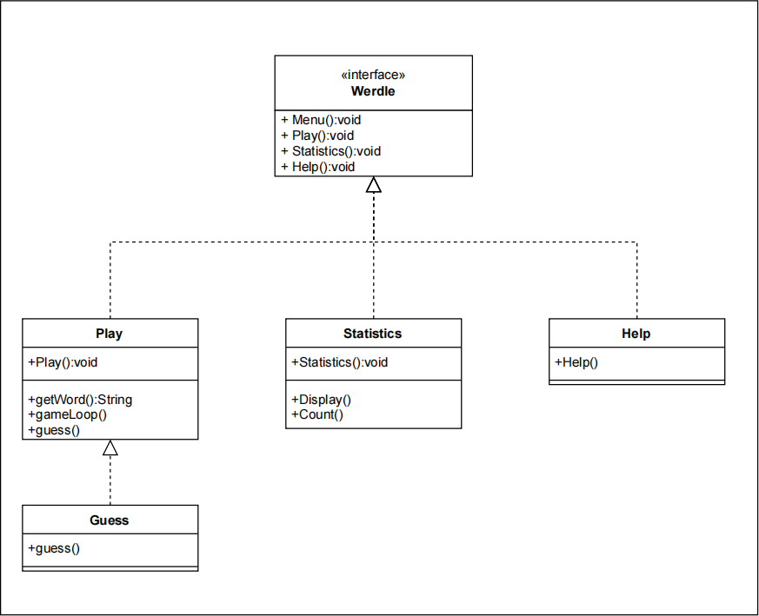

Second Step: Display the main menu
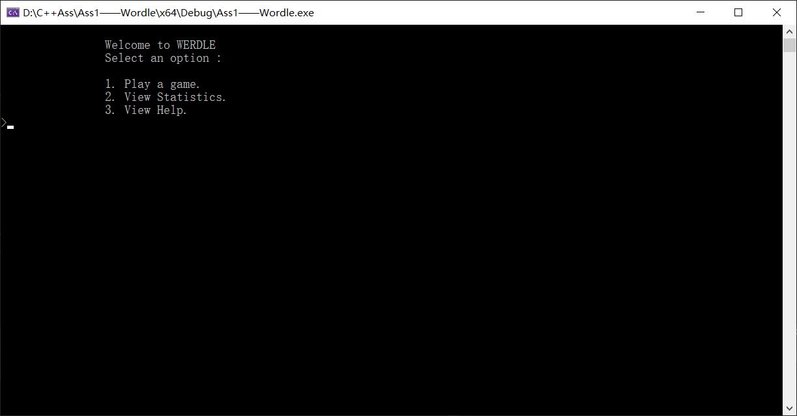

Third Step: Display the 3 options, show the pages and return to main menu
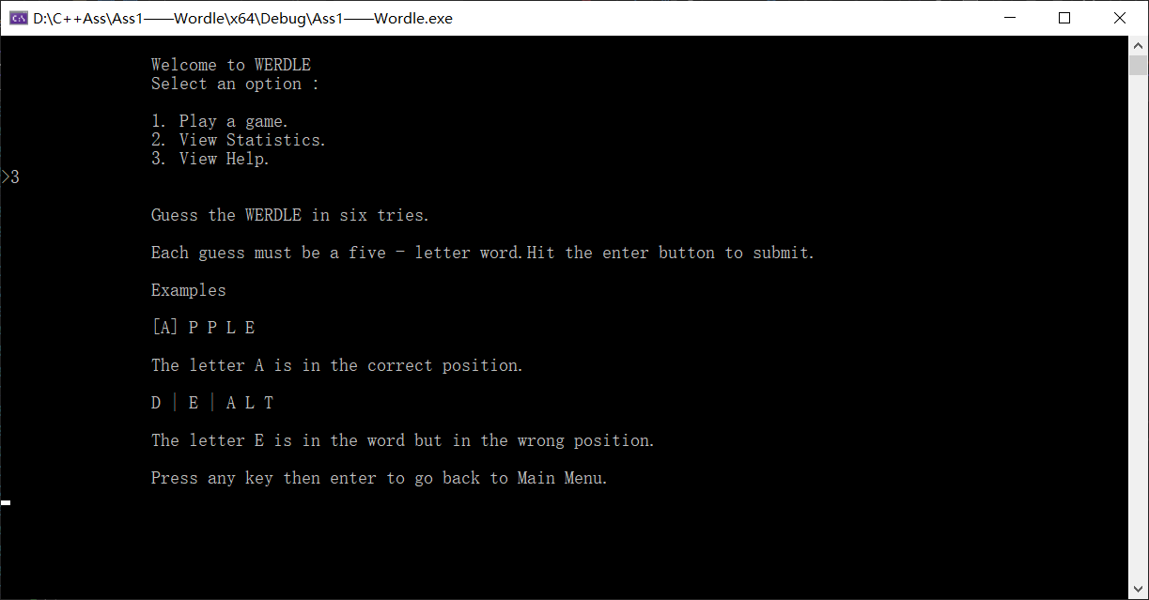
Use system(‘cls’) to clear the current interface
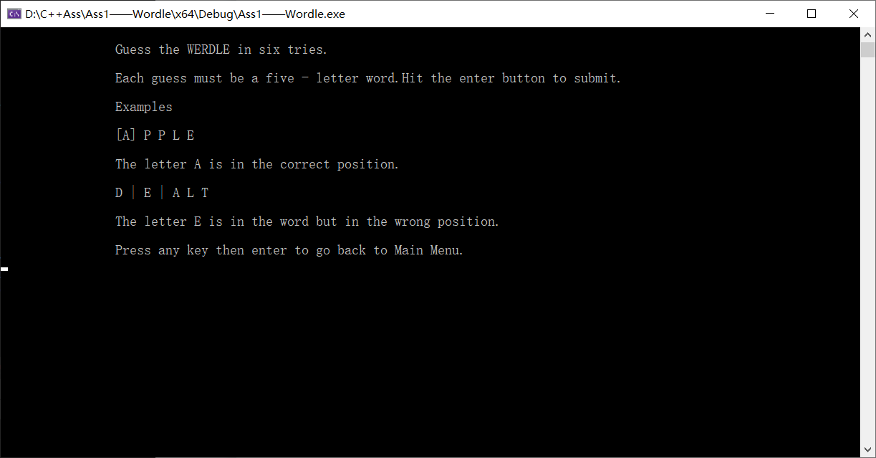

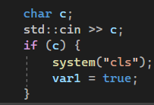define a new char and use if, when any key is input, display the main menu.

Fourth Step: Design the guess class

Fifth Step: Design the statistics class

