14 - Chunks of Bytecode
Bob sets up the basic data structures we will be using for our bytecode interpreter and compiler. A “Chunk” is an array of bytecode values which owns another array of constant values. The bytecode values could represent either instructions or parameters. There is an array of line numbers with a one-to-one correspondence with the code array.
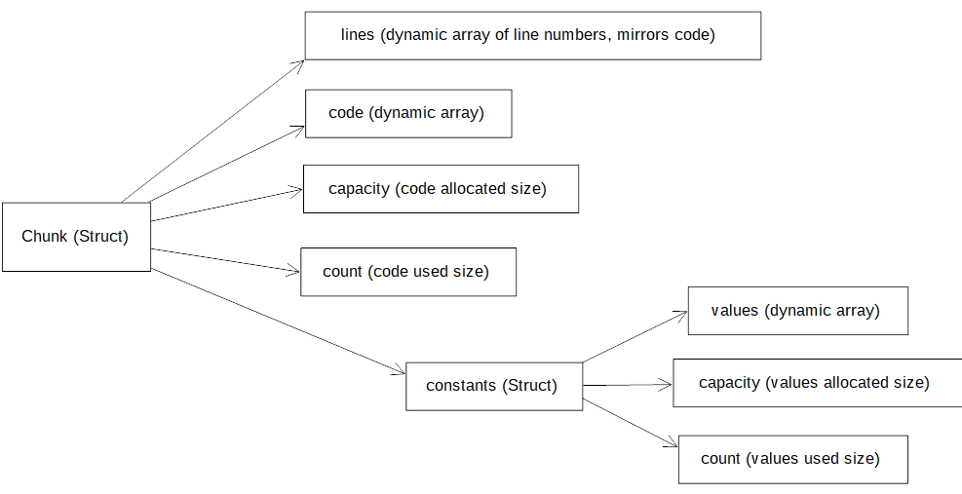
It’s fairly straightforward. A little asymmetrical since the bytecode array owns the constant values array, but I suppose that makes the schema cleaner. I changed the array index types from “int” to “unsigned” and added some typedefs to try to have a bit more context while reading the code.
It is slightly concerning that the example adds an OP_CONSTANT then adds the constants array index to the code array. The code array has type “uint8_t” whereas the constant array index is “int” in the original and “unsigned” for me. In either case, the index can overflow “uint8_t”. Okay, actually Bob addresses this in Challenge 2. I assume we’ll add a check for this later.
So far this is pretty approachable.
15 - A Virtual Machine
In which we add a VM to execute a chunk of OpCodes, and add arithmetic OpCodes to see the VM in action. The VM has an instruction pointer (IP) which points to the next OpCode to be executed from the chunk, and also a stack where values are stored. “stackTop” points beyond the last value.
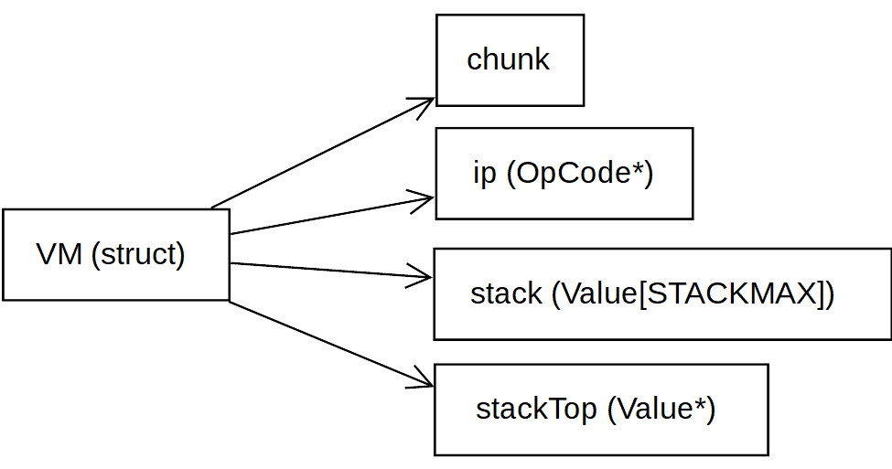
I did have to study one line of code for disassembling instructions in debug mode:
(ChunkIndex)(vm.ip - vm.chunk->code)
The code is subtracting the base pointer of the OpCode array from the instruction pointer. It turns out that you can subtract two pointers, and the result is the distance in elements between the pointers. The confusion was seeing a subtraction where the result is not the same type, ‘-’ : Pointer × Pointer → Int, but it’s clear enough after looking it up.
Pretty good chapter. I went through “debug.c” and added column headers to make the printout more self explanatory, and renamed a few variables so that “constants.values[constant]” would read as “constants.values[constant_index]”. Just annotating the code to make sure I understand it, since I did lose the thread last time when I was following the ~monthly release of chapters.
I did notice that the VM pops all arithmetic arguments from the stack, then pushes the result. It could just modify the last argument on the stack with the result, but I suppose that would be less conceptually pure, and I don’t know what changes to expect down the line.
16 - Scanning on Demand
This one is pretty straightforward- useful, but dead simple after completing part I. We implement the scanner to prepare for the parser, which compiles our bytecode. We set up the REPL, and I made a small detour to replace “fopen” with “fopen_s”, since the static analyzer gave me a warning that “fopen” is deprecated. The function “skipWhitespace” also through me for a loop, because I’m not used to seeing intentional fallthrough in a switch statement.
The difference compared to jlox is that we don’t treat scanning as a separate pass; the parser will request tokens from the scanner, which will scan dynamically.
17 - Compiling Expressions
In this chapter we set up the parser, and Bob introduces the idea of Pratt parsing. We have a table where the rows correspond to different tokens that the parser may encounter; the token type is the key. There is a column containing a function to call if the token is encountered at the start of a subexpression, for example a number or left parenthesis. There is another column containing a function to call if the token is encountered after a subexpression has been parsed, e.g. binary operators, or latter function calls. Then another column contains the precedence of the token. This means that arithmetic operators are parsed in the right order, but I think it will also prevent functions from being called twice later, e.g. f(x)(y) would be excluded by the precedence rules.
The parser will keep building the subexpression if the tokens it encounters are greater or equal precedence, and the binary rule adds one to the predence. So an expression like “1 * 2 + 3 + 4 * 2” would:
- Start parsing with ADD precedence
- Encounter the 1 and parse it using the prefix rule with no precedence
- Encounter the * and parse it using the infix rule with MULT+1 precedence
  - Encounter the 2 and parse it using the prefix rule with no precedence
  - Encounter the +, which has lower precedence than MULT+1, so end this level of recursion
- Encounter the + which is equal to ADD precedence, parse infix rule with ADD+1 precedence
  - Encounter the 3 and parse w/ prefix rule
  - Encounter the +, which has lower precedence than ADD+1, so end this level of recursion
- Encounter the + which is equal to ADD precedence, parse infix rule with ADD+1 precedence
  - 4 parsed as prefix
  - * precedence is greater or equal ADD+1, so parse as infix
  - 2 parsed as prefix
So it parses in the right order and keeps left-associativity by adding 1 to the current precedence.

I didn’t understand Pratt parsing the last time I went through this chapter, but after studying it for a bit, I think I like it. It has the advantage over recursive descent that you don’t go through a whole slew of recursive function to get down to the terminal rules. You perhaps need to think more about very deliberately assigning precedence, but that is a minor drawback compared to the advantages.

One thing to note is that the rules of Lox allow us to have a single PREC_UNARY for prefix operators. In some languages this may be undesirable, e.g. -2^2 should be equal to -4, not 4. In this case we could add a fourth column to the table to have separate prefix and infix precedence values. Lox only has left-associative binary operators, but with right-associative operators such as ‘^’ you might also have a column to specify the associativity of operators.
Also, I don’t believe “infix” is entirely the appropriate term, as infix and postfix operators e.g. 3! would be handled the same by the Pratt parser.
You could use the Shunting Yard Algorithm to avoid recursion, although that adds the complexity of a stack of operators.
18 – Types of Values
We change the Value type to be a tagged union, that is a struct with a union and an enum indicating the type of union in this instance. In addition to the “double” types we supported earlier, we add NIL and Boolean types. Most of the work in this chapter is spent augmenting our previous framework with support for Boolean values.
It’s pretty straightforward. I renamed some of the macros because I got lost trying to understand what they were doing with Values last time I was working through. The new names probably go too far into implementation details, but that is appropriate for an educational exercise.
I noticed that Lox only has double numbers, and uses straightforward double equality comparison, so loops are liable to run an extra time or stop an iteration early. Oh well, it is a toy language! The extra work of also using integers, or doing something approximating integer comparison wouldn’t be that fun anyway.
19 - Strings
In the previous chapter we dealt with types that could reasonably fit in the union; now we add a pointer for dynamically sized objects. I changed the name of this typedef from “Obj” to “HeapObj” to hopefully help me remember the context.
I think perhaps there is too much abstraction happening with the C macro system, so that I need to take care I understand everything.
So we outfit our union with a pointer, and then there is a lot of code to handle interpreting heap objects as string objects via casts, and a lot of string munging to setup and work with the string.
We spend the last part of the chapter make sure we store a reference to each heap object and free it on exit. I was curious if this is important since the OS should free all memory on exit anyway, but apparently freeing is important for memory detection tools like valgrind.
Kind of an “eat your spinach” chapter- hopefully I grasped it sufficiently. The viola sketch was funny.
20 – Hash Tables
A hash table data structure is implemented using open addressing to resolve collisions. We use the FNV-1a hash algorithm on the key strings. A substantial part of the work is including tombstones to represent deleted entries, which is necessary to keep lookup chains intact.
We start interning all strings to make comparison easier. The compiler is still emitting non-interned strings, but the VM uses interning on concatenation, our only string operation currently.
So we’ve spend the last couple chapters building up our framework for new features down the road. First we implemented strings, which are more broadly heap-allocated Values. Now we have a hash table, so that we can bind Values to unique strings.
21 – Global Variables
We begin implementing our declaration and statement rules, starting with “print”, which pops a value off the stack and prints it. Then where before we had just evaluated expressions, we add the expressionStatement rule which interprets the expression then pops the value it leaves on the stack. Presumably the expressionStatement will have some side effect to be useful, but we don’t judge. We also implement error recovery synchronization, where we scan ahead to the start of the next statement. This could be achieved by finding a semicolon indicating the end of a statement, or a “var” or “class” type keyword to indicate the start of a statement. I wonder how this works in languages with newline statement terminators, where lines may also be continued by parameter lists or binary operators.
We end up changing the ParseFn signature to accommodate a Boolean argument indicating if the expression is assignable. We could have avoided that for the infix rule by having a different signature, but I guess it was better to keep things simple. It is annoying that you can’t omit parameter names in C.
I did have a moment where I had to check myself and make sure that I still understand what is happening. The stack is storing values only. The “chunk” holds an array of bytecodes, and it is processed from left to right with the possibility of jumps. The interplay between the chunk and the stack can be hard to keep up with, for example with assignment we evaluate the RHS to the stack, then have a SET instruction and constant index to set the value. I can see how it works, but it’s a bit of a mind bender!
22 – Local Variables
Whereas we created a hash table on the VM for global variables, local variables are stored on the stack. At this point we should call it a “stack”- we still add and remove elements in true stack fashion, but we access variables by index midway through the “stack”.
We introduce a “Compiler” struct which holds information for the local scope. The Compiler has an array of Local structs, which themselves have a name and a depth. The compiler also has a localCount and scopeDepth. There is some tricky language here. A “local” variable is the opposite of a global variable, it does not necessarily need to be in the current scope. “localCount” refers to all the variables from this scope up to but not including the global scope.
It’s interesting… there is a lot of duplication on the stack. In executing the calculation 2+2, we stack state after accessing local variables and before the addition is: [ 2 | 2 | 2 | 2 ]. I suppose an optimization to remove redundancy would be complicated.
The use of local variables at runtime is amazingly simple. We just have a little bit of effort at compile time to determine the relative stack offset of the local variable, and make sure the scoping rules are observed, but it’s simpler than it looks.
23 – Jumping Back and Forth
We start implementing control flow. It’s starts out simple, just determining how far to jump over an IF statement body if the condition isn’t met. I did learn about the comma operator, which I haven’t encountered before. We define a macro:
#define READ_SHORT() \ (vm.ip += 2, (uint16_t)((vm.ip[-2] << 8) | vm.ip[-1]))
The comma operator only returns the last argument, but executes all arguments in order. The comma only acts as an operator that way when it is nested in parenthesis, otherwise it is a separator. It’s the kind of thing you wouldn’t see too often, but I can’t blame Bob for flexing his C skills. I actually do appreciate learning obscure features of the language.
It’s interesting that we always take an ELSE branch, even if it’s just our own work to pop the condition value off the stack. A more optimized compiler might have no jump following a lone IF body.
Conceptually control flow isn’t too difficult. We use backpatching, conditional jumps move forward, loop jumps move backwards. All in all there are five different control flow statements to implement, and it’s hard not to get a little hand-wavy.
24 – Calls and Functions
We implement functions as a heap-allocated object, defining a struct which contains the arity, a chunk of bytecode, and the name. It’s interesting that we store the name at runtime, but I suppose that results in better error messages. The data structuring is relatively easy to understand.
It’s interesting that native functions are incorporated into the runtime. I would have expected them to be resolved at compile time, but I guess that would cut down on interoperability.
25 – Closures
Normally when a variable goes out of scope, we could remove it from existence. However, we want lambda functions to take ownership of their captured variables. We start solving this by wrapping every function in a closure struct.
It seems a bit wasteful to treat any variable outside the local scope of a function as a captured variable, after all, not all upvalues will be out of scope when the function is called. We only see the most complicated behaviors when we return functions, so that the function’s outer scope goes out of scope. I suppose treating all upscope variables as upvalues is the simplest solution without adding too many cases to handle.
This is a hard chapter. Lambdas have a lot of minutia, but I rarely use them, so it’s hard to muster up interest. Maybe it would be a different story if I spent a lot of time in JavaScript or a functional language. I’m worried I’ll need a thorough understanding of this chapter to really get garbage collecting, so I’ll probably need to review the last two chapters.

