Algorithm Design

Login
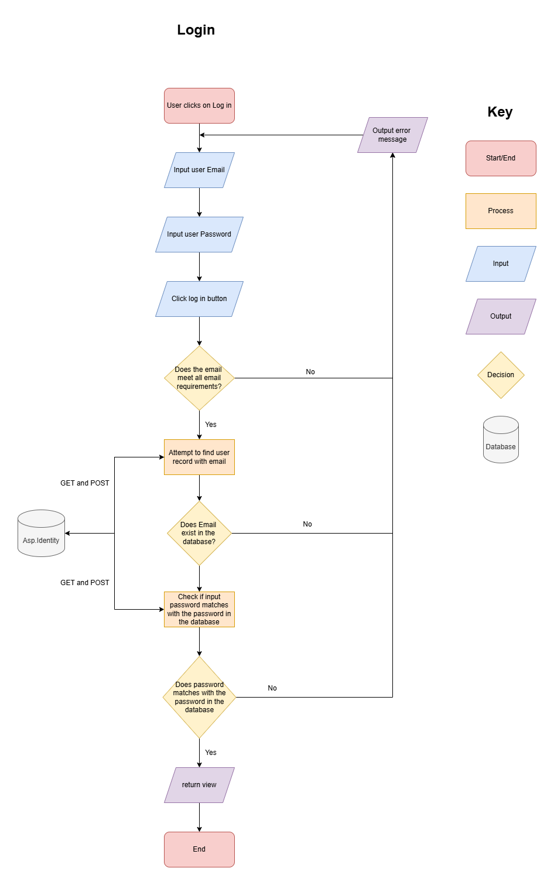
For the user to log in the first thing the user needs to do is to click on the Login button. After that the user enters his email and password then the system checks if the email meets the validation checks and the system checks if the email and the corresponding password matches the one in asp.net identity. Once the inputs have been confirmed it will return the user to the homepage already logged in. If the inputs don’t match or the email failed the validation checks it will send out an error message.

Register
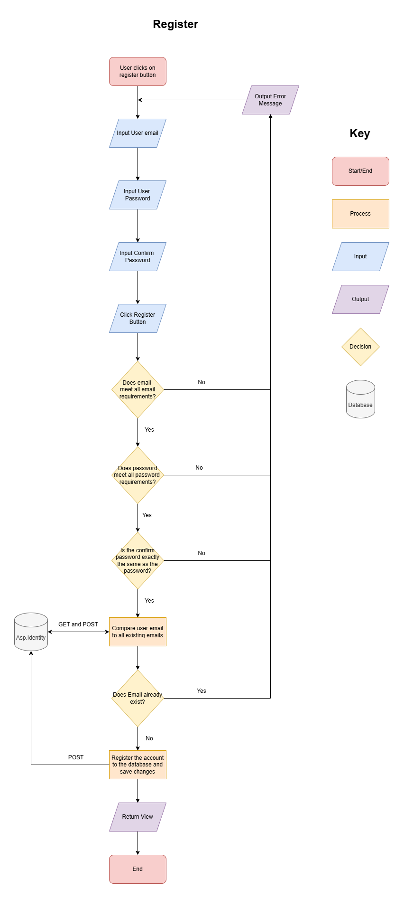
(please zoom in if not visible)

For registering an account, the user needs to click on the register button/link first. After that the user enters the email, password and confirm password. Once the user is finished entering the details the system will then perform a validation check on the email and password inputs if the inputs meets all the requirements. If there is at least one validation check that has failed the system will sent out an error message. If both inputs pass the validation checks then the system proceeds to the next step where the system checks the database if the email that was entered is already in the database. If the email already exists the system will then output an error message. If not then it stores the details and save the changes to the database. Afterwards the system returns view.

Seed Data
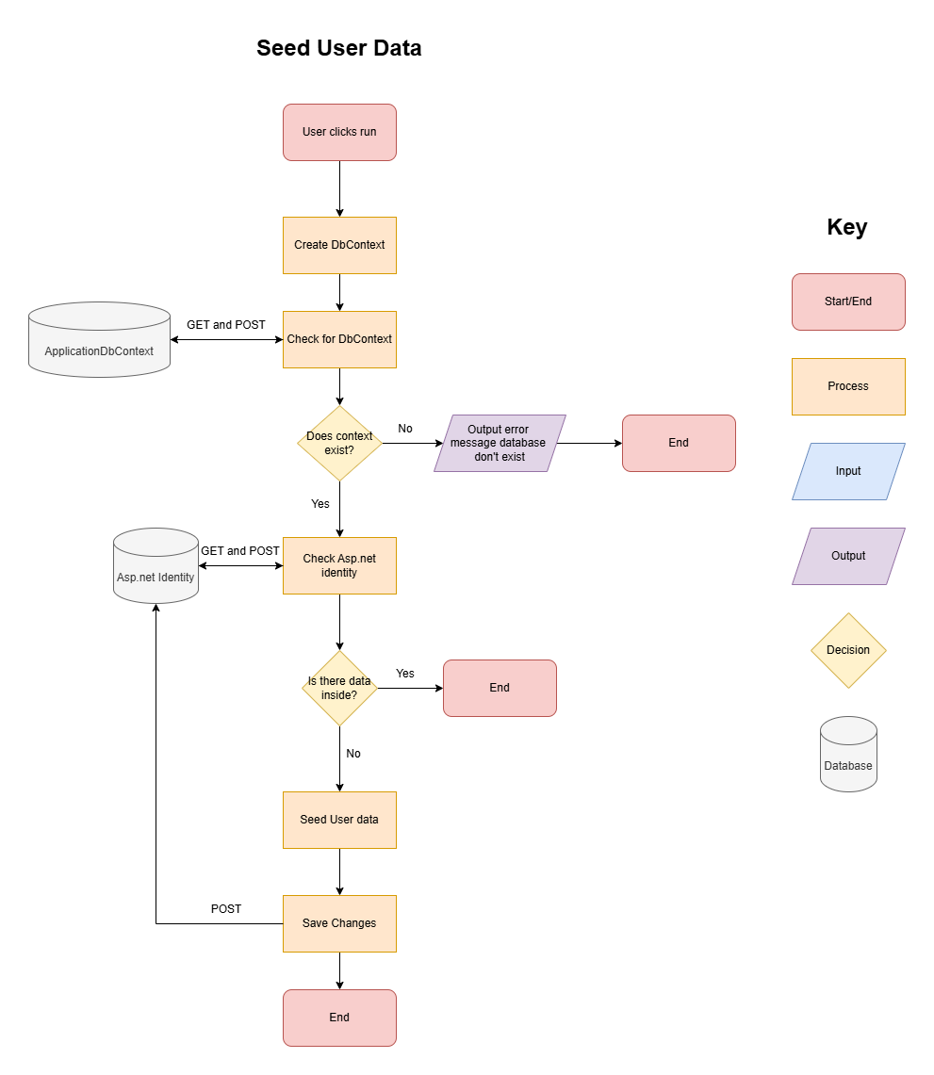
Once Run is clicked it creates Dbcontext and check if the database exists. If no it prints out an error message. If yes it the checks if data is inside the database. If yes it continues running normally. If no it will then seed the created user data into the system and save the changes into database.

Add to Cart Feature
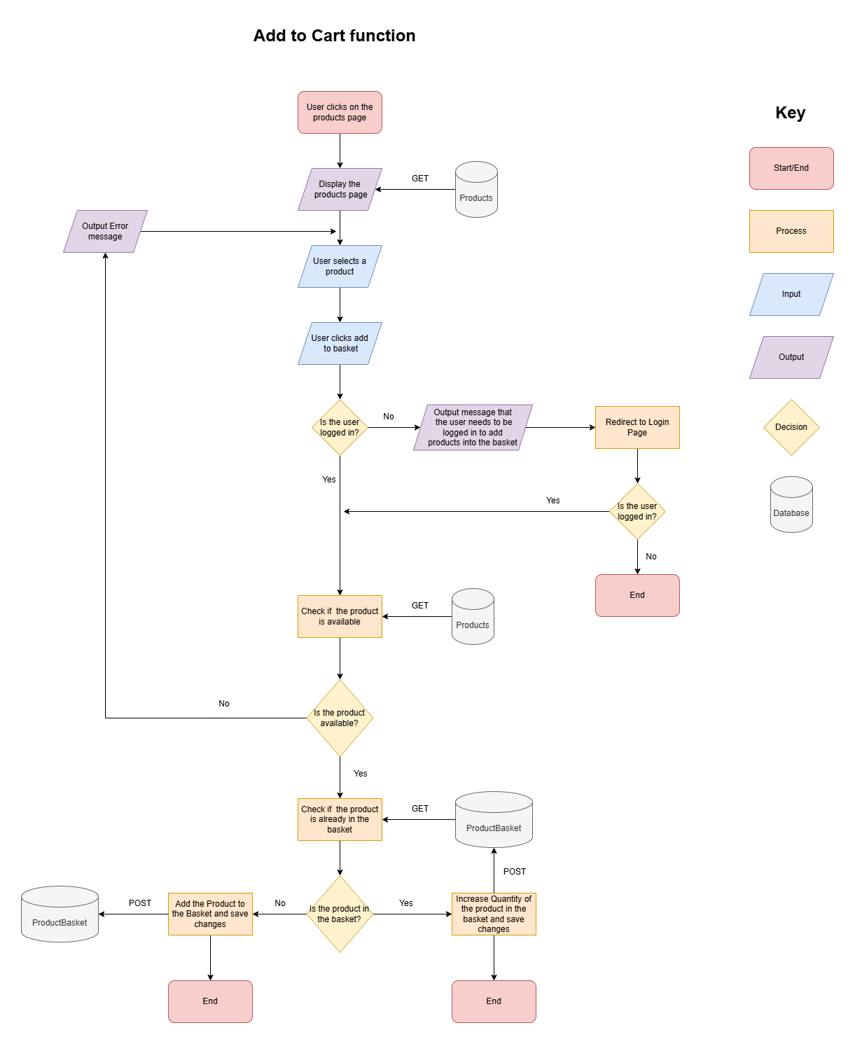
(please zoom in if not visible)

First the user needs to select a product in the products page and add the product into the basket. Before allowing the user to add a product in the basket the system will check if the user is logged in if not it will output an error message and redirect the user to the log in page. Once the user is logged in, the system will check the database if the product the user wants is available. If the product is not available, the user will send out an error message and will not allow the user to add the item in the basket. If the product is available, it will then check if the product is already in the basket. If the product is already in the basket, the system must increase the quantity of the product in the basket and save the changes. If not, the system must add the product to the basket as a new item and save the changes to the database.

Ordering the Products
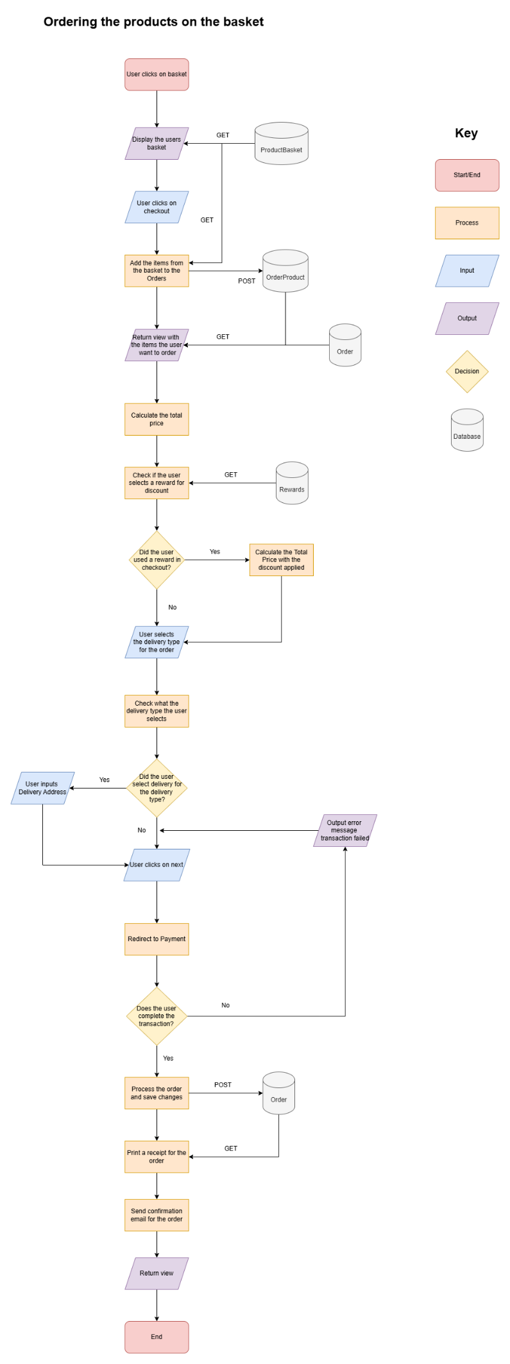
(please zoom in if not visible)

The user clicks the basket icon and then it will return the view of the basket with every product the user added to the basket. Once the user checks every product in the basket is correct, the user then clicks the button for the checkout. The system will then copy the items from the basket to create an order. The system will then return the view for the order having details like their total price and all the items the user wants to order. In the checkout the user can select a loyalty reward. If the user use a loyalty reward the system will apply the discount to their order. After that the user will then select what delivery type the user wants. If the user selected delivery for the delivery types an input/select will pop-up asking the user to input/select an address to where the order will be delivered. If the user selected collection the user will then proceed to the next step where the user will be redirected to the payment. The system then checks if the transaction was successful. If the transaction was not successful the system will output an error message and send the user back to the checkout page. If the transaction was successful the system will process the order, send a confirmation email for the order and prints out a receipt for the order to the user.

