Visual Designs

Site Map
(please zoom in if not visible)
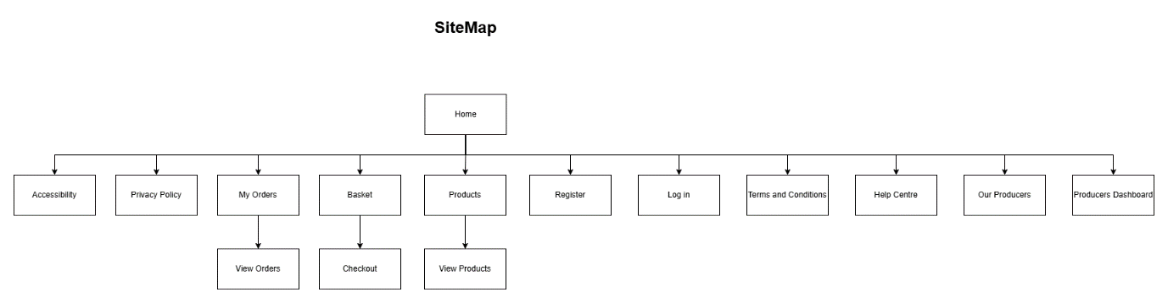

Homepage
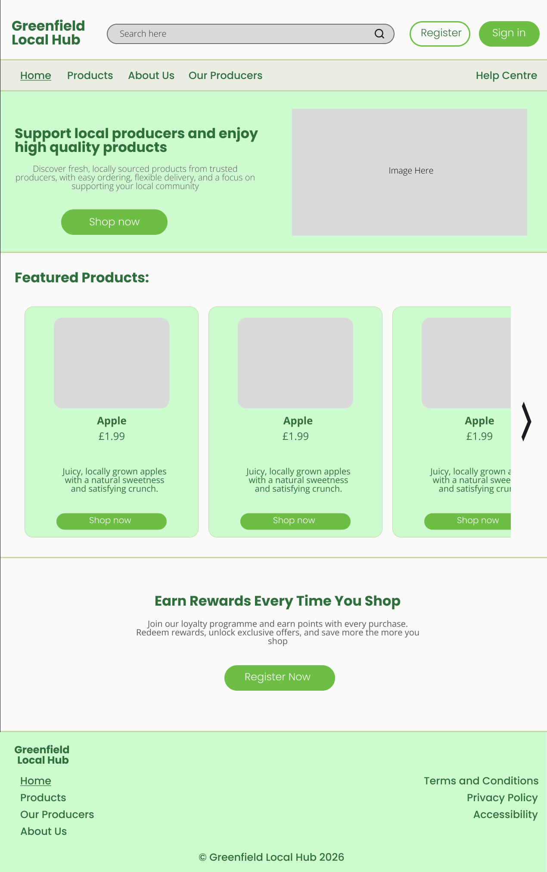

Navigation Bar (Navbar)
The navigation bar is positioned at the top of the page as this follows standard web design conventions. Placing the navigation at the top help users find key areas or products of the website easily and quickly. This helps the users to navigate efficiently in the website overall improving the websites usability. The nav bar uses a background colour of E9EDE4 which creates a soft, clean appearance that aligns with the theme of the company. The navigation links use Poppins, Medium, font size 24 and colour 2F6F3E to ensure visibility and consistency with the typography. Wherever the users active page is, such as “Home” is underlined to provide a clear visual indicator of the user’s current location within the website which improves the user experience. The “Help Centre” navigational link is positioned on the far right of the navbar to avoid clutter on the nav bar improving the user experience.

Navbar Header
Above the nav bar, a header section is used to display key elements. The company logo is positioned on the left following common web design patterns allowing the users to recognise the brand and return to the homepage if needed. A search bar is positioned at the centre to help the users find products quickly. The search bar uses a background colour of D9D9D9 with a stroke colour of 6B6B6B making the search bar clearly visible while maintaining a neutral appearance. The placeholder text “Search Here” uses Open sans, Light, font size 20 and colour 2E2E2E to ensure its readability. On the right side of the header a register and login button is included. The register button uses a background colour of FAFAF8 with a border colour of 6DBE45 making it stand out subtly without overwhelming the design. The button text uses Poppins, Light, size 24 and colour 2F6F3E. Meanwhile the sign in button uses a background colour of 6DBE45 and the text is the same as the register button except for the colour which is FAFAF8 for the sign in button. This helps clearly separate the two buttons making it easier for users to know which is which. Both buttons help reinforce the brands identity.

Divider line
A thin divider line with a colour of C5D8A4 with a weight of 3 is used to separate sections with one another. This helps structure the layouts clearly and improve visual hierarchy without distracting the user.

Hero Section
The hero section of the homepage uses a background colour of CEFAD0 which helps reinforce the theme of the company. The soft green colour creates a welcoming first impression while maintaining consistency with the brand identity. The layout follows common web conventions where text is aligned to the left and a supporting image is placed on the right. This improves readability and ensures that the users know what the website is about. The button is positioned below the body text creating a clear visual flow guiding the user.

Headings
The headings use Poppins, Bold, font size 32 and colour 2F6F3E. This font was chosen because it is modern, clean and matches well with the theme of the company making it suitable to draw the users attention. The green colour reinforces the brand identity and matches the theme of the company. Using consistent heading styles throughout the website ensures a clear visual hierarchy helping users quickly identify important sections which improves the overall user experience.

Body Text
The body text uses Open Sans, light, font size 20 and colour 595959. Open Sans was selected for its high readability. The slightly muted grey colour reduces visual strain compared to pure black while maintaining sufficient contrast against the background colour.

Buttons
Buttons use a background colour of 6DBE45 with text styled in Poppins, Light, font size 24 and colour FAFAF8. The green button colour helps in making interactive elements clearly visible while maintaining the theme of the website. The light colour text provides strong contrast against the buttons background colour making it clear and visible. The buttons styling remains consistent within the website which help improves the usability and navigation of the website overall improving the user experience.

Featured Products Section
The featured products section is designed using a card-based layout to clearly present product information is a structured and visually appealing way. Each product is displayed within an individual card. The card uses a CEFAD0 background colour and C5D8A4 stroke. Inside the card there is the products image, name, price, a short description of the product and a button that says shop now. The cards are arranged in a horizontal carousel layout. This design encourages user interaction by using a navigational arrow the users can click to see more products overall improving the user experience.
The product name uses Open Sans, Bold, font size 24, colour 2F6F3E. This styling makes sures that the product name stands out clearly within the card making it easily recognisable. The use of bold weight in the typography establishes visual hierarchy while the green font colour maintains consistency with the overall theme of the website.
The price and short description use Open Sans, Regular and colour 2F6F3E the only difference between the two is the font size which is font size 24 for the price and 20 for the short description. This displays the product information in a clear and readable format. The slightly smaller font size from the short description helps establish a hierarchy within the cards. The consistent use of the colour green for the font colour help maintains the overall theme for the website. For the button I used the same design as the other buttons I only changed the font size which is now 20. Using the same helps make the website more consistent and easier to navigate.

Footer
The footer is positioned at the bottom of the page following common conventions providing users a secondary navigation and important information. The company logo is placed on the top left to reinforce brand identity. At the bottom in the footer a copyright text is included to establish professionalism and ownership of the website which is also industry standard and common convention with business websites. On the right side of the footer there are footer link for terms and conditions, privacy and accessibility setting. These are positioned in the right side of the footer to have a properly organised footer links in the footer which improves the user experience. All navigational links use Poppins, Medium, font size 24 and colour 2F6f3E maintaining consistency with the design.

Login
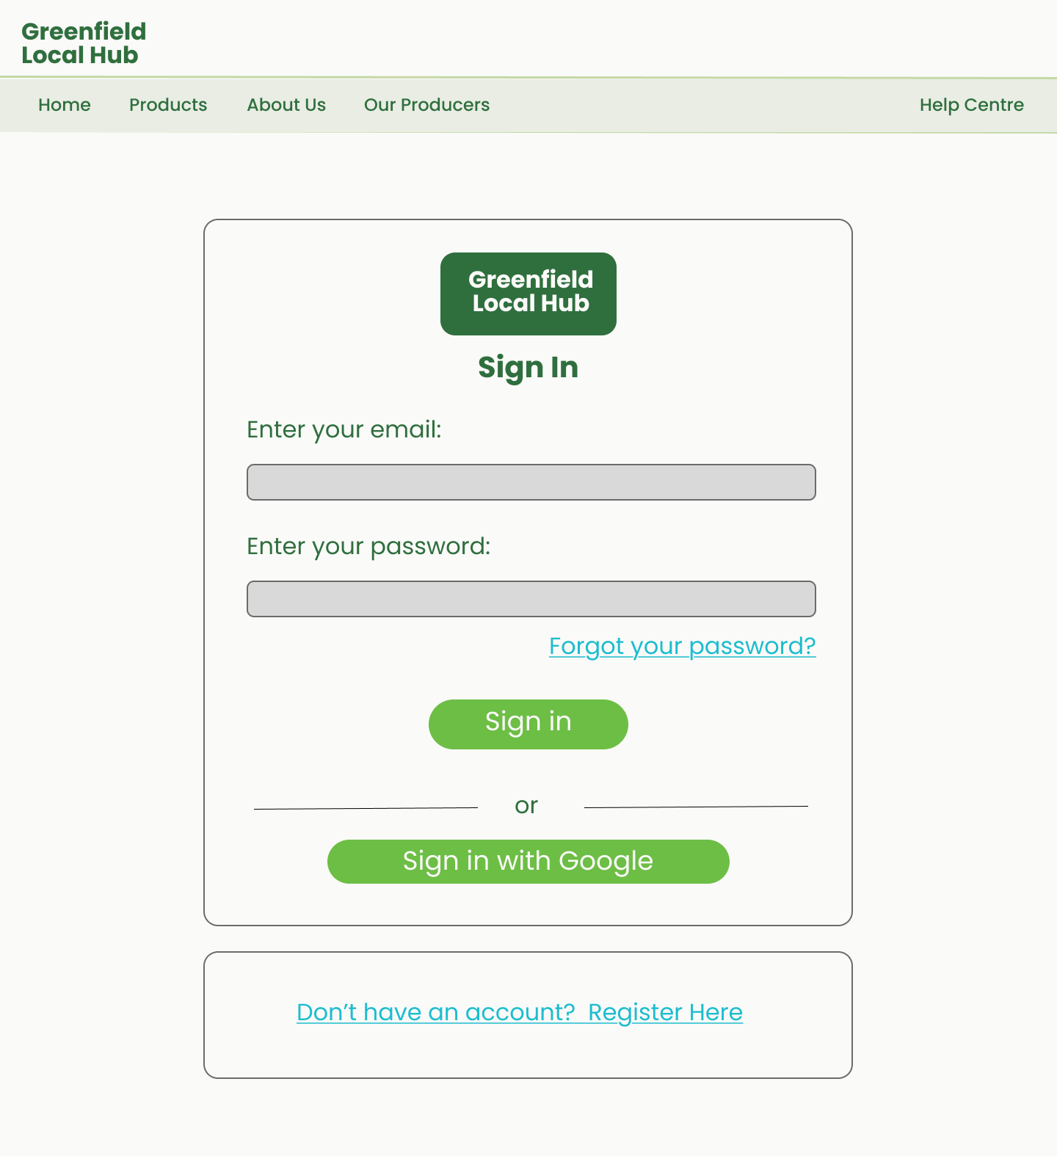
The login form is placed in a centered card container to separate the authentication process from the rest of the website. This follows industry standards for authentication pages helping users focus on a single task without distraction. A centered layout also improves accessibility and works well across different screen sizes. The Login texts contain the same design as the H1 and Body text in the home page. The forgot your password and register here links have the same typography as the body text except I changed the colour into #ADD8E6 and underlined the text so that user will be able to recognise immediately that the text are clickable links. I separated both links so that user won’t mis click which link is for which one. This prevents accidental navigation while still providing a clear path for users who are on the wrong page. Using a button underneath the forms for users to login in so that the users can log in using alternative sign in methods. This follows common authentication patterns seen across modern websites.

Register
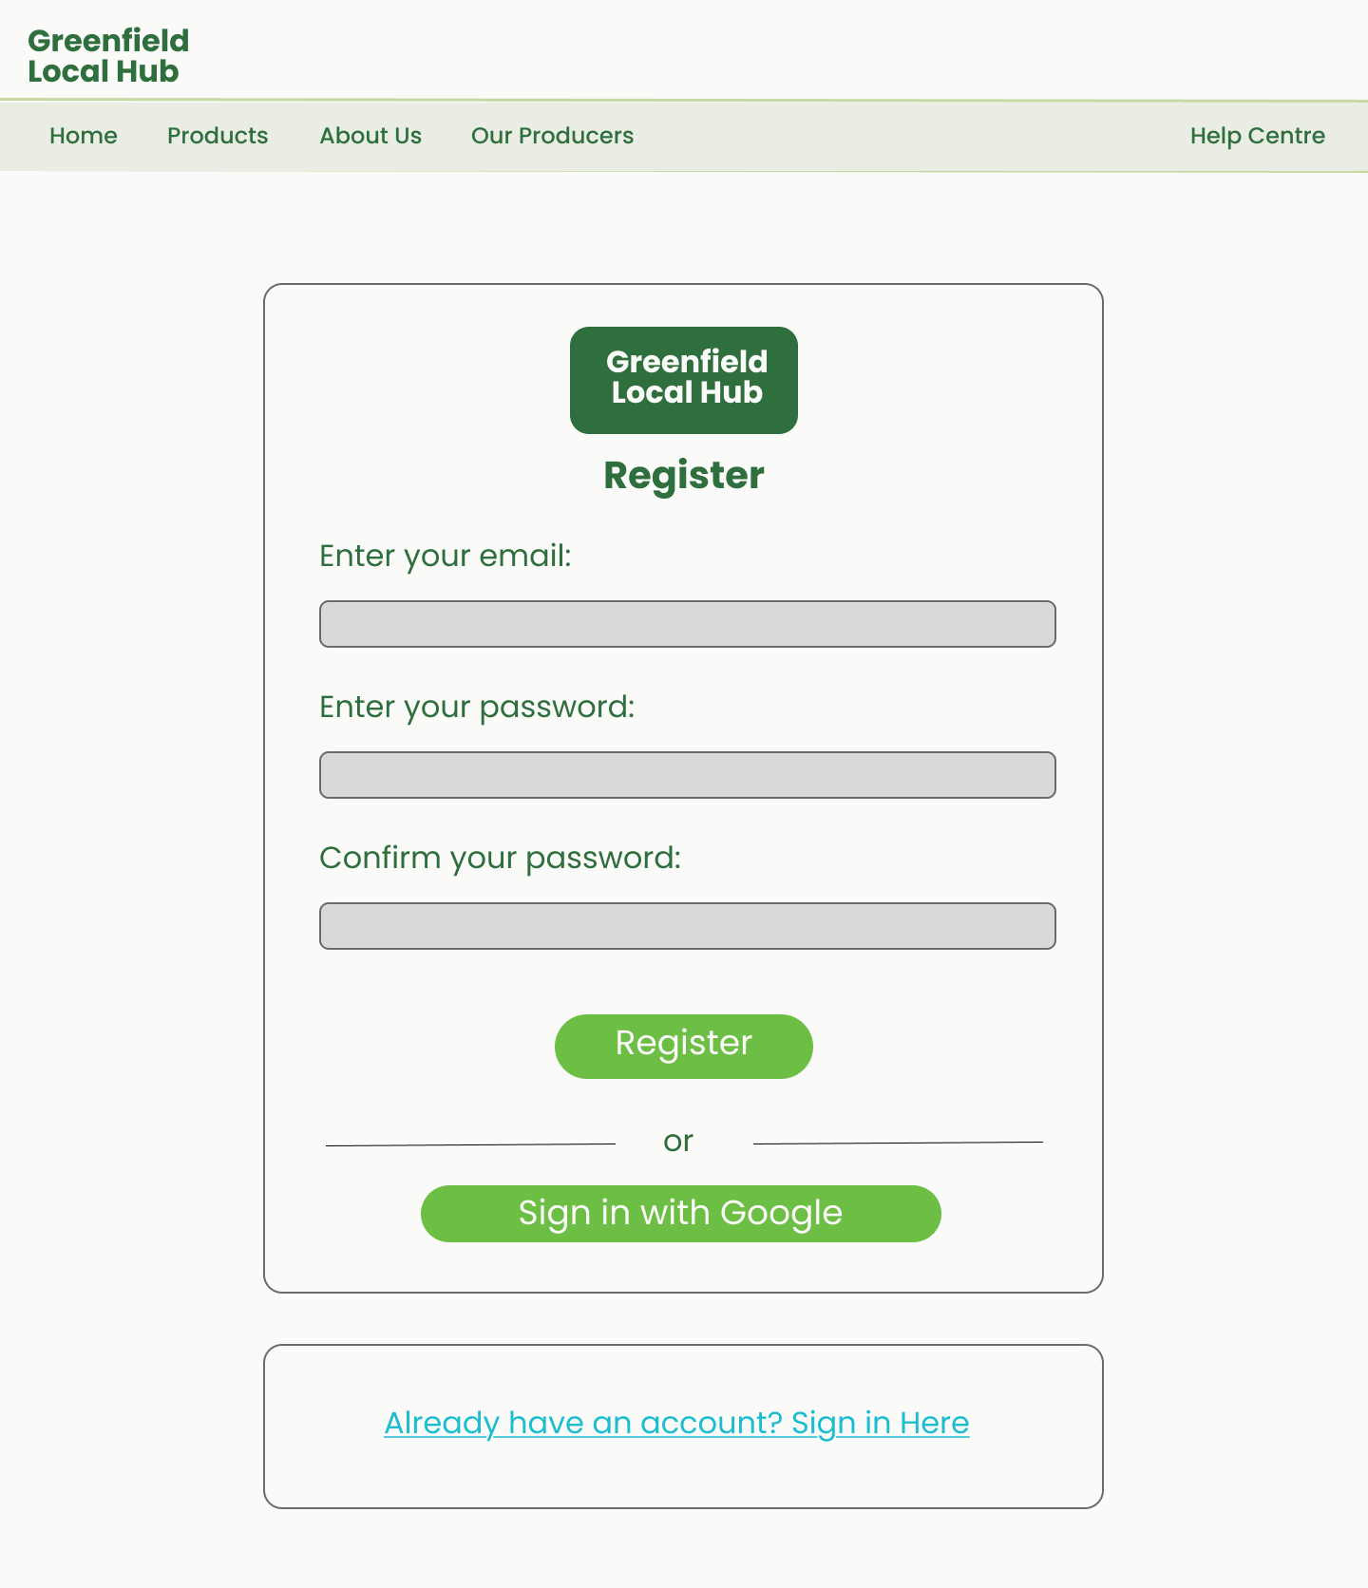
The register form is placed in a centered card container to separate the authentication process from the rest of the website. This follows industry standards for authentication pages helping users focus on a single task without distraction. A centered layout also improves accessibility and works well across different screen sizes. The texts used for the form contain the same design as the H1 and Body text in the home page. The sign in here links have the same typography as the body text except I changed the colour into #ADD8E6 and underlined the text so that user will be able to recognise immediately that the text are clickable links. I separated both links so that user won’t mis click which link is for which one. This prevents accidental navigation while still providing a clear path for users who are on the wrong page. Using a button underneath the forms for users to sign in so that the users can sign in using alternative sign in methods. This follows common authentication patterns seen across modern websites.

Products
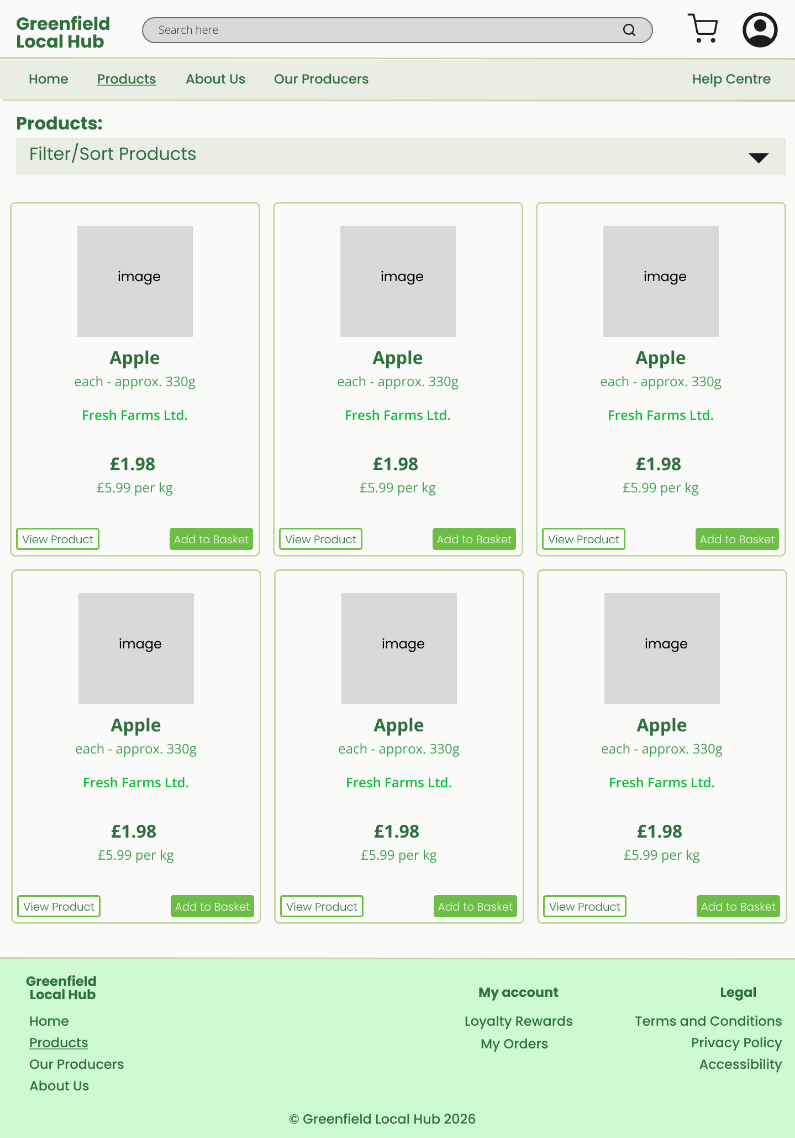
Displaying products in a card format are industry standard as storing products in cards makes it easier for users to scan multiple products quickly which then makes it easier for the users to compare products with one another overall improving the user experience. The cards use a background colour of E9EDE4 and having a stroke of C5D8A4 making it easier to separate the products and have the text in the card clear and visible. For the product name and price, I used Poppins, Medium, font size 28 and colour 2F6F3E so that users will be able to see immediately what the products name and price is. For the producers name I used Poppins, Medium, font size 26 and a colour of 66ff00 to highlight the producer of the product while allowing the user to recognise the text as a clickable link. For the design of the button of the cards I placed both in the bottom as this are common convention in websites in this industry as it improves usability. The design I used for the button is the same as the sign in and register button except I changed the rounded corners of the button into 10 making it better in the cards. The filter and sort features are hidden in an accordion to prevent clutter in the page. This improves the overall user experience of the website.

Producers
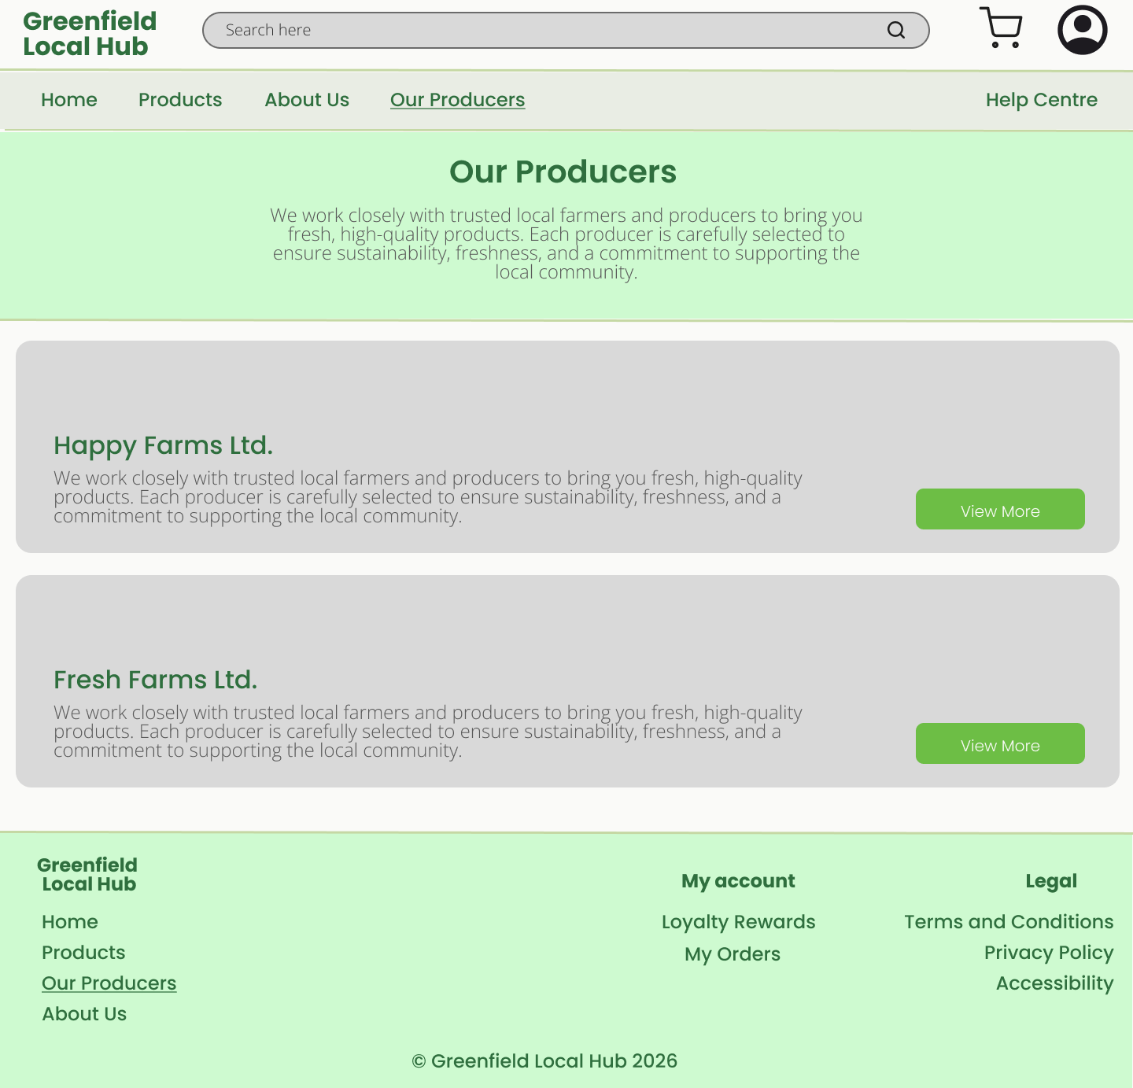
For the producers’ page, I used Poppins, Bold, font size 36 and colour 2F6F3E for the heading of the page this ensures the clarity of the text and readable. This ensures that it can catch the users attention making sure the users know where their current location is. A body text is placed below the header to support the header this help the users understand what the page is about reducing confusion about the page. The body text uses Open Sans, light, font size 20 and colour 595959. This establishes a clear hierarchy between the heading and the body while keeping it clear and visible to the users. This ensures a proper contrast with the background colour of the section ensuring readability and clarity of the text. Each different producer is stored in a wide card layout making it easier for users to scan for multiple producers at the same time. In the card the producers name design is Poppins, Regular, font size 30 and colour 2F6F3E. This ensures that the producers name is clear and readable so that users will be able to find quickly the producer they’re looking for. Below the Producers name is a body text about the producer’s description providing a summary of information about the producer. The body text uses the design Open Sans, light, font size 20 and colour 595959. This helps establish a clear hierarchy between the two while maintaining readability and clarity. Lastly at the bottom left of each cards a button is placed so that the users can click it to more information about the producer. The button uses a background colour of 6DBE45 with the text design being Poppins, Light, size 24 and colour FAFAF8 making sure there is a proper contrast between the text and the background colour. This follows common Ui standards as it improves usability and clarity.

Producer Dashboard
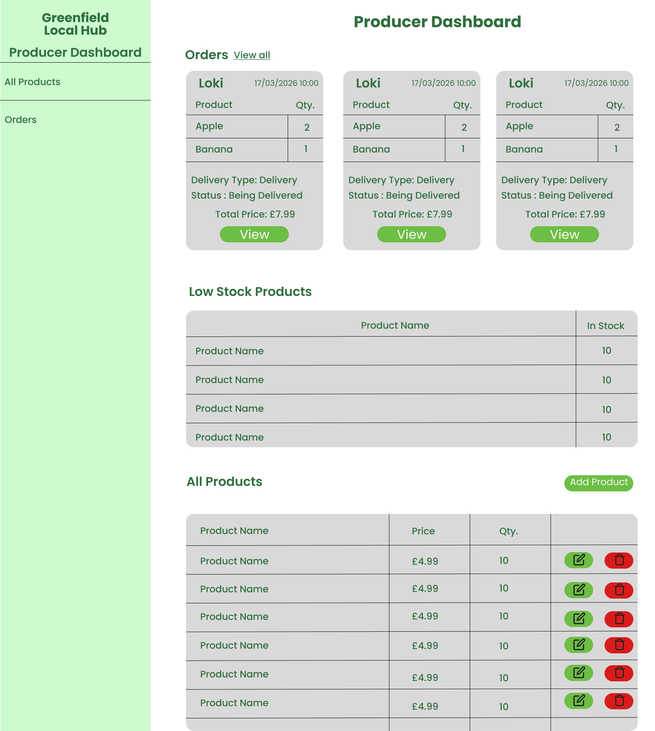
For the producers’ dashboard I used a side navbar so that the producer can quickly navigate each section in the dashboard. For the headers in the page, I used Poppins, Regular, font size 30 and colour 2F6F3E. This ensures readability and clarity of the text helping users recognise important key areas on the page. For the body text and navigational links, I used Poppins, Regular, font size 20 and colour 2F6F3E. This establishes a clear hierarchy between the headings and the body text helping users understand where the content of each heading is in. The header and body text design are what I used throughout the whole page. This follows common web conventions as it improves clarity and readability.
Orders
For the orders for the producer’s product, I stored different orders making it easy for the producer to see multiple orders they have received and to be able to know what are the details of each order. The background colour for each card is E9EDE4. This ensures readability and clarity of the body text stored inside the cards. A small table is shown between the cards so that the producers can see which products and how many does the customer’s order. The table helps in organising the products that the customers ordered improving the cards’ organisation. The view more button design is 6DBE45 with the text design being Poppins, Light, size 24 and colour FAFAF8. This button design is what I used mostly throughout the entire webpage making sure the theme is consistent throughout the website.
Low stock products
The products that have low stocks available in the system is displayed in the dashboard this help producers keep track of their product inventory. The products are stored in a table format with a background colour of E9EDE4. The use of the colour E9EDE4 is appropriate as this provides a good contrast with the body text the page uses. This ensures the readability and clarity of the text.
All Products
The all products table utilises the same format as the low stock products where it’s a table with the background colour of E9EDE4. Storing all the products the user listed in a table format help ensure that the products are properly organised.
The buttons placed on the right side of the table help producers edit or delete their products quickly. The button design for the edit of the products has a background colour of 6DBE45. Meanwhile the delete button colour is B80F0A making it a different colour from the edit one. This help users accidentally clicking the wrong button. This helps clearly separate the two buttons making it easier for users to know which is which. This follows common web conventions improving the usability and navigation of the website.

