Research
Task Brief
You work for a software development company. The company has secured a new contract to develop a digital solution for Greenfield Local Hub. GLH is a cooperative of local farmers and food producers. GLH offers:
- A single location retail outlet for locally produced food and drink
- Collective marketing for local farmers and food producers
- Product management, stock control and product traceability.
GLH would like to develop a digital solution that will:
- Provide information about the producers, their methods and the benefits of buying locally
- Allow customers to:
  - View products with transparent pricing and availability
  - Place orders for collection or delivery
  - Manage their accounts and view order history
- Provide a dashboard to enable producers to manage stock levels, update product details and view orders.
The client has conducted market research with existing customers to identify features that could be included in the digital solution. The features suggested by the client are:
- Order management, scheduling and tracking features
- A loyalty scheme that provides discounts and special offers
- Accessibility features to support a wide range of users

Food and Drinks Market

Sainsbury’s
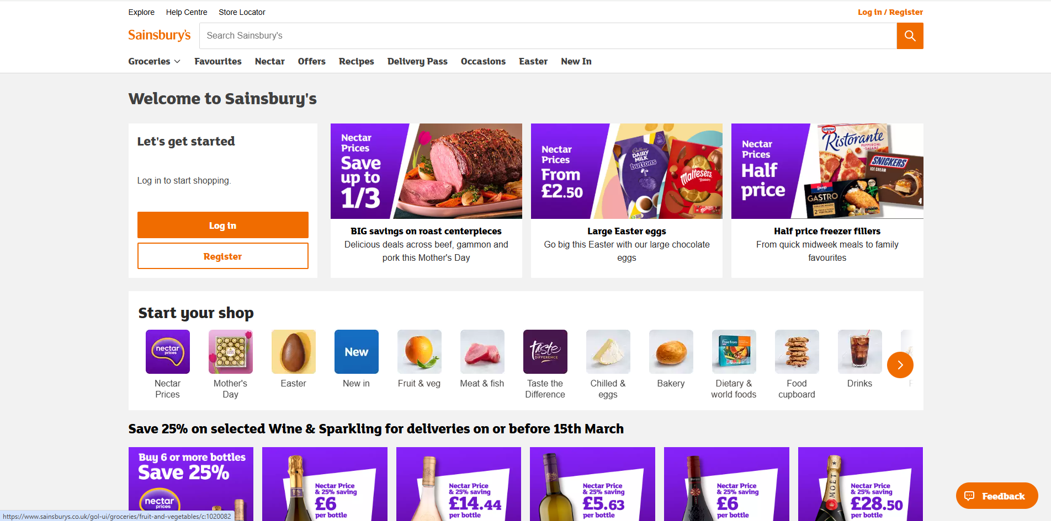

System Requirements
Hardware:
Spec level: The website is optimised for average consumer devices. Works well on typical laptops tablets, and smartphones. Doesn’t require high-spec hardware
Load requirements: Pages load efficiently, no intense graphic or heavy processing
Software:
Compatibility: Compatible across major browsers
Availability: The website is available 24/7, with redundancy systems to prevent downtime.
Tech: Most likely uses HTML5, CSS3, JavaScript frameworks
Overview of the features
Target Audience:
Primary: Grocery shoppers in the UK, both in-store planners and online buyers
Generic Features (Common for Grocery Websites):
Product search and filtering
Online shopping cart and checkout
Delivery and click-and-collect options
Customer account management (order history, saved addresses)
Promotions, offers, and loyalty program integration (Nectar points)
Unique Features on Sainsbury’s:
Nectar Points Integration: Users earn loyalty points directly through the website and app.
Recipe Integration & Meal Planning: Offers curated recipes with ingredients that can be added to the cart instantly.
Smart Reordering: For repeat purchases, users can quickly reorder previous items.
Dietary and Lifestyle Filters: Filters for vegan, vegetarian, gluten-free, low-calorie, etc., which streamline product discovery.
Newly Emerging Technologies
AI – Product recommendations, smart search, and predictive basket suggestions. AI also powers customer service chatbots.
Touch based Interface – Optimised for smartphones and tablets with responsive design
User Interface
Overall Look:
Clean, minimalistic, and user-friendly layout. Clear categorisation of products and sections.
Colors:
- Main palette: Orange, White, Green, and Black.
- Orange is used for CTA (Call-to-Action) buttons like “Add to Basket,” which draws attention effectively.
- White space improves readability and reduces visual clutter.
Graphics:
- Images: High-quality product images with zoom functionality.
- Videos: Short recipe videos and promotional clips.
- Animations: Subtle hover effects on buttons and menus; smooth scrolling.
Fonts & Styling:
- Simple, sans-serif fonts (like Helvetica or Arial style) for clarity.
- Font sizing is readable on all devices, with hierarchy for headings, subheadings, and body text.
Language:
- Friendly, concise, and persuasive. Clear product descriptions, easy-to-understand instructions for checkout, delivery, and loyalty points.
Evaluation:
- UI is effective. Visual hierarchy, color contrast, and navigation enhance usability. Occasional busy pages with too many offers can be slightly overwhelming.

Security and Legal
Security:
- Login Systems: Secure login with email/password; optional multi-factor authentication (MFA) for app users.
- Data Validation: Payment and personal data validated via HTTPS, ensuring encryption.
- Cookies: Used for personalization, session tracking, and analytics; cookie consent is requested at first visit.
- Data Storage: Complies with standard e-commerce practices; data encrypted and stored securely.
Legal:
- Data Protection: Complies with UK GDPR standards; privacy policy clearly outlines data usage.
- Images and Videos: Most media is proprietary, or rights are obtained; credits or acknowledgements for third-party content when used.
- Copyright Compliance: Sainsbury’s avoids legal issues by using licensed images, promotional material, and recipe videos.
Evaluation: Security and legal compliance are robust, building user trust for online transactions.

ASDA
System Requirements
Brief introduction to level of hardware and software being used
- High spec or low spec hardware
- Compatibility, Availability
Overview of the features
- Target Audience
- What the features are generically
- Then, what is unique features
- For those unique features – I want you to evaluate them
- Mention how they use these features to meet user needs
Newly Emerging Technologies
- What technology do they use? – E.g – VR, AR, AI, Voice Based systems, Smart Devices, 3D Printing, Touch based interface
- How do they use it?
- Is it effective?
User Interface
- How it looks – Is it good, bad, effective and say why
- The colours they use
- The Graphics they use – IMAGES, VIDEOS, ANIMATIONS
- The font styles and sizing
- The Language they use
Accessibility Features
- What accessibility features – Change text size, background colours, text to speech,
- Help tools – Chat bot, FAQ, Guide to using the website
- Is it effective?
Security and Legal
- Security – Login Systems, Verifying Emails, Validation, How our data is being stored, Cookies

- The cookies have been explained clearly in their cookie policy page
- For users’ personal data it’s explained what personal data is, what data they hold, how they use data, etc. in your data at a glance page.
- Legal – Data Protection, Images and Videos used , did the break copyright or have they acknowledged where it originated or did they use their own videos and images.

