Yt-dlp-tk
Tk-Based Interface For Yt-dlp

ABSTRACT
A graphical user interface (GUI) which with Yt-dlp as the backend. The interface is divided into tabs, each specializing in a particular function.

Synopsis
Yt-dlp-tk is a graphical user interface (GUI) for the Yt-dlp Python package. Yt-dlp has a command-line utility but is actually a Python package. This interface is written in Python and uses this package.

User Interface
Yt-dlp-tk is a graphical user interface (GUI). When it’s first opened, the user is greeted with the “Download” tab, where they can search up a video by URL and then download it.

Technical Specification
Yt-dlp-tk is a Python package that can be called on the commandline. It uses the Model-View-Presenter (MVP) architecture.
The View is a class called YtdlptkInterface. One of the methods creates the interface; it is called in the main function. It uses a combination of native Tk widgets and some custom ones. The Model and Presenter are both classes of the same names.

Signals
Signals implement the observer pattern. In this case the observer is whatever object decides to hold signals inside itself. Signals are implemented in the signal class in utils, and observers are defined with the observer protocol under the same module.
And object which uses a signal is called its owner, and whichever object is connected to it is called the observer.

Interface Widgets
The interface module defines some custom widgets that are extensions to preexisting ones. These so-called mega widgets are composed of a frame with the actual underlying widget inside, along with some other potential widgets.

Loading and Saving Settings
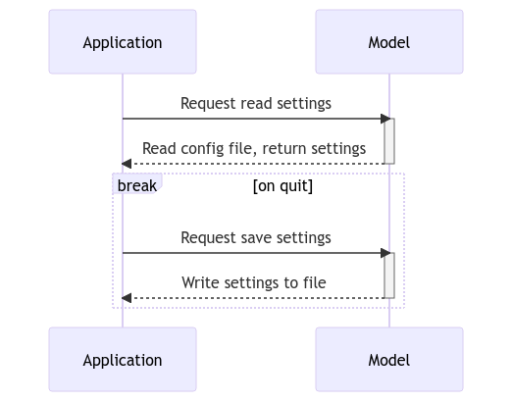
When the application loads, it asks the Model to read a configuration file and return the settings as some kind of data structure. When the user quits, the application asks the Model to save the settings to the configuration file.
The reading aspect can be controlled by the Presenter; that is, it can ask the Model to do it rather than the Model doing it automatically.
Reading: To load a configuration file, the Model first needs to know where to find it. Using a library, it finds the user-specific configuration directory. After finding the file, it is read and a configuration file parser is created.
A data structure is returned containing values defined in the configuration file. If any of the settings options are undefined or invalid, sensible fallbacks are used instead.
If the configuration file does not exist, then default settings must be used.
Writing: To write a configuration file, a path is decided; this is done in the same way as when reading the file. Something that is not shown in this graph is the application getting a data structure from the View and sending that to the Model. Just like when reading the configuration file, if any of the settings given by the interface is invalid or missing, they are replaced with sensible fallbacks.

