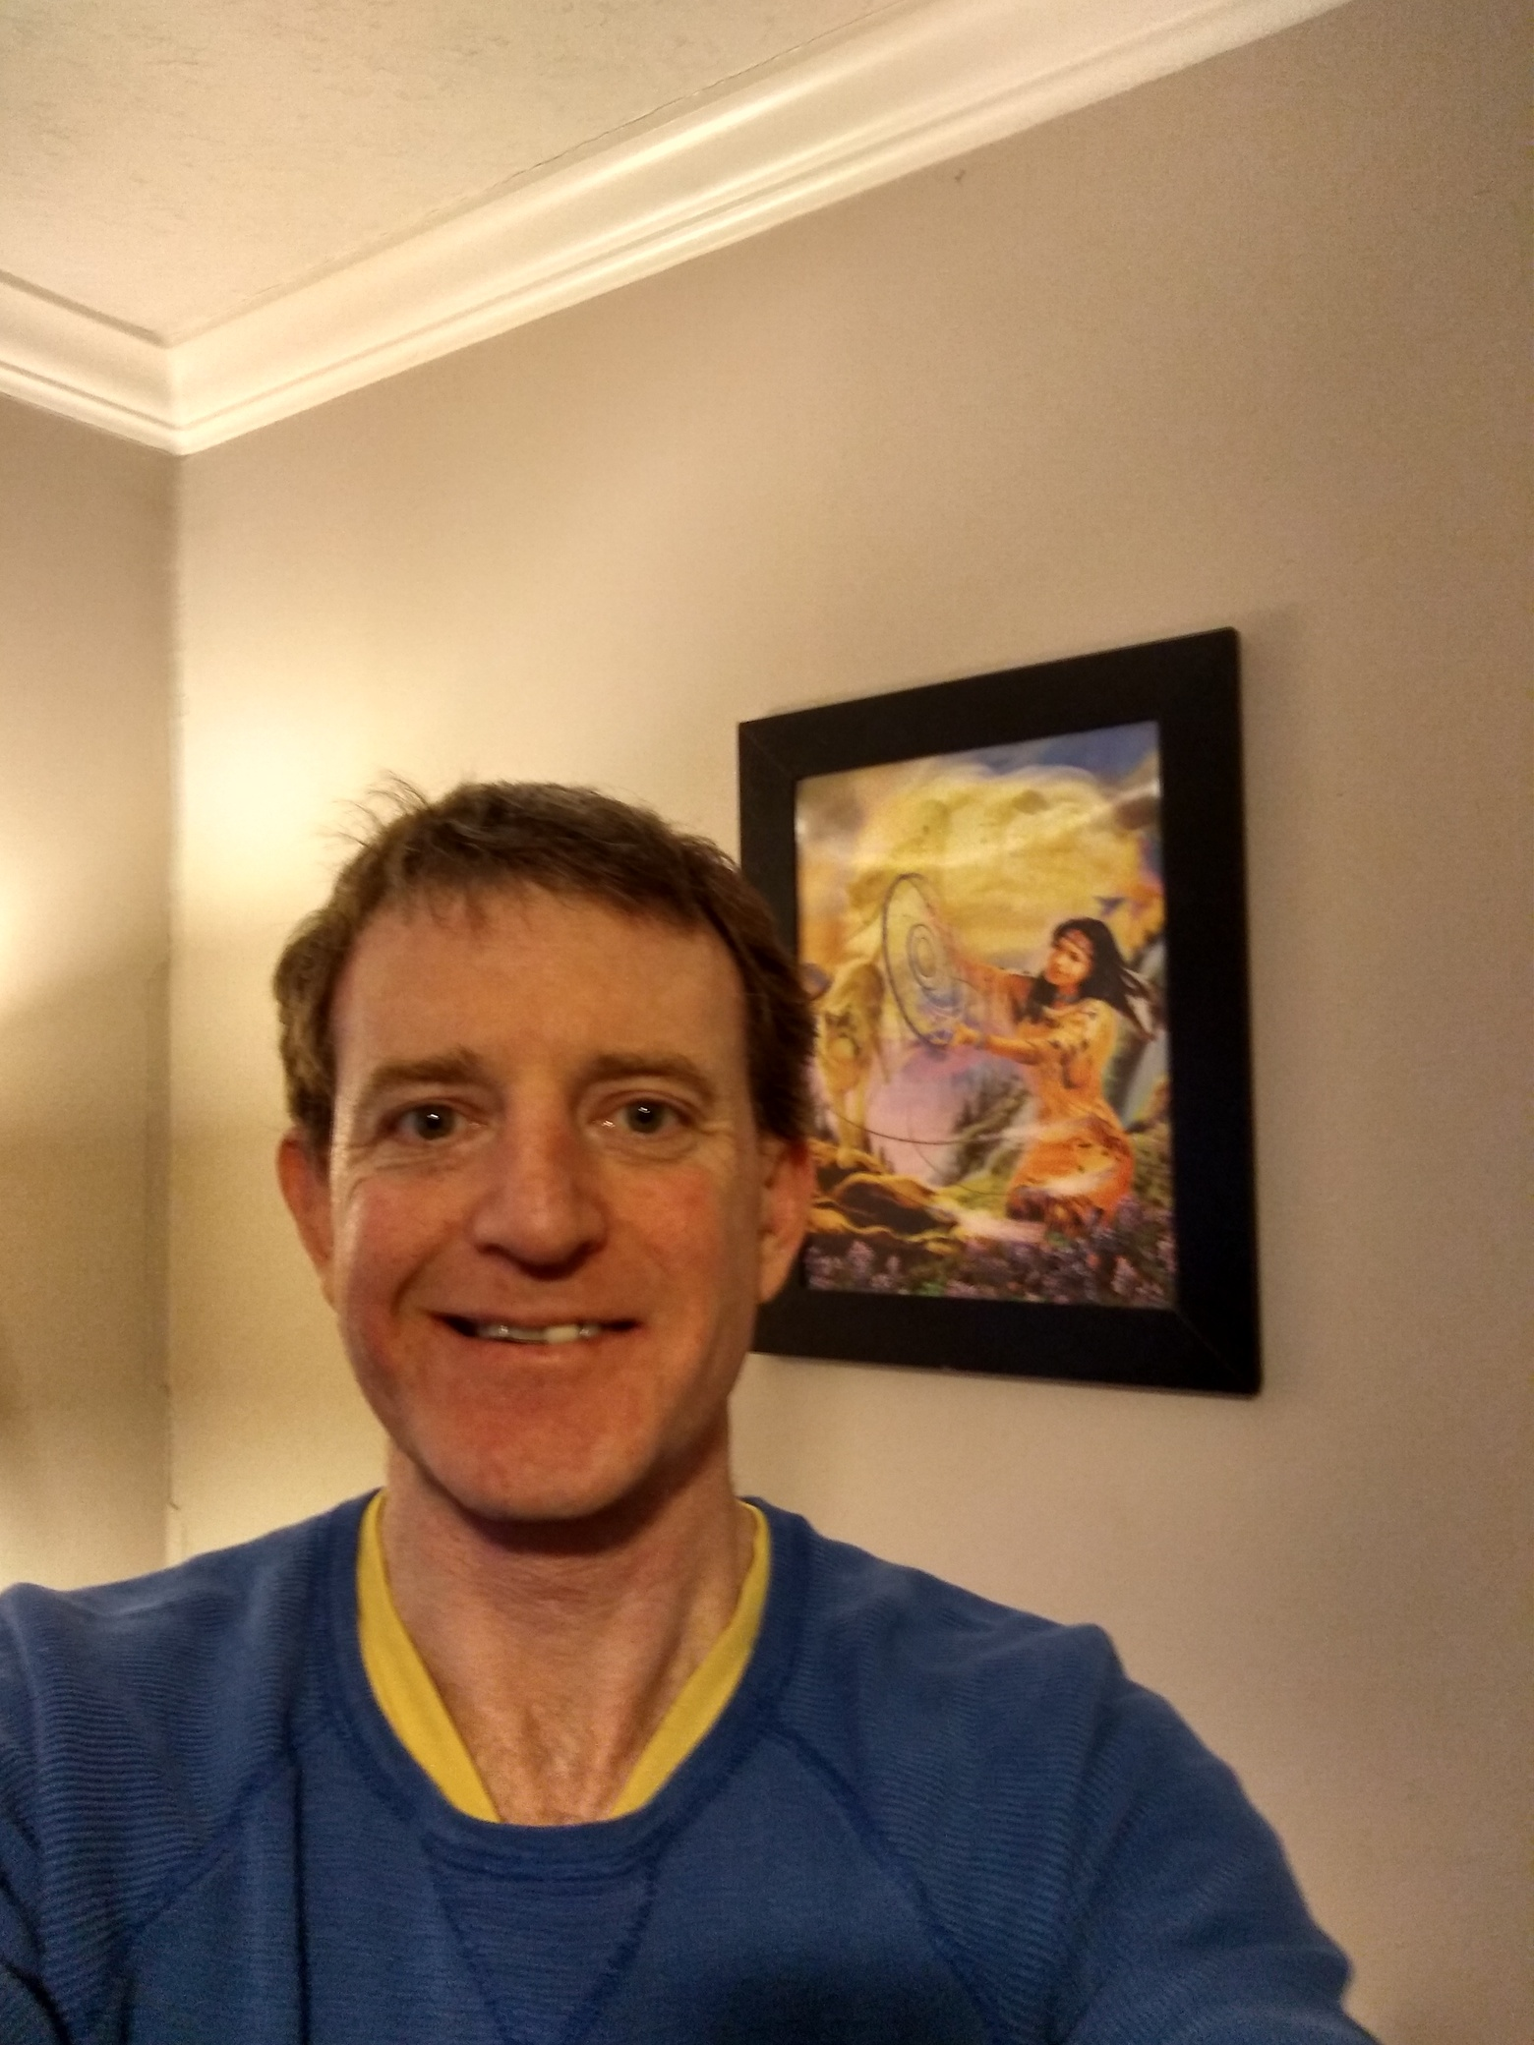
John Edgar Flaherty IV
1.502.419-4058
JohnEBoyBaby@yahoo.com

EDUCATION

1999 CUM LAUDE, B.S. Computer Science, 3.2/4.0, The Citadel, citadel.edu
1996 SUMMA CUM LAUDE, B.S. Business Management, 4.0/4.0, Brenau University, brenau.edu

HONORS

Name on the wall at Naval Justice School, Newport, Rhode Island as top graduate, 1992
Navy Commendation Medal(1), U.S. Navy, 1994
Navy Achievement Medal(4), U.S. Navy, 1990,1992,1999, 2000
Presidential Commission as Naval Officer, U.S. Navy, 1999
President of Phi Theta Kappa, Georgia Military College, 1994-1995
Academic Honor Member of Alpha Psi Nu, Brenau University, 1995-1996

EXPERIENCE

11/2017 to present
Independent Consultant/Admin in Real-Estate Sector/ExloringLouisville.com
Software Engineer
Louisville Kentucky
Maintained, enhanced & developed for my own startup company and do work for my family's real-estate business primarily using Python 3, ASP.NET 4, C#.net, VB.net, Javascript, jQuery, HTML5, CSS3D, SQL Server, SQLite, and third-party web services APIs. Handle LISTING to CLOSE entire process and CONTRACT to CLOSE entire process for a team of real estate agents as well as other technical software ideas and technologies they and I find for us to KEEP OUR SINCERE, RESPECTFUL, PUREHEART IN TRUTH WITH G_D “TOTAL COMMITMENT AND NOTHING LESS” PROMISE we truly do mean to all sellers and buyers, clients. I AM A MOST SERIOUS ONE, but I AM funny but I AM TRUTH so if you are not telling the 100% TRUTH or will play favorites, family, friends, or make exceptions for TRUTH then pass me by we will not see eye to eye. My name is on the wall at Naval Justice School, Newport, Rhode Island, ameriQa. “FEEL ME”. I lost 2 little girls in the Philippines Meldi at 11 and Mari at 22 and it hurt and still hurts; a most serious one AM I. “CAN YOU FEEL NOW?” Seriously, I AM PUREHEART AND I AM FUNNY BUT TRUTH IS A MOST SERIOUS MATTER AND I PROTECT G_D LIKE AN INFANT ATTENTIVE TO G_D TO TRUTH TO PUREHEART LOVING KIND LIKE AN INFANT. You can smile and shake your head now. Love you tQQ. :-)

3/2017 to 11/2017
Rainbow Design, LLC.
Software Engineer
Louisville Kentucky
Developed bug fixes and enhanced existing web based desktop solutions used throughout the telecommunications and fiber network maintenance industries working with various technical support teams as well as multiple levels of management.
Primarily developed desktop and mobile web based solutions using ASP.NET 4.5 MVC, Entity Framework, SQL Server stored procedures, Visual Studio 2012, Team Foundation Server, C#.NET, JavaScript, jQuery, jQuery DataTables, Twitter Bootstrap, SignalR, AJAX, CSS and HTML5 technologies.

4/2016 to 3/2017
Independent Consultant
Software Engineer
Louisville Kentucky
Maintained, enhanced & developed new use cases, prototypes, tests, and production code using ASP.NET 4, Javascript, Interact, HTML5, SQL Server, SQLite, and web services APIs for various local and web clients.

10/2014 to 4/2016
Altec Industries, LLC.
Software Engineer
Elizabethtown Kentucky
Developed new mobile web-based applications using ASP.NET 4.0, then to the Microsoft Entity Framework, Visual Studio 2010, SQL Server 2005, C#.NET, JavaScript,AJAX, CSS & HTML.
Maintained, enhanced and fixed numerous bugs in existing VB.net WPF application used throughout the manufacturing plant.
LEAD Developer responsible for architecture, planning, communication between all levels of management and training college interns and mechanical and industrial engineers on use of applications as well as teaching hows/whys of software development.
Wrote and enhanced SQL Server stored procedures as well as interfaced with various MS Access databases and MS Excel spreadsheets used throughout the plant by various departments.

1/2012 to 10/2014
Ford Motor Company
Software Engineer
Louisville Kentucky
Re-wrote Ford's Worldwide Manufacturing Quality Control (QC) in many languages (Portuguese, Chinese, Thai, etc.) upgrading code from VB6 to VB.net 2.0.
Wrote new as well as maintained and enhanced existing Oracle database procedures.
Reverse engineered old VB6 COM components and re-wrote them in VB.net 2.0 with an Oracle backend.
Performed Quality Assurance tests daily on other developer’s code prior to production check-in.
Architected and implemented new web-based solutions after the major re-write was finished.

1/2011 to 1/2012
PetFirst Healthcare
Software Engineer
Jeffersonville Indiana
Upgraded an existing, large, multi-project complex solution in ASP.NET 1.1 to ASP.NET 4.0 singlehandedly.after only 3 months on the job.
Participated in complex transition from SQL Server stored procedures to a Microsoft Entity Framework based solution during major re-write of the pet insurance application.
Primarily developed using Visual Studio 2003 and 2010, SQL Server 2005, and C#.NET, JavaScript,AJAX, CSS and HTML technologies.

4/2009 to 1/2011
Independent Consultant
Louisville, KY
Software Engineer
Developed REST-based, multimedia software system, interfaced with MLS Real Estate data and industry professionals. Utilized Visual Studio 2010, Silverlight 4.0, ASP.NET 4, HTML4, Javascript, CSS, and various commercial APIs.

7/2008 to 3/2009
Allscripts
Chicago, IL (worked REMOTELY from Louisville, Kentucky/Chicago Illinois
Software Engineer
Re-wrote the entire Imaging Record Auditing system which integrated as a software application within multiple of Allscripts's Electronic Health Records solutions used by thousands of independent medical doctor offices and large metropolitan hospitals.
Developed C#.NET 2.0, SQL Server 2005 T-SQL complex stored procedures, VB6 COM components routinely to address bug fixes and enhancements to specifications.
Interacted frequently with the technical support call center staff and project managers, release coordinators, business analysts, testers, directors, and other business-related personnel.in order to learn how systems work and interoperate with one another.
Learned and maintained various database schemas related to individual hospital and doctors' offices as schemas changed based on each doctor’s and each hospital’s independent needs requiring often the dropping of some database tables, creation of new database tables and re-writing stored procedures to correctly interoperate with the revised database schema.

1/2008 to 7/2008
Kindred Healthcare
Louisville, KY
Software Engineer
Developed in C#.NET 1.1 and .NET 2.0 routinely to address bug fixes and enhancements to meet software design and functional specifications for a medical accounting/time management/claims processing solution as well as a large web-based technical support project..
Enhanced Classic ASP 3.0 along with the Javascript and VBScript on the client side as well as the VB6 COM components and T-SQL stored procedures on the server side in order to maintain and enhance a technical support call center application.
Interacted frequently with project managers, release coordinators, business analysts, testers, directors, and other business-related personnel to find workable solutions.
Collaborated with .NET developers, Quality Assurance Testers, Database Administrators, Production Release specialists to solve Point-Of-Care (POC) system and reporting issues.
Learned and interoperated with five main database models for each of the five main database systems utilized for each independent part of the larger project: Accounting, Time Management, Claims Processing, Technical Support, and Reporting.

8/2007 to 12/2007
Flextronics International Ltd.
Louisville, KY
Software Engineer
Utilized .NET 3.0, WPF, LLBL Gen Pro, Smart Client Software Factory May 2007 release, Infragistics 3rd Party WPF controls, and various Microsoft Enterprise Library modules.
Developed using LLBL Gen Pro to generate an object-relational-model that corresponded to the SQL Server 2005 data model that served as the data access layer for the application being developed.
Developed a custom barcode label printing mechanism that worked with the Zebra ZM6 Plus barcode label printer and WASP 39 M code 39 barcodes that worked in a touchscreen graphical user interface environment using .NET 2.0, but without the use of the standard Windows PrintDialog control.
Developed a custom OpenFileDialog control that worked in a touchscreen graphical user interface environment without the use of the standard Windows OpenFileDialog control.
Worked long hours often 30+ hours of overtime each week to ensure deadlines were met collaborating with various database programmers of the enterprise-level MARC and BAAN manufacturing/purchasing systems as well as smaller Java-based, Visual BASIC 6.0-based, Visual BASIC for Applications-Excel-based and Visual BASIC for Applications-Access-based systems utilized at various local sites in order to analyze what specific functionality needed to be configurable and what information could be obtained from pre-existing database systems.
Communicated daily with various business analyst as well other internal IT, manufacturing, engineering personnel in order to analyze business rules, user interfaces, data model issues, what needed to be configurable as well as assisting with User Acceptance Testing (UAT) on the dock during pre-production testing.

Humana
Louisville, KY
Software Engineer
Worked with VB .net & C# .net 2.0 as well as Classic ASP version 3.0, JavaScript, XSLT, HTML 4, and Single-Sign-On Security COM components written in Visual BASIC version 6.0
Debugged and fixed numerous production code COM components written in Visual BASIC version 6.0
Enhanced numerous production code GUI pages written in Classic ASP version 3.0, Javascript, and XSLT as well XHTML 1.0 and/or HTML 4 and T-SQL SQL Server 2005 stored procedures.
Learned and operated numerous internal Intranet software utilities utilized to configure enterprise level settings communicating with various internal personnel in order to procure User Acceptance Testing (UAT) certification for all code changes prior to production deployments.
Entrusted with the enterprise level production turn process involving communication at various levels from configuration to quality assurance testing to production code issues with personnel in the IT Security department as well as Web Turns department.
Drafted technical correspondence outlining specific procedures for other consultants that will assume a similar role so that knowledge transfer and a standardized turnover strategy will exist into the future explaining step-by-step how to accomplish from assignment to acceptance correct software maintenance within the organization.

9/2005 to 3/2007
State of Kentucky Transportation Cabinet
Frankfort, KY
Software Engineer
Implemented Oracle PL-SQL backend with ASP.NET 1.1 and 2.0 C# with an ASPX, ASMX, HTML4, XML front end using HTTPS/Secure Sockets Layer and various cryptopgraphic algorithms: AES, RSA, DES3 encryption/decryption and SHA hashing as well as ASPNET_REGIIS.EXE to protect the web.config connection strings section.
Developed using a myriad of pre-written use cases to write from scratch a complex relational-data-driven software system, Environmental Analysis and Tracking System, for the State of Kentucky's Transportation Cabinet in less than one year.
Broke new ground as the sole implementer of the first official Environmental Tracking and Analysis System (E.A.T.S.) that exists among the 50 state governments in America.
Implemented various security algorithms and authentication mechanisms including HTTPS/Secure Sockets Layer, AES, DES3 and RSA to include Protected Configuration Provider, ASPNET_REGIIS.EXE.
Successfully transitioned from Visual Studio 2003/ASP.NET 1.1 to Visual Studio 2005/ASP.NET 2.0 during the development of the Environmental Analysis and Tracking System.
Wrote a custom TreeView control tied to a PL-SQL database-driven using an XML approach.
Creatively architected and wrote new functionality to allow system administrators to dynamically add/edit/delete database fields on the fly, dynamically position associate input controls to their liking, and dynamically associate newly defined fields relationally to other non-dynamic, constant, pre-defined database fields.
Communicated routinely with the State of Kentucky's security experts, database administrators, system administrators, business analysts, data modelers, Business Object integrators, Crystal Reports integrators and the Director of the Division of Environment Analysis, Railroad engineers, Archeologists and Geologists to ensure that all parties were kept up to date of appropriate system. architecture and implementation details
Setup a new training program to assist other developers on staff and maintained responsibility for the successful training of several experienced programmers transitioning from an Oracle Forms and/or Clarion development environment to a C#.NET development environment.

4/2002 to 9/2005
Segrest Investments, Inc. / Mortgage First, Inc.
Louisville, KY
Software Engineer/Real Estate Assistant/Loan Officer
Developed solutions using SQL Server and XML backends with ASP.NET 1.0 middle tier business logic and HTML, Javascript, CSS frontends primarily focused on interfacing between Real Estate agents and Load Officers to assist in getting MLS listings into the MLS system, uploading and upgrading photos for home listings and scheduling client meetings with Loan Officers and Closing Attorneys.

9/1986 to 4/2002
US. Navy
Various worldwide assignments
Personnelman, Legalman, Naval Engineer, Naval Navigation, Surface Warfare Officer, Anti-Submarine Warfare Officer, Public Affairs Officer, Physical Readiness and Training Officer

