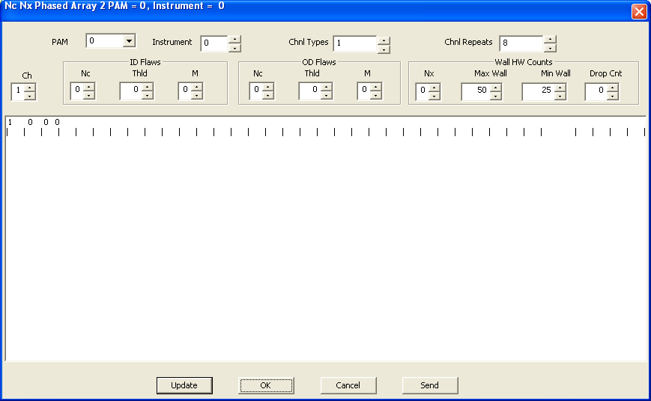

void CNcNx::OnBnClickedBnUpdate()

{

// TODO: Add your control notification handler code here

CString s,t,u;

int nTab = **15**;

int nErrCnt = 0;

if ( (m_nChnl < 1) || (m_nChnl > 8) )

{

MessageBox(_T("Invalid Channel Number - correct and then resubmit"), _T("Input Error/n"), MB_OK);

return;

}

if ( (m_nNcId == 0) || (m_nNcOd == 0) )

MessageBox(_T("Nc = 0 means not a flaw channel"), _T("Input Warning/n"), MB_OK);

if (m_nNx == 0)

MessageBox(_T("Nx = 0 means not a wall channel"), _T("Input Warning/n"), MB_OK);

// t = _T(". . . . . . . . . . . . . . . . .");

m_lbOutput.SetTabStops(nTab);

t **= _T("|\t|\t|\t|\t|\t|\t|\t|\t|\t|\t|\t|\t|\t|\t|\t|\t|\t|\t|\t|\t|\t|\t|\t|\t|\t|\t|\t|\t|\t|\t|\t|\t\t|\t|\t|\t|\t|\t|\t|\t");**

s.Format(_T("%2d %d %3d %d"), m_nChnl,m_nNcId, m_nThldId, m_nMId);