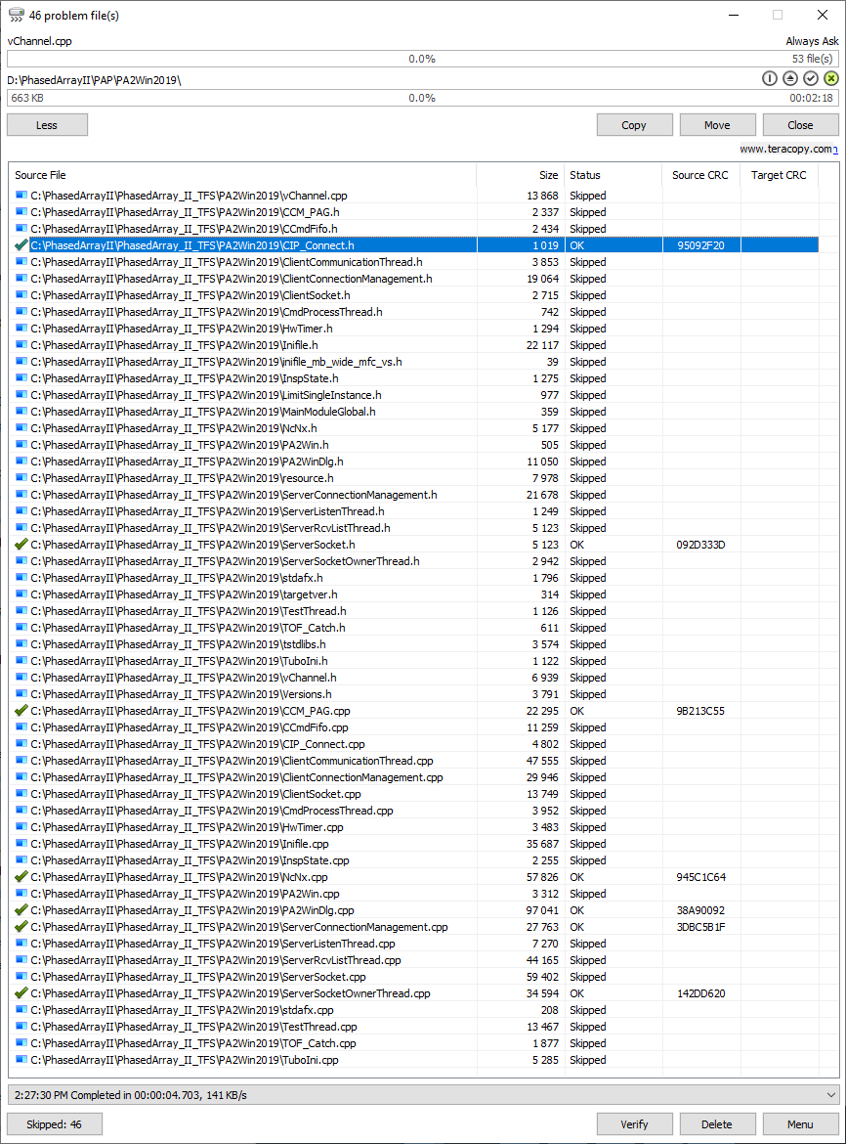
9/29/2020 C++/header files from PAP. Location:C:\PhasedArrayII\PhasedArray_II_TFS\PA2Win2019 – Corvalent Win10

