CS ELEC 6 – Introduction to Cognitive Computing
Prefinal-Final-Final Project Proposal
COGNITIVE CAMPUS ASSISTANT
An Enrollment Requirements and Student Services Advisor for GRA SCHOOL Registrar’s Office
Team:
Mirabete, John Earl C.
Napili, Tristan
Knowledge and conversation
Data and learning
Integration and interface
Perception and analytics
BSCS, School of Engineering and Computer Studies · CS4-A · 1st Semester, AY 2026–2027
Instructor: Neal Errol K. Bulawan

PART 1: THE SITUATION

1. Title Page
Ask anything about enrollment, requirements, fees, clearance or your documents. Answers come from the GRA SCHOOL - Registrar's Office rule base and knowledge base, with a confidence score and the source shown.

2. The Situation
The place and the people. The Registrar’s Office of Gra School serves freshmen, transferees, and returning students every enrollment period. Two to 2 staff members answer questions at the window, by Messenger, and by phone. Most of the answers are already printed in the student handbook and on posted announcements, but students still ask staff in person.
How the work is done today. A student joins the queue, states the concern, and the staff member recalls the requirements for that type of student, checks the documents the student carries, and tells the student which window to visit next. The same steps are repeated for each student.
What goes wrong. The team’s observation as clients of the service (to be completed with the numbers collected) points to these problems:
- Repeated questions: the same five or six questions (requirements, schedule, fees, clearance, office hours) make up most of the queue.
- Inconsistent answers: different staff members or older posts give different wording or outdated dates.
- Wasted trips: students arrive with incomplete documents and are sent back.
- Staff overload at peak days, with no record of which questions are most common, so staff cannot plan ahead.
Evidence the team collects (public information and own experience only) | Value
Queue observations (number of visits, date, time of day) | [n visits; dates]
Average waiting time observed | [minutes]
Share of questions that were repeats of the five common topics | [%, from n questions noted]
Number of times a student was sent back for missing documents | [count]
Source of each number | [team log, date, who recorded]

3. Users and Their Needs
Role | User story
Freshman | As a freshman, I can ask what documents I need to enroll so that I do not make a wasted trip.
Transferee | As a transferee, I can tell the assistant what documents I already have and learn exactly which are missing.
Returning student | As a returning student, I can ask about clearance steps and deadlines so that I enroll on time.
Any student (Filipino or English) | As a student, I can type a question in English, Filipino, or Taglish and receive an answer; the separate Voice page records or plays back audio without speech-to-text.
Any student | As a student, I can see why the assistant gave an answer and reach a real staff member when it is unsure.
Registrar staff | As a staff member, I can see which questions are most common and which the assistant could not answer, so that I can update announcements.
Registrar staff | As a staff member, I can see a staffing or announcement recommendation together with its evidence and confidence before I act.
Office head | As the office head, I can see weekly volume and feedback trends and a forecast of the next week.

4. Human Task Model
One member role-plays the staff member and handles one typical request aloud (“Can I enroll? I am a transferee and I have my TOR”) while another member records the think-aloud. The steps below are a draft that the team must replace and confirm with its own recording.

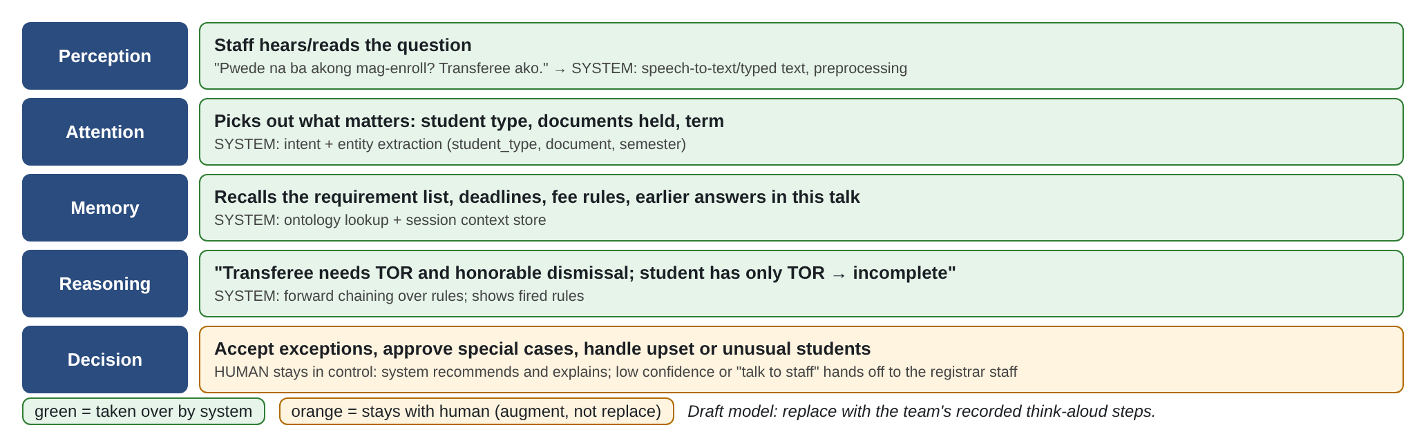
Figure 1. Human task model (perception, attention, memory, reasoning, decision). Green steps are taken over by the system; orange stays with the human.
The system takes over the repetitive recall and checking work (steps 1–4). The human keeps the decision: exceptions, special cases, and upset students stay with the registrar staff. The design therefore augments the staff rather than replacing them.

PART 2: THE PROPOSED COGNITIVE SYSTEM

5. System Overview and Why It Must Be Cognitive
Cognitive Campus Assistant is a web application where students and staff use a typed English, Filipino, or Taglish assistant for enrollment and student-service questions. A separate Voice page records from the microphone or accepts an audio upload and provides playback; it does not transcribe speech. The application has role-based student and staff accounts, an explainable hybrid reasoning engine (forward and backward chaining over 13 registrar rules), student-facing announcements, shared documents and approved knowledge, and a staff workspace for inquiries, question review, content management, and analytics. Student and staff account records can use Supabase PostgreSQL when DATABASE_URL is configured; other application content still uses local files.
Characteristics needed.
- Interactive: it asks clarifying questions when the question is unclear or a fact is missing.
- Iterative and stateful: it remembers the student type and documents already mentioned during the session.
- Contextual: answers depend on student type, term, and language (Taglish), not only on keywords.
- Adaptive: the intent model is retrained from the failed-query log so that it improves with use.
Why ordinary software is not enough. A fixed menu or keyword search fails on varied phrasing and mixed language, cannot give a confidence score, and cannot learn from missed questions. A conventional program also cannot weigh uncertain evidence for a staff recommendation. At the same time, the enrollment policy is fixed and must be auditable, so the decision part uses explicit rules, and the language part uses a trained model. Combining both is what makes the system cognitive rather than a plain FAQ bot.

6. Features and Scope
Will build (3 weeks, 2 members) | Will not build
F1 Student self-registration; role-based student/staff login with PBKDF2-SHA256 password hashing; staff accounts created by authorized administrators; optional Supabase PostgreSQL account storage | Live integration with a school SIS/ERP; automatic migration of all local application files to cloud storage
F2 “Can I enroll?” eligibility check using forward chaining, showing rules fired | Diagnosis, legal, or financial advice; payment processing
F3 Confidence on every answer; clarification and hand-off when low | Native mobile app or Messenger deployment
F4 Voice input: record from the browser microphone or upload an audio clip, with playback (no speech-to-text in this build) | Text-to-speech replies and many-language support (Filipino and English only)
F5 Feedback sentiment classifier (thumbs and short comments) | Automated replies to staff mail or social media
F6 Staff dashboard & Advanced Futuristic Settings Dashboard (10 management modules, real-time hardware telemetry via psutil, database backups, audit logging, and role-tailored student settings) | Automated replies to external staff mail or third-party social media bots

7. Architecture
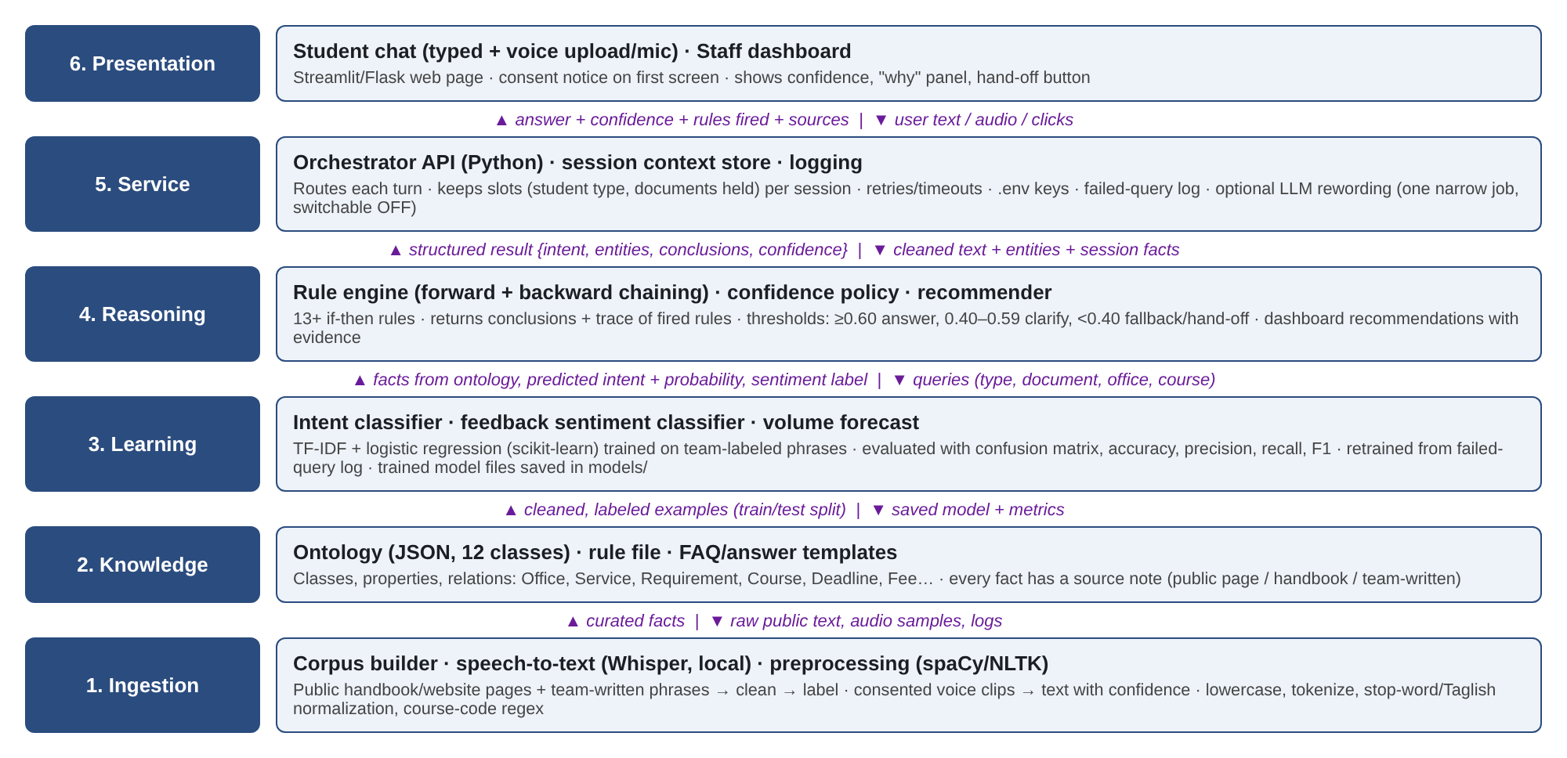
Figure 2. Six-layer architecture with the data crossing each boundary.
Service / library | Layer | Used for | Cost
Python, pandas, scikit-learn | Learning | Intent and sentiment models, forecast | Free
Python standard library (re), own rules | Ingestion | Preprocessing and entity patterns | Free
No speech-to-text | Voice | Recording and playback only; nothing is transcribed in this build | Free, runs on laptop
JSON ontology and own rule engine | Knowledge, Reasoning | Facts, rules, chaining trace | Free
Streamlit | Presentation | Chat page and dashboard | Free
psutil, hashlib/hmac, secrets, psycopg, JSON | System & Security | System telemetry, role-based authentication, optional PostgreSQL account storage, local preferences and file-backed application content | Free, standard / lightweight Python libraries

8. Knowledge Design
Draft ontology (12 classes). Stored as a JSON file in data/ontology.json: 11 record sections holding 41 records, each with its own source note. The Student class is not stored in the file - it is the session memory in code/dialogue.py.
Class | Main properties | Relationships
Student | type, term, documents_held (session only) | hasType → StudentType
StudentType | name (freshman, transferee, returning) | requires → Requirement
Requirement | name, description, issuing_body | neededFor → Service
Service | name, steps, online_or_window | providedBy → Office; hasFee → Fee; hasDeadline → Deadline
Office | name, location, hours | provides → Service
Course | code, title, units | prerequisiteOf → Course; partOf → Program; offeredIn → Semester
Program | name (e.g., BSCS), max_units | contains → Course
Semester | name, start_date, end_date | has → Deadline
Deadline | label, date | appliesTo → Service
Fee | label, amount, payment_options | chargedFor → Service
Policy | statement, source | appliesTo → StudentType
Announcement | text, date_posted, source | about → Service

All facts are taken from public pages or the handbook, or written by the team, with a source note on each. The requirement lists below are drafts; the team must verify them against the actual handbook of GRA SCHOOL.
First rules (13). Forward chaining over facts such as student_type(transferee) and has(tor). “not” is negation as failure on base facts only (closed-world assumption), which keeps results independent of rule order. This prototype was run and tested: rules_trace.py at the project root passes its 6 own cases, and the suite in tests/test_app.py runs 20 hand-made rule cases plus the ontology-agreement, entity-extraction and conversation checks - 81 checks in total, all passing.
# | IF | THEN
R1 | student_type(freshman) | needs(form138)
R2 | student_type(freshman) | needs(psa_birth_certificate)
R3 | student_type(transferee) | needs(tor)
R4 | student_type(transferee) | needs(honorable_dismissal)
R5 | student_type(returning) | needs(clearance)
R6 | needs(D) AND NOT has(D) | missing(D)
R7 | missing(D) | docs_incomplete
R8 | student_type(freshman) AND has(form138) AND has(psa_birth_certificate) | docs_complete
R9 | student_type(transferee) AND has(tor) AND has(honorable_dismissal) | docs_complete
R10 | student_type(returning) AND has(clearance) | docs_complete
R11 | docs_complete AND fees_paid | eligible(official_enrollment)
R12 | docs_complete AND NOT fees_paid | next_step(pay_assessment)
R13 | docs_incomplete | next_step(submit_missing_documents)

Forward chaining trace, worked by hand. Facts (made-up student): student_type(transferee), has(tor). In each cycle, all rules are matched against the facts at the start of the cycle.
Cycle | Rule fired | Binding | New fact
1 | R3 | – | needs(tor)
1 | R4 | – | needs(honorable_dismissal)
2 | R6 | D = honorable_dismissal (has(tor) exists, so D = tor does not fire) | missing(honorable_dismissal)
3 | R7 | D = honorable_dismissal | docs_incomplete
4 | R13 | – | next_step(submit_missing_documents)
5 | none | R8–R12 do not match | stop (fixpoint)

Answer shown: “Submit your honorable dismissal first,” with fired rules R3, R4, R6, R7, R13. Backward chaining is used for “why can’t I enroll?”: goal eligible(official_enrollment) needs R11 → docs_complete and fees_paid; docs_complete via R9 needs has(tor) (true) and has(honorable_dismissal) (unknown, so it fails); therefore the blocking fact is the missing honorable dismissal.

9. Data and Corpus Plan
Item | Plan
Sources | Public school website pages, published handbook, and posted announcements (no data requested from any office); phrases and records written by the team; voice clips recorded by consenting teammates and classmates.
Size | Intent corpus: 335 labelled questions across 10 intents (minimum is 200) - 50 team-written, 274 AI-drafted drafts, 3 labelled by staff in the dashboard, 8 harvested from the chat log. Feedback corpus: about 120 short comments labeled positive, neutral, negative - 120 drafted, all by the same source. Test set: 50 unseen questions written by a member who did not write the training phrases - still to be written. Speech: no speech corpus, because the build has no speech-to-text.
Labels | One intent label per phrase; sentiment label per comment; the reference text of each audio clip for word error rate.
Cleaning | Remove duplicates, lowercase, normalize spelling variants of Taglish (e.g., “po”, “pano”), mask course codes consistently, strip any personal detail; keep a change log.
Split | 80% train / 20% test, stratified by label, with a fixed random seed; the 50 unseen questions are never used in training or tuning.
Known gaps | Mostly Filipino and English; few regional-language phrases. The 274 AI-drafted questions are drafts, not team writing: 26 of the 300 produced were exact duplicates after normalisation and were dropped, and the rest still have to be replaced. The intent hold-out is drawn from the same writer distribution as the training data, so it is optimistic. There is no speech data at all, because there is no speech-to-text.

A sample of 50 team-written labeled items (5 per intent) is attached in Appendix C and as data/starter_corpus_50.csv. The data card will use the course template and be completed in the Final. The training corpus now holds 335 labelled questions: 50 team-written, 274 AI-drafted drafts still to be replaced, 3 labelled by staff in the dashboard, and 8 harvested from the chat log.

10. Technique Comparison
Accuracy figures in this section were targets to be measured when the section was first drafted. The build has since been trained and measured on this machine, so every measured number is now given in the Accuracy column with its caveat, and a row that still says “to pilot” has not been measured yet.
Layer | Options compared | Accuracy | Data needed | Cost | Explainability | Choice and why
Intent recognition | (a) TF-IDF + logistic regression  (b) cloud NLU service | (a) measured: hold-out accuracy 0.90, macro F1 0.90; 5-fold CV macro F1 0.81 ± 0.03  (b) to pilot | (a) about 30 phrases per intent  (b) 10–15 per intent | (a) free  (b) free tier with quota | (a) top words per prediction  (b) score only | (a): data stays local, probability gives confidence, and every prediction can be explained at the defense - chosen and built
Knowledge storage | (a) JSON ontology  (b) OWL in Protégé | Same facts | Same facts | Both free | (a) readable by all members  (b) formal reasoning | (a): simpler for four people in 3 weeks; OWL is a stretch goal
Reasoning | (a) forward/backward chaining rules  (b) learned classifier for eligibility | (a) exact on policy (20 hand-made cases in tests/test_app.py, all passing)  (b) depends on data | (a) handbook only  (b) labeled eligibility cases | Both free | (a) shows rules fired  (b) hard to explain | (a): policy is fixed and must be auditable
Trained model (feedback) | (a) Naive Bayes  (b) logistic regression | (a) measured: hold-out accuracy 0.67, macro F1 0.64 - below the 0.75 target | About 120 comments | Free | Both show word weights | Chosen after pilot; start with (a) as Bayes-based baseline
Perception | (a) Whisper local  (b) cloud speech API | (a) and (b) measured by word error rate on 20 clips - not measured, because no speech-to-text was built | None for training | (a) free  (b) free tier | (a) transcript with confidence  (b) same | No speech-to-text was built, so this row is deferred. The Voice page records and plays back only, and the assistant answers typed questions.
Conversation | (a) own dialogue manager in Python  (b) Rasa | Both able | Phrases and flows | Both free | (a) transparent  (b) more setup | (a): fewer moving parts; Rasa is the fallback
Analytics / recommendation | (a) moving average + rules with evidence  (b) ARIMA | (a) measured: 3-week moving average, mean absolute percentage error 0.29 on the log’s own weeks - above the 0.25 target | Chat logs (sample) | Free | (a) simple to explain | (a): little data, so a simple, explainable method
Interface | (a) Streamlit  (b) Flask + HTML | – | – | Free | – | (a): faster to build both chat and dashboard

11. Conversation Design
Intents (10) and entities (5, plus the assessment-payment flag). Each intent from the rule base, the knowledge base, or a hand-off.
Intent | Example | Handled by
greet | “hi po good morning” | Greeting and privacy notice
ask_requirements | “what do I need to enroll as a freshman?” | Ontology (Requirement)
check_eligibility | “can I enroll? transferee ako, may TOR” | Rules (forward chaining)
ask_schedule_deadline | “when is the last day of enrollment?” | Ontology (Deadline)
ask_fees_payment | “where do I pay my assessment?” | Ontology (Fee)
ask_office_hours_location | “what time does the registrar open?” | Ontology (Office)
ask_course_prereq | “prerequisite of CS 201?” | Ontology (Course)
ask_clearance_process | “how do I get my clearance?” | Ontology (Service)
request_human | “pakausap po sa staff” | Hand-off
give_feedback | “thanks, that was helpful” | Sentiment classifier

Two notes on this table, both from the running build. “pakausap po sa staff” scores 0.37 for request_human, below the 0.40 fallback line, so it currently gets the fallback message instead of a hand-off; “I want to talk to a staff member” (0.75) does hand off. And “thanks, that was helpful” reaches the sentiment path but raises there, because code/sentiment.py:118 loads the model from a name that does not exist (MOD_PATH instead of MODEL_PATH) - a one-line defect that has to be fixed before F5 can be claimed.
Entities: student_type (freshman, transferee, returning), document (TOR, Form 138, clearance, …), office, course_code (pattern such as CS 201), semester or date.
Preprocessing: lowercase, tokenize, normalize Taglish particles, extract entities with patterns and a dictionary.
Confidence policy: probability ≥ 0.60 answers; 0.40–0.59 asks a clarifying question with buttons; below 0.40 triggers the fallback message and, after two misses, a hand-off. Every answer shows its confidence. One documented deviation: when the top intent leads the runner-up by 0.25 or more the answer is given even inside the clarify band, and the answer card shows the real confidence and the margin - otherwise an unambiguous question such as “what do I need to enrol as a freshman” (0.59 against 0.09 for the runner-up) would be met with a clarifying question.
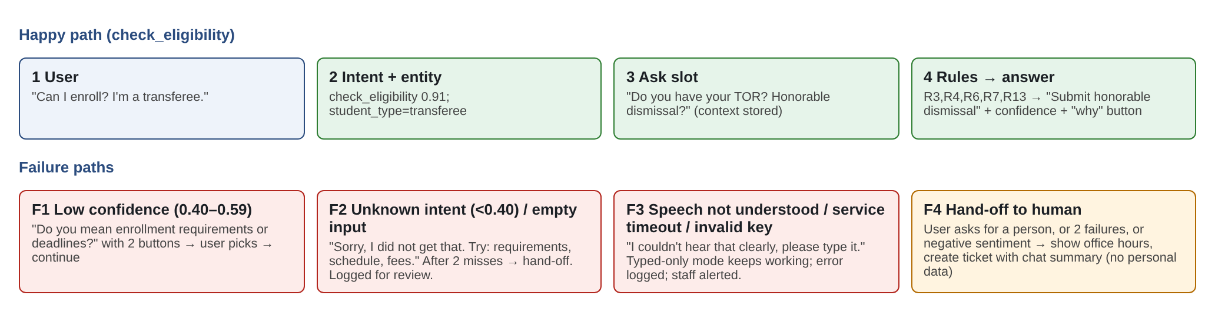
Figure 3. Conversation flow: happy path and failure paths.
Script (happy path). Student: “Can I enroll? I am a transferee and I have my TOR.” → System (check_eligibility 0.80): “Not yet - you still need to submit a document. Still missing: Honorable Dismissal.” with the backward-chaining explanation and fired rules R3, R4, R6, R7, R13. → Student: thumbs up (feedback logged). The two-turn version in the earlier draft does not work yet: a bare follow-up such as “TOR lang” scores 0.18 for check_eligibility, below the 0.40 fallback line, so the assistant falls back instead of continuing. Such fragments have to enter the corpus, or a bare document mention has to be handled before the intent model, before the two-turn script can be claimed.
Failure paths. (F1) Low confidence: the assistant asks a clarifying question with buttons - “Can I enroll?” with no student type offered yet asks Freshman, Transferee or Returning student. (F2) Unknown or empty input: a helpful prompt, logged for review, and a hand-off on the second miss - both verified. (F3) There is no speech-to-text in this build, so the Voice page cannot fail that way: it records from the microphone or accepts an uploaded clip and plays it back. The API-timeout and invalid-key paths do not apply either,. (F4) Hand-off works for “I want to talk to a staff member” (0.75) and “Can you connect me to a real person?” (0.69), but not yet for “pakausap po sa staff” (0.37, below the fallback line) - those Taglish phrases have to be added to the corpus. Context (student type, documents held) is remembered within the session.

Screen Mockups
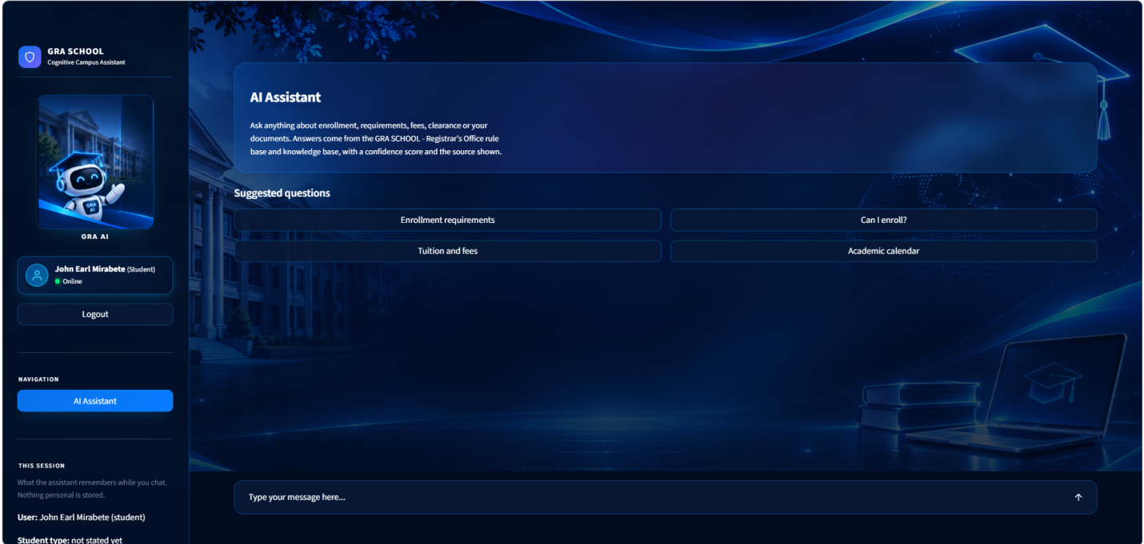

Figure 4. Student chat mockup with a recommendation shown with its confidence, rules, and source.
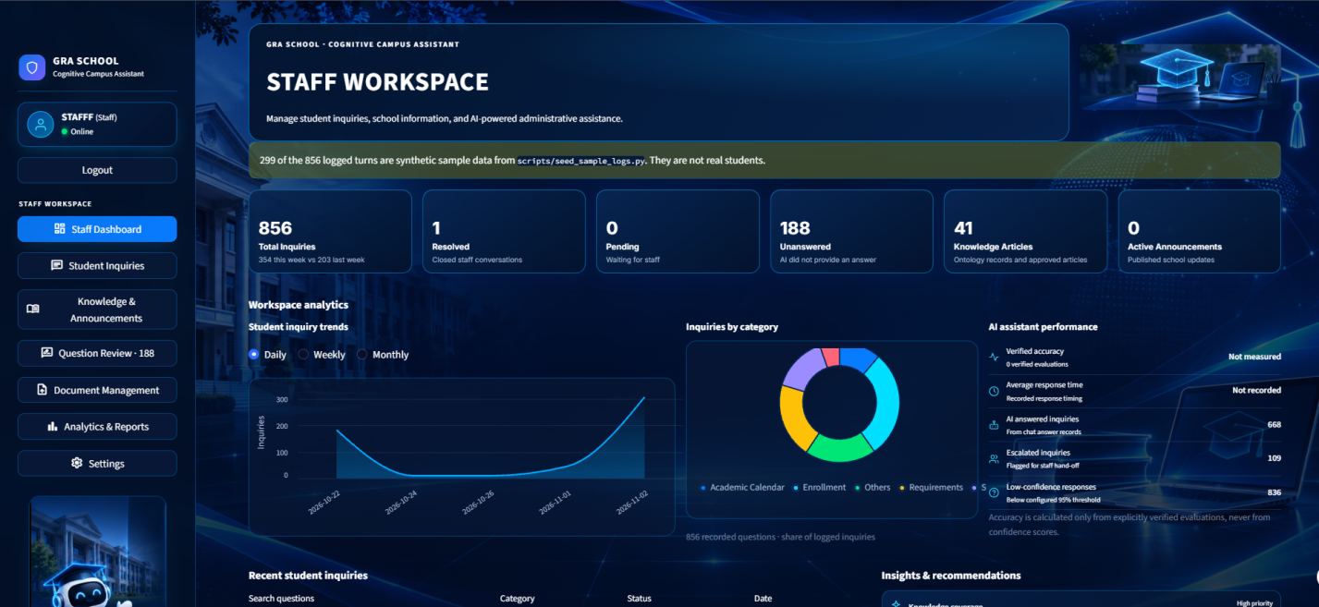

Figure 5. Staff dashboard mockup: descriptive views, weekly volume forecast, and evidence-backed recommendations. The complete interface architecture encompasses five cohesive views: (1) Unified Login and Account Registration with role-based access; (2) Student AI Assistant chat with explanation cards and suggested prompts; (3) Voice upload and playback; (4) Staff analytics and question triage dashboard; and (5) Advanced Futuristic Settings Dashboard featuring real-time system telemetry, automated/manual database backups, audit trails, and role-tailored views for staff and students.

12. Implemented System Update and Deployment
Status as of 2 November 2026. The working application now includes the following implemented workflows in addition to the original proposal scope:
- Student support handoff: a student can request staff assistance. Staff must explicitly take over before replying. If staff do not respond within five seconds, the assistant resumes the conversation.
- Staff inquiry review: questions appear in a table that refreshes every five seconds so new student inquiries become visible without a manual page reload.
- Student-facing school content: students can view published announcements, approved knowledge articles, and documents shared with them. Staff can upload documents for selected students and manage shared files.
- Account security and storage: student self-registration and administrator-controlled staff accounts use the unified role-aware authentication system. When a valid PostgreSQL DATABASE_URL is configured, account records are stored in Supabase rather than the Render instance's temporary filesystem.
- Deployment: the Streamlit application is configured for Render at https://graschool-chatbot.onrender.com. The app requires a valid Supabase Session Pooler connection string in Render's private DATABASE_URL setting before persistent account storage can be verified. No database password or connection string belongs in this document or the Git repository.
Persistence limitation: Supabase storage currently covers student and staff accounts. Conversations, uploaded documents, announcements, knowledge files, and other local JSON/files may still be lost when the free Render service restarts or redeploys. The account migration from data/users.json only works when that file still exists on the running instance and the destination account table is empty.
Local validation at the time of this update: 38 staff-workspace tests and 81 application checks passed. This does not verify the live Supabase credentials, remote database connectivity, or Render's production health.

13. Evaluation Plan
Component | Metric | Target | Test data
Intent model | Macro F1 (plus confusion matrix, accuracy, precision, recall) | ≥ 0.80 on 50 unseen questions; retrained at least once with results documented | 50 unseen questions
Confidence | Accuracy of answers at confidence ≥ 0.60 | ≥ 85% | Held-out set
Rules | Correct conclusion and fired-rule trace | 100% of 20 hand-made cases | 20 cases written by the team
Sentiment | Accuracy and per-class F1 | ≥ 0.75 accuracy | 20% held out
Speech | Word error rate | < 20% on 20 or more local clips | Consented clips
Conversation | Task completion and failure paths handled | ≥ 3 failure paths work; hand-off works in 100% of tries | Peer test script
Failure handling | Empty input, unknown intent, No API timeout, invalid key | All 4 handled gracefully and logged | Failure drill
Dashboard forecast | Mean absolute percentage error | ≤ 25% on held-out weeks | Sample logs
Fairness (Final) | Accuracy gap between 2 groups (e.g., English vs. Taglish; clear vs. noisy audio) | Gap ≤ 10 points, or mitigation applied | Test set split by group
Measured status, on this machine, at the time of writing: intent model 0.90 hold-out accuracy and 0.90 macro F1 over 67 held-out questions, 5-fold CV macro F1 0.81 ± 0.03, against the 0.80 target - but on a hold-out drawn from the same writer distribution, so the 50 unseen questions still have to be written and scored. Confidence: 5 of the 67 held-out questions were answered at 0.60 or above and all 5 were correct - the 85% target is met on 5 cases, which is not yet evidence. Rules: 20 of 20 hand-made cases pass. Sentiment: 0.67 accuracy and 0.64 macro F1 on 120 comments, below the 0.75 target, and the loader defect above stops the model from being used at all. Speech: not measured, no speech-to-text. Conversation: empty input, unknown intent and the two-miss hand-off all verified; the Taglish hand-off phrase and the two-turn script are not. Failure handling: 2 of the 4 drills verified (empty input, unknown intent) and the other 2 - API timeout and invalid key - do not apply while no provider is wired. Dashboard forecast: mean absolute percentage error 0.29 on the log’s own weeks, above the 0.25 target, on 6 backtested points. Fairness: not measured.

14. Preliminary Privacy and Risk Plan
- Personal data touched: typed questions (may contain a name by accident), voice clips of teammates, and chat logs. The system never asks for a name, ID number, grades, or contact details, and all records used in development are made up.
- Consent: a notice on the first screen states purpose and storage; a signed consent form is collected from every person whose voice is recorded; no health, religious, or financial details are collected.
- RA 10173 principles: transparency (notice and “why this answer”), legitimate purpose (answering enrollment questions only), proportionality (collect only what is needed; mask or remove personal details from logs; keep raw logs for a short, stated period of days - a team decision that has not been taken yet. code/logger.py currently keeps the log indefinitely and does not mask it, so this is the next thing to write.
- Who could be treated unfairly: students who write in Taglish or regional languages, speakers with accents or noisy audio, and first-generation students unfamiliar with office terms. Mitigations planned: more varied training phrases, test accuracy by group, human hand-off always available.
- Other risks: wrong policy information (mitigated by source notes and instructions to confirm with staff), API keys leaking (kept in .env and never committed), and answering everything (not allowed; off by default).

15. Work Split
Member | Final build responsibility
Both Members - Knowledge and conversation | Ontology, rules, inference engine, intents, entities, dialogue flows, conversation design chapter
Both Members - Data and learning | Corpus, cleaning, labeling, model training and retraining, bias check, data card, evaluation report
Both Members - Integration and interface | Orchestrator, keys, errors, logging, chat interface, installation guide
Both Members - Perception and analytics | Speech input and 20-sample test, dashboard, recommender with evidence and confidence, user manual
All members | Architecture, privacy safeguards, peer testing, pull-request reviews, presentation

16. APPENDICES

Appendix A: TOOLS
Members: John Earl C. Mirabete and Tristan P. Napili
Tool | Used for | Part of the project | Member responsible
Github, canva and vs.code | Drafted the proposal text and tables;the figure mockups; wrote and ran the draft rule-engine prototype and the starter phrases | Whole proposal; code/rules_trace.py; data/starter_corpus_50.csv | Both Members

We declare that we reviewed, understood, and can explain and change every part of this submission, including any part produced with AI assistance.
Signed:

Appendix B : Consultation Minutes
Consultation | Date and attendees | Topics discussed | Decisions and action items
Prefinal 1 | [date; members present] | [topics] | [decisions]
Prefinal 2 | [date; members present] | [topics] | [decisions]

Appendix C – Corpus Sample (50 items, team-written drafts)
ID | Text | Intent label
S001 | hello | greet
S002 | hi po good morning | greet
S003 | good afternoon po | greet
S004 | hey, may I ask something? | greet
S005 | kumusta po | greet
S006 | What documents do I need to enroll as a freshman? | ask_requirements
S007 | ano po ang requirements for transferee? | ask_requirements
S008 | What do I need to bring to the registrar for enrollment? | ask_requirements
S009 | Requirements for returning students po? | ask_requirements
S010 | Do I need a PSA birth certificate to enroll? | ask_requirements
S011 | Can I enroll now? I am a transferee and I have my TOR | check_eligibility
S012 | I'm a freshman, I already have Form 138 and PSA, am I ready to enroll? | check_eligibility
S013 | Am I eligible to enroll as a returning student? | check_eligibility
S014 | Check if my documents are complete | check_eligibility
S015 | pwede na ba ako mag-enroll, wala pa akong clearance | check_eligibility
S016 | When is the last day of enrollment? | ask_schedule_deadline
S017 | What is the schedule for late enrollment? | ask_schedule_deadline
S018 | Kailan ang start ng classes this semester? | ask_schedule_deadline
S019 | When is the deadline for adding and dropping subjects? | ask_schedule_deadline
S020 | What date is the payment of fees? | ask_schedule_deadline
S021 | How much is the tuition for a BSCS student? | ask_fees_payment
S022 | Where do I pay my assessment? | ask_fees_payment
S023 | Pwede po ba installment ang payment? | ask_fees_payment
S024 | What are the payment options at the cashier? | ask_fees_payment
S025 | Magkano ang miscellaneous fee? | ask_fees_payment
S026 | What time does the registrar open? | ask_office_hours_location
S027 | Where is the library located? | ask_office_hours_location
S028 | Anong oras po ang office hours ng guidance office? | ask_office_hours_location
S029 | Saan ang registrar's office? | ask_office_hours_location
S030 | Is the registrar open on Saturday? | ask_office_hours_location
S031 | What is the prerequisite of CS 201? | ask_course_prereq
S032 | Can I take Data Structures if I haven't passed Programming 1? | ask_course_prereq
S033 | anong prerequisite ng CS ELEC 6? | ask_course_prereq
S034 | Which subjects should I take in 2nd year first semester? | ask_course_prereq
S035 | How many units can I take this semester? | ask_course_prereq
S036 | How do I get my clearance? | ask_clearance_process
S037 | What are the steps to get a clearance for graduation? | ask_clearance_process
S038 | Ano po ang process ng clearance sa library? | ask_clearance_process
S039 | Who signs the clearance form? | ask_clearance_process
S040 | Do I need clearance before enrolling again? | ask_clearance_process
S041 | I want to talk to a staff member | request_human
S042 | Pakausap po sa registrar staff | request_human
S043 | Can you connect me to a real person? | request_human
S044 | human agent please | request_human
S045 | I need help from the office directly | request_human
S046 | Thanks, that was very helpful! | give_feedback
S047 | The answer was wrong, I wasted my time | give_feedback
S048 | Ang bilis ng sagot, salamat po | give_feedback
S049 | This is confusing and not useful | give_feedback
S050 | Great assistant, easy to use | give_feedback

Source for all items: written by the team for this project (no real people, no data from any office). Status: the corpus has been extended to 335 labelled questions - these 50 team-written items, 274 AI-drafted drafts still to be replaced by the team, 3 labelled by staff in the dashboard, and 8 harvested from the chat log. The 274 AI drafts have to be replaced before the data card is honest.

Appendix D – Candidate Situations Submitted
Rank | Situation | Why
1 | Cognitive Campus Assistant (enrollment and student services) | Public information is easy to find; we are clients of the service
2 | [Candidate 2] | [reason]
3 | [Candidate 3] | [reason]

