4.0 Methodology, Results and Discussion
4.1 Methodology
The prototyping methodology focuses on developing an early working model of a system or software to test and refine its design before completing the final version. This approach allows the developer to visualize how the app functions, gather feedback, and continuously adjust the design until it satisfies user and system requirements.
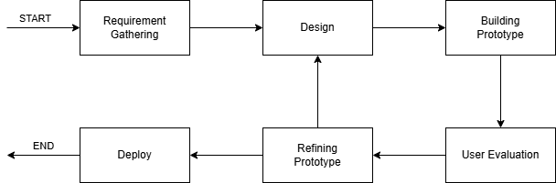

Figure 1: Prototyping Model
The developer adopted the prototyping model as the primary method for the project’s design and development process. This model effectively outlines a structured plan and sequence of activities needed to create the application. It allows the proponent to design and build a working prototype that can be tested and improved before making the final version. By using this method, missing features can be identified early, minimizing potential errors in later stages.

Prototyping model has 6 phases these are the following:
- Requirement Gathering
In this first phase, the proponent listed and planned what the app needs, such as its purpose, features, and system requirements. The proponent also looked at different apps and websites that have similar functions to get ideas and inspiration for the project.

B. Design
In this phase, the proponent used the gathered information to plan the app’s layout and design. The proponent created simple sketches and diagrams to show how the app would look and how users would move through it.

C. Building Prototype
In this phase, the proponent used Figma to make a visual prototype of the app. This version is only a sample and is used to check the look and flow of the app. It is not final and can still be changed or improved.

D. User Evaluation
In this phase, the proponent personally tested and reviewed the prototype to check if it works as planned. The proponent observed the design, flow, and functions to see what parts needed improvement or changes before moving to the next phase.

E. Refining Prototype
In this phase, the proponent applied the feedback to fix errors and add missing features. The goal is to make the prototype closer to the final version and to make sure it meets the needs and expectations of the user.

The proponent repeated these steps more than once until the app reached the desired result and was ready for personal use.
4.2 Requirements Specification
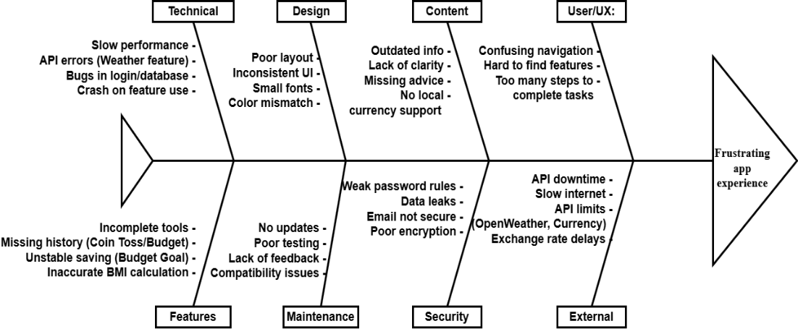
4.2.1 Operational Feasibility

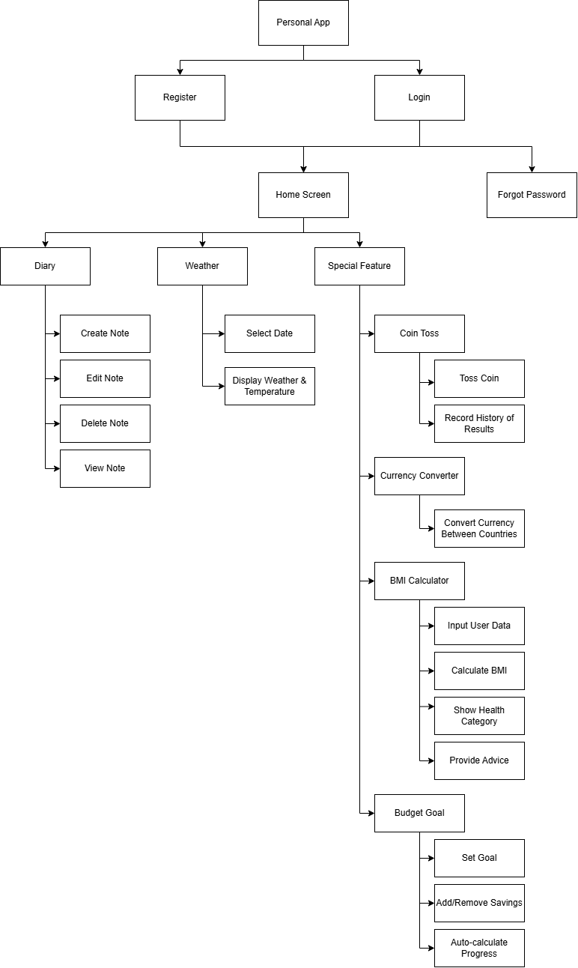
Figure 2: Fishbone Diagram

Figure 3: Functional Decomposition Diagram
4.2.2 Technical Feasibility
System Compatibility (Hardware, Software, and Other Technologies)
- Hardware Compatibility:
  - The app runs on Android device with sufficient processing power.
  - Minimum device requirements: 1 GB RAM and a basic processor to support features like weather updates, diary notes, and tic tac toe.
  - Internet connectivity is required for features such as Weather API, Firebase database interactions, and Currency Conversion.
- Software Compatibility:
  - Developed using Flutter, ensuring support for Android environments.
  - Firebase handles authentication, database, and email functionalities (e.g., forgot password).
  - OpenWeather API integration requires internet and HTTP request handling.
  - Compatible with modern Android and Windows versions; minimal OS versions can be specified for deployment.
- Other Technologies:
  - Dart programming language with Flutter framework.
  - UI/UX Design: Figma is used to prototype and design the app interface before implementation. This ensures a responsive and intuitive design across devices.
  - Local storage and history tracking (e.g., tic tac toe history, crossword puzzle progress) via Shared Preferences or SQLite for offline support.
Relevance of the Technologies
- Flutter: Provides a unified framework for cross-platform development, reducing development time and ensuring consistent UI/UX across devices.
- Firebase: Efficiently handles backend needs like authentication, database, and email without separate server setup.
- OpenWeather API: Integrates dynamic weather data, improving app functionality and user experience.
- Figma: Essential for designing prototypes and UI mockups, improving communication of design ideas and reducing development errors.
- Dart: Offers fast performance and smooth integration with Flutter’s reactive model.
- APIs & Libraries: Coin toss history, currency conversion, and BMI calculations are handled efficiently using Flutter’s ecosystem.
4.2.3 Schedule Feasibility
Task | Week 1 | Week 2 | Week 3 | Week 4
Project Planning
UI Design: Login/Register/Forgot Password
UI Design: Home Screen & Navbar
UI Design: Diary & Weather
UI Design: Special Features (Tic Tac Toe, Sudoku, BMI, Budget)
Table 1: Gantt Chart for the month of July 2025

Task | Week 1 | Week 2 | Week 3 | Week 4
Code the Design: Login/Register/Forgot Password
Code the Design: Home Screen & Navbar
Code the Design: Diary & Weather
Code the Design: Special Features
Table 2: Gantt Chart for the month of August 2025

Task | Week 1 | Week 2 | Week 3 | Week 4
Code the Function: Login/Register/Forgot Password
Code the Function: Home Screen & Navbar
Code the Function: Diary & Weather
Code the Function: Special Features
Table 3: Gantt Chart for the month of September 2025

Task | Week 1 | Week 2 | Week 3 | Week 4
Firebase Setup & Auth
Final Testing & Debugging
Project Completion
Table 4: Gantt Chart for the month of October 2025

4.2.4 Economic Feasibility
- Analysis of Costs and Benefits
  - Costs
    - Development Costs:
    - Android Studio & Flutter environment setup: Minimal (free tools)
    - Developer time (programming, UI/UX design, testing)
  - Firebase Costs:
    - Free tier for authentication, database, and hosting initially
    - Paid tier if usage exceeds free limits (e.g., high user base or data storage)
  - Maintenance Costs:
    - Bug fixes, updates, and occasional server usage costs
  - Other Costs:
    - Third-party APIs (e.g., OpenWeather API, if usage exceeds free quota)
- Benefits
  - User Benefits:
    - Easy personal diary management
    - Real-time weather information
    - Interactive and entertaining features (Tic Tac Toe, Rock Paper Scissors, Sudoku)
    - Financial awareness via Crossword Puzzle feature
  - Developer/Owner Benefits:
    - Potential monetization (ads)
    - Increased portfolio value
    - Data insights for future enhancements
- Cost Recovery Scheme
  - Advertisements:
    - Integrate optional in-app ads to cover hosting or API costs
4.2.5 Requirements Modeling
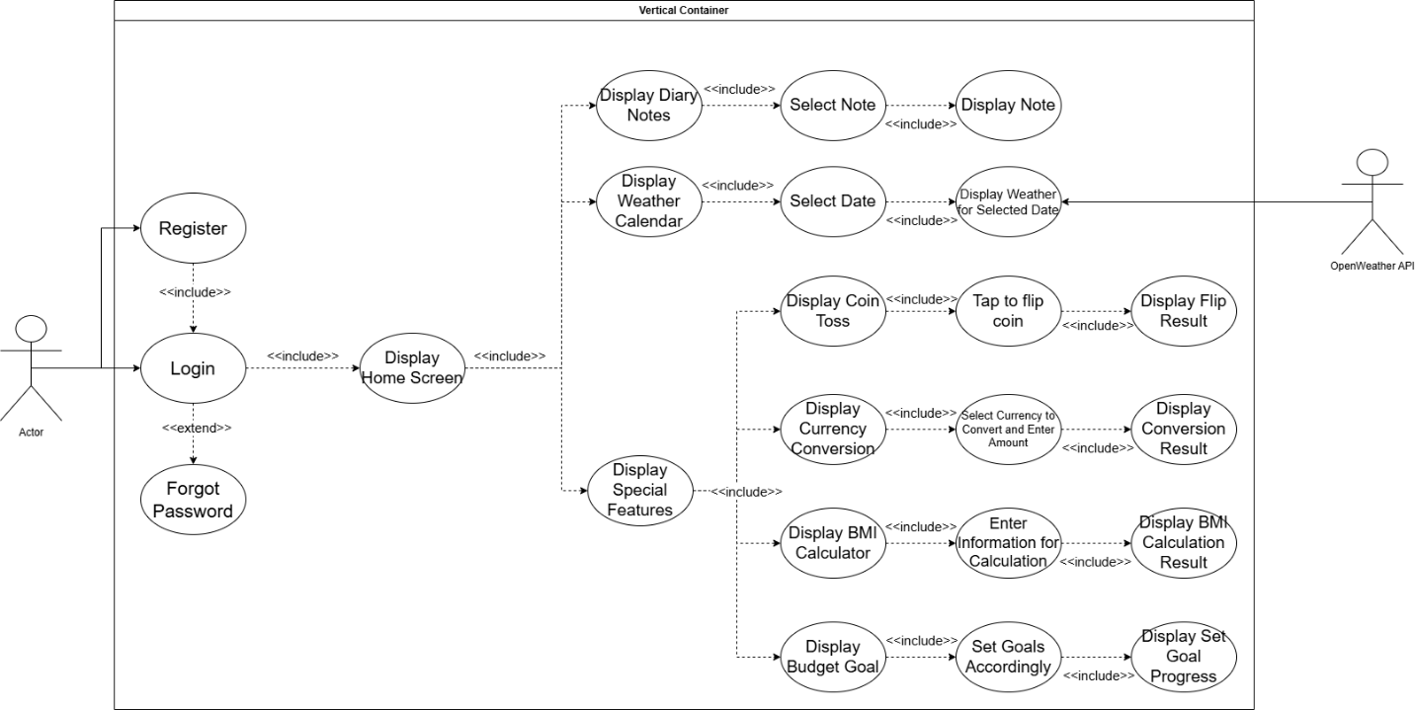
4.2.5.1 Use Case Diagram

Figure 4: Use Case Diagram

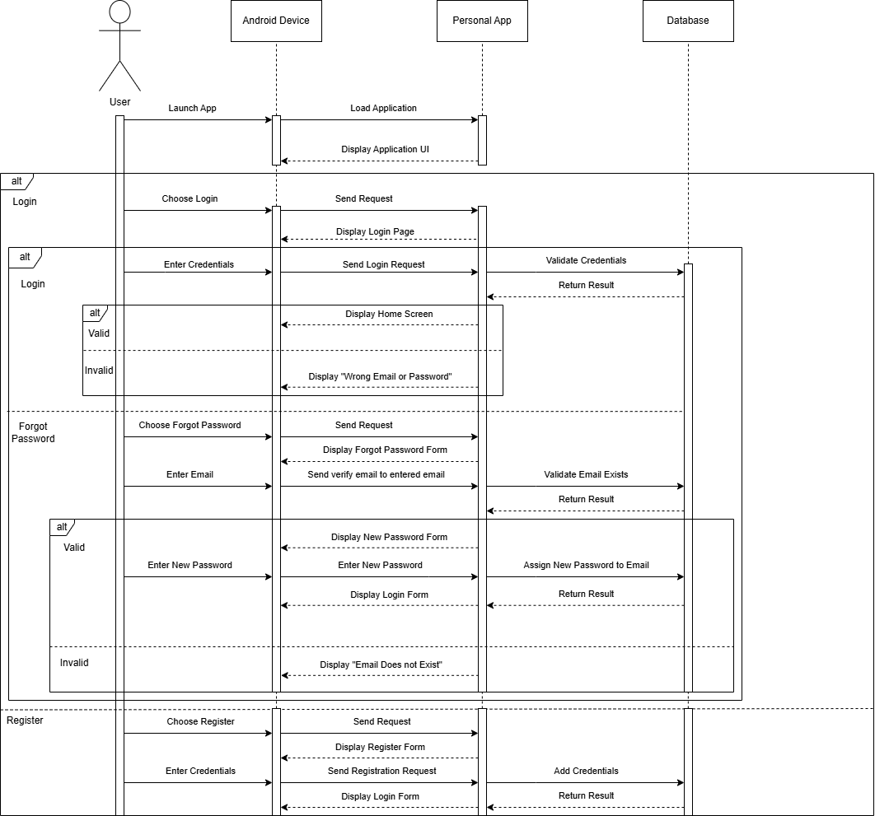
4.2.5.2 Sequence Diagram

Figure 5: Sequence Diagram Login/Register Module
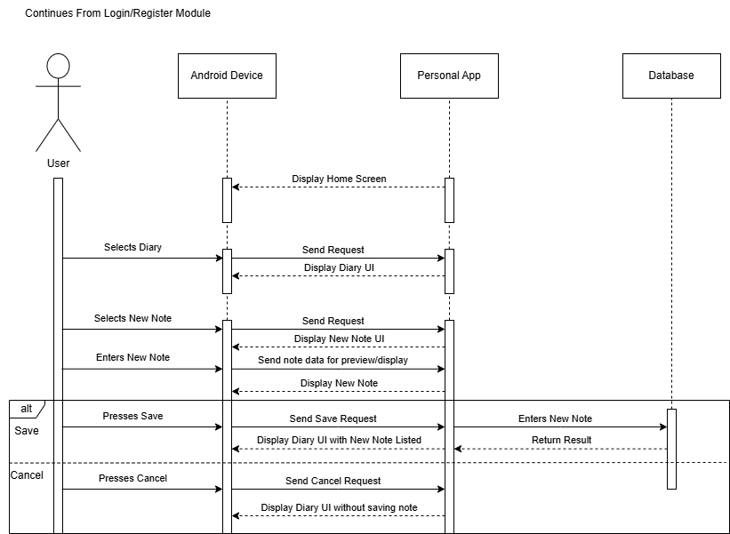
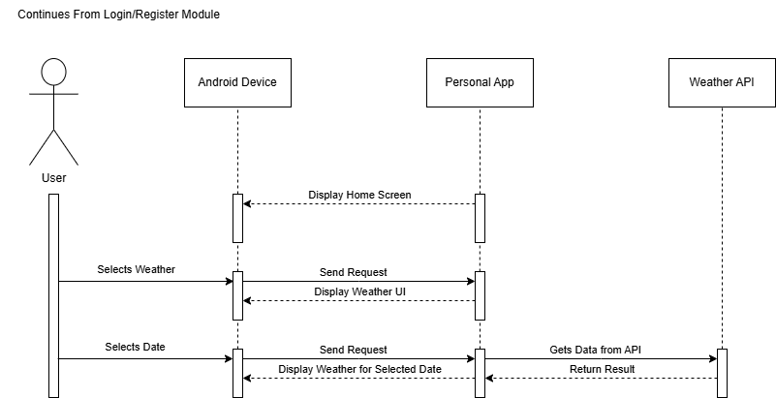
Figure 6: Sequence Diagram Diary Module
Figure 7: Sequence Diagram Weather Module
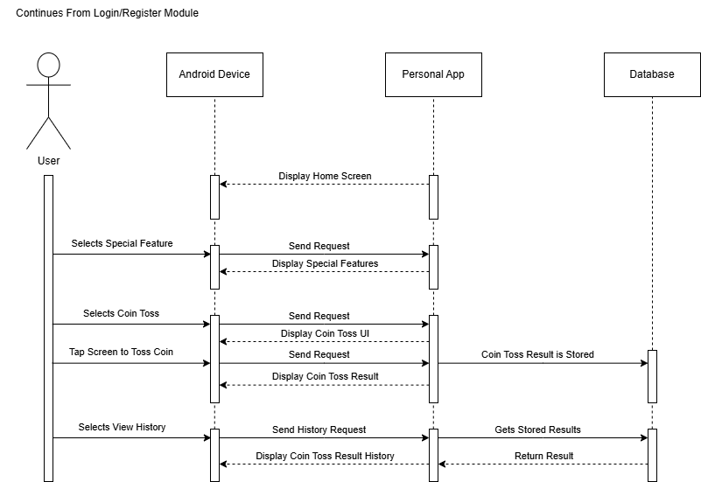
Figure 8: Sequence Diagram Tic Tac Toe Module
Figure 9: Sequence Diagram Rock Paper Scissors Module
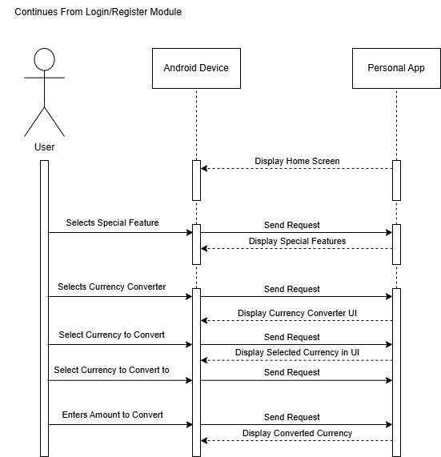
Figure 10: Sequence Diagram Sudoku Module
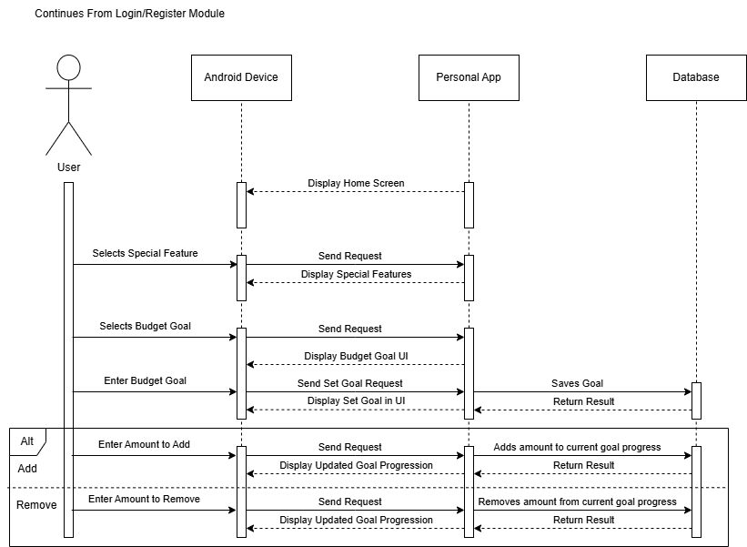
Figure 11: Sequence Diagram Crossword Puzzle Module
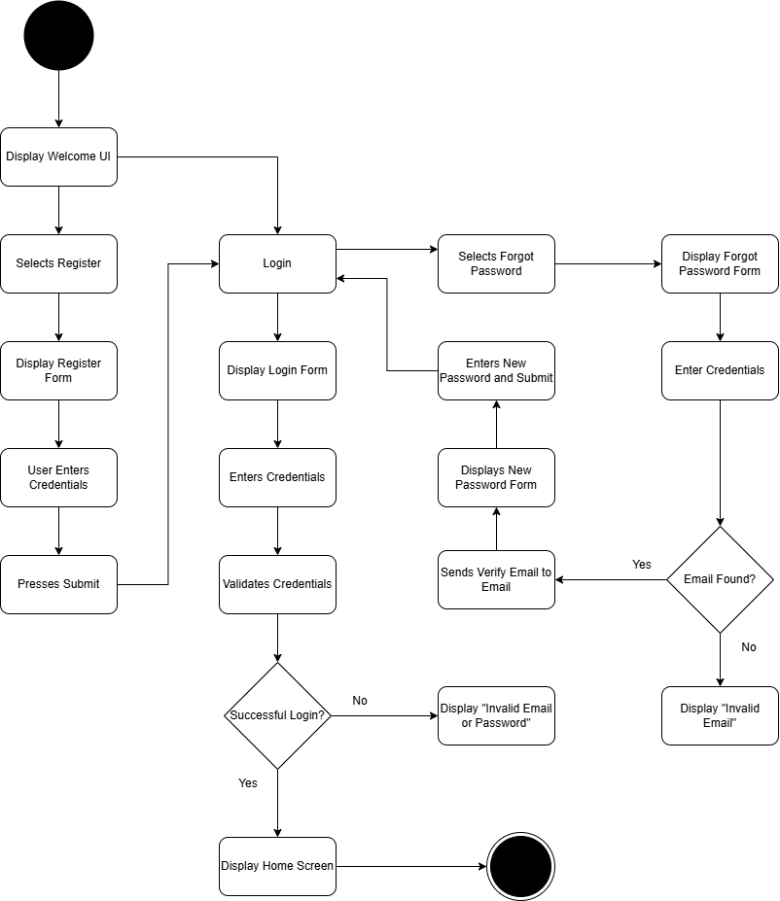
4.2.5.1 Activity Diagram

Figure 12: Activity Diagram Login/Register Module
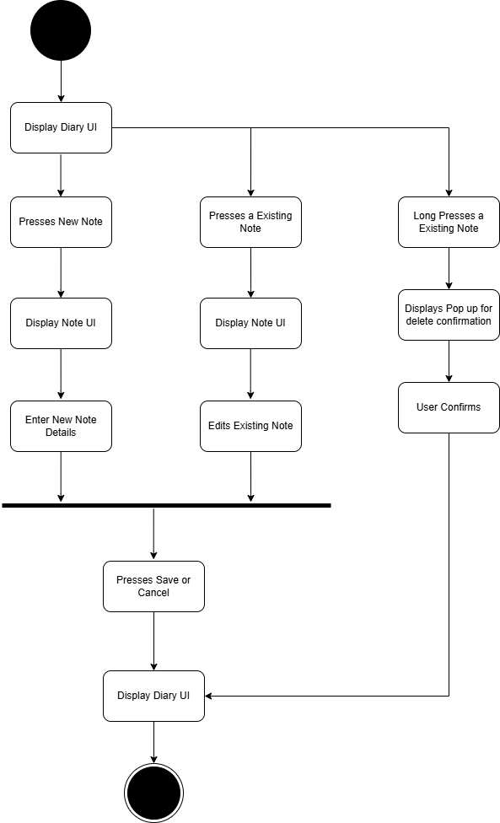
Figure 14: Activity Diagram Diary Module
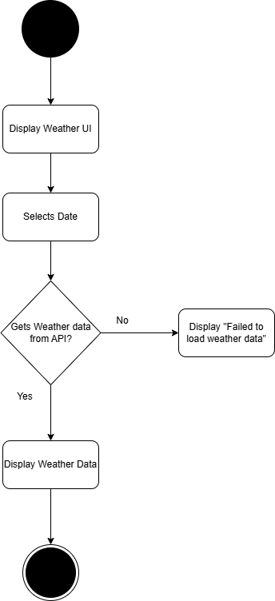
Figure 13: Activity Diagram Weather Module
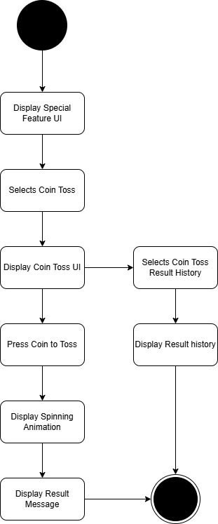
Figure 14: Activity Diagram Weather Module
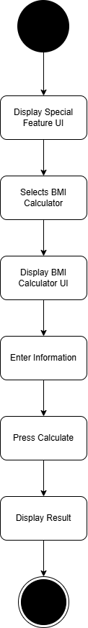
Figure 15: Activity Diagram Rock Paper Scissors Module

Figure 16: Activity Diagram Rock Paper Scissors Module
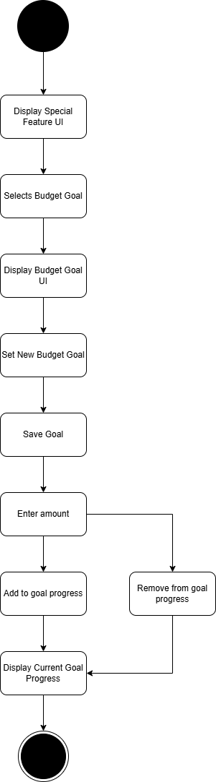
Figure 17: Activity Diagram Crossword Puzzle Module
4.2.6 Risk Assessment/ Analysis
As BSIT students, keeping up with the continuous evolution of mobile technologies presents a consistent challenge in developing a android application using Flutter and Firebase. The proponents encountered several risks, particularly their limited experience in mobile app development, integration of APIs such as OpenWeather for weather features, and Firebase authentication for login and password recovery.

These technical aspects require a deeper understanding of backend and frontend synchronization, data management, and API configuration. Furthermore, designing and maintaining multiple features such as the diary, BMI calculator, sudoku, and crossword puzzle tracker increases the project’s complexity and risk of system bugs or performance issues.

To address these challenges, the proponents will dedicate time to studying Flutter and Firebase integration, consulting online documentation, and testing each feature thoroughly. This effort aims to minimize technical errors, enhance user experience, and ensure that the application functions effectively across different devices and platforms.
4.3 Design
4.3.1 Output and User-interface Design
The interface of the application is styled with a calming blue background, a black bottom navigation bar, and gray input containers for user entries and content fields. Its layout maintains consistency by placing the username, profile icon, and add button at the top, followed by a search bar and a list view for diary entries. The bottom navigation bar provides access to the main modules of the application.

The color scheme consists of three primary colors: blue (#007BFF), black (#000000), and gray (#D3D3D3). Blue is used as the background color, black is applied to the navigation bar and header, and gray is used for the text boxes and content sections. White text (#FFFFFF) is applied to labels and icons over dark areas for proper contrast. These colors establish clear visual separation between interface elements.



Figure 18: Blue Figure 19: Black Figure 20: Gray
The app uses the Roboto typeface, a modern sans-serif font that ensures consistent readability across all screens. Roboto provides uniform letter spacing and clear visibility for both titles and content fields. Text elements such as labels, diary titles, and placeholders use regular and medium weights depending on hierarchy.
Figure 21: Roboto
The icons in the interface represent each function directly. The bottom navigation bar includes icons for the following features: a notebook icon for the Diary module, a cloud icon for the Weather feature, a circular icon for the Special Features, and a logout icon for logout. The top section includes a profile icon representing the user and a plus icon for adding new entries.

Figure 21: Roboto
Other interface components include consistent spacing, alignment, and padding across all modules. The layout follows a fixed structure that adapts to both mobile and desktop screens without altering the arrangement of elements.

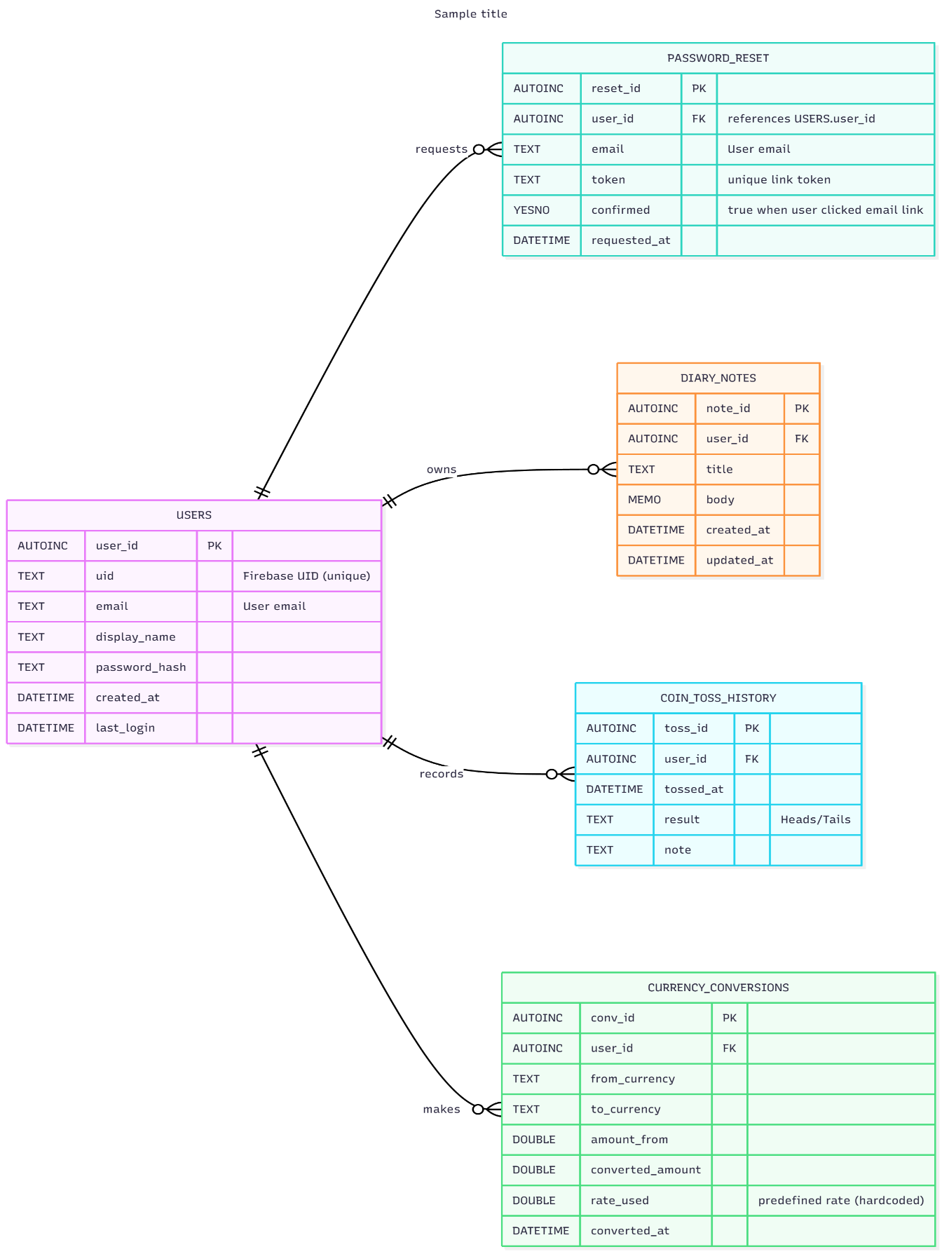
4.3.2 Data Design

Figure 23: Entity Relationship Diagram 1st half
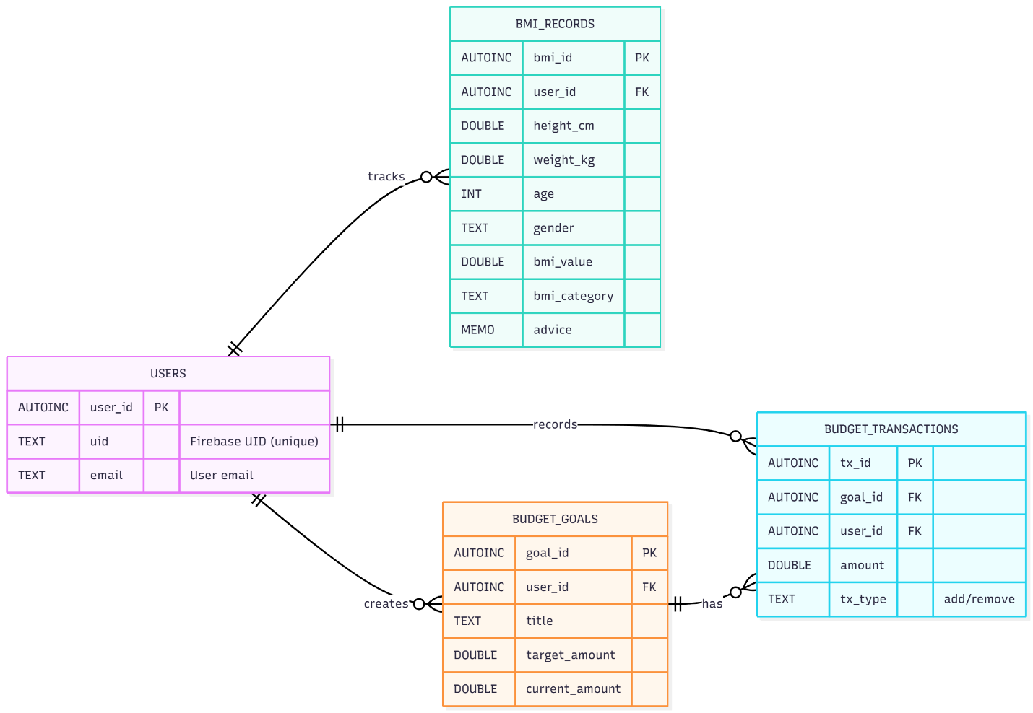
Figure 24: Entity Relationship Diagram 2nd half

Data Dictionary
    - System Architecture
      - Network Model
The system follows a Client–Server Model using Firebase as the backend. The client (user’s device) runs the Flutter app on Android. The server side is handled by Firebase Services, which includes: Firebase Authentication for login, registration, and password reset via email. Cloud Firestore for storing user data such as diary notes and crossword puzzles.

      - Network Model
The project uses a Star Topology centered on Firebase’s cloud infrastructure. Each client (user) connects independently to the central Firebase system. There is no peer-to-peer communication between users; all operations pass through Firebase. Firebase servers automatically scale and route requests through Google Cloud’s global network.
      - Security
The system upholds data security through Firebase’s built-in encryption and reliable communication protocols. User authentication is managed via Firebase Authentication, which securely handles login, registration, and password recovery using encrypted email verification. All data exchanges between the app and Firebase occur over HTTPS, preventing unauthorized access during transmission.

Access to the database is controlled by Firestore Security Rules, allowing users to view or modify only their own data. Sensitive information such as API keys is securely stored, and input validation prevents malicious data entry. In addition, Firebase automatically manages data backups and redundancy, ensuring reliability and privacy for all users.

4.4 Development
4.4.1 Software Specification
- Android Studio Giraffe | 2022.3.1 Patch 2 (Free)
Source: https://developer.android.com/studio
- Flutter 3.19.0 (Free and Open Source)
Source: https://flutter.dev
- Firebase (Free tier available)
Source: https://firebase.google.com
- Figma (Free)
Source: https://www.figma.com
- Google Material Icons (Free)
Source: https://fonts.google.com/icons
- Draw.io (Free)
Source: https://www.draw.io
- Mermaid Chart (Free)
Source: https://mermaid.js.org
4.4.2 Hardware Specification
The application was developed using the following hardware specifications:
Component | Specification
Operating System | Microsoft Windows 10 Pro
System Manufacturer | Emaxx Technology Inc.
System Model | EMX-A70FM2-iCafe
Processor | AMD A6-7400K Radeon R5, 6 Compute Cores 2C+4G 3.50 GHz
Memory | 16.0 GB RAM
Page File | 205 mb used, 16125 mb available
DirectX Version | DirectX 12

Table 5: System Information
Component | Specification
Card Name | AMD Radeon(TM) R5 Graphics (991 MB)
Manufacturer | (AMD) Advanced Micro Devices Inc.
Chip Type | AMD Radeon Graphics Processor
DAC Type | Internal DAC
Display Type | Full Display Type
Approx. Total Memory | 8631 mb
Current Display Mode | 1366 x 768 (32 bit) (60Hz)

Table 6: Display Device
4.4.3 Program Specification
Program Specification of the Personal App
Module: Login / Register
Purpose: To allow users to create an account or log in to an existing one securely using Firebase Authentication.
Events:
- Display the login and register buttons when the application starts.
- When the user selects Register, display fields for name, username, email, and password.
- When the user selects Login, display fields for email and password.
- Upon pressing the Login or Register button, authenticate the user through Firebase.
- Redirect the user to the Home screen upon successful authentication.
Module: Forgot Password
Purpose: To allow users to reset their password securely via email.
Events:
- Display the "Forgot Password?" link on the login page.
- When tapped, prompt the user to enter their registered email.
- Send a password reset link via email through Firebase Authentication.
- User clicks the confirmation button in their email to reset their password.
Module: Diary
Purpose: To let users create and manage personal notes or entries.
Events:
- Display the list of existing notes when the Diary tab is opened.
- Click the Add (+) button to create a new note.
- Display fields to input title and note content.
- Tap Save to store the note in Firebase.
- Tap a note to open and edit its content.
- Hold tap on existing note to remove a note after confirmation.
Module: Weather
Purpose: To show the weather and temperature of the selected date using the OpenWeather API.
Events:
- Display a calendar and weather section when the Weather tab is opened.
- Select a date to display weather details for that day.
- Show temperature, and weather condition (e.g., sunny, cloudy, rainy).
- Update information dynamically through the OpenWeather API.
Module: Tic Tac Toe
Purpose: To simulate a virtual tic tac toe and record its history.
Events:
- Display the Toss Coin button when the module is opened.
- When pressed, randomly generate Heads or Tails.
- Display the result immediately.
- Store each result in the history list.
- Allow users to view the list of past results.
Module: Sudoku
Purpose: To allow users to convert values between different currencies using predefined conversion rates (hard-coded).
Events:
- Display input fields for the amount and two dropdowns for currency selection.
- When the Convert button is pressed, calculate and display the converted value using stored conversion rates.
Module: Rock Paper Scissors
Purpose: To calculate and display the user’s Body Mass Index (BMI) with corresponding category and health advice.
Events:
- Display input fields for height, weight, age, and gender.
- Tap Calculate to compute BMI.
- Display the BMI result with a health category (e.g., Underweight, Normal, Overweight).
- Provide advice on maintaining a healthy weight based on the result.
Module: Crossword Puzzle
Purpose: To allow users to set savings goals, track progress, and manage their budget.
Events:
Display the user’s goals when the Crossword Puzzle tab is opened.
- Tap Add Goal to set a goals target amount, and initial savings.
- Tap Add or Remove to update savings.
- Automatically calculate and display the user’s progress as a percentage or progress bar.
- Allow users to edit or delete goals.

Table 8: Program Specification of Personal App
4.5.4 Programming Environment
4.5.4.1 Front-End
A. Flutter Framework
The front-end of the application was developed using the Flutter framework, which allows the creation of visually appealing, responsive, and cross-platform user interfaces using a single codebase. Flutter’s widget-based structure made it easier to build and customize UI components such as the bottom navigation bar, forms, buttons, and input fields.

B. Dart Language
The user interface logic and interactive features were coded using the Dart programming language, which is optimized for fast performance and seamless integration with Flutter. Dart enabled smooth animations and efficient state management across the application’s various modules.
4.4.4.2 Back-End
A. Firebase
The back-end of the system utilizes Firebase, a cloud-based platform by Google. Firebase provides real-time database storage, authentication, and hosting services. It was used for managing user login and registration, storing diary entries, saving Rock Paper Scissors and Crossword data, and sending password reset emails securely.

B. Firebase Authentication and Firestore
Firebase Authentication was implemented for secure user account management using email and password, while Cloud Firestore handled structured data storage and retrieval for app modules such as Diary, Tic Tac Toe history, and Crossword Puzzles.

4.4.4.3 Programming Considerations and Issues
During the development of the application, several programming considerations and issues were encountered. One of the main challenges involved integrating Firebase services, particularly in configuring secure connections for authentication and real-time database access. The integration of the OpenWeather API also required handling network permissions and managing asynchronous data retrieval to ensure accurate and timely weather updates.

Additionally, maintaining consistent data across multiple modules, such as the Diary, Rock Paper Scissors, and Crossword Puzzles, required efficient state management techniques in Flutter. Lastly, the developers focused on user experience optimization, ensuring that the application’s layout, animations, and transitions provided an intuitive and seamless interaction for users.

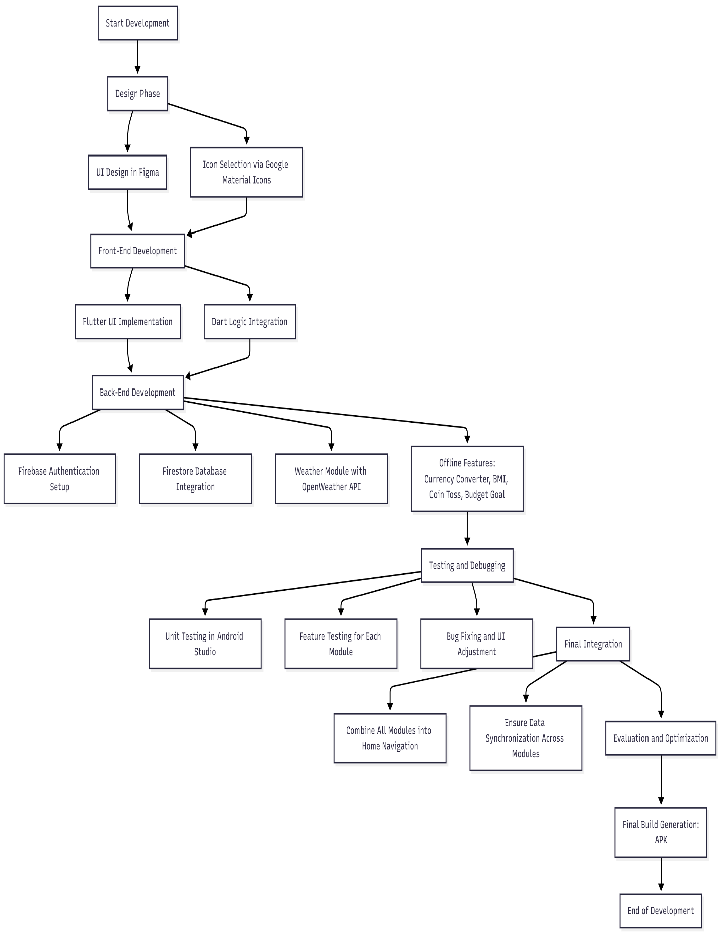
    - Development Diagram
Figure 25: Development Diagram
4.6 Installation Processes
The installation process transitions from traditional manual methods of record-keeping to the newly developed digital application for personal management. The Direct Changeover approach was used in implementing the new system. This method involves the immediate replacement of the old system with the new one once the application is fully developed, tested, and verified to function properly.

In this approach, the users immediately begin using the new system after installation without operating the old one simultaneously. This was chosen because the application functions as a standalone personal tool and does not rely on legacy data or external systems, minimizing potential risks during transition.

The installation process began by configuring the Firebase backend, which includes setting up authentication, Firestore database collections, and API integrations. Once the backend setup was complete, the Android Studio environment was prepared for deployment, and the application’s build was generated as an APK file. The APK was then installed on a compatible Android device for final testing and verification of functionality.

Once testing was successfully completed, the app was deployed for everyday user access and operation. The Direct Changeover approach allowed for faster implementation, easier monitoring of performance, and immediate adoption of the improved features such as diary management, weather updates, BMI calculation, tic tac toe history, and crossword puzzle tracking.

