Contents

1. Introduction 2

2. Quick Start Guide 2

3. General Program Usage 2

3.1 Logging into system 2

3.2 Review Open and Closed RIDs 2

3.3 Entering New RIDs 3

3.4 Responding to a RID 3

3.5 Closing a RID 3

3.6 Adding Notes to a RID 3

3.7 Viewing Responders Solutions 3

3.8 Viewing and Filtering RIDs 3

3.8.1 Viewing Open or Closed RIDs 3

3.8.2 Viewing and Filtering RIDs from a particular Reviewer 4

4. Updating Entries already Posted 4

5. Link to Documentation Zip File 4

6. Link to ORR Agenda and Schedule 4

7. Help File 4

8. Revisions 7

*Copyright (C) 2013*

*Associated Universities, Inc. Washington DC, USA.*

*This program is free software; you can redistribute it and/or*

*modify it under the terms of the GNU General Public License as*

*published by the Free Software Foundation; either version 2 of*

*the License, or (at your option) any later version.*

*This program is distributed in the hope that it will be useful,*

*but WITHOUT ANY WARRANTY; without even the implied warranty of*

*MERCHANTABILITY or FITNESS FOR A PARTICULAR PURPOSE. See the*

*GNU General Public License for more details.*

*You should have received a copy of the GNU General Public*

*License along with this program; if not, write to the Free*

*Software Foundation, Inc., 675 Massachusetts Ave, Cambridge,*

*MA 02139, USA.*

*Correspondence concerning this software should be addressed to:*

*Internet email: jeffland@nrao.edu.*

*Postal address: NTC*

*National Radio Astronomy Observatory*

*1180 Boxwood Estate Road*

*Charlottesville, VA 22903 USA*

# Introduction

The web-based RID tracking system is used to enter, update, and manage Review Item Discrepancies (RIDs), Questions (RIQ’) and Comments (RICs) originating from design reviews. Motivation for developing this system arose in anticipation of the large number of RIDs possible for the Front End Operational Readiness Review.

This document provides instructions for using the system.

# Quick Start Guide

1. Point your browser to the URL the contains the Rids.php file and login using the appropriate credentials
2. Once logged in, review existing RIDs from the main screen, shown in Figure 2.
3. Enter new RIDs by pressing the **Add a RID** button at the top of the main screen, which shows the RID input form in Figure 3. Once there:
   1. Select a document from the dropdown list. To narrow the choices in the list, enter text into the filter box immediately below that box and click the **Set Filter** button.
   2. Fill out the other information shown on the form. *Required* fields are identified on the form.
   3. Press the **Submit entry for checking** button at the top of the screen. A message will be displayed for a few seconds confirming the entry was posted in the database.
   4. Before the confirmation page changes, you can press your browser’s **Back** button to enter similar information about another RID. Otherwise, you will be returned to the main RID page.
4. To respond to a RID, or add additional information about a RID:
   1. Select the RID by clicking its hyperlink on the left side of the main screen, Figure 2,
   2. press the **Add notes or respond to this RID** button at the top of the Responses and Notes form, Figure 4, which will display the form shown in Figure 5, and
   3. enter the information required and press the **Post note about this RID** button.
5. To close a RID, follow Steps 4 above and select the **RID Closed** box on the form, Figure 5.
6. Responder’s solutions and notes from others are viewed by clicking on the RID number hyperlink listed on the far left side of the main screen in Figure 2. Clicking that link then displays the Responses and Notes form, Figure 4.

# General Program Usage

## Logging into system

Point your browser to the URL the contains the Rids.php file and login using the appropriate credentials

## Review Open and Closed RIDs

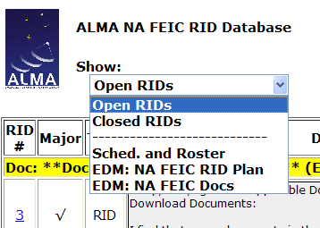Once logged in, you can review existing RIDs from the main screen, shown in Figure 2. That screen is organized by grouping reviewed documents in alphabetical order and listing relevant RIDs below each document heading. The RIDs are ordered in inverse chronological order.

Figure 1: Navigation Dropdown Box

Use the select box entitled “Show” in Figure 1 to show RIDs that are either open or closed.

## Entering New RIDs

New RIDs are entered by pressing the **Add a RID** button at the top of the main screen, which shows the RID input form shown in Figure 3. Once there:

1. Select a document from the dropdown list. To narrow the choices in the list, enter text into the filter box immediately below that box and click the **Set Filter** button.
2. Fill out the other information shown on the form. Required fields are identified on the form.
3. Press the **Submit entry for checking** button at the top of the form. A message will be displayed for a few seconds confirming the entry was posted in the database.
4. Before the confirmation page changes, you can press your browser’s **Back** button to enter similar information about another RID. Otherwise, you will be returned to the main RID page.

## Responding to a RID

To respond to a RID, or add additional information about a RID, click the RID number hyperlink on the left side of the main screen, then click the **Add notes or respond to this RID** button at the top of the Responses and notes form, Figure 4, which will display the form shown in Figure 5. Enter the information required and press the **Post note about this RID** button.

## Closing a RID

To close a RID, click the hyperlink for the RID number on the main screen, than **Add notes or respond to this RID** button at the top of the Responses and Notes form, Figure 4, which will display the form shown in Figure 5. Select the RID Closed box, enter your name, and press the **Post note about this RID** button. The following screen will show the RID is closed, and it will move from the Open RIDs to Closed RIDs on the main screen.

## Adding Notes to a RID

To add additional information about a RID, click the hyperlink for the RID number on the main screen, then press the button **Add notes or respond to this RID** at the top of the Responses and Notes screen, Figure 4, to display the screen shown in Figure 5. Enter the information required and press the **Post note about this RID** button.

## Viewing Responders Solutions

Responder’s solutions to a RID and notes from others are counted and listed below the originators name on the main screen, Figure 2. The solutions are viewed by clicking on the RID number hyperlink listed on the left side of the main screen in Figure 2 which then displays the Responses and notes screen, Figure 4.

## Viewing and Filtering RIDs

RIDs can be filtered by showing only Open or Closed RIDs, or those from a particular originator.

### Viewing Open or Closed RIDs

The main screen allows viewing open or closed RIDs by selecting your choice from the **Show** dropdown box at the top left of the screen in Figure 2. Also available from the dropdown box are links to the ORR Review plan and FEIC areas on ALMA EDM.

### Viewing and Filtering RIDs from a particular Reviewer

To view RIDs entered by a particular reviewer, select the originator’s name in the **Filter by RID Originator** dropdown box located on the top right of the main screen in Figure 2. Select None to return to viewing Open RIDs from all reviewers.

# Updating Entries already Posted

Allowing users to modify their own entries, while preventing others from doing the same, requires unique login credentials for each user, which is not implemented in this version of the software. Consequently, users can’t modify the **Description** and **Originator’s Suggested Solution**s once they are posted to the database. However, several remedies are available:

1. Add a note (see Section 3.6) to the rid with corrections listed,
2. mark the existing RID as “Closed” and enter a new RID, or
3. email [jeffland@nrao.edu](mailto:jeffland@nrao.edu?subject=Question%20re%20RID%20Doc%20Management%20System) with details of how to change the database record.

# Link to Documentation Zip File

The documentation zip file can be downloaded from the link **ORR_Docs** in the top center of the main screen. Be sure to select save when your browser asks to either open or save that file.

# Link to ORR Agenda and Schedule

Use the drop down box on the main screen (Figure 1) to load the latest review agenda and roster. Also available from that dropdown box are links to the ORR Plan and the top FEIC directory on ALMA EDM with ORR documents.

# Help File

The help document is available from the hyperlink on the top left of the main screen.

Questions should be e-mailed to [jeffland@nrao.edu](mailto:jeffland@nrao.edu?subject=Question%20re%20RID%20Doc%20Management%20System).

Figure 2: Main Screen Layout

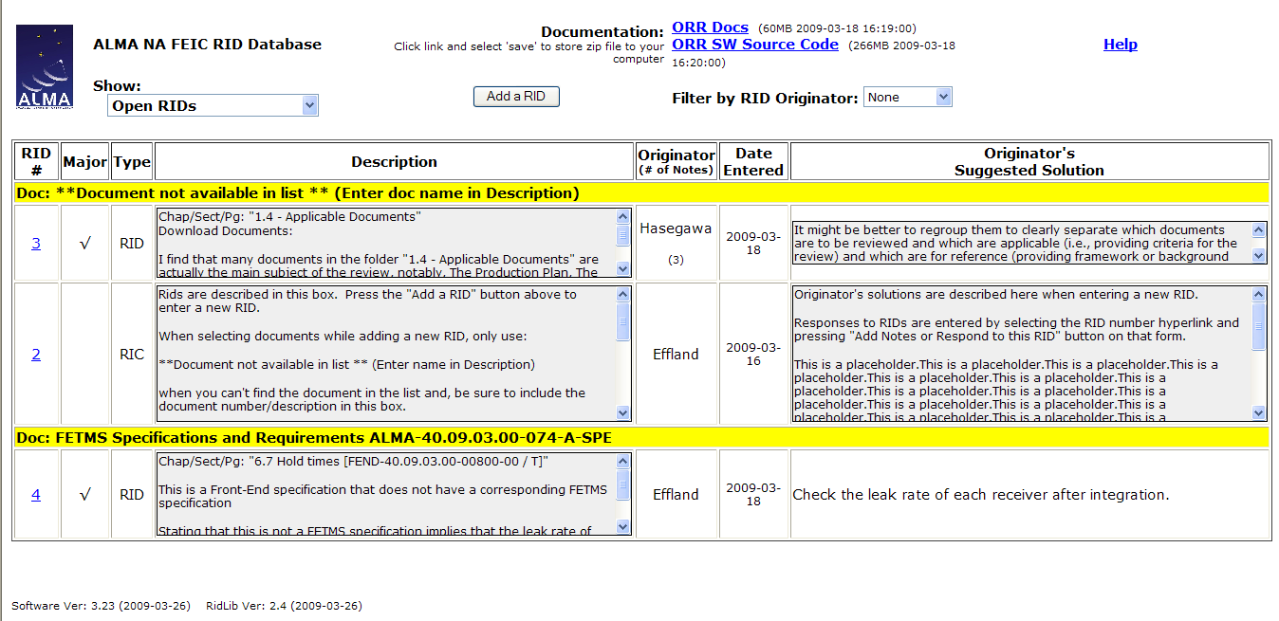

Figure 3: RID Input Form

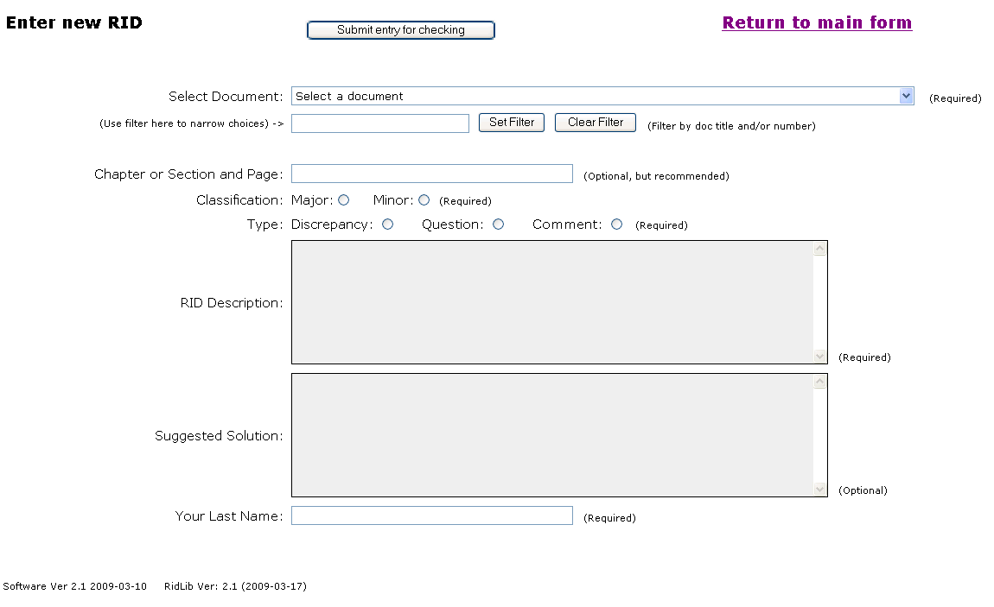

Figure 4: Responses and notes listing

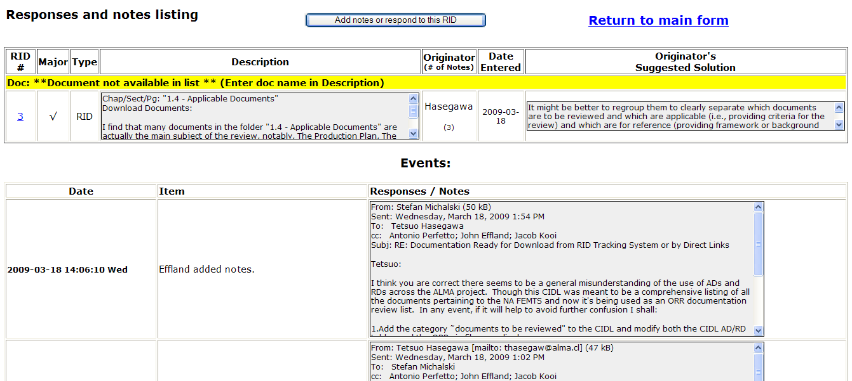

Figure 5: Response and Notes Input Form

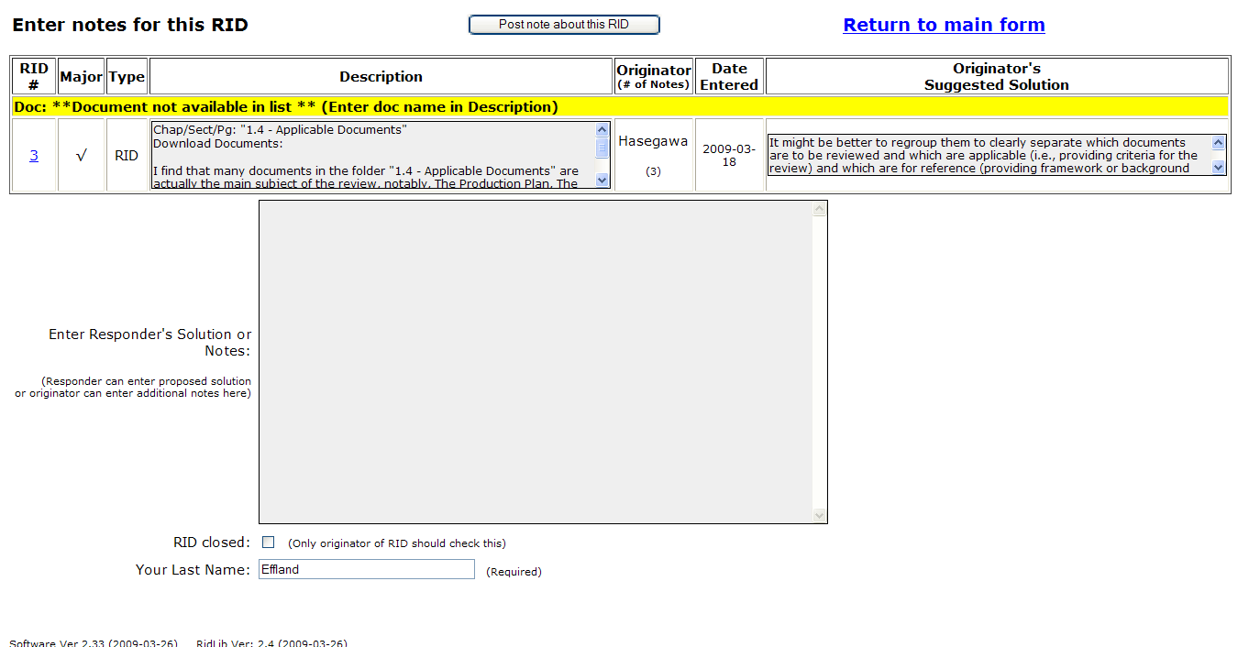

# Revisions

| **Revision Number** | **Date** | **Who** | **Details** |
| --- | --- | --- | --- |
| 1.0 | 2009-03-16 | jee | Initial, from Task Tracking System |
| 1.1 | 2009-03-17 | jee | Updated with additional sections. |
| 1.2 | 2009-03-18 | jee | Added information of agenda link and updated main screen fig. |
| 1.3 | 2009-03-26 | jee | Added number of notes section and updated figures |
| 1.31 | 2013-04-10 | jee | Removed credentials and paths to directories |
|  |  |  |  |